Abdul shahid 0352098
CRM TESCO REPORT
03/11/2020

Executive summery
Tesco CRM will be looked at.
The advantages and disadvantages will be looked at. With the use of CRM how to better attract customers to become regular shoppers at Tesco. With the use of the loyalty latter we can see how much up the ladder the customers are. CRM models will also be looked at along with ethics and sustainability. We will also look at corporate social responsibility along with the triple boron line.

Contents page
Introduction/procedures ………………..p4
Findings ………………………
2.1..CRM………p5-6
The loyalty ladder……….p7-8
2.2 ethics……….p9
Sustainability…………p10
CRM models……………p11-15
2.3 corporate social responsibility…………….p16-17
Triple bottom line……………….p18-19
Conclusion……………………….p20
Recommendations …………………………..p21
References…………………………. P22-24

- introduction
this report was requested by the chief executive of Tesco. The date requested was 3/6/2020. The purpose of the report is to look at CRM in Tesco along with ethics and sustainability. This report was compiled by Abdul Shahid on 3/7/2020.

Procedures
Test books and the internet will be used to write this report.

2.1
Customer relationship management (CRM) refers to the principles, practices, and guidelines that an organisation follows when interacting with its customers. From the organisation's point of view, this entire relationship encompasses direct interactions with customers, such as sales and service-related processes, forecasting, and the analysis of customer trends and behaviours. Ultimately, CRM serves to enhance the customer's overall experience”. (Investopedia. 2020)
In 1919 Jack Chen opened a small shop. During this time, groceries were being sold from a small stall in London. The name Tesco was formed in 1924. In 1929 Tesco opened its first store in the area of oak, Edgeware in north London. The Tesco tea was the first branded product of Tesco. The Tesco Clubcard was introduces in 1995. Tesco could keep records of what each customer preference was and in turn send out offers catered to each individual. By giving money off coupons, it would entice customers in returning to shop again at Tesco. To this day Tesco still remains one of the largest retailers even though a lot of competition from smaller and cheaper rivals such as Aldi and Lidl. They distinguish themselves from their smaller rivals by not only selling food, but also electronics, clothing, and financial/monetary services.
Satisfying customer needs is of great importance to Tesco CRM in building a good customer base and forming a good relationship.
Having good CRM
Enhances better customer service.
Numerous strategic advantages are gained with a good CRM system. One of the advantages are, an added personal touch to existing relationships between the customer and Tesco.
Facilitates discovery of new customers
Identifying potential customers is very useful with a good CRM system. Tesco keep track of existing customer profiles and then use them to determine which group of people to target for maximum clientele return.
Increase customer revenues
With CRM data in ensures Tesco has good co-ordination of campaigns in marketing. Data can be filtered to ensure that the promotion does not target customers who have already purchased that particular product. Tesco uses the data to introduce loyalty programs which will facilitate a higher retention rate of customers.

Enhanced customer loyalty
The CRM software is less costly in measuring Tesco customer loyalty. Loyal customers, in most cases become a source of recommendation of the business and the service offered. Thus, Tesco can promote their services to new potential customers based on recommendations from existing customers.
Facilitates optimised marketing
With the help of CRM Tesco is able to understand the behaviours and needs of their customers. Marketing their products to customers at the correct time in achieved. The software ensures that sales representatives have access to the most lucrative customer groups. Such information is crucial in targeting certain customers that are most likely to gain higher profits for Tesco. Tesco business resources will be meaningfully optimised with marketing.
But CRM systems also have negatives.
When CRM systems are installed, the human element is eliminated. Which means the normal everyday interaction between humans are eliminated which some task may require. The customer is having to deal with an automated massage rather than a human voice.
Employees may have a lack of commitment which in turn could lead to dissatisfied customers and result in losing revenue.
Sensitive information or customers is stored in this system. For example, credit card details or personal details which can be leaked intentionally or unintentionally in the wrong hands.

The loyalty ladder is a great way of measuring customers loyalty.
The loyalty ladder is a tool for marketing communicators. The idea is that consumers can be moved along a continuum of loyalty using a number of integrated marketing communications techniques (it is also referred to as a branding ladder). (Marketingteacher.com. 2020)
Tesco in the united kingdom is regarded as the most successful company in terms of relationship management. There are many reasons for this which include consistently adding value at every touch point to customers, thus making customers ending this relationship very difficult. The Tesco loyalty scheme is the Clubcard. This card is used for every single transaction. So, that data is recorded from each and every customer who scans the Clubcard. Coupons are then sent to the customer catered around their buying habits. Some promotion is given after transactions in terms of money off vouchers for fuel so you can fill up in their petrol stations. Essentially, the customer become loyal to the brand which has significance to them in terms of a service, product, experience, or solution.
As with continuums of behaviour such as UACCA – Unawareness, Awareness, Comprehension, Conviction, Action, or AIDA – Awareness, Interest, Desire, Action, the loyalty ladder begins from a point where the consumer has Not Yet Purchased, then he or she buys the product for the first time (Trialist), if the trial has been a success he or she returns to buy again and again (Repeat Purchaser) and finally the consumer buys no other brand (Brand Insistent). (Marketingteacher.com. 2020)

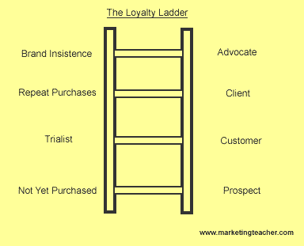

The diagram above is of a loyalty ladder.
The customer is merely a prospect at the not yet purchased stage. This is where the customer is trying the products to becoming a customer.
The repeat purchaser is the customer since they are becoming loyal.
In the end the customers become the advocate, (i.e. activist or campaigner) as they are brand insistent. Great brands like Tesco, Nike, BMW, adidas are all in this highly desired position.
The idea of the loyalty ladder is to move the prospect along the ladder to a point where there is partner. External customers are supported by marketing activities. As the customer moves along the ladder, there will be direct indications and measurements of the results between the customer and Tesco. The loyalty ladder is useful as it helps customer loyalty and retention.
Customer lifecycle management is a tool that helps to ensure of leads and customers are receiving high quality, service personalised to the customer. This creates an effective one to one customer journeys, promoting a better brand reputation with improved customer loyalty.

2.2
Definition: The Ethics is the branch of philosophy that deals with the principles of morality and the well-defined standards of right and wrong that prescribe the human character and conduct in terms of obligations, rights, rules, benefit to society, fairness, etc.
In other words, the ethics encompass the human rights and responsibilities, the way to lead a good life, the language of right and wrong, and a difference between good and bad. This means it is concerned with what is right or wrong for the individuals and society. The term “ethics” have been derived from the Greek word “ethos” which means character, habit, disposition or custom. (Learning Theories. 2020)
According to Fiends of the Earth regulations need to be tighter to prevent unfair and unethical trading practices of Tesco.
It is believed by the environmental campaign group that they way U.K’s supermarket chain operate are damaging the local communities, suppliers, small retailers and ultimately the customers.
In an MPs briefing, Friends of the Earth (FoE) say Tesco claims that they are creating new jobs for people overlooked the direct impact on local shops and communities.
FoE believes a cap should be made on retail floor space of superstores and for the local authority to take into account out of town developments on the businesses in the centre before planning is granted. The group also suggests that Tesco is paying their suppliers low prices in the UK in order to maximise profits. They want an independent watch dog to enforce stronger statutory supermarket code of practice.
As some of Tesco’s ethical policies and against human and the world, it may discourage customers from shopping in Tesco.

Tesco and sustainability

Following Tesco’s impressive results, with targets achieved, the next big priority for Tesco should be sustainability, in order to keep on gaining a higher share in this already highly competitive grocery market.

45 plastic packaged vegetable and fruits such as bananas, apple and oranges were removed from the Watford and Swindon Extra stores. In an initiative introduced by Tesco. As customers are already accustomed to buying loose fruit and veg already, this will save unnecessary packaging.

As the smaller stores use more packaged fruit and veg, Tesco should move this trial to the smaller convenience stores. This meets the demand of customers for a more environmentally conscious choice. In a London store, Marks and Spencer started a trial of two aisle of plastic free fruit and veg prior to Tesco’s scheme, however Tesco will have a greater impact as the stores are larger with a greater customer base.

As the population is becoming more environmental conscious customers, Tesco announced by the end of 2019 it will ban hard to recycle plastic packaging line black trays, bread bags. In turn enhancing its sustainability credentials.

This commitment is bold as it shows a greater sense of urgency from other similar schemes of other grocers. For example, Iceland are aiming to emilite plastic on all own branded products by 2023. Supermarkets who act quicker tend to build a better reputation as a sustainable retailer. And as a result, will get a greater shopping spend.

Tesco collaboration with recycling technologies

Tesco has announced a trial in collaboration with recycling technologies in 10 stores, this will help customers to recycle the hard to recycle plastics such as pet food packages and crisp. Councils in the locality do not recycle these items currently, and as councils are enduring further cuts, supermarkets could fill the gaps in the recycling service.
As competitor Sainsbury’s struggles with falling like-for-like sales, it could use sustainability to boost its performance and reputation by capitalising upon an increasing number of consumers being influenced by sustainability credentials. For instance, the retailer could partner with international recycling company TerraCycle to provide and promote in-store recycling stations for a wide range of products (e.g. contact lenses, pens, coffee pods). (Verdict Retail. 2019)
Tesco should note that customers are looking to retailers to take actions to tackle climate change. And the visibility of plastic is only one of the elements of sustainability. Retailers who can persuade customers that significant action is being taken will benefit in the long run by attracting customers and in turn ensure the sustainability of its supply chain.

CRM MODLE
We are discussing here:
- IDIC Model
- QCI Model
- CRM Value Chain Model

IDIC Model

This model is developed by Peppers and Rogers. It is suggested that companies should take four actions to building, retaining and keeping a long term one to one relations with its customers.
- Identify
- Differentiate (value, need)
- Interaction
- Customize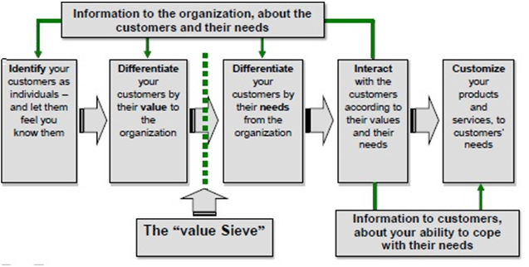

Identify

A deep knowledge on its customers should be identified along with who the customers are.

Differentiate

The VALUE and NEEDS should be differentiated in two bases.

Value
Differentiate the customers and identify which in generating most value now and who will offer most for the future.
The customers who are generating more value for the business should be given more precedence.

Need:
Differentiate your customers according to their needs.

Different customers will have certain individual needs. And serving these needs will need to done accordingly thus gaining more knowledge about their needs.

Interaction
Tesco must interact with customers and ensure they understand what customer expectations are and their relationship with the brand.
Tesco should consider with customers their interaction according to the value and needs that they are providing.
By interacting with customers directly, customers feel that Tesco care about their needs and treats them with significance. These efforts will make customers loyal to Tesco and will help build a long-term relationship.
Customise
After the differentiation of the customers’ needs and values, the product will have to be customised according to that value and need.
In order for the customer expectation to be met, product offers need to customised according to the customer needs and expectation.
Failure in this third step will mean that something wrong with step two or step three. A return back to the previous step would need to be taken to see where the company went wrong and re arrange the steps.

QCI MODEL

The QCI model is the product of a consultancy firm.

The word relationship is omitted from this model, rather referring to it as a customer management model.

In order to acquire and retain customers, at the heart of the model Tesco should depict the series of activities required to perform in order to attract these customers.

People are featured in this model with the use of technology to assist in these activities.
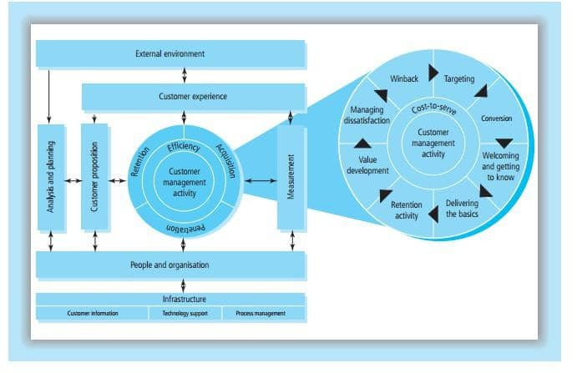
In this model a series of activities relate to people, employees the organisation itself and technology. According to this model, the relationship process with the external environment. The external environment directly effects the customer experience when wanting to interact with the organisation. The planning process of Tesco will also be affected by the external environment.
As shown on the figure, customer experience affects three future activities. Which are customer management, customer proposition, customer management activity and the measurement.
A customer proposition means, a product or service offered to the customer against the price.
The process of customer management activity is acquiring and capturing the customer. This starts with targeting followed by a conversation, selling the product in the end retaining the customer or wining the customer back. This activity affects the customer experience in how Tesco acquires and retains a customer and also penetrates.
Finally, the customer experience is affected by the measurement process. People in Tesco have a relation with the planning process, customer proposition, customer management activity and measurement. This is because ultimately CRM starts and ends with people.
CRM value Chain model
CRM is an information technology enabled sale and service function. For Tesco these three letters are emotionally contested. It’s a little more than targeted one to one communication. This CRM tool is simply a tool to manage customer relationship with the help of information technology, people, companies process, customer data and customers themselves.

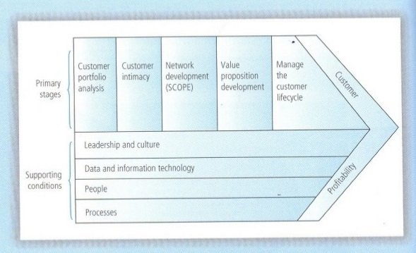
This CRM chain is well established, and a model Tesco follow when developing their CRM strategies.
This model has been five years in the making and has been used in a number of business to consumer and business to business settings. This model is based on strong theoretical principle requirements of a business.
In ensuring that Tesco builds a long term mutually valued relationship with its strategically significant customers is the ultimate purpose of the CRM value chain.
But Tesco must remember that not all customers are strategically significant. Some customers maybe too expensive to acquire and service. They might buy infrequently or make late payments or even default payment. These customers may make extraordinary demands, expansive, short run, customised output and then they defect to other competitors. These customers are called strategically insignificant customers.

2.3
Corporate social responsibility
Corporate social responsibility is about companies giving back to society and playing a reasonable part. Fund raising for worthy causes is a big part. Fundraising is a worthy cause and should be done together between companies, customers and communities can and should thrive together.
In 2019 Tesco raised two million pounds through the Tesco dance beats campaign for their charity partners. British heart foundation, diabetes UK and cancer research UK.
Tesco with the use of CSR, it presents themselves an opportunity to strengthen relations with stake holders at each and every level. This has become a crucial part of developing Tesco’s strategies and partnership.
CSR is a way for Tesco giving back to society. This way it strengthens customers, employees, and suppliers value towards Tesco. The CSR of Tesco not only increases company performance but also generates a positive social impact.
So what is corporate social responsibility, and why is it so important and what are the benefits?
CSR is efforts made by Tesco in improving society and contributing towards a development which is sustainable. This is also known as corporate citizenship or corporate conscience. Tesco’s CSR describes the initiatives run in evaluating and taking responsibility for the impact on issues ranging from environments to human rights.
CSR is a self-regulatory plan for a business (Tesco), focusing on social and environmental benefits, economic benefits for all stakeholders involved. For example, investors, employees, customers, and other groups both internal and external.
The purpose of Tesco CSR is to encourage Tesco to work in an ethical manner in terms of working towards having a positive impact on society through ensuring the growth is sustainable.
Sustainability not only applies to the environmental factor but also can refer to aspects for Tesco including economic, hiring, training or procurement.
CSR refers to lengths a business will go that is deemed by the law to be compulsory, as stated by environmental associations and regulators.
CSR will have a short-term cost may not show an immediate economic gain for Tesco. But will show social and environmental progress.

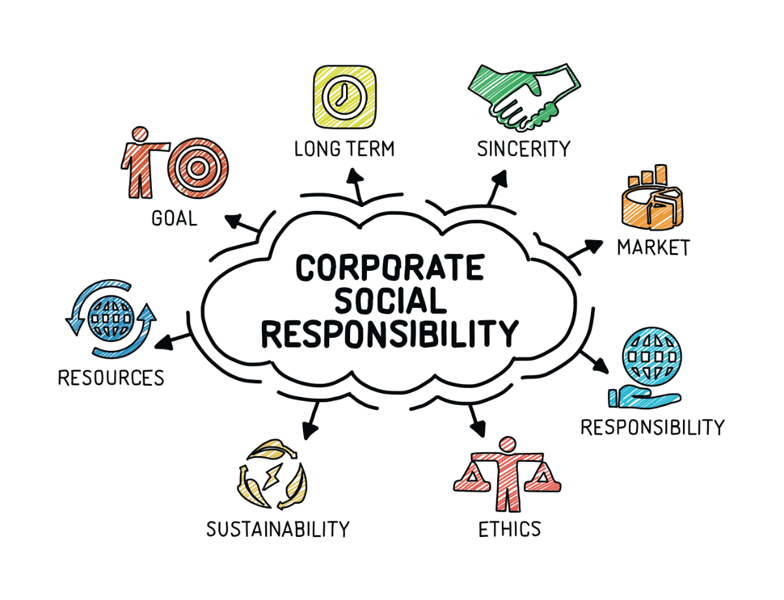

Elkington's Triple Bottom Line model is an influential model that has helped share the corporate social responsibility agenda.
The short video below provides an overview of Elkington's Triple Bottom Line model and there are some additional study notes below the video.
Elkington's Triple Bottom Line - Explained
What is the “Triple Bottom Line”? (Elkington's Triple Bottom Line (CSR) | Business | tutor2u, 2020) (Elkington's Triple Bottom Line (CSR) | Business | tutor2u, 2020)
The Triple Bottom Line is a concept that encourages the assessment of overall business performance based on three important areas: Profit, People and Planet
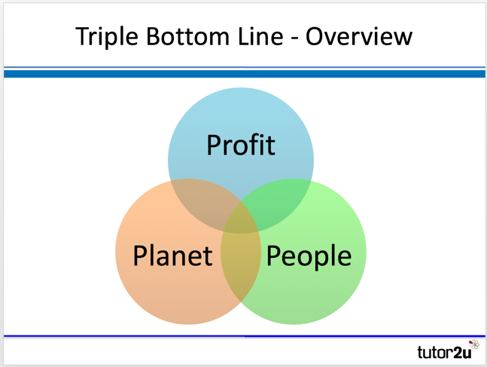Elkington Triple Bottom Line - People, Planet & Profit
Limitations with Traditional Measures of Business Performance
The Triple Bottom Line approach (Profit, People and Planet) arose out of frustration with traditional, financially focused measures of business performance, which have tended to emphasise profit as the key metric
- Businesses are usually assumed to be profit-maximisers
- Profit is the traditional measure of business success
- Profit is closely linked with business value (e.g. share price and market capitalisation)
- Profit is often the basis for financial incentives (e.g. senior management bonuses). (Elkington's Triple Bottom Line (CSR) | Business | tutor2u, 2020)
Obviously there is to Tesco success then just making profit.
John Elkington in this model argues a balanced approach to measuring the performance over time.
Profit, people, and planet over a period of time measures Tesco’s financial, social, and environmental performance.
Profit –
Manager will be familiar to this.
This is identified from statements such as profit and loss account.
Audited- a reliable figure.
Planet –
Measuring the impact of Tesco’s activity towards the environment.
It is more tangible for example emissions, green energy, use of sustainable inputs.
People –
Measures to what extent Tesco’s is socially responsible.
It is harder to calculate and report reliably and consistently.
The benefits of measuring the triple bottom line for Tesco is.
it will encourage Tesco to think beyond only making profits but making it while helping the environment. CSR reporting will be encouraged. It will also support the measurement of sustainabiltgy and environmental impact.
The criticism of the triple bottom line
It is not a very useful tool in measuring the overall performance of a business.
It is hard to consistently measure people and the planet.
There is no legal requirement to report it.

3.0
to conclude it could be said that Tesco is using CRM to full capacity in the sense the Clubcard which gives customers points in store to shop at a later time. Tesco’s mission “to be champion for customers” is achieved here with the use of CRM. Not only that Tesco also looks out for sustainability not only for products but also the environment which further encourages customers to shop in Tesco. But some lack of ethics due to slave labour would put off some customers as they would think that Tesco is only looking to maximise profit.

Recommendation
The recommendation would be to not use slave labour again in the future which might distract potential customers from shopping in Tesco.
Another good idea would be to involve the end users in the CRM implementation planning process. By doing that Tesco will be able to not only get customer ideas but also reach out to enthusiastic and influential individuals who can Evangelise CRM. Always train staff regularly as data is always being updated. Communicate openly between different teams to get the most success out of CRM. Make CR M mobile so it can be used at different paces for example in the home especially now with covid-19 around.
Always look at customer feedbacks to see if any changes need to be made.

References
Academized.com. 2016. Customer Relationship Management (CRM) Sample Research Paper By Academized.Com In Tesco. [online] Available at: <https://academized.com/samples/customer-relationship-management-in-tesco> [Accessed 2 July 2020].

Business Jargons. 2020. What Are Ethical Theories? Definition And Meaning - Business Jargons. [online] Available at: <https://businessjargons.com/ethical-theories.html> [Accessed 3 July 2020].

Chaffy, D., 2020. What Is Customer Lifecycle Marketing? Smart Insights. [online] Smart Insights. Available at: <https://www.smartinsights.com/ecommerce/web-personalisation/what-is-lifecycle-marketing/> [Accessed 3 July 2020].

Coursehero.com. 2020. What Are Some Decisive Uses Of A SWOT Analysis And CRM In Serving Customers.Docx - What Are Some Decisive Uses Of A SWOT Analysis And CRM In Serving | Course Hero. [online] Available at: <https://www.coursehero.com/file/26522831/What-are-some-decisive-uses-of-a-SWOT-analysis-and-CRM-in-serving-customersdocx/> [Accessed 1 July 2020].
Cyberiansoft.com. 2020. CRM Risks And Benefits. [online] Available at: <http://www.cyberiansoft.com/CrmRisksBenefits.aspx> [Accessed 1 July 2020].

Evening Standard. 2020. Tesco Branded 'Unfair And Unethical'. [online] Available at: <https://www.standard.co.uk/news/tesco-branded-unfair-and-unethical-6949514.html> [Accessed 3 July 2020].

Investopedia. 2020. Customer Relationship Management - CRM Goes Beyond Just Software. [online] Available at: <https://www.investopedia.com/terms/c/customer_relation_management.asp> [Accessed 1 July 2020].

Learning Theories. 2020. Ethical Theories And Frameworks - Learning Theories. [online] Available at: <https://www.learning-theories.com/ethical-theories-and-frameworks.html> [Accessed 3 July 2020].

: Lucidchart.com. 2020. 4 CRM Models That Boost Customer Loyalty | Lucidchart Blog. [online] Available at: <https://www.lucidchart.com/blog/crm-models> [Accessed 3 July 2020].

: Marketing for the Micro-business. 2020. Generating And Increasing Customer Loyalty For Your Micro-Business. [online] Available at: <http://www.marketingforthemicrobusiness.co.uk/marketing-advice-for-micro-businesses/generating-and-increasing-loyalty/> [Accessed 3 July 2020].

Marketingteacher.com. 2020. Loyalty Ladder. [online] Available at: <http://www.marketingteacher.com/the-loyalty-ladder/> [Accessed 3 July 2020].

Purt, J., 2014. Consumer Behaviour And Sustainability - What You Need To Know. [online] the Guardian. Available at: <https://www.theguardian.com/sustainable-business/2014/sep/10/consumer-behaviour-sustainability-business> [Accessed 3 July 2020].

Thegivingmachine.co.uk. 2020. Corporate Social Responsibility - A Simple Guide - The Giving Machine. [online] Available at: <https://www.thegivingmachine.co.uk/corporate-social-responsibility-simple-guide/> [Accessed 3 July 2020].

Salesforce.com. 2020. How Customer Lifecycle Management Can Help With Customer Retention. [online] Available at: <https://www.salesforce.com/products/marketing-cloud/best-practices/customer-lifecycle-management/> [Accessed 3 July 2020].

Schneider, D., 2020. CRM Models (Customer Relationship Management Model) - Ninjaoutreach. [online] NinjaOutreach. Available at: <https://ninjaoutreach.com/crm-models/> [Accessed 3 July 2020].

Softwaredoit.com. 2020. 11 Advantages And Disadvantages Of CRM. [online] Available at: <https://www.softwaredoit.com/gb/crm-software-recommendation/advantages-of-crm.html> [Accessed 1 July 2020].

Tesco PLC. 2020. Our History. [online] Available at: <https://www.tescoplc.com/about/our-history/> [Accessed 30 June 2020].

Tesco PLC. 2020. People. [online] Available at: <https://www.tescoplc.com/sustainability/people/> [Accessed 3 July 2020].

Tesco PLC. 2020. Core Purpose And Values. [online] Available at: <https://www.tescoplc.com/about/how-we-do-business/core-purpose-and-values/> [Accessed 3 July 2020].

Tesco PLC. 2020. People. [online] Available at: <https://www.tescoplc.com/sustainability/people/> [Accessed 3 July 2020].

Taylor, M., 2014. Advantages Of Customer Relationship Management - CRM Simplified. [online] CRM Simplified. Available at: <https://crm.walkme.com/advantages-customer-relationship-management/> [Accessed 1 July 2020].

tutor2u. 2020. Elkington's Triple Bottom Line (CSR) | Business | Tutor2u. [online] Available at: <https://www.tutor2u.net/business/reference/csr-elkingtons-triple-bottom-line> [Accessed 2 July 2020].

Verdict Retail. 2019. Tesco And Sustainability: Retailer Unveils Initiatives To Capture Consumers. [online] Available at: <https://www.retail-insight-network.com/comment/tesco-and-sustainability/> [Accessed 2 July 2020].

