

Assessment 1 – Reading Task Template
PART 1: Upload your photo of your A3 in-class notes here:
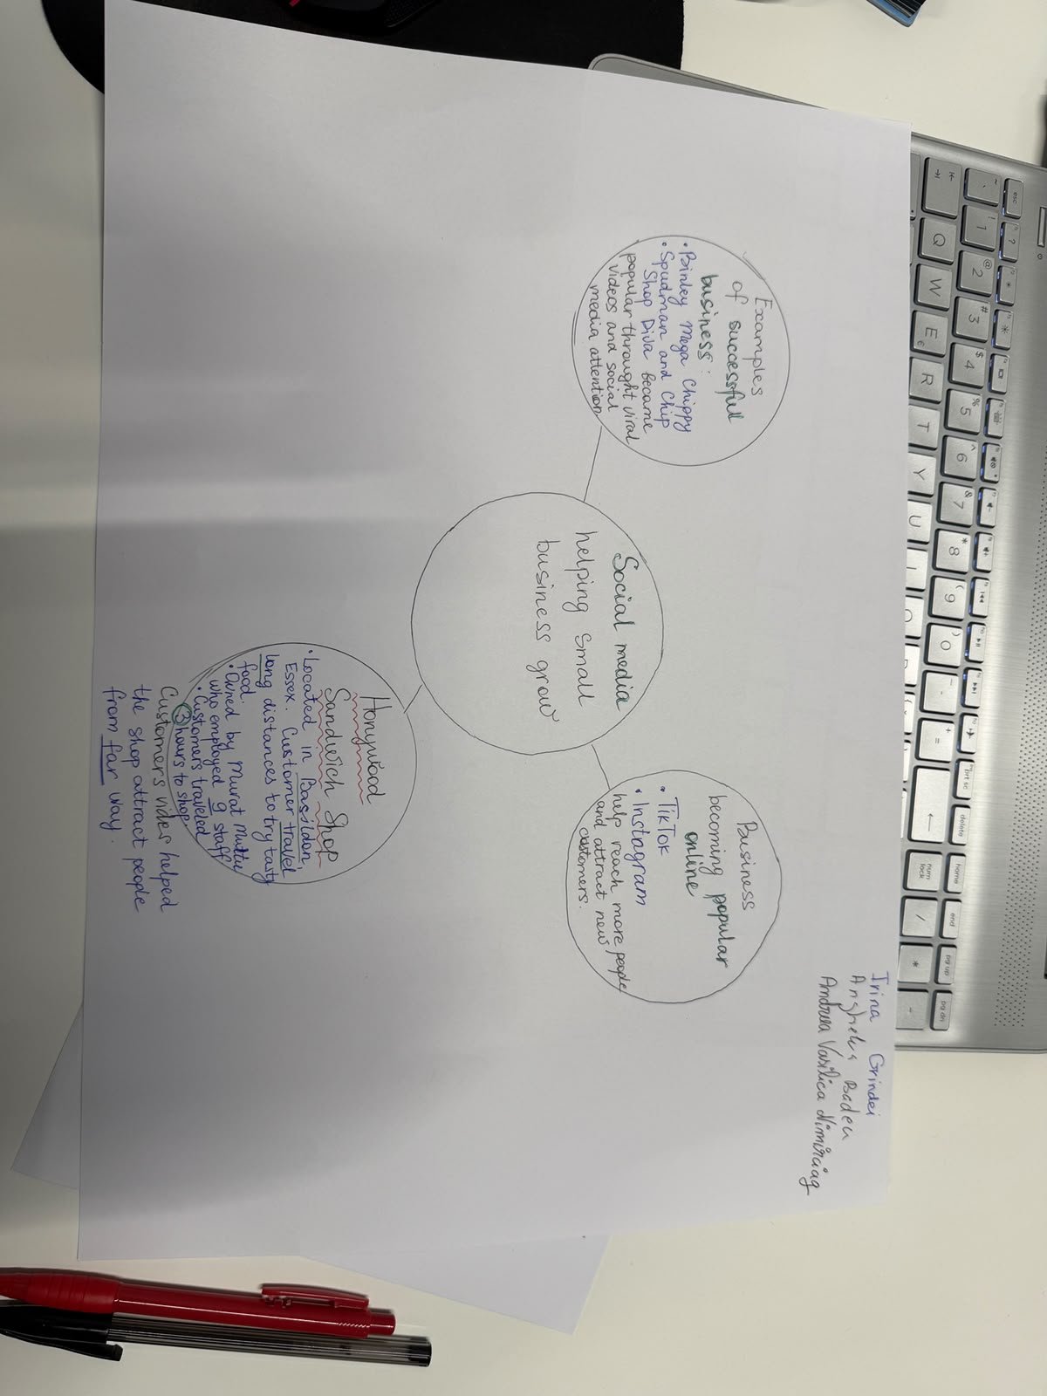

PART 2:
- Answer every question below in 1-3 full sentences.
- Use your own words. Do not use generative AI to answer these questions.
- Include a specific detail from the text when asked.
REMINDER
- The main idea is the overall message of the whole text.
- A key point helps to explain the main idea.
- A specific detail or example from the text shows that the key point is true.

- What is the main idea of the whole text?

The main idea of the whole text is that social media is playing a key role in the growth of business. Platforms like TikTok and Instagram have made it very easy for businesses to get noticed. The idea of the text is how a small business can become big and the centre of a viral trend through the power of social media, attracting people from near and far.

- What is one key point that supports the main idea, and which specific example from the text shows this?
One key point that supports the main idea is the number of businesses enjoying a boost in business after going viral. An example that supports this idea is that ‘Customers travelled three hours for our chicken burger’, as said by the owner of Honeywood Sandwich Shop in Basildon. This shows the power of virality on social media to grow businesses and have a wider reach.
- What is a different key point that supports the main idea, and which specific example from the text shows this?
A different key point that supports the main idea is ‘People buy from people’. An example of this is Little Love’s Pamper Bus, a mobile beauty salon that was started by Chloe Huggins and Rose Bliss, and they show how authentic and relatively to show brand have helped them generate 45 million views in less than a year. They also share that they travel around Essex but also get inquiries from the United States and Bahamas, showing how powerful social media is and can contribute to the international presence of a business.

- Which part of the text do you think is most important, and why?
A part of the text that is most important is the story of Linda Hunter, a 62-year-old lady who used to sell clothes for 46 years at markets in Essex, Kent, and London. She started her online business and became able to ship outfits in the UK and even to Australia. It shows that the power and potential of social media are not limited to any specific age and type of business; it can help a sandwich shop which has loyal customers from nearby areas and a clothing shop that operates at a very small local level run by a 62-year-old.

Reflection:
- What did you find difficult in this task (including in-class components), and why was it difficult?
In this one thing that I found most difficult was identifying key points because the text involves a lot of examples, and it is difficult to identify which one of them is a key point. The reason is that some of the highlighted points are mere comments or experiences, whereas others are very strong opinions and ideas, making it difficult to identify if they make for a key point in the text or not.

- What helped you with this difficulty, and how did it help you?
Reading multiple times and trying to understand the text helped me with this difficulty and identify key points to answer earlier questions in this task. Reading the text multiple times and understanding its meaning helped in identifying whether it is a key point or a statement telling a story about a business.

Assessment 2- TEEL Writing
Importance of motivation in the workplace
Topic
Motivation is a driver of high engagement, better performance and higher output in the organisation.
Evidence + justification
Motivation is very important in the workplace as it can lead to increased job satisfaction and make the work more fulfilling for them, which leads to higher engagement. At the same time, feeling motivated at work can also make positive impact on the wellbeing of employees.
Explanation
Better job satisfaction and engagement have a direct effect on the performance and productivity of people. Motivated employees are more likely to be enthusiastic, committed and proactively involved in various organisational and job-related activities.
Link sentence
Therefore, it can be said that motivation is a very important driver of engagement, performance and output in the organisation. Overall, a motivated employee is more likely to generate better results compared to an employee who lacks motivation.

Assessment 3- Reflective Presentation
Today I am going to talk about academic skills and my experience of developing academic skills during the 10 weeks of the module. Academic skills are very important as they enable students to process information and achieve high academic performance it can also benefit them in the professional world.
During the 10 weeks of the module, two important academic skills that I developed are reading and comprehension and clear writing and editing. Reading and comprehension are very important academic skills, and that involves ability of an individual to read written text, process its meaning and connect it with existing knowledge rather than only memorising information. Reading and comprehension further involve skills like skimming, deep reading and extracting main concepts from academic texts. Clear writing and editing skills are another important academic skill that involves the ability of an individual to structure thoughts while writing, to ensure the reader can easily read and understand the text.
The present assessment is one of the examples which helped me learn and develop these skills. The first assessment requires to read text and answering questions on the basis of the text that helped me develop and improve reading and comprehension skills. The second assessment was TEEL writing, and this helped me improve clear writing and editing skills.
One of the challenges that I experienced during the module was comprehending a few concepts. However, I tried to understand them multiple times and also asked my peers and did some online research, and I understood those concepts.
Reading & comprehension and Clear writing & editing skills are very important for future studies, especially when studies get complicated and learners need to go through complicated texts. At the same time, clear writing and editing skills are also important for workplace development, as many types of jobs require an individual to possess good knowledge and written communication. Having these skills can also improve my employability and give me an advantage over those who lack these skills. Therefore, these skills can help in academic success through faster reading and comprehension and effective writing and in workplace success as well.
During these 10 weeks, I have developed two important skills, and I will continue to practice them to further improve these skills.

