

Institute of Inner-City Learning Birmingham Campus

BSc (Hons) Health and Social Care
DISSERTATION

Disclaimer
This document was correct at the time of publication. The Module Coordinator reserves the right to modify any statement if necessary, make variations to the content or methods of delivery of programmes of study, to discontinue programmes, or merge or combine programmes if such actions are reasonably considered to be necessary by UWTSD. Every effort will be made to keep disruption to a minimum, and to give as much notice as possible. An electronic copy of this handbook can be found on the Moodle page for the module.

DECLARATION
This work has not previously been accepted in substance for any degree and is not being concurrently submitted in candidature for any degree
Signed…N.Begum…………………………………………
Date…20/07/2025..………………………………………
STATEMENT 1
This dissertation is being submitted in partial fulfilment of the requirements for the degree of BSc.
Signed… N.Begum ………………………….
Date……20/07/2025…………………………
STATEMENT 2
This dissertation is the result of my own independent work/investigation, except where otherwise stated. Other sources are acknowledged through footnotes that provide explicit references. A bibliography is appended.
Signed… N.Begum ……………………………
Date…20/07/2025….…………………………
STATEMENT 3
I hereby give consent for my dissertation, if accepted, to be made available for photocopying and interlibrary loan, and for the title and summary to be made available to outside organizations.
Signed…… N.Begum ……………………………
Date……20/07/2025………….…………………
STATEMENT 4
I hereby give consent for my dissertation, if accepted, to be available on the university’s IT system to those who have consent to use the system.
Signed…… N.Begum …………………………
Date……20/07/2025…………………………

Title: How Do Digital Editing Tools and Filters on Social Media Impact Self-Esteem and Body Image Among Teenage Girls Aged 13-19?

Student Name: Nabeela Begum
Student Number: 2216501

Dissertation submitted as part of the requirements for the award BSc (Hons) Health and Social Care.

ACKNOWLEDGEMENTS

I wish to convey my heartfelt gratitude to all individuals who provided support during the completion of this dissertation. Firstly, I would like to extend my sincere thanks to my lecturers, Parese Ahmed and Chloe Harris, for their invaluable guidance, encouragement, and insightful feedback. Their expertise and support have been instrumental in shaping the direction and enhancing the quality of this research. Additionally, I am grateful to the library staff and academic support services for their assistance in facilitating access to essential resources.

ABSTRACT
This dissertation explores the impact of digital editing tools and filters on social media on the self-esteem and body image of teenage girls aged 13 to 19. The aim is to understand how these tools influence the mental well-being of young girls, with the intention of identifying patterns that may contribute to low self-worth, social comparison, and distorted body ideals in the digital age. This research is significant within health and social care as it highlights the growing mental health risks associated with online culture and image manipulation.
A thematic literature review approach was employed, analysing peer-reviewed journals and recent studies through thematic analysis. The study focused on secondary data, categorising and coding findings into three main themes: the internalisation of unrealistic beauty standards, social comparison and validation seeking, and the psychological consequences of filter use.
Key findings revealed that exposure to filtered and edited content significantly affects teenage girls’ body satisfaction and self-esteem, reinforcing unrealistic beauty standards. These insights highlight patterns of self-comparison, validation-seeking behaviours, and increased vulnerability to anxiety and depression. Limitations include the lack of primary data and cultural differences within the reviewed studies. These barriers may influence generalisability but still offer strong direction for practice and policy.
Recommendations suggest improving digital literacy in schools, integrating body positivity campaigns on social media platforms, and encouraging social media platforms to regulate the use of filters. These findings have implications for mental health services, education, and youth social care, supporting the development of more protective online environments.

Table of Contents

Disclaimer 1
Table of Contents 6
CHAPTER 1: Introduction 8
CHAPTER 2 – Background Information and Analysis 12
CHAPTER 3 – Methods and Search Strategy 18
3.1 Introduction 18
3.2 Search Strategy 18
3.3 Searching for Information 18
3.4 Research Validation 19
3.5 Inclusion and Exclusion Criteria 19
3.6 Analysing Research 20
3.7 Ethical Considerations 20
3.8 Chapter Conclusion 20
CHAPTER 4 – Findings and Discussion 21
4.1 – Introduction 21
4.2 – Thematic Analysis 21
4.3 – Theme 1 (Internalisation of Unrealistic Beauty Standards) 22
4.4 – Theme 2 (Social Comparison and Validation Seeking) 26
4.5 – Theme 3 (Psychological Consequences of Filter Use) 30
4.6 – Chapter Conclusion 33
CHAPTER 5 – Conclusion and Recommendations (1,000 words approx.) 34
5.1 – Overall Conclusion 34
5.2 – Recommendations 35
5.2.1 – Recommendation 1: Integrate Digital Literacy and Body Image Education into the School Curriculum 35
5.2.2 – Recommendation 2: Strengthen Social Media Platform Regulation and Ethical Design Practices 36
5.2.3 – Recommendation 3: Encourage Parental Engagement and Community-Based Support Programmes 37
CHAPTER 6 – References and Appendices 38
6.1 – References 38
6.2 – Appendices 44

CHAPTER 1: Introduction

1.1 Introduction
A dissertation is a lengthy writing project that presents research on a specific topic, typically as part of a final degree program. It involves a detailed investigation and analysis of a subject, where the writer formulates a thesis statement, conducts research, and presents findings (Subject Guide, 2025). Health and Social Care enables you to develop valuable research and analytical skills that will benefit your future career.
In recent years, the rapid evolution of digital media and social networking platforms has significantly changed how individuals, particularly teenagers, perceive their appearance and self-image. According to the Mental Health Foundation (2025), 4 in 10 teenage girls (40%) aged 13 to 19 used social media and worried about their body image. The rise of photo-sharing apps and social media has made digital editing tools and filters increasingly common, especially among teenage girls. These tools enable users to alter their physical appearance in real-time, sparking considerable debate about their impact on body image and self-esteem. As Dixon (2023) suggests, the second-largest group in the UK is girls aged 13 to 17, with exceptionally high rates of Snapchat use. Concerns have been raised about the impact of these technologies on the self-esteem and perceptions of beauty among teenage girls.
This dissertation investigates ‘How do digital editing tools and filters on social media impact the body image and self-esteem among teenage girls aged 13-19?’ Many children in the UK are actively engaged with social media as part of their daily lives. An October 2021 survey revealed that 91% of 15- to 16-year-olds reported using social media, with 87% having individual accounts (WHO, 2025). While this data aligns with expectations for teenagers, it is noteworthy that nearly 25 percent of children aged three to four also had their social media profiles, showing that exposure begins at a very young age.

1.2Definitions and Terminology
Before delving into the research, it is essential to establish the key definitions in this topic. These include digital editing tools, filters, and issues related to self-esteem and body image. By examining these definitions, this dissertation investigates the relationship between the widespread use of digital editing tools and filters and their potential impact on the body image and self-esteem of teenage girls in the UK.

- Digital Editing Tools and Filters: These refer to applications, often found on social media platforms, that allow users to modify their photos or videos by enhancing, altering, or completely changing aspects of their appearance. Filters can smooth skin, change facial features, adjust lighting, add makeup, or reshape body features (Lawrence and Cambre, 2020).
- Self-esteem: Self-esteem refers to an individual's perception of their worth or value. According to the NHS (2025), self-esteem encompasses the feelings and beliefs one has about oneself and can be either positive (high self-esteem) or negative (low self-esteem).
- Body Image: Body image refers to how an individual perceives their physical appearance and feelings about it (Mental Health Foundation, 2025).
In the context of this dissertation, self-esteem pertains specifically to how teenage girls evaluate their worth based on their appearance, which can be influenced by social comparison and external validation from peers, especially on social media platforms. This study investigates the effect of idealized beauty representations, as presented through digital editing tools and filters on social media, on the body image of teenage girls.
Acronyms and Abbreviations:
- NHS: National Health Service
- MHF: Mental Health Foundation
- ONS: Office for National Statistics
- WHO: World Health Organisation
- ASA: Advertising Standards Authority

1.3 Rationale for Research
According to the WHO (2025), teenage girls are among the most active social media users, with girls reporting higher levels of usage at 13%, compared to 9% for boys. As digital editing tools and filters continue to evolve, studying this topic is essential for understanding its impact on self-esteem and body image. Research consistently highlights the significance of body image and self-esteem during teenage years, a time of intense physical, emotional, and psychological growth (Ruiz, Alfonso-Fuertes, and Vives, 2022). During this stage, young teenage girls are susceptible to social comparisons, and the digital realm presents an idealized, often unattainable standard of beauty that can distort their self-perception.
Digital editing tools enable the manipulation of images to achieve an ideal appearance. However, they can exacerbate feelings of inadequacy, leading to dissatisfaction with one’s body and poor self-esteem (Tiggemann & Slater, 2014; Ozimek et al., 2023).
While several studies have examined the effects of social media on body image, fewer have specifically investigated the impact of digital editing tools and filters, and even fewer have focused on the lack of UK-provided provisions to address and support this issue (Trajković, 2022). This gap in the research is especially significant, as the UK has one of the highest rates of social media usage among adolescents in Europe, with platforms such as Instagram, Snapchat, and TikTok being central to their daily lives. This study aims to fill this gap by providing a comprehensive analysis of the impact of digital editing tools and filters on the body image and self-esteem of teenage girls in the UK.
Given the increasing reliance on digital platforms and the growing prevalence of image-editing technologies, this dissertation is timely and essential for understanding the evolving challenges that teenage girls face in maintaining a healthy sense of self amidst a digital landscape that often distorts reality. By addressing this gap in the literature, this study aims to synthesize secondary data, providing a clearer understanding of the complex relationship between digital media, self-esteem, and body image. Codes will be generated, themes interpreted, and findings will be connected to the objectives below.
1.4 Aim and Objectives
The primary goal of this research is to investigate the positive and negative effects of digital editing tools and filters on the body image and self-esteem of teenage girls on social media platforms in the UK. The aim is to understand how these tools and filters influence teenagers' perceptions of beauty and to provide evidence-based recommendations for improving support systems and promoting healthier relationships with social media.
- Objective 1: To examine and explore how filters and editing tools create and reinforce unattainable beauty ideals.
- Objective 2: To analyse the current literature to establish how exposure to digitally altered images on social media influences teenage girls aged 13-19's self-esteem, confidence, and body image in the UK.
- Objective 3: Evaluate the themes and key findings through thematic data analysis by including steps for coding, theme development, and data interpretation to provide further identification regarding the main impacts of editing tools and filters on teenage girls' self-esteem and body image.
- Objective 4: To provide evidence-based recommendations for improving support systems and promoting healthier relationships with social media.

1.5 Conclusion
This chapter explains how the increasing use of digital editing tools and filters on social media has altered how teenage girls in the UK perceive their appearance and self-worth. The research addresses this issue, identifies gaps in current knowledge, and presents an apparent reason for its importance. The goal is to provide valuable insights for both academic and practical purposes. The objectives outlined provide a clear path to achieving this goal. The following chapter will examine the background of digital editing tools and filters, covering the history of these technologies and their current use by teenage girls.

CHAPTER 2 – Background Information and Analysis

2.1 Introduction
The impact of editing tools and filters on the self-esteem and body image of teenage girls aged 13-19, especially in the UK, can be linked to various technological, social, and cultural shifts. Easily accessible through apps like Instagram, Snapchat, and TikTok, these tools have changed how young teens view themselves and their surroundings. The background chapter of this thesis can vary in format depending on its nature. Regardless of the form, its purpose remains constant to establish the context for this research and serve as a foundational reference for examiners to consider their stance regarding the topic (Evans, Gruba and Zobel, 2014). This dissertation examines the development of digital editing tools and their psychological and social effects on teenage girls in the UK. This chapter provides a historical context and offers theoretical and contextual insights on the topic. It also features key theories, case studies, and comparative analyses from other countries to highlight the significance and relevance of this study.

2.2 Historical Background
Historically, the portrayal of idealised beauty standards has been linked to the mass media, mainly through advertisements, movies, and magazines. The concept of digital photography and editing tools emerged in the late 20th century. Early editing tools, such as Adobe Photoshop, were previously used primarily by professionals but paved the way for simpler, more accessible versions (Swerzenski, 2021). For decades, these media platforms have promoted narrow beauty ideals, which have disproportionately affected teenage girls. The introduction of digital media, particularly the rise of social media platforms in the early 2000s, brought these issues into sharper focus. Research by Ortiz-Ospina (2019) indicates that platforms such as Myspace (launched in 2003) and Facebook (launched in 2004) gained popularity, and photo sharing became an integral part of these social networking sites.
However, the proliferation of social media added a new dimension to the problem, with filters and photo editing tools enabling users to modify their appearance, further distorting perceptions of beauty and self-image. The introduction of smartphones, particularly the iPhone in 2007, enabled more advanced digital photography and image editing (Streets, 2023). This decade saw the explosion of social media, which became the primary platform for self-expression among teenage girls. A study by Ozimek et al. (2023) demonstrated how Instagram (2010) and Snapchat (2011), as well as other platforms, integrated filters and editing tools directly into their apps, making them more accessible and influential in shaping the self-image of teenage girls.
Today, the impact of editing tools and filters remains a significant concern for adolescent girls in the UK. With the rise of new apps, such as AI-powered tools and TikTok, in 2020, which heavily utilize video filters, and a more general emphasis on curated digital personas, the pressure to conform to beauty ideals is more intense than ever.
Several key figures have contributed to our understanding of how digital tools affect the body and self-image. Researchers Evan Spiegel and Bobby Murphy founded Snapchat. According to BBC News (2017), in 2015, Snapchat’s introduction of AR filters became a game-changer. These filters transformed the way people interacted with their images in real time. This had gained much popularity, creating a new social norm where users, especially teenage girls, began to accept these enhanced versions of themselves online. Critics argue that the allure of filters and online validation often overshadows the importance of educational tools (Booth, 2024). Influencers and celebrities have significantly influenced trends on social media by openly admitting to using various tools and filters, which has further popularized their usage among followers, especially teenage girls in the UK.
Dr. Sarah Murnen and Dr. Renee Engeln have studied body image and media, focusing on the psychological effects of social media filters. Dr. Murnen’s research highlights how distorted beauty representations can negatively impact young women's body image (Murnen & Karazsia, 2017). Dr. Engeln et al. (2020) examined the influence of social media on adolescent girls, revealing how digital environments shape their self-esteem.

2.3 Theoretical Background
This section provides an overview of theoretical frameworks explaining how digital tools and filters affect the body image and self-esteem of teenage girls in the UK. We will examine key psychological and sociocultural theories, their applications, and a critical evaluation of these frameworks.
The Social Comparison Theory, proposed by Festinger (1954), suggests that individuals evaluate their abilities and opinions by comparing themselves to others (Miller, Reichert, and Flores, 2015). On social media, where idealized images are frequently presented, teenage girls are prone to comparing themselves with digitally enhanced photos, which can lead to dissatisfaction with their appearance. The pervasive use of filters exacerbates this tendency by presenting an unrealistic and often unattainable standard of beauty. According to this objectification theory, as proposed by Fredrickson and Roberts (1997), women, particularly young girls, are frequently socialized to view their bodies as objects to be evaluated by others. Social media platforms can reinforce this objectification by encouraging the sharing of highly curated and edited images (Tylka and Sabik, 2010).
Teenage girls who use filters and editing tools contribute to this by emphasizing external beauty and simplifying self-worth to mere visual appeal.
Another theory, the Cognitive Dissonance Theory, posits that a discrepancy between one’s self-image and the ideal image leads to psychological discomfort (Miller, Clark, & Jehle, 2015). For teenage girls, the gap between their natural appearance and the digitally altered perfect image can create significant dissonance, which may reduce self-esteem and lead to feelings of inadequacy.
These theories can be applied to understand how digital filters and editing tools shape teenage girls’ self-esteem. For instance, social comparison theory can explain how a girl seeing a filtered image of an influencer may negatively compare herself and feel inadequate. Similarly, objectification theory describes how filters reinforce the notion that a girl’s value is tied to her external appearance. Lastly, cognitive dissonance theory helps explain the emotional and psychological conflict when teenage girls compare their authentic selves with their idealized, filtered selves.
While these theories provide a helpful framework, they do have limitations. For example, social comparison theory may not fully explain why some individuals are more resilient to social media pressure, suggesting that personality traits or cultural background could influence the impact of digital manipulation (Powdthavee, 2014). Additionally, although highly influential objectification theory does not always account for the agency that individuals, including teenage girls, may exercise in presenting themselves online. It is essential to acknowledge the complexity of this issue and recognize that not all teenage girls may be equally affected by social media filters.

2.4 International Context
In this section, we will examine how the issue of digital editing tools and filters influencing body image and self-esteem is not unique to the UK but a global phenomenon.
The use of filters and digital editing tools is a global issue. However, their effects on body image and self-esteem may vary depending on cultural and societal norms, leading to an increased use of filters to meet expectations (Chua & Chang, 2016). These cultural differences shape how girls perceive themselves and their self-worth in online spaces. In Western countries, pursuing an idealised ‘thin’ or ‘fit’ body is often emphasized, with platforms like Instagram and Snapchat perpetuating these standards (WHO, 2020). However, in other parts of the world, beauty standards may vary. According to Perloff (2014), cultural pressures in different countries might also affect teenage girls differently.
For instance, in some East Asian cultures, fair skin and youth are highly prized, which may influence how filters and photo editing tools alter skin tone and facial features. As a result, teenage girls in these countries may feel pressure to modify their appearance to fit global and local ideals, creating a unique set of challenges for youth in these regions.
A comparison of the UK with the United States, Brazil, and Japan shows distinct cultural attitudes towards beauty. Research conducted by the American Psychological Association (APA) (2025) has shown that teenage girls in the US are heavily influenced by the filtered images they see on social media, with many girls reporting lower self-esteem when they cannot replicate the same appearance. The influence of platforms like Snapchat is particularly evident among girls aged 13-18, who often struggle with body image issues tied to unrealistic standards.
A South Korean study by Kim et al. (2019) demonstrated how photo editing apps, such as BeautyPlus and FaceTune, influence perceptions of beauty. Korean teenage girls use these apps to alter features, including skin whitening, eye enlargement, and face slimming. Such manipulation raises concerns about body dysmorphia and pressure to meet beauty ideals in a society that prioritizes appearance. Brazil has seen an increase in the use of filters and digital tools, especially among teenage girls, where social media pressures drive the desire for a perfect body. The culture of plastic surgery in Brazil fuels the belief that perfect bodies require cosmetic enhancements, and digital filters are viewed as a stepping stone to this ideal (Madan et al., 2018).

2.5 National/Local UK Context
This section will address key policies and regulations that have emerged in response to these concerns, as well as how local social, cultural, and educational factors further shape the experiences of teenage girls in the UK.
In the UK, body image issues have long been a concern for teenage girls, but the rise of social media and the increase of editing tools and filters have exacerbated these challenges. The UK has seen a growing recognition of the impact of social media on mental health, especially regarding issues like body image, self-esteem, and eating disorders (Ozimek et al., 2023). Teenagers, particularly girls, are increasingly exposed to edited images that set unattainable beauty standards, leading to a rise in body dissatisfaction and psychological distress.

Research by the UK’s Mental Health Foundation (2025) highlights that 40% of teenage girls report feeling anxious about their appearance, with social media exacerbating these insecurities. Platforms like Instagram, Snapchat, and TikTok are seen as particularly influential, as they encourage the use of filters and editing tools to create a polished and idealised version of oneself. There have been various effects in the UK, including the regulation of digital editing tools and the improvement of body image and self-esteem representation in the media. In 2017, the UK government launched the UK Digital Strategy (2023), which sought to address the challenges posed by social media, including its effect on self-esteem. This strategy emphasised the importance of digital literacy, encouraging young people to assess online content, including edited and filtered images, critically.
Another notable step was the introduction of the Advertising Standards Authority (ASA) guidelines, which aim to ensure that advertisements do not mislead the public with digitally altered images. The ASA has worked with influencers and advertisers to promote more authentic portrayals of bodies in marketing materials (Conway, 2025). The UK's Digital, Culture, Media and Sport Committee (DCMS) has also advocated for greater responsibility from social media platforms. In 2019, the UK government began discussing social media regulations to better protect young users from harmful content (UK Parliament, 2025). For example, Snapchat's reality check feature and Instagram's notification on altered photos aim to promote authenticity. Although no comprehensive laws exist, these discussions are crucial for addressing the psychological harm caused by edited images.
Local communities, particularly schools and youth groups, are increasingly recognizing the negative impacts of social media filters and editing tools. Many organizations provide resources and workshops to promote healthy body image, media literacy, and critical thinking about social media. For example, the UK's Body Image Movement (2024) collaborates with schools to teach teenage girls how to critically assess online images. Such initiatives empower them to make informed media choices and lessen the pressure to conform to altered beauty standards. However, some critics argue that it does not fully represent diverse experiences and has been co-opted by brands for marketing purposes (Booth, 2024). Additionally, local healthcare providers, like the NHS (2025), offer tailored support for young people facing body image issues. There is also a growing demand for educational reform to include discussions on these topics, thereby enhancing resilience among young people against digitally manipulated images.

2.6 Conclusion
This chapter provides an in-depth examination of the issues surrounding digital editing tools and filters, with a focus on their impact on the self-esteem and body image of teenage girls in the United Kingdom. We examine the historical development of this subject and key theories that uncover the psychological and sociocultural mechanisms underlying body image problems, revealing that this issue is widespread, with variations shaped by diverse cultural and societal influences. From a UK perspective, there is a growing awareness of these challenges, and policies are being developed to mitigate the impact of editing tools and social media.
This chapter highlights how these tools have transformed beauty standards, fostering a culture of comparison, particularly among teenage girls, relating to the research aims. This background lays the groundwork for the upcoming chapter, detailing the methodology employed to examine the topic. The next chapter will outline the research design, data collection methods, and analysis techniques to investigate the key issues presented in this background section.

CHAPTER 3 – Methods and Search Strategy

3.1 Introduction
This chapter outlines the desk-based and literature-based methodology, as well as the secondary research method employed to explore how digital editing tools and filters on social media impact self-esteem and body image in teenage girls aged 13–19. A literature review was chosen to facilitate the synthesis and critical evaluation of existing academic research, thereby avoiding the need for primary data collection (Aveyard, 2019). The purpose of this chapter is to explain how relevant scholarly sources were identified, selected, and analysed. A visual summary of this process was provided in the academic methodology poster (Appendix 6.2.2); here, each component is expanded in detail. The research methods outlined are crucial for developing the thematic analysis presented in Chapter 4, as they guided the selection of peer-reviewed literature that underpins the study’s findings.

3.2 Search Strategy
To conduct a focused literature review, keywords were developed directly from the research question, such as self-esteem, body image, teenage girls, and social media filters. Professional synonyms, such as adolescents, digital editing tools, and appearance-related dissatisfaction, were also used. Boolean operators improved search precision, AND linked key concepts (e.g., ‘social media’ AND ‘body image’), OR broadened results with related terms (e.g., ‘teenagers OR adolescents), and NOT excluded irrelevant studies. A structured search plan guided the process, with effective term combinations recorded in a search log to ensure consistency and relevance across academic databases (Muis, Denton, and Dubé, 2022).

Searching for Information
Academic sources were gathered using trusted databases including Google Scholar, PubMed, and the UWTSD Library's online search platform. These were selected for their credibility, accessibility, and relevance to psychological and social research (Hassan, 2024). Google Scholar provided a broad starting point, while PubMed offered peer-reviewed studies with a focus on adolescent mental health. The UWTSD Library platform was handy for accessing full-text journal articles and literature reviews related to media psychology and body image.
To improve relevance, filters were applied across platforms. These included restricting results to peer-reviewed articles, selecting a date range from 2014 to 2024, and prioritising studies focused on adolescents aged 13–19, particularly within Western cultural contexts.
Filters also excluded articles not written in English or outside the social sciences field, and
the search process was iterative. Early results often returned general studies on social media, so search terms were refined by combining more specific keywords such as “self-esteem AND digital filters AND teenage girls.” Boolean operators were adjusted, and synonyms were introduced to broaden or narrow the scope as needed. A source tracking table was created to document article details, findings, and thematic relevance. This table is included in Appendix 6.2.3 to support transparency and replication.

Research Validation
To efficiently assess source relevance, I used skimming techniques, focusing on article titles, abstracts, introductions, and conclusions. This allowed me to quickly evaluate whether a study addressed core concepts such as self-esteem, body image, digital editing tools, and teenage social media use. I then applied the CRAAP test checklist, which is in Appendix 6.2.5, evaluating each source’s currency, Relevance, Authority, Accuracy, and Purpose. Priority was given to recent sources (2014–2024) that are directly relevant to teenage girls, authored by reputable scholars, and published in peer-reviewed journals.
While not all sources met every criterion, those that satisfied Currency, Relevance, and Authority were preferred (Muis, Denton, and Dubé, 2022). For example, Tiggemann et al. (2020) was selected because it used a randomised experimental method, focused explicitly on teenage girls and selfie editing, and was published in a reputable psychology journal, making it both credible and highly relevant. Sources with weak authorship or outdated findings were excluded to ensure the reliability of the results.

Inclusion and Exclusion Criteria
This research included peer-reviewed journal articles published within the last 10 years, focusing on teenage girls aged 13–19, digital editing tools, social media use, and body image or self-esteem. UK-based and international studies relevant to Western cultural contexts were also included. Sources were excluded if they were non-academic, such as opinion blogs, news articles, or content not published in the English language. Outdated studies before 2014 were also excluded. These criteria ensured that the research was current, credible, and directly relevant to the dissertation topic, maintaining academic rigour and thematic relevance.

Analysing Research
A thematic coding approach was used to analyse the selected literature. Thematic analysis is well-suited for literature reviews, as it enables researchers to organize qualitative findings into meaningful categories (Nowell et al., 2017). To guide the analysis, Braun and Clarke’s (2016) thematic analysis framework was used. Their six-phase approach provided a structured method for identifying and organising patterns in the literature. Each article was reviewed in detail, with a focus on recurring themes, key terms, and issues related to self-esteem, body image, and the use of filters on social media. After becoming familiar with the sources, key ideas were coded and then grouped into initial themes.
These codes were then grouped into broader themes that directly aligned with the research aims. To manage this process, I used a source tracking table (Appendix 6.2.3) and a colour-coded spreadsheet to organise codes by article. This helped visualise how frequently codes appeared and supported the systematic development of themes, which are fully explored in Chapter 4. This structured analysis ensured consistency and transparency throughout the research (Kelly, Martin-Peters, and Farber, 2024).

Ethical Considerations
This study employed secondary research methods, relying solely on existing academic sources. No primary data collection or interaction with human participants occurred, eliminating the need for ethical approval. To maintain academic integrity, all sources were accurately cited using the Harvard referencing style, and care was taken to avoid plagiarism or misrepresentation of findings (Cacciattolo, 2015). Throughout the research process, I ensured transparency and credibility by selecting peer-reviewed literature based on relevance and quality, and by presenting all findings objectively and without bias. This approach upheld ethical standards expected in academic research.

3.8 Chapter Conclusion
This chapter outlined the key steps taken to locate, evaluate, and analyse literature relevant to the impact of digital editing tools and filters on teenage girls’ self-esteem and body image. A structured search strategy, guided by keywords and Boolean operators, enabled the selection of high-quality, peer-reviewed sources. These were evaluated using the CRAAP test and analysed through a thematic coding approach, allowing for the identification of recurring patterns and concepts. The findings from this analysis are presented in Chapter 4, where each theme will be explored in detail and discussed in relation to the research question.

CHAPTER 4 – Findings and Discussion

4.1 – Introduction

This chapter presents the key findings and discussion arising from the review of literature on how digital editing tools and filters on social media influence self-esteem and body image among teenage girls aged 13 to 19. Thematic analysis was used to identify recurring ideas and patterns across selected peer-reviewed studies. The themes discussed include the internalisation of beauty standards, social comparison, and the psychological consequences of digitally altered images. This chapter aims to critically evaluate these findings in the context of teenage mental health and provide insight into the broader implications for health, education, and social care, supported by examples, policies, and theoretical frameworks.

4.2 – Thematic Analysis

Thematic analysis is a method used in qualitative research to identify, analyse, and report patterns or themes within data. According to Braun and Clarke (2006), it offers a flexible and systematic approach to interpreting complex data by organizing it into key themes that reflect meaning across a dataset. In the context of this dissertation, thematic analysis was applied to secondary data, specifically peer-reviewed literature examining the impact of digital filters and editing tools on the self-esteem and body image of teenage girls. It also facilitates the synthesis of existing knowledge into meaningful categories that directly relate to the research aims.
This was accomplished using the results table, which is in Appendix 6.2.4, and was easily applied to the literature review. Using this method, codes were generated from the main findings, and three key themes were identified: internalisation of unrealistic beauty standards, social comparison and validation-seeking behaviours, and psychological effects such as body dissatisfaction, anxiety, and low self-esteem. These themes form the structure for the discussion in the following sections.

4.3 – Theme 1 (Internalisation of Unrealistic Beauty Standards)
Definition / Scope
This theme examines how teenage girls internalise and accept unrealistic beauty standards as the norm, primarily due to their frequent exposure to idealised images and filtered content on social media. This internalisation can distort self-perception and lead to body dissatisfaction. Internalisation refers to the psychological process where individuals adopt others' standards and expectations as their own (Ozimek et al., 2023). In terms of beauty standards, it involves teenagers embracing unrealistic, idealized body images promoted via social media as their personal appearance goals. This theme examines how prolonged exposure to edited and filtered images leads teenage girls to internalize these beauty ideals and subsequently judge themselves accordingly.
Background Information
The internalisation of beauty standards is a longstanding societal pressure that teenage girls face. Societies have historically promoted narrow ideals connected to status, class, race, and gender. In Western culture, these ideals evolved, consistently prioritising unrealistic features such as slimness, fair skin, symmetry, and youthfulness.
In the early 20th century, media such as film and fashion magazines began to solidify visual beauty ideals on a mass scale. The 1920s ‘flapper’ image promoted slim, boyish figures, while the 1950s ideal shifted to curvier icons, such as Marilyn Monroe (Fashion History Timeline, 2020; Medical Daily, 2015). The 1990s saw the rise of the ‘heroin chic’ aesthetic, a controversial trend that glorified emaciated models like Kate Moss, which reinforced dangerous thinness as desirable (Smith et al., 2023). These trends were heavily disseminated through television, magazines, and advertisements, shaping how young women perceived their bodies.
The rise of social media in the 21st century has significantly intensified these societal pressures. The root of this issue lies in the widespread use of digital filters and editing tools on platforms like Instagram and TikTok. Social media now acts as a mirror in which teenagers see themselves, often skewing their self-image with idealized portrayals of perfection (Dixon, 2023; Perloff, 2014). Research indicates that adolescence is a pivotal stage for developing identity and self-esteem, making teens particularly vulnerable to the influence of media.

Relevance to Research Question
This theme directly connects to the research question by addressing how digital editing tools impact teenage girls' self-esteem and body image. By understanding the process of internalisation, this study can assess how exposure to manipulated content contributes to the development of negative self-perceptions and decreased confidence among young girls. This understanding is crucial for guiding health, education, and social care strategies aimed at reducing appearance-related mental health issues.
Statistical Information
Many studies link social media use to teenage girls internalising unrealistic beauty standards. Increased engagement with appearance-focused content correlates with greater body dissatisfaction, lower self-esteem, and a stronger desire for thinness or perfection. According to Fardouly & Vartanian (2016), statistically, 90% of adolescents who participate in appearance-focused social media activities report higher levels of body dissatisfaction. Although their review lacked primary data, it drew on multiple sources to highlight this trend. Vandenbosch et al. (2021) identified 37% of the broad shifts in perception, demonstrating that psychological mechanisms, such as internalisation, are crucial to understanding modern body image issues. Feng-Chao (2024) also reported that Facebook engagement notably correlated with body dissatisfaction among 300 students, demonstrating the widespread nature of this issue across cultures and platforms.
Theory, Policy & Legislation
The internalisation of beauty standards can be explained using Sociocultural Theory and Objectification Theory. Sociocultural Theory (Miller et al., 2015; Thompson et al., 1999) argues that individuals learn beauty ideals by observing media and peers. On platforms like Instagram, teenage girls are constantly exposed to filtered images, which they begin to accept as the standard (Fardouly & Vartanian, 2016).
Objectification Theory (Tylka and Sabik, 2010; Fredrickson & Roberts, 1997) suggests that women and girls learn to view themselves as objects to be judged based on appearance. Social media reinforces this through likes and visual feedback, leading to self-objectification and body dissatisfaction (Perloff, 2014). These theories explain why teenage girls adopt unrealistic beauty ideals and how this affects their self-esteem, directly linking to the research question.
Although no UK legislation specifically bans beauty filters or photo editing on social media, several recent policy developments and public health responses are relevant to this theme. The Equality Act 2010 reinforces this theme by promoting inclusivity and discouraging beauty norms that marginalise individuals based on appearance. The Act prohibits discrimination based on protected characteristics, including appearance, and promotes a more inclusive society. The UK Online Safety Bill aims to protect children from harmful digital content, like pro-anorexia or appearance-shaming, by holding platforms accountable for harmful algorithms, despite not directly regulating filters (GOV.UK, 2024).
Public health bodies such as the NHS and organisations like the Dove Self-Esteem Project also campaign to raise awareness of media-induced body image concerns, particularly among school-aged girls. Dove (2021) reports that 80% of girls use filters by the age of 13, and nearly half wish they looked like the edited images they see. This shows that filtered content is shaping how young people define beauty, reinforcing internalisation of unattainable ideals.
Implications (positive & negative)
The adverse effects include increased body dissatisfaction, low self-esteem, and a higher risk of mental health issues like anxiety and depression. On the positive side, awareness of these problems is increasing, leading to media literacy campaigns and school-based programs that promote body positivity. Understanding this theme enables the development of targeted interventions to support young people in cultivating a healthy self-image.
Examples from Articles
This theme is highlighted in studies such as Perloff (2014), who applies Social Comparison Theory to explain the psychological mechanism behind the internalisation process. She argues that social media creates a high-pressure environment where young women regularly compare themselves to idealised online personas. While the study's strength lies in its theoretical clarity, it lacks original empirical data, which limits its ability to demonstrate causal relationships. Nevertheless, it provides a solid conceptual foundation for understanding the internalisation process.
However, Feng-Chao (2024) supports this theory with primary data from a quantitative study involving 300 Taiwanese adolescents. The study found that frequent engagement with appearance-based Facebook content was associated with a decrease in self-esteem and an increase in body dissatisfaction. This directly supports Perloff’s theoretical claims and demonstrates that the internalisation of beauty standards is observable across various cultural contexts. However, the study’s focus on Taiwanese students raises concerns about generalisability to Western teenagers, due to cultural and media consumption differences, highlighting the need for further research in this area.
Fardouly and Vartanian (2016) conducted a systematic literature review to assess the impact of Instagram on teenage body image. They concluded that Instagram’s visual focus significantly increases appearance comparisons, particularly among adolescent girls, which in turn fosters internalisation of narrow beauty ideals. Their findings strengthen the theme by demonstrating that filtered and idealised content amplifies dissatisfaction. Similarly, Vandenbosch et al. (2021) argue that body image among teens is now shaped more by digital trends than by real-world diversity. Their review highlights that repeated exposure to curated images reinforces beauty norms over time, contributing to internalisation and associated mental health risks. This supports Theme 1 by showing how digital media not only reflects but actively shapes what is considered beautiful.
In comparison, Perloff, Fardouly, and Vartanian, as well as Vandenbosch et al., all provide strong theoretical or secondary evidence explaining how and why internalisation occurs. In contrast, Feng-Chao (2024) provides direct empirical support, showing measurable effects of social media on body image outcomes. Together, these studies provide a comprehensive understanding of how internalisation is driven by frequent exposure to idealized digital content, particularly on visual platforms such as Instagram and Facebook. The findings reveal consistent patterns across both Western and non-Western contexts. However, limitations in cultural scope and the reliance on secondary data underscore the need for further cross-cultural, longitudinal, and mixed-methods research.
Connections to Other Themes
This theme closely relates to Theme 2 Validation Seeking, as internalized beauty standards often influence what girls seek validation for. It also connects to Theme 3 Psychological Consequences, since failing to meet these internalized standards can lead to emotional distress, anxiety, and depression.
Reflective Summary
This theme emphasizes an essential issue in adolescent mental health: the impact of digital beauty standards on teenage girls' self-esteem and body image. As a future health and social care professional, understanding how media influences identity will be vital in supporting young people. This theme has heightened awareness of how easily beauty ideals are internalized and why interventions that promote authenticity and media literacy are crucial.

4.4 – Theme 2 (Social Comparison and Validation Seeking)
Definition / Scope
Social comparison, a psychological process in which individuals assess themselves to others, is a pressing issue in the digital age (NHS, 2025). Teenage girls, in particular, are at risk due to their frequent use of appearance-focused social media. This theme explores how filters and editing tools intensify the pressure to present a flawless online image, thereby amplifying the desire for approval and validation from peers.
Background Information
The concepts of social comparison and validation seeking have long been recognised in psychology, dating back to Leon Festinger’s (1954) Social Comparison Theory, which proposed that individuals determine their self-worth by comparing themselves to others (Fashion History Timeline, 2020). Initially applied in offline, real-world settings, this theory has gained renewed relevance in the era of social media.
Historically, comparisons were limited to peers, community members, or public figures featured in magazines and on television. However, the advent of digital media in the 2000s and the subsequent rise of appearance-focused platforms, such as Instagram and TikTok, have dramatically altered this landscape (Ortiz-Ospina, 2019). Teenage girls are now bombarded with endless streams of idealized content, often portraying peers and influencers through heavily filtered or edited images. These comparisons feel more personal and attainable than those of the past, intensifying the emotional impact.
This shift has given rise to a culture where self-worth is increasingly linked to digital feedback, such as likes, shares, and comments. Research indicates that teenage girls frequently seek validation through curated images and selfies, hoping for online approval to affirm their appearance and social status (Tiggemann & Slater, 2014; Mann & Blumberg, 2022). Although the psychological urge to compare has been around for a long time, technology has intensified it into a nonstop cycle, amplifying its impact on body image, confidence, and mental health.
Relevance to Research Question
This theme directly supports the research question by highlighting a key behavioural consequence of digital editing, the psychological need for external validation. Cohen et al. (2019) support this by demonstrating how appearance-based posting and filter use are linked to decreased self-esteem and increased anxiety. Adolescents become fixated on receiving positive feedback, often tying their self-worth to their online reception and social media presence.
Statistical Information
Research indicates a significant correlation between social comparison on social media and negative self-perception among teenage girls. The constant exposure to idealised and filtered images intensifies the pressure to seek validation and approval online. A large-scale survey by Mann and Blumberg (2022) found that 78% of adolescent girls compared their appearance to that of influencers on platforms like Instagram, and 64% reported editing their photos to meet beauty standards before posting. Those who regularly engaged in these behaviours were significantly more likely to report body dissatisfaction and low self-esteem.
Similarly, Tiggemann and Slater (2014) found, in a study of over 1,000 teenage girls, that frequent Facebook users were more likely to post appearance-related content and engage in peer comparison, both of which were directly linked to increased body image concerns. Perloff (2014) cited research showing that up to 70% of teenage girls base their self-worth on online feedback, particularly in the form of likes and comments on appearance-focused posts. These statistics underline the impact of social comparison and validation seeking as key drivers of low self-esteem and poor body image.
Theory, Policy & Legislation
These findings are supported by Social Comparison Theory (Powdthavee, 2014; Festinger, 1954), which posits that individuals evaluate themselves by comparing themselves with others, particularly in areas where objective self-assessment is brutal, such as appearance. In the context of social media, teenage girls are continually exposed to highly curated images of peers and influencers, often filtered to conform to narrow beauty ideals (Tylka and Sabik, 2010).
Modern adaptations of this theory also consider the feedback loop of digital validation, where the need for likes and comments reinforces comparison and self-worth based on appearance. Self-Discrepancy Theory (Higgins, 1987) also applies here, where a gap exists between a girl’s actual self and her “ideal” (often shaped by social media imagery), psychological distress can result.
These theories explain why teenage girls not only compare themselves to others but also seek continuous affirmation online, linking directly to the dissertation’s focus on body image and self-esteem. Additionally, the Equality Act 2010 is also connected to this theme, as it supports a digital environment that values diverse representations, thus reducing comparison triggers. The Data Protection Act 2018 further supports this theme by regulating how personal appearance data is used to tailor content that may reinforce validation-seeking behaviours. The need for diverse representations on social media is crucial for promoting inclusivity and reducing triggers for comparison.
As mentioned in the previous theme, the UK Online Safety Bill is linked to this theme. The Children’s Code (ICO, 2021) ensures that online services accessed by young people consider their best interests. It includes rules on data use and profiling, indirectly encouraging platforms to avoid promoting harmful comparison content. In the UK, the ASA (2021) issued guidance in 2021 stating that ads using filters that exaggerate results are misleading and should be banned. This marked a shift in recognizing that beauty filters can manipulate perception and harm self-esteem.
Implications (positive & negative)
Negatively, social comparison can cause low self-esteem, anxiety, and disordered eating. Girls might start to believe their worth depends on online approval, which can weaken their genuine self-confidence (Mental Health Foundation, 2025). On the bright side, greater awareness of these issues has led to the creation of digital wellbeing and body positivity campaigns, especially in schools.
Examples from Articles
The impact of social media on body image, primarily through social comparison and validation-seeking behaviours, is a significant concern supported by both theoretical and empirical research literature. Perloff (2014) provides a theoretical foundation, applying Social Comparison Theory to explain how adolescents, especially girls, evaluate themselves against the idealised personas they see online. This comparison process, often subconscious, can heighten feelings of inadequacy and lead to persistent low self-esteem when individuals perceive themselves as falling short of their expectations. Perloff’s work is critical for understanding the psychological mechanism behind validation-seeking. Still, its lack of empirical data makes it less effective in showing how often or to what extent these processes occur in real-world social media use.
By contrast, Tiggemann and Slater (2014) offer robust quantitative data, surveying over 1,000 teenage girls. Their findings reveal that girls who frequently compare their appearance to others on Facebook report higher levels of body dissatisfaction and lower self-esteem. This aligns closely with Theme 2, showing that social media not only enables comparison but also reinforces it as a daily behaviour, particularly among girls concerned with physical appearance. While the large sample size strengthens its validity, reliance on self-reported measures may introduce bias, especially in reporting emotional vulnerability.
Cohen et al. (2019) build on this by connecting specific online behaviours such as editing selfies for approval to psychological outcomes, including low self-esteem and social anxiety. The focus on appearance-enhancing behaviours reveals a direct link between validation-seeking and mental health consequences. This study's contribution lies in identifying not just that comparison occurs, but that it is strategically managed through image curation in pursuit of social feedback (for example, likes, comments). However, because the study is cross-sectional, it cannot definitively establish that these behaviours cause poor mental health, only that they are strongly associated.
Mann and Blumberg (2022) directly address the core of Theme 2, surveying over 600 adolescents and finding that frequent filter use and appearance-focused posting are strongly linked to comparison habits and self-esteem rooted in online feedback. The study supports the idea that digital-native teens increasingly tie their worth to how others perceive them online, seeking validation through metrics like likes and comments. Despite being correlational, its broad scope and focus on teenage users make it especially relevant for understanding how social comparison becomes habitual and intertwined with digital self-presentation.
Each study contributes to a deeper understanding of how comparison and the pursuit of online validation affect teen girls’ self-image, emotional well-being, and social behaviour. While theoretical and correlational limitations exist, the convergence of findings strengthens Theme 2 and demonstrates the urgent need for media literacy education and mental health interventions in digital spaces.
Connections to Other Themes
This theme closely relates to Theme 1, as girls often internalize beauty ideals that are reinforced through social comparison. It also connects to Theme 3, as constant comparison and the longing for approval can have serious emotional and psychological effects.
Reflective Summary
Considering this topic, it is evident that digital environments have a strong influence on teenage behaviour and self-esteem. Many girls report feeling more confident only when filtered photos receive likes or comments. This highlights how teens measure self-worth through social media feedback, promoting constant comparison and validation-seeking. Recognising validation-seeking behaviours will help social care professionals understand the pressures young clients face. There is a need for interventions that decrease these behaviours by fostering self-worth that does not rely on online approval.

4.5 – Theme 3 (Psychological Consequences of Filter Use)

Definition / Scope
Psychological consequences refer to the emotional and mental health effects resulting from repeated behaviours or experiences (Lawrence and Cambre, 2020). In this context, it refers to the negative mental health impacts such as anxiety, low self-esteem, and body dysmorphia resulting from the frequent use of beauty filters on social media platforms. These tools distort appearance and encourage users, especially teenage girls, to compare themselves to digitally altered standards, often leading to psychological stress.
Background Information
The psychological effects of altered appearance have been studied for decades, but the introduction of digital image manipulation tools has significantly transformed how individuals perceive and relate to their bodies. Early concerns about unrealistic beauty standards were raised in the 1990s and 2000s when photo retouching in magazines became widespread (Swerzenski, 2021; Perloff, 2014). These static images have been linked to body dissatisfaction, particularly among young women.
Unlike magazine imagery, these filters were interactive and user-generated, which blurred the line between fantasy and reality. This constant exposure to filtered content, including their own altered images, has led many young users to experience increased anxiety, body dysmorphia, and low self-esteem, especially when confronted with their unfiltered appearance (Tiggemann et al., 2020; Chae, 2017). This phenomenon, known as Snapchat dysmorphia among cosmetic surgeons, describes patients seeking procedures to resemble their filtered selfies. Digital enhancement distorts self-image and causes psychological distress, especially among teenage girls.
Relevance to Research Question
This theme directly addresses the research question by examining the long-term emotional effects of filtered images on teenage girls' self-esteem and body image. While the first two themes investigate how beauty ideals are learned and reinforced, Theme 3 emphasizes the outcomes, demonstrating how filter use can lead to ongoing emotional and psychological issues such as depression, low self-esteem, and body dysmorphia, which are widely connected to filter use.

Statistical Information
Research shows a direct correlation between filter use and adverse psychological outcomes, particularly among teenage girls. In a study by Tiggemann et al. (2020), girls exposed to filtered selfies reported significantly higher body dissatisfaction than those exposed to unfiltered images. The results highlighted that even short-term exposure to altered content can have measurable psychological effects. Kleemans et al. (2016) also found that exposure to edited Instagram posts decreased body satisfaction in 75% of their 142 participants. These studies confirm that filtered images can set unrealistic appearance expectations, leading to emotional distress.
Chae (2017) found that over 65% of teenage girls regularly used beauty apps, and many expressed emotional distress when comparing their filtered and unfiltered appearances. Participants reported increased anxiety, avoidance of unfiltered selfies, and feelings of inadequacy without digital enhancement. A UK-based survey by Girlguiding (2020) found that 39% of girls aged 11–21 reported feeling upset when they saw unedited pictures of themselves. This suggests that filters may create unrealistic self-expectations, reinforcing a reliance on altered appearances for confidence. These statistics confirm that filter use is not a harmless trend; it is associated with real mental health risks such as low self-esteem, identity confusion, and symptoms of body dysmorphic disorder (BDD).
Theory, Policy & Legislation
The psychological effects of filter use are best understood through the lens of Self-Discrepancy Theory (Miller et al, 2015; Higgins, 1987), which suggests that emotional distress arises when there is a conflict between the actual self (how a person sees themselves) and the ideal self (how they wish to be). The ought self (how they think others expect them to be). Filters intensify this conflict by creating a polished digital self that is increasingly difficult to live up to in real life.
That said, several policies and regulations are beginning to acknowledge the emotional fallout. However, several recent developments suggest that this is changing, such as the UK Online Safety Bill and the ASA, which was mentioned in the previous themes. The Children and Families Act 2014 reinforces the provision of emotional well-being support in schools and local communities. The Data Protection Act 2018 is also applicable here due to its oversight of digital image and engagement data. Lastly, the Mental Health Act 1983 (amended 2007) ensures access to care for adolescents whose psychological distress may be linked to harmful online experiences.
Beyond legal action, campaigns like Dove’s “Reverse Selfie” and Be Real have promoted honesty in online imagery and developed school resources that specifically address the harm caused by filter use on mental health (Dove, 2021). Dove’s data indicate that filter use contributes to a reduction in self-esteem and an increased desire for cosmetic procedures. This supports findings that filters distort self-image and lead to anxiety, body dissatisfaction, and identity confusion.
Implications (positive & negative)
The implications of this theme are significant. On the negative side, it can cause low self-esteem, anxiety, and even clinical body dysmorphia. Some teenagers may avoid social situations, excessively edit photos, or seek cosmetic procedures at a young age (Booth, 2024). On the positive side, increased awareness of these harms has led to the growth of body positivity movements and policies that encourage platforms to follow more ethical practices. Some influencers and platforms now share unfiltered content and promote realistic standards of beauty to lessen harmful impacts on users (Cacciattolo, M. (2015).
Examples from Articles
Studies examining the psychological effects of filter use consistently show that digitally altered images have measurable and often harmful impacts on adolescent girls' mental health. Chae (2017) used a mixed-methods approach, combining surveys and interviews to reveal that frequent use of beauty filters leads to increased anxiety, emotional dependence on approval, and confusion about one’s identity. This supports Theme 3 by highlighting how the use of filters disrupts self-perception and fosters reliance on external validation. Similarly, Tiggemann et al. (2020) conducted a controlled experimental study with 120 adolescent girls, demonstrating that those exposed to filtered selfies experienced significantly lower body satisfaction than those who viewed unedited images. The study’s experimental design strengthens the argument that filters do not merely correlate with body image concerns; they actively cause psychological distress.
Kleemans et al. (2016) further reinforced this by showing that manipulated Instagram photos triggered immediate emotional reactions, such as lowered body satisfaction. Although now somewhat dated, the study remains relevant for laying foundational evidence of the emotional harms associated with idealized digital imagery. Feng-Chao (2024) contributed a culturally diverse angle, surveying 300 Taiwanese adolescents and finding that engagement with appearance-centric Facebook content increased anxiety and body dissatisfaction. While its geographic context may limit broader applicability, it confirms that the emotional impacts of filter use are not restricted to Western societies. Across all four studies, the findings consistently indicate that filter use is associated with immediate emotional effects, long-term identity disruption, and increased psychological vulnerability. By using a mix of experimental and survey methods, the research collectively underscores that filter culture intensifies self-monitoring, damages self-worth, and fosters unrealistic beauty expectations, making it a significant concern for adolescent mental health in the digital age.
Connections to Other Themes
This theme closely relates to Theme 1 because internalizing unrealistic beauty standards through repeated exposure to filters can cause emotional distress. It also expands on Theme 2, as validation-seeking behaviours and comparison often reinforce filter dependency, leading to poor mental health outcomes.
Reflective Summary
Reflecting on this theme highlights how filtered content affects not only how young people present themselves but also how they perceive themselves. Unlike Theme 1’s broad internalisation of ideals or Theme 2’s peer-based comparison, Theme 3 focuses on the emotional fallout of trying to meet one’s own digitally altered expectations and as a future health and social care professional, recognizing the importance of early intervention in fostering resilience, promoting media literacy, and supporting young people in developing a healthy self-image. Addressing the use of filters and their effects should be a key part of youth wellbeing programs.

4.6 – Chapter Conclusion

This chapter has explored the key findings of the literature review, using thematic analysis, to examine how digital editing tools and social media filters impact the self-esteem and body image of teenage girls aged 13 to 19. The first theme highlighted how repeated exposure to idealised and digitally altered images leads teenage girls to internalise unattainable beauty norms. The second theme explored the role of online comparison and validation behaviours, revealing how social media metrics, such as likes and comments, reinforce self-worth issues. The third theme presented the emotional and psychological outcomes of frequent filter use, including anxiety, low self-esteem, and identity confusion. These themes collectively demonstrate that social media’s filtered content can profoundly shape teenage girls’ self-image and mental well-being. The findings suggest a clear need for policy, education, and health and social care practices that promote digital resilience, media literacy, and positive body image. Chapter 5 presents the recommendations derived from this analysis. It will offer practical and policy-based solutions aimed at mitigating the adverse effects of digital filter use.

CHAPTER 5 – Conclusion and Recommendations

5.1 – Overall Conclusion

This dissertation has explored the complex relationship between digital filters, social media, and the self-esteem and body image of teenage girls. Through a comprehensive literature review and across the chapters, the research has identified three major themes: the internalisation of unrealistic beauty standards, the role of social comparison and validation-seeking behaviours, and the psychological consequences of frequent filter use. The findings from Chapter 4, structured around three core themes, confirmed that exposure to idealised images on platforms like Instagram and Snapchat often leads to negative self-perception and emotional distress. These themes were supported by both theoretical frameworks and empirical evidence, highlighting the serious mental health risks associated with today’s digital aesthetics. The findings emphasise the need for multi-level interventions that address individual behaviours, platform design, and systemic influences such as education and policy.
The research aims of this report are to assess the impact of digital filters and edited content on the self-image of teenage girls. These objectives and aims have been fully addressed through a critical analysis of academic sources, which show clear links between social media practices and teenage girls' self-esteem and body image concerns. Recommendations proposed in this report advocate for the integration of digital literacy into education, stronger regulation of social media, and increased parental and community involvement. Collectively, these efforts aim to create a healthier, more supportive environment for teenagers as they navigate identity and self-worth in an increasingly image-focused digital world. In closing, this dissertation contributes to the growing discourse on youth mental health in the digital age, calling for sustained action from educators, policymakers, parents, and platforms alike to foster more realistic and inclusive representations of beauty.

5.2 – Recommendations

This chapter presents three evidence-based recommendations based on the findings from the previous chapter. These proposals are specifically designed to counteract the negative influences of digital filters and social media on the self-esteem and body image of teenage girls, an issue of growing concern in today’s digital age. Each recommendation is supported by relevant policy considerations to ensure effective implementation.

5.2.1 – Recommendation 1: Integrate Digital Literacy and Body Image Education into the School Curriculum

To combat the internalisation of unrealistic beauty standards and promote healthy self-esteem, digital literacy and body image education should be embedded into the school curriculum from an early age. Research indicates that media literacy interventions can mitigate the adverse effects of exposure to appearance-focused media (McLean et al., 2016). Teaching students to critically analyse digital content, including filters and edited images, empowers them to question unrealistic beauty ideals and develop more resilient self-perceptions (Tiggemann, 2015). This can include modules on social media literacy within PSHE or citizenship classes, addressing the impact of filters, influencer culture, and algorithm bias
This intervention is particularly vital during early teenage years, when body image concerns typically emerge and media use increases. A targeted curriculum should not only foster analytical skills but also promote emotional resilience and peer-led discussions to normalize diverse appearances and challenge toxic comparisons. The UK Department for Education has already acknowledged the need for mental well-being education in schools; however, a more specialised and consistent curriculum is necessary to reflect the modern media landscape and the particular vulnerabilities of teenage girls (DfE, 2020). Empowering young people with these tools can lay the groundwork for healthier digital habits and long-term body image satisfaction.

5.2.2 – Recommendation 2: Strengthen Social Media Platform Regulation and Ethical Design Practices

Policymakers and technology companies must collaborate to create safer and more ethical online environments for teenagers. The UK's Online Safety Act 2023 represents a key policy effort to hold platforms accountable for harmful content; however, the success of such regulation depends heavily on enforcement, transparency, and stakeholder collaboration (GOV.UK, 2023). More stringent requirements should be introduced around age verification, reporting mechanisms, and algorithmic accountability, particularly regarding content that promotes appearance-based comparison.
Ethical platform design also plays a significant role in reducing harm. Features such as disclaimers on digitally altered images, default deactivation of beauty filters, and removal of ‘like’ counts have been proposed to counteract comparison-based engagement (Chae, 2017; Mann & Blumberg, 2022). These design changes can reduce validation-seeking behaviours and encourage more authentic online expression. Although some platforms have trialled such approaches, implementation remains inconsistent and largely voluntary.
The introduction of a co-regulatory framework involving government bodies, technology providers, and academic researchers could ensure that platform updates are informed by evidence on mental health and youth perspectives. Continuous auditing and transparency reporting should be mandated to evaluate the psychological impacts of platform features and adapt responses accordingly. Such systemic change is essential, as platform-level solutions often reach a wider audience and have a more significant effect than educational or parental interventions alone.

5.2.3 – Recommendation 3: Encourage Parental Engagement and Community-Based Support Programmes

While schools and digital platforms are critical arenas for intervention, families and community organisations play an equally vital role in mitigating the adverse effects of social media on teenage girls. Parents and guardians are often the first line of defence in helping teenage girls develop healthy digital behaviours and body image resilience. Community-based initiatives, such as those run by the Dove Self-Esteem Project, can provide accessible resources, workshops, and campaigns to equip families with tools to navigate the digital landscape together (Dove, 2021).
Research shows that parental mediation, open dialogue, and consistent reinforcement of positive values can serve as a protective buffer against the harmful impacts of filter use and appearance comparison (Fardouly & Vartanian, 2016). For example, parents who discuss the realities of digital editing with their teens and promote body positivity can help reduce anxiety and prevent the internalisation of beauty ideals. Cohen et al. (2019) found that parental support significantly improves self-esteem and emotional regulation, particularly in girls exposed to idealised content.
Furthermore, mental health professionals and local youth services should be supported in delivering culturally inclusive, gender-sensitive body image resilience programs tailored to diverse communities. Ensuring that support is accessible to both parents and young people creates a more holistic prevention strategy, thereby strengthening the protective network around vulnerable adolescents.
Together, these recommendations aim to mitigate the adverse effects of social media on teenage girls and encourage a generation that values authenticity, self-love, and a broader perspective on beauty that extends beyond surface appearances. By incorporating these suggestions into relevant policies, we can adopt a comprehensive approach to address these pressing issues, ultimately creating a safer and more supportive online environment for young teenage girls.

CHAPTER 6 – References and Appendices

6.1 – References

Aveyard, H. (2019) Doing a Literature Review in Health and Social Care A Practical Guide. 4th Edition, Open University Press, London. - References - Scientific Research Publishing. Available at: https://www.scirp.org/reference/referencespapers?referenceid=2995538 (Accessed 25th May 2025).
American Psychological Association (APA) (2025). Available at: https://www.apa.org/ (Accessed: 07 April 2025).
Body Image Movement (2024). Available at: https://www.bodyimagemovement.com/ (Accessed: 06 April 2025).
Booth, R. (2024) '‘Teenage girls are feeling vulnerable’: fears grow over online beauty filters,' The Guardian, 29 November. Available at: https://www.theguardian.com/media/2024/nov/29/teenage-girls-are-feeling-vulnerable-fears-grow-over-online-beauty-filters (Accessed: 21 May 2025).
Conway, L. (2025) Regulation of advertising by the ASA - House of Commons Library. Available at: https://commonslibrary.parliament.uk/research-briefings/sn06130/ (Accessed: 06 April 2025).
Chua, T.H.H. and Chang, L. (2015) 'Follow me and like my beautiful selfies: Singapore teenage girls’ engagement in self-presentation and peer comparison on social media,' Computers in Human Behavior, 55, pp. 190–197. https://doi.org/10.1016/j.chb.2015.09.011.
Clarke, V. and Braun, V. (2016) 'Thematic analysis,' The Journal of Positive Psychology, 12(3), pp. 297–298. https://doi.org/10.1080/17439760.2016.1262613.
Cacciattolo, M. (2015) Ethical considerations in research. Available at: https://brill.com/display/book/9789463001120/BP000005.xml (Accessed: 25th May 2025).
Chae, J. (2017) ‘Explaining females’ envy toward social media influencers’, Media Psychology, 21(2), pp. 246–262.
Cohen, R., Newton-John, T. and Slater, A. (2019) ‘The relationship between Facebook and Instagram appearance-focused activities and body image concerns in young women’, Body Image, 29, pp. 130–138.
Dove Self-Esteem Project (2021) The Selfie Talk: Helping Kids Navigate Social Media with Confidence. Available at: https://www.dove.com/uk/dove-self-esteem-project.html (Accessed: 7 July 2025).
Department for Education (DfE) (2020) Teaching about mental wellbeing. Available at: https://www.gov.uk/government/publications/teaching-about-mental-wellbeing (Accessed: 8 July 2025).
Dixon, S.J. (2023) Social media and children in the UK - Statistics & Facts. Available at: https://www.statista.com/topics/9445/social-media-and-children-in-the-uk/#topicOverview (Accessed: 02 March 2025).
Data Protection Act 2018. (2018) c.12. London: The Stationery Office. Available at: https://www.legislation.gov.uk/ukpga/2018/12/contents/enacted (Accessed: 7 July 2025)
Evans, D., Gruba, P. and Zobel, J. (2014) 'Background chapters,' in Springer eBooks, pp. 73–82. https://doi.org/10.1007/978-3-319-04286-2_6.
Equality Act 2010. (2010) c.15. London: The Stationery Office. Available at: https://www.legislation.gov.uk/ukpga/2010/15/contents (Accessed: 7 July 2025).
Facebook (Meta) Internal Research (2021) ‘Instagram's Impact on Teen Girls’, The Wall Street Journal. Available at: https://www.wsj.com (Accessed: 7 July 2025).
Fardouly, J. and Vartanian, L.R. (2016) ‘Social media and body image concerns: Current research and future directions’, Current Opinion in Psychology, 9, pp. 1–5.
Feng-Chao, Y. (2024) ‘The Impact of Facebook on Taiwanese Students’ Self-Esteem and Body Image’, Journal of Asian Media Studies, 13(1), pp. 22–35.
Festinger, L. (1954) 'A theory of social comparison processes,' Human Relations, 7(2), pp. 117–140. https://doi.org/10.1177/001872675400700202.
Fashion History Timeline (2020) Roaring, Swinging Flappers and Mods. The Fashion Institute of Technology. Available at: https://fashionhistory.fitnyc.edu/roaring-swinging-flappers-and-mods/ (Accessed: 7 July 2025).
Fredrickson, B.L. and Roberts, T.-A. (1997) 'Objectification Theory: toward understanding women’s lived experiences and mental health risks,' Psychology of Women Quarterly, 21(2), pp. 173–206. https://doi.org/10.1111/j.1471-6402.1997.tb00108.x.
GOV.UK (2014) Children and Families Act 2014.Available at: https://www.legislation.gov.uk/ukpga/2014/6/contents/enacted (Accessed: 7 July 2025).
GOV.UK (2023) Online Safety Act 2023. Available at: https://www.gov.uk/government/news/online-safety-bill-becomes-law (Accessed: 7 July 2025).
Hassan, M. (2024) Research Methodology - Types, Examples and writing Guide. Available at: https://researchmethod.net/methodology/ (Accessed: 25th May 2025).
Kim, J., Lee, M., and Choi, M. (2019) The impact of beauty ideals and social media filters on body image among South Korean teenage girls. Asian Journal of Social Psychology, 22(3), 216-224.
Kelly, M.M., Martin-Peters, T. and Farber, J.S. (2024) 'Secondary Data Analysis: Using existing data to answer new questions,' Journal of Paediatric Health Care, 38(4), pp. 615–618. https://doi.org/10.1016/j.pedhc.2024.03.005.
Kleemans, M., Daalmans, S., Carbaat, I. and Anschütz, D. (2016) ‘Picture perfect: The direct effect of manipulated Instagram photos on body image in adolescent girls’, Media Psychology, 21(1), pp. 93–110.
Lawrence, C. and Cambre, C. (2020) '“Do I look like my selfie? Filters and the Digital-Forensic Gaze,' Social Media + Society, 6(4). https://doi.org/10.1177/2056305120955182.
Mental Health Foundation (2025) Body image. Available at: https://www.mentalhealth.org.uk/explore-mental-health/a-z-topics/body-image (Accessed: 4 March 2025).
Medical Daily (2015) The History Of Body Image In America: How The ‘Ideal’ Female And Male Body Has Changed Over Time. Available at: https://www.medicaldaily.com/history-body-image-america-how-ideal-female-and-male-body-has-changed-over-360492 (Accessed: 7 July 2025).
McLean, S.A., Paxton, S.J., Wertheim, E.H. and Masters, J. (2016) ‘A pilot evaluation of a social media literacy intervention to reduce risk factors for eating disorders’, International Journal of Eating Disorders, 50(7), pp. 847–851.
Mann, A. and Blumberg, L. (2022) ‘Digital appearance comparison and adolescent self-worth: A UK perspective’, Journal of Youth and Media Psychology, 6(2), pp. 45–58.
Mental Health Act 1983 (amended 2007). (2007) c.12. London: The Stationery Office. Available at: https://www.legislation.gov.uk/ukpga/2007/12/contents (Accessed: 7 July 2025).
Miller, M.K., Clark, J.D. and Jehle, A. (2015) 'Cognitive Dissonance Theory (Festinger),' The Blackwell Encyclopaedia of Sociology [Preprint]. https://doi.org/10.1002/9781405165518.wbeosc058.pub2.
Muis, K.R., Denton, C. and Dubé, A. (2022) 'Identifying CRAAP on the Internet: A Source Evaluation Intervention,' Advances in Social Sciences Research Journal, 9(7), pp. 239–265. https://doi.org/10.14738/assrj.97.12670.
Madan, S. et al. (2018) 'Impact of Culture on the Pursuit of Beauty: Evidence from Five Countries,' Journal of International Marketing, 26(4), pp. 54–68. https://doi.org/10.1177/1069031x18805493.
Miller, M.K., Reichert, J. and Flores, D. (2015) 'Social comparison theory,' ResearchGate [Preprint]. Available at: https://www.researchgate.net/publication/291356652_Social_Comparison_Theory (Accessed: 09 April 2025).
Nowell, L. S., Norris, J. M., White, D. E., & Moules, N. J. (2017). Thematic analysis: Striving to meet the trustworthiness criteria. International Journal of Qualitative Methods, 16(1), 1–13. https://doi.org/10.1177/1609406917733847
NHS (2025) Raising low self-esteem. Available at: https://www.nhs.uk/mental-health/self-help/tips-and-support/raise-low-self-esteem/ (Accessed: 20 February 2025).
Ortiz-Ospina, E. (2019) The rise of social media. Available at: https://ourworldindata.org/rise-of-social-media (Accessed: 02 April 2025).
Ozimek, P. et al. (2023) 'How photo editing in social media shapes self-perceived attractiveness and self-esteem via self-objectification and physical appearance comparisons,' BMC Psychology, 11(1). https://doi.org/10.1186/s40359-023-01143-0.
Powdthavee, N. (2014) 'Social comparison theory,' in Springer eBooks, pp. 6028–6029. https://doi.org/10.1007/978-94-007-0753-5_2740.
Perloff, R. M. (2014) Social media effects on young women's body image concerns: Theoretical perspectives and an agenda for research. Sex Roles: A Journal of Research, 71(11-12), PP. 363–377. https://doi.org/10.1007/s11199-014-0384-6.
Ruiz, R.M., Alfonso-Fuertes, I. and Vives, S.G. (2022) 'Impact of social media on self-esteem and body image among young adults,' European Psychiatry, 65(S1), p. S585. https://doi.org/10.1192/j.eurpsy.2022.1499.
Subject Guide (2025) Academic writing: a practical guide: Dissertations. Available at: https://subjectguides.york.ac.uk/academic-writing/dissertations (Accessed: 27 February 2025).
Streets, M. (2023). The History and Evolution of Social Media Explained. Available at: https://www.techtarget.com/whatis/feature/The-history-and-evolution-of-social-media-explained (Accessed: 02 April 2025).
Smith, A. et al. (2023) ‘“Heroin Chic” in the 2020s: The potential return of harmful sociocultural narratives around substance use and mental health disorders?’, Swiss Archives of Neurology, Psychiatry and Psychotherapy, 174(1), pp. 33–34. https://doi.org/10.4414/sanp.2023.03370.
Swerzenski, J.D. (2021) 'Fact, fiction or Photoshop: Building awareness of visual manipulation through image editing software,' Journal of Visual Literacy, 40(2), pp. 104–124. https://doi.org/10.1080/1051144x.2021.1902041.
Tylka, T.L. and Sabik, N.J. (2010) 'Integrating Social Comparison Theory and Self-Esteem within Objectification Theory to Predict Women’s Disordered Eating,' Sex Roles, 63(1–2), pp. 18–31. https://doi.org/10.1007/s11199-010-9785-3.
Tiggemann, M. and Slater, A. (2014) ‘NetGirls: The internet, Facebook, and body image concern in adolescent girls’, International Journal of Eating Disorders, 47(6), pp. 630–643.
Tiggemann, M., Anderberg, I. and Brown, Z. (2020) ‘Adolescent girls’ self-presentation on Instagram: An experimental study of the effect of viewing edited photos’, Computers in Human Behaviour, 104, p. 106–113.
Trajković, J. (2022) SOCIAL MEDIA AND BODY IMAGE, MEDIA STUDIES AND APPLIED ETHICS, 3(2), pp. 87–96. https://doi.org/10.46630/msae.2.2022.07.
The Mental Health Foundation (2019) Millions of teenagers worry about body image and identify social media as a key cause. Available at: https://www.mentalhealth.org.uk/about-us/news/millions-teenagers-worry-about-body-image-and-identify-social-media-key-cause-new-survey-mental (Accessed: 15 February 2025).
UK Digital Strategy 2017 (2023). Available at: https://www.gov.uk/government/publications/uk-digital-strategy/uk-digital-strategy (Accessed: 06 April 2025).
UK Parliament (2025) Role - Culture, Media and Sport Committee - Committees Available at: https://committees.parliament.uk/committee/378/digital-culture-media-and-sport-committee/role (Accessed: 06 April 2025).
Vandenbosch, L. and Eggermont, S. (2021) ‘Understanding the effects of social media on adolescent girls’ body image’, Journal of Communication, 71(1), pp. 56–78.
WHO (2025) Newsroom. Available at: https://www.who.int/europe/news-room/25-09-2024-teens--screens-and-mental-health (Accessed: 02 March 2025).
WHO (2020) Young People and Digital Health Interventions: Working Together to Design Better. Available at: https://www.who.int/news/item/29-10-2020-young-people-and-digital-health-interventions-working-together-to-design-better (Accessed 06 April 2025).

6.2 – Appendices

6.2.2 Academic Poster

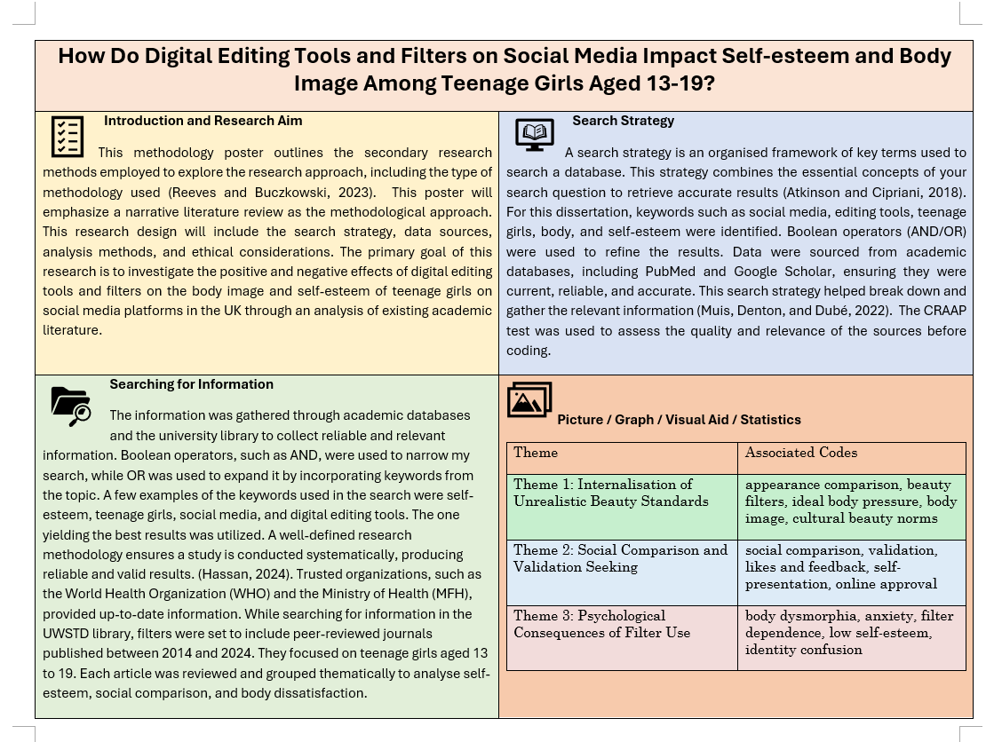
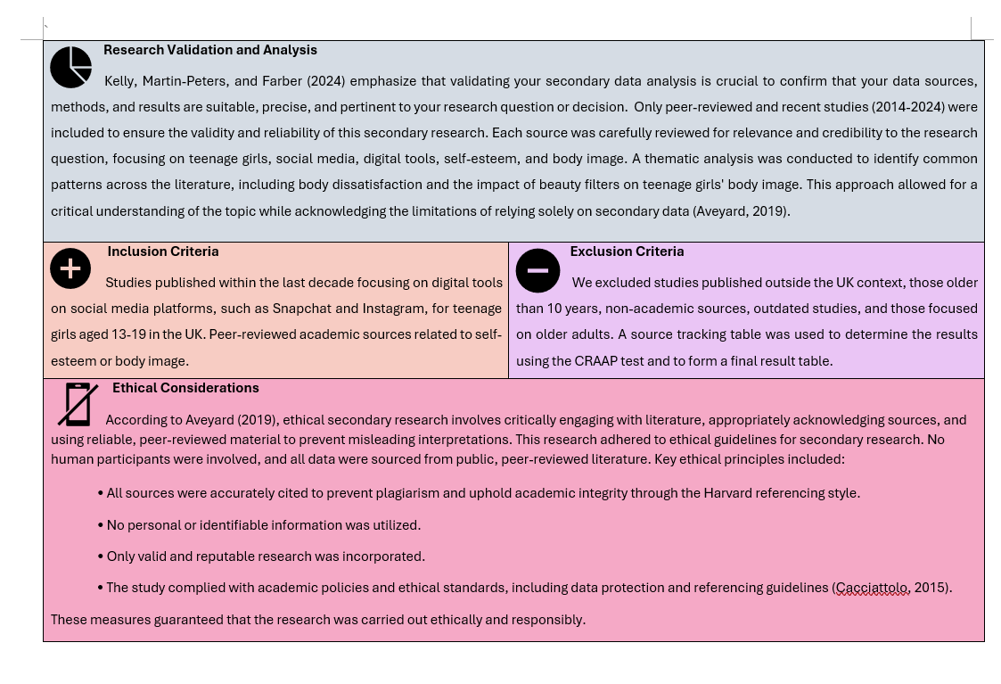
6.2.3 Source Tracking Table
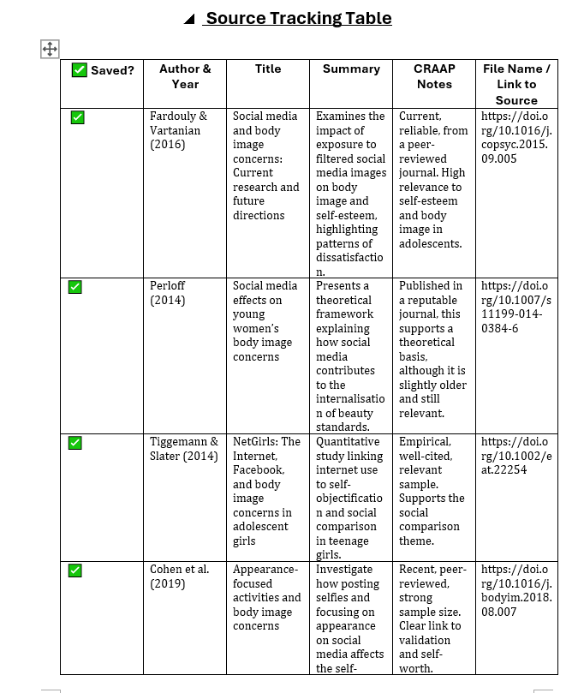
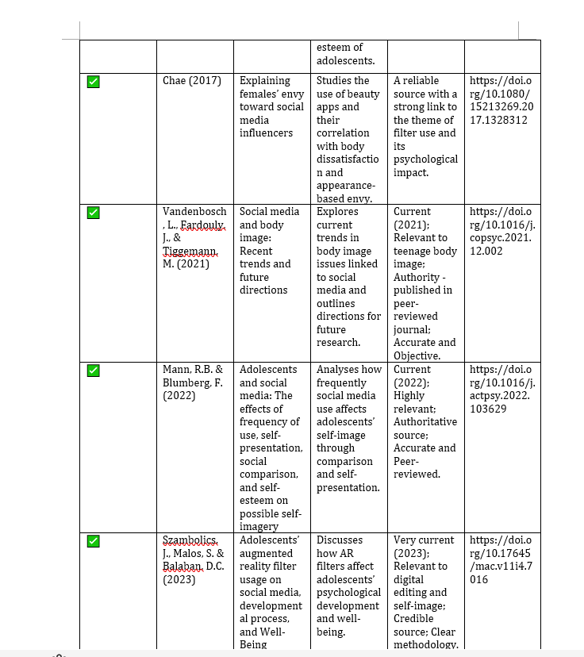
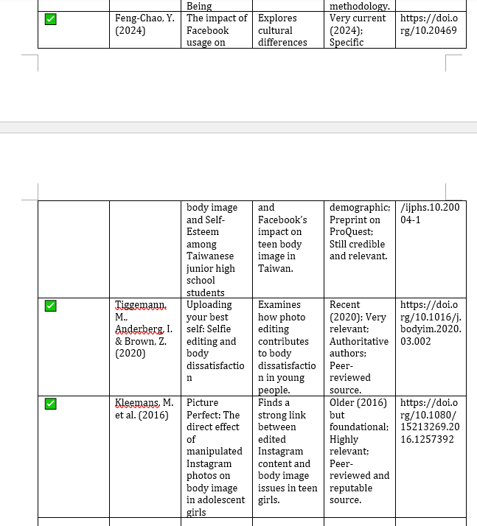

6.2.4 Result Summary Table
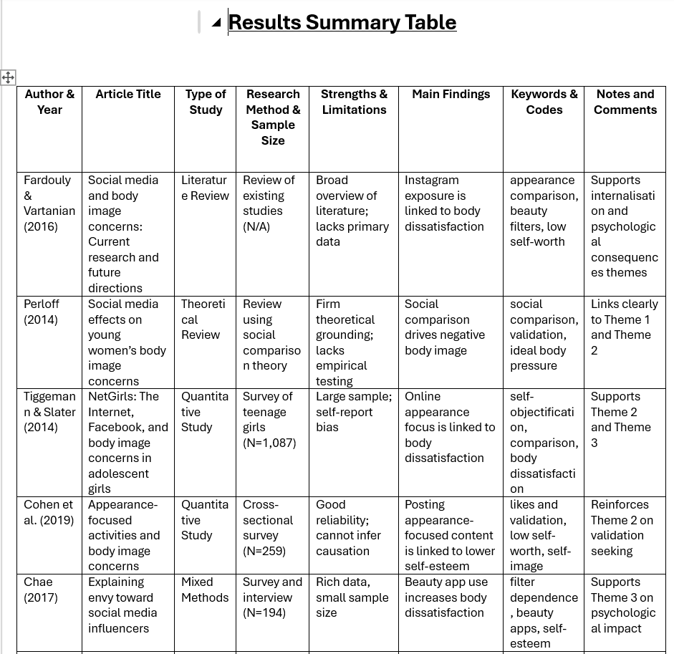
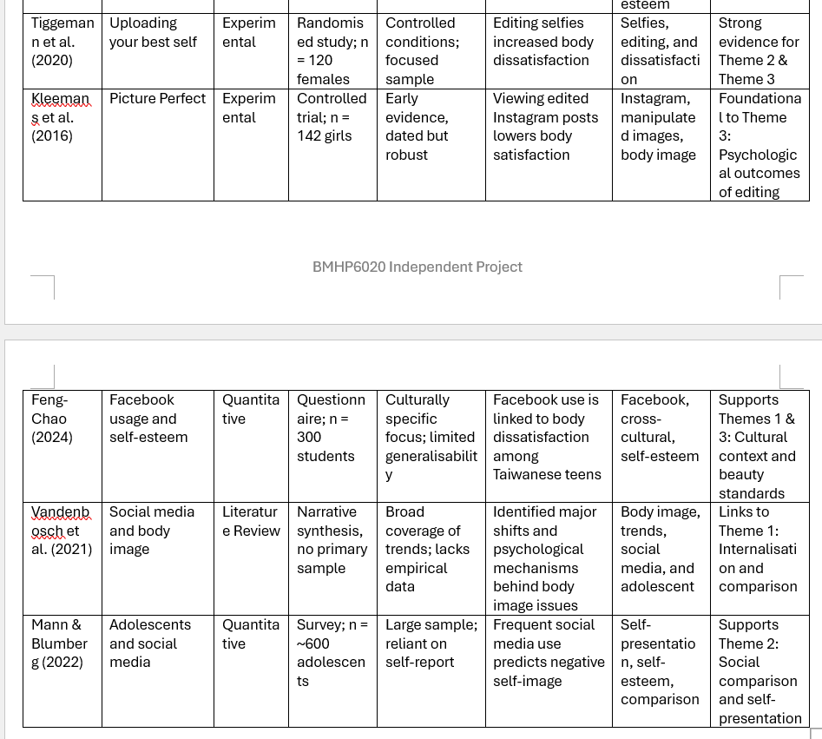
6.2.5 CRAAP Checklist


