

Postgraduate/Distance Learning

Assignment coversheet & feedback form

THIS SHEET MUST BE THE FIRST PAGE OF THE ASSIGNMENT YOU ARE SUBMITTING (DO NOT SEND AS A SEPARATE FILE)

For completion by the student:
Student Name: Hilda Hermann

Student University Email: 1706721@student.uwtsd.ac.uk
Module code: HPCA7008  Module title: Heavenly Discourses | Student ID number:  1706721 |  |  | Educational support needs:  No
Assignment title: Written Assignment: Compare and contrast the expression or representation of the sky: The Horologion of Andronikos Kyrrhestes or Tower of the Winds in Athens, Greece, and the Radcliffe Observatory’s Tower of the Winds in Oxford, England

Assignment due date: 08-06-2020
This assignment is for the 1st 2nd 3rd 4th 5th 6th module of the degree
I confirm that this is my original work and that I have adhered to the University policy on plagiarism.

Signed ……………………………………………………………………... Hilda Hermann

Email submission:if you are submitting this form via email, please tick this box □

(as a substitute for your signature) to confirm that you agree to the above declaration.
Assignment Mark
1st Marker’s Provisional mark
2nd Marker’s/Moderator’s provisional mark
External Examiner’s mark (if relevant)
Final Mark

NB. All marks are provisional until confirmed by the Final Examination Board.

For completion by Marker 1 :

Comments:

Marker’s signature: |  |  | Date:
For completion by Marker 2/Moderator:

Comments:

Marker’s Signature: |  | Date:
External Examiner’s comments (if relevant)

External Examiner’s Signature: |  | Date:

Compare and contrast the expression or representation of the sky:
The Horologion of Andronikos Kyrrhestes or Tower of the Winds in Athens, Greece, and the Radcliffe Observatory’s Tower of the Winds in Oxford, England
Word count: 2009

Introduction
This essay compares and contrasts the expression or representation of the sky by two buildings: The octagonal Horologion of Andronikos Kyrrhestes or Tower of the Winds, in Athens, Greece, dated to the second century BCE, and the Radcliffe Observatory’s Tower of the Winds in Oxford, England, whose construction was completed in 1795 (Figure 1). This topic is considered in terms of the buildings’ elements and functions, the material culture at the time of construction, and the re-use of antiquity. Both buildings, and their instruments/mechanisms, assisted in the measurement of sky phenomena.

The Horologion of Andronikos Kyrrhestes, sited at the foot of the Acropolis, is one of only two astronomically significant monuments recognised by UNESCO. Its apparent replica in Oxford, England, is a Historic England listed building for its special architectural or historic interest. The architects of both Towers are known: Andronikos of Kyrros’ name was recorded in the treatise written c. 27 BCE by the Roman author and architect Vitruvius titled De Architectura (I.6.4), and by the Roman scholar Varro in De Re Rustica (III.5.17), written c. 37 BCE. Although the Horologion of Andronikos Kyrrhestes had initially been dated to c. 50 BCE, its architectural details indicate that the second-half of the second century BCE is a more likely period. By comparison, the origins of Oxford’s neoclassical Tower of the Winds can be traced to sketches made by British architectural historians James Stuart and Nicholas Revett of the Athenian Tower, which were published in The Antiquities of Athens and Other Monuments of Greece in 1762. This book is said to have influenced the Greek revival in European architecture during the Enlightenment, as well as interest in the octagon as a geometric plan motif.
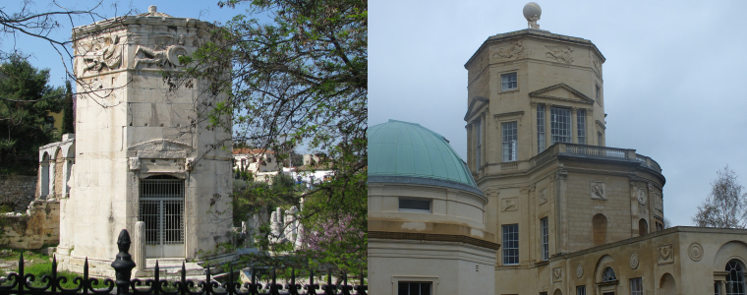
Figure 1 The Horologion of Andronikos Kyrrhestes, Athens (left), and Radcliffe Observatory’s Tower of the Winds, Oxford (right).
Elements and functions
The Horologion of Andronikos Kyrrhestes, constructed from white Pentelic marble stands approximately 14 m tall and 8 m in diameter, and has a cylindrical annex to its south side. In contrast, its Radcliffe Observatory counterpart is sited on top of a two-storey building and was constructed from yellowish limestone. Although both towers have eight sides, the Tower of the Winds (Oxford) is not a regular octagon, but a ‘strongly canted square’, indicating that its architect, James Wyatt, presented a design of his own interpretation that consciously evoked the Athenian building. Unlike the Horologion of Andronikos Kyrrhestes, the eight faces of the Oxford Tower are all fitted with windows, presumably where telescopes and other astronomical equipment could be used.

Common to the exterior of both Towers, however, are prominent relief sculptures of ancient Greek Wind gods, one on each side (Figure 2): Boreas (N), Notus (S), Apeliotes (E), Zephyrus (W), Kaikias (NE), Skiron (NW), Eurus (SE), and Lips (SW). As Classics academic Carol Atack notes, the relief sculptures of the Wind gods that appear on both buildings reflect a connection between myth and the scientific measurement of time and space. While the sculptor of the panels on the Horologion of Andronikos Kyrrhestes remains unknown, there is record of the Radcliffe Observatory reliefs being created by John Bacon, which mentions that they were ‘so different in spirit from his Greek originals as to have become themselves original’.

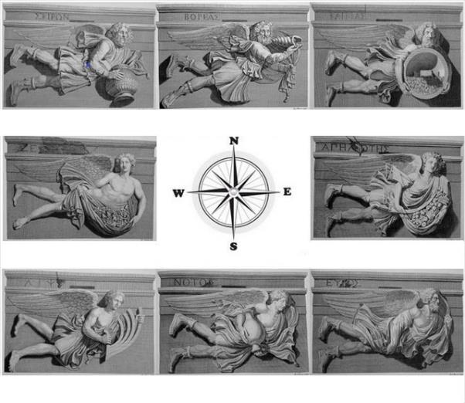
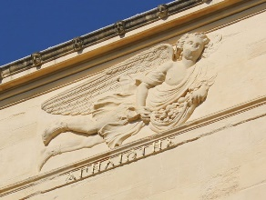
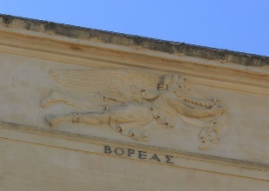
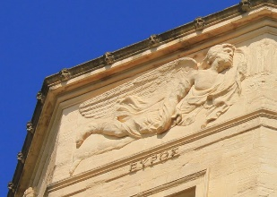
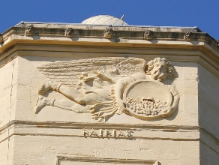
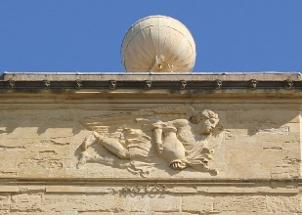
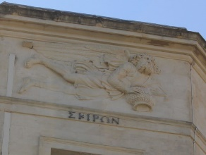
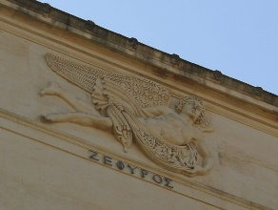
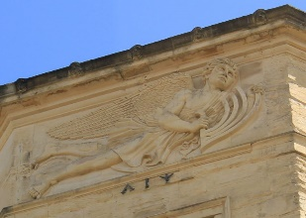
Figure 2 Reliefs of the Wind gods on the Horologion of Andronikos Kyrrhestes, Athens (greyscale) and their corresponding reliefs on the Tower of the Winds, Oxford (colour).
NORTH / BOREAS: A bearded male wearing a tunic and cloak, holding a shell trumpet, and representing the cold winter air.
NORTH EAST / KAIKIAS: A bearded male in a tunic and cloak, holding a shield of hailstones.
EAST / APELIOTES: A young male whose cloak is filled with fruit and grain.
SOUTH EAST / EURUS: A bearded male whose cloak billows in the wind (not associated with any of the Greek seasons).
SOUTH / NOTUS: A young male in a tunic and cloak, emptying an amphora of water. He represents the storms of late summer and autumn, and is feared as a destroyer of crops.
SOUTH WEST / LIPS: A young male in a cloak, holding the stern of a ship.
WEST / ZEPHYRUS: A young male whose cloak is filled with flowers, representing the west wind that brings the light spring and early summer breezes.
NORTH WEST / SKIRON: A bearded male in a tunic and cloak, with an overturned pot spilling hot coals, representing the onset of winter.

Below each relief sculpture on the Horologion of Andronikos Kyrrhestes are incisions marking out individually calculated vertical sundials. These were used for measuring the time of day from sunrise to sunset and determining the seasons of the year. Each sundial has three day curves, one for the equinoxes, and one for each of the solstices. This indicates that astronomical knowledge was integral to the Tower’s construction and purpose, but this aspect was not apparently carried through to its later Oxford namesake. Instead, the Radcliffe Observatory’s second storey displays decorative reliefs of the signs of the zodiac, modelled in Coade artificial stone by J.C.F. Rossi, which Classical archaeologist Christopher Dickenson suggests were ‘based on the designs shown on another surviving artefact from antiquity’ − the Roman-era Farnese Globe.

Both Towers have decorative lion’s head spouts around the edges of their roofs to carry off rainwater, which was a common feature in ancient times. According to Vitruvius, a bronze weather vane in the form of the Greek god of the sea, Triton, topped the Horologion of Andronikos Kyrrhestes, with a wand in hand indicating the prevailing wind. By the eighteenth century, the weather vane had disappeared; but based on Vitruvius’ description, Stuart and Revett included it in their illustration. However, the weather vane was not added to the Radcliffe Observatory, which was crowned instead by a statue of Atlas and Herakles supporting an undecorated globe. As Dickenson suggests, ‘an educated viewer of the observatory would no doubt have made the link between the reliefs of the zodiac, the Farnese Atlas and the sculpture on the roof’. On the observatory’s north side, relief depictions of morning, noon and evening were personified in the Classical style. Dickenson concludes that the building was ‘designed to appeal to the sensibilities of an educated audience steeped in knowledge of ancient culture and art’.

There is a large opening/entrance on both the northeast and northwest sides of the Horologion of Andronikos Kyrrhestes, with smaller, window-like openings to the south, north and west. Inside the Tower, topping the eight vertical walls, is a vaulted ceiling made up of 24 marble plates (Figure 3, left). Archaeological evidence suggests this depicts the sky: traces of ‘glittering Egyptian blue’ pigment were found, with surface indentations indicating that it was likely ‘adorned with stars fashioned in gold leaf’. Unlike Radcliffe Observatory's vast expanse of windows, light in the Athenian Tower appears to have been limited. However, archaeologist Hermann Kienast suggests that the wall surfaces were worked in a manner that increased the reflectivity of the marble, and that the architect included narrow slits at the joins and above the exterior relief blocks, which let in small amounts of light for both practical and aesthetic purposes. Notably, ‘the interior faces of the slits above the Wind sculptures were much taller than on the exterior, and they angled upward, thus increasing … illumination of the gold stars’.
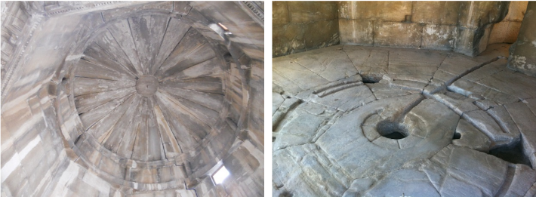
There are drawings on the interior walls and, on the floor, there are ‘curved grooves, straight channels and round-shape beddings’ (Figure 3, right). According to James Evans, it was only in the 1960s that archaeological investigation suggested these incisions conducted water to drive an anaphoric clock. Evangelia Panou and Anastasios Violetis contend that this indicates that a hydraulic mechanism similar to a planetarium was in operation at the site.
Figure 3 Internal view of the Horologion of Andronikos Kyrrhestes’ roof panels (left) and floor carvings (right).

While the design of the Horologion of Andronikos Kyrrhestes has endured, it is apparent that the buildings it has inspired do not necessarily reflect the same purpose. The Radcliffe Observatory was sold to Sir William Morris in 1929 as ‘the atmosphere in England was considered unsuitable for certain astronomical associations’, which included the weather, urban development, and light pollution. It currently forms part of a centre for medical research.

Material culture
Panou and Violetis submit that, in antiquity, significant advances in astronomy and mathematics were made by using arts and culture as a way of interpreting the movement of celestial bodies. Whereas Evans suggests that reconstructing the material culture of Greek and Roman astronomy presents considerable challenges, it has been proposed that the Horologion of Andronikos Kyrrhestes reflects the complementary use of science and arts, and represents the holistic philosophical thinking of that time. Despite the dominance of geocentrism, sundials were accurate astronomical instruments for measuring time, emphasising the importance of time in social life in antiquity. Kienast suggests that Andronikos viewed the Tower as a symbol of cosmic order and that the Wind gods were not just decorative, but an allegory of world order. The dome ceiling, with its depiction of the heavens, offers a supporting framework for ‘an apparatus that had a relationship with the stars in the cosmos’. Joseph Noble and Derek de Solla Price concur that, apart from telling the time, an anaphoric clock would have given ‘a quite theatrical simulation of the known universe’.

By comparison, Dickenson suggests that the modelling of the Radcliffe Observatory on the Horologion of Andronikos Kyrrhestes was ‘more than merely an expression of philhellenism’, which was prevalent at that time – part way between the publication of The Antiquities of Greece and the birth of the modern Greek nation state. Instead, the appeal of the Horologion of Andronikos Kyrrhestes as an observatory model may have been the result of the rifts that were beginning between the humanities and the sciences. The Horologion of Andronikos Kyrrhestes had been mentioned by Vitruvius and represented a peak of scientific achievement, and, similarly, the new observatory was positioned at the forefront of its era’s quest for knowledge. Dickenson further suggests that, by copying the Horologion of Andronikos Kyrrhestes, the Radcliffe Observatory was not only making reference to the ancient building, but also to Stuart and Revett’s ‘cutting-edge’ research and ‘ground-breaking’ publication, which was funded by the Society of the Dilletanti, members of which would have been well versed in the Classics.

Re-use of antiquity
Archaeological evidence indicates that the Horologion of Andronikos Kyrrhestes had several diverse functions and accumulated fragments of changing civilisations before it was unearthed by the Greek Archaeological Society in the mid-1800s. It has been posited that the Horologion of Andronikos Kyrrhestes not only served as an astronomical and weather-forecasting station, as alluded to by Vitruvius and Varro, but also had a role as a central social and commercial meeting point near the Roman Agora.

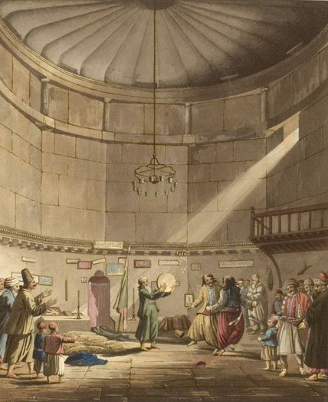
The Tower’s post-classical use included a Christian church in late Roman times, and an Islamic Sufi tekke during mid-seventeenth century Ottoman rule (Figure 4). Noble and De Solla Price concluded that the Horologion of Andronikos Kyrrhestes most likely served an astrological rather than solely a timekeeping purpose, and in 1668 the Turkish traveller, Evliya Qelebi, was certain it was an astrological monument, mentioning unnoticed or destroyed features since his time. Similarly, the change in Radcliffe Observatory’s original use illustrates that perspectives and paradigms can be altered. Wyatt’s re-use of the past, by modelling the Radcliffe Observatory on the Horologion of Andronikos Kyrrhestes, but altering its proportions and scale, may have been in response to contemporary architectural styles, and thus a topic for Classical reception studies. The Tower of the Winds (Oxford) could be seen as an attempt to link the past and the present, and an attempt at cultural continuity between antiquity and modern times. However, according to Atack, the differences between the two towers indicate that ‘one cannot recreate the past without change’.
Figure 4 ‘Dance of the Dervishes’ in Edward Dodwell’s Views in Greece (London, 1821).

Conclusion
This essay has considered the expression or representation of the sky in the second century BCE Horologion of Andronikos Kyrrhestes and the eighteenth century Radcliffe Observatory’s Tower of the Winds. It considered the elements and functions of each building, the material cultures at the times of their construction, and the re-use of antiquity. The Horologion of Andronikos Kyrrhestes has been recognised as a monument of astronomical heritage because it is related to social uses of astronomy in ancient Athens and in Ancient Greece in general, evidenced in its recording in the UNESCO ‘Portal to the Heritage of Astronomy’. It is the only monument preserved since the Hellenistic period that is related to astronomical observations, cultural activities, and the application of astronomical techniques and technology to other sciences such as mathematics and arts. In the eighteenth century, it was possible to see the Radcliffe Observatory’s Tower of the Winds as both an ancient and a revitalised symbol of the cosmos and the elements, rather than simply having the practical value of timekeeping or being able to identify the direction of the wind. Each Tower of its time suggests not only the architects’ understanding of the cosmos, but also their ability to relate this to society in general as an expression or representation of the sky.

References
Atack, Carol, ‘The two towers: looking at time in Athens and Oxford’, 7 November 2016. Anachronism and Antiquity project, Faculty of Classics, University of Oxford. <https://anachronismandantiquity.wordpress.com/2016/11/07/the-two-towers/> [accessed 5 June 2020]
Cartwright, M., Tower of the Winds, Ancient History Encyclopedia. 31 March 2017. <https://www.ancient.eu/article/1044/> [accessed 4 June 2020]
Centre for the Study of Diagonality, ‘Tower of the Winds’ (n.d.). <https://centerfordiagonality.org/tower-of-the-winds/> [accessed 4 June 2020]
Dickenson, Christopher, ‘Hellenistic Athens comes to 18th Century Oxford’, Monuments of Roman Greece, 27 November 2014. <https://romangreece.wordpress.com/2014/11/27/the-radcliffe-observatory-hellenistic-athens-comes-to-18th-century-oxford/> [accessed 4 June 2020]
Dickenson, Christopher, ‘The Two Towers (of the Winds)’, Monuments of Roman Greece. 14 November 2014. <https://romangreece.wordpress.com/2014/11/14/the-two-towers-of-the-winds/> [accessed 4 June 2020]
Esdaile, K.A., ‘The Radcliffe Observatory’, Journal of the Royal Society of Arts, 78.4044 (1930), pp. 755−759.
Evans, James, ‘Material Culture of Greek and Roman Astronomy’, Handbook of Archaeoastronomy and Ethnoastronomy (New York: Springer, 2015)
Evans, James, The History and Practice of Ancient Astronomy (Oxford: Oxford University Press, 1998)
Historic England, ‘The Nuffield Institute for Medical Research / The Radcliffe Observatory’, National Heritage List for England. <https://historicengland.org.uk/listing/the-list/list-entry/1047070> [accessed 5 June 2020]
Kienast, J.H., ‘The Tower of the Winds in Athens’, The Australian Archaeological Institute at Athens Bulletin, 9 (2013), pp. 20−29
Liritzis, I. and Panou, E., ‘The Horologion of Andronikos Kyrrhestes (The Tower of the Winds)’, Portal to the Heritage of Astronomy, UNESCO (2017-2018). <https://www3.astronomicalheritage.net/index.php/show-entity?identity=90&idsubentity=1> [accessed 4 June 2020]
MacKay, P.A., ‘A Turkish Description of the Tower of the Winds’, American Journal of Archaeology, 73.4 (1969), pp. 468−469
Noble, Joseph V. and De Solla Price, Derek J., ‘The Water Clock in the Tower of the Winds’, American Journal of Archaeology, 72.4 (1968), pp. 345−355
Panou, E. and Violetis, A., ‘Teaching Astronomy Using Monuments of Cultural Heritage: The Educational Example of “Horologion of Andronikos Kyrrhestes”’, Scientific Culture, 4.2 (2018), pp. 77−83
Reade, Vera, ‘The Radcliffe Observatory, Oxford, 1772−1929’, Journal of the British Astronomical Association, 82 (1972), pp. 377−378
Sherwood, Jennifer and Pevsner, Nikolaus, The Buildings of England: Oxfordshire (New Haven and London: Yale University Press, 1974)
Stuart, James and Revett, Nicholas, The Antiquities of Athens (London, 1762)
Vitruvius, De Architectura, trans. M.H. Morgan (London: London University Press, 1914)
Webb, Pamela A., ‘Review: Hermann J. Kienast, Der Turm der Winde in Athen. Archäologische Forschungen, Bd 30 (Wiesbaden: Reichert Verlag, 2014)’, Bryn Mawr Classical Review 2015.09.35 <https://bmcr.brynmawr.edu/2015/2015.09.35/> [accessed 4 June 2020]

Images
Fig. 1: Christopher Dickenson, <https://romangreece.wordpress.com/2014/11/27/the-radcliffe-observatory-hellenistic-athens-comes-to-18th-century-oxford/> [accessed 4 June 2020]
Fig. 2: Athens: Geocaching/notiosanemos & arikim <https://www.geocaching.com/geocache/GC490JA_winds> [accessed 4 June 2020]
Oxford: The eight winds at Radcliffe Observatory, Green Templeton College, University of Oxford <https://www.gtc.ox.ac.uk/about/history/radcliffe-observatory/eight-winds/> [accessed 4 June 2020]
Composite image by author.
Fig. 3: UNESCO Portal to the Heritage of Astronomy https://www3.astronomicalheritage.net/index.php/show-entity?identity=90&idsubentity=1 [accessed 4 June 2020]
Fig. 4: ‘Dance of the Dervishes’ in Edward Dodwell’s Views in Greece (London, 1821). In public domain.

I. Liritzis and E. Panou, ‘The Horologion of Andronikos Kyrrhestes (The Tower of the Winds)’, Portal to the Heritage of Astronomy, UNESCO (2017-2018). <https://www3.astronomicalheritage.net/index.php/show-entity?identity=90&idsubentity=1> [accessed 4 June 2020].
Historic England, ‘The Nuffield Institute for Medical Research / The Radcliffe Observatory’, National Heritage List for England. <https://historicengland.org.uk/listing/the-list/list-entry/1047070> [accessed 5 June 2020].
James Evans, The History and Practice of Ancient Astronomy (Oxford: Oxford University Press, 1998), p. 131.
James Evans, ‘Material Culture of Greek and Roman Astronomy’, Handbook of Archaeoastronomy and Ethnoastronomy (New York: Springer, 2015), p. 1592; M. Cartwright, ‘Tower of the Winds’, Ancient History Encyclopedia. 31 March 2017. <https://www.ancient.eu/article/1044/> [accessed 4 June 2020].
Pamela A. Webb, ‘Review: Hermann J. Kienast, Der Turm der Winde in Athen. Archäologische Forschungen, Bd 30 (Wiesbaden: Reichert Verlag, 2014)’, Bryn Mawr Classical Review 2015.09.35. <https://bmcr.brynmawr.edu/2015/2015.09.35/> [accessed 4 June 2020]
Centre for the Study of Diagonality, ‘Tower of the Winds’ (n.d.). <https://centerfordiagonality.org/tower-of-the-winds/> [accessed 4 June 2020].
Liritzis and Panou, ‘The Horologion of Andronikos Kyrrhestes (The Tower of the Winds)’, p. 80.
Jennifer Sherwood and Nikolaus Pevsner, The Buildings of England: Oxfordshire (New Haven and London: Yale University Press, 1974); Christopher Dickenson, ‘The Two Towers (of the Winds)’, Monuments of Roman Greece. 14 November 2014. <https://romangreece.wordpress.com/2014/11/14/the-two-towers-of-the-winds/> [accessed 4 June 2020]; Christopher Dickenson, ‘Hellenistic Athens comes to 18th Century Oxford’, Monuments of Roman Greece, 27 November 2014. <https://romangreece.wordpress.com/2014/11/27/the-radcliffe-observatory-hellenistic-athens-comes-to-18th-century-oxford/> [accessed 4 June 2020].
Evans, The History and Practice of Ancient Astronomy, p. 131; Evangelia Panou and Anastasios Violetis, ‘Teaching Astronomy Using Monuments of Cultural Heritage: The Educational Example of “Horologion of Andronikos Kyrrhestes”’, Scientific Culture, 4.2 (2018), p. 80; Sherwood and Pevsner, The Buildings of England: Oxfordshire.
Carol Atack, ‘The two towers: looking at time in Athens and Oxford’, 7 November 2016. Anachronism and Antiquity project, Faculty of Classics, University of Oxford. <https://anachronismandantiquity.wordpress.com/2016/11/07/the-two-towers/> [accessed 5 June 2020].
K.A. Esdaile, ‘The Radcliffe Observatory’, Journal of the Royal Society of Arts, 78.4044 (1930), p. 755.
Liritzis and Panou, ‘The Horologion of Andronikos Kyrrhestes (The Tower of the Winds)’.
Vera Reade, ‘The Radcliffe Observatory, Oxford, 1772−1929’, Journal of the British Astronomical Association, 82 (1972), p. 377; Dickenson, ‘Hellenistic Athens comes to 18th Century Oxford’; Historic England, ‘The Nuffield Institute for Medical Research / The Radcliffe Observatory’.
Dickenson, ‘Hellenistic Athens comes to 18th Century Oxford’.
Evans, ‘Material Culture of Greek and Roman Astronomy’, p. 1593.
Evans, The History and Practice of Ancient Astronomy, p. 131−132.
Dickenson, ‘Hellenistic Athens comes to 18th Century Oxford’.
Dickenson, ‘Hellenistic Athens comes to 18th Century Oxford’.
Liritzis and Panou, ‘The Horologion of Andronikos Kyrrhestes (The Tower of the Winds)’; Webb, ‘Review: Hermann J. Kienast, Der Turm der Winde in Athen’.
Webb, ‘Review: Hermann J. Kienast, Der Turm der Winde in Athen’.
Panou and Violetis, ‘Teaching Astronomy Using Monuments of Cultural Heritage’, p. 80.
Evans, The History and Practice of Ancient Astronomy, p. 131−132.; Joseph V. Noble and Derek J. de Solla Price, ‘The Water Clock in the Tower of the Winds’, American Journal of Archaeology, 72.4 (1968).
Panou and Violetis, ‘Teaching Astronomy Using Monuments of Cultural Heritage’, p. 80.
Reade, ‘The Radcliffe Observatory, Oxford, 1772−1929’, p. 378.
Panou and Violetis, ‘Teaching Astronomy Using Monuments of Cultural Heritage’, p. 79.
Evans, ‘Material Culture of Greek and Roman Astronomy’, p. 1590; Panou and Violetis, ‘Teaching Astronomy Using Monuments of Cultural Heritage’, p. 81.
Liritzis and Panou, ‘The Horologion of Andronikos Kyrrhestes (The Tower of the Winds)’.
Webb, ‘Review: Hermann J. Kienast, Der Turm der Winde in Athen’.
Webb, ‘Review: Hermann J. Kienast, Der Turm der Winde in Athen’.
Noble and De Solla Price, ‘The Water Clock in the Tower of the Winds’, p. 352.
Dickenson, ‘Hellenistic Athens comes to 18th Century Oxford’.
Dickenson, ‘Hellenistic Athens comes to 18th Century Oxford’.
Dickenson, ‘Hellenistic Athens comes to 18th Century Oxford’.
Dickenson, ‘Hellenistic Athens comes to 18th Century Oxford’.
Webb, ‘Review: Hermann J. Kienast, Der Turm der Winde in Athen’; Centre for the Study of Diagonality, ‘Tower of the Winds’.
Panou and Violetis, ‘Teaching Astronomy Using Monuments of Cultural Heritage’, p. 80; Liritzis and Panou, ‘The Horologion of Andronikos Kyrrhestes (The Tower of the Winds)’.
Webb, ‘Review: Hermann J. Kienast, Der Turm der Winde in Athen’; Cartwright, ‘Tower of the Winds’; Noble and De Solla Price, ‘The Water Clock in the Tower of the Winds’, p. 347.
Noble and De Solla Price, ‘The Water Clock in the Tower of the Winds’; P.A. MacKay, ‘A Turkish Description of the Tower of the Winds’, American Journal of Archaeology, 73.4 (1969), p. 468.
Atack, ‘The two towers: looking at time in Athens and Oxford’.
Panou and Violetis, ‘Teaching Astronomy Using Monuments of Cultural Heritage’, p. 80.

