Student Name: Corey H J McComb
P Number: 2004966
Programme of Study: Graphic and Digital Arts
Module: ADAD4018
Ways of Thinking Lecturer’s Name: Martin Bush

Tasks in the order I received them:
Task 1: Observational Writing = 589 words.
Task 2: Manifesto Writing = 702 words
Task 3: Practice-based Writing = 538 words

Task 1: Observational Writing

Semiotics is a general theory of all existing languages... all forms of

communication - visual, tactile, and so on... There is general semiotics,

which is a philosophical approach to this field, and then there are many

specific semiotics. (Eco, U., 1976. A theory of semiotics.)

Semiotics is the understanding that everything within our environment can be broken

down into categories of Icons, Signs and symbols. First adapted by the late

Ferdinand de Saussure (1857- 1913). Saussure created the term “semiology” Today

we practice the contemporary meaning “semiotics” (Sebeok, 1976 47-58.) Today’s

society is ad driven capitalism propaganda, every street you walk down. Every bus

you hop on. Every time you turn on the TV. I am being sold something even as I type

up while doing my research. With some companies using the age old tradition of sex

to sell products (Manchón – L, 2020, p. 18). This form of communication is

stimulating my eye and keeping my interest at its peak, even if the connotation is

negative. I have been told an anecdote by use of semiotic practices. (Venkatesh,

2020)

For this task I will break down Three important aspects of my chosen ad to annotate,

My end goal is to clearly show my understanding of these semiotics and explain why

they are used in mass advertising. In my attempt to recognise these practices I also

aim to conclude what has changed from my first impression of the poster to now with

more information/ new way of seeing.

2018 saw Spotify introduce the “2018 Goals” campaign. The intent behind the

Campaign was to display the consumers music patterns and playlists through

Collecting personal data and applying sourced songs to New year’s resolutions. ‘Be

As loving as the person who put 48 Ed Sheeran songs on their I love Gingers

playlist’. This is a bold move by Spotify, promoting the idea that they view their

audiences personal information, however done in a quirky humorous

manner. There is a vulnerable intent behind this ad, as David DeSteno PHD

proposes in ‘The truth about trust: how it determines success in life, love , learning

and more’ We are currently walking around in a society flooded in distrust and

dishonesty, brands not being transparent has become a growing concern in recent

years. Volkswagen being one blueprint example. (CNBC, 2019) This is a blatant shot

at promoting “brand transparency” evoking the feeling of trust in Spotify the brand.
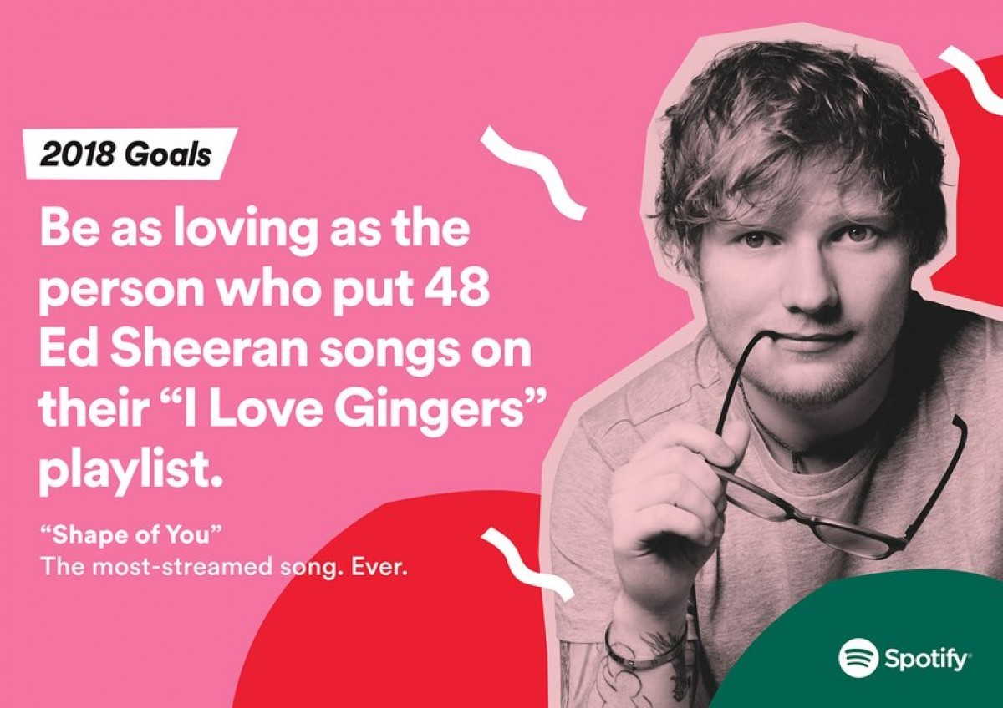

Fig 1.2018 Goals, Spotify Advertising campaign, 2017

The use of an icon comes in the form of a photograph of Ed Sheeran, linking the signifier to

the icon of the artist referred to in the text. This visual mark helps consumers who may not

be familiar with Ed Sheeran, a photograph automatically feels more intimate and personal

than words alone. As for “Shape of You. The most streamed song. Ever.” The symbolic signs

are a way of communication in our English language that state “Shape of You” has reached

A milestone never before achieved. Breaking a world record. (Chandler, D.

(2017). Semiotics: The Basics. 3rd ed.0) Highlights the importance of signs in our

Language. Language creates a model of the world along with everything around it, using the

Database that is our brain we break down these signs into communication tools.

To summarise my outlook on this poster from when I started has changed because I have

noted and analysed the semiotic practices used to deliver the core messages of the

campaign. The signs in context of the advertisement construct provide a playful yet

informative explanation.

Bibliography

Eco, U., (1976). A theory of semiotics., Bloomington: Indiana University Press.

Mas-Manchón, L. (ed.) (2020). Innovation in Branding and Advertising Communication, p. 18)

Venkatesh, (2020) Propaganda, Opinion, Advertising: Can You Tell Them Apart?
https://mediabuddhi.substack.com/p/propaganda-opinion-news-advertising

David DeSteno PHD (2014) ‘The truth about trust: how it determines success in
life, love , learning and more’

(cnbc,2019)https://www.cnbc.com/2019/07/31/former-audi-boss-charged-in-the-vw-diesel-scandal-that-wont-die.html

Chandler, D. (2017). Semiotics: The Basics. 3rd ed.0)

List of figures

2018 Goals, Spotify, (2017) https://www.smartinsights.com/traffic-building-strategy/campaign-of-the-week-how-spotify-showed-the-power-of-data-analytics-in-their-marketing-campaign/

Task 2: Manifesto Writing

- If it is not to be done right. Do not do it at all.

- Hatred in the heart for others who are not similar to you is a gross lack of empathy,
understanding and education.

- Pandering over the past is a waste of potential. Building a better tomorrow by acknowledging the pain and finding you, is the key to success.

- We as a society must become more vocal. In a time that everything Is communicated digitally we must take a stance against personal injustices and societal issues.

- Eat the rich.

- Creative subject careers are not to be overlooked. Set down Adobe software in front of a Lawyer and see how the roles of knowledge are reversed.

- Religion is the root of harm in this world.

- Change is healing. Character building. A tool that shapes your spirit and resilience.

3 areas of exploration:

Hatred in the heart for others who are not similar to you is a gross lack of empathy,

understanding and education.

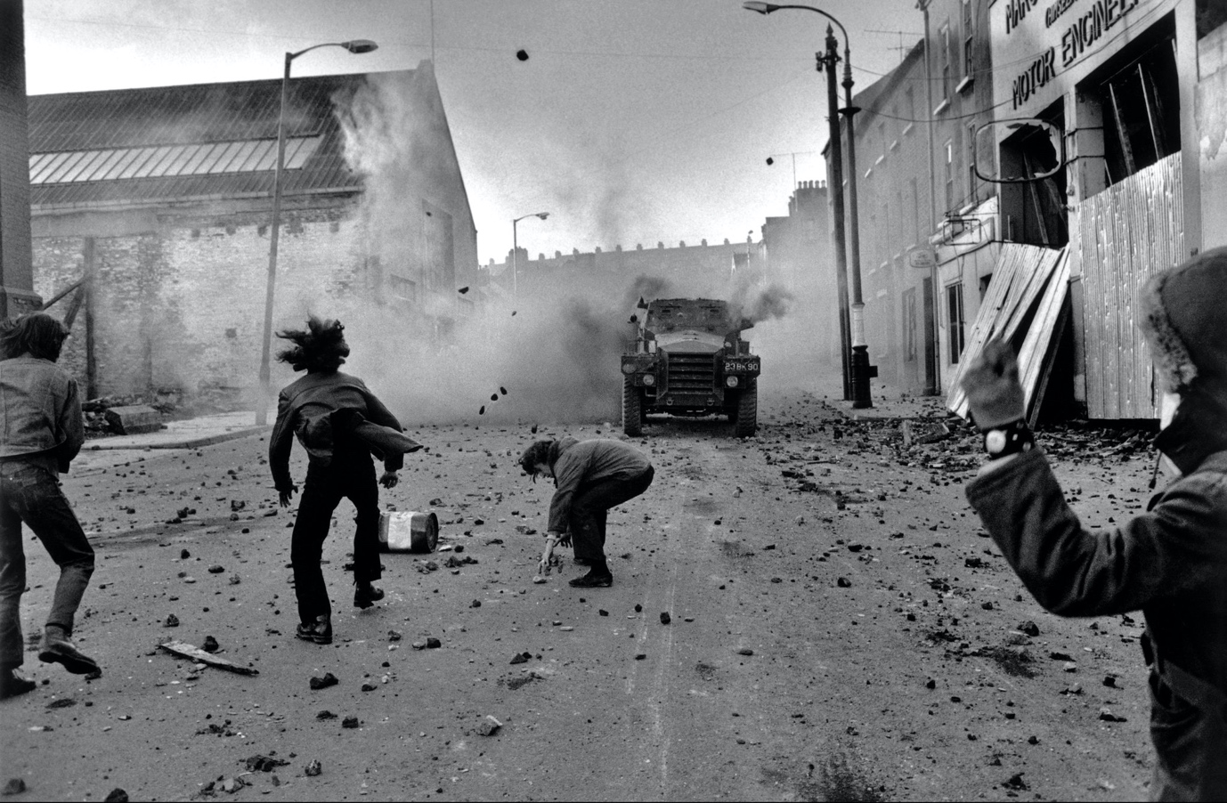

Fig 1. Rioters throwing stones at British troops in Londonderry, 1972

Stats for hate crimes are at an all-time high. 7,145 in America in the year 2017 alone that

have actually been noted, with half never getting reported (APA, 2017). A place I know all

too well that has plugged a reputation of violence and division is Northern Ireland. Many

factors have contributed to the decades of horror in the small county of Antrim, Misuse of

information and lack of education have fuelled the nation with rage and anger that they feel

should be taken into their own hands mentioned by Sean Harnett in his autobiography,

Charlie One (2016, p.34) It brings up the question can we blame others who intend to hurt

when they are trained in ignorance, similar to brainwashing. Education and a grasp of

understanding should be reinforced harder in academic settings, more so than

Pythagoras Theorem in Mathematics. What is a point of working so relentlessly for

grades to be “accepted” in a world that is so unjust. I think this year has taught us a lot

about division. Especially politically. We now see the true intent for our government an

example being the prejudice’s they hold to this day upon the north of England. (Morris, 2017)

Pandering over the past is a waste of potential. Building a better tomorrow by

acknowledging the pain and finding you, is the key to success.
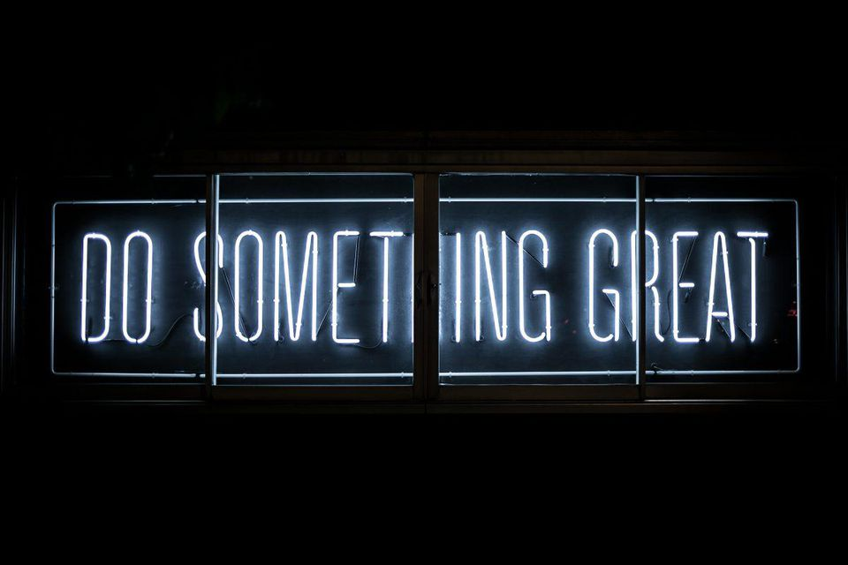

Fig 2. Do something great, Chris Tibbs

Waking up and changing the world might be for some, However for most of us this is not

Attainable. We must construct our own path and not search for it in others. (Badiou. A, 2019)

Getting caught up in the swill of life is often draining. Waking up and feeling deflated is a

feeling most of us have felt before in our lifetime. Past scenarios can swamp us in a pit of

despair. Sourcing rituals that boost productivity, alongside a feeling of satisfaction will keep

you on the right track to become a well-rounded and successful being. Success is not

becoming Prime minister or A Nobel peace prize winner. I believe the greatest success you

can have in life is acknowledging the past. The caused pain, and getting on with things.

Explore new places, only do things that bring you joy, as simple as a getting a haircut. The

smallest of tasks that uplift your spirit, makes the biggest difference in your future. This stems

into careers as studies show happiness has the potential to increase income (business news

daily, 2020). When you hold on to what was never meant to be you cannot flourish.

Eat the rich.
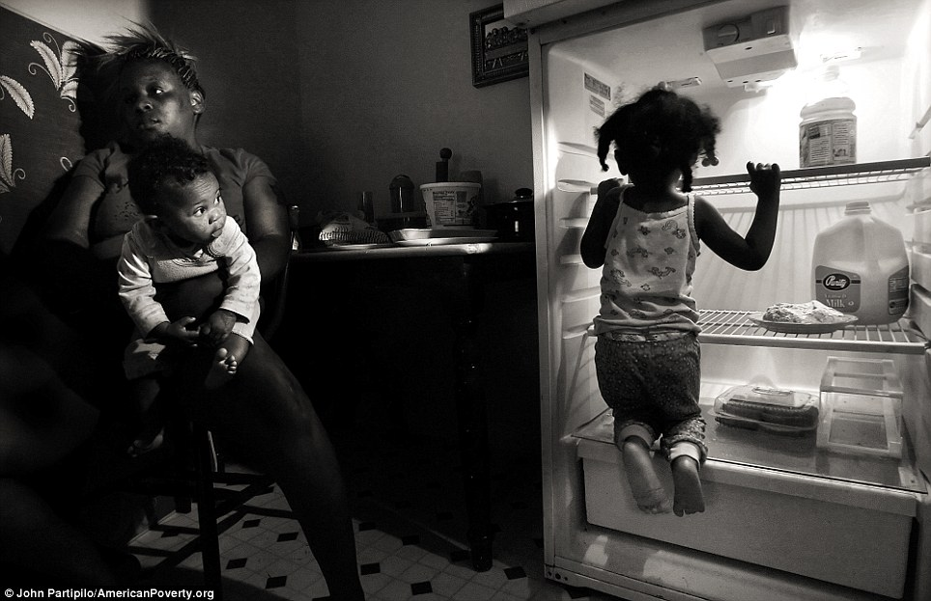

Fig 3. Deziray Morris holds baby Raijohna in her apartment while her daughter Kendra looks for something to eat. (2012)

Taxing the rich has always been shady business, as highlighted in Wealth (2017, p.16) the

power you possess the easier it is for one to participate in tax evasion, funny how the people

who can afford to pay feel elite enough to not contribute, when you have good hard working

people trying to make a living. Living by the rules doing their part. This is a gross cycle of

inequality and abuse of power. “Eat the rich” (GQ, 2019) explains the beginning of this phrase.

Which has now found new meaning in the digital area particularly among Gen Z. For too long

the rich have been stealing jobs from normal folk who can barely afford to eat each week

(Amazon), when it is not stealing jobs they are stealing from creators and selling it off as their

own for a quick buck. Kim Kardashian being a prime example (Daily mail online, 2017). Why

is not a bigger issue, the blatant inequality and greed of the wealthy has gone on too long.

The only way I see fit to stop this carnage is to vote with your wallet. Give to those who are

deserving off your money. Local businesses, smaller creators E.G we will never see change in

this hellish cycle when we continue to put these people at the top.

Bibliography

APA,(2017) https://www.apa.org/advocacy/interpersonal-violence/hate-crimes

Harnett, S. (2016). Charlie One: The True Story of an Irishman in the British Army and His Role in Covert Counter-Terrorism Operations in Northern Ireland. [ebook] Irish Academic Press. Available at: https://www.perlego.com/book/874578/charlie-one-the-true-story-of-an-irishman-in-the-british-army-and-his-role-in-covert-counterterrorism-operations-in-northern-ireland-pdf

Badiou, A. (2019). Happiness. [ebook] Bloomsbury Publishing. Available at: https://www.perlego.com/book/876329/happiness-pdf

BND, (2020) https://www.businessnewsdaily.com/7995-reasons-to-do-what-you-love.html

Knight, J. and Schwartzberg, M. (eds.) (2017). Wealth: NOMOS LVIII. [ebook] NYU Press. Available at: https://www.perlego.com/book/721004/wealth-nomos-lviii-pdf

Daily Mail Online, (2017) https://www.dailymail.co.uk/tvshowbiz/article-5154199/Kim-Kardashian-accused-stealing-designers-ideas.html

List of figures

Fig 1- Rioters throwing stones at British troops in Londonderry, (1972) Accessed from: https://www.nytimes.com/2018/10/04/world/europe/northern-ireland-troubles.html Gilles Peress/Magnum Photos

Fig 2 - Do something great. Accessed from: https://unsplash.com/@clarktibbs

Fig 3 - Deziray Morris holds baby Raijohna in her apartment while her daughter Kendra looks for something to eat, (2012) Accessed from : https://www.dailymail.co.uk/news/article-2117997/Making-invisible-visible-Haunting-pictures-Americas-vulnerable-people-shot-photojournalists-poverty.html

Task 3: Practice - based Writing: A reflection on large scale commission work for a client/ live project.

Stress panic and fear! Emotions that ran through my body as if hit by a train. It was just

another day in college, the start of a new term. You need to understand that merely two years

ago the thought of using adobe software including Photoshop and Illustrator put me into a fit

of rage like no other. I was not willing to learn the software, I thought any being that

could use it, were not human. Akhtar, S. (ed.) (2018). Fear: A Dark Shadow Across Our

Life Span mentions in his book the factor of self-sabotage. I lost confidence the previous

year making art digitally, I was addiment I was never going to open up creative

software again (obviously that did not last long, Now I study Graphic design) My own

stubborn attitude was deteriorating my own success and creative abilities.
I created strong response signals in my head that I wanted to remain safe and stick to what I

know. The easy option. “Do the thing you fear and the death of fear is certain.” – Ralph

Waldo Emerson. (Canfield, 2020) Being complacent was not an option. My assignment for

the term was to create a full scale commission for Lisburn City and Castlereagh Council. The

brief was an ode to the town I am from, brightening the area for a new hotel being built in

the town centre. Done in Illustrator we would later narrow our chosen area of the town to

glorify and have weekly meetings with a board member of the council to review our work.

Unprepared was an understatement! I had 4 months to learn an unfamiliar software, have the

piece pixel perfect by the end, whilst doing my other assignments. Aggressively scrambling

to educate myself I turned to sources like books such as Learn Adobe Illustrator CC for

Graphic Design and Illustration: (Chelius, C. and Schwartz, 2018, P. 17). Alongside online

video resources as I consider myself a visual learner. Learn Illustrator in 5 MINUTES!

Beginner Tutorial. (Flow studio, 2017) was a helpful source.

I could feel my confidence growing further each day as a I began to understand the process

of the craft. The start of the project was riddled with fatalities. The original concept was to be

changed halfway through as the client persevered the perspective of the artwork was unfit. A

useful book (although about acting) that teaches excellent exercises in the face of disappoint

and how to handle criticism is An attitude for acting (Tidmarsh, 2015. P.8) A guide that

would have been useful to me at the time. The blow came harder due to the fact I was the

only individual who had to change my outcome.

Rejection fuels my desire to work more profusely. Communicating with the client I was at a

better understanding of what she needed. I see this as a skill within itself. I did not express

my disappointment I listened, I adapted and ultimately overcame the hurdle, to make a piece

that got admiration when completed.

The experience was character building, I learnt skills I thought I could never master.

Communication and time availability are factors thrusted upon me that ignited the spark and

the passion I have for Visual communication today.

Bibliography

Akhtar, S. (ed.) (2018). Fear: A Dark Shadow Across Our Life Span. [ebook] Taylor and Francis. Available at: https://www.perlego.com/book/1510922/fear-a-dark-shadow-across-our-life-span-pdf

Jack Canfield, (2020) https://www.jackcanfield.com/blog/overcoming-fear/

Chelius, C. and Schwartz, R. (2018). Learn Adobe Illustrator CC for Graphic Design and Illustration: Adobe Certified Associate Exam Preparation. 2nd ed. [ebook] Pearson. Available at: https://www.perlego.com/book/885608/learn-adobe-illustrator-cc-for-graphic-design-and-illustration-adobe-certified-associate-exam-preparation-pdf

Tidmarsh, A. (2015). An Attitude for Acting: How to Survive (and Thrive) as an Actor. [ebook] Nick Hern Books. Available at: https://www.perlego.com/book/1420594/an-attitude-for-acting-how-to-survive-and-thrive-as-an-actor-pdf

