Enhancing Hospitality Through Innovation
For The Cape Grace, Cape Town, South Africa

Name of Consultancy: Horizon Consultancy

Module: Organisational Consultancy
Module code: BMIH6005
Student’s Name: Alina Grigore
Student’s ID: 2127560
Lecture Name: Jaliya de Silva

Table of Contents
Executive Summary 3
Introduction 5
Analysis 7
Identified Issue 7
Impact Analysis 7
Root Causes of the Problem 8
Feedback and Reputation 8
Income and Scope 8
Research Methodology and Sources 9
PESTEL Analysis 9
SWOT Analysis 12
TWOS Analysis 15
Recommendations and Change Management 18
Recommendations: 18
Impact and measurement analysis 20
Benefits 21
Cost for Implementation 22
Change management plan 23
Action Plan 27
Conclusion 30
Reference 32

Executive Summary
This report suggests a digital transformation plan for the ultra-sprawling and famous Cape Town, South Africa’s luxury hotel, The Cape Grace. The hospitality sector undergoes the digitalizing revolution, lastly creating digital users who are no longer satisfied with standardized but with continuous digital and personalized experiences. The feature that characterizes Cape Grace is that it is a well-known hotel with excellent service, luxurious accommodations, and an ideal location. While it managed to gain a strong presence on major OTAs, the hotel’s limited digital network, for example, the website, which is not highly optimized for mobile devices, and the absence of an app will create difficulties in reaching tech-oriented guests and having a competitive advantage with hotels that feature advanced digital tools. This presents a great opportunity for Cape Grace not only to follow the expanding digital trends in the luxury hospitality sphere but also to make the brand leader among the top hotels in its niche. The business has a solid and effective digital marketing analysis and dimension that was made to determine how the hotel is performing online. This consisted of a SWOT assessment that determined its pluses, minuses, opportunities, and hazards. Through the analysis, the individual strengths, such as the long-term clients and known image of the company, were revealed. Hence, digital presence proved to be a weakness because not all information was digitalized, and manual processes were a shortcoming as the information was not digitalized. A TOWS matrix, once the strengths and weaknesses of The Cape Grace are identified, would come to light very clearly as to how various weaknesses can be addressed and the threats posed by the digital landscape can be mitigated. Innovation-driven policy recommendations were aimed at digital inequality and safeguarding the remaining core values of the organization. They are a defence against cognitive decline, especially in the elderly, as they involve brain exercise, which engenders the production of new nerve cells through the learning process. Develop a user-friendly mobile app with mobile booking and check-in, room control, and concierge service components for digital access on the phone. Try improving the mobile version of the website to provide a flawless experience to the user. To be able to get the word to the point where each guest is being personally reached out using email marketing and targeted social media campaigns. Ensuring a smooth interface for chatbot users and guest support for simple requests and questions. Provide staff with digital competencies and skills to interact and transfer information through new technologies and exceed the current service delivery standards in the digital lens. Sell the idea of Change Management that would bring forth an atmosphere of digital adoption. Put in place a data analytics platform that will collect and explore guest information from divergent sources. Use these insights to personalize the guests’ experience, steer the marketing with data, and make decisions that are grounded on data. Enforce that all data collection and storage practices are in line with relevant regulations and provide cybersecurity strength sufficient to guard guest data from any kind of breaches. Provide a privacy policy clearly and transparently in a data-transparency manner, making it easy to understand. The action plan illustrates what steps should be taken to achieve the key recommendations determined, as well as the anticipated period and cost to follow-up. This, together with planning the digital transformation process, fosters The Cape Grace while it undergoes the digital transformation. Using this digital transformation strategy, Cape Grace shall gain key opportunities for “big” benefits for the hotel. Guests will receive a momentary demonstration of what it is like to be taken care of and how it is quite easy through a convenient mobile app. Operations will be better performed through continued process improvement and intelligent decision-making that is grounded on data. The Cape Grace embodies the forward-thinking travelers, and it can maintain itself as the lead brand in digital hospitality in Cape Town. As a result, Cape Grace Hotel, through a thorough implementation of digital transformation, can upgrade the quality of service, optimise its operations, and remain ahead of the competition in a digital era. This is a guidance handbook that suggests strategies for realizing the objectives. The Cape Grace will always remain a progressive luxury hospitality innovator. It is also recognized that Horizon Consultancy has a leadership style that will guarantee that Cape Grace is on a path to success in the future. Thus, we are here to collaborate with The Cape Grace to convert our actions into practice.

Introduction
The hospitality industry is following the track of digital change. Today, guests would hold no bars and would desire one-of-a-kind experiences, starting from online booking to in-room personalized settings (Canary Technologies, 2022). The Cape Grace Hotel, which is well known for its top-notch personal customer service, faces the challenge of finding a way to adapt to the increasing digital eye. This project seeks to close the gap between guests and hotels by encouraging two-way communication (Bwalya and Phiri, 2014). Thus, it will avoid accidental breaking of the hotel’s brand image. Indubitably, the Cape Grace Hotel, decorated and styled in the colorful past of Cape Town City, represents luxury accommodation. Situated near the famous Victoria and Waterfront Building, this elite, chic, stylish hotel offers guests the ultimate harbor view & best access to the heart of town and is packed with excitement. The hotel, which was opened in 1991, acquired fame for personal attention, superiorly comfortable rooms (from the impressive studios to lavish suits), and unmatched detail — just to mention a few (Cape Grace, 2024). Despite that, the fast-paced hospitality industry of today makes it necessary, nowadays, to be on top of the game with customer excellence and heavenly surroundings, which is not enough. At Horizon Consultancy, a premier organization in the hospitality industry offering strategic transformation services, there is an insight into the central crossroads at which the Cape Grace Hotel is located. Smart travelers are becoming technology-oriented and are now looking for flawless digital quality, which, however, should not overshadow the traditional forms of hospitability. This is an important twist that can be called a competition for The Cape Grace. This specific feature of the hotel has put it in the spotlight, but it needs to follow the trend of digitization to provide travelers with modern services such as online booking, mobile check-in, smart room controls, and sufficient online guest services. In this process of digital transformation, Cape Grace needs to be clear and grab a comprehensive grasp of its parameters. To get to the point, Horizon Consultancy will apply the multidimensional way using already established concepts such as, example, PESTEL, SWOT, and TOWS the rest. Horizon Consultancy is a prime consultant. It undertakes strategy transition projects for the hospitality industry and is a highly recognized leader in this field (Belcourt et al., 2013). Experts in the group appeal to hotels to shift their practices in response to the dynamically changing environment. Business Analysis of the hotel by Horizon Consultancy, with the help of frameworks, concentrates on diving deep into an individual hotel’s data and unique positioning in the marketplace (Brierley, 2006). At the heart of the platform, innovative digital solutions and digital marketing strategies are combined to give individual hotels, such as The Cape Grace, the tools required to be forward-looking while still retaining their core values and demonstrating a competitive edge that is so necessary for the digital age (Baron and Armstrong, 2007). With the synthesis of these frameworks and a more defunct analysis of guest feedback, competitor offerings, and industry trends, Horizon Consultancy will come up with a powerful understanding of the exact needs of The Cape Grace. The data-driven action plan will be the basis for the strategy, which will come to light as a fully integrated digital feature (Aust et al., 2019). There will be necessary recommendations and a change management plan for Cape Grace to enhance its brand visibility and upgrade its reputation.


Analysis
The Cape Grace, a prestigious Cape Town hotel, faces a critical challenge: being incorporated into the management and leadership team of the hospitality industry to tackle the digital revolution properly. Despite its modern features, the hotel is popular within the world as it provides classy service and incomparable luxury, but at the same time, it runs the risk of being overtaken by others who are up-to-date with digital technologies (Buttrick, 2009). In this propaganda, we shall try to provide details thoroughly along with the consequences.
Identified Issue
The Cape Grace Hotel is praised for its international standard of service and luxury. However, the major obstacle becomes the theme of carrying over digital progress while the industry is being modernized. The complete absence of tech integration will become the cause of negative multi-way risk that would result in the hotel being forced to close down.

Impact Analysis
- Travelers are looking into more digital services where they can make bookings and even also during the trip. Based on a Trip Advisor survey, 87% of thrill seekers say that in-room technology is the most important criterion they take into account when choosing accommodation (Chicha and Phiri, 2024). The void left by the recent demise of tech-savvy clients of the now-defunct high-tech Cape Grace could be a good enough reason for tech-savvy customers to keep their distance.
- By doing this, labor-intensive administrative tasks like booking and check-in can be handled using technology to reduce the cost of several employees while at the same time improving their productivity.
- Data analysis on another level helps the guests to know their needs and their preferences (Burnes, 2014). We could provide a customized response to such guests or create a list of items they might require. Even if the facility is well-managed, The Cap Grace is likely to have difficulty competing against hotels that provide a more intimate setting.

Figure 1: Impact Analysis of Cape Grace
Source: Author

Root Causes of the Problem
Focus on Traditional Service: As a result, Cape Grace highly values a personal touch that is unique to itself, which might be a reason against the reproduction of the same through digital media that is perceived to be impersonal.
Limited Investment in Technology: The cost of designing and rolling out digital solutions is high because of the need to create systems of roads, develop software, and train staff. The hotel might have had poorly planned budgeting.
Lack of Competitor Analysis: Without analyzing how competitors use digital tools to improve visitor experience, The Cape Grace may fall behind.

Feedback and Reputation
However, other customer complaints revealed a lack of digital features. On some recent trip advisor reviews, in the new days, customers desired mobile check-in and control options inside the room (CIPD, 2023). It is understood as a trend defined by providing digital services and convenience in guest services.

Income and Scope
It is difficult to calculate the economic impact of the digital issues in Cape Grace because no internal data is available. On the other hand, Hotel Media Resources claims that a hotel that is equipped with good digital environments can get higher booking rates, higher guest satisfaction, and revenue. This problem encompasses more than merely digital features. The hotel should change its organisational culture so that it can provide personalised services with the available innovation.

Research Methodology and Sources
Horizon will analyse different perspectives. Finally, the report presents a clear picture of the challenges in the digital age that The Cape Grace Hotel is dealing with. The sources that are used to analyse the current situation are listed below:
- Branches of the travel industry share their views on the trends of digital transformation.
- Guest feedback is posted on platforms like TripAdvisor.
- Industry cases of successful digital integration in boutique hotels.
- News articles and reports about the relevance of the South African tourism industry.

PESTEL Analysis
A PESTEL analysis is a macro-environmental tool aimed at identifying and comprehending the factors that might affect a company from the outside (Bruyère and Barrington, 2013). In the present role of this case study, the application of PESTEL analysis can be of substantial importance.
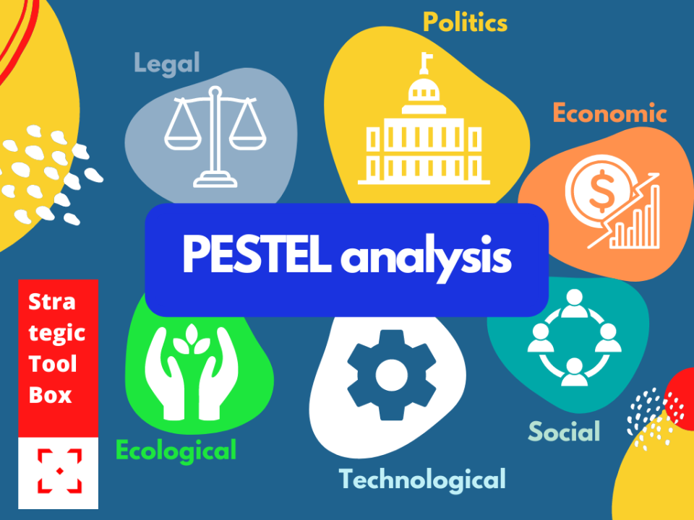
Figure 2: Six Elements of PESTEL Analysis
Source: (Cosmas and Krishnan, 2023)
Through assessing these intangible elements of digital transformation, The Cape Grace can draw meaningful conclusions on any threats that are posed and exploit new opportunities that are available.
Factors | Description | Impact On Cape Grace
Political | The government implies regulations about online booking platforms, travel duties, and data confidentiality and safety. | Strong data privacy regulations may affect customisation and information-gathering initiatives. Policies that support online booking services may result in fewer direct reservations (Subramaniam et al., 2011).
Economic | Global economic fluctuations and currency exchange rates also affect international trade. The many South African economy and tourism inventions and trends are weakened by the recessions (Sou Veasna et al., 2024). This means that there is a decrease in tourist spending, which results in a decrease in the booking rate. | The smart move for The Cape Grace Hotel is to have a sophisticated digital marketing strategy derived from knowing the tourism trends, thus being able to target the population with higher spending compared to what other population groups can afford.
Social | Increasing consumer use of mobile technology and digital travel platforms (Shahid et al., 2018). Prominent public figures have a significant influence on individuals’ voting behaviour. | The hotel needs to focus on getting a user-friendly mobile app and 24/7 online booking presence to provide the clients with the highest expectations (Fernando, 2023). The app design should allow green environment features’ incorporation into the system.
Technological | Instantaneous improvements in mobile innovations and also online travel sites generate traffic (Sinman, 2024). Increasing cyber threats as well as customers’ data security regulations. | The Cape Grace mobile app and digital services need to constantly embrace cutting-edge technologies to maintain their competitive edge and remain up to date (Covey, 2021). Adequate cyber security programs that utilise strong safety measures are a must for maintaining client data breaches and building up clarity that leads to trust.
Environmental | Green Tourism Focus of the industry is shifting towards a more sustainable type of tourism (GuestService, 2024). Environmental regulations provide a framework for hotel management. | Cape Grace can do a lot to display its approach to sustainability when using their digital platform. Environmental regulations may require inputs in energy-saving techniques.
Legal | Legal And Regulatory Shifts for Staff Training/Digital Literacy (Schreyögg, 2005). Data privacy regulation and cyber security compliance are also key components. | Cape Grace should make sure the employees go through a training program that is according to labour laws and provides them with correct digital skills. Implement data privacy laws and regulations like GDPR and CCPA.

Table 1: PESTEL Analysis of Cape Grace
Source: Author

SWOT Analysis
The SWOT analysis is an indispensable instrument that helps to expose the inner strengths and weaknesses a business has, as well as points out prospects on a global level and threats a company may face locally (Dlačić et al., 2018). In the sense that The Cape Grace can conduct a SWOT analysis, it shows that it has the entire picture of its current situation (Whittington and Molloy, 2005). The research brings forth the most prominent characteristics of the hotel; for example, its name is well known, the facility has a great position, and keeps the customers coming back (Scheuing and Christopher, 1994). While it detects the strong and weak areas, such as the lack of digital adventures and the use of manual processes, it also reveals the company’s competitive advantage (Drucker and Maciariello, 2015). The identified weaknesses can be eliminated by parameterizing the options offered by digital transformation. Digital tools adoption by The Cape Grace renders it an attractive option for tech-savvy travelers, guarantees personalized guest encounters and boosts its brand image (Fisman and Sullivan, 2014). On this basis, Cape Grace can strategically plan the digitalization that will draw on the available opportunities, thus working on the strengths and minimising weaknesses (Gert Noordzij, 2014). This will prove The Cape Grace to be competitive and also enjoy a high rank in the era of digital hospitality services.
SWOT ANALYSIS
Strengths | Weakness
- The Cape Grace had well-earned prestige for outstanding service, special attention, and luxurious amenities.  - Situated on the shores of V&A Waterfront and only a short distance away from the city’s busy streets, it provides guests with unparalleled views of the harbour and close access to the sights and sounds of Cape Town.  - The Cape Grace Hotel’s clientele is formed largely by faithful patrons who cherish the special mood and the attention to detail characterising the stay in this place.  - The hotel has long enjoyed a reputable brand identity that is known to resonate with luxury, exclusivity, and South African hospitality.  - The compassionate crew from Cape Grace gained their reputation for being among the best in the industry for their impeccable level of service. | - Currently, Cape Grace is devoid of mobile applications and has a website optimised for desktop usability, not mobile experience.  - Using paper methods, such as booking, registration, and guest contact, can be the main reason for inefficiencies.  - Hotels could miss out on substantially using guest data to personalise experiences and enhance marketing campaigns.  - The emphasis on the classical service provision may be the reason for the unwillingness of the organisation to apply digital tools.
Opportunities | Threats
- For instance, digital amenities can be a magnet for all kinds of guests whose preference is to access information effortlessly.  - With the availability of digital tools, processes can be more streamlined, which can be linked to cost savings and better employee productivity (Wales, 2024).  - Data analysis can help to set up room preferences in advance, position duly recommendations, and lead to a more individualised stay.  - Digital transformation is the leading edge in the hotel business, and embracing it will let The Cape Grace be future-oriented and creative. | - There is a risk that the customers who prefer a digital experience may segment hotels that provide these features.  - Guests can express their serious dissatisfaction in online reviews, which in turn can damage their reputation.  - Installing digital tools must come along with strict data security measures to enhance guest privacy and prevent falling victim to data breaches.  - The accelerated course of technological development requires continuous adjusting and high spending on innovative technologies.

Table 2: SWOT analysis of Cape Grace
Source: Author

TWOS Analysis
A TOWS matrix is an addition to the results of the SWOT analysis; here, these strengths, weaknesses, opportunities, and threats are analysed to develop the actions and strategies for the business (Jereb, 2024). In the context of the merits of the technique, this would move the hotel to capitalise on the available strengths and opportunities to fight weaknesses and threats (The Ritz, 2023).
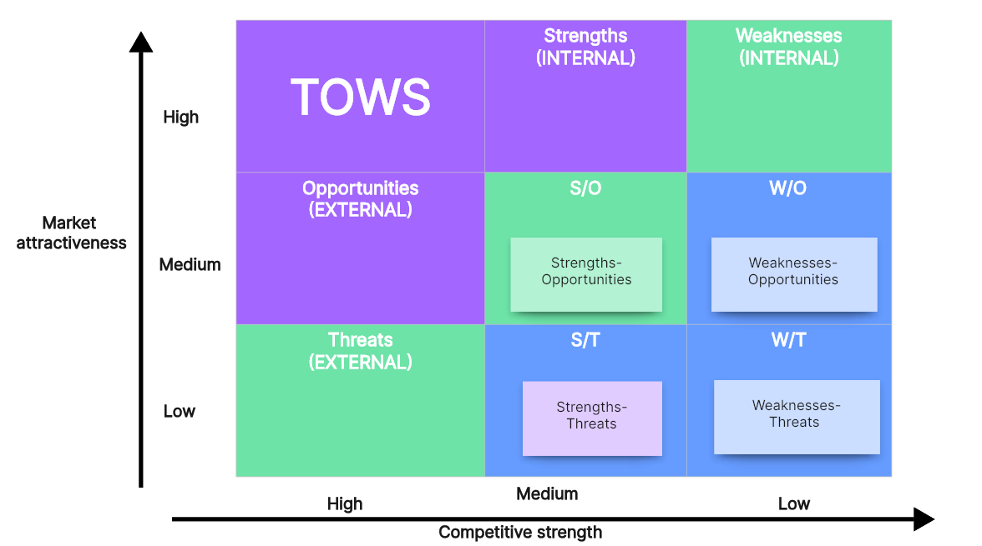
Figure 3: TWOS Matrix
Source: (John Arthur Henschke, 2021)
For instance, if The Cape Grace takes advantage of its recognised brand name (resource), they may successfully use its new mobile app (chance), which will compensate for the initial resistance to the new technologies adoption among the guests (weakness) (UK HRM, 2020). The tool of the TOWS matrix allows Cape Grace to identify potential threats and opportunities from consumers and competitors and adapt to the digital marketplace (Johnson, 2005).
Internal  External | Strengths  - Renowned Reputation  - Prime Location  - Loyal Clientele  - Strong Brand Identity  - Experienced Staff | Weakness  - Limited Digital Presence  - Manual Processes  - Limited Data Analysis  - Potential Resistance to Change
Opportunities  - Attract Tech-Savvy Guests  - Increase Operational Efficiency  - Personalize Guest Experiences  - Enhance Brand Image | SO strategies  - Create a mobile app that focuses on the hotel’s status, enticing a tech-savvy crowd.  - Use guest data for digital-based marketing campaigns to achieve a personalised guest experience.  - Build the expertise of the experienced staff on digital tools to enable them to give the best digital service possible. | WO strategies  - To span the digital gap between users and optimise our mobile app and website UI/UX for seamless operations.  - Leverage data analytics to handle the lack of data analysis and evangelise the idea of digital adoption to tackle change resistance.
Threats  - Competition  - Negative Guest Reviews  - Data Security Concerns  - Technological Evolution. | ST strategies  - Balance competition against the feature richness of the mobile app and our unswerving care for great service.  - Eliminate the likely possibilities of negative reviews by focusing on the upsizing of digital services that will surpass their anticipated expectations. | WT strategies  - Data security is achieved by implementing reliable security measures for the platform to safeguard guest data.  - Thus building trust, which prevents negative guest reviews.

Table 3: TWOS Analysis of Cape Grace
Source: Author

Recommendations and Change Management
The situation of Cape Grace, which is known for its personalised service and luxury accommodations, has hit the obstacle of adjusting to the digital revolution in the hospitality industry. This chapter starts with a vast list of ideas that are intended to close the digital gap, maintaining the hotel’s traditional style.

Recommendations:
- Develop a Mobile App and Optimise Website:
- Build an intuitive and easily navigable mobile app featuring:
- Saving users from the hassle of booking and checking in on the spot for the ride to their destination.
- In the rooms, they can have emergency controls for temperature, lighting, and amenities.
- Recommendation and assistance functionality by Humanized concierge services.
- A verification of loyalty & writing special offers for the clientele.
- Website Optimisation: Enable the site to be fully functional on any type of device for a smooth user experience across devices.
Implementation: Join hands with a renowned app developing company such that they design and build the app for Cape Grace. Develop user testing to check app can work properly and easily to use it. Get the site’s design and content ready for mobile screen adaptation.
- Embrace Digital Guest Communication:
- Channels: Send emails and use paid advertisements on social media channels to reach the guests who are coming before and after their stay, as well as the guests who stayed but haven’t had the chance to contact the hotel yet.
- Personalisation: Use guest data to offer custom-tailored messages based on their preferences, including specified recommendations and special offers.

- Chabot: Integrate a Chabot that makes it easy for the user to navigate the website and app to answer concerns, offer guest support, and provide 24/7 assistance to them.
Implementation: Construct a complete digital marketing plan with guest segmentation and messaging that resonates with the target audiences, which are a major part of the marketing strategy (Kipping and Clark, 2012). A Reciprocal or CRM system is to be used to collect and manage guests’ information for relationship purposes and personalised communications (Hospitality softnet, 2021). Collaborate with a Chabot development firm that can give the hotel a Chabot that will assist all clients effectively and has useful information.
- Invest in Staff Training and Support:
- Digital Literacy: Train employees to understand the use of new digital instruments as well as how consumers can talk to them in new communication channels.
- Guest Engagement: Train staff as to how integrating technology and personalised guest service can be made seamless. No matter how advanced automation is, human control should still be a top priority.
Implementation: Organise workshops and training sessions in which the trainees would be guided by digital technology specialists. Initiate a free dialogue and take into account the apprehensions of employees about the digital transformation (Sarala, 2000). Design the performance metrics that encourage the reckoning of the utility of new technologies and the individualised ways of providing services.
- Data-Driven Decision Making:
- Guest Data Analysis: Implementing a data collection and analysis system that would gather guest data from multiple channels (reservations, everything they like, reviews, and so on).

- Personalisation: Leverage data for personalisation of guest experiences, such as setting room preferences ahead of time, offering tailored recommendations, and being quick to identify guest needs.
- Operational Efficiency: Use data analytics to locate the operational gaps, prioritise process streamlining, and make the most effective use of the limited resources at hand.
Implementation: Make some investments in the hotel’s server and business intelligence solution. Hire a data analyst partner to build dashboards and unpack reports and insights. Utilise hotel data for marketing campaigns, guest experience approach, and operational decisions.
- Prioritise Data Security and Privacy:
- Compliance: Make sure that all data collection and storage activities are performed without any violations of data privacy regulations such as GDPR and CCPA.
- Data Security: Adopt strong cyber security measures as one of the ways to prevent data leakage or unauthorised access to guest information.
- Transparency: Be clear and transparent about data privacy standards and post them in a place that tourists can easily see.
Implementation: Carrying out a data security audit and incorporating appropriate security activities is a recommendation. Conduct cyber security reviews regularly and put solutions in action to be one step ahead of the changing danger (Ivanova et al., 2023). Specifically, the information collection procedures and users’ rights should be included in the privacy policy for the app and the website.

Impact and measurement analysis
The multi-level approach of evaluating the outcomes of the transformation for Cape Grace Digital is the recommended approach. By regularly taking the pulse of these metrics, hotels like Cape Grace will be able to spot-check performance, pick out areas that need to be improved, and adequately refine their digital strategy to boost their ranking in the growing competition (Sánchez et al.,2024). Metrics will track:
- App Downloads and Usage: Watch applause and level of guest contentment, and take some basic service feedback.
- Website Traffic and Conversion Rates: Quantify website traffic after SEO page optimisation with a key emphasis on mobile devices and reservation ratio.
- Guest Satisfaction Surveys: In the guest survey questions, identify the answers that might reflect customers’ satisfaction toward digital features and overall experience.
- Revenue Growth: Track the online booking revenues and total guest spending, which will be useful in computing the influence of digital adoption on hotel profitability.

Benefits
- A user-friendly mobile app equipped with functional activities like online check-in, in-room controls, and personalised tips will help guests be more independent and at ease (Roger et al., 2024). Digital communication, including Chabot and targeted marketing, will tailor the guest’s needs to what everyone likes.
- The provision of a convenient online booking process through the mobile app and Web optimisation targeted at tech-savvy travellers will enhance the likelihood of them booking directly from the website (Nolan, 2018). Marketing campaigns driven by data can direct their communications to various consumer groups, which will lead to higher online sales and thriving revenues.
- Digital tools, such as the management system for reservations and automated guest communications, can easily simplify the procedures and manual tasks and allow more time for the staff to interact with essential guests (O’Mahoney, 2021). Such enables operational costs down and boosts the productivity of the staff.
- Through analysing guest data analytics, The Cape Grace Hotel can learn key things about its guests’ likes and dislikes. The analytics can then be employed to further customise the experience (Robberson, 2019). It can adjust room prices and develop properly targeted marketing campaigns that speak to guests with specific needs.
- The hotel will be taking advantage of digital transformation to become a digital hospitality forward leader in this city. This also lures those guests who are seeking a technological experience while the hotel holds its reputed personalised services and grand accommodations (Njuka and Phiri, 2021).

Figure 4: Benefits of implementation of the Strategies
Source: Author

Cost for Implementation
Here’s a breakdown of the estimated costs for Cape Grace’s digital transformation, considering its size and potential income.
- The range given shows mid-sized development efforts with main functionalities like reservation, guest regulation, in-room control, and basic guest interaction. It can fluctuate from one method to another. It will depend on features, complexity, and chosen development partner (Newton, 2019). It will cost around $20,000 - $50,000.
- Improving the website to be responsive to smartphones is a more cost-effective solution than a complete rebuild (Moonitz, 2016). The final mark reflects the website’s status and the implementation area of optimisation, respectively. The estimated cost for this plan is $5,000 - $15,000.
- Collaboration with a local training facility on a trending personnel upgrade course provides a cost-benefit option (Merli et al., 2019). Discovering and taking advantage of the online tools available for additional skill development during the training will also be an option to rationalise the expenses. Expense for this plan is $2,000 - $5,000
- In the context of data analytics, cloud-based subscription services for data analytical instruments can be scaled quite easily to the size of data volume (Merrilees and Herington, 2007). Affordable schemes addressed to smaller hotels like The Cape Grace can be lucrative in terms of the guest intelligence and suggestions they bring along. The hotel may have to spend $1,000 to $3,000 yearly.

Change management plan
The digitalisation strategy for the Cape Grace Hotels is contingent on a strategic change management process. Kotter’s 8-step change model provides a general and step-by-step framework for managing a smooth change period and reducing staff resistance (Kotter, 2012). A change management plan represents the structured instrument designed to support an organisation in its transition process (Kotter and Whitehead, 2010). It attempts to lessen the friction and ensures that the exchange of power is achieved swiftly. Kotter’s 8-Step Model of Change is the most known framework according to the study conducted.
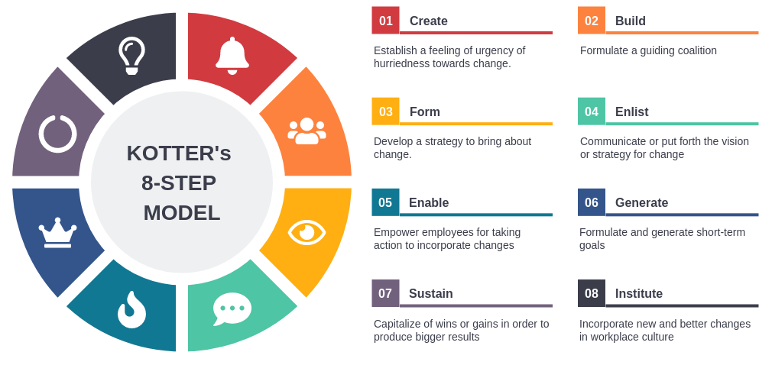
Figure 5: Kotter’s 8-step Model
Source: (Kotter, 2014)

This encompasses crafting an absolute alarm, a sturdy leadership team, outlining a clear vision, employee empowerment, celebrating first wins, and firmly fixating the new habits onto the company culture (IPMA, 1987). A change management plan stipulates measures for addressing apprehensiveness as well as training so that the probability of a successful digital transformation becomes high.
KOTTER’S 8 STEP CHANGE MANAGEMENT MODEL
- Develop a sense of Urgency. | - Cape Grace needs to run workshops to highlight an industry-related trend and showcase that the modern guest emphasises digital experiences.  - Highlight figures on forfeited turnover as a result of no digital approaches.  - Make sure to stress the importance of a change to make the hotel competitive and provide it with sustainability.
- Form a powerful coalition. | - Build a leadership group consisting of senior executives, IT experts, and division heads who will guarantee the success of the digital transformational initiative (Mckinsey, 2023).  - Elaborate on the leadership team issues, addressing details of the vision and strategy related to digital adoption.  - Undeniably, we have a clear vision of The Cape Grace star in digital hospitality while maintaining the idea of traditional personal service.
- Develop vision | - Lay down a tactical action plan consisting of concrete objectives relative to every recommendation.  - Disseminate that vision and strategy through clear and frequent messages to all staff members.
- Communicate the Change Vision | - Use various channels of communication to inform staff in their departments through town hall meetings, departmental briefings, and internal newsletters.  - Hold regular communication meetings to address personnel worries and respond to their questions during the meetings and one-on-one sessions.  - Among the advantages of digital transformation for the staff, the hotel may include enhanced speed, guest satisfaction, and employment chances.
- Empower Broad-Based Action | - Use interdisciplinary teams that combine staff from different departments (receptionists, housekeeping, IT) to let them take part in developing, testing, and implementing the app (Mavridopoulou and O’Mahoney, 2020).  - By giving the responsibility for the entire digital plan to members of the staff, Cape Grace can empower and engage them.  - Reward and praise the accomplishments of the personnel involved in coordinating and implementing the project as the process goes along.
- Generate Short-Term Wins | - Implement the pilot program on mobile devices with just a few leading features as the first step, such as mobile check-in.  - Exhibiting successful pilot projects and expressing positive customer reviews demonstrate confidence and encourage staff to sustain the change process.
- Consolidate | - Once the first-phase features have been successfully executed, conduct a staff feedback session to uncover any remaining concerns and work on their resolution.  - Improve and extend the digital platform based on the comments of the guests and usage statistics.  - Merge digital tools within the current work process to make sure that staff members can effectively use the new technologies.
- Anchor change | - Reward and praise staff who are keen to have the latest technologies and produce superior guest experiences using digital tools (Zhang, 2019).  - Integrate technical literacy and technology training into the ongoing staff development programs.  - Make periodic assessments of the effectiveness of digital transformation and tweak what is not working to facilitate ongoing improvements.

Table 4: KOTTER’S 8 STEP CHANGE MANAGEMENT MODEL
Source: Author

Action Plan
A road map (action plan) is a detailed direction showing how the objectives are to be reached (Kumar, 2023). It encompasses the blueprint of tasks, timelines, tasks, and resource estimates for a progression from idea to completion (Zhu, 2021). Everyone can stay informed and ensure that things are moving forward without becoming stuck in the centre (Whittington et al., 2020). There will be no confusion thanks to the clear structure. The plan’s deadlines and objectives inspire teams and promote accountability. It will assist staff in anticipating and removing possible obstacles (Wilkins, Merrilees, and Herington, 2007). Cape Grace can increase their chances of having a smooth and effective shift to a digital world by strictly adhering to this strategy.
No | Task | Descriptions | Desired outcome | Time Scale | Planned Budget
1 | Smartphone Application  Development | Provide an easy-to-use mobile application with functions such as secure mobile check-in and booking. Room switching options for heating, lighting, and features. Digital consultative services are available for recommendations and assistance. Loyalty program incorporation and individualised offerings. | Guest comfort and experience customisation were also improved during this process. | 6-8 months | $20,000 - $50,000
2 | Website Optimisation | Talk to a web development agency so that it makes the existing website mobile-friendly. Create a hassle-free experience that works on all Cape Grace’s devices. | A mobile site was developed to facilitate the best possible user experience, higher traffic to the website, and the possibility of higher online bookings. | 2-3 months | $5,000 - $15,000
3 | Employee training | Share digital competence lessons with all team members. Topics may include relying on the mobile app usability and guest care. Extra attention to data privacy and data security policies. | Providing digital tools for better guest support. Train employees in new technologies and excellent digital services rendering. | 6 months- ongoing | $2,000 and $ 5,000.
4 | Data Analytics Implementation | Subscribe and provision a cloud-based data analytics system. Integrate the info from all the sources, such as bookings, guest preferences, and reviews (Liang and Chi, 2011). Prepare reports and analyses that will define marketing plans and other guest experience programs. | Being able to receive actual guest insight for personalisation, resource allocation, and decision-making powered by data helps us better understand the needs of our customers. | 3-4 months | $1,000 - $2,600 per year (membership)

Table 5: Action Plan for integrating digital features
Source: Author

Conclusion
The thesis is structured on the conclusion of the consultancy report that provides a comprehensive analysis of the digital world that Cape Grace is currently facing, in particular, its guests’ experiences. The research pinpointed the tendency to prefer digital representation and insist on keeping up with the competition in the changing context of the hospitality industry. Fortified by the SWOT analysis, we established that this hotel’s well-earned reputation, superb location, and loyal base of frequent guests are the greatest competitive advantages to work with. Yet, a poorly developed digital presence and the lack of automation could significantly impede the growth paths and future accomplishments. In our TOWS matrix case, strengths doorways discovered what weaknesses we can address and how to better enhance competition in the digital market, which is comprised of advanced digital experiences. The actionable recommendations were proposed to close the gap between the digital and core values of Cape Grace. The result was designed to preserve and streamline operations, reduce waste, and improve customer experience, among other things. The suggested plan of action emphasised making a user-friendly mobile app and a website optimised for mobile friendliness and communication with guests based on data analytics. Personal stabilisation activities, such as providing classes for staff training and building a digital use culture based on Kotter’s 8-Step Change Model, were highlighted as essential factors for creating a successful changeover. The proposed action plan specified how the following recommendations would be carried out daily. It also provides projected timelines and costs associated with the procedure. By undertaking and executing this cycle of activities, the organisation finds the best ways to direct and carry out the digital transformation process, distancing it from unpredicted problems and facilitating the achievement of the most favourable results. With the support of these recommendations can be at Cape Grace can enhance the guest experience a great potential. A hassle-free mobile app for booking, check-in, and control of in-room operations will lead to an enhanced experience and boost convenience. Data-driven communication, tailored advice, and digital concierge service will inspire every guest and lead them to feel comfort. In addition to this, operational efficiency can be improved by adaptation of a lean process method or data-driven decision-making approach. The effective unfolding of these digital transformation tactics will make The Cape Grace the chief ragamuffin in digital hospitality among the players in Cape Town. Such customisation will enable the Cape Grace Hotel to continue attracting tech-savvy travellers who seek digitalisation and exceptional customer service. Digital competence will be a staple of the Cape Grace fleet, and it will be responsible for the further development of the fleet’s success in the years ahead. We note that, finally, Horizon Consultancy is grateful to The Cape Grace for the time and consideration allowed to work with each other on this project. The offered directions are certainly the toolkit for The Cape Grace to embark on the exciting digital alternative path. We have high hopes for the opportunities that are open to The Cape Grace, securing digital targets and attaining further success in their business perspective.

Reference
- Aust, I., Matthews, B. and Muller-Camen, M. (2019). Common Good HRM: A paradigm shift in Sustainable HRM? Human Resource Management Review, [online] 30(3), p.100705. doi:https://doi.org/10.1016/j.hrmr.2019.100705.
- Baron, A. and Armstrong, M. (2007). Human capital management: achieving added value through people. London; Philadelphia: Kogan Page Ltd.
- Belcourt, M., Mcbey, K., Hong, Y. and Yap, M. (2013). Strategic human resources planning. Andover: Nelson.
- Brierley, E. (2006). Talent on tap: getting the best from freelancers, interims, and consultants. London: Chartered Institute of Personnel and Development.
- BruyèreS.M. and Barrington, L. (2013). Employment and work. Thousand Oaks, Calif Sage Publications.
- Burnes, B. (2014). Managing change: a strategic approach to organisational dynamics. 4th ed. Harlow: Prentice Hall.
- Buttrick, R. (2009). The Project Workout. FT Press.
- Bwalya, C. and Phiri, J. (2014). Human resource management journal. London: Industrial Relations Services And Personnel Publications, Ltd.
- Canary Technologies (2022). How to Collect Hotel Guest Feedback - A Guide. [online] www.canarytechnologies.com. Available at: https://www.canarytechnologies.com/post/hotel-guest-feedback-guide.
- Cape Grace. (2024). Cape Grace - Cape Town Luxury Hotel. [online] Available at: https://www.capegrace.com/.
- Chicha, M. and Phiri, J. (2024). Factors Influencing the Adoption of E-Marketing in the Tourism Industry by SMEs in Developing Countries Based on the UTAUT Model. Open Journal of Business and Management, 12(01), pp.521–539. doi:https://doi.org/10.4236/ojbm.2024.121032.
- CIPD (2023). CIPD | Build your impact and career in the people profession. [online] CIPD. Available at: https://www.cipd.org/en/.
- Cosmas, A. and Krishnan, V. (2023). What AI means for travel—now and in the future | McKinsey. [online] www.mckinsey.com. Available at: https://www.mckinsey.com/industries/travel-logistics-and-infrastructure/our-insights/what-ai-means-for-travel-now-and-in-the-future.
- Covey, S.R. (2021). The 8th Habit: From Effectiveness to Greatness. [online] Goodreads. Available at: https://www.goodreads.com/book/show/19291797.
- Dlačić, J., Grbac, B. and Lazarić, M. (2018). Exploring relationship quality in the hospitality industry. Tourism and hospitality management, 24(2), pp.287–306. doi:https://doi.org/10.20867/thm.24.2.3.
- Drucker, P.F. and Maciariello, J.A. (2015). Management Today. New York, NY: Collins.
- Fernando, J. (2023). Return on Investment (ROI): How to Calculate It and What It Means. [online] Investopedia. Available at: https://www.investopedia.com/terms/r/returnoninvestment.asp.
- Fineer, D. (2022). Great Hotel Service: 101 Ways to Create Great Customer Service and Experience in the Hospitality Industry: Avkan, Orkun: 9781077139947: Amazon.com: Books.
- Fisman, R. and Sullivan, T. (2014). The org is the underlying logic of office life. Princeton, NJ Princeton Univ. Press.
- Gert Noordzij (2014). Project management of hotel opening processes: exploring better ways to open new hotels. North Charleston: Createspace Independant Publishing Platform.
- GuestService (2024). GuestService: The Key to Your Hotel’s Digital Transformation Journey? - GuestService. [online] Available at: https://guestservice.net/guestservice-the-key-to-your-hotels-digital-transformation-journey/.
- Hospitality softnet (2021). Hotel Training & Tools for Selling Process & Hotel Catering. [online] www.hospitalitysoftnet.com. Available at: https://www.hospitalitysoftnet.com/hotel-training-services/training-tools/.
- IPMA (1987). Public personnel management. International Personnel Management Association, Alexandria, Va.
- Ivanova, N., Egorova, O. and Ivanova, T. (2023). Digital Transformation - an overview | ScienceDirect Topics. [online] www.sciencedirect.com. Available at: https://www.sciencedirect.com/topics/computer-science/digital-transformation.
- Jereb, D. (2024). ReviewPro Learning & Support Center. [online] Reviewpro.com. Available at: https://go.reviewpro.com/s/topic/0TO57000000XlP5GAK/surveys-guest-satisfaction-surveys?language=en_US.
- John Arthur Henschke (2021). Facilitating adult and organisational learning through andragogy: Aa history, philosophy, and major themes. Hershey, Pa: Igi Global.
- Johnson, M. (2005). The Independent Consultant’s Survival Guide. CIPD Publishing.
- Kipping, M. and Clark, T. (2012). The Oxford Handbook of Management Consulting. OUP Oxford.
- Kotter, J. (2014). The 8 steps for leading change. [online] Kotter International Inc. Available at: https://www.kotterinc.com/methodology/8-steps/.
- Kotter, J.P. (2012). Leading Change. Boston, Mass.: Harvard Business School Press.
- Kotter, J.P. and Whitehead, L.A. (2010). Buy-In. Harvard Business Press.
- Kumar, P. (2023). Service Quality in the Hospitality Industry: Understanding and Improving Customer Satisfaction - hmhub. [online] Journal of Management. Available at: https://hmhub.in/principles-of-marketing-management/the-service-quality/.
- Liang, S. and Chi, S.S. (2011). FOLLOWER AFFECT LINKING TRANSFORMATIONAL LEADERSHIP TO JOB PERFORMANCE: A CROSS-LEVEL ANALYSIS. Academy of Management Proceedings, 2011(1), pp.1–6. doi https://doi.org/10.5465/ambpp.2011.65869724.
- Mavridopoulou and O’Mahoney, J. (2020). Elitism in Strategy Consulting: How Institutional Prestige Influences Recruitment. Management Consulting Journal, 3(1), pp.12–22.
- Mckinsey (2023). How to serve today’s digital traveler | McKinsey. [online] www.mckinsey.com. Available at: https://www.mckinsey.com/industries/travel-logistics-and-infrastructure/our-insights/how-to-serve-todays-digital-traveler.
- Merli, R., Preziosi, M., Acampora, A. and Ali, F. (2019). Why should hotels go green? Insights from guests’ experience in green hotels. International Journal of Hospitality Management, 81(0278-4319), pp.169–179. doi https://doi.org/10.1016/j.ijhm.2019.04.022.
- Merrilees, B. and Herington, C. (2007). Service quality in hotels. International Journal of Hospitality Management, 26(4), pp.840–853. doi:https://doi.org/10.1016/j.ijhm.2006.07.006.
- Moonitz, M. (2016). Changing Concepts of Business Income: Report of Study Group on Business Income. Harvard Law Review, 66(3), p.563. doi:https://doi.org/10.2307/1336712.
- Newton, R. (2019). MANAGEMENT CONSULTANT: mastering the art of consultancy. S.L.: Financial Times Prentice.
- Njuka, D.A. and Phiri, J. (2021). Factors Influencing Social Media in Managing Corporate Reputation. Technology and Investment, 12(02), pp.66–81. doi:https://doi.org/10.4236/ti.2021.122005.
- Nolan, C. (2018). CHR & PIHE: Hospitality Innovations in the Digital Age: Cost Restructuring, Artificial Intelligence, Culture, and Technology. [online] Cornell Nolan. Available at: https://sha.cornell.edu/events/chr-pihe-hospitality-innovations-in-the-digital-age-cost-restructuring-artificial-intelligence-culture-and-technology/.
- O’Mahoney, J. (2021). How Small Consultancies Grow: Challenging Problem-Based Theorising. Management Consulting Journal, 4(1), pp.5–20.
- Robberson, L. (2019). International Journal of Employment Studies. John Wiley & Sons, Inc.
- Roger, M., Liu Shulin, Byiringiro Enock and Gashema, B. (2024). Does ICT Development, and Innovation Dissemination Promote Economic Growth and Human Capital? An Econometric Approach Based on East African Countries. Journal of human resource and sustainability studies, 12(01), pp.172–203. doi:https://doi.org/10.4236/jhrss.2024.121010.
- Sánchez Jiménez, M.Á., Gómez Carmona, D. and Moral Moral, M. (2024). Evolution of the impact of social media in hospitality: A bibliometric analysis. Journal of Destination Marketing & Management, [online] 31(3), p.100868. doi:https://doi.org/10.1016/j.jdmm.2024.100868.
- Sarala, R. (2000). British Journal of Management Index Volume 11 2000. British Journal of Management, 11(4), pp.365–367. doi:https://doi.org/10.1111/1467-8551.00179.
- Scheuing, E.E. and Christopher, W.F. (1994). The Service Quality Handbook: With Contributions from 57 International Experts. Amazon. New York: Amacom Books.
- Schreyögg, A. (2005). Coaching at Work. Organisationsberatung, Supervision, Coaching, 12(4), pp.309–319. doi:https://doi.org/10.1007/s11613-005-0118-2.
- Shahid Iqbal, M., Ul Hassan, M. and Habibah, U. (2018). Impact of self-service technology (SST) service quality on customer loyalty and behavioral intention: The mediating role of customer satisfaction. Cogent Business & Management, 5(1). doi https://doi.org/10.1080/23311975.2018.1423770.
- Sinman, D. (2024). Hotel Audit and Restaurant Inspection App. [online] GoAudits. Available at: https://goaudits.com/hospitality/.
- Sou Veasna, Uk Chanveasna, Kang Sovannara, Wu, W.-Y. and Heng Ngounhort (2024). A Cross-Level Analysis of Linking Transformational Leadership and Employee Creativity to Enhance Task Performance: The Mediating Effects of Person-Supervisor Fit and Psychological Empowerment. Journal of human resource and sustainability studies, 12(01), pp.132–171. doi:https://doi.org/10.4236/jhrss.2024.121009.
- Subramaniam, Collier, P., Phang, M. and Burke, G. (2011). The effects of perceived business uncertainty, external consultants, and risk management on organisational outcomes. Journal of Accounting & Organizational Change, 7(2), pp.132–157.
- The Ritz (2023). The Ritz-Carlton Yacht Collection. [online] The Ritz-Carlton Yacht Collection. Available at: https://www.ritzcarltonyachtcollection.com/experience/service.
- UK HRM (2020). UK Human Resource Management Articles. [online] Hrmguide.co.uk. Available at: http://www.hrmguide.co.uk/.
- Wales (2024). Audit Wales. [online] www.audit.wales. Available at: http://www.audit.wales/.
- Whittington, R. and Molloy, E. (2005). HR’s role in the organisation: shaping change. Research report. London: Chartered Institute of Personnel and Development.
- Whittington, R., Regner, P., Angwin, D., Johnson, G. and Scholes, K. (2020). Exploring Strategy. 12th ed. Hoboken: Pearson.
- Wilkins, H., Merrilees, B. and Herington, C. (2007). Towards an understanding of total service quality in hotels. International Journal of Hospitality Management, 26(4), pp.840–853. doi:https://doi.org/10.1016/j.ijhm.2006.07.006.
- Zhang, X. (2019). Research on the Impact of Brand Experience on Brand Love. American Journal of Industrial and Business Management, 09(04), pp.898–903. doi:https://doi.org/10.4236/ajibm.2019.94061.
- Zhu, J. (2021). Digital Transformation in the Hospitality Industry | Boston Hospitality Review. [online] www.bu.edu. Available at: https://www.bu.edu/bhr/2021/10/04/digital-transformation-in-the-hospitality-industry/.

