

Strategic Growth Opportunity: Expanding Ecotricity's Integrated Solar Energy and Battery Storage Solutions for UK SMEs.

Master of Business Administration
LCMB7037- Business Development Proposal
Business Development Proposal Outline



Student Name: Florina Maria Vlad
Student ID: 2227241

Table of Contents
Chapter 01: Introduction 1
1.1 Overview of the Company 1
1.2 Opportunistic Idea Description 1
1.3 Research Aim and Objectives 3
Chapter 02: Research Methodology 4
2.1 Research Approach and Design 4
2.2 Data Collection Methods and Sources 4
2.3 Data Selection and Analytical Framework 5
2.4 Financial Evaluation 5
2.5 Research Ethics, Reliability and Limitations 5
Chapter 03: Market Research and Validation 7
3.1 UK Renewable Energy Market Size and Growth 7
3.2 Target Market Size and Customer Segmentation 8
3.3 Customer Needs, Behaviour and Demand Validation 9
3.4 Competitor Activity and Market Positioning 10
3.5 Pricing Trends and Commercial Feasibility 11
3.6 Market Entry Barriers and Regulatory Considerations 12
3.7 Market Validation and Strategic Opportunity 12
Chapter 04: Risk Management 13
Chapter 05: Project Timeline 15
References 16

Chapter 01: Introduction

1.1 Overview of the Company
Founded by environmental entrepreneur Dale Vince in 1995, Ecotricity is a British renewable energy business aiming to speed up the move away from fossil fuels to renewable energy. The company has been acknowledged as a leader in the supply of green electricity and services, providing supply of renewable electricity, green gas and other energy services (Ecotricity, 2025a) to both domestic and commercial customers all over Britain. The unique Bills into Mills strategy is to reinvest profits in renewable energy systems instead of shareholder dividends (Ecotricity, 2025b).
Ecotricity have designed 24 wind parks, each with a number of wind turbines, with a total capacity of 74 wind turbines, and three solar parks, with a total capacity of 17.5 MW (Ecotricity, 2025b). The mix of fuels used for its electricity generation in the 2024-March 25 quarter was 100% renewable, with sources of wind, hydropower, solar and bio generation. Some 10% of its electricity, however, was produced by its own generators, the rest by other generators and wholesale arrangements (Ecotricity, 2025c).
Technological innovation, commercial decarbonisation and energy affordability are factors that shape growth opportunities in the UK renewable energy market, which is becoming more competitive. They have proven success with sustainability credentials, business customer relationships, and renewable generation experience, making them a solid base to consider strategic expansion into integrated energy solutions for business customers.

1.2 Opportunistic Idea Description
The strategic opportunity is a single, integrated solar photovoltaic (PV) / battery storage / smart energy management service for small and medium-sized enterprises (SMEs) in the UK. This would be an expansion of Ecotricity's existing business portfolio by complementing its renewable energy packages, which would help customers to better manage electricity costs and operational resilience instead of creating a new business.
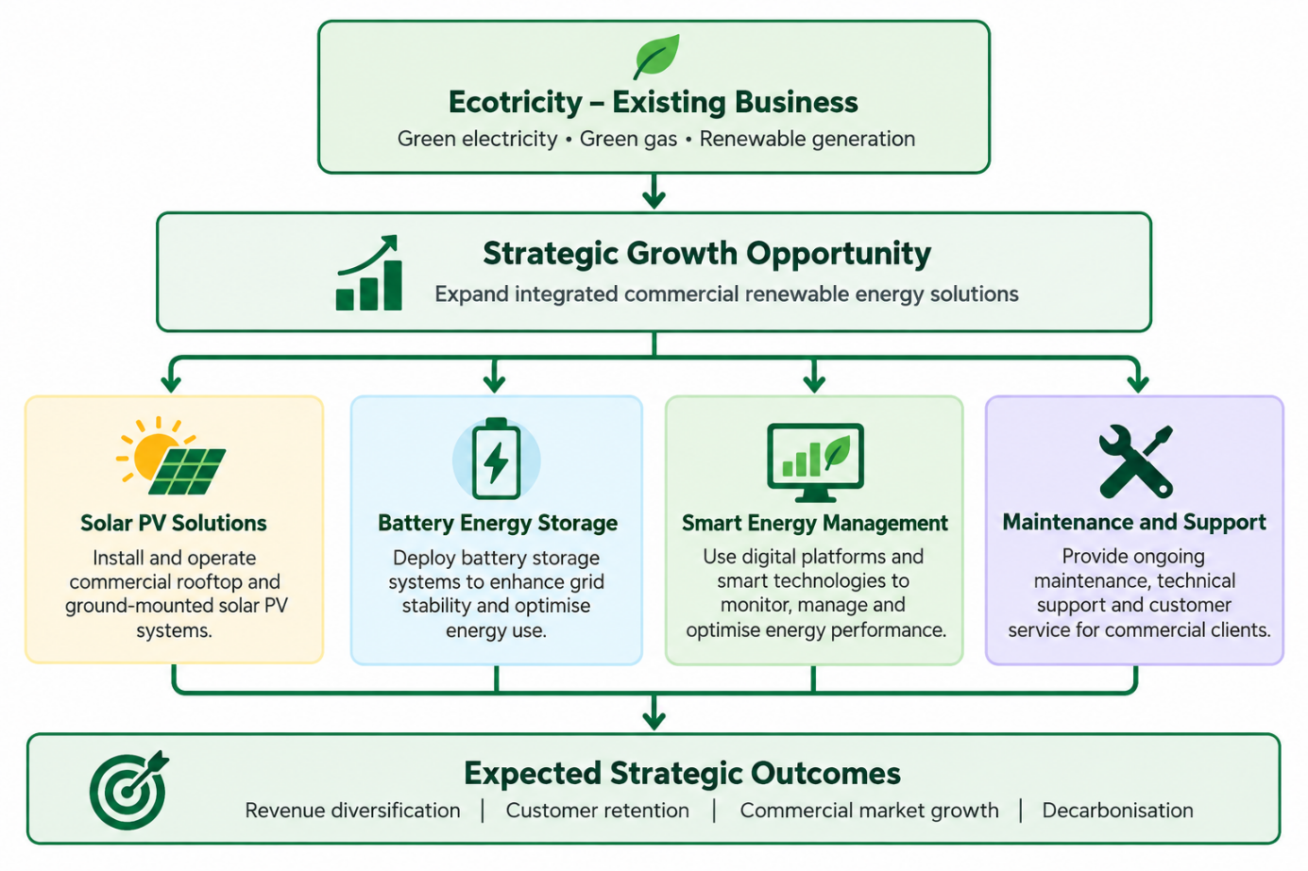
Diagram 1: Proposed Strategic Growth and Expansion Framework (Source: Author)
This opportunity is backed up by significant market growth of solar energy in the United Kingdom. The Department for Energy Security and Net Zero (DESNZ, 2026) reported that solar electricity generation in the UK rose by around 37% in 2025 to a total of 20 TWh. However, solar capacity grew by about 15% to 21.7 GW (DESNZ, 2026). While the growth in the market is encouraging, the developments indicate a favourable scenario for commercial investment in renewable energies but not alone financial viability of the proposed expansion.
Ecotricity is already supplying renewable electricity to commercial customers and providing the opportunity for them to generate renewable energy on site (Ecotricity, 2025c). This would be complemented by packaged solar installations, battery storage systems, energy monitoring, and maintenance services among the additional capabilities envisioned by the proposed strategy. This would create more service revenue, enhance customer relationships and contribute to Ecotricity's sustainability goals. Growth would need to be carefully evaluated for customer demand, investment, regulations, technical delivery capabilities, and competition prior to growth.

1.3 Research Aim and Objectives
This research aims to evaluate the strategic and financial feasibility of expanding Ecotricity's integrated solar energy and battery storage services within the UK SME market. The objectives of this study are –
- To investigate UK renewable energy market trends, SME customer demand and potential expansion opportunities for Ecotricity.
- To assess Ecotricity's competitive position and strategic growth potential using PESTLE, SWOT, competitor analysis, Porter's Five Forces and Ansoff Matrix.
- To develop appropriate marketing, operational and human resource strategies to support the proposed expansion.
- To evaluate the financial feasibility, funding requirements and risks of the expansion through a projected 12-month cash flow analysis.

Chapter 02: Research Methodology

2.1 Research Approach and Design
This will be secondary research which will incorporate qualitative and quantitative evidence to analyse the strategic growth opportunities that Ecotricity has within the United Kingdom's Renewable Energy market. The investigation will be conducted using a pragmatic research philosophy that leaves a range of evidence to cover aspects of the commercial, operational and financial side of the proposed expansion. Samwayis and Underwood et al. (2023) tell us that the type of research design must match the research goals and what type of evidence needs to be gathered.
A descriptive and exploratory research design will be used to investigate Ecotricity's current business activities, the industry and opportunities to expand integrated solar PV (Photovoltaic) / battery storage and smart energy management for UK SMEs (Small and Micro Enterprises). Since a systematic assessment of the available market evidence is required, but primary data collection can be expensive, secondary research is appropriate.

2.2 Data Collection Methods and Sources
Credible and publicly available data will be obtained from sources such as governmental statistical reports, Ecotricity's corporate publications, peer-reviewed and academic journals and industry research. The Department for Energy Security and Net Zero (DESNZ, 2026) will supply official evidence on renewable generation of electricity, on installed capacity and the development of sectors. Information, evidence and indicators regarding energy market competition in retail markets will be made available by Ofgem (2026).
Further data will be sourced from Companies House, the Office for National Statistics (ONS) and appropriate industry publications for renewables. The sources identified between 2021 and 2026 will have precedence, as this will ensure contemporary relevance, with emphasis on sources published within the last five years, and earlier academic publications will support the established theoretical frameworks.

2.3 Data Selection and Analytical Framework
Relevance, credibility, date of publication, methodological transparency and geographical applicability will be criteria for the selection of evidence. The emphasis will be on the presentation of official statistics, verified corporate disclosure and peer-reviewed research. Promotional literature and unverifiable, commercial claims and market estimates that do not support the text will be avoided (unless for the ability to make a valid comparison with the text).
PESTLE, SWOT, competitor analysis, Porter's Five Forces and the Ansoff Matrix are the tools that would be used to analyse the collected evidence. These frameworks will analyse external market factors, organisational resources, pressures and opportunities for strategic growth.
Qualitative data will be analysed using thematic analysis, and common opportunities, barriers, and implementation needs will be outlined. Braun and Clarke (2006) provide a flexible approach to thematic analysis for finding patterns within qualitative evidence. Comparable quantitative data will be used to aid the comparisons for the market, cost assumptions, and projected financial performance.

2.4 Financial Evaluation
This study will conduct a 12-month cash flow statement to analyse investment expenditure and installation costs, operational expenses and possible income flows, and a statement will be generated to address financial feasibility. The commercial viability will be assessed using scenario analysis based on assumptions of the change in equipment and sales performance in relation to the fluctuation of customer demand. Assumptions will be made explicit when not provided by a specific company, with credible, market-based assumptions to support.

2.5 Research Ethics, Reliability and Limitations
The research will adhere to academic integrity principles by accurately using the Harvard style for referencing, providing transparent interpretation and analysis of data, and ensuring appropriate acknowledgement of sources. Wherever possible findings will be cross checked among independent publications. One of the drawbacks is that it relies on data from others and is therefore not comprehensive enough to provide a true picture of the internal financial situation, priorities or needs of Ecotricity. Accordingly, recommendations will be for proposed decisions based on evidence, not evidence-based decisions.

Chapter 03: Market Research and Validation

3.1 UK Renewable Energy Market Size and Growth

Figure 1: Low-Carbon Share (%) of GB Electricity Generation, 2022–2025 (Source: DESNZ (2026)
The UK renewable energy sector now has a significant level of development, largely in line with decarbonisation goals, technology advancements and a move towards lower carbon electricity generation. Throughout 2025, low-carbon generation made up 73.3% of Great Britain's electricity generation, which is an increase from 62.7% in 2022, according to DESNZ (2026). These figures do include nuclear generation; please do not assume these to be renewable electricity shares. However, they do reflect the structural change of the electricity system.

Figure 2: Government Solar Capacity Ambition (Source: DESNZ (2024)
The UK Government's Clean Power 2030 Action Plan backs solar power to achieve its 45-47 GW installed capacity target for 2030, alongside battery storage reaching a capacity range of 23-27 GW (DESNZ, 2024). Commercial rooftops are another significant deployment opportunity as identified in the Solar Roadmap, adding to the potential relevance of integrated energy services (DESNZ, 2025).

3.2 Target Market Size and Customer Segmentation
The United Kingdom is home to a large number of small businesses, which could be a significant market opportunity for SMEs. In 2025, DBT estimated that there were around 5.68 million SMEs, representing almost 99.9% of all private-sector businesses. These businesses employed around 16.9 million people and created PS 2.83 trillion in turnover. The total SME population does not represent the actual market as many of them don't have the right premises, electricity demand, financial savings to install solar panels.
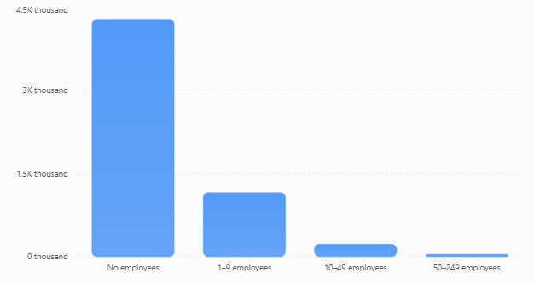
Figure 3: UK SME Population by Business Size, 2025 (Source: DBT (2025)
The proposed expansion would focus on SMEs from commercial premises with significant electricity consumption during the day, such as manufacturing units, warehouses, food premises and retail outlets. These segments may be attractive due to their operational activities, which may enable an increased direct use of the electricity produced by solar energy. Roof ownership, building suitability, electricity consumption and investment capacity are factors that should be taken into account in customer qualification.

3.3 Customer Needs, Behaviour and Demand Validation
The attractiveness of energy and the management of operating costs are determining factors when purchasing happens. The Office of Gas and Electricity Markets (Ofgem) (2026) found 70% of the businesses surveyed were able to pay for energy, but 27% suffered challenges doing so. Additionally, 29% had changed their energy supplier in the year prior to this survey, reflecting the commercial appetite for reevaluating energy agreements.

Figure 4: UK Business Energy Market Survey Findings, 2025 (Source: Ofgem (2026)
Importantly, Ofgem (2026) discovered that 41% of businesses had 'no barriers' to decarbonisation, down from 27% in 2024. But the individual most frequently reported barrier was cost, with 15% reporting such a barrier. This indicates better preparedness towards sustainability but, by itself, that does not indicate willingness to buy a solar system and storage. Ecotricity can do so by customised feasibility assessment, transparent financial projections, flexible financing options, ongoing performance monitoring, etc. However, direct validation would require customer enquiries, some demonstration installations and proof of actual purchase commitments need to be met.

3.4 Competitor Activity and Market Positioning
The UK commercial renewable energy market is home to existing electricity service suppliers as well as solar specialist installations and integrated energy service providers. Ecotricity already provides renewable electricity to SMEs and provides on-site electricity generation, providing it with the existing commercial foundation (Ecotricity, 2025c). But there are some competitors working on similar integrated solutions, which makes differentiation increasingly important.
A comparison from Good Energy is particularly useful. In March 2026, the company announced its fifth solar installation business acquisition in about 18 months, which will extend its solar installation capacity and geographical reach (Good Energy, 2026). It also enters into renewable power purchase and renewable electricity supply contracts as part of its existing services, along with the installation of solar power plants. This highlights the installation role, financing by the customer and long-term association with the customer in the competitive world. An integrated renewable supply relationship and differentiated packages designed specifically for SMEs and services could be a source of differentiation, as could be its unique positioning on environmental matters. However, the installation quality would still have to be proven, as well as the price and the value measurable for the customer – not the environment – would still be instrumental for competitive advantage.

3.5 Pricing Trends and Commercial Feasibility
The cost is an important factor as it is both an initial upfront capital cost for commercial solar and battery installations, as well as an opportunity for subsequent electricity savings. Project costs vary based on the capacity of the installation, building parameters, battery size and complexity of electrical infrastructure and installation. For this reason, a blanket installation charge would not be appropriate to evaluate the proposed services by Ecotricity. Limited availability of finance is a major challenge in commercial rooftop solar development identified by the UK Government's Solar Roadmap, which noted that smaller businesses often lack creditworthiness needed for investment in solar.
Ecotricity should therefore explore a variety of potential pricing models, with direct equipment acquisition being one of them, as well as instalment financing and third-party funded Power Purchase Agreements. The economic viability of the various alternatives would be dependent on the customers' electricity use, the percentage of electricity consumed, the financing banks and the time to pay off the system. The cost of equipment (quoted) and the tariff data (commercial) would have to be retrieved to make final financial projections.

3.6 Market Entry Barriers and Regulatory Considerations
Although the sector is developing favourably, growth would be constrained by operational and regulatory limitations. Business installations might need proper planning evaluation, structural appropriateness examinations, electrical safety adherence and distribution network grants. In England, rooftop solar systems that are not domestic can be permitted to have a permitted development right with certain restrictions and conditions (UK Government, 2015).
Other obstacles are grid connection capacity, access to workforce, battery system safety and access to project finance. This would in turn require certified installation partners, certified electrical engineers, trusted suppliers and relevant contractual agreements. Established installers might also limit market penetration unless the firm has strong financial and operational advantages. The implementation plan that is phased would minimise exposure to investments, as the suggested services would be subjected to commercial validation.

3.7 Market Validation and Strategic Opportunity
Secondary evidence suggests a viable strategic opportunity for Ecotricity, with ongoing government clean energy targets and a large population of SMEs and business energy affordability concerns. These indicators, however, indicate market potential and not actual, present customer purchase intentions. A practical validation process would include testing the technical feasibility of potential SME sites, requesting supplier quotes, estimating installation economics and acquiring initial customer signoffs. Pilot projects should include measurement of customer acquisition costs, installation margins, predicted electricity savings and operational performance and satisfaction.
Successful pilot results could lead to a larger commercial roll-out. On the other hand, if there is insufficient customer demand, or the project is not economically competitive, project service packages may be adjusted prior to major investments. As a whole, the evidence indicates that there is a need to investigate further the feasibility of the integrated solar and battery storage extension planned by Ecotricity, but a more convincing financial viability of the large-scale implementation is not yet shown.

Chapter 04: Risk Management
Identified Risk | Likelihood | Impact | Mitigation Strategy
High initial investment costs | High | High | Implement phased investment and explore external financing or strategic partnerships.
Strong market competition | High | High | Differentiate through integrated services, competitive packages and customer support.
Low customer adoption | Medium | High | Conduct SME market validation and offer flexible payment options.
Regulatory and policy changes | Medium | High | Monitor DESNZ and Ofgem requirements and maintain regulatory compliance.
Equipment supply chain disruption | Medium | Medium | Establish multiple suppliers and maintain contingency procurement arrangements.
Technical installation and system failure | Medium | High | Employ qualified contractors, conduct inspections and provide maintenance support.
Financial and cash flow uncertainty | High | High | Prepare 12-month cash flow projections, sensitivity analyses and contingency budgets.
Shortage of skilled technicians | Medium | Medium | Develop recruitment, training and accredited contractor partnerships.
Table 1: Risk Management (Source: Author)

Chapter 05: Project Timeline
Activities | 1 | 2 | 3 | 4 | 5 | 6 | 7 | 8 | 9 | 10 | 11 | 12 | 13 | 14
Research planning | ■ | ■
Literature review and methodology | ■ | ■ | ■ | ■
Market research and validation |  | ■ | ■ | ■ | ■
Outline submission |  |  |  |  | ■
Company and competitor analysis |  |  |  |  | ■ | ■ | ■
Business analysis models |  |  |  |  |  | ■ | ■ | ■ | ■
Marketing and sales strategy |  |  |  |  |  |  |  | ■ | ■ | ■
Operations and HR planning |  |  |  |  |  |  |  |  | ■ | ■ | ■
Financial and cash flow analysis |  |  |  |  |  |  |  |  |  | ■ | ■ | ■
Risk assessment and reflection |  |  |  |  |  |  |  |  |  |  | ■ | ■ | ■
Editing and referencing |  |  |  |  |  |  |  |  |  |  |  |  | ■ | ■
Final submission |  |  |  |  |  |  |  |  |  |  |  |  |  | ■
Table 2: Gantt Chart (Source: Author)

References
- Braun, V. and Clarke, V. (2006). Using thematic analysis in psychology. Qualitative Research in Psychology, 3(2), pp.77–101. doi: https://doi.org/10.1191/1478088706qp063oa.
- DBT (2025). Business population estimates for the UK and regions 2025: Statistical release. [online] GOV.UK. Available at: https://www.gov.uk/government/statistics/business-population-estimates-2025/business-population-estimates-for-the-uk-and-regions-2025-statistical-release [Accessed 8 Oct. 2026].
- DESNZ (2024). Clean power 2030 action plan: A new era of clean electricity – main report. [online] GOV.UK. Available at: https://www.gov.uk/government/publications/clean-power-2030-action-plan/clean-power-2030-action-plan-a-new-era-of-clean-electricity-main-report [Accessed 8 Oct. 2026].
- DESNZ (2025). Solar roadmap: United Kingdom powered by solar (accessible webpage). [online] GOV.UK. Available at: https://www.gov.uk/government/publications/solar-roadmap/solar-roadmap-united-kingdom-powered-by-solar-accessible-webpage [Accessed 8 Oct. 2026].
- DESNZ (2026). Energy trends: March 2026. [online] GOV.UK. Available at: https://www.gov.uk/government/statistics/energy-trends-march-2026 [Accessed 8 Oct. 2026].
- Ecotricity (2025a). For your business. [online] www.ecotricity.co.uk. Available at: https://www.ecotricity.co.uk/for-your-business [Accessed 8 Oct. 2026].
- Ecotricity (2025b). How ecotricity became the world’s first Green Energy Company. [online] Ecotricity.co.uk. Available at: https://www.ecotricity.co.uk/our-news/2025/how-ecotricity-became-the-worlds-first-green-energy-company [Accessed 8 Oct. 2026].
- Ecotricity (2025c). What is ‘bills into mills’ and why is it good news for your business? [online] Ecotricity.co.uk. Available at: https://www.ecotricity.co.uk/our-news/2025/what-is-bills-into-mills-and-why-is-it-good-news-for-your-business [Accessed 8 Oct. 2026].
- Good Energy (2026). We’re expanding our solar installation services | good energy for business. [online] Good Energy for Business. Available at: https://www.goodenergy.co.uk/business/insights/were-expanding-our-solar-installation-services/ [Accessed 8 Oct. 2026].
- Ofgem (2026). Retail market indicators. [online] Ofgem. Available at: https://www.ofgem.gov.uk/news-and-insight/data/data-portal/retail-market-indicators [Accessed 8 Oct. 2026].
- Saunders, M., Lewis, P. and Thornhill, A. (2023). Research methods for business students. 9th edn. Pearson.
- UK Government (2015). The town and country planning (general permitted development) (England) order 2015. [online] Legislation.gov.uk. Available at: https://www.legislation.gov.uk/uksi/2015/596/contents [Accessed 8 Oct. 2026].

