Research, build, and deploy a Virtualised Enterprise network
Network Operating Systems and Services

University of Wales Trinity Saint David

Salma Mollah
ID: 2337272
Table of Contents
Task 1 2
Hypervisor 2
IP Address 3
Routing 4
Network Services 5
Task 2 6
2.1 6
VirtualBox 6
2.2 8
Windows Server download and network setting 8
Windows Client downloads and network setting 14
Debian Server download and network setting 18
Debian Client download and network setting 23
2.3 26
IP Configuration 26
PING 36
Successful connectivity within same networks. 36
Unsuccessful connectivity within different networks 39
Task 3 42
Technical Reflection on Network Deployment and Testing 42
Personal Reflection 43
References 44

Task 1

Hypervisor
Hypervisor and the Types of hypervisors
A hypervisor (VMM) is software, firmware, or hardware that creates and manages virtual machines, allowing multiple operating systems to run on a single host. There are two types: Type 1 and Type 2. Type 1 hypervisors run directly on hardware, offering high performance, strong security, and good scalability, making them ideal for enterprise use; examples include VMware ESXi, Hyper-V, and KVM. Type 2 hypervisors, like VirtualBox and VMware Workstation, run on a host OS, making them easier to install and use but less efficient. They are best suited for testing, learning, and development rather than production.
Reflection
A Type 2 hypervisor (e.g., VirtualBox, VMware Workstation) is suitable for this topology because it runs on top of an existing OS, requires less-specialized hardware, and is easier to set up for mixed environments like Windows Server 2022 and Debian Server. While it offers less performance and scalability than Type 1, it is sufficient for small-scale or enhanced lab topologies where flexibility, compatibility, and low hardware requirements are more important than enterprise-level performance.
Justification
In the SWANSEA.ACCA domain, the Type 2 hypervisor works well because it supports both Windows and Debian clients easily and can run on standard hardware without needing a dedicated machine. This fits environments with limited resources while still allowing domain services, Linux servers, and client systems to coexist. Security needs are moderate and manageable through the host OS, making Type 2 acceptable for this topology. [1] [2]

IP Address
The Internet is a massive collection of interconnected networks that communicate using a standard set of rules called the TCP/IP protocol suite. Whenever data is sent across the Internet—for example, when a user opens a website—the information follows a structured transmission process. The data is first broken into smaller units known as packets. Each packet contains part of the overall data, as well as important control information such as the source and destination IP addresses, sequence numbers to keep the packets in order, and error-checking details. These elements ensure that the packets can be reliably delivered across different networks.
Once formed, packets are assigned a destination IP address, which allows routers to determine where the data should go. As the packets move through the Internet, they may follow multiple different paths depending on network traffic, congestion, or availability. This path diversity helps maintain efficiency and resilience. When the packets reach their destination device, TCP reassembles them into the original message—whether it is a web page, an image, or an email. If any packets are lost or damaged along the way, TCP detects the issue and requests retransmission, ensuring accurate and complete delivery.
A key component of this system is the IP address, a unique numerical identifier assigned to every device that communicates using the Internet Protocol. Much like a postal address, an IP address identifies a specific device and indicates its location within the network. This helps routers deliver data efficiently. Two major versions of IP addresses exist: IPv4, which uses 32-bit numbers and supports about 4.3 billion unique addresses, and IPv6, which uses 128-bit numbers, providing an enormously larger address space and improved routing features to support the growing number of Internet-connected devices.
Networking hardware also plays an essential role in directing data. Routers work at Layer 3 of the OSI model and forward packets between different networks using IP addresses. They rely on routing tables and algorithms to select efficient delivery paths. Switches, by contrast, operate at Layer 2 and connect devices within a single Local Area Network. Using MAC addresses, switches ensure data is sent only to the intended device, reducing unnecessary traffic.
IP addressing is fundamental to network functionality. It provides unique identification for devices, enables routing across networks, allows subnetting for improved management and security, and supports the long-term scalability of the Internet. [3] [4]

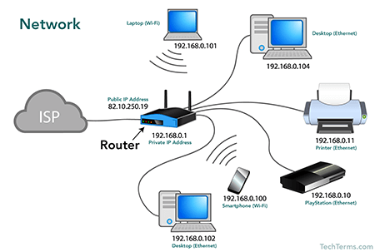
This image is from online source.

Routing
Routing is the process of determining the most efficient path for data to travel from a source to a destination across interconnected networks. It relies on routing protocols—sets of algorithms and rules designed to select optimal, reliable, and loop-free routes for data packets. Routers maintain routing tables that list potential destinations and their corresponding next hops; when a packet arrives, the router refers to this table to decide where to forward it next. Routing is generally divided into static and dynamic types. Static routing involves manually configuring fixed network paths, making it simple, secure, and predictable, though it lacks flexibility since it cannot automatically reroute traffic if a link fails. Dynamic routing, by contrast, uses protocols such as RIP, OSPF, or EIGRP to automatically learn and adapt routes based on real-time network changes, making it more suitable for large or evolving networks.
In a network setup where a Debian Server acts as a DHCP relay and a Windows Server provides network services; a hybrid routing strategy works best. Static routes can define stable paths between internal subnets, while dynamic routing protocols like OSPF can manage routes between routers and external networks, ensuring efficient IP address allocation, automatic route updates, and reliable inter-server communication. [5]

Network Services
Modern network services such as Virtual Private Networks (VPNs), Dynamic Host Configuration Protocol (DHCP), Active Directory Domain Services (AD DS), and Certificate Authorities (CAs) are essential for maintaining secure, efficient, and centralized network operations. A VPN creates an encrypted tunnel between remote users and private networks, protecting data transmitted over public connections through protocols like IPsec or SSL/TLS, and enhancing security with strong encryption (such as AES-256) and multi-factor authentication. DHCP streamlines IP address management by automatically assigning and leasing addresses to devices, minimizing configuration errors and administrative workload; reliability can be further improved with DHCP reservations and redundant servers. AD DS, Microsoft’s directory service, centralizes authentication, authorization, and policy enforcement within a domain, providing single sign-on (SSO) and consistent security through Group Policy. Maintaining multiple domain controllers and auditing permissions regularly are key best practices for AD environments. Meanwhile, Certificate Authorities (CAs) manage digital certificates within a Public Key Infrastructure (PKI), verifying the identity of users and devices to secure communications. Proper certificate lifecycle management—including renewal, revocation, and secure key storage—is vital for sustaining encryption trust. Collectively, these technologies enable organizations to build networks that are secure, scalable, and well-coordinated. [6]

Task 2

2.1

VirtualBox
Based on the research and the given topology, VirtualBox (a Type 2 hypervisor) is the most practical choice for building this network. It supports both Windows Server 2022 and Debian seamlessly, which is essential for the SWANSEA.ACCA domain environment. VirtualBox requires no dedicated hardware, making it ideal for a lab setup with limited resources, while still offering reliable networking features such as internal networks, NAT, and host-only adapters. Its ease of installation, wide OS compatibility, and flexibility allow the Windows and Debian servers, along with their clients, to run efficiently and interact exactly as required in the topology.
I downloaded VirtualBox (my chosen Type 2 hypervisor) directly from the official Oracle VirtualBox website, ensuring the software came from a trusted and secure source, and I choose Windows host as VirtualBox Platform Package.
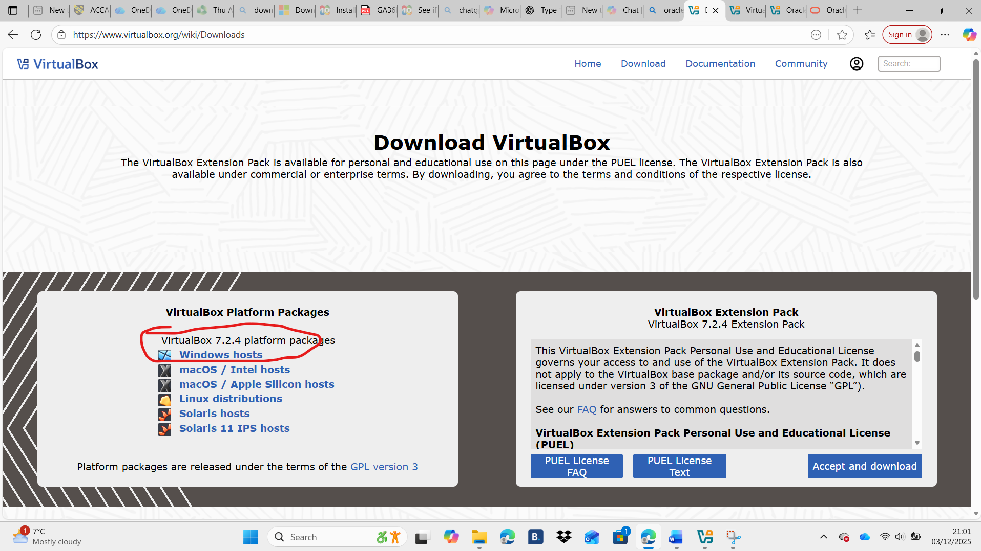

This is the image of the VirtualBox with no VM.
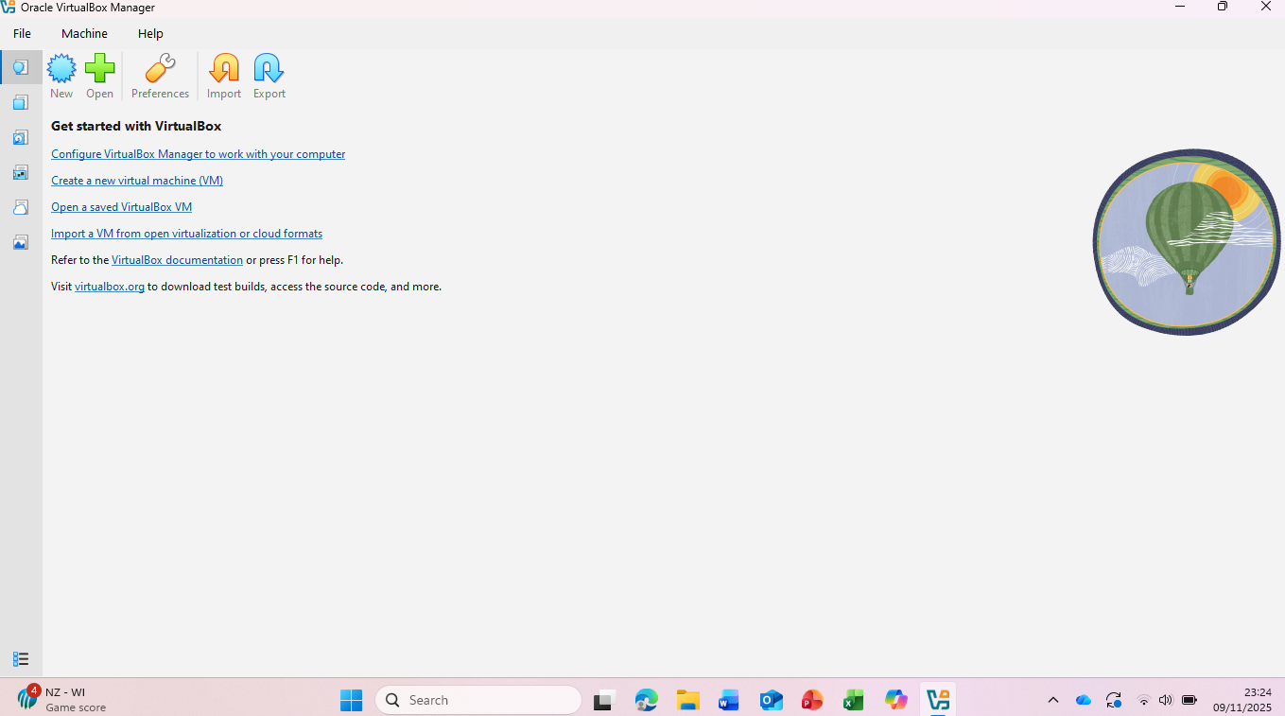

2.2

Windows Server download and network setting
I downloaded Windows 19 for the Windows Server, from the official page of Microsoft Evaluation Center, and I choose ISO file.
This is how I started the installation and set up of the Windows Server:
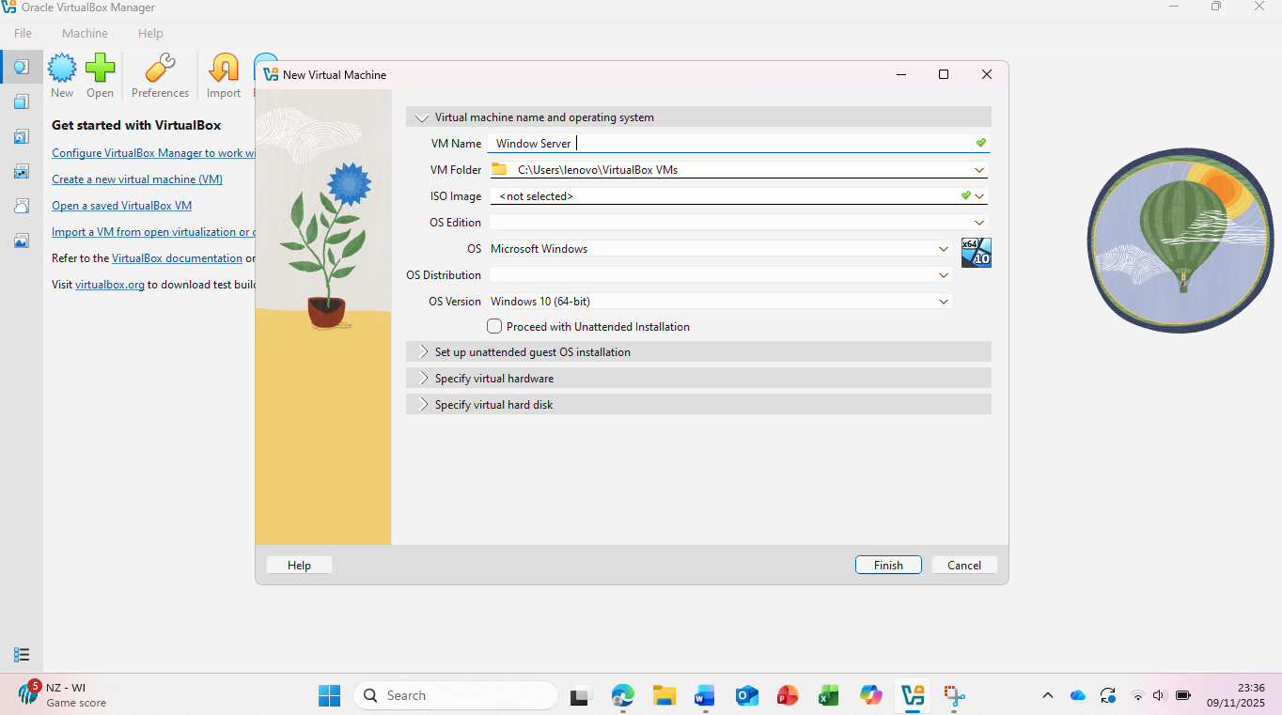

In OS version I choose (Windows Server 64 bit)
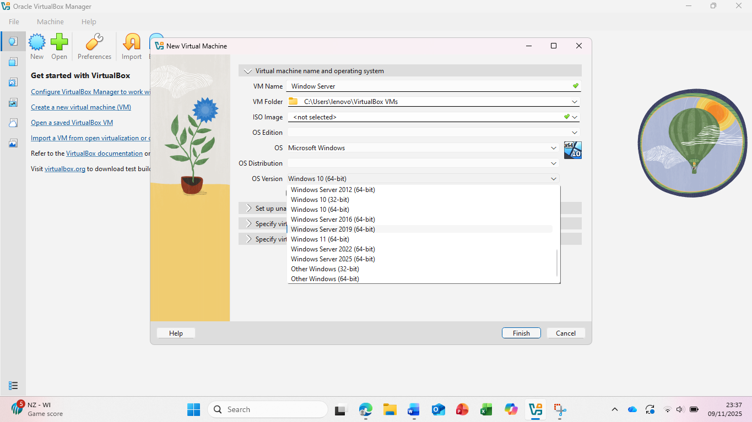
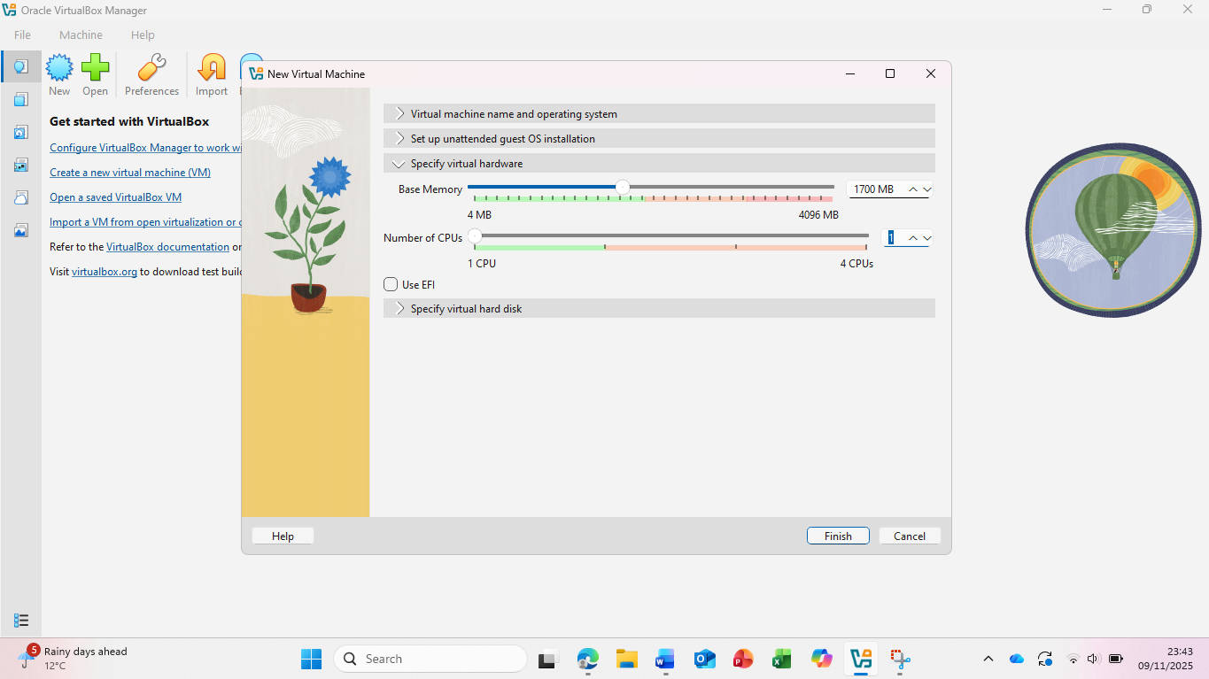
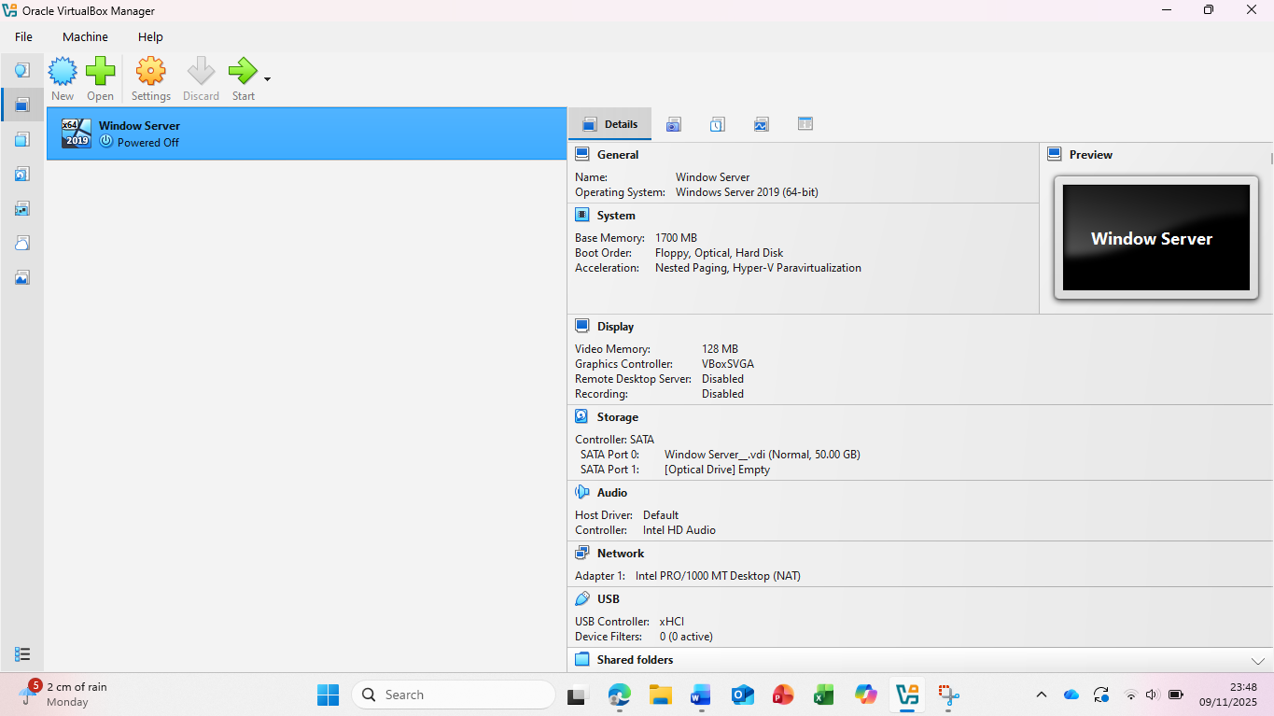

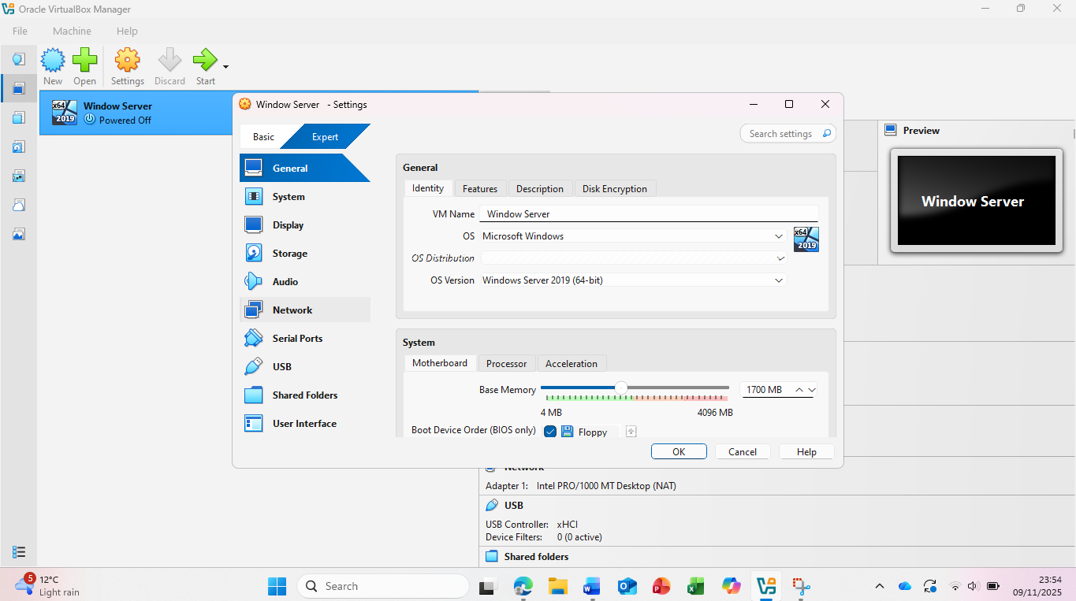

I configured Adapter 1 to use the Internal Network and set Adapter 2 to Bridged Network, allowing the virtual machine to communicate both internally and with the external network.
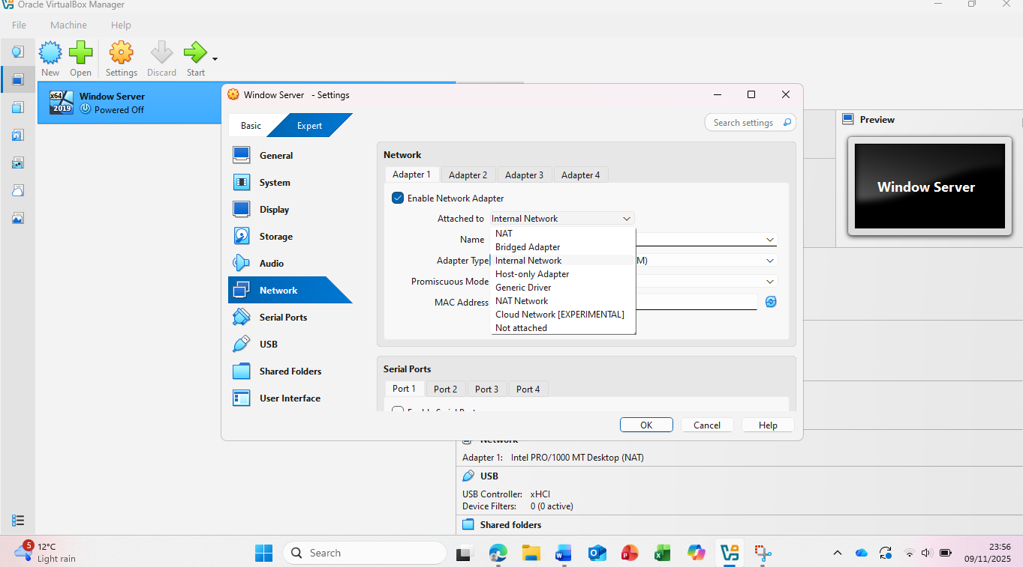

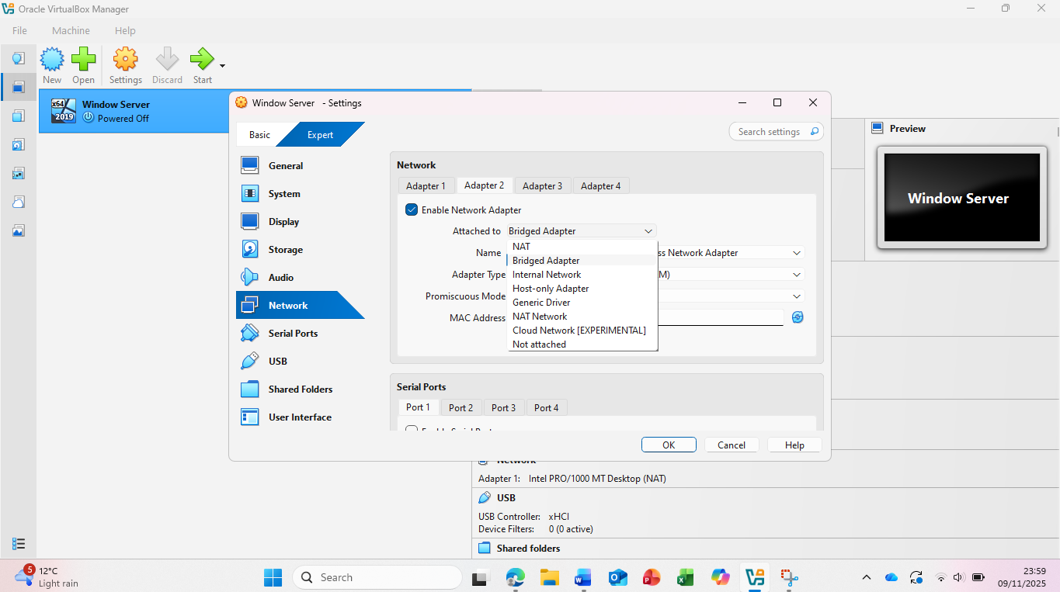

To upload the Windows Server 2019 ISO file, I selected Storage, clicked Empty, and then chose the ISO file to upload.
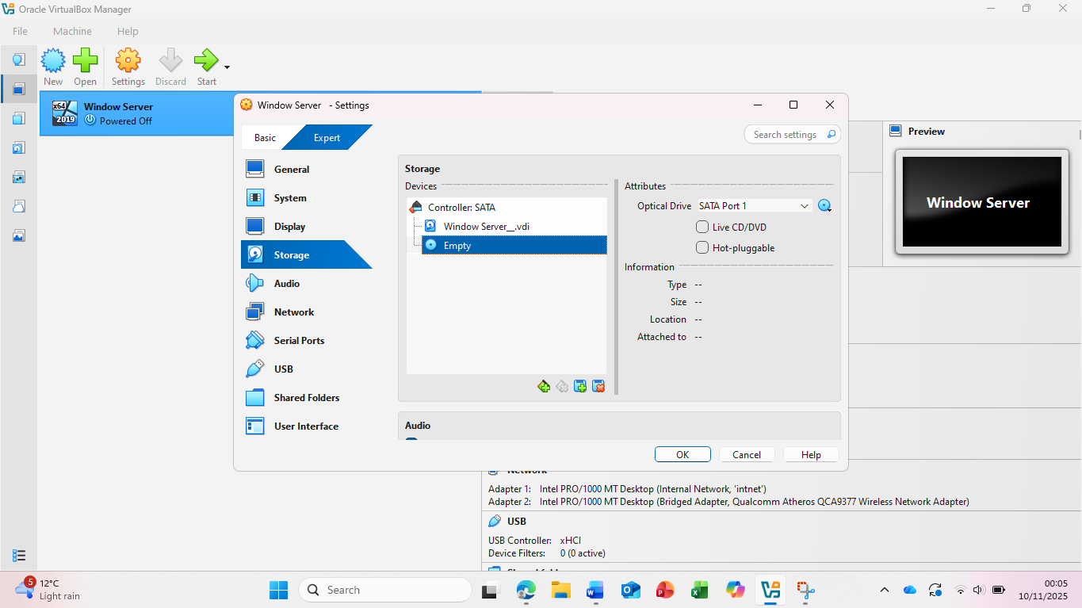
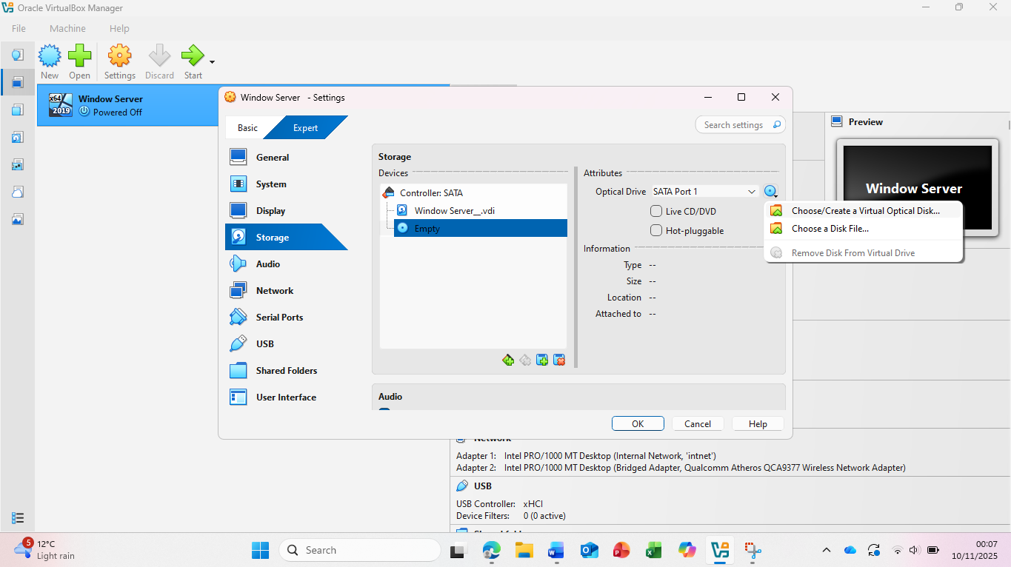
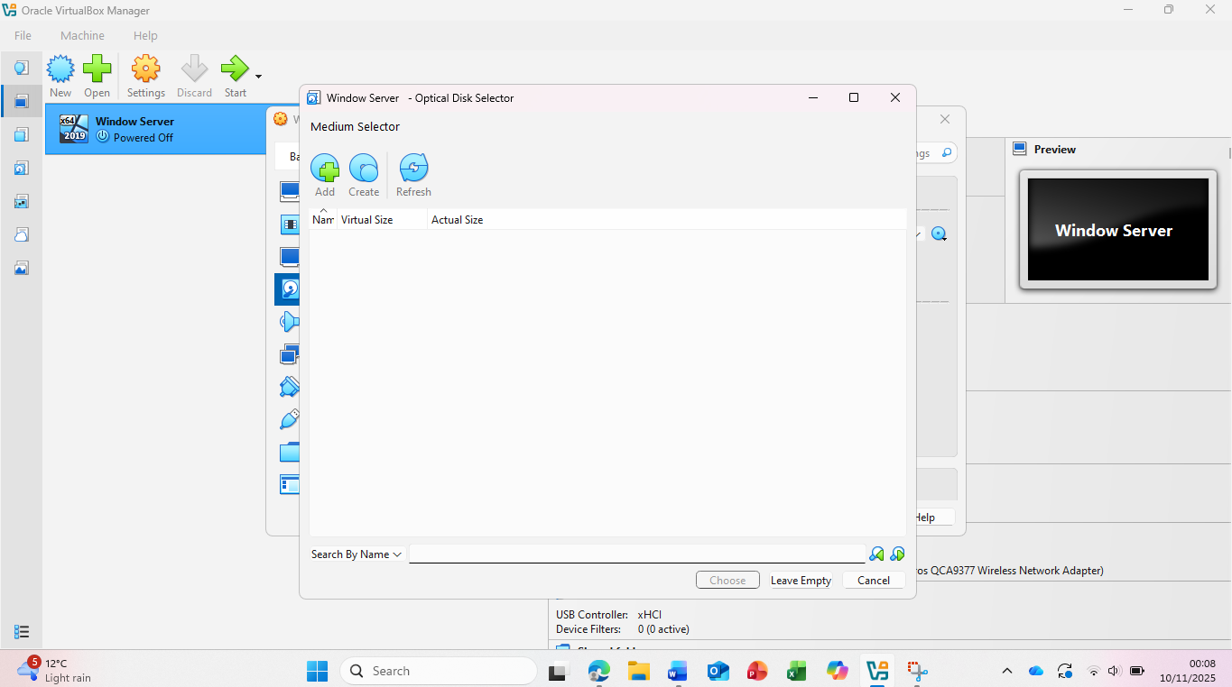

I started with the installation:
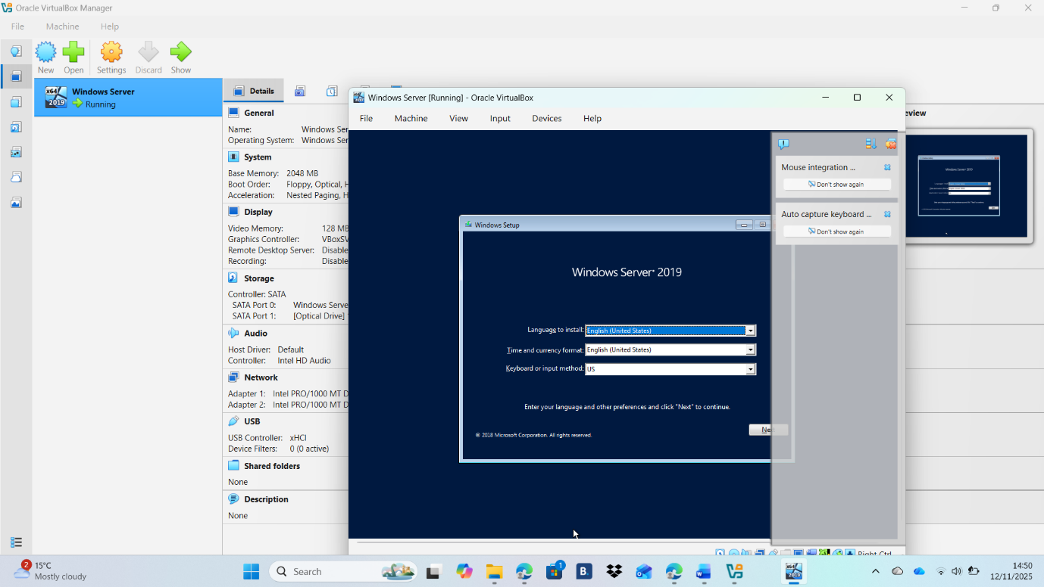

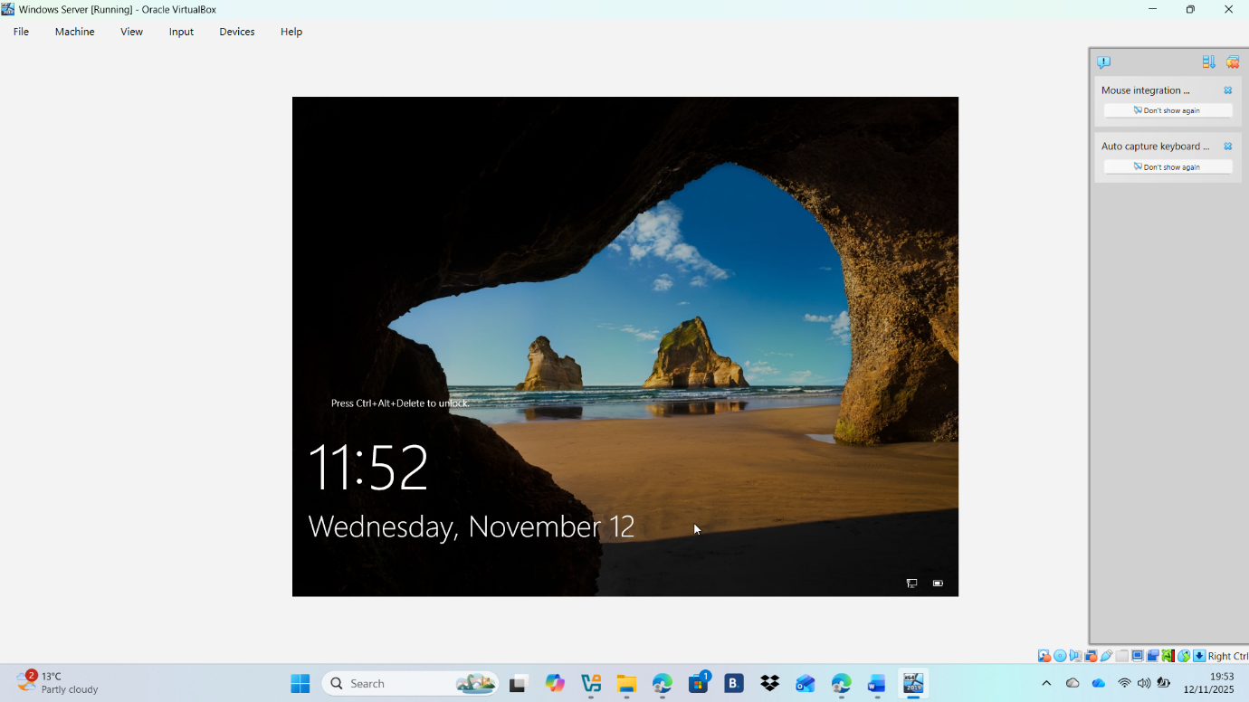

Windows Client downloads and network setting

I downloaded Windows 10, from the official page of Microsoft Software Downloads and convert it in ISO file:
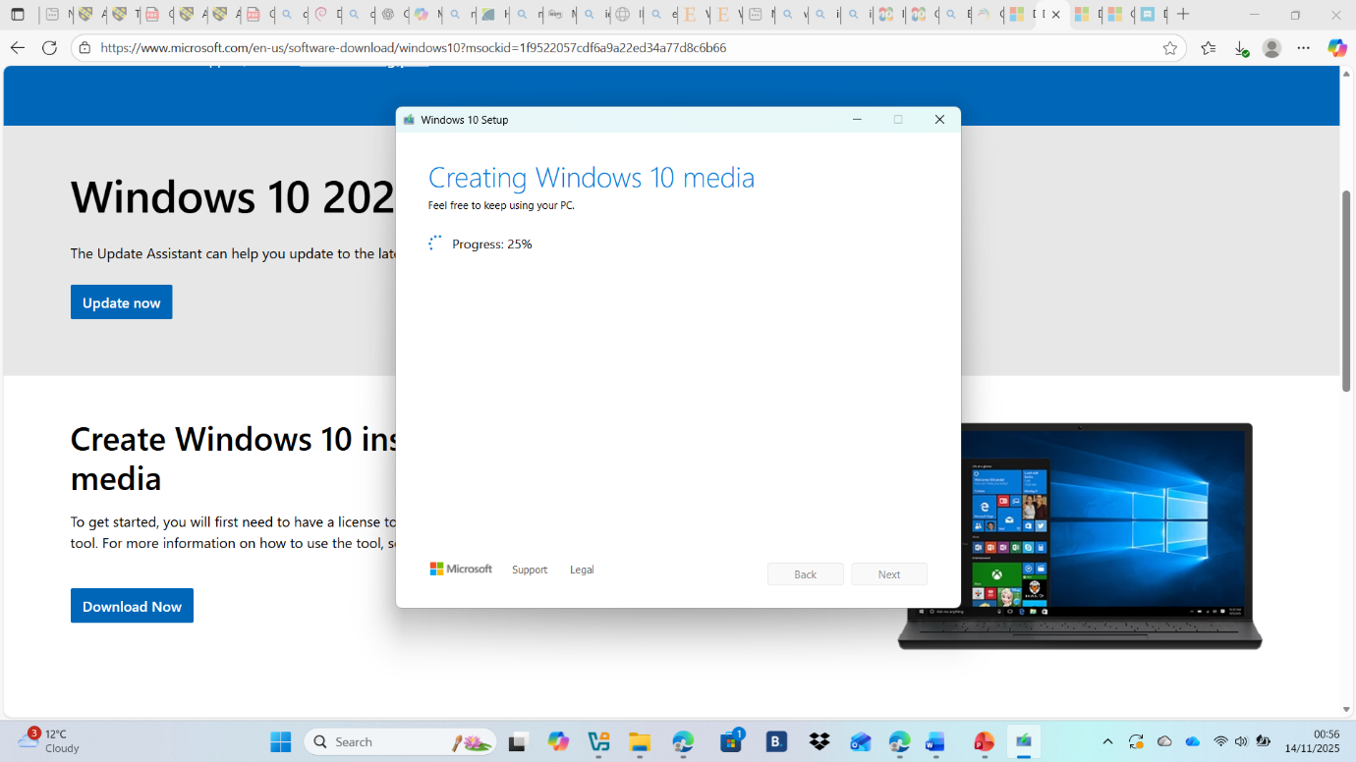

I started the installation process:
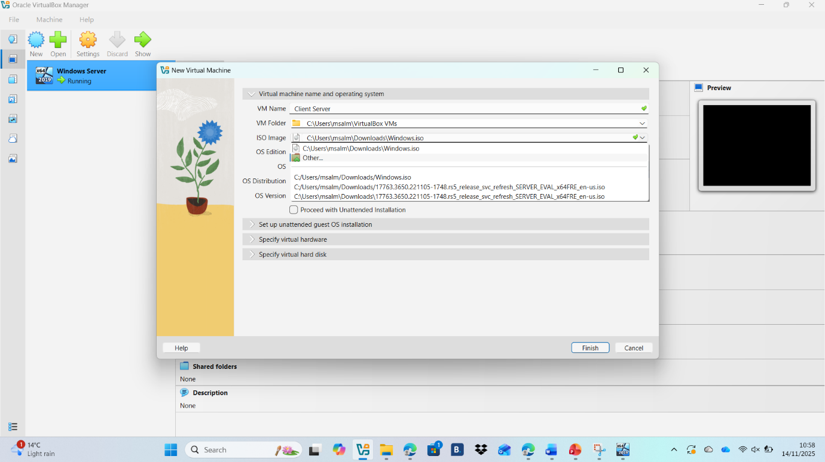
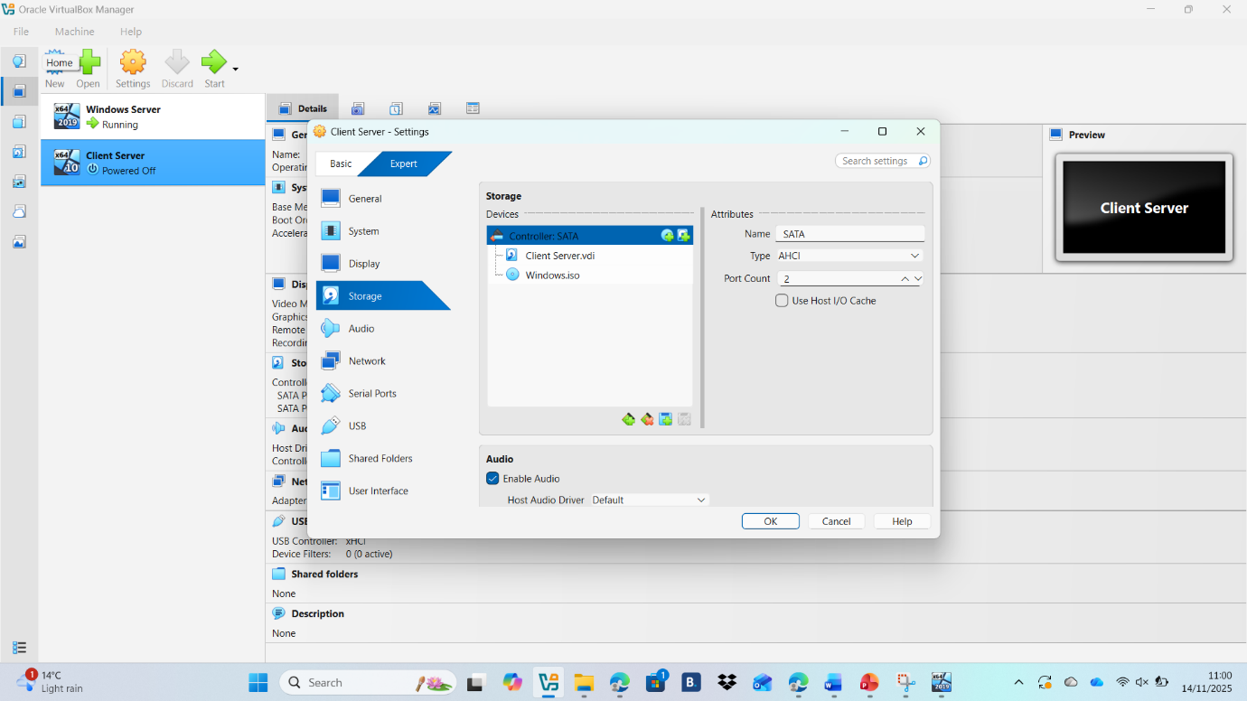

I configured Adapter 1 to use the Internal Network and set Adapter 2 to Bridged Network, allowing the virtual machine to communicate both internally and with the external network same as like Windows Server.
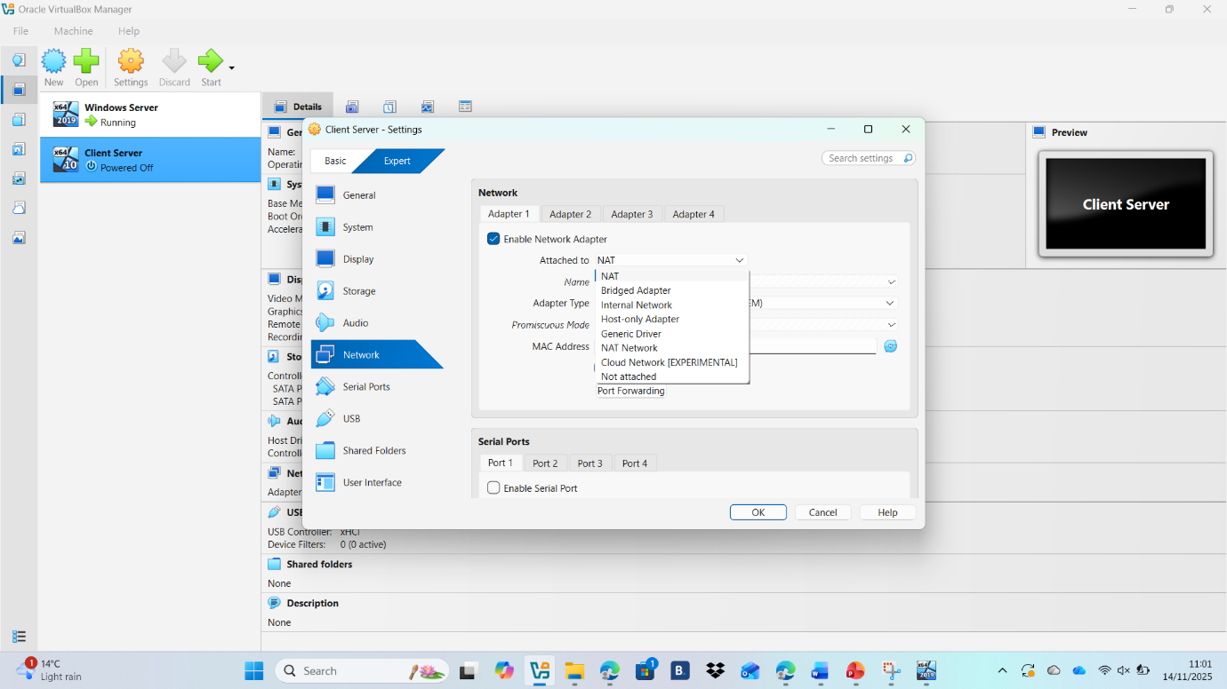
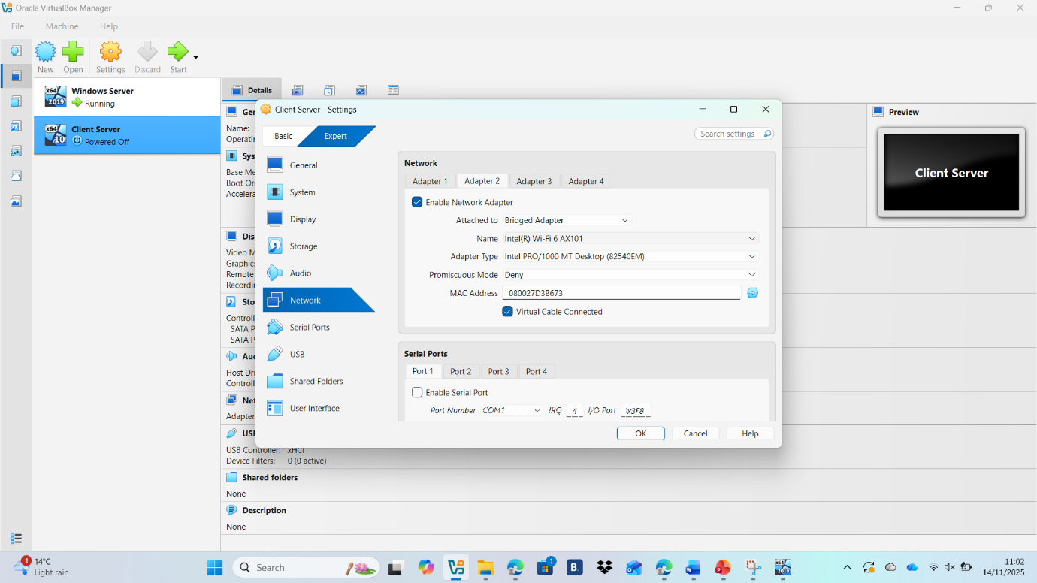

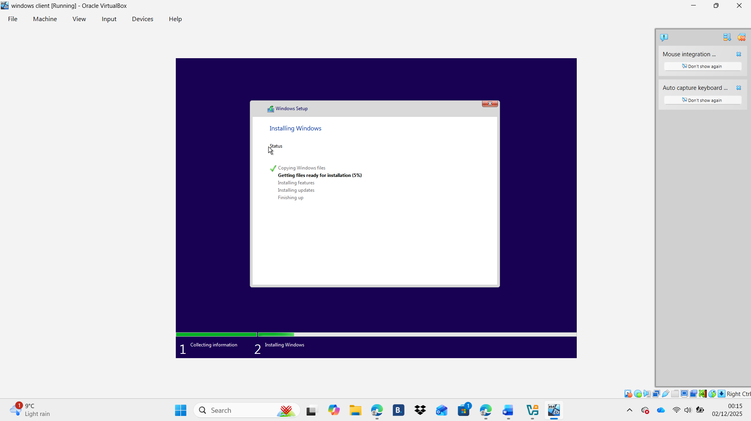
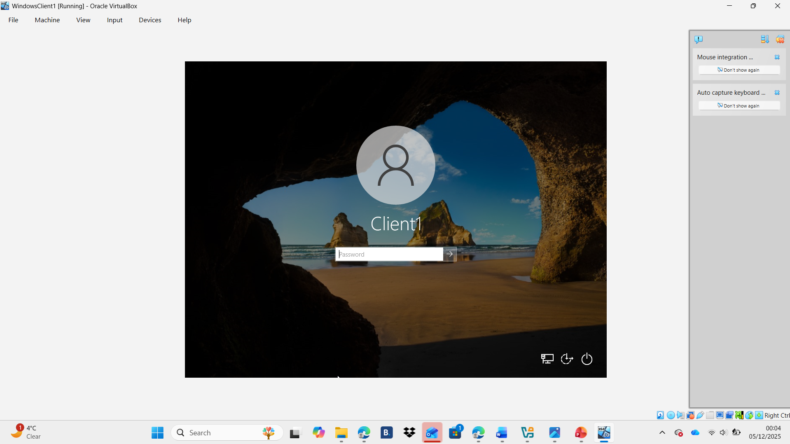

Debian Server download and network setting
I downloaded Debian 13 from debian.org and started with the setup:
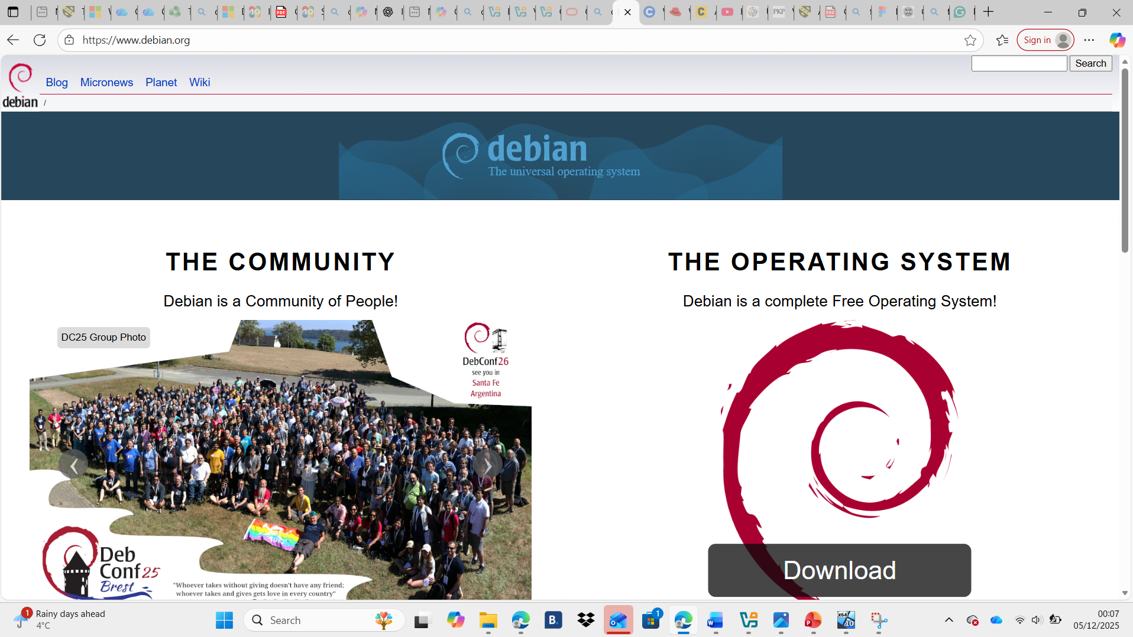

I started with the setup:
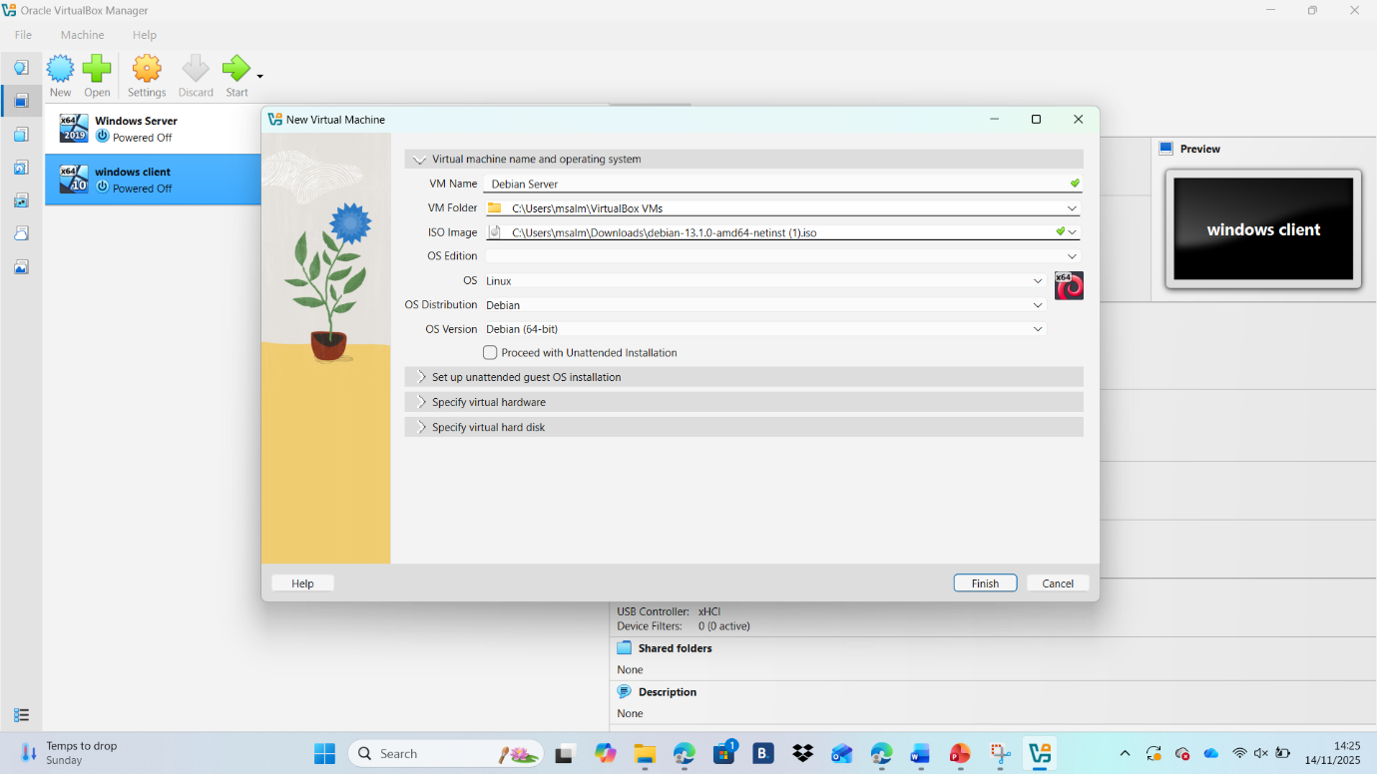

I set up the network same as I did with the Windows Server and Client:
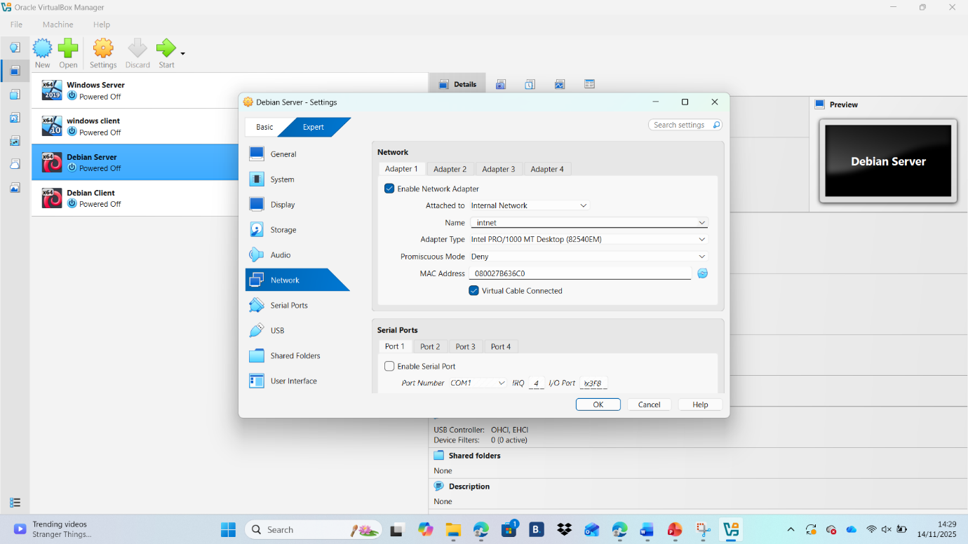
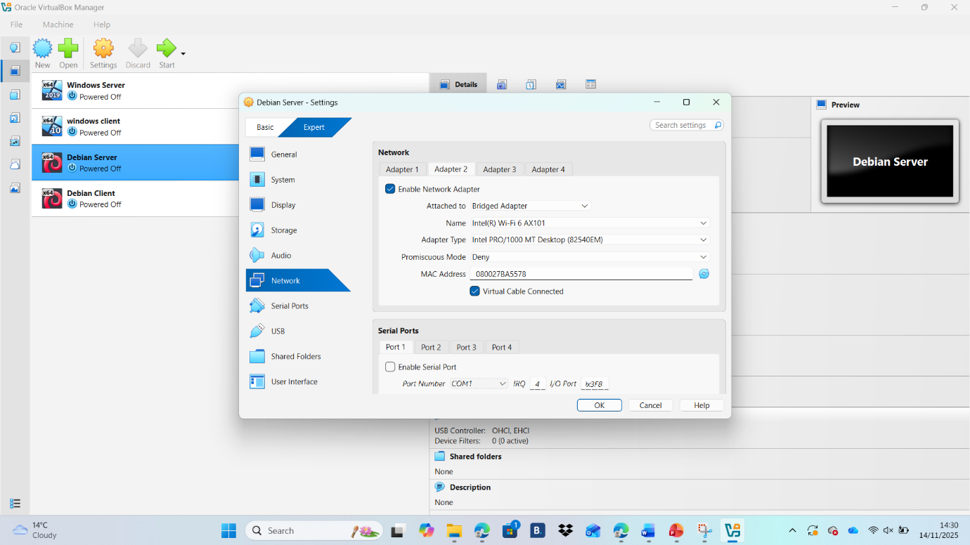

Then I started with the installation:
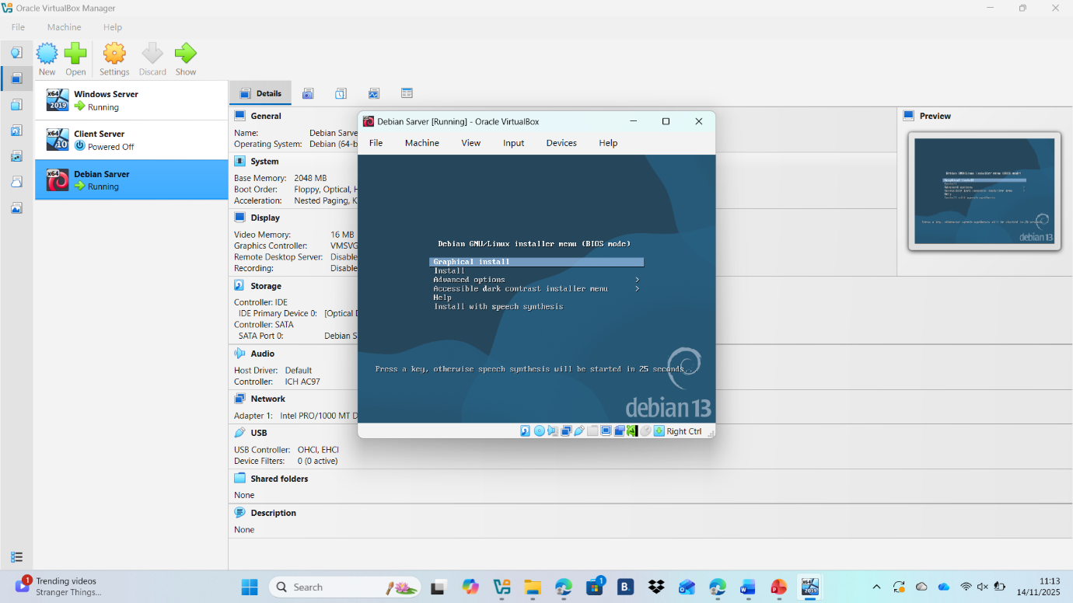
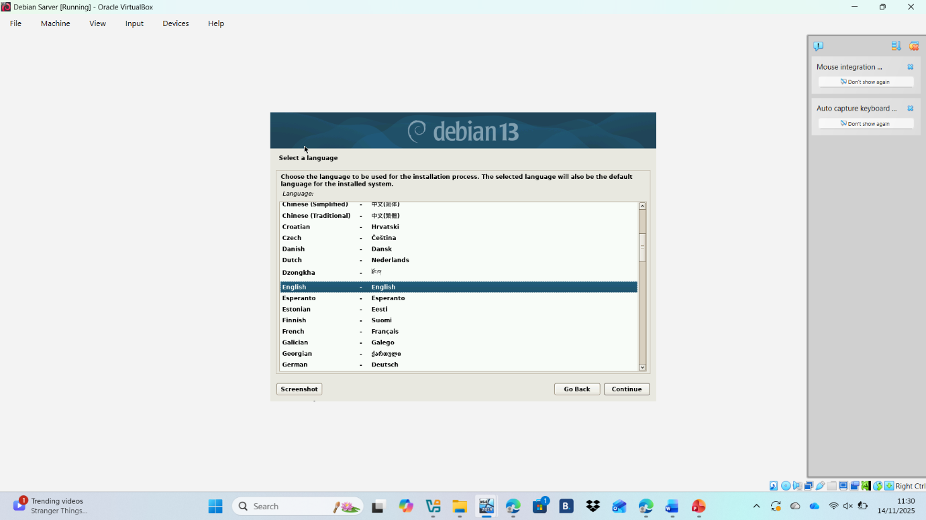
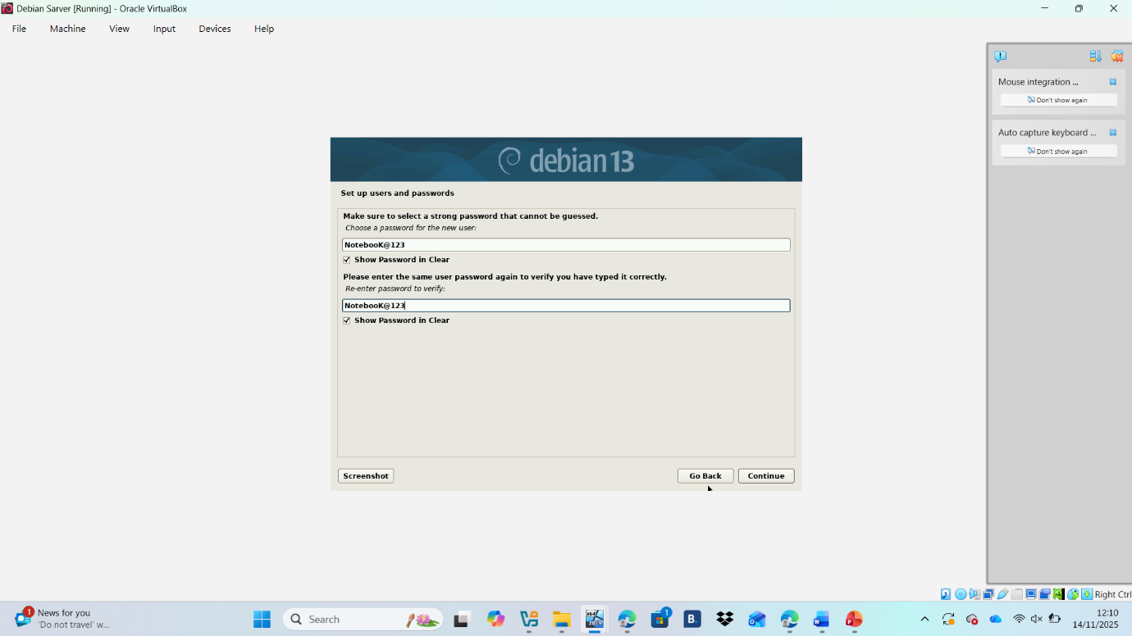

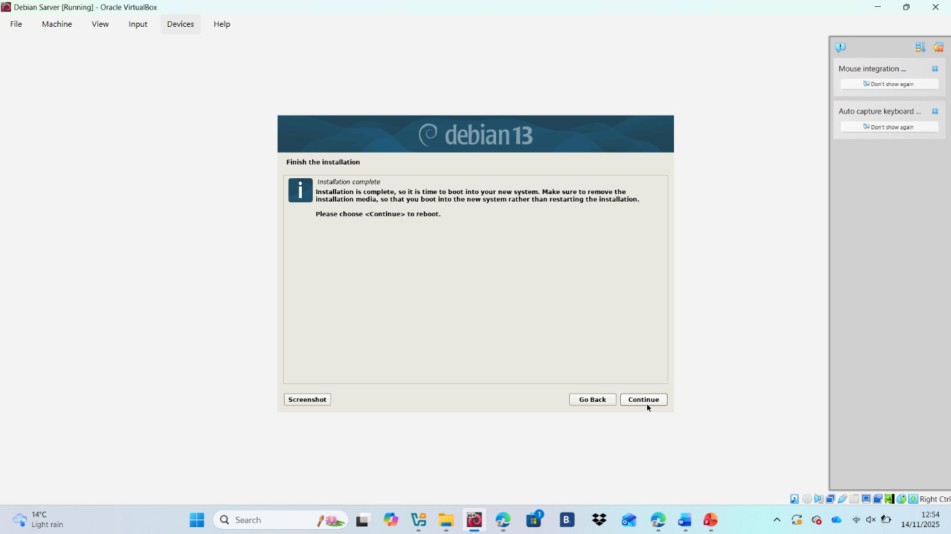
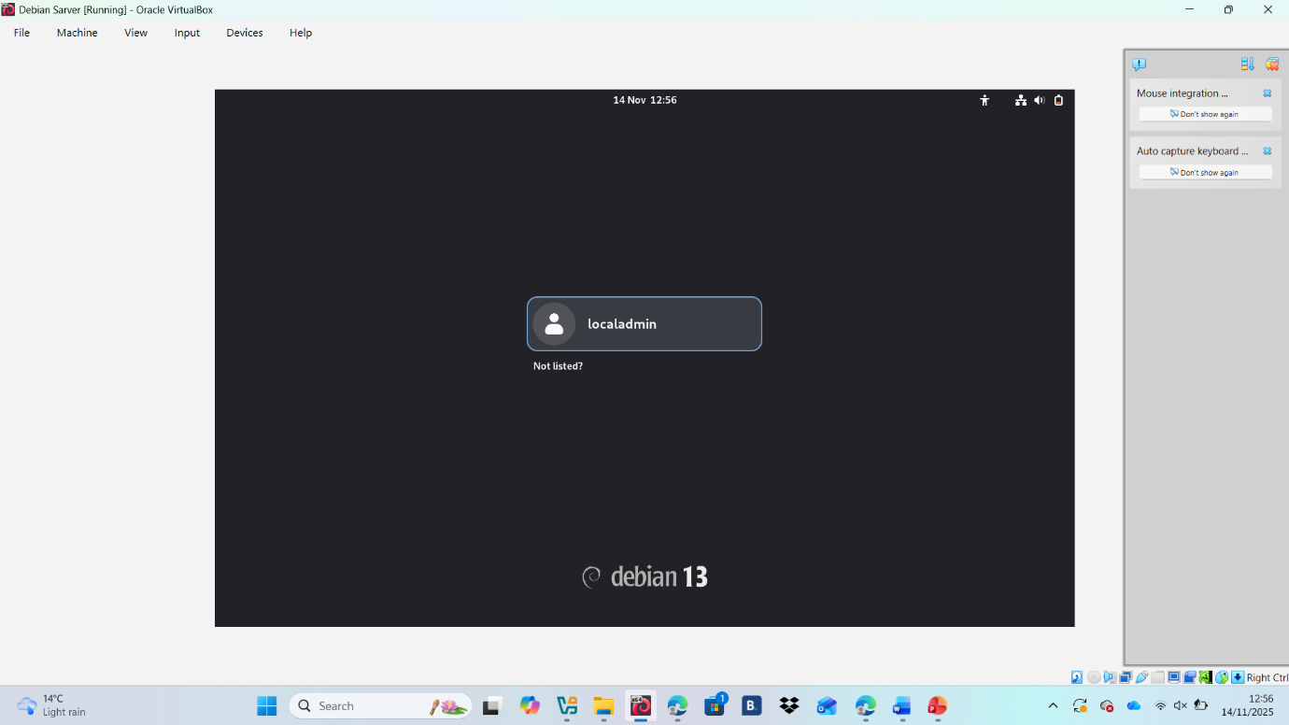
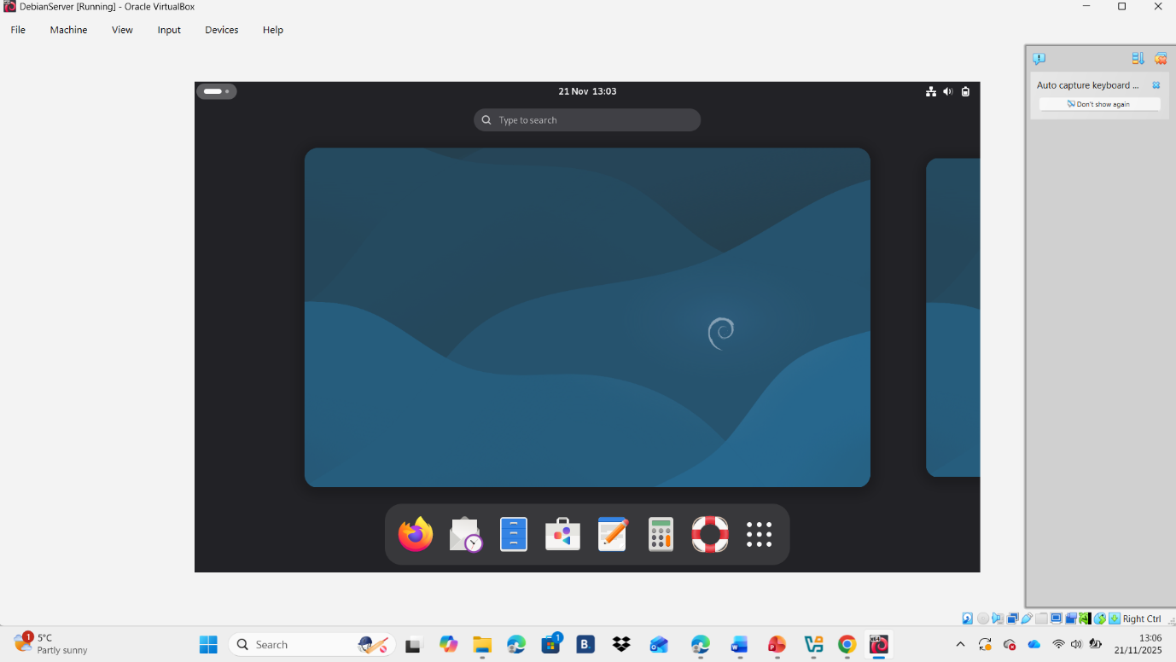

Debian Client download and network setting
I did the same thing for the Debian client. First, I downloaded Debian 13 (the same version I used for the Debian server) and then proceeded with the setup and installation.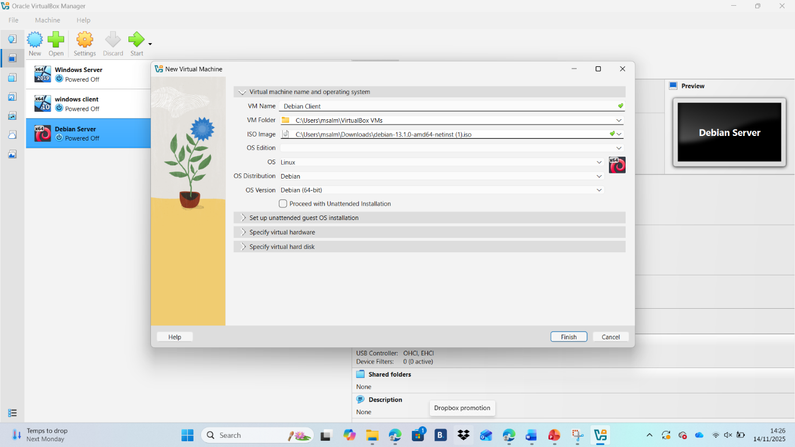

For network setting I did the same process for all VM.
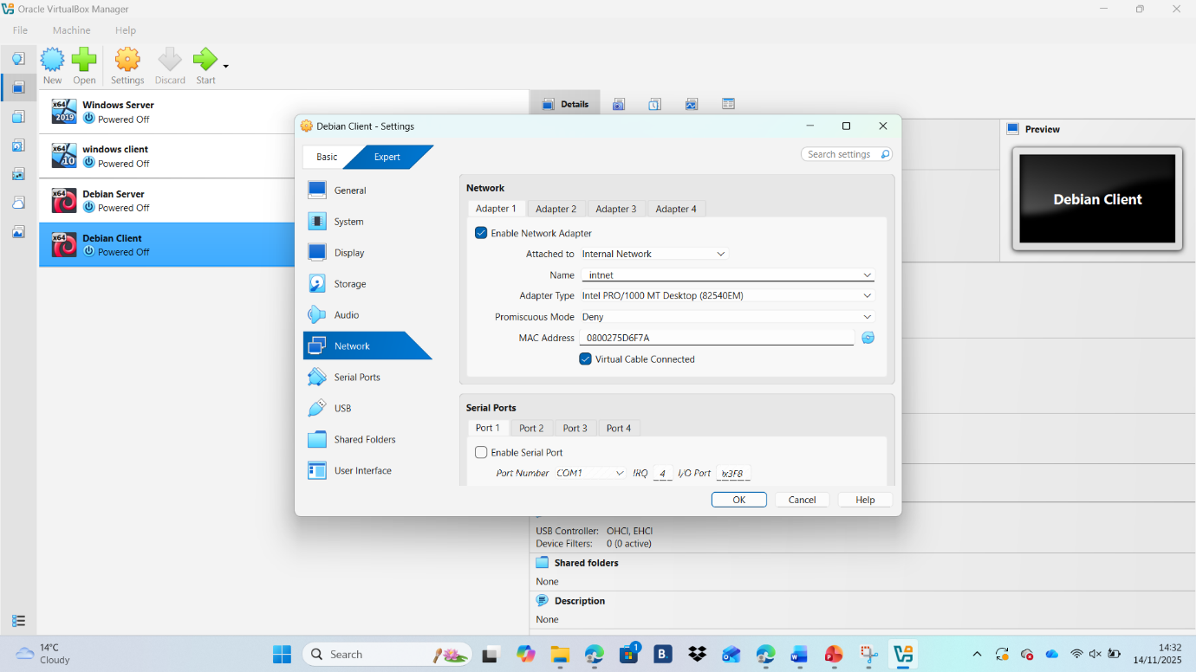
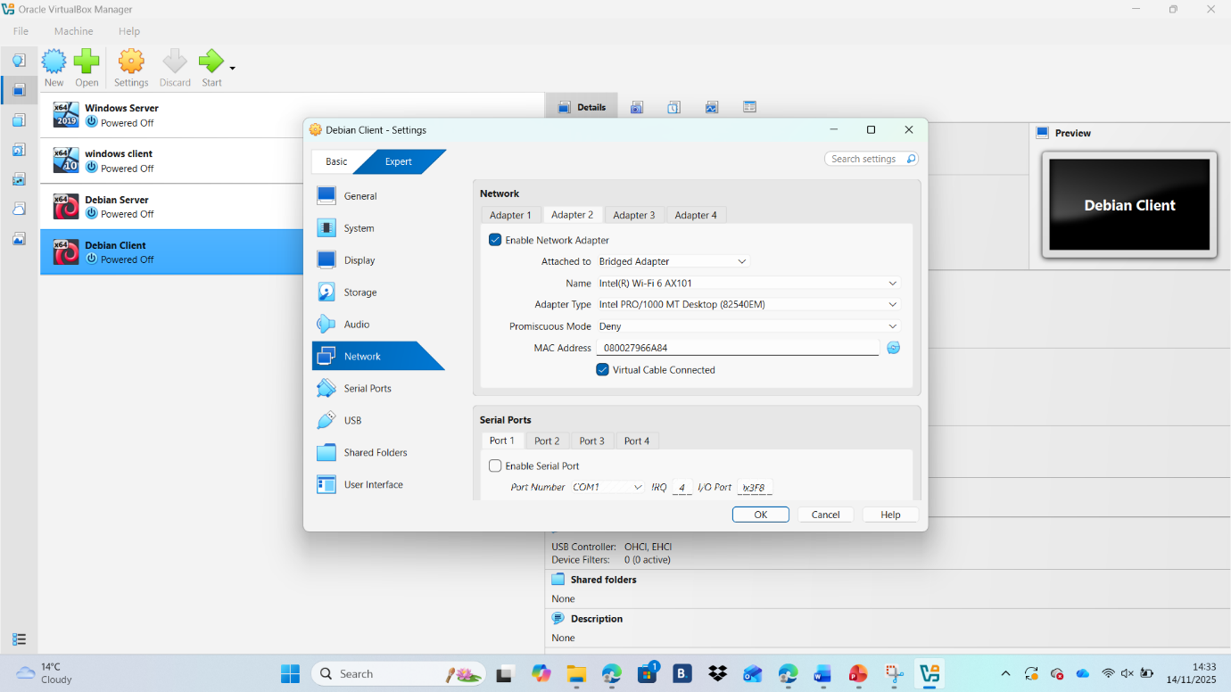

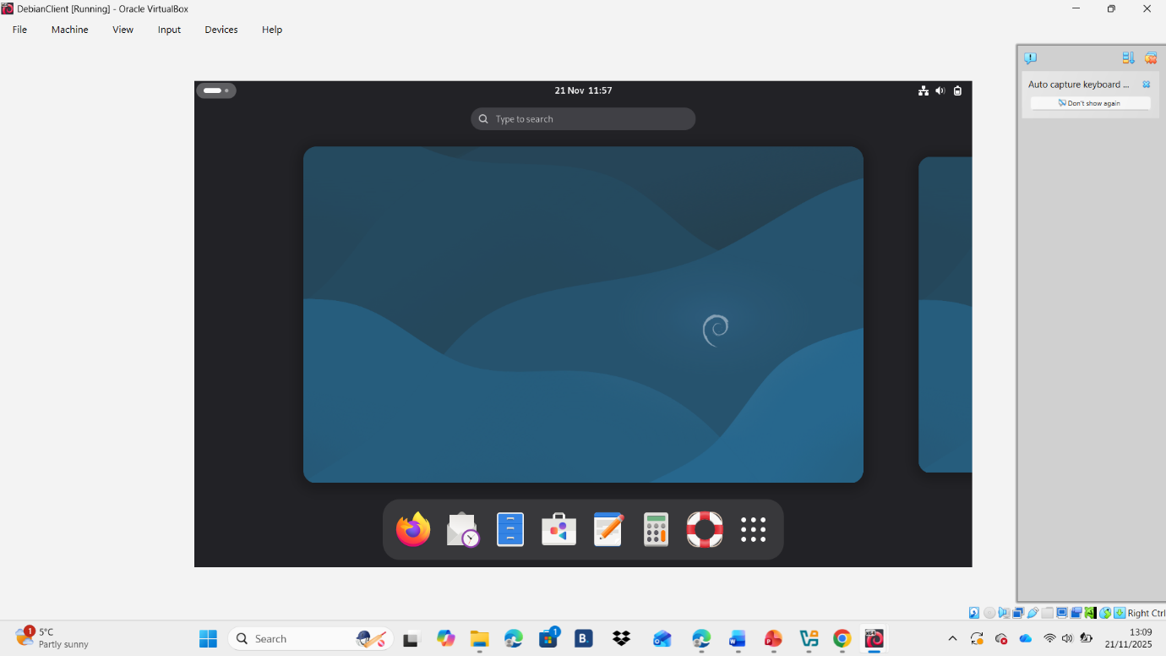

This is the final image of my VirtualBox with all my Virtual Machine (Windows Server, Windows Client, Debian Server and Debian Client) installed:
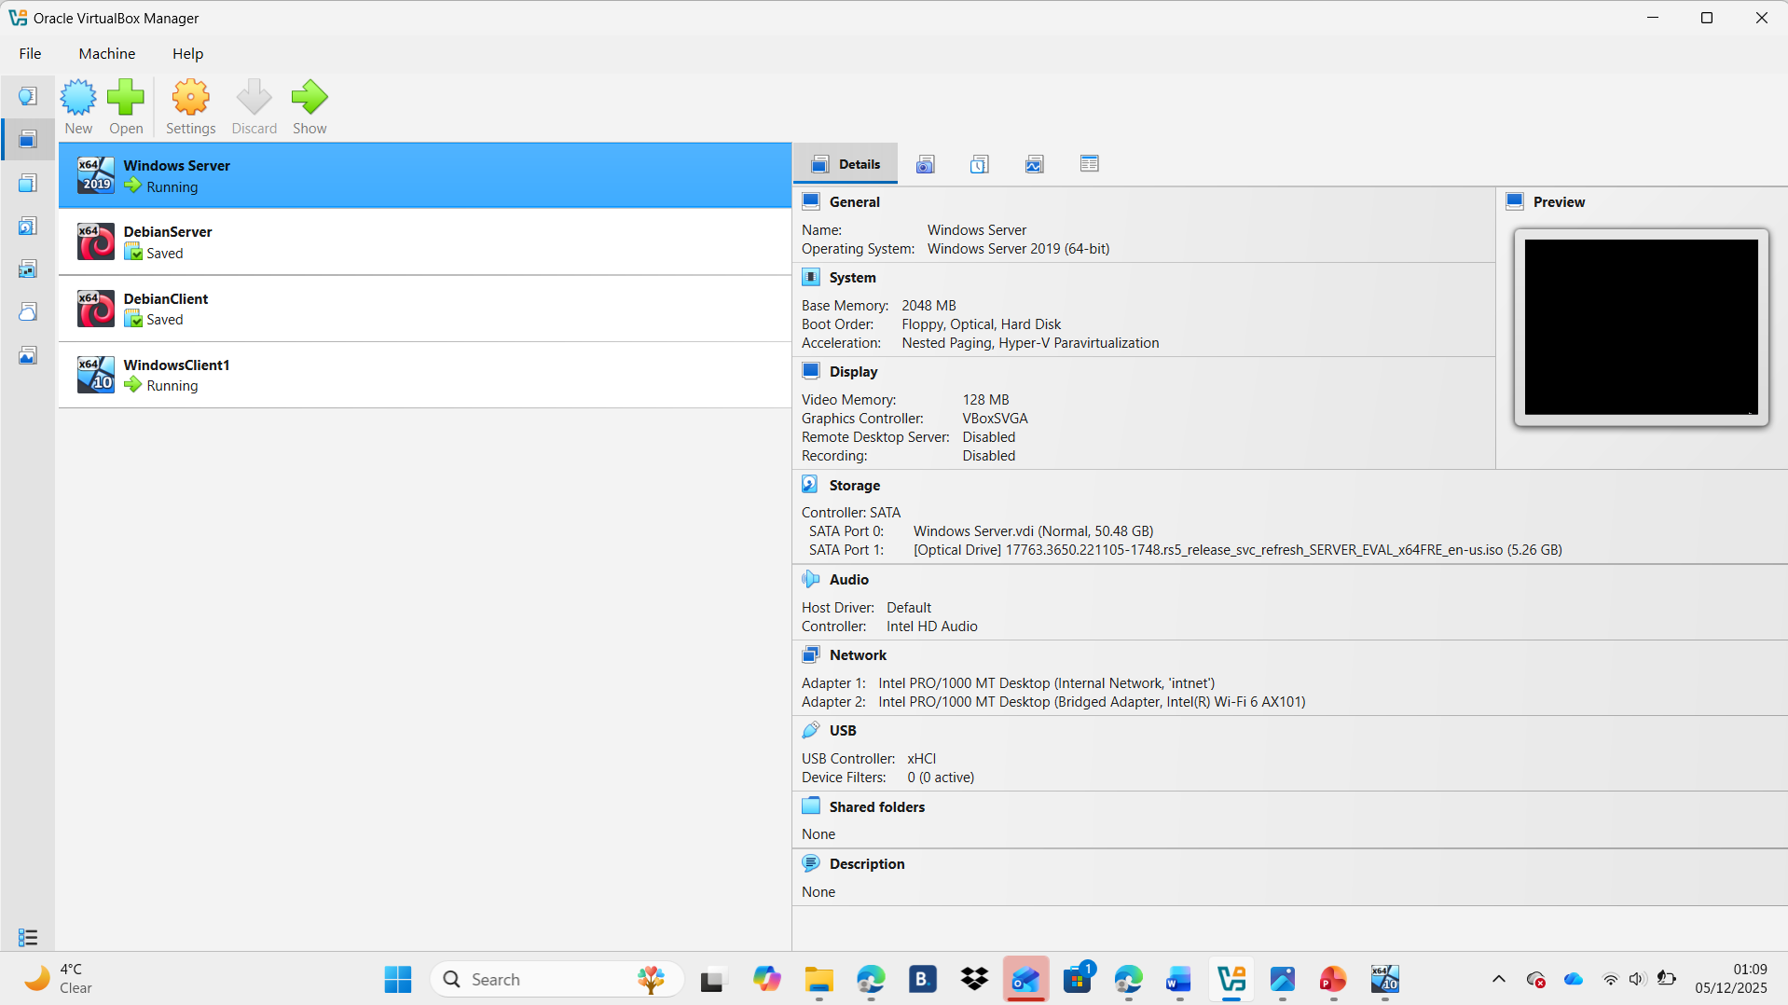

2.3

IP Configuration

Windows Server
I configured my Window Server with the IP address 192.168.1.1
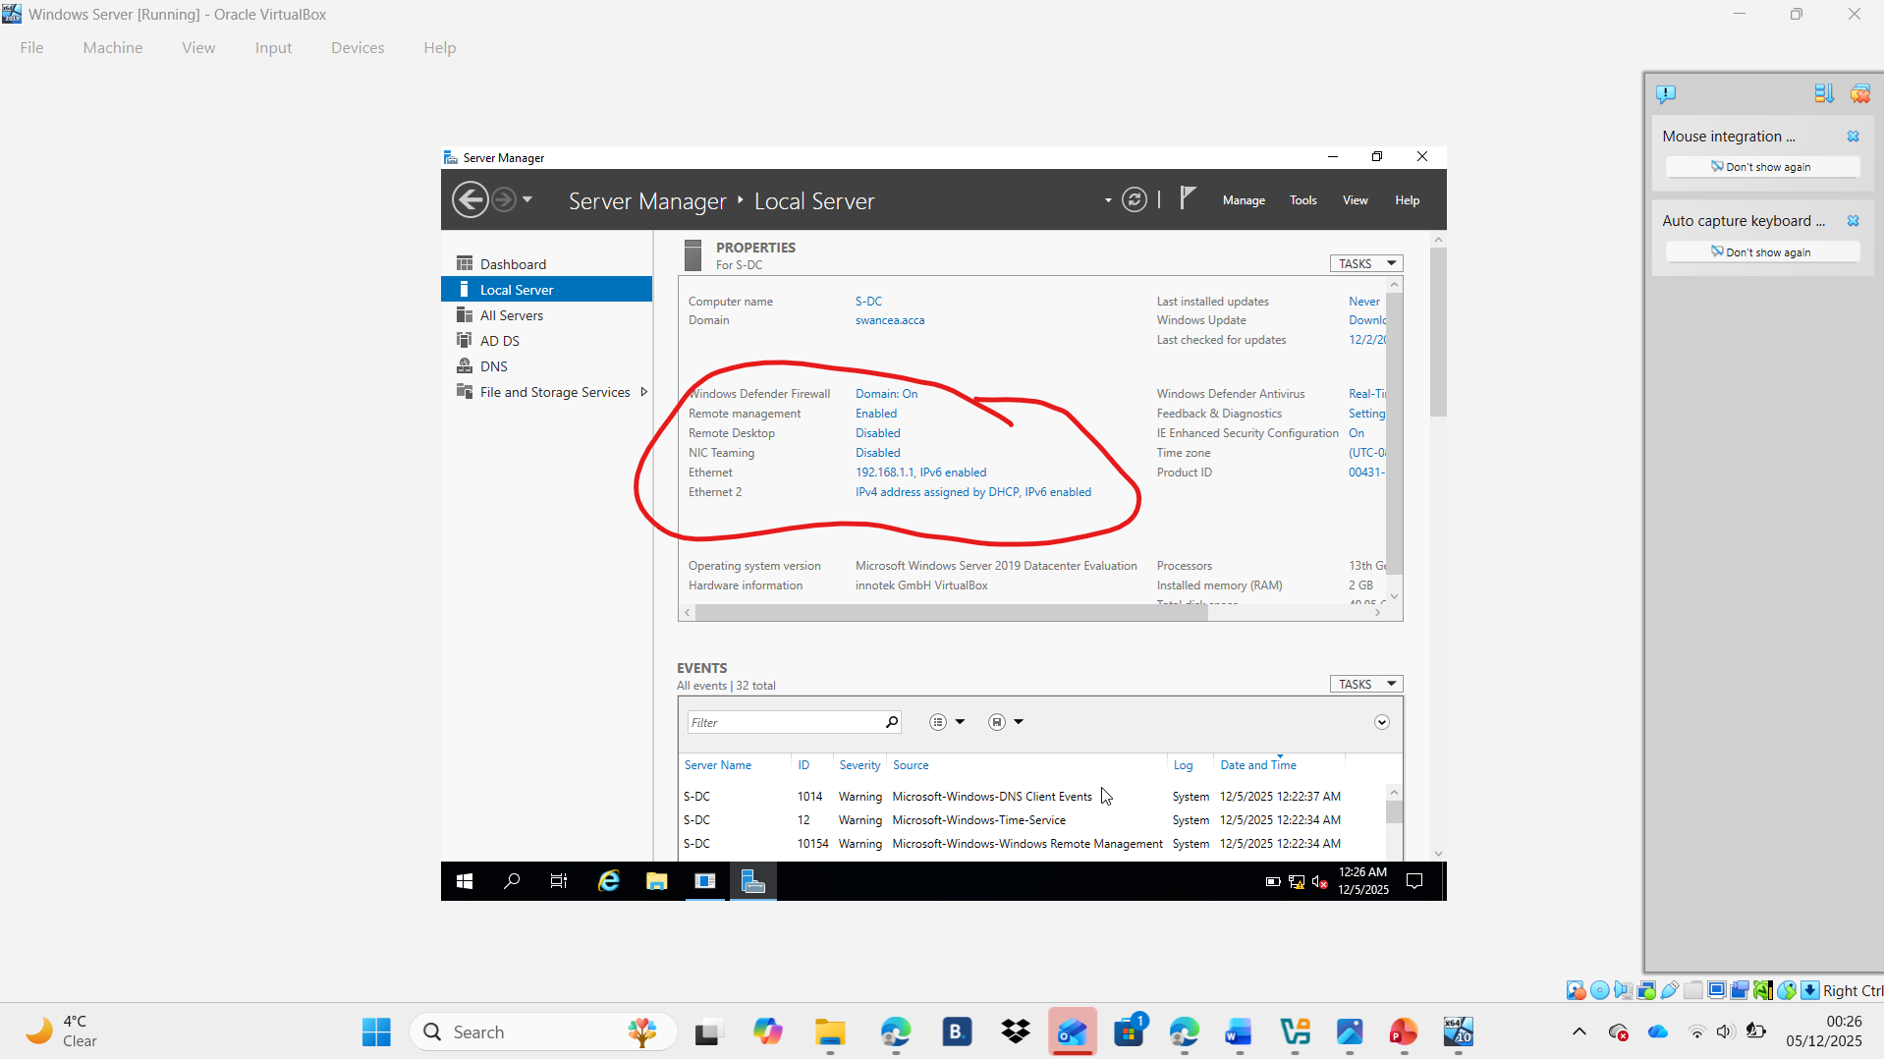

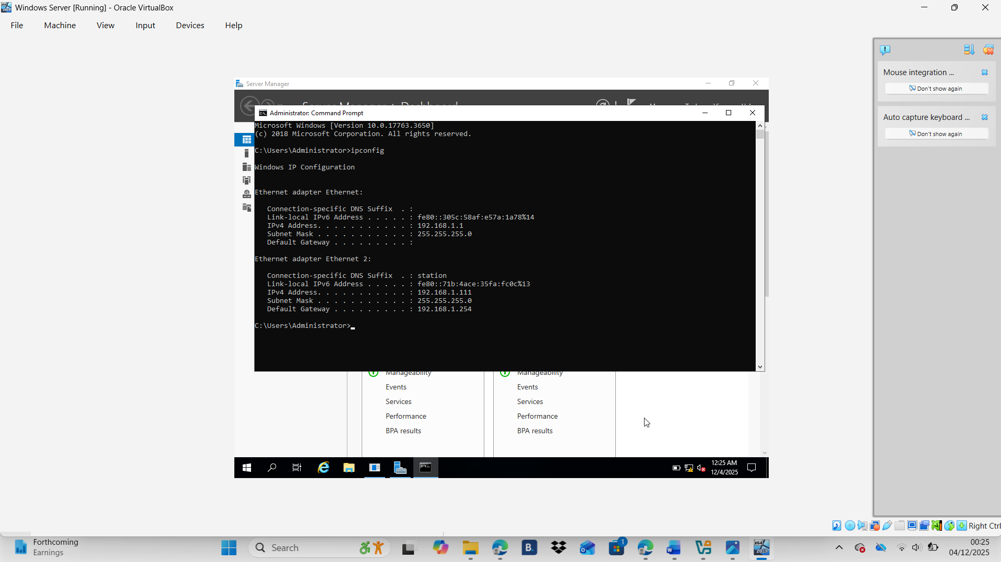

Windows Client
The fooling screenshot are the process of IP configuration for my Windows Client and the IP address that I assigned is 192.168.1.10:

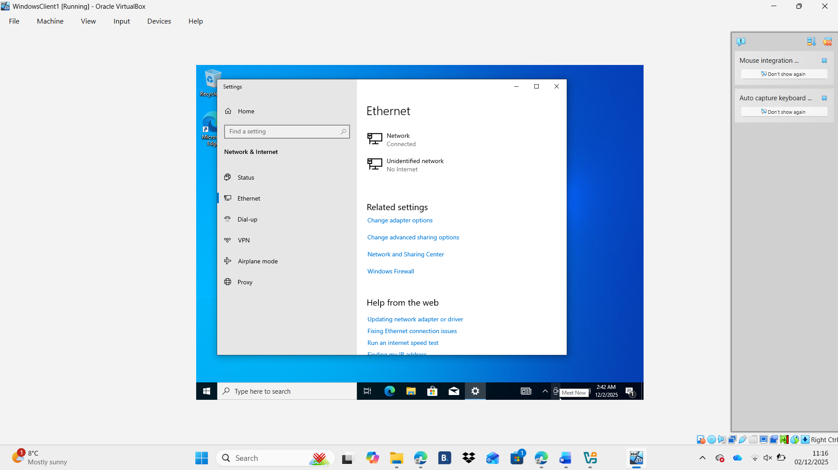
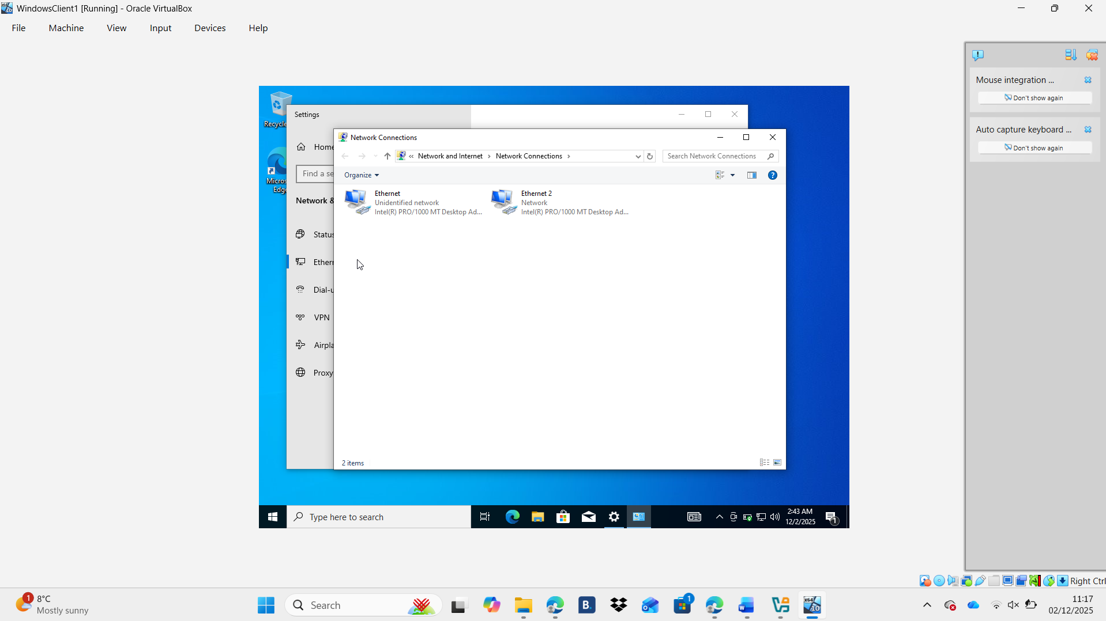
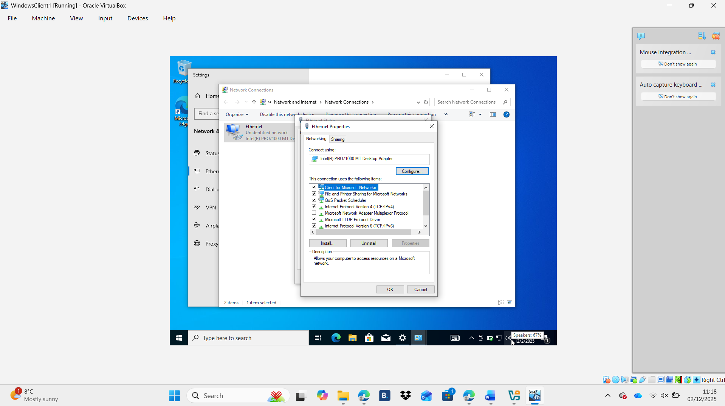
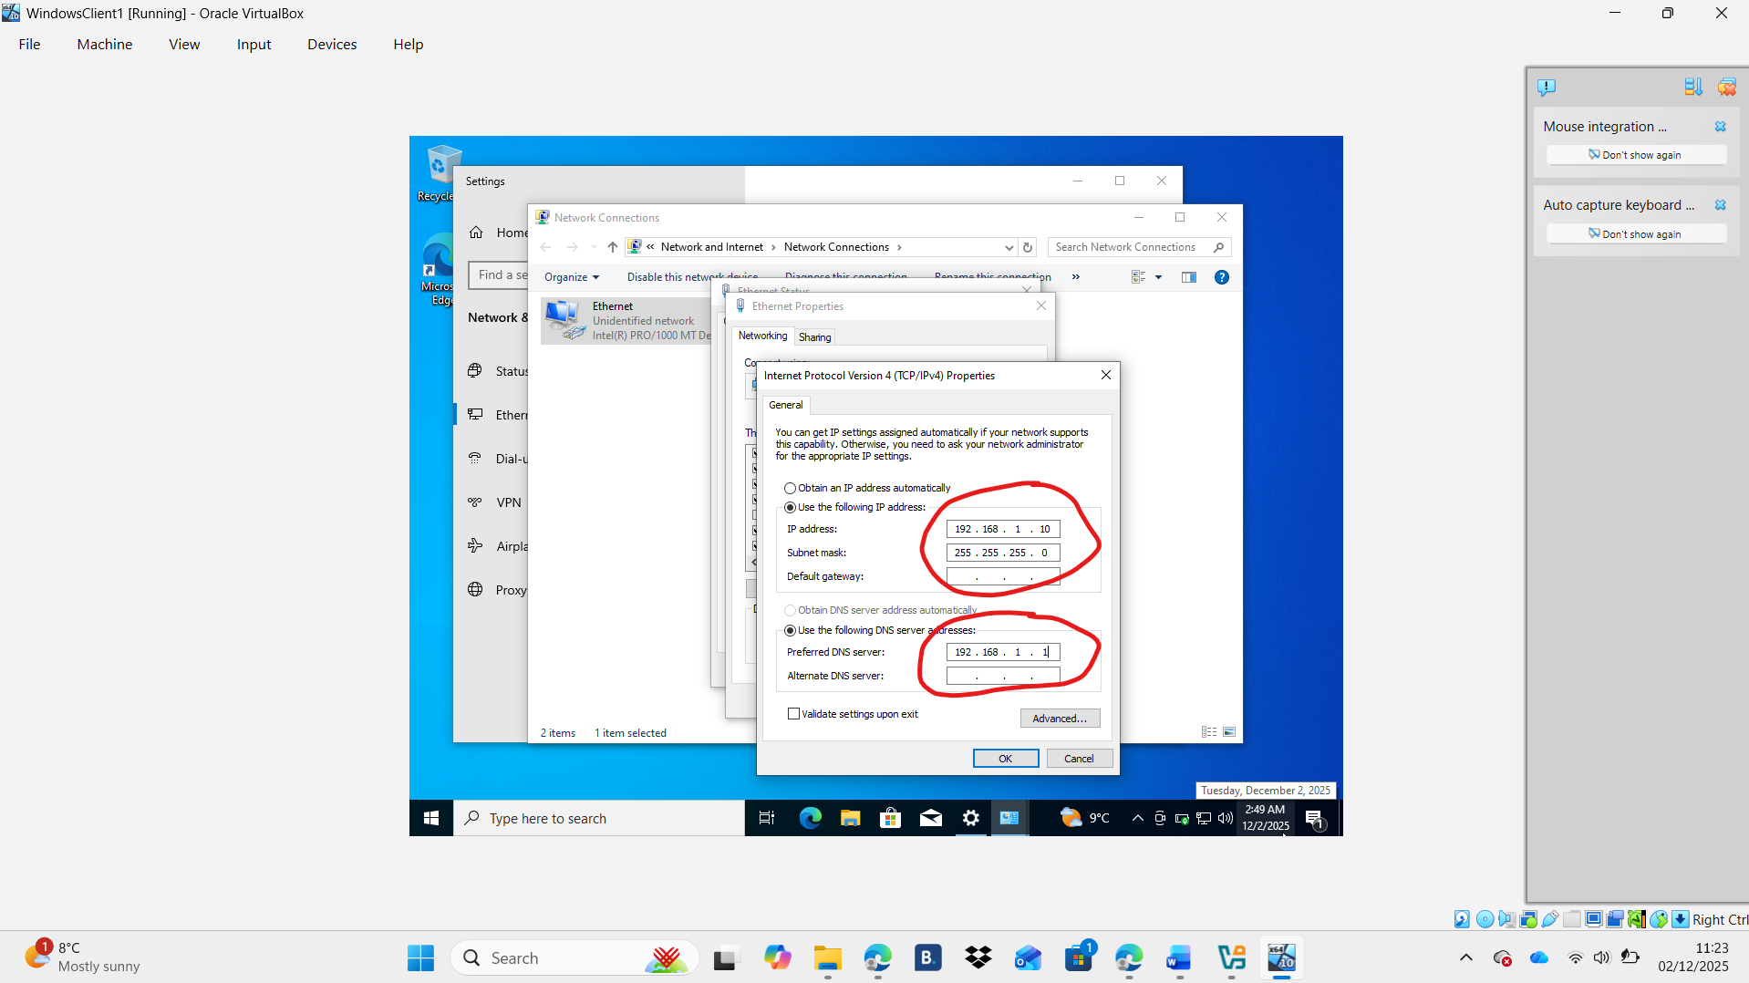

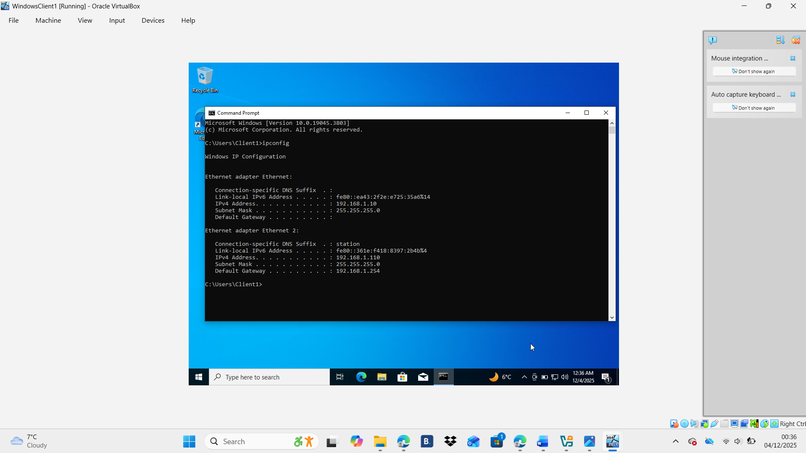

Firewall setting
A firewall is a security system designed to monitor, filter, and control incoming and outgoing network traffic based on predefined rules. Its main purpose is to protect networks and devices from unauthorized access, cyberattacks, and harmful data. Firewalls act as a barrier between a trusted internal network and untrusted external networks, such as the Internet. They can be hardware-based, software-based, or built into operating systems. By examining data packets, firewalls decide whether to allow or block traffic depending on security policies. This helps prevent malware, intrusion attempts, and unauthorized communication, ensuring safer and more controlled network operations.
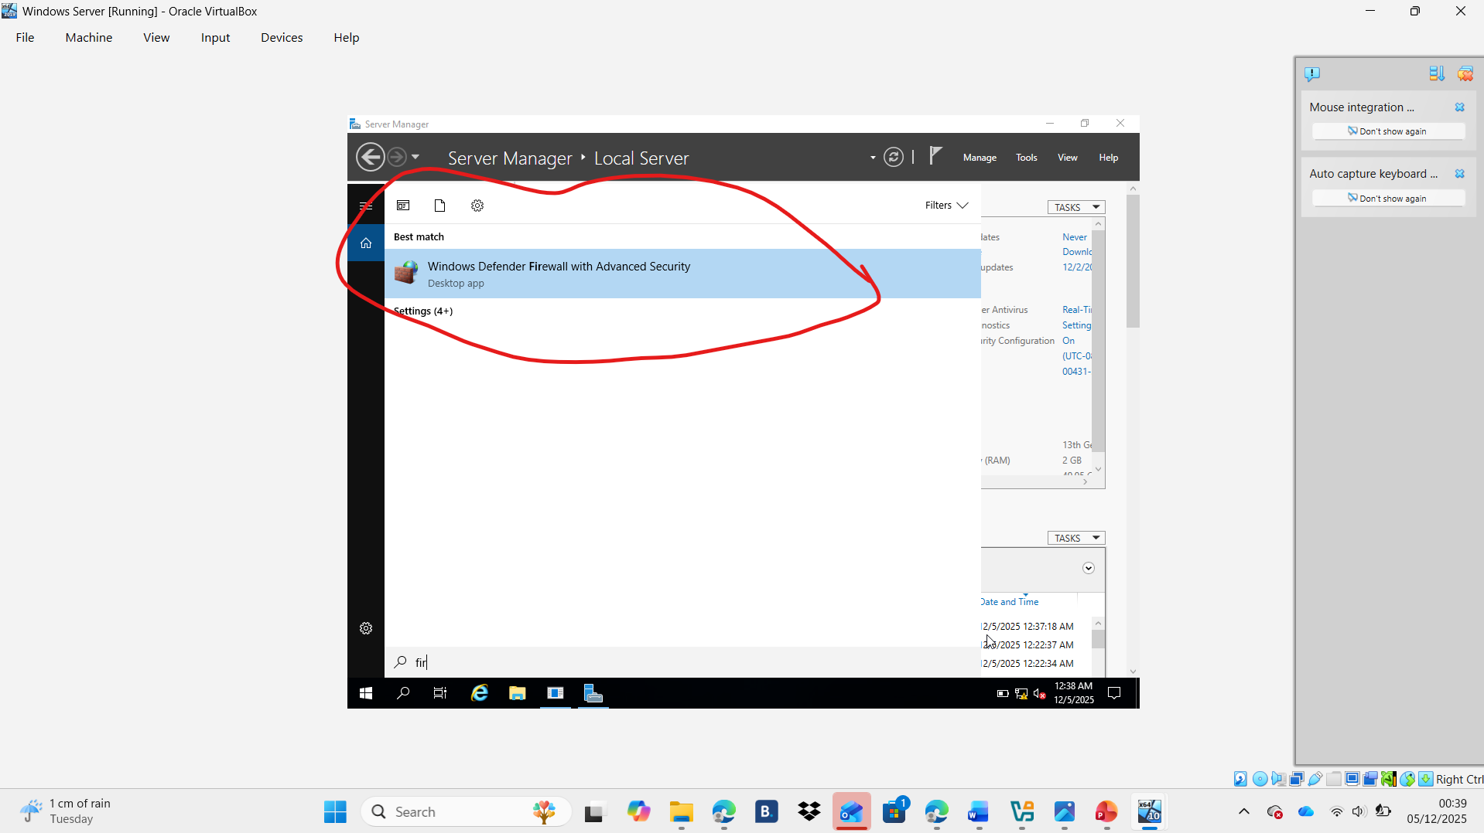
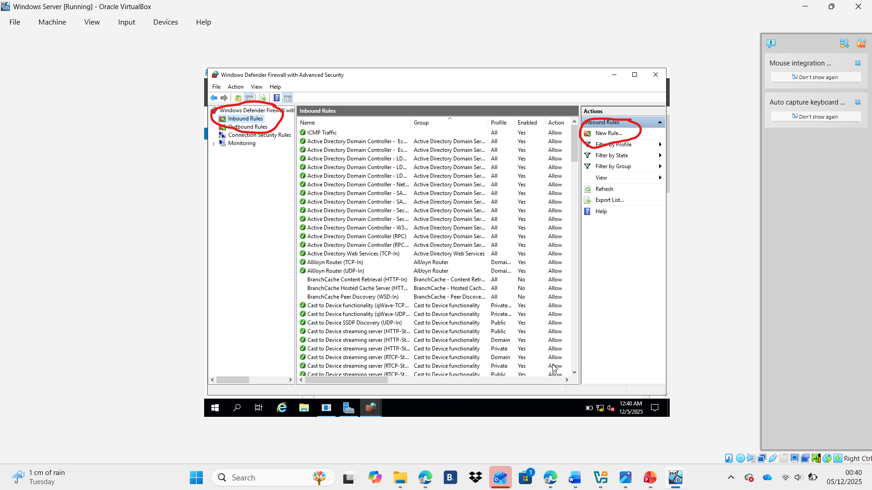
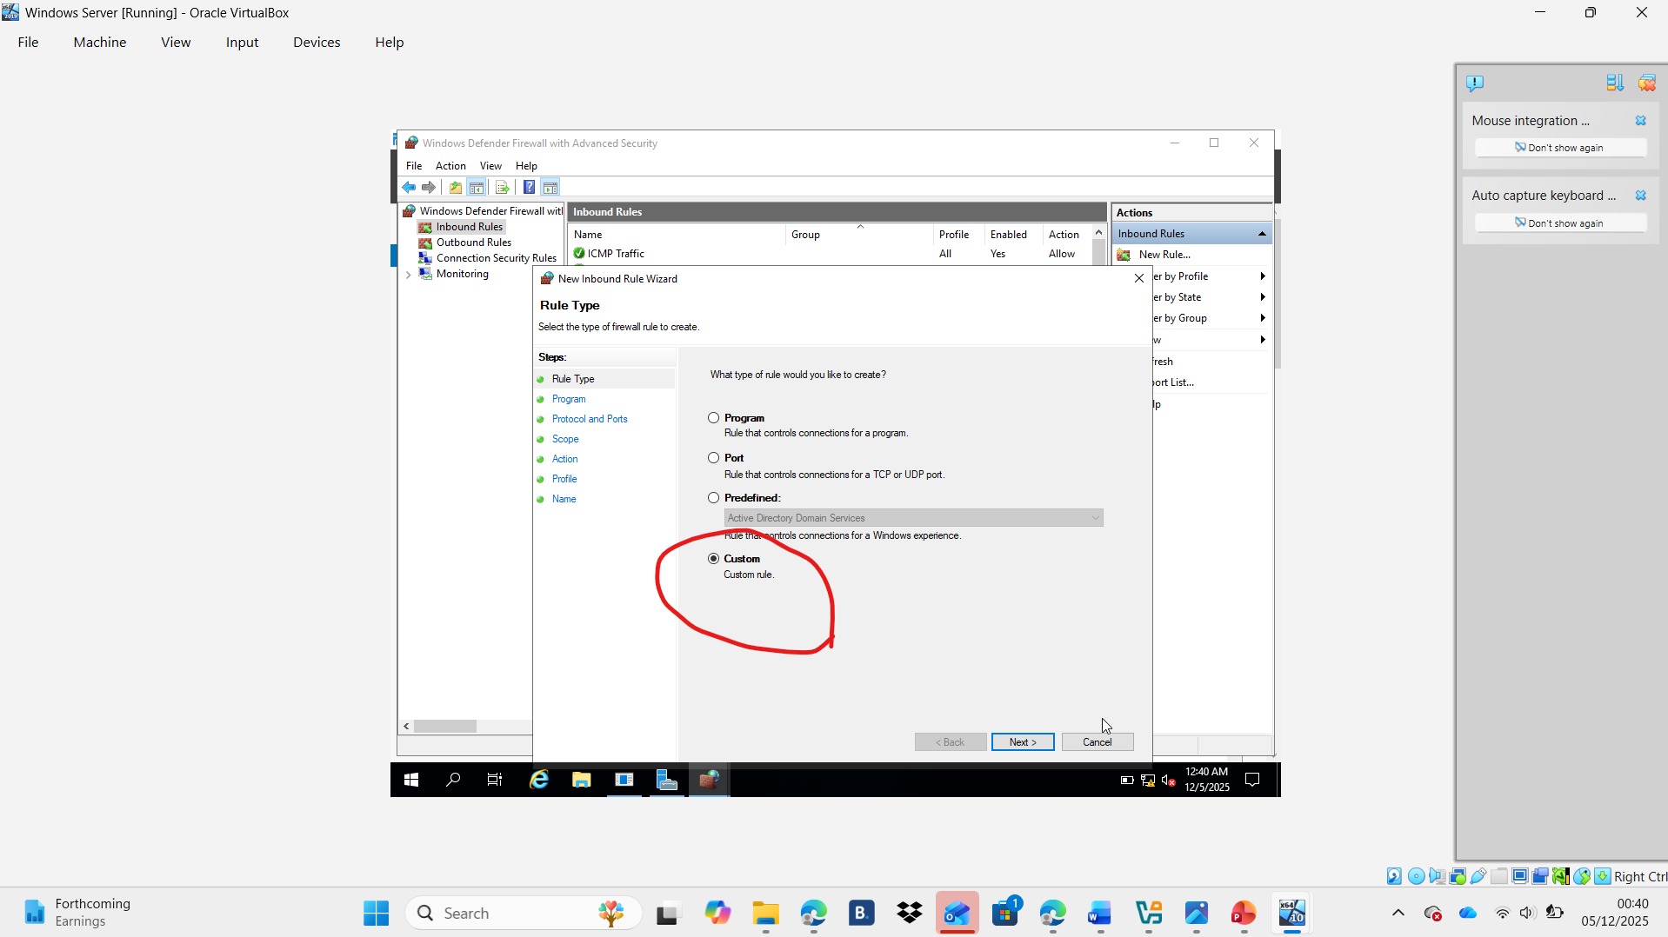
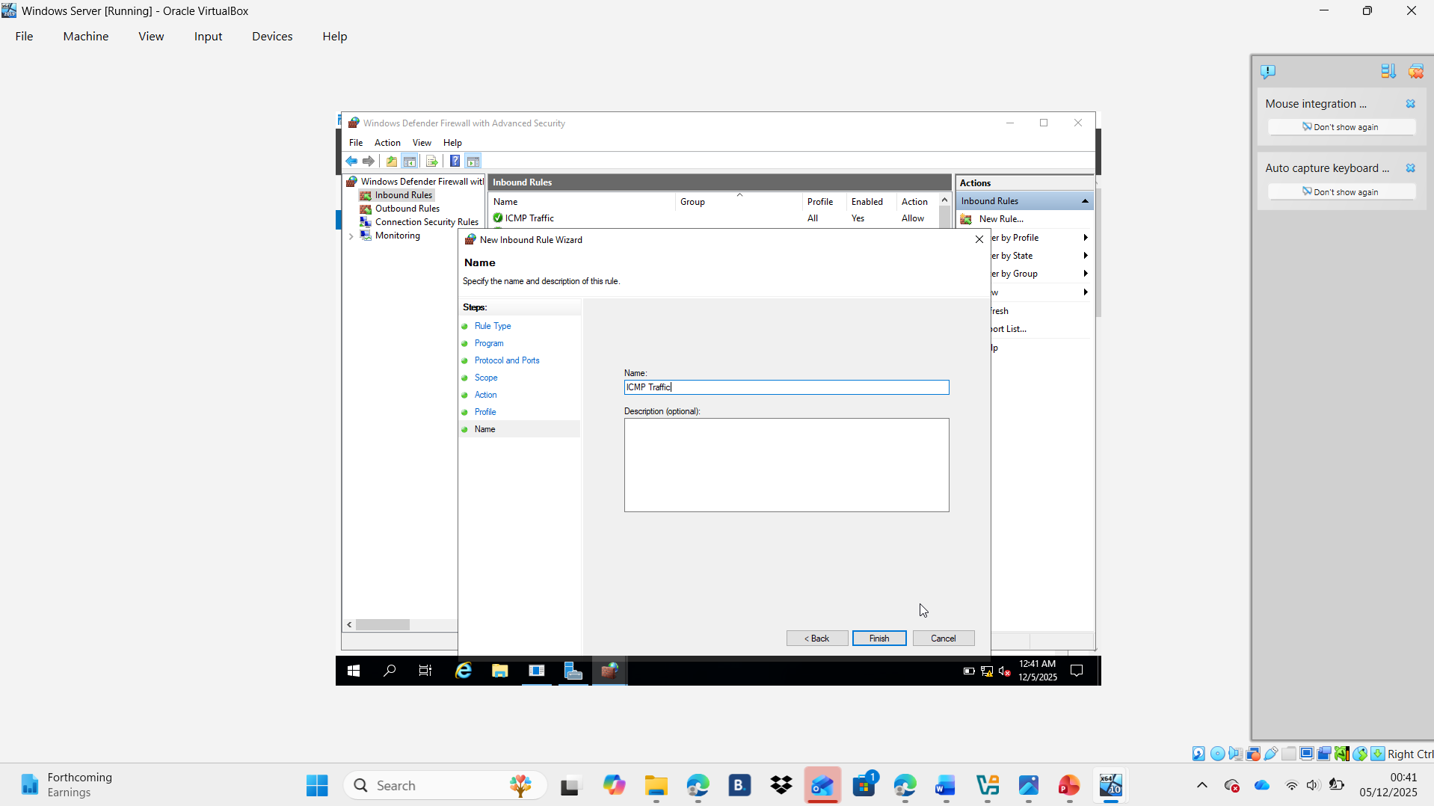
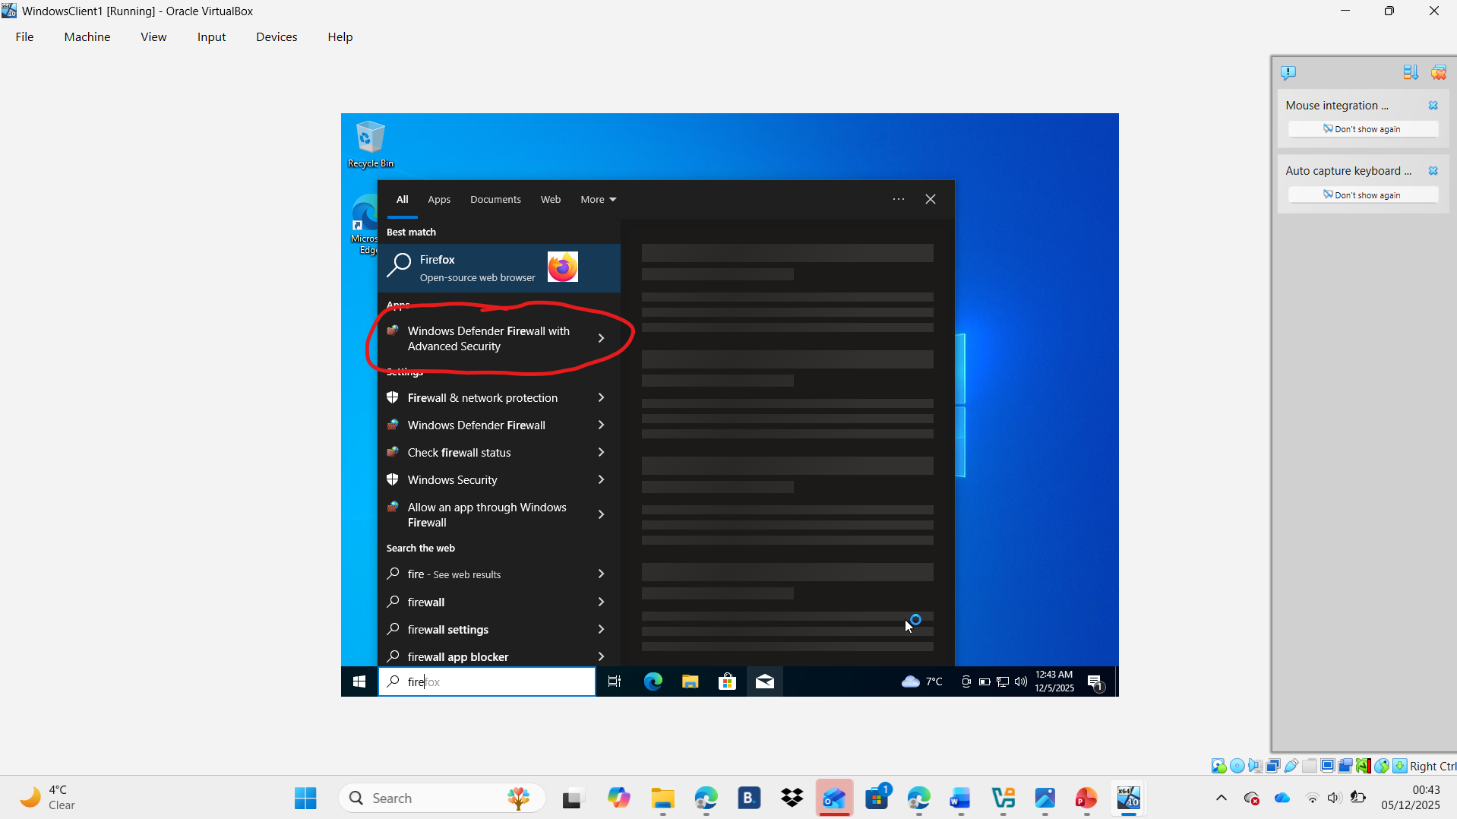
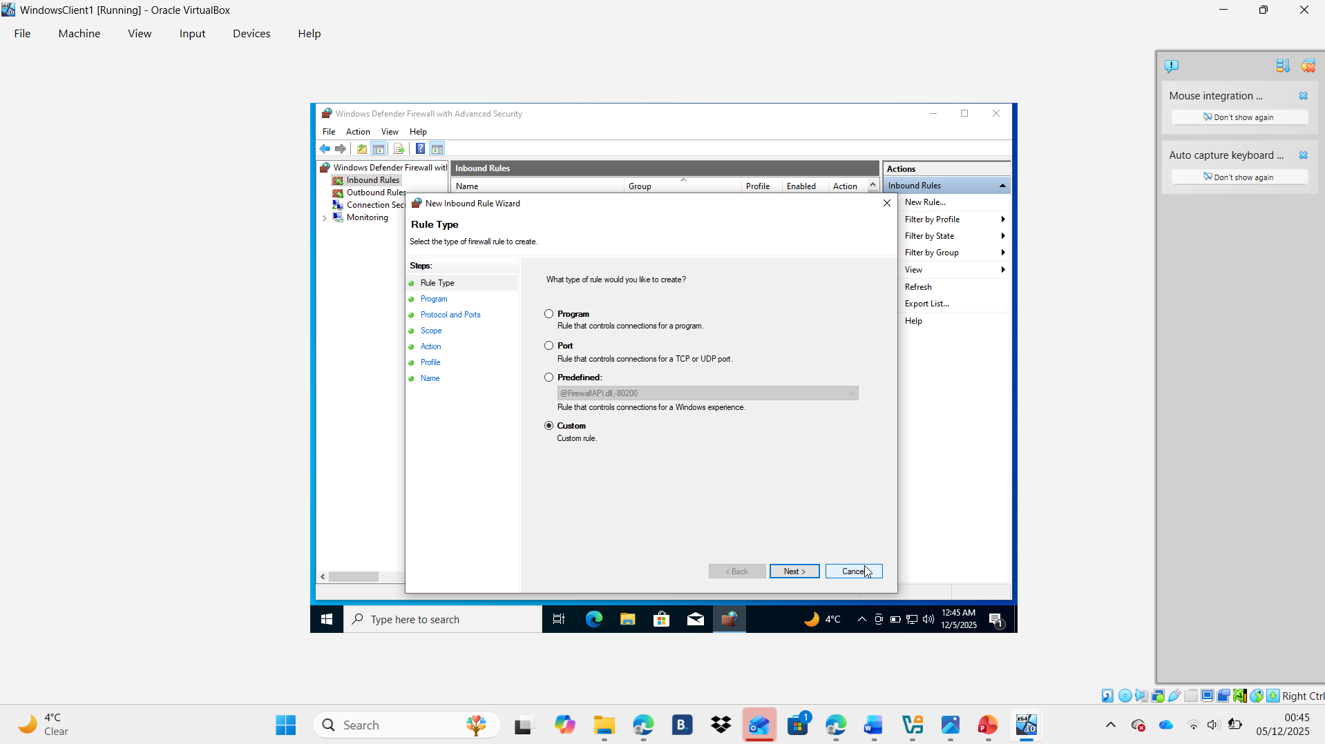
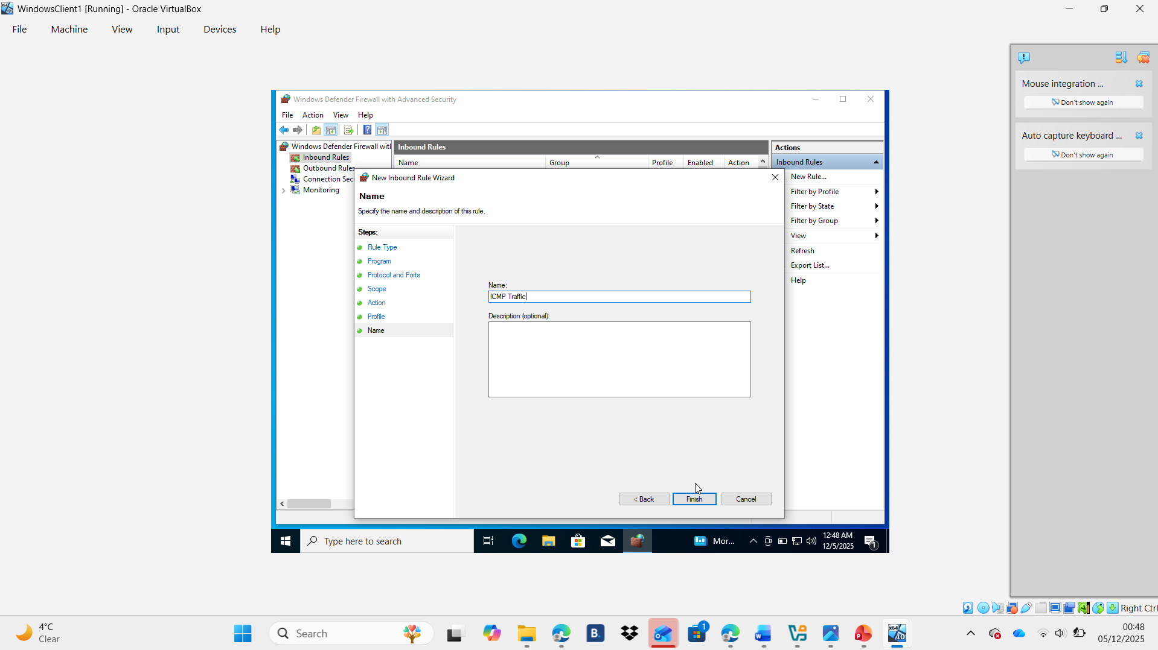

Debian Server
The fooling screenshot are the process that I did for assign IP address 192.168.2.1 to my Debian Server :
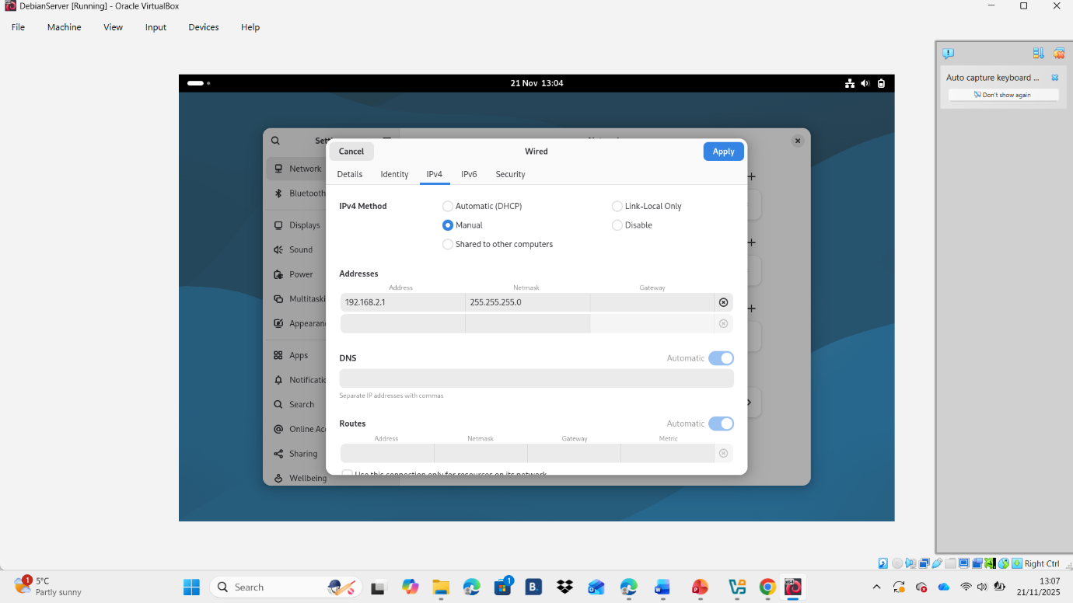
This screenshot is the IP configuration from the Debian Server:
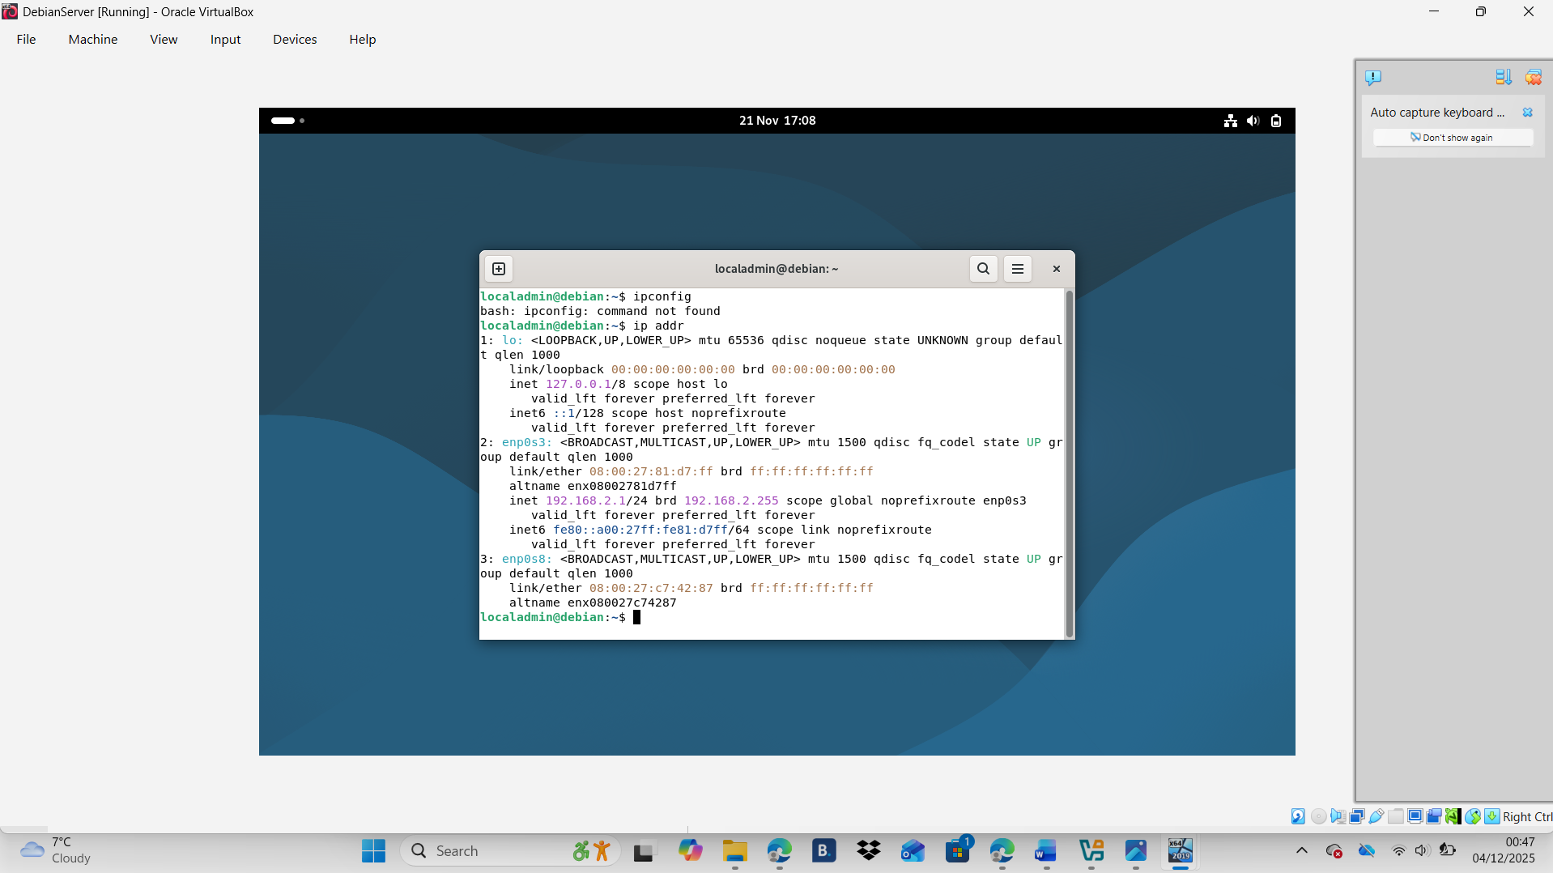

Debian Client
The fooling screenshot are the process that I did for assign the IP address 192.168.2.10 to my Debian Client:
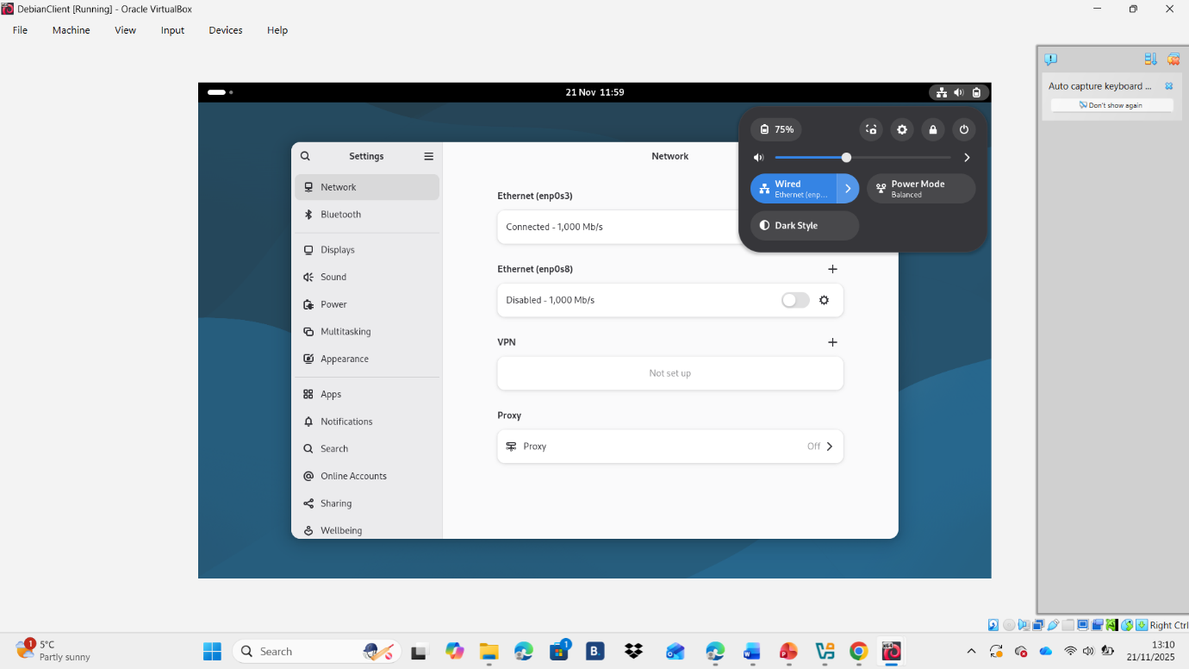
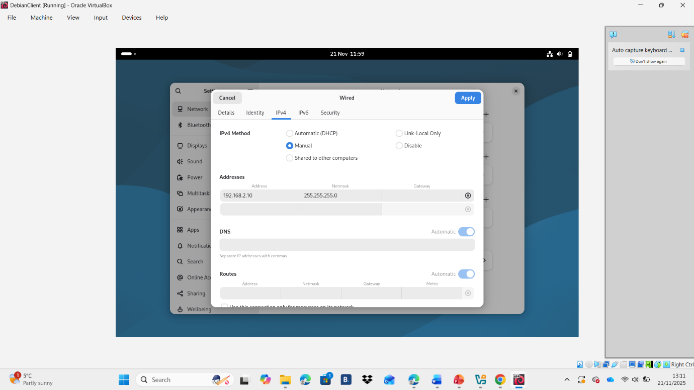

This is the screenshot of the IP configuration for my Devian Client:
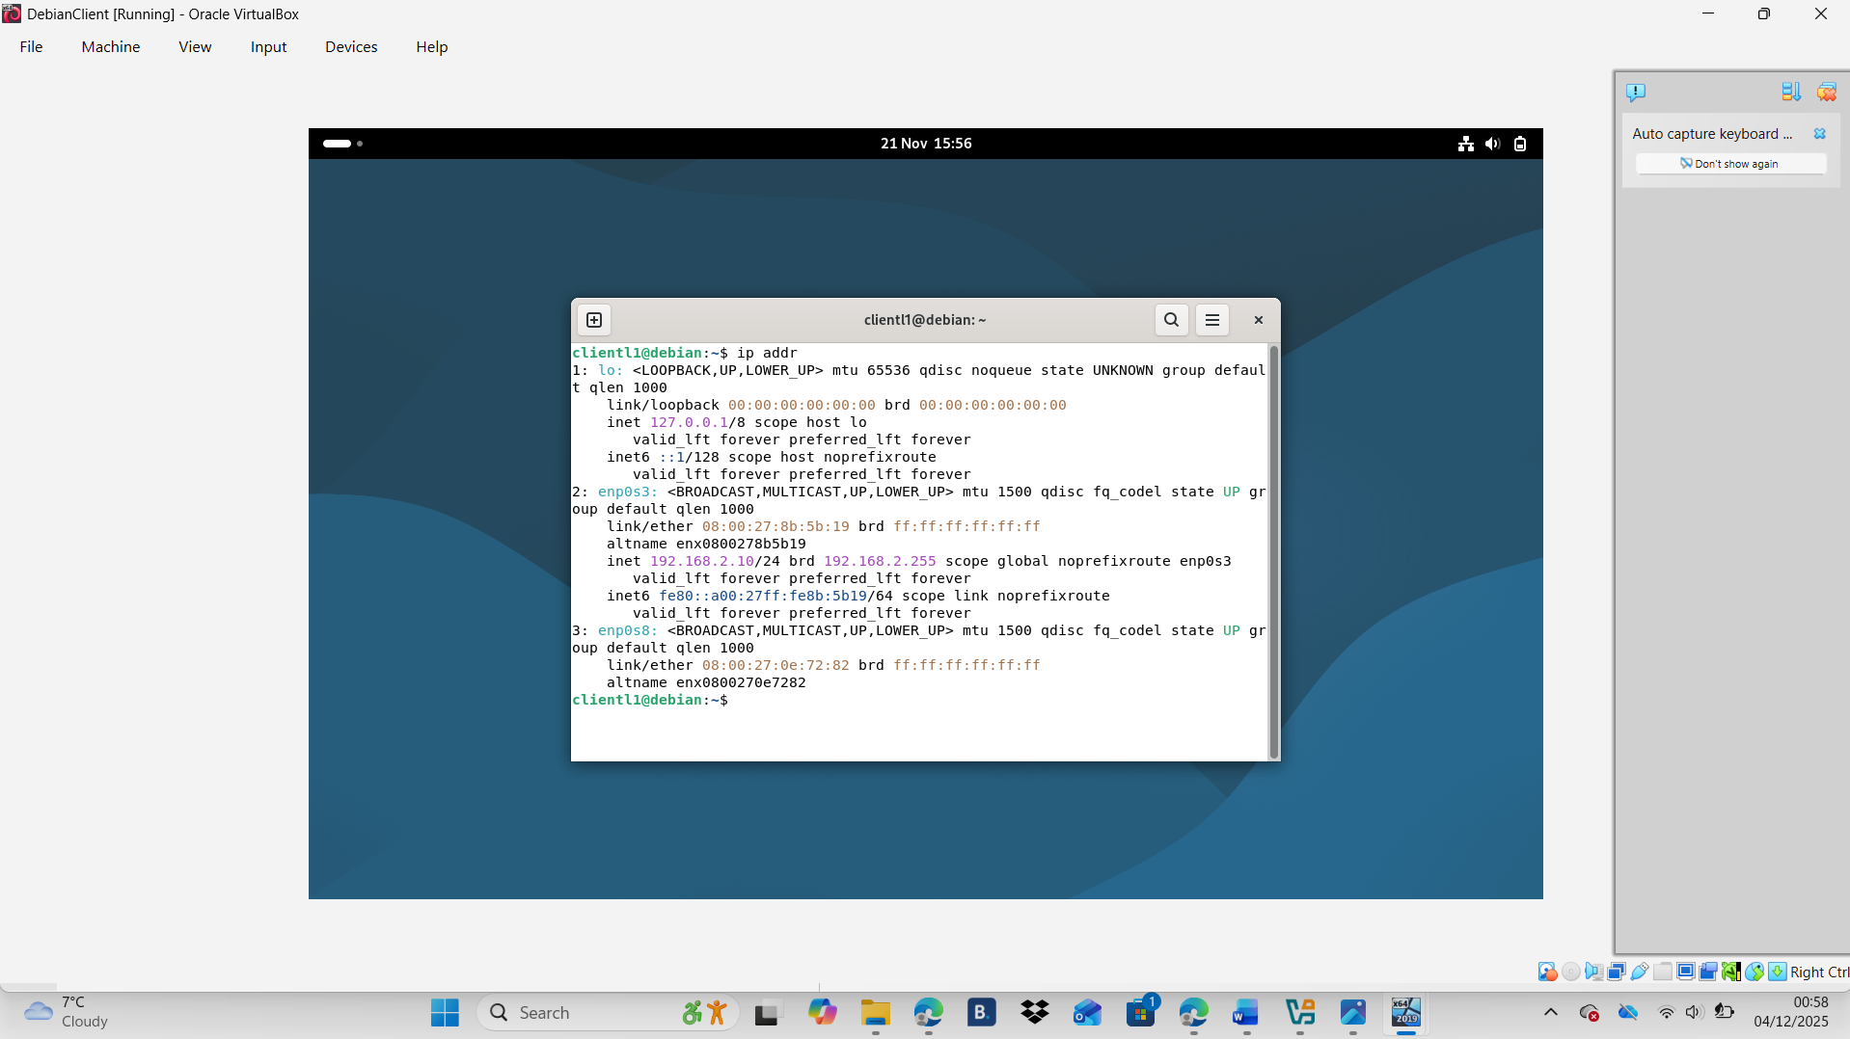

PING
Ping is a basic network diagnostic tool used to test connectivity between devices. It works by sending small ICMP Echo Request packets to a target device and waiting for ICMP Echo Reply responses. If replies are received, it confirms that the device is reachable and communicating properly on the network. Ping also measures round-trip time, helping identify delays or performance issues. If no response returns, it may indicate network problems, incorrect IP settings, or that the device is offline or blocking ICMP traffic. Overall, ping is a simple but essential tool for verifying network connections and troubleshooting communication issues.

Successful connectivity within same networks.

Windows Server and Windows Client ping
In Windows, the ping process begins when you enter the ping command followed by an IP address or hostname in Command Prompt. Windows sends ICMP Echo Request packets to the target device and waits for Echo Replies. The results display response times, packet loss, and overall connectivity status.

Windows Server ping screenshot:
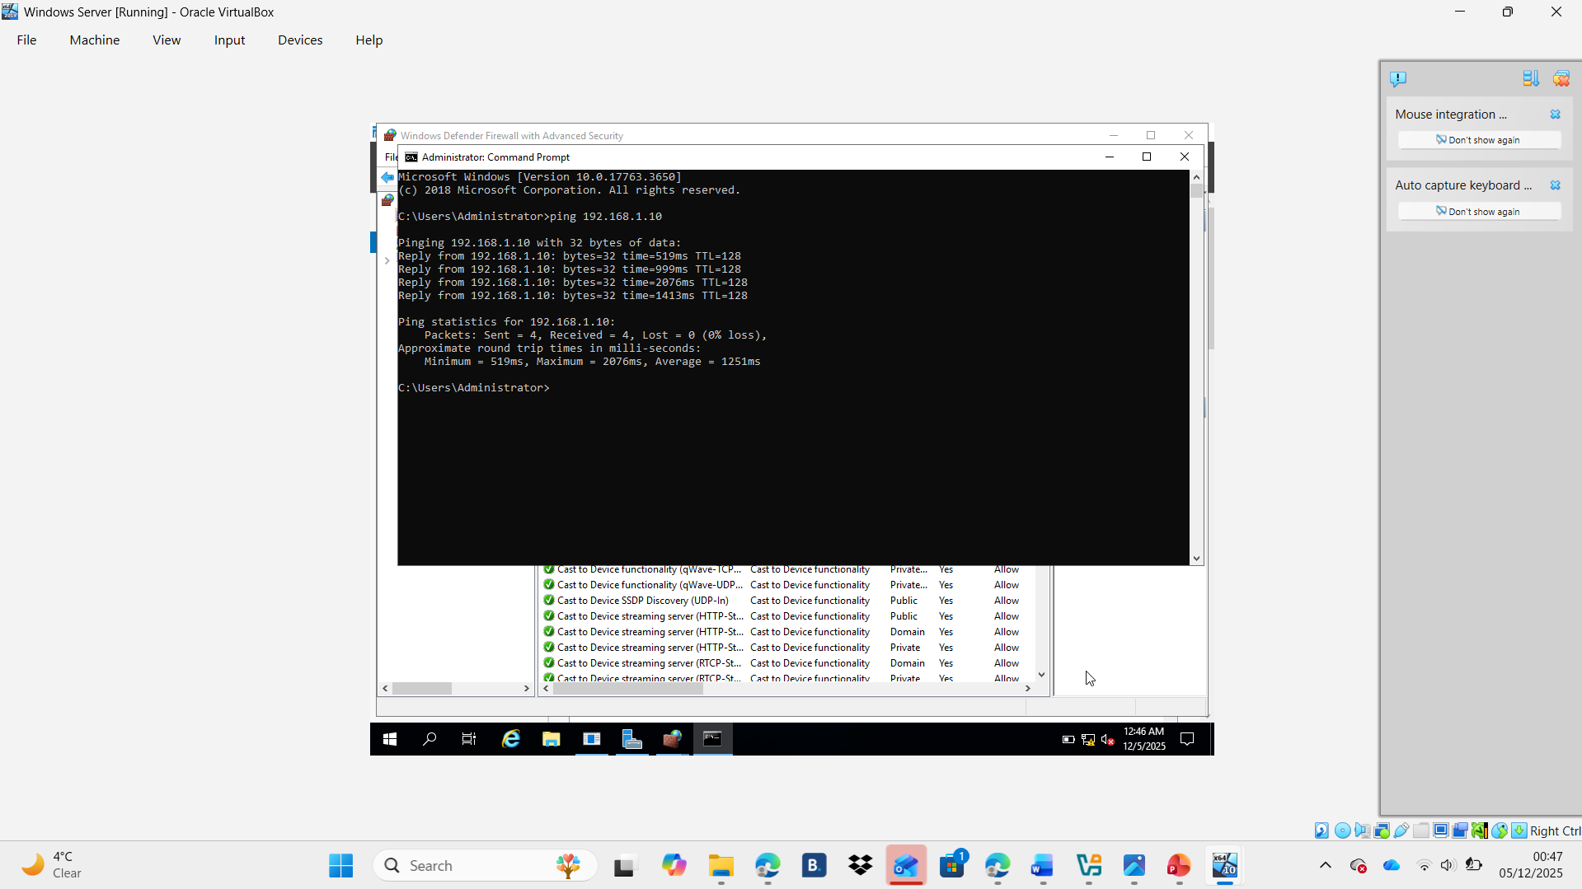

Windows Client ping screenshot:
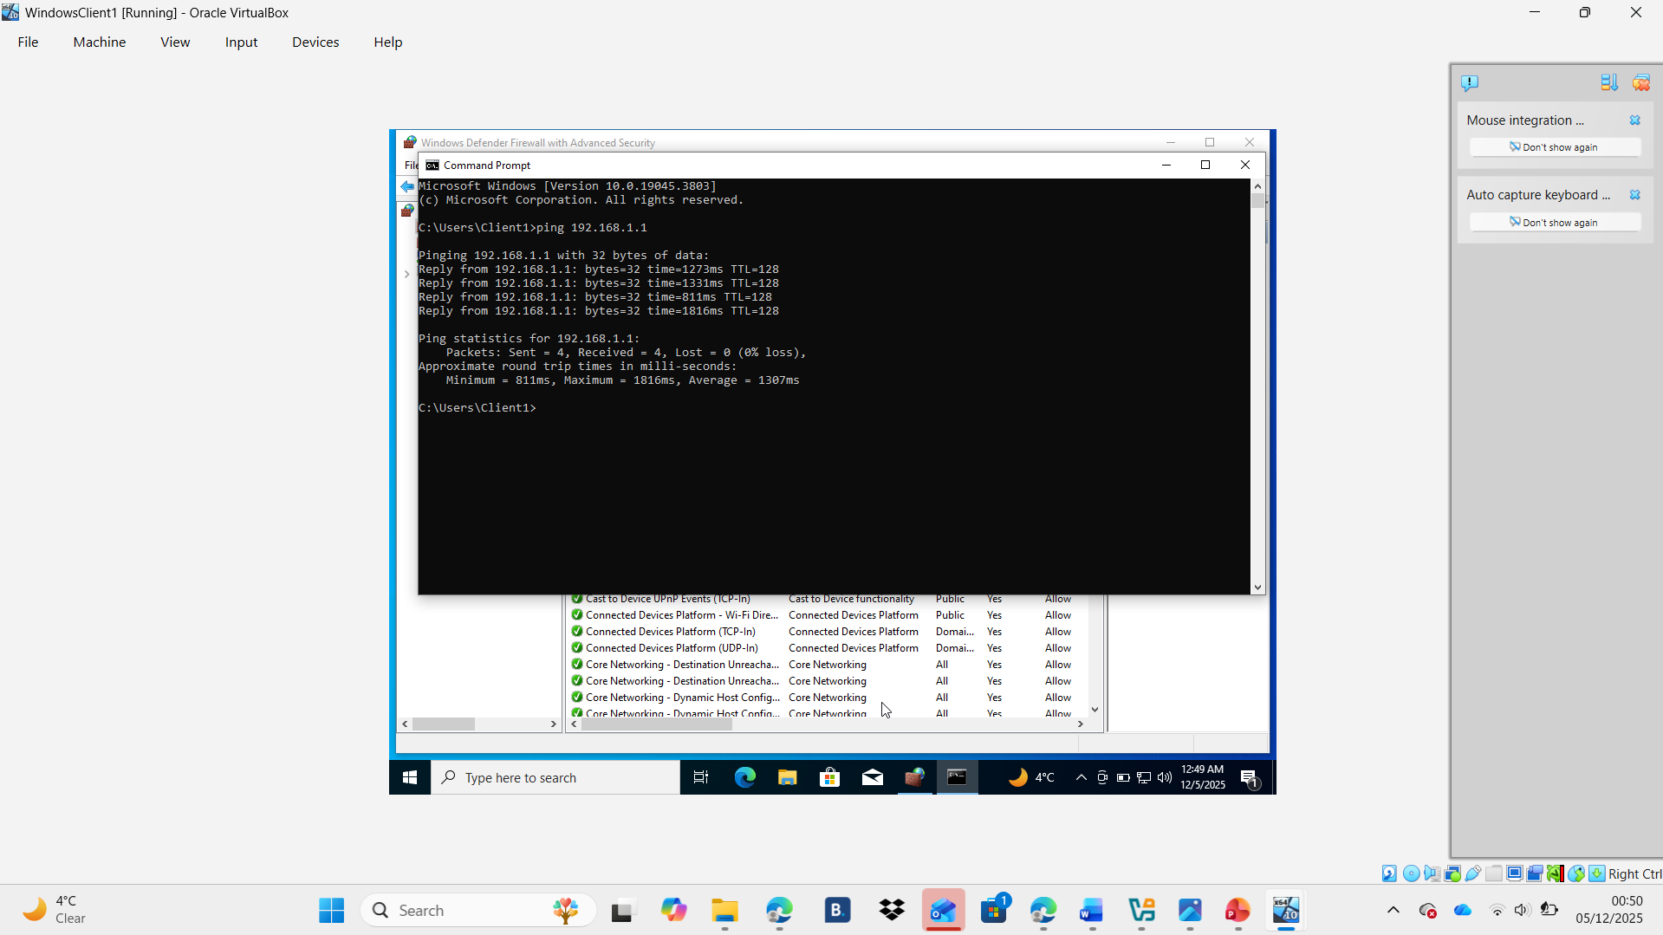

Debian Server and Debian Client ping
I checked the IP address of the Debian server using ip addr, then went to my Debian client and opened the terminal. From there, I used the ping <server-ip> command to test the connection between the two systems. Once I entered the server’s IP, I started receiving reply to messages, which showed that the network connection was working properly. I pressed Ctrl + C to stop the ping. This confirmed that my client could successfully reach the server and that basic connectivity between them was established.

Debian Server ping screenshot:
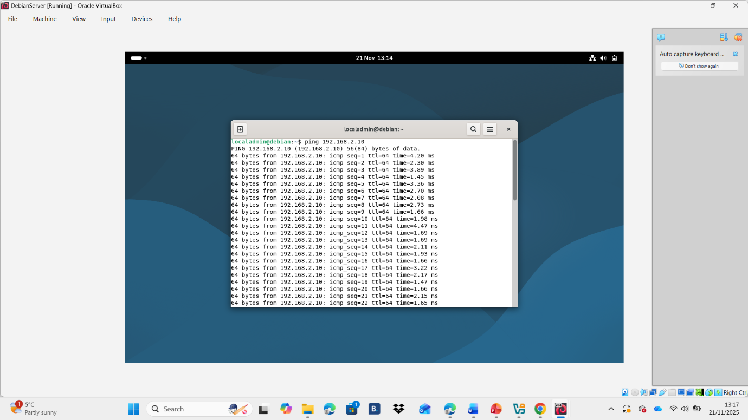

Debian Client ping screenshot:
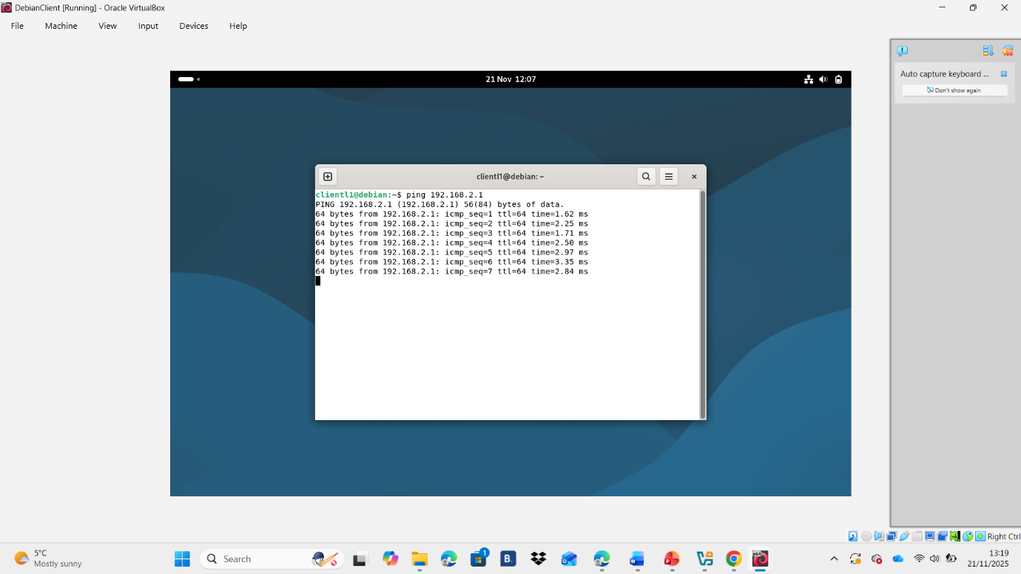

Unsuccessful connectivity within different networks
The ping between the Windows OS network (192.168.1.0/24) and the Debian OS network (192.168.2.0/24) is unsuccessful because the two networks are separate and rely on the Windows Server 2019 and Debian Server routers to forward traffic. If routing is not properly configured, packets cannot travel between the networks. Missing static routes, disabled IP forwarding, or firewall rules on either server will block ICMP traffic. Since each client sits in a different subnet, they cannot communicate directly without correct routing. As a result, ping requests fail because the packets never reach the destination network or are dropped along the path.

Debian Server to Windows Server :
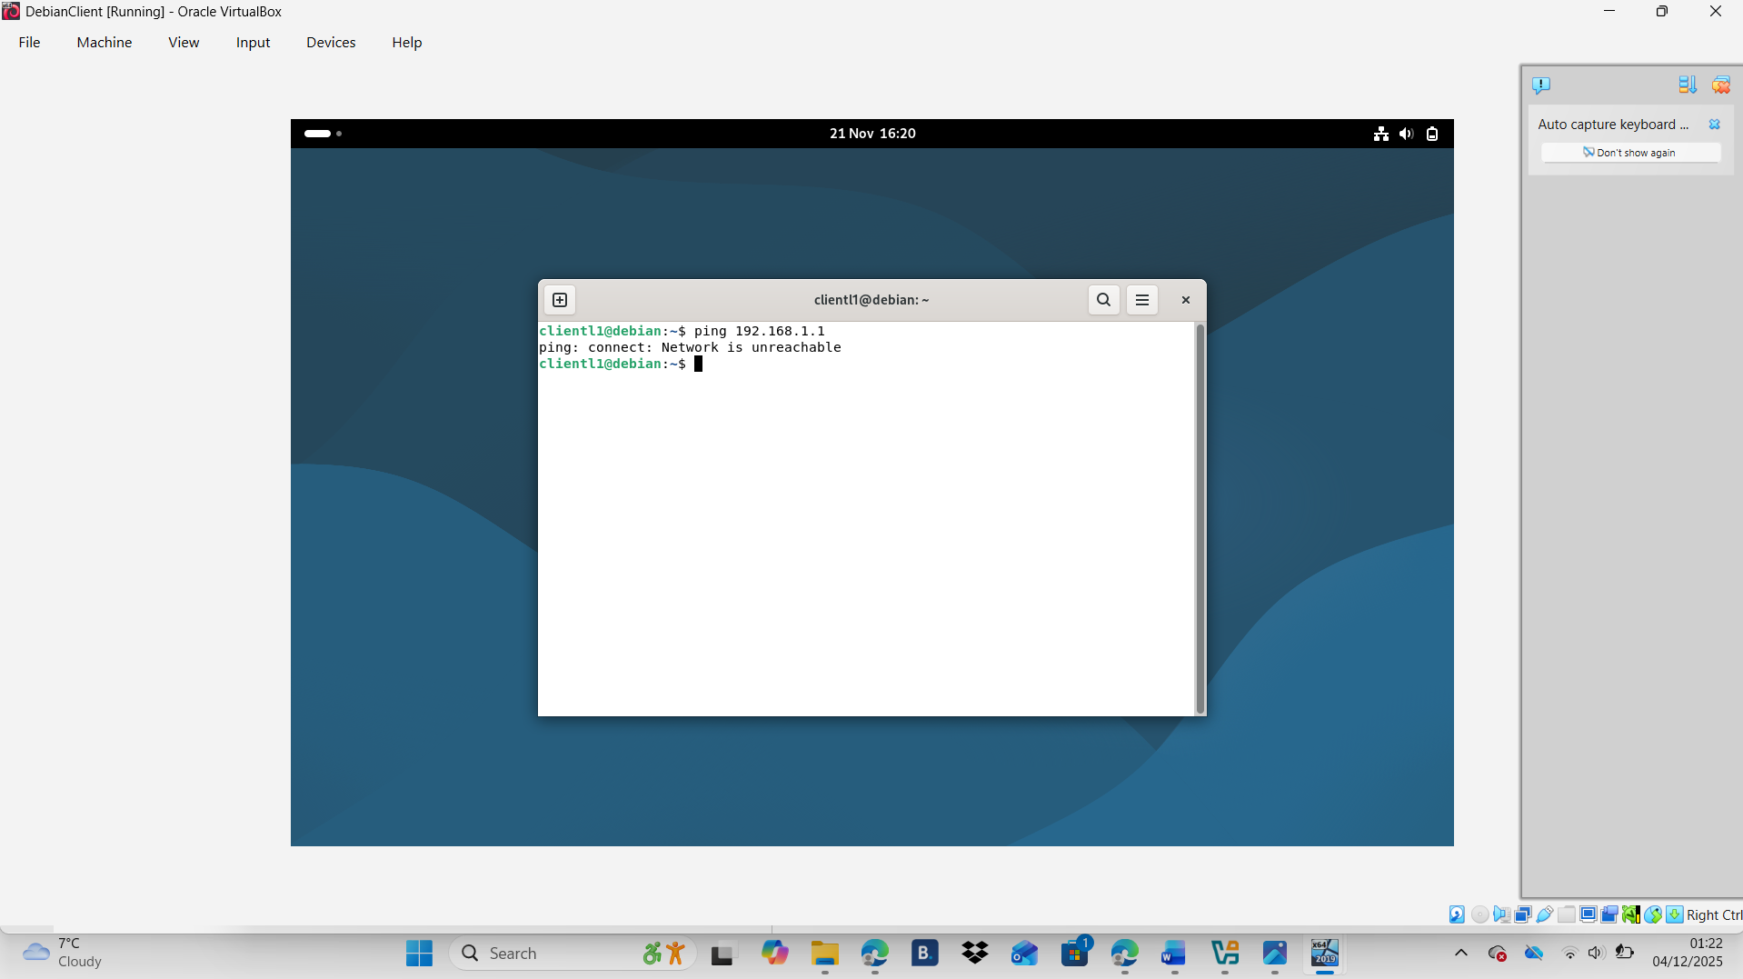
Debian Client to Windows Client:
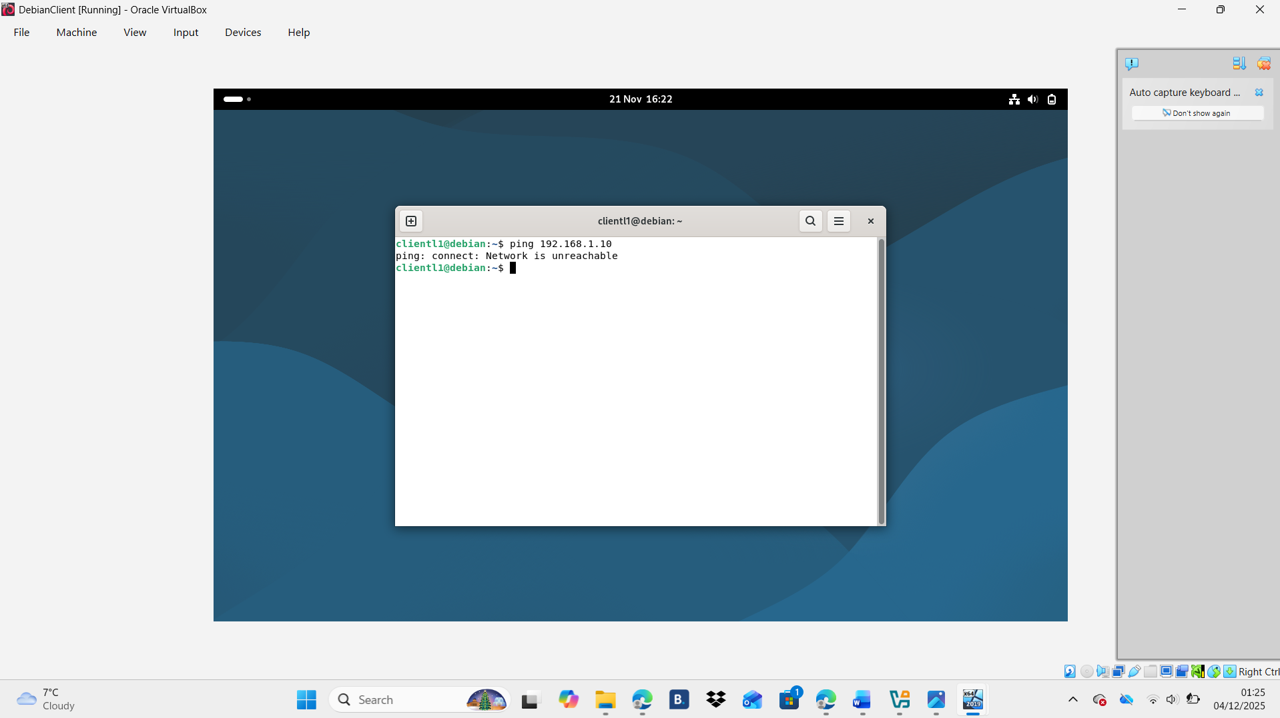
Windows Client to Debian Server:
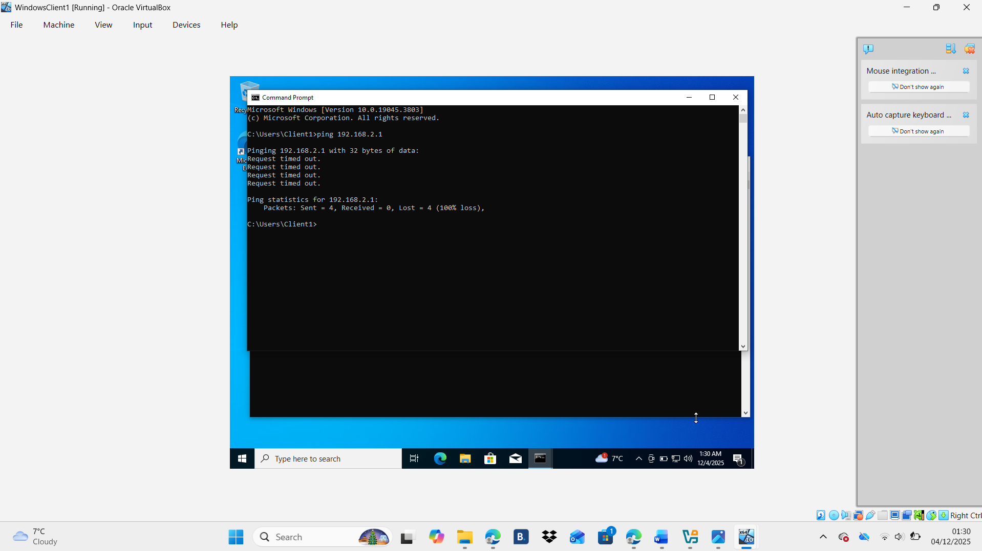
Windows Client to Debian Client:
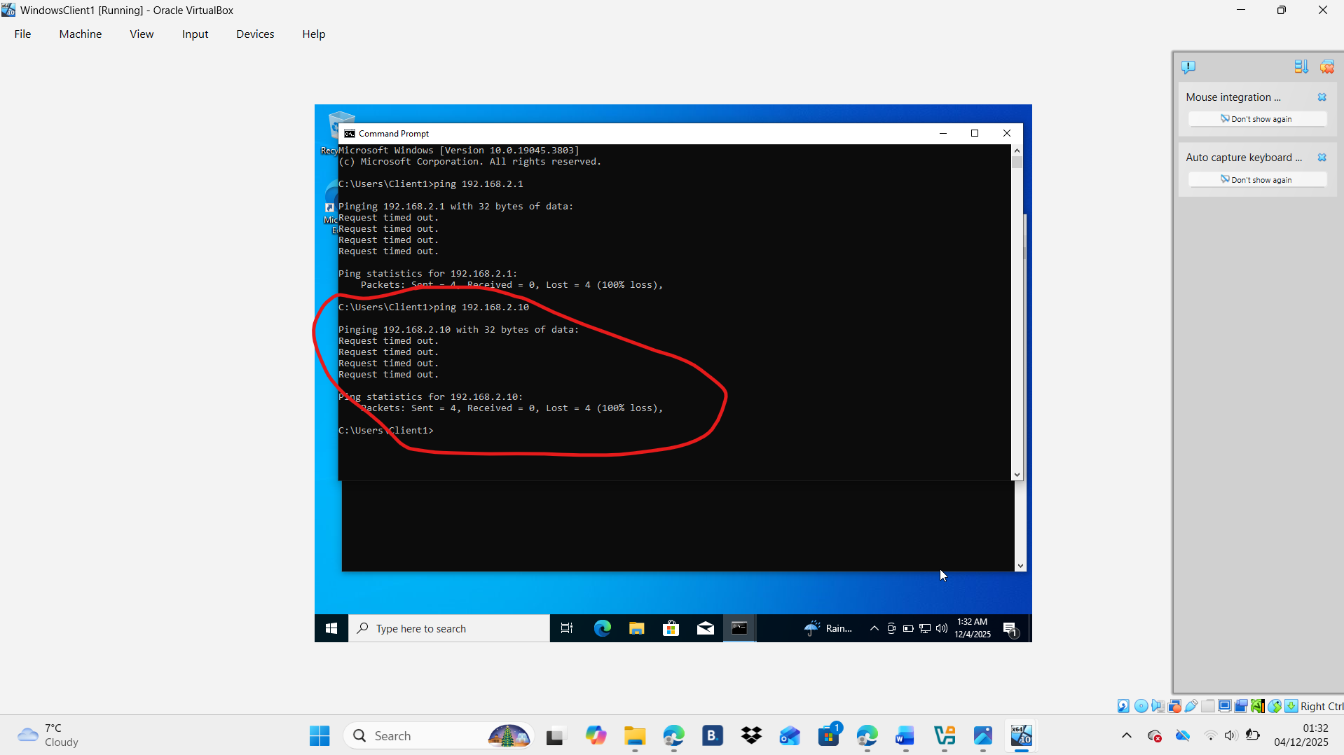

Task 3

Technical Reflection on Network Deployment and Testing
During the network deployment and testing phase, I faced several technical issues that required careful troubleshooting. The first problem occurred while installing Debian OS; I had mistakenly chosen the minimal version without a desktop environment, which prevented the graphical interface from loading. Reinstalling Debian with the Desktop Environment option resolved the issue. A second challenge arose with the Windows 10 installation file, which was not in ISO format and therefore incompatible with virtual machine setup. After checking the file extension and confirming the mismatch, I converted it into an ISO, allowing installation to proceed. I also encountered network connectivity issues on the Windows Server machine, which could not communicate with other devices. After reviewing adapter settings, cables, and IP configurations—and getting help from colleagues—I identified and fixed the misconfiguration. These experiences strengthened my understanding of OS installation, file formats, and network configuration while reinforcing the value of systematic troubleshooting and collaboration.

Personal Reflection
Throughout this project, I gained a stronger understanding of system installation, virtualization, and network configuration. Using VirtualBox was a key choice because its snapshots and clear network settings made it easier to manage virtual machines and understand how virtual networks function. I encountered several challenges, beginning with Debian failing to load due to installing it without a desktop environment, which I resolved by reinstalling with the correct option. I also had difficulty installing Windows 10 because the file I downloaded was not an ISO; after confirming the issue, I converted it to ISO format so VirtualBox could recognize it. IP configuration required careful planning to avoid conflicts, and while testing connectivity, the Windows Server failed to connect due to a VirtualBox network misconfiguration that I fixed with help from my friends. These troubleshooting experiences improved my problem-solving skills and confidence in managing virtual networks.

References

[1] | Coursera, “What Is a Hypervisor? Types, Use Cases, and Career Opportunities,” 17 September 2025. [Online]. Available: https://www.coursera.org/articles/what-is-hypervisor?msockid=0399c84673556ea21f1cda20726d6f77.
[2] | Red Hat, “What is a hypervisor?,” 3 January 2023. [Online]. Available: https://www.redhat.com/en/topics/virtualization/what-is-a-hypervisor.
[3] | S. Norman, “A Technical Look At How Data Is Transmitted On The Internet,” 18 March 2025. [Online]. Available: https://computercity.com/hardware/networking/how-is-data-is-transmitted-on-the-internet.
[4] | P. Networking, Director, How Data moves through the Internet - Networking Fundamentals. [Film]. 2021.
[5] | D. A. Rao, “Understanding Routing Protocols: Key Insights for Networks,” Scivast.
[6] | Engineering Science & Technology Journal, “VIRTUAL PRIVATE NETWORKS (VPN): A CONCEPTUAL REVIEW OF SECURITY PROTOCOLS AND THEIR APPLICATION IN MODERN NETWORKS,” Engineering Science & Technology Journal, 2024.
[7]

