https://www.nytimes.com/2020/09/13/business/dealbook/milton-friedman-essay-anniversary.html?searchResultPosition=6

Greed Is Good. Except When It’s Bad. Sept. 13, 2020

Sept. 13 is an important date in the world of business. Fifty years ago on that day — today — Milton Friedman published a seminal essay in The New York Times Magazine that is still hotly debated in business and policy circles. DealBook teamed up with The Times Magazine to revisit the legacy of the so-called Friedman Doctrine in a special issue out today in print. This newsletter runs through some of the highlights, along with bonus material and other features to mark the occasion.

A free market manifesto that changed the world, reconsidered
It was the essay heard round the world. Milton Friedman’s “The Social Responsibility of Business Is to Increase Its Profits” laid out arguably the most consequential economic idea of the latter half of the 20th century. The essay, published in The New York Times Magazine on Sept. 13, 1970, was a call to arms for free market capitalism that influenced a generation of executives and political leaders, most notably Ronald Reagan and Margaret Thatcher.
Mr. Friedman, who was on the faculty of the University of Chicago and who died in 2006 at 94, was no mere economist; he was a kind of celebrity. He became a regular on the talk-show circuit. PBS even gave him a 10-part series. Fifty years later, his theories on the primacy of shareholders and the priority of profits still hold sway over large parts of the corporate world.
We wanted to mark the occasion by stirring a series of discussions and debates, so we assembled more than 20 experts — including C.E.O.s, Nobel laureates and other top thinkers — and asked them to respond to the essay. Some addressed specific passages, and others took on the entire argument. A selection of their responses is below; you can read extended versions online and see all of the annotations in the context of the full original essay in print.
ADVERTISEMENT
Continue reading the main story
* * *
Friedman: “The Social Responsibility of Business Is to Increase Its Profits”
• Marc Benioff, chief executive of Salesforce
I’ll never forget reading Friedman’s essay when I was in business school in the 1980s. It influenced — I’d say brainwashed — a generation of C.E.O.s who believed that the only business of business is business. The headline said it all. Our sole responsibility to society? Make money. The communities beyond the corporate campus? Not our problem.
- Thanks for reading The Times.
Subscribe to The Times
I didn’t agree with Friedman then, and the decades since have only exposed his myopia. Just look where the obsession with maximizing profits for shareholders has brought us: terrible economic, racial and health inequalities; the catastrophe of climate change. It’s no wonder that so many young people now believe that capitalism can’t deliver the equal, inclusive, sustainable future they want.
* * *
Friedman: “What does it mean to say that ‘business’ has responsibilities?”
• Howard Schultz, emeritus chairman of Starbucks
I’ve asked this question since opening my first coffee shop in 1986. My answer, a rebuke of Friedman’s single-minded focus on profits, appeared in our company’s original mission statement: “We wish to be an economic, intellectual and social asset in communities where we operate.” We would do this not at the expense of profits, but to grow them.

Editors’ Picks



Quiz: Can You Tell a ‘Trump’ Fridge From a ‘Biden’ Fridge?

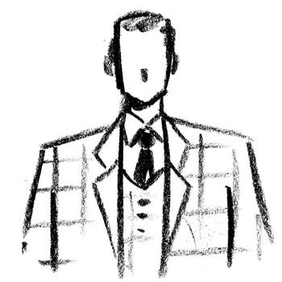

‘He Managed a Smile and Thanked Charles for the Compliment’

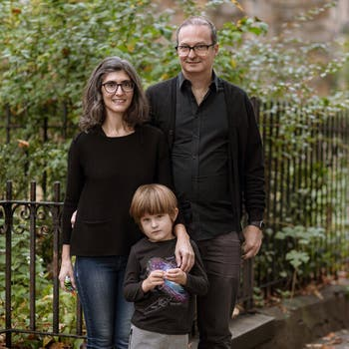

Condo or Co-op? A Young Family Discovers the Differences and Makes a Big Decision

ADVERTISEMENT
Continue reading the main story
If Friedman had balked, asserting that Starbucks could have performed even better without these “socially responsible” activities, I would have told him what I told an institutional investor who wanted me to slash health care costs during the Great Recession, or what I said to a shareholder in 2013 who falsely claimed that Starbucks’s support of gay rights hurt profits: If you feel you can get a better return elsewhere, you are free to sell your shares.
In 2013, I stood in front of Starbucks shareholders and posed this question: “What is the role and responsibility of a for-profit public company?” Friedman’s flawed answer is not his legacy. His legacy is the question itself — which today’s leaders must answer with a renewed commitment to balancing moral purpose and high performance.
____________________________
Today’s DealBook Briefing was edited by Andrew Ross Sorkin in Connecticut and Jason Karaian in London.
____________________________
Friedman: “In a free-enterprise, private-property system, a corporate executive is an employee of the owners of the business. He has direct responsibility to his employers. That responsibility is to conduct the business in accordance with their desires, which generally will be to make as much money as possible while conforming to the basic rules of the society, both those embodied in law and those embodied in ethical custom.”
• Marianne Bertrand, professor of economics at the University of Chicago Booth School of Business
The shareholder-primacy view of the corporation — which gives little voice to the workers, customers and communities that are impacted by corporate decisions — has been the modus operandi of United States capitalism. Why did this view become so dominant? One rationale was a practical one. Rather than being asked to balance multiple, often conflicting, interests among stakeholders, the manager is given a simple objective function. More important, though, was the naïve belief, dominant in the Chicago school at the time, that what is good for shareholders is good for society — a belief that rested on the assumption of perfectly functioning markets. Unfortunately, such perfect markets exist only in economics textbooks.
• Daniel Loeb, chief executive of Third Point
Friedman’s timeless essay resonates today as corporate America embraces “stakeholder capitalism,” a popular concept that is inconsistent with the law. Stakeholder capitalism distorts the incentive that prompts investors to risk their capital: the promise of a profit on their investment. So, I share Friedman’s concern that a movement toward prioritizing ill-defined “stakeholders” might allow some executives to pursue personal agendas — or simply camouflage their own incompetence (until it is starkly revealed by poor shareholder returns).
* * *
Friedman: “This process raises political questions on two levels: principle and consequences.”
• Erika Karp, chief executive of Cornerstone Capital Group
ADVERTISEMENT
Continue reading the main story
Friedman makes the mistake of not including two words: “long term.” Had he talked about “long-term principle and long-term consequences,” businesses might be more thoughtful about deploying financial capital, natural capital and human capital. Respect for the value of each form reinforces the long-term value of the other. Friedman once said: “Governments never learn. Only people learn.” And so, investors and corporations have learned a better and more holistic way to serve our shareholders for the long term. That is free-market economics for the 21st century.
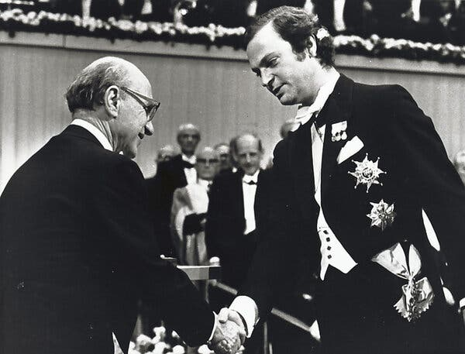
Image
Milton Friedman, left, accepts the Nobel Memorial Prize in Economic Sciences from Sweden’s King Carl Gustaf in 1976.Credit...AP Photo/Peter Knopp
Friedman: “This is the basic reason why the doctrine of ‘social responsibility’ involves the acceptance of the socialist view that political mechanisms, not market mechanisms, are the appropriate way to determine the allocation of scarce resources to alternative uses.”
• Joseph Stiglitz, professor of economics at Columbia University, was awarded a Nobel Prize in 2001
By the time he wrote this essay, Friedman, who had done distinguished analytic and empirical work in economics, had become largely a conservative ideologue.
I gave a talk at the University of Chicago around this time, presenting an early version of my research establishing that in the presence of imperfect risk markets and incomplete information — that is, always — firms pursuing profit maximization did not lead to the maximization of societal welfare. I explained what was wrong with Adam Smith’s invisible-hand conjecture, which said that the pursuit of self-interest would lead, as if by an invisible hand, to the well-being of society. During the seminar, and in extensive conversations afterward, Friedman simply couldn’t or wouldn’t accept the result; but neither, of course, could he refute the analysis — it has been a half-century, and my analysis has stood the test of time. His conclusion, as influential as it was, has not.
Today the downside of Friedman’s perspective is even darker: Is it Mark Zuckerberg’s social responsibility to allow wanton disinformation to roam over his social media platform? Is it Zuckerberg’s responsibility to lobby to get rid of a pesky foreign competitor while fighting for his company to be free from anti-competitive restraints and any accountability, so long as it increases his bottom line? Friedman would say yes. Economic theory, common sense and historical experience suggest otherwise. It is good that the business community has awaked. Now let’s see whether they practice what they preach.
* * *
Friedman: “They can do good — but only at their own expense.”
• Dambisa Moyo, global economist and the author, most recently, of “Edge of Chaos.”
ADVERTISEMENT
Continue reading the main story
The heart of what Friedman was saying remains largely true, but I have a fundamental problem with this sentence. For most corporations today, the question of “doing good” has become an existential question. Companies operate as going concerns — they want to survive. They face technological changes, changes in consumer preferences, changes in regulation, and these changes are forcing companies not to fight against the changes but to adapt. Take the example of a pharmaceutical company searching for a solution for cancer. The goal is a social good. From the companies’ perspective, they’re on the same page as society. The pursuit of profit does not need to run counter to what will benefit society. In some cases the interest of the corporation is absolutely married to the social good.
* * *
Friedman: “To illustrate, it may well be in the long-run interest of a corporation that is a major employer in a small community to devote resources to providing amenities to that community … ’
• Glenn Hubbard, professor of economics at Columbia Business School
Friedman’s argument was controversial 50 years ago, and it’s controversial again today. But it’s still more or less correct. Somewhat unfairly, Friedman’s focus has been taken to mean “short-term value,” generating gains to benefit current shareholders at the expense of other stakeholders. But Friedman is best read as embracing maximizing shareholder value over the long run. Toward that end, short-term gains at the expense of stakeholders — who might decide not to work for, supply to or buy from the firm — make little sense.
There is another rub, and Friedman anticipated it: Even long-term shareholder-value maximization can’t address all problems faced by a firm. Some problems — climate change, for example — are arguably more complex than Friedman envisioned. In these cases, public policy changes are required.
* * *
Friedman: “In the present climate of opinion, with its widespread aversion to ‘capitalism,’ ‘profits,’ the ‘soulless corporation’ and so on, this is one way for a corporation to generate good will as a byproduct of expenditures that are entirely justified in its own self-interest.”
• Ken Langone, a founder of Home Depot and the author of “I Love Capitalism!”
Here’s the most misunderstood among Friedman’s many deep insights — a company can make good-will expenditures “that are entirely justified in its own self-interest.” I see that as an extension of the most fundamental truth in capitalism, that in any voluntary exchange both parties benefit.
If we ignore Friedman’s crystalline perception — that profits are the driving focus — then the entire mission, good will included, falls apart. When we turn the idea of profit into a callous slur, as Friedman’s laziest critics often do, we are demeaning the essential propelling force that enables all these interconnected good works to occur.
ADVERTISEMENT
Continue reading the main story
All our investors, employees, partners and customers also deserve the freedom and security to do good will in their own individual ways, too. But they cannot spread those wings unless the company delivers the profits to lift them.
Are those ordinary people so bereft of charity and common sense that they must grant some newspaper pontificator or a special-interest group with a bullhorn the imaginary right to dictate how their company channels the money they rightfully earned and counted on? As Friedman warned us, to argue yes does worse than belittle every American. It turns the whole of our lives into politics. It means that every jockeying constituency that marauds our government also gets to compete and finagle over how your savings and investment are spent.
* * *
Friedman: “That is why, in my book ‘Capitalism and Freedom,’ I have called it a ‘fundamentally subversive doctrine’ in a free society, and have said that in such a society, ‘there is one and only one social responsibility of business — to use its resources and engage in activities designed to increase its profits so long as it stays within the rules of the game, which is to say, engages in open and free competition without deception or fraud.’
• Darren Walker, chief executive of the Ford Foundation
In propaganda, an accusation often betrays an admission. The most “subversive doctrine” was — and remains — Friedman’s own. His doctrine absolved the firm of its responsibility to serve as a force for racial integration and inclusion. It produced generations of corporate leaders dedicated to the sacred primacy of shareholder value.
In that way, Friedman’s thinking became theology — the intellectual scaffolding that allowed its disciples to justify decades of greed-is-good excess. Gone were the days when someone like my semiliterate grandfather, with only a third-grade education, could work as a porter and benefit from a profit-sharing plan provided by a company that dignified his work. In their place were new conditions in which our social contract frayed and our economy tilted out of balance — fomenting the unsustainable inequalities that plague America today.
Friedman ignored that in a democratic-capitalist society, democracy must come first. “We, the people” grant businesses their license to operate — which they, in turn, must earn and renew.
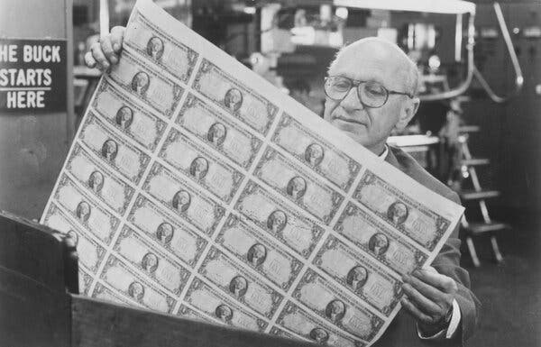
Image
The desire of shareholders “generally will be to make as much money as possible,” Milton Friedman wrote.Credit...PBS

Further reading (and listening)
“Has Business Left Milton Friedman Behind?”
In a column introducing the anniversary project, Andrew asks: “What would Mr. Friedman make of this current moment?”
In his essay, he calls outspoken C.E.O.s “unwitting puppets of the intellectual forces that have been undermining the basis of a free society.” So how would he judge today’s corporate leaders, who increasingly disavow that view of profit as business’s only responsibility — and use their money and influence to back movements pushing for racial equality, addressing climate change or taking overt political positions?
“How Liberals Opened the Door to Libertarian Economics”
ADVERTISEMENT
Continue reading the main story
For more on the historical context in which Mr. Friedman’s essay landed, the author Kurt Andersen writes about how a “decade of free speech and anything-goes outlandishness made his previously outlandish economic ideas seem worthy of discussion in respectable circles.”
For businessmen who felt demonized by public opinion and besieged by tougher government regulation for the last few years, the militancy of the Friedman doctrine in The New York freaking Times a year after Woodstock was thrilling. And then, as now, to get what they were mainly after politically — superlow taxes, minimized regulation — they exploited the voter backlash against street protests by aggrieved, angry younger Americans.
“What Milton Friedman Missed About Social Inequality”
In an extended online version of their remarks in the magazine, Delaware’s former chief justice Leo Strine Jr. and the Allbirds co-founder Joey Zwillinger write about the “rueful irony in this anniversary.”
Mr. Friedman wrote the influential essay at a time when economic security was strong, as the New Deal’s principles produced widespread prosperity, reduced poverty and helped Black Americans take their first real strides toward economic inclusion. Since then, the United States has gone backward in economic equality and security — a situation that the Covid-19 pandemic has exposed for all to see.
Mr. Strine and Mr. Zwillinger also joined us for a DealBook Debrief conference call, which you can listen to here. During the call, the former judge described the need for a “truth and reconciliation commission” for capitalism, reflecting on the issues — like social injustice and climate change — that have grown in prominence in the 50 years since Mr. Friedman published his essay.
What do you think? What did Milton Friedman get right — and wrong? Should businesses have any priorities more important than profits? Can companies serve shareholders and other stakeholders equally? Let us know at dealbook@nytimes.com. Include your name and location and we may include your response in a future newsletter.

