Sunila khan: 1813037
Lecturer: Sujeewa Herath
BMSK 50002: Developing Relationship and
Workplace Achievement
Date: 21st July 2020

Content Page
Table of Contents
Sunila khan: 1813037 1
Introduction 3
Methodology 3
Development Vehicles 3
Motivation 4
Type of Motivation 4
Extrinsic Motivation 4
Intrinsic motivation 4
Process of motivation 4
Motivation theories 5
Vroom’s Expectancy Theory 5
Herzberg's Theory 5
Maslow Hierarchical Needs Theory 6
Commitment 7
Organisational Commitment 7
Characteristics of commitment 7
Effective Commitment 7
Continuous Commitment 7
Normative commitment 8
Employee Engagement 8
Elements of Engagement 8
Development Vehicles in Workplace 9
Profile of the Business 9
Potential Benefit to the Organisation 10
Motivate employees 10
Demotivate Employees 10
Importance of Commitment 10
Control Oriented Approach 10
Commitment Strategy 11
Problem with the Concept of Commitment 11
Effective Commitment factor 11
Drivers of Engagement 12
Engagement Tools 12
Outcome of Employee Engagement 13
Potential Benefit to the Individual 13
Person profile 13
SWOT Analysis 14
Personal Development Plan 15
Personal Development Plan (PDP) 16
Conclusion 16
Reference list 18
Appendix A: 20
Appendix B: 21
Motivation theories 21
Appendix C: 21
Vroom’s Expectancy Theory: 21

Introduction
This report highlighted development vehicles and also discuss methodology. Briefly explain how development vehicles are important in workplace. How organisational used development vehicle to motivate their employees, what is the benefit to keep employees motivated in organization? How beneficial is employee engagement? How engaged people give better performance and raised the standard of organization? Also discuss about different theories which are used in workplace. Purpose of the report is how development vehicle impact in the organisations and employees. This report also highlighted potential benefit of individual in organisation. Framework SWOT analysis and personal development plan is used which gives a clear picture of future planning.

Methodology
Report highlighted also methodology. Methodology is a method to collecting data and information. According to Kothari, (2004) “Methodology is defined scientific and systematic research for information of specific topic.”
I used the collecting data method from organization website for the interview of the person to find out how his/her organization motivate, committed to the job and how they engaged with organization. In this report I used myself as an employee. I interviewed myself and method I used for interview. I looked all the survey and feedback which they received from employees. I collected all the data to argue my report.
This report also highlighted different theories, how they used theories to keep employee satisfy and for the higher performance.

Development Vehicles
Development vehicles are very important for any organisation Without these vehicles we cannot progress. In my report I am going to talk about three development vehicles which are, commitment, motivation and employee engagement but there are many more development vehicles which are also backbone of any organization and without the development vehicles they cannot reach their goals, progress and achievement.
Some development vehicles are:
- Human resource management (HRM)
- Performance management
- Feedback
- Motivation
- Commitment
- employee engagement
- Rewards
- Training
- E-Learning
- Workplace learning and development
- Leadership and management development

Motivation
Motivation is reasoning to do something or willingness and goal, basically motivation is push ourselves to reach our goal and committed to the job, for example, I choose management course to have a better career and finding a good job. Management course motivates me to attend the university to fulfil my goals and future aims. According to business dictionary (2020), “Internal and external factors that stimulate desire and energy in people to be continually interested and committed to a job, role or subject, or to make an effort to attain a goal.”

Type of Motivation
There are many types of motivation, but I am going to talk about two types of motivation which are:
- Extrinsic motivation
- Intrinsic motivation

Extrinsic Motivation
Extrinsic motivation is doing something to get a reward from the environment it is involved money reward social recognition and it is controlled by an outside source.

Intrinsic motivation
Intrinsic motivation is an individual motivation, for example, fulfil our self-desire and empower yourself. Intrinsic motivation is doing something because you enjoy it. It is not because you expect reward and feedback. You do something because of your own satisfaction.
For example, little children love to play and learn new skills by playing they motivate to learn some new skills. According to Deci and Ryan (2010) “When people are playing and learning that way they are more motivate and willing to do anything throughout their life.

Process of motivation
Motivation is an essential process. Motivation process has three elements.
- Need
- Action
- Rewards
For example, I need a house my action would be finding all good pay, great job to save some money for the house and my reward will be to buy a house.
An explanation of the model of motivation process is at appendix A.

Motivation theories
From time to time lots of motivation comes to improve the employability and management skills including Vroom theory, Maslow’s theory, Alderfer’s theory, McClelland’s theory. The purpose of the theories is to engage employee and management to better outcome. Some theories proven are good some bad. According to Miner (2005) “Theories can be good or bad, frequently somewhere in between. They can seek truth or some other goals. Many additional ways to classify theories exist as well although the labels that result often are self-evident approaches require more discussion.”
See appendix B for details of some theories.

Vroom’s Expectancy Theory
Vroom's theory is based on three factors. It is developed by Victor Vroom in 1964. According to Parijat and Bagga (2014) “Every employee has some personal goals which they like to achieve. That is why they work hard in organizations. These personal goals can be fulfilled by organizational rewards or work outcomes. Therefore, the relationship between organizational rewards or work outcomes and personal goals is important.”
Vroom theory is based on three factors. One of the factors is expectancy. Employees think when they work hard, they will be returned extra rewards, basically they expect outcome. Second factor is instrumentality that mean certain outcome you wish to achieve. Third one is that rewards satisfied individual goal.
See appendix C for details of Vroom’s theory:

Herzberg's Theory
Herzberg’s well-known motivation theory based on two factors which are hygienic factor and motivation factor. He thinks there are two different ways to motivate employees at work. First of all, motivate employee so they can work hard to improve organisational progress. He identifies hygienic factor too. If hygienic factor not present, they cannot motivate employees. According to Alfayad and Arif (2017) “This theory determined that different aspects cause job dissatisfaction and satisfaction, Herzberg’s theory categorizes the factors, which affect job satisfaction into hygiene, and motivational factors.”

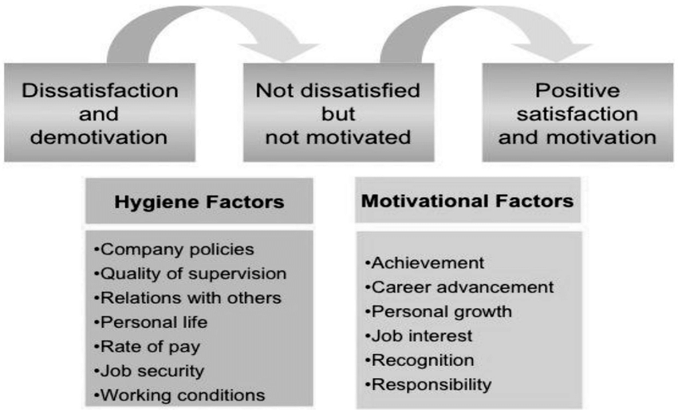

Maslow Hierarchical Needs Theory
Maslow hierarchical needs developed by psychologist and Professor Abraham Maslow in 1943. It is based on 5 levels pyramid shape. It is one of the most famous and effective theory which used marketing, management and many organisations. It is used in Human resources too. There are five levels of human needs which employee needs to fulfil at work. It starts on basic needs like food, air, water, clothes when those needs are met, we are looking for next needs like safety. For example, health, job, personal security, and then we move next level, which is belonging like love, friendship, family these are the basic needs of lower level. When all these three levels are met then we move another two levels which is esteem needs like self-respect and self-confidence. Top level is self-actualization, for example, you need to open your own company own project etc. According to Huitt (2007) “Maslow hierarchical human needs based on two grouping basic needs and growth needs each lower need must be met before moving to the next higher level.”
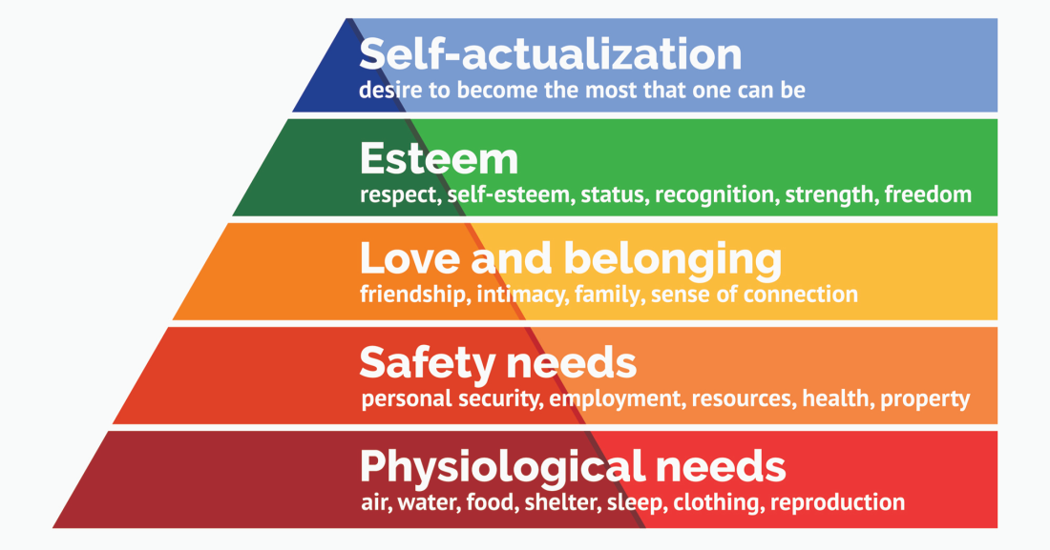

Commitment
Commitment is promise or agreement to do something in a future or being bond emotionally to people or organization. Commitment is a good way to engage other people or companies. Committed people always try their best and think the solution of the problems. According to Ghemawat (1991) “Commitment is only possible reason to think things through in depth.”

Organisational Commitment
Organisational commitment is individual employee psychology and emotional attachment with organisations. People who committed to organisations they are more motivate to reach their targets and goals and they involved more practically in organisations. According to Mowday, Steers, and Porter (1978) “Organization commitment is an Individual's identification with involvement in a particular organisation.”

Characteristics of commitment
According to Meyer and Allen (1991) “Organisational commitment has three separable components which are desire affective commitment, a need continuance commitment, and an obligation normative commitment to maintain and motivate employees in any organisation."

Effective Commitment
Effective commitment is you want to do something for the organisation because you could be emotionally attached to the organisation or you are very loyal with the company you want to see their progression because you treated a company like your own company.

Continuous Commitment
Continues commitment is you continue working for an organisation because you cannot afford to leave, in other words employee staying with the company because of their needs.

Normative commitment
Employees staying with organisations because they might face pressure from others to remain in the company. For example, employee thinks his boss invests so much training and time that is why he wants to stay with them or sometime if employee thinks they have a better job or better career they leave the company, this kind of commitment called normative commitment.

Employee Engagement
Employee engagement is emotional commitment to the organisational and organisational goal. When employee engage and committed to the organisations, they always gave their best and goes for the extra miles. If employee do not commit and motivate, they cannot be engaged with the organisation.
Employee engagement is made stronger bond between employee and employer.
According to Markos and Sridevi (2010) “Employee engagement is stronger predictor and positive organisational performance which is clearly showing the two-way relationship between employer and employee”
Employee engagement concept is one of the popular tools which is used nowadays in HRM and many more organisations use employee engagement processes. This process is important because they help organisations to reach their goals. According to Saks (2006) “Employee engagement has become a hot topic in recent years among consulting firms and in the popular business press.”
Employee engagement motivates the employees to engage with their work. Employees’ dedications towards the work is always positive and they are always focused, full of energy always ready to put some extra effort and they look forward to fulfil all the organisational needs and goals.
According to Bhuvanaiah and Raya (2014) “The main emphasis was to keep engagement levels up that create a continuous engagement culture for building highly productive workforce. Survey shows that 60% of highly engaged employees exceed the expected level of performance.”

Elements of Engagement
Engaged employees can easily get future achievement and goals for themselves and also for the organisations. They are committed and motivated for their work and always be loyal with the organisation and staff. Their involvement for the organisation is always admirable.
There is some more element of employee engagement:
- Share ideas and value.
- Always being involve.
- Build trust.
- Emotionally attached.
- Better outcome result
- Fair deals.
- Loyal.
- Motivate.
- Commitment.
- Teamwork.
- Management support.
- Growth.

Development Vehicles in Workplace

Profile of the Business
I am going to talk about where I worked before, the place is called Avery Healthcare. Avery Healthcare is for residents with dementia and nursing care home in the UK. They deliver highest standard of living for their costumer for peace of their mind and their family and friends. They have more than 60 care home across the UK. (Avery Healthcare2020)
Care home open 24 hours, most of the carers staying days and night. Also, there are work senior nurses to help vulnerable and ill resident. They also provide a service for people who wants to stay for short term recovering from illness or someone who is unable to look after themselves. They provide opportunity for the patients who wants to live for short terms and also provide the facilities who want to stay their long-term conditions.
Dementia is a very challenging an emotional experience for life. Avery provide all the facilities for the person who having an illness and their family to trust Avery care home for their loved ones. They are providing freshly cooked meal three times like home. They also give them menu choices. Avery providing lot of wellbeing activities like quiz, to keep mental health up to date and also, they maintain the balance between mental and physical activities to keep them healthy and fit.
Avery also provide personal care service who needs support with their daily life living such as bathing, dressing, medication, supervision, cooking, cleaning and mobility which they cannot manage at home.

Potential Benefit to the Organisation

Motivate employees
Avery motivate their employees to give them job opportunity and progress to the future. If employees do extra hours they get paid extra. Avery paid sick pay, double pay on bank holiday, holiday pay, extra vouchers from the different shops that way they can motivate their employees to stick with them. Basically, they provide intrinsic an extrinsic motivation to the employee to keep them motivated to their work and for the better performance so they treat employees both way money wise and reward wise because some people like money and some people like reward. Avery strategy is bit of both, they give extra pay for the extra hours and plus also they provide some vouchers for the reward. According to Ganta (2014) “Most employees need motivation to the better performance and good outcome. Some employees motivated with money while others find recognition and rewards personally motivating.”

Demotivate Employees
Avery negative point is they didn't celebrate employee small success, for example, if they did something good and put some extra effort, they did not say to the employees you did very good, they are very impressed. In my point of view this is a negative point to demotivate employees that way they cannot focus, and it impacts with their performance and effect relationship with other employees. According to Anitha (2014) “Special focus and effort is required specifically when you work as a team otherwise your relationship with co-workers have shown significantly higher impact on employee engagement and their performance.”

Importance of Commitment
Commitment is a very important factor of any organisation. Commitment give employee responsibility, encouragement, achieve the targets. Avery tried their best to get committed employees that is why they offer future growth and job satisfaction so they can motivate employee and committed to their organization. Some people in Avery worked with them very long period that’s why they emotionally attached with organisation; they provide effective commitment to them, but it is not the case for everyone. Everybody has their own circumstance, some stick with them because of their situation.

Control Oriented Approach
Some organisations use control-oriented approach for the committed strategy and for the high performance. Control oriented approach is management decided job description, job roles, job responsibilities and job positions basically job is ready for the employees. Management fix the jobs and the job roles. According to Walton (1985) “Every employee responsible for a fixed job and is required to perform up to the minimum standard defined for that jobs.”
People come for the interview and ready to start work. Avery Healthcare use control-oriented approach in their organisation.

Commitment Strategy
Commitment strategy is a team working system. Avery healthcare used Commitment strategies in their organization to be planning employees’ job, their job description, job role and employee’s job responsibility to complete the task and share responsibilities with the other team members.
Time might be more flexible to use commitment strategy. People may take more responsibilities and share different task in team member in different days. Task will be more interesting, and employee did not feel bored to do same task every day. This is a reason Avery used commitment strategy in their workplace.

Problem with the Concept of Commitment
Main problem is the concept of commitment because some people do not know what they are committed to. Different writer has different argument, concept and opinions about the word commitment.
Some examples:
- Commitment to organisation.
- Job commitment.
- Career commitment.
To understand more clearly concept of commitment it is necessary to analyse commitment properly. According to Becker (1960) “understand commitments fully, analyse commitment and understand the situations bit more.”

Effective Commitment factor
These are some effective commitment factors:
- Salary.
- Flexibility.
- Career progression.
- Teamwork.
- Employee involvement.
- Problem solving and decision making.
- Trust.
- Training.
Avery heath care improve their organization more. If they apply effective commitment factor to their organization.

Drivers of Engagement
Avery care home try to engage their employees in their organisation, they use monthly meeting tactic to listen to employees’ suggestions, ideas, so they can improve their service and make any future changes for the progression. That way employee feels more engaged to the company because they have two-way communication. Communication is key to engage employee in organisation.
Avery do free training for their employees and they give some future opportunity and also they have some reward system to engage their employees in their organisation. Some employee can see their future progression in this organisation that why they are more motivated and engaged to the company.
Avery needs some more improvement to engage their employees. They can arrange different type of activities like World Cafe approach, development day that way they can engage more employees.
As a manager and leader into your organisation they have to focus on key drivers to engage employees and build relationship to another employee's. Research says if employee engaged their performance will be more effective. According to Bedarkar and Pandita (2014) “The concept of employee engagement has now gained even more importance, since many drivers have been identified, which impact employee performance and well-being at workplace.”
To use driver of engagement managers can build strong connection with their employees- and build their trust. Give them a little reward, for example, offer free meals or coffee to keep them happy and more engaged. If employees are happy they can contribute more and perform better. Give them freedom like let them decide little decision related to their job. When you give your employees choice, they can feel more engaged. Give them a growth opportunity to their jobs, give them a task variety so they can enjoy their work because some people when they do one thing, they get bored easily, give them feedback so they have a clear idea what you are expecting from them.

Engagement Tools
Using the engagement tools Avery or any other organisation they can engage their employee modes
- Feedback
- Health and safety
- Rewards
- Training and coaching
- Job satisfaction
- Setting target
- Communication
- Teamwork
- Employee voice
- Treat people equally
- Good pay rate
- World cafe approach (brain storming)
- Development day

Outcome of Employee Engagement
- Put some extra effort
- Willing to do extra miles
- Willing to do help colleagues
- Organisation progress better
- Positive attitude in workplace
- Strong management

Potential Benefit to the Individual
As an employee Avery company motivate me from their reward system. When I do some extra hours, they give me extra money which motivated me to do some extra work for them. I can see my future growth with them that is why I am committed to the organisation and organisation engaged me through their meetings where I can share my ideas, thoughts and opinions with them directly face to face.
Demotivate elements and factors at the company they did not give variety of task that is why people get bored quickly because they do not want to do same job every day. Another thing when people work hard, they get extra money but the others they did not get extra money. This is the reason some people do not commit to the organisation. Avery Healthcare need to organise World Cafe approach or development day programmes to keep employee engaged, motivate and committed.

Person profile
Sunila Khan
Stechford
Birmingham
B33
Tel: 0121 781 00 00
Email: nshh786@yahoo.co.uk
I am energetic, ambitious, confident and responsible person. I love to do different task, challenges and activities. I love to learn new things. I have excellent communication skills. I know how to handle difficult situations. I recently done higher certificate of education level 4 and um continue my study to get more knowledge and improve myself
I am working at Avery Healthcare as a chef. I learnt many different skills in my workplace which gave me excellent experience in the future.

SWOT Analysis
SWOT analysis is a key part of any business and strategic plan. SWOT is strength, weakness, opportunity and threats. Strength and weakness are internal factor and opportunity, threats are external factor. SWOT used for the businesses to get a clear idea pros and cons. It is normally based in four boxes. According to Gurel and Tat (2017) “SWOT Analysis is a tool used for strategic planning and strategic management in organizations. It can be used effectively to build organizational strategy and competitive strategy.”

Strengths  - Communication skills  - Team working  - Quick learner  - Good at making judgments  - Can do attitude  - Make a list to save time  - Problem solving and decision making | Weaknesses  - Consuming time  - Social media  - Learn digital skills  - bored to do same task  - New IT system  - Poor typing
Opportunities  - Leadership management  - Working with different people  - Learn from others  - New career direction  - Gathering experience  - Improve English language  - Work placements  - Personal growth  - Two-way communication | Threats  - Language barrier  - Time stealers  - Lack of internet knowledge  - Unexpected events  - Too many competitors  - Horrible boss  - Poor management strategies  - Political and economic theatre

Personal Development Plan
Research shows personal develop plan used for different purpose. It is also used in organisations to find out employee's performance, job, salary, short term or long-term planes. According to Beausaert, Segers and Gijselaers (2011) “Morden day organisations are increasingly implementing assessment tools such as Personal Development Plans. They research more and study presented and better understanding of how to use Personal Development Plan (PDP), to assessed employee performance and work it out how to undertakes learning activities for the better and higher performance to improve the productivity.”

Personal Development Plan (PDP)

Skill | Action | Time frame | Rescores
Improve IT skills | Join more courses | 6 months | Apply online courses
Improve my English skills | Reading books | When I get a chance | Communicate with English
Improve problem solving and decision-making skill | Brain storming,  Critical thinking | Whenever have an opportunity | Observe situation and others
Understand of leadership | Attending more development programme | 12 months | Attend all leadership programme meetings

Conclusion

In this report I found to use the method of development vehicles in organisation that way we can improve employee's performance to get higher result and work achievement. I found motivated employees put extra effort into their work and task because motivated employees are more committed to their job and they are more engaged with organisation and with other employees. Motivate employees always looking forward to achieving their and organisational goals. There are two type of motivations some people motivate with Intrinsic factor of motivation and other motivate with extrinsic motivation.
I also found organisations use different kind of theories to motivate and engage their employees. I found lots of details of Herzberg’s theory, Vroom Expectancy theory and Maslow hierarchical are needed and I personally recommend Maslow hierarchical is good compared to other theories because it fulfils all the requirement of humans. It is start from basic needs and slowly raised to get higher needs and goals.
I found three type of commitments which is effective commitment, continuous commitment and normative commitment. In my point of view effective commitment is the stronger commitment to compare the other ones. Effective committed employees are always loyal and honest with the organisation and they give always 100% but other types of commitments always change depending on circumstances which is not good for the organisation and employees.
Finally, I recommend SWOT analysis. SWOT analysis is important and give us a clear picture to improve any kind of department. It is very useful tool for the any organization, workers and workplace. SWOT analysis clearly tells us which area we are very good and which area we need to improve, and I also research personal development plan to tells what kind of skills, action, time and resources required.

Reference list
Alfayad, Z. and Arif, L.S.M., 2017. Employee voice and job satisfaction: An application of Herzberg two-factor theory. International Review of Management and Marketing, 7(1), pp.150-156. [Accessed 05 June 2020]
Anitha, J., 2014. Determinants of employee engagement and their impact on employee performance. International journal of productivity and performance management.
Avery Healthcare (2020) available at https://www.averyhealthcare.co.uk/ [Accessed 07 June 2020]
Bhuvanaiah, T. and Raya, R.P., 2014. Employee engagement: Key to organizational success. SCMS journal of Indian Management, 11(4), p.61. [Accessed 06 June 2020]
Bedarkar, M. and Pandita, D., 2014. A study on the drivers of employee engagement impacting employee performance. Procedia-Social and Behavioral Sciences, 133, pp.106-115.
Beausaert, S.A., Segers, M.S. and Gijselaers, W.H., 2011. Using a personal development plan for different purposes: Its influence on undertaking learning activities and job performance. Vocations and Learning, 4(3), pp.231-252.
Business dictionary (2020) http://www.businessdictionary.com/definition/motivation.html [Accessed 29 June 2020]
Becker, H.S., 1960. Notes on the concept of commitment. American journal of Sociology, 66(1), pp.32-40. [Accessed 07 June 2020]
Deci, E.L. and Ryan, R.M., 2010. Intrinsic motivation. The corsini encyclopedia of psychology, pp.1-2. [Accessed 29 June 2020]
Ghemawat, P., 1991. Commitment. Simon and Schuster. [Accessed 05 June 2020]
Ganta, V.C., 2014. Motivation in the workplace to improve the employee performance. International Journal of Engineering Technology, Management and Applied Sciences, 2(6), pp.221-230.
Gürel, E. and Tat, M., 2017. SWOT analysis: a theoretical review. Journal of International Social Research, 10(51).
Huitt, W., 2007. Maslow's hierarchy of needs. Educational psychology interactive, 23. [Accessed 05 June 2020]
Kothari, C.R., 2004. Research methodology: Methods and techniques. New Age International. [Accessed 08 June 2020]
Mowday, R.T., Steers, R.M. and Porter, L.W., 1978. The measurement of organizational commitment (No. TR-15). OREGON UNIV EUGENE GRADUATE SCHOOL OF MANAGEMENT AND BUSINESS. [Accessed 05 June 2020]
Meyer, J.P. and Allen, N.J., 1991. A three-component conceptualization of organizational commitment. Human resource management review, 1(1), pp.61-89. [Accessed 05 June 2020]
Markos, S. and Sridevi, M.S., 2010. Employee engagement: The key to improving performance. International journal of business and management, 5(12), p.89. [Accessed 05 June 2020]
Miner, J.B., 2005. Organizational Behavior: Essential theories of motivation and leadership. one (Vol. 1). ME Sharpe. [Accessed 04 June 2020]
Parijat, P. and Bagga, S., 2014. Victor Vroom’s expectancy theory of motivation–An evaluation. International Research Journal of Business and Management, 7(9), pp.1-8. [Accessed 04 June 2020]
Saks, A.M., 2006. Antecedents and consequences of employee engagement. Journal of managerial psychology. [Accessed 06 June 2020]
Walton, R.E., 1985. From Control to Commitment in the Workplace: In factory after factory, there is a revolution under way in the management of work. US Department of Labor, Bureau of Labor-Management Relations and Cooperative Programs. [Accessed 06 2020]

Appendix A:

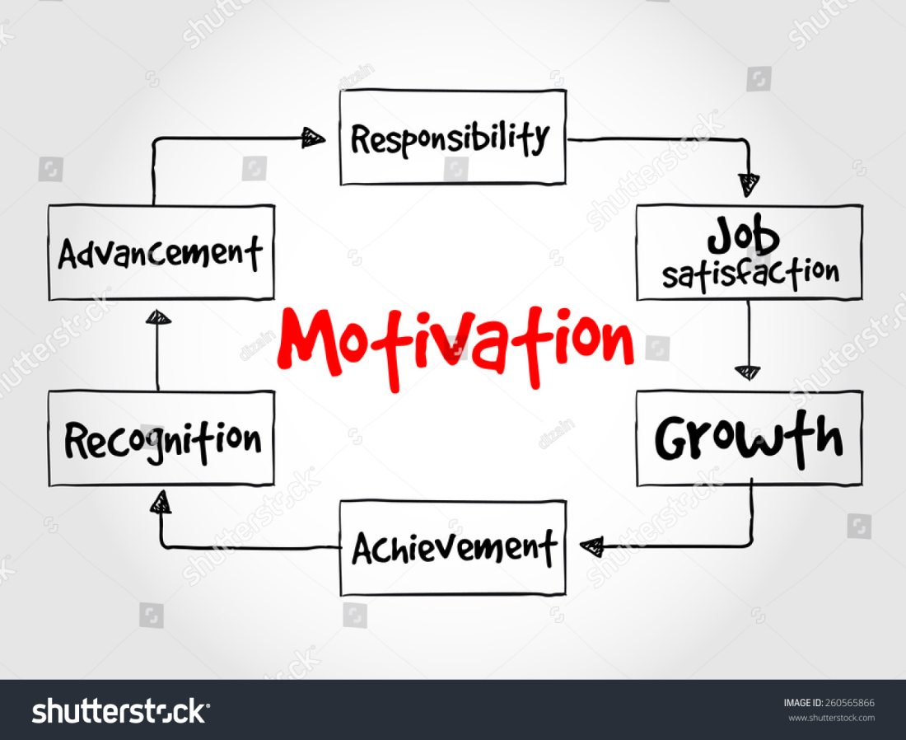

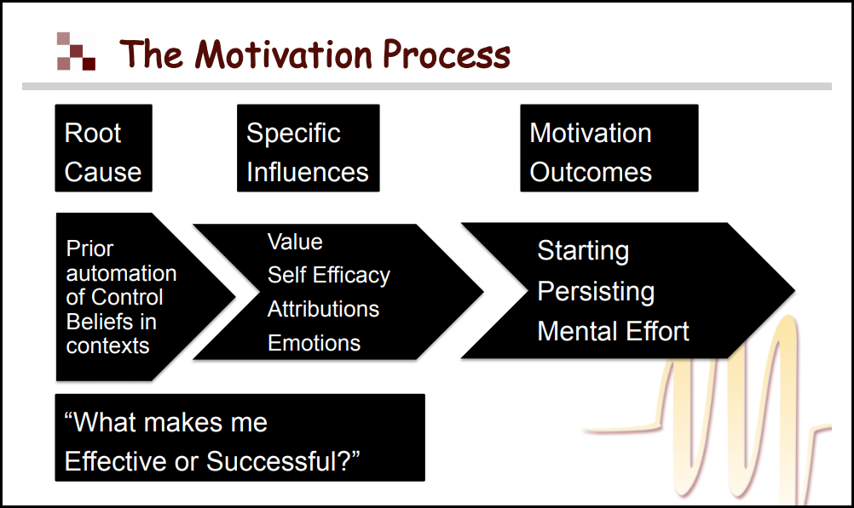

Appendix B:

Motivation theories
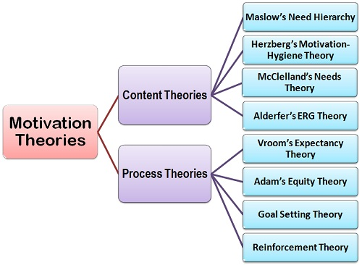

Appendix C:

Vroom’s Expectancy Theory:



