

LOCATION: /Swansea | LLEOLIAD: abertawe
LEVEL 6 | LEFEL 6
EXAMINATION PERIOD | CYFNOD ARHOLIADAU
NOV 2021 | 2021

MODULE CODE: ACMA6000
ADVANCED PROCESSES AND MATERIALS
TIME: 2.5 HOURS

answer ALL QUESTIONS

Equipment or materials required – None
Adnoddau neu ddefnyddiau sydd eu hangen - Dim

1 (a) Discuss in detail the advantages and limitations of the laser, solid state, welding
process which is becoming more widely used in the automotive and domestic
appliance industries for the purpose of fabrication and
assembly. Your answer should consider surface preparation, weld integrity,
exclusion of the atmosphere, potential defects and distortion.
(10 marks)

1 (b) Critically appraise the Tungsten Arc Gas Shielding process
which can be used in the following modes: straight polarity, reverse polarity, pulsed,
and plasma. Your answer should include reference to the following:

i) The type, nature, properties and functions of the gases used.

ii) The overall “quality” of the welds produced in terms of potential defects and
distortion.
(10 marks)

2 (a) Corrosion and wear resistant coatings can be applied to metallic substrates
using the Thermal Spraying process.

Compare the Thermal Spraying process to other commonly used coating
processes, such as Electro-plating and Weld cladding with particular
reference to:

i) The adhesion/bonding of the coating.

ii) The overall integrity of the coating (i.e. porosity, inclusion and oxide
content).

iii) The Health and Safety/COSHH implications.
(10 marks)

2 (b) Nickel and its alloys are widely used for applications where creep resistance at
elevated temperatures is necessary. Discuss the mechanisms operating in nickel
alloys which contribute to their enhanced creep performance.

(10 marks)

3 (a) Discuss in detail the limitations of recovering and recycling metals and polymers.
Your answer should take into account:

i) The appropriate sorting procedures and their principles

ii) The effects that contamination has on the resultant properties of these recycled
materials.

(10 marks)

3 (b) Distinguish, in terms of composition and properties, between the three major
stainless steel types, namely:

i) Austenitic Stainless Steel
ii) Ferritic Stainless Steel
iii) Martensitic Stainless Steel
(10 marks)

- Fourth Exam Question (20 marks)

- Commercially available aluminium alloys for car body stampings offer weight savings over steel bodied cars. This improves performance and economy. The manufacturers also claim an improvement in the environmental impact of the vehicle. With reference to lifecycle based carbon accounting, why might this claim be a candidate for serious scrutiny. (6 marks)

- Illustrate the argument by comparing your estimated lifecycle based carbon emissions per kilometer between the following two vehicles.

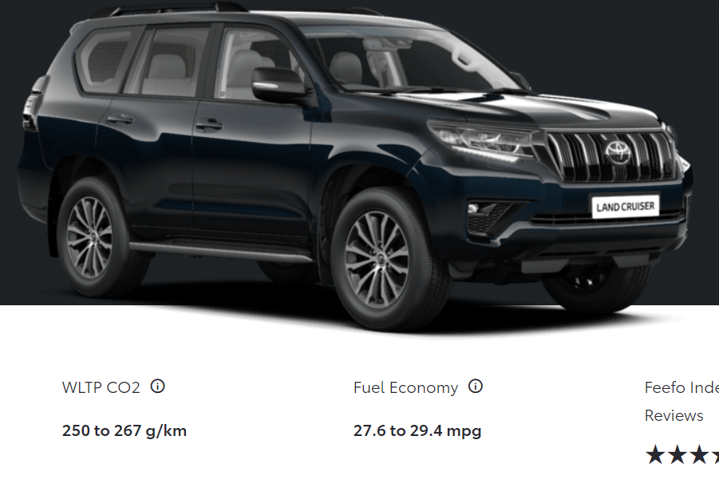
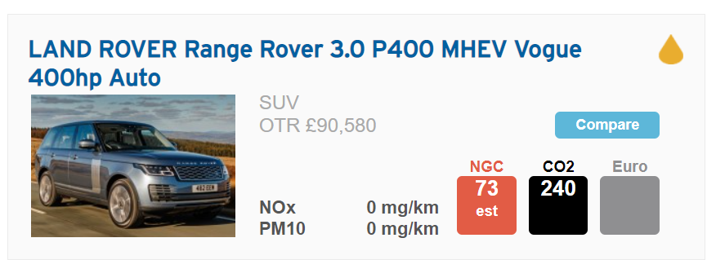
Fig 1

You may assume that the life of each vehicle is 250,000 km and that the steel body work of the Toyota weighs 800kg while the aluminium bodywork of range rover has a mass of 375kg. You may assume that all other components (Engine, driveline etc) have similar lifecycle carbon footprints and contain 800kg of aluminium, 300 kg of steel, 50 kg of copper and 120 kg of plastics. (10 Marks)

Reference : Material embodied carbon footprints :

Sheet steel. 1.2 kg/kg
Aluminium 14.5 kg/kg
Copper 9 kg/kg
Plastics 1.5 kg/kg

- Referring to their manufacturing processes (fig 2) and what you know about aluminium recycling, aluminium distribution vehicle manufacture and vehicle operation, industry Identify 4 areas where the lifecycle carbon footprint of aluminium cars can be improved. (4 marks)

pto

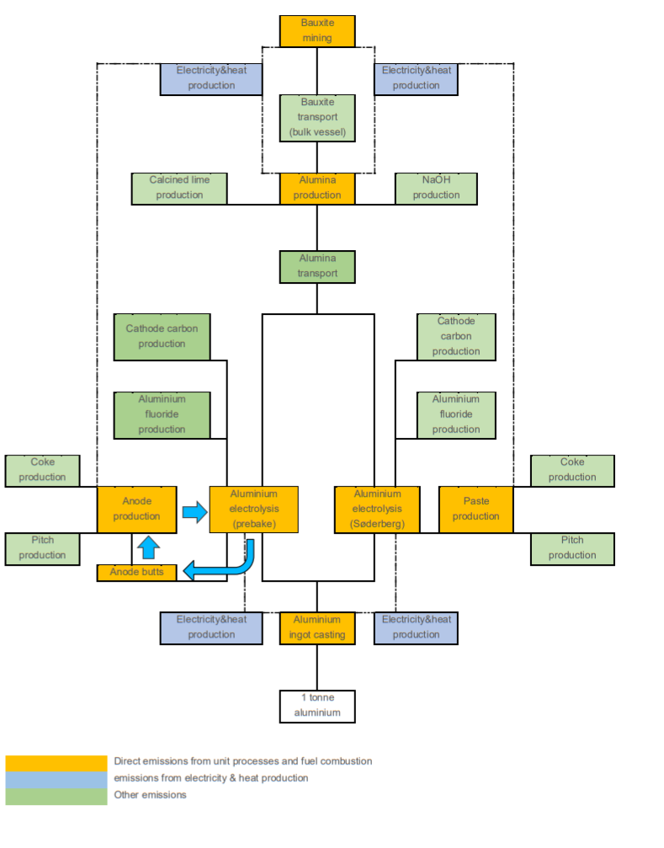fig 2

Diwedd/End

