

University of Wales Trinity Saint David
School of Engineering
Service Logistics (M6X01294)
Chris Ashmead
1902167
BSc (Hons) Logistics and Supply Chain Management

Abstract

Over the last two decades, the logistics and supply chain industry has been subjected to a monumental and substantial shift in consumer behaviour. Therefore, in response, organisations began investing heavily in digitalisation and integrating it throughout all aspects of their supply chains as a means to meet such demands and expectations placed upon them. Additionally, the inclusion of digitalisation has played a significant role in helping organisations to ascertain a greater level of efficiency, transparency, productivity, and interconnectivity throughout all their supply chains allowing them to trade and conduct business with other companies worldwide. However, through the continued increase in the size of supply chains, it can also be seen as an area of vulnerability and an increasing concern regarding cyber-attacks. Therefore, to address the challenge of cyber threats, organisations have implemented more advanced forms of technology such as cybersecurity and its associated tools that can prevent, detect, and nullify these ever-increasing threats. Furthermore, from an alternative perspective, many companies have witnessed that through its practical application, cybersecurity can be used to achieve a competitive advantage over rival firms.

Table of Contents
1. Introduction 4
2. Defining cybersecurity and related concepts 5
2.1. Cybersecurity 5
2.2. Cyber Risk 5
3. The importance of cybersecurity within organisations 6
4. Benefits of addressing cybersecurity in supply chains 7
5. Generating a competitive advantage by creating cyber security competencies 7
5.1. DHL's Resilience360 Supply Watch 8
8
8
Conclusion 9

1. Introduction

In the contemporary era, logistics organisations have continually integrated a range of digital technologies such as Artificial Intelligence and Augmented Reality to deal with the persistent rise of globalisation, to fulfil the increasing expectations and requirements from consumers, to ascertain greater transparency to observe forever changing markets, and ensure that they can remain competitive against rival companies by increasing production capacity whilst simultaneously minimising their overall costs and errors. Furthermore, the need for these technologies has been highlighted with the worldwide Covid 19 Pandemic, and its effects on global trade routes continue to be seen. However, due to the heavy dependence on such technologies, many organisations have found themselves the victims and target of various cyber-attacks, with aims including but not limited to stealing confidential data and industrial espionage. A most notable security breach was the NotPetya virus of 2017, which contributed to over $10 billion in global economic damages to a range of industries. Furthermore, (Haschak and MD, 2019) accentuates that the regularity and the cost implications of cyber-crime on organisations has doubled during the past five years and is anticipated to triple in the next five. Moreover, a recent report further reveals that as of 2020, there have been more than 36 billion records exposed by malicious actors (Security, 2020) and that the associated costs of cybercrime for organisations usually equates to 2.9 million dollars every minute (Świątkowska, 2020).

Therefore, as a measure to alleviate and neutralise other cyber risks and disruption, many companies have begun to invest heavily in and focus their attention on the utilisation of more cyber security-based initiatives. However, regardless of the extensive attention surrounding the eminent danger that cyber-attacks presently impose on organisations, unfortunately, it is not always met with the necessary amount of concern or prioritisation. There remains a surprisingly large number of companies and corporations positioned poorly and thus ill-equipped to address the everchanging cyber issues. Many leading company executives still only consider cybersecurity as a significant priority once an encroachment on the company's supply chains has arisen, ignoring the many benefits that a secure and all-encompassing strategy or programme would harness and instead of seeing the negative impact on their business of not having sufficient protocols in place.

Therefore, this report aims to provide those company executives and logistics organisations that have minimal cyber safety measures currently in place with a greater level of transparency and deeper understanding of the vital role that cyber security-based practices can provide their organisation with. Furthermore, the report will help establish how cybersecurity can be seen as a valuable asset for enhancing organisational learning, providing new opportunities, and helping to develop a better competitive advantage.

Competitive advantage - relates to those considerations that enable an organisation to generate products and services that are of a superior nature and are of a significantly lower cost than their closest competitors (Twin, 2021).

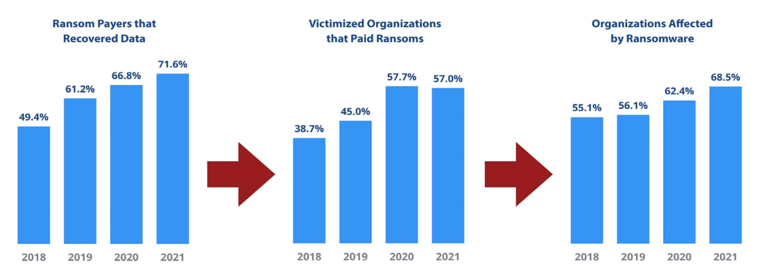
Figure 1 - The recovery, cost, and effects of ransomware on organisations

(Zaharia, 2022)

To shed greater light on the severe effects that cyber threats currently have on organisations, fig 1 shows a causal nexus of the significant percentage increase over a four-year period with regards to the amount of recovered data, associated costs that have been paid in ransom by exploited corporations and the staggering number of organisations that have fallen victim to the demands of malicious actors.

2. Defining cybersecurity and related concepts

2.1. Cybersecurity

- Cybersecurity can be defined as an approach and string of activities bound to a combination of risk management processes executed at a national or company level to safeguard the morality of classified information kept within cyberspace (Schatz et al, 2017).
- Cybersecurity is classified as a combination of various implements, policies, notions, regulations, and risk management recommendations that can be applied to preserve the digital environment, an organisation, and its valuable assets (ITU, 2009).

2.2. Cyber Risk

- Cyber risk can be defined as "any risk resulting from the use of electronic data and its transmission, including technology tools such as the internet and telecommunications networks; physical damage that may be caused by cyber-attacks; fraud committed by misuse of data or any liability arising from data, storage and transfer" (CRO, 2014).
- Cyber risk concerns all aspects of risk that are related to all online activities, such as the stockpiling of confidential data or carrying out transactions online, which may be subject to reputational damage, a deficit of funds and disruption to the structure of an organisation (NAIC, 2022).

3. The importance of cybersecurity within organisations

Whilst many of the world's leading organisations, such as Apple, have continued to implement the use of privacy as a necessary means to distinguish themselves away from their closest competitors (Panzarino, 2019). This has meant that a level of confidentiality and security have become integral to Apple's overall brand image (Benner and Mozur, 2016), whilst other organisations have failed to acknowledge how to effectively take care of cybersecurity and its related risks on a functional level. Furthermore, although businesses are aware of the varying trends allied with cybersecurity and digitised data, most companies still feel reluctant and incapable of dealing with them effectively. Moreover, it has emerged from a recent study that fifty per cent of those CEOs of American based conglomerates are deeply worried about the implications surrounding cybersecurity (PWC, 2022). Additionally, in a recent survey undertaken by UK based cybersecurity company BlueVoyant. It was revealed that ninety-seven per cent of businesses they had surveyed had been adversely affected by cyber breaches that had taken place within their supply chains (BlueVoyant, 2020).

Additionally, the global covid pandemic has brought about increased usage of digitalisation and remote work. It has dramatically increased a company and their employees' reliability on information technology and the internet as a source to remain in constant communication with and connected to other businesses and the outside world, whilst the cybersecurity issues are not being correctly resolved (Nabe, 2022) Although companies are still readily investing in a plethora of security safeguarding measures like antivirus software, encrypted VPNs and backups. However, it is often seen that such steps to neutralise cyber threats often fall by the wayside. This is because such a technical-based approach overlooks both the issues within an organisation and their employees, who can be seen as being a significant factor in why cybersecurity risks are occurring in the first place (Kosutic, 2021). For example, insufficient employee training or company policy inductions could lead to security breaches.

Furthermore, although professional norms can be implemented, such as ISO 27001, to manage information security effectively, Kosutic (2021) stipulates that the outcome of those organisations that apply such security techniques is often unsatisfactory, with the breaches of security never being entirely suppressed. A compelling reason why such dilemmas resonate can be primarily because cybersecurity initiatives are only seen as simply compliance and technological exertions, while cybersecurity, to be deemed effectual, needs to be viewed from a broader perspective (Kosutic, 2021).

4. Benefits of addressing cybersecurity in supply chains

Additionally, to providing organisations with a financial benefit through better information security integration, there are also several other benefits of implementing cybersecurity:

- Having a secure information system means it is more dependable and robust, which ultimately improves customer care, reduces related costs, and protects a company's reputation (Horne et al, 2017).
- Complying with legislative, statutory, and licit requirements can generate a range of benefits for an organisation, such as retaining its current client base and reducing any associated penalties (Acuna, 2016).
- Having the appropriate security certification enables a logistics organisation to demonstrate that they are compliant with various security conditions. Furthermore, this can be highly beneficial to an organisation's investors that do not meet the necessary compliance regulations but have classified data that needs to be protected. Moreover, security certification can be seen as an effective means for a company to stay in business. For example, a customer may need the appropriate security certification as a prerequisite to continue the working relationship. Additionally, having security certification can be seen as an effective means of attracting new stakeholders and suppliers, especially if the organisation is seeking a more significant international presence (Kosutic, 2021).

5. Generating a competitive advantage by creating cyber security competencies

For organisations to establish a level of competitive advantage and reap the benefits through the implementation of cyber security, they first need to introduce a variety of dynamic capabilities which are unparalleled and hard to replicate by their competitors (Direction, 2021). Moreover, (Wang and Ahmed, 2007) stipulates those dynamic capabilities are considered an organisation's primary inclination to consistently incorporate, alter, restore, and seek to continuously develop the organisation's core competencies. Nevertheless, to sustain a competitive edge of rival firms, it is imperative that such capabilities are deeply rooted within all operational undertakings of an organisation.
The following eleven capabilities outlined by (Direction, 2021) can provide a clear direction of how a company is able to achieve a competitive advantage through cybersecurity.

- Informing - enables an organisation to broadcast critical cyber - data to all branches of their organisation as well all external stakeholders of their supply chains.
- Having an awareness of technology - recognising the various types of security technology currently being used and then implementing the most appropriate security technology to support the organisation.
- Making security as user friendly and as unambiguous as possible - so that an organisation can implement protection devices and regulations so that everyone throughout an organisation has the same overall understanding.
- Brand building - the ability of an organisation to generate trust as a vital aspect of its brand.
- Offsetting security and business - having the dexterity to implement an adequate amount of protection to mitigate risks whilst ensuring that all business activities are not adversely affected or halted.
- Prioritising - implies that an organisation has established which cyber-based undertakings are considered the most critical. Hence, they can invest a significant amount of money and resources.
- Ascertaining a level of expert knowledge - can enable a company to appease their customers and safeguard confidential data.
- Rewarding people - supposes that an organisation should merge security key performance indicators to determine and keep track of the level of cyber protection implemented within their various products and services and seek to reward those individuals and teams when it has been achieved.
- Analysing data - to have the adeptness to discover various patterns within a substantial amount of data to make appropriate security decisions.
- Embedding - implies that an organisation can implement multiple security rules and an assortment of security technologies to conduct its daily operations.

5.1. DHL's Resilience360 Supply Watch
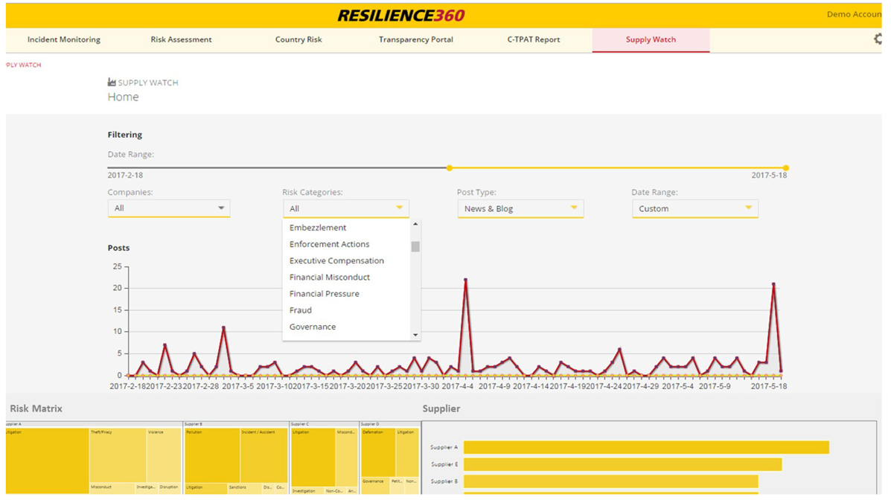

Figure 2 - DHL'S Resilience360 Supply Watch

(DHL, 2017)

The German global parcel delivery specialists DHL is a notable organisation implementing stringent cyber-based capabilities. In 2017, the company introduced an inextricable part into its current Resilience360 Supply chain risk management programme known as DHL Supply Watch. The newly integrated extension, DHL Supply Watch, allows the company to use cybersecurity tools to detect disruptions within its supply chains before succumbing to financial harm or long-term reputational damage. Furthermore, in the aftermath of a cyberattack, the programme can be effective in quickly determining which of the company's suppliers might have been affected and the necessary security measures to be implemented to counteract the effects of future cyber-attacks within their supply chains.

6. Main driver for the implementation of cybersecurity in the logistics sector

The main reason logistics organisations implement cybersecurity comes from the expectations of the various stakeholders that the company conducts business with. To further elaborate, many corporations demand that their vendors have applied security-based initiatives before they consider conducting business with them. Moreover, in a majority of cases, most corporate buyers often favour those suppliers that have applied a set of security conditions like ISO 27001. Therefore, implementing a variety of security standards can help a logistics supplier build a significant amount of trust with a buyer, thus also helping them maintain a good working relationship (Kosutic, 2021).

Conclusion

To summarise, this report has provided a comprehensive account of how the application of cybersecurity can play a clear and decisive role in the logistics sector. It has been highlighted that cybersecurity can not only be used as an effective tool before, during and after cyber-attack. But it can be effectively applied by organisations to ascertain a level of competitive advantage over their competitors by instilling trust between their stakeholders. Additionally, cybersecurity can also be seen as an essential asset to help to improve a company's image, which can be considered as a contributor towards strengthening business relationships or can provide opportunities for a company to establish new ones by showing them how serious that they take onboard the security of data. Consequently, it is hoped that this report can be a revelation to alter the varying opinions and misconceptions that resonate with top-level management that only see cybersecurity from an operational perspective and not from a strategic one.

References

Acuna, D., 2016. Enterprise Computer Security: A Literature Review. Journal of the Midwest Association for Information Systems, 2016(1), pp.37–53. https://doi.org/10.17705/3jmwa.00016.
Benner, K. and Mozur, P., 2016. Apple Sees Value in Its Stand to Protect Security. The New York Times. [online] 20 Feb. Available at: <https://www.nytimes.com/2016/02/21/technology/apple-sees-value-in-privacy-vow.html> [Accessed 28 February 2022].
BlueVoyant, 2020. Managing cyber Risk across the Extended Vendor Ecosystem.
CRO, F., 2014. The cyber risk challenge and the role of insurance. [online] Available at: <https://www.thecroforum.org/wp-content/uploads/2015/01/Cyber-Risk-Paper-version-24-1.pdf> [Accessed 22 February 2022].
DHL, 2017. DHL Supply Watch: Machine learning to mitigate supplier risks. [online] DPDHL. Available at: <https://www.dpdhl.com/en/media-relations/press-releases/2017/dhl-supply-watch-to-mitigate-supplier-risks.html> [Accessed 1 March 2022].
Direction, S., 2021. Investing in cybersecurity: Gaining a competitive advantage through cybersecurity. Strategic Direction, 37(2), pp.19–21. https://doi.org/10.1108/SD-11-2020-0205.
Haschak, M. and MD, S., 2019. Cyber Security and Its Implication on Material Handling and Logistics. p.18.
Horne, C.A., Maynard, S.B. and Ahmad, A., 2017. Organisational Information Security Strategy: Review, Discussion and Future Research. Australasian Journal of Information Systems, [online] 21. https://doi.org/10.3127/ajis.v21i0.1427.
ITU, 2009. Overview of Cybersecurity.
Kosutic, D., 2021. The Impact of Cybersecurity on Competitive Advantage.
Nabe, C., 2022. Impact of COVID-19 on Cybersecurity. [online] Deloitte Switzerland. Available at: <https://www2.deloitte.com/ch/en/pages/risk/articles/impact-covid-cybersecurity.html> [Accessed 22 February 2022].
NAIC, 2022. Dynamic capabilities: A review and research agenda - Wang - 2007 - International Journal of Management Reviews - Wiley Online Library. [online] Available at: <https://onlinelibrary.wiley.com/doi/abs/10.1111/j.1468-2370.2007.00201.x> [Accessed 28 February 2022].
Panzarino, M., 2019. Apple ad focuses on iPhone’s most marketable feature — privacy | TechCrunch. [online] Available at: <https://techcrunch.com/2019/03/14/apple-ad-focuses-on-iphones-most-marketable-feature-privacy/?guce_referrer=aHR0cHM6Ly93d3cuZ29vZ2xlLmNvbS8&guce_referrer_sig=AQAAAG5joNugZQmoesKUZpD--it4p0SmEz77l6sFjRXasS1gPBRrcxQuOUp1jvR-WFatiGVKhZzgBQrS84atOfj40glwKLxLOwRo_fan-MDDnkeviNMYzuTs0vqbtFxwRia4zfmp4xMnEhV8Se0oVTRgInjy1e1DWMjaxLSy-iR6mQ-Y&guccounter=2> [Accessed 28 February 2022].
PWC, 2022. pwc-23rd-global-ceo-survey.pdf. [online] Available at: <https://www.pwc.com/gx/en/ceo-survey/2020/reports/pwc-23rd-global-ceo-survey.pdf> [Accessed 22 February 2022].
Schatz, D., Bashroush, R. and Wall, J., 2017. Towards a More Representative Definition of Cyber Security. The Journal of Digital Forensics, Security and Law. [online] https://doi.org/10.15394/jdfsl.2017.1476.
Security, R., 2020. 2020 Q3 Data Breach QuickView Report.pdf. [online] Available at: <https://pages.riskbasedsecurity.com/hubfs/Reports/2020/2020%20Q3%20Data%20Breach%20QuickView%20Report.pdf> [Accessed 22 February 2022].
Świątkowska, D.J., 2020. Tackling cybercrime to unleash developing countries’ digital potential. p.49.
Twin, A., 2021. Competitive Advantage Definition. [online] Investopedia. Available at: <https://www.investopedia.com/terms/c/competitive_advantage.asp> [Accessed 24 February 2022].
Wang, C.L. and Ahmed, P.K., 2007. Dynamic capabilities: A review and research agenda. International Journal of Management Reviews, 9(1), pp.31–51. https://doi.org/10.1111/j.1468-2370.2007.00201.x.
Zaharia, A., 2022. 300+ Terrifying Cybercrime & Cybersecurity Statistics (2022). Comparitech. Available at: <https://www.comparitech.com/vpn/cybersecurity-cyber-crime-statistics-facts-trends/> [Accessed 27 February 2022].

