ACCB4012
Database Design
Information Engineering
Thomas Platt
5-1-2020

Table of Contents
Introduction 2
Table Creation 2
Entity relationships 3
Form Creation 4

Introduction

I have been tasked with the creation of a database for a bookstore based in Swansea. They have some specific requirements as to what features that they would need to operate. They pride themselves on having great customer interaction this is something that they would not like to lose when this system is implemented.

Table Creation

To create the tables I used SQL I used the following commands to create each time changing the data to what is appropriate:
CREATE TABLE Books(Book_ID TEXT(5) CONSTRAINT book_id_pk PRIMARY KEY, Title TEXT(30), Author TEXT(30), Genre TEXT(15), Rare TEXT(3), Collectable TEXT(3), First_Edition TEXT(3), No_in_Stock NUMBER, Release_Date DATE)
Upon creating the tables using this method I went through and checked that all the fields were correct, and I realised I had missed out a few possible fields, so I then added them through the design menu. After doing this I added input masks to the fields that require it, here are a few examples:
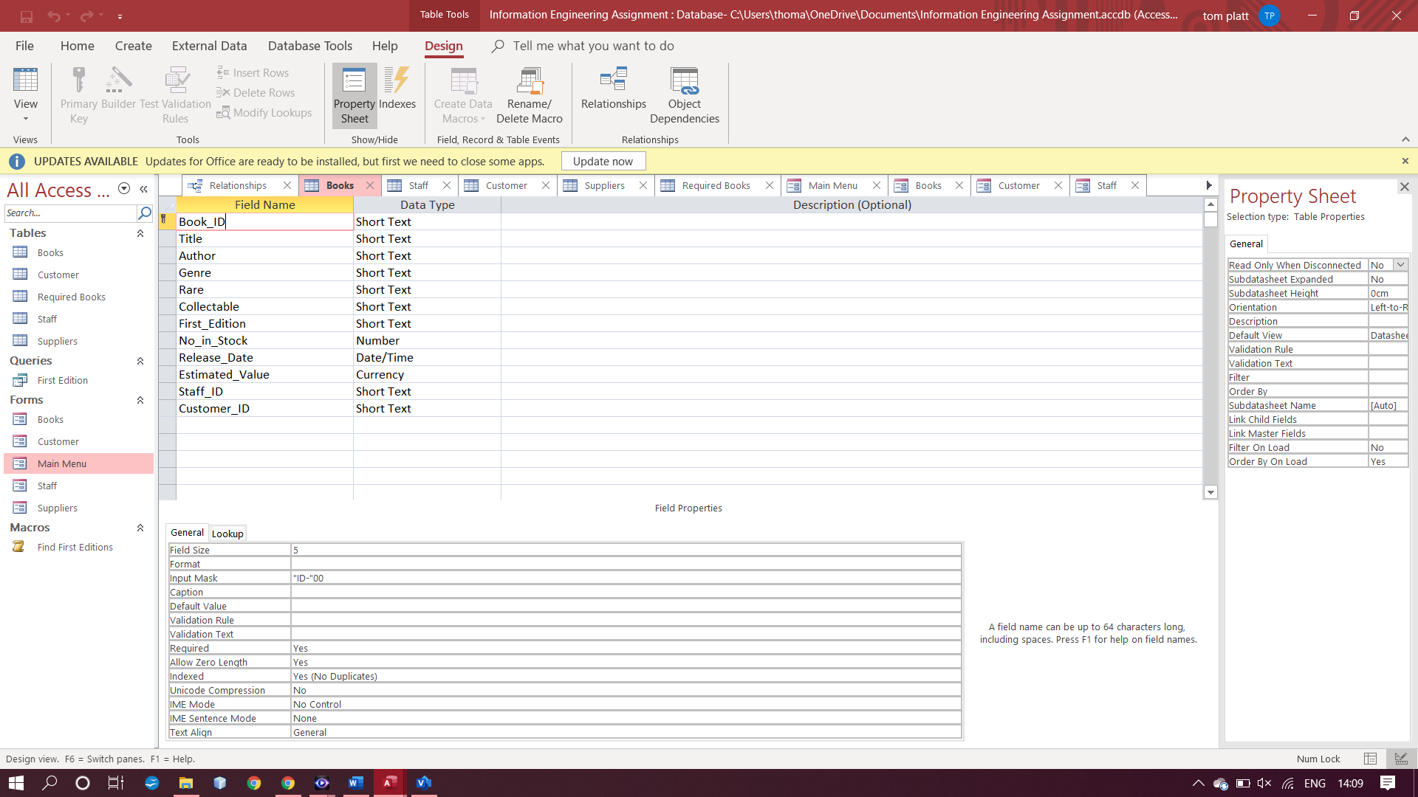
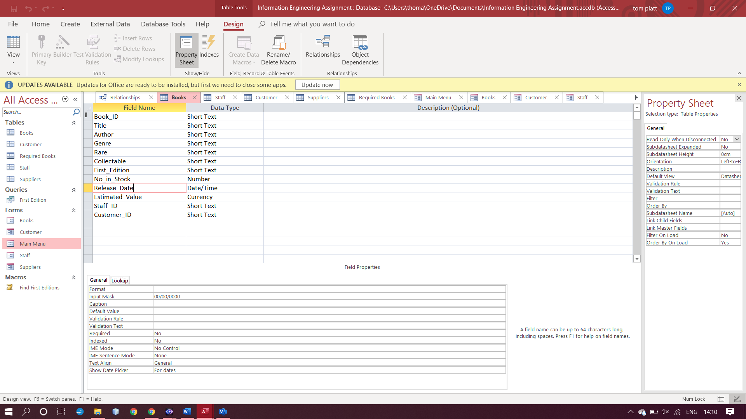
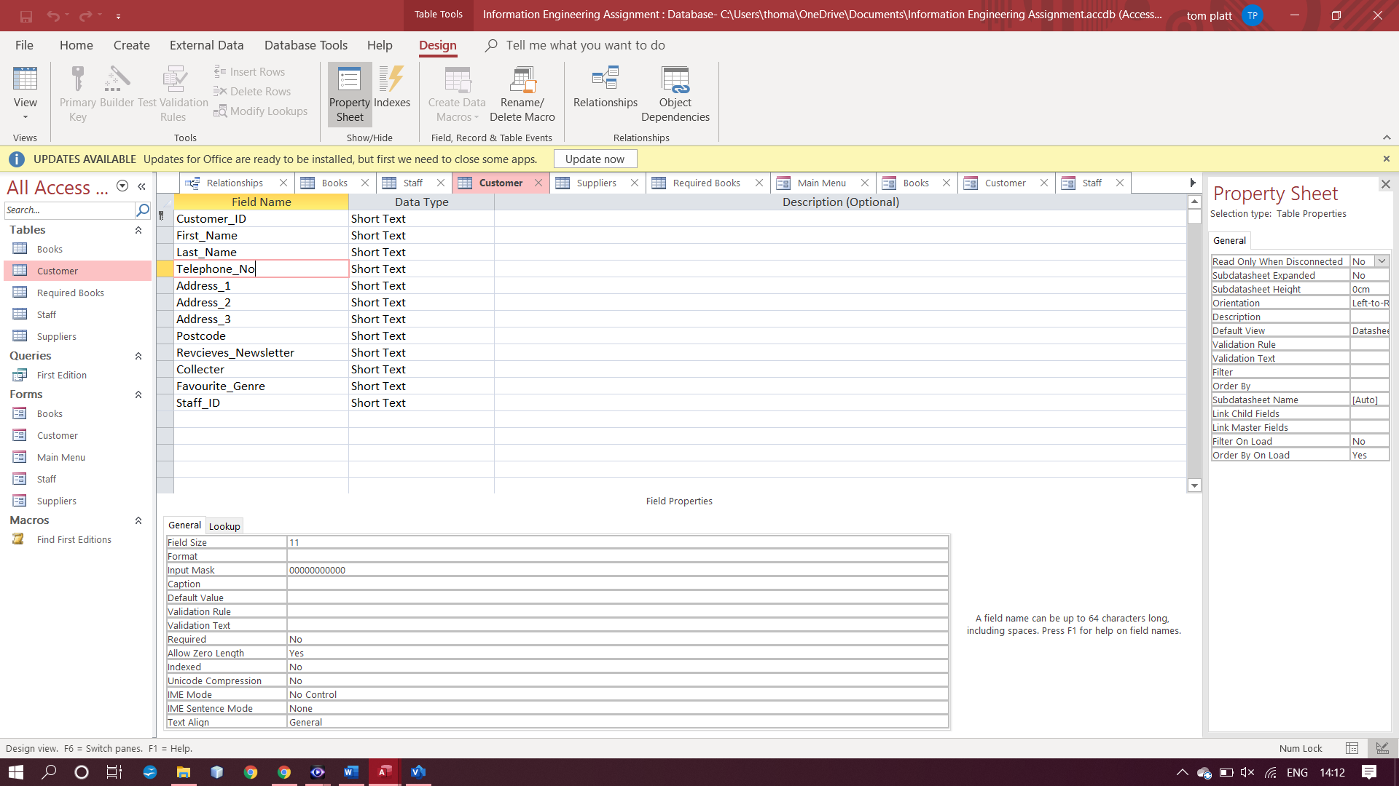

All ID fields start with ID- and then two numbers following. The release date field requires the date to be entered in the following format dd/mm/yyyy this ensures no letters or symbols are entered into this field. Finally, the telephone number fields only allows 11 numbers to be entered ensuring that no letters or symbols are entered.

Entity relationships

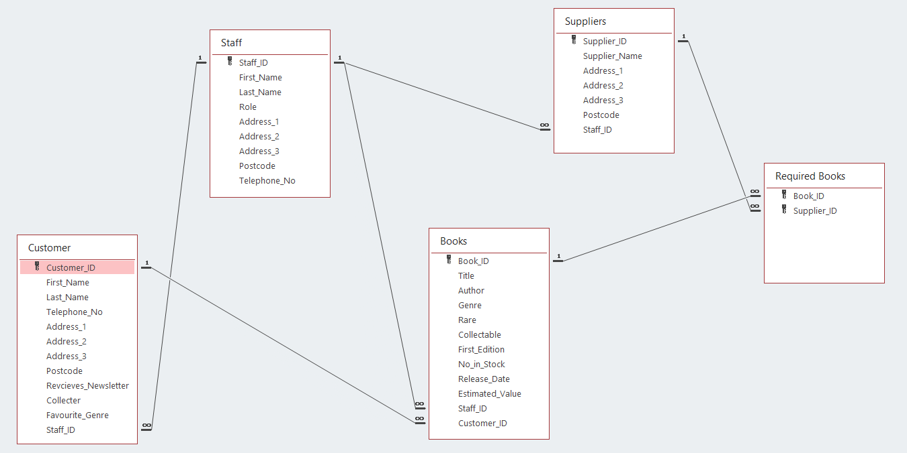

The relationships that I created are as follows:
A member of staff can deal with multiple customers.
A customer can purchase many books.
A member of staff can deal with many books.
A member of staff can deal with multiple suppliers.
A supplier can supply multiple books and many suppliers may supply the same book.

Form Creation

In order to create a simple looking menu system for the company to use I created multiple forms that display the data in an easy to understand way so that it is as easy as possible to perform the required tasks. There are five forms, main menu, books, staff, suppliers and customers.
Main Menu:
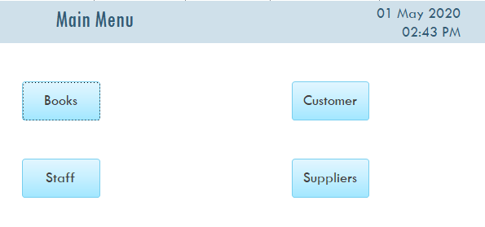
Each button takes the user to the respective form.

Books, staff, suppliers and customers:
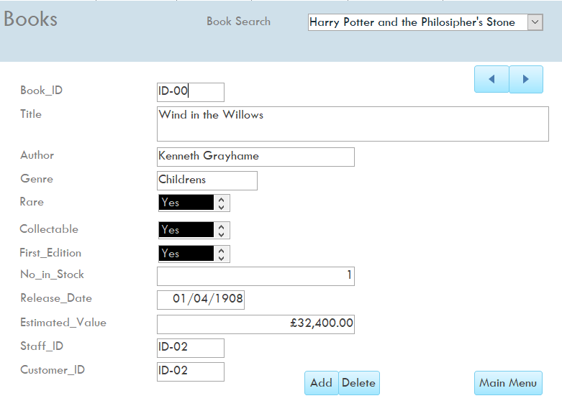

The design for all the tables are the same but with different data fields. There is a search which allows for a name to be entered or select an option from a drop-down menu. When an option is selected it will be displayed in the boxes below. The arrow buttons allows the user to navigate to the next or previous record in the table. The add button allows the user to add a new record to the database. The delete button allows the user to delete the currently selected record from the database. Finally, the main menu button returns the user to the main menu. I did create a query and macro however it did not work as I would have liked it to and hence, I did not place it on a form.



