Name: Andreea Madalina Gheorghiu
Student ID: 1813703
Module code: BMSK4001_LON
Assignment Name: Academic and Employability Skills
Lecturer’s Name: Sylvia Hoffmann

Table of Contents
Introduction 2
Definition of employability skills 2
Analyze the relevant employability skills 2
• Problem solving 2
• Communication 2
• Adaptability 3
• Being able to use technology effectively 3
• Time management 3
Why should we identify our employability skills? 3
Importance of employability skills for the employers 4
Models of employability skills 4
✓ USEM employability model (2004) 5
✓ Bridgstock employability model (2009) 6
✓ The CBI/NUS (2011) 7
Personal SWOT Analysis 8
Plan of action to improve my skills to meet employer’s need (SMART) 9
Employability skills that need to develop in the future 10
Conclusion 10
References 11

Introduction
As an individual is very beneficial to possess different academic and employability skills to be able to obtain their career goals. There are a lot of types of skills such as multitasking, teamwork and communication. The skills that every single one of us have depend on our background, qualifications or other factors that may influence this and it also depends on our capability to learn or develop new skills. The main reason to have and develop those skills is for our future career as in being able to have our dream job or work in that specific field that we have our qualifications in.

Definition of employability skills
The term of ‘’employability skills’’ describes a group of strengths that an individual has after coming out of an academic curriculum or course applicable at a workplace and also the strength to engage in lifelong learning . Those strengths could be very beneficial in their day to day life and also for the employer (Duszyński, 2019)

Analyze the relevant employability skills

Problem solving
Being able to solve a problem within the business environment involves sometimes analyzing figures and fact, confronting with a new challenge and manage to get to the end of it, coming up with new ideas and putting them into practice at the work place (Duszyński, 2019).

Communication
In our days it is very important to be able to communicate effectively at the work place. If an individual is able to listen effectively, emphasize and pull rational conclusions after receiving the information shows that they have really strong communication skills (Duszyński, 2019).

Adaptability
This skills is one of the most important skills that a candidate could have. In our days things can change by the day such as: technology, business ideas, new competition etc. being able to adapt also show that you are ready and want to learn new things to develop your knowledge and after making few mistakes you could come up with new efficient ideas for the business (Duszyński, 2019).

Being able to use technology effectively
In the 21st century technology runs our lives. It does not matter what field you work in you will always need to have knowledge about the technologies that are relevant to your work place. That is why being able to use technology effectively became one of the top skills when it comes to employment (Duszyński, 2019).

Time management
Time management is essential at the work place. Not being able to manage your time effectively at work can affect your results. Sometimes if you find it hard to prioritize your tasks can create a really bad contrast between the professional and personal life (Duszyński, 2019).

Why should we identify our employability skills?
The reason we should identify our employability skills is because it makes us more conscious of what our strengths and weaknesses are. Nevertheless it also helps us in our face to face job interviews, writing effective job applications and building our self-confidence. As an individual you will feel very confident and comfortable to speak openly about your strengths and weaknesses and the employer could see this as a very strong and essential skill (The University of Sydney , n.d.).

Importance of employability skills for the employers
In our days, employers consider employability skills vital for their business. They no longer go just for candidates that have good qualifications, if they do not have the key employability skills they risking no to get the job. Some of the key skills employers look for are: team working, time management, punctuality, problem solving, adaptability, strong communication skills, strong IT Skills etc. Some of them I have mentioned and explained above but for example, being able to work effectively in a team is beneficial for the business as you could get projects or presentations to work on together and you should definitely be able to listen and cooperate with others, this could also create a nice and peaceful environment within the workplace. Those skills play a strong role in your professional life. If those skills are non-existent the employer will be able to see if from your performance. From a manager’s point of you those aptitudes are more of a service that the employee brings in the organization. With the help of those skills the worker can help with the development of the business. Another reason why employers look for those competences in a candidate is that they can assist and help the business to combat all or any challenges that might come along (studentingera, 2018)

Models of employability skills
Employability skills are more important to an employer on today’s market as they prefer those abilities over any educational qualifications. When the candidate has those skills they help the company develop and gain better results. There are a lot of concepts of employability explained through various methods. Some of the models I am going to discuss down below.

USEM employability model (2004)
The USEM model gives an idea of what a graduate should gain after finishing their degree and make use of them in their work lives. U stands for Understanding, S for Skills, E for Efficacy beliefs and M for Metacognition. This model was proposed by Knight and York in 2004. This model creates a relationship between personal qualities with the skills and knowledge needed to give wider personal efficacy and employability (Martin & Sara, n.d.).
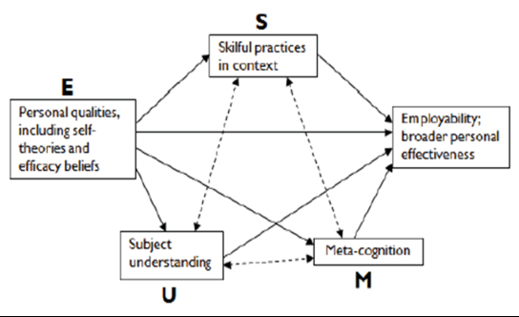

Figure 1. USEM Employability Model (2004)
Source: https://www.heacademy.ac.uk/system/files/downloads/khechara-development_of_employability_skills.pdf

Bridgstock employability model (2009)
This model was established in 2009 and it offers a different perspective of what a graduate’s skills for employability should be. In this model one of the most important skills is career management. Bridgstock thinks that employability takes more than just possessing general skills listed by employers. She is highlighting that things in business change fast and there is a competitive economy, so the graduates should also be able to explore the world of work and manage their career business themselves (Doug Cole and Maureen Tibby, n.d.).

Her model shows that:
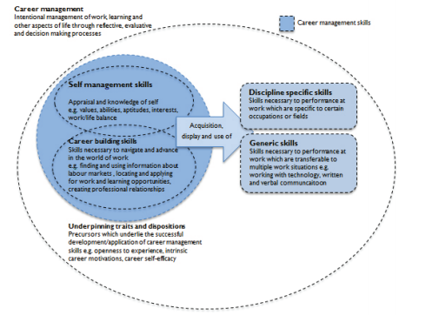

Figure 2. Bridgstock’s Employability Model (2009)
Source: https://www.heacademy.ac.uk/system/files/resources/Employability_framework.pdf

The CBI/NUS (2011)
The CBI/NUS proposed in 2011, concentrates more on how to get students engaged in employability and encourage them to take responsibility of the way they are developing in their employability career from the start of their journey in university. They created a source which focuses on the importance of employability and practical ways in which students can improve their employability. They have agreed that employability falls under an umbrella which includes a range of skills, characteristics and knowledge. They have also established that positive attitude is very important and it is considered to be the heart of employability (Doug Cole and Maureen Tibby, n.d.)

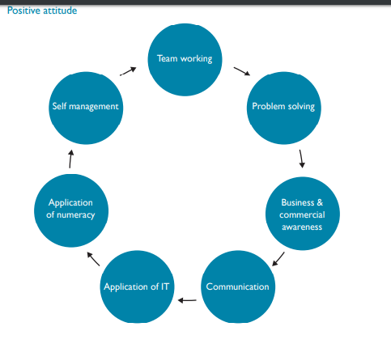

Figure 3. CBI/NUS (2011)
Source: https://www.heacademy.ac.uk/system/files/resources/Employability_framework.pdf

Personal SWOT Analysis
Down below, I have created a personal SWOT Analysis in order to determine my strengths and weaknesses and to have a clearer view on how it can affect me in the future. From this table I can see some of the opportunists I might have in regards to my strengths and how my weaknesses affect me in my professional life.

STRENGHTS  - Fast learner  - Strong communication skills  - Strong IT / Technology skills | WEAKNESSES  - Time management  - Team work  - Not enough employment experience
OPPORTUNITIES  - I could find a job that will help me improve my weaknesses and build a better CV  - Get a job within the IT sector and develop my knowledge | THREATS  - Not finding a job easily as I find it quite hard to work with people  - Not being able to prioritize my tasks and not attending interviews on time

Table 1. Personal SWOT Analysis
Source: (Personal experience)

Plan of action to improve my skills to meet employer’s need (SMART)

Above I have analyzed my strengths, weaknesses and what I need to improve on. Here I am going to create a table and set some SMART objectives in order to help me work on my flaws.
SPECIFIC ACTIONS | MEASURABLE | ACHIEVABLE | RESOURCES | TIME-BOUND
Managing my time better | I will set up deadlines, avoid doing more things at the same time and prioritizing my tasks. | I will watch videos and read articles on how to manage your time | Internet | End of my academic year
Working more efficiently as part of a team | I will listen more effectively to the other team members, engage more in socializing | I will engage in more group activities/meetings, socialize more , work on my patience | Internet  Parks  Restaurants | Summer Holiday
Gain more experience in employability | Make some changes on my CV, working on my skills, being more confident | Apply to jobs on a regular basis | Internet  Volunteering work | End of my academic year

Table 2. Plan of action to improve my skills
Source: (Created by Andreea Madalina Gheorghiu)

Employability skills that need to develop in the future
After taking a close look at my ‘’Personal SWOT Analysis’’, I came to the conclusion that I have to work a lot more on my employability skills in order to get my dream job. For example I could start working on my patience in order to be able to work in a team more effectively. I could also start taking into consideration more ideas and opinions coming from my co-workers. In regards to time management I could watch some videos or read some articles on how to make the difference between the things that ‘’ I HAVE TO DO’ and the things that ‘’I MUST DO’’. Things that ‘’I have to do’’ are important but not as important as the one ‘’ I must do’’. Learning how to manage my time would be very beneficial for my professional life and future career. However, lack of employability experience plays a big role in my CV as in our days employers want to see some sort of experience rather than educational qualifications. In my opinion if I work on my weaknesses such as team working and time management I will definitely be able to get a job where I can gain experience and learn new skills.

Conclusion
In conclusion I think that having employability skills plays a vital role in everyone’s life. If you acknowledge that you lack in some fields you could always go and research for tips on how to improve, engage in group activities, ask for feedbacks from employers, friends, teachers and take into consideration their opinion. I have also came to the conclusion that employability experience plays a big part in getting a job as the employer looks for experience as well as a degree. In some jobs experience might be more important than the degree. During my research for this assignment I found three very important models of employability, I have also created my personal SWOT analysis and created my Plan of action on how to improve my flaws in order to be suitable to get a good job, in a big organization and have a better career prospect. I also think that by working on those weaknesses I will expand my horizon after I finish my university year and get my degree.

References

Doug Cole and Maureen Tibby. (n.d.). Retrieved from https://www.heacademy.ac.uk/system/files/resources/Employability_framework.pdf
Duszyński, M. (2019, March 20). Zety . Retrieved from https://zety.com/blog/employability-skills
Martin, S., & Sara, K. (n.d.). University of Wolverhampton. Retrieved from https://www.heacademy.ac.uk/system/files/downloads/khechara-development_of_employability_skills.pdf
studentingera. (2018, June 25). Studenting Era . Retrieved from http://studentingera.com/blog/importance-of-employability-skills-from-employers-perspective/
The University of Sydney . (n.d.). Retrieved from https://sydney.edu.au/careers/students/career-advice-and-development/employability-skills.html

