Digital Strategy Report

Empowering people to look after their own health and well-being in the community through Telehealth technology.

Author: Sue Hamer
Student Number: 2112925
19 May 2022
Word Count: 3503
1.0 Introduction

The key challenges for the health and care system, nationally and locally is to meet the health and care demands of a visibly funded system, within the environment of an aging population (The Medic Portal, 2022). This is further exacerbated by a population living longer with many long-term conditions, so the delivery and quality of care needs to be balanced with limited human and financial resources. As a consequence of these key challenges, the health and care system will need to change how and where health care services can be delivered, in order to continually improve outcomes for patients and the quality of care (Craig, 2013).
We need a future where people and staff feel empowered and better informed to allow innovation and improvement to prosper, as identified as one of the three principles in the Topol Review (2019). This has been accelerated through the Covid-19 pandemic, where advances in digital technologies have meant things that were once thought impossible have come to fruition, with the support of collaboration between organisations and best practice shared. Digital technology is a key enabler and Introducing Health Information Technologies (HITs) has the potential to deliver care more effectively and efficiently (Prgomet et al. 2019); ensuring healthcare remains accessible and sustainable.
Digital Transformation plays a key role in facilitating the attainment of strategic change to support the delivery of health and social care services. As stated by Tsiknakis and Kouroubali (2009) in their literature research, healthcare continues to encounter demands internally and externally, from a reduced workforce, ageing population and increased demand on services.
Building a successful digital strategy is integral, which is not just about the technology, but the cultural change and co-creating a product which has the power to improve economic growth, quality of life and sustainability, which NHS Providers and the Digital Strategy for Wales recognise as some of the success factors.
In 2015, A Digital Health and Social Care Strategy for Wales was published with a vision based on 4 themes. (Figure 1). These encompass “Information for you”, focusing on people looking after their own health and being able to connect with health & social care professionals more effectively and efficiently. “Supporting professionals” to allow access to information to allow them to do their jobs more effectively and most importantly safely with a focus on interoperability between systems and a once for Wales approach. The third vision is about “Improvement and Innovation” through accessing data to make informed decisions, and lastly having a “planned future” so partnership working is harnessed, and stakeholder engagement is at the heart of any change models.

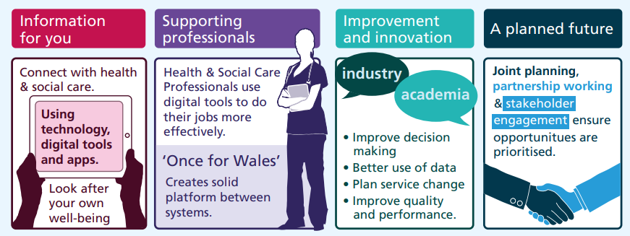

Figure 1
A Digital Health and Social Care Strategy for Wales Vision
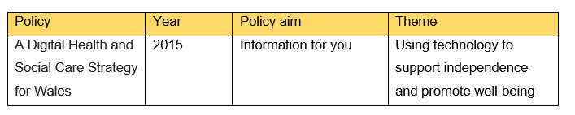
For the context of this paper, the policy goal being reviewed is “Information for you” as detailed in table 1.

Table 1
Policy aim

A lot of work has been achieved over the past few years to support the requirements of the Welsh Government policy goal as identified in the Health and Social Care Strategy (2015), for example free public wi-fi in hospitals and access to My Health Online, which allows patients to use a portal to book GP appointments or request repeat prescriptions, which supports ‘care closer to home’, which is detailed as a priority in the Digital Health and Social Care Strategy (2015); A Healthier Wales (2021) and what Greaves et al. (2018) believes as an important component. However, there are service improvements that still need to be strengthened as these initiatives are not being adopted at scale in Powys to fulfil the policy gap from having internal discussions with GP Practices and the Living Well Team, as well as personal experiences. These focus on:
- Care closer to home (reduce travel times, particularly in rural Wales)
- Helping older people or those with long-term conditions, mental health, or a disability
- Improve quality of life at home
- Using technology, digital tools, and applications to connect with health & social care
- Empowering people to look after their own health & wellbeing.

The above are also factors evidenced in NHS England’s Long-Term Plan, where the goal is to go mainstream with digital enabled care across the NHS.
This paper will look to review how the Welsh Government policy aim can be enabled by digital technology to support independence and connect with people to allow health care professionals to make informed decisions by having access to real time data and information, improved channels of communication and empowering people to look after their own health and well-being. The review will enable service improvements to be realised through the creation of a gap analysis and options appraisal to establish a best fit solution for Powys Teaching Health Boards health care professionals and residents.
2.0 Method
2.1 Gap Analysis
To understand how the policy aim can be supported digitally; ensuring implementation is appropriate and meets the needs of the underpinning policy, a gap analysis was used to evaluate the current situation, the desired state and what needs to be achieved to bridge the gap.
From engaging with the Living Well Service Team, they identified three key objectives to improve communication and empower patients:
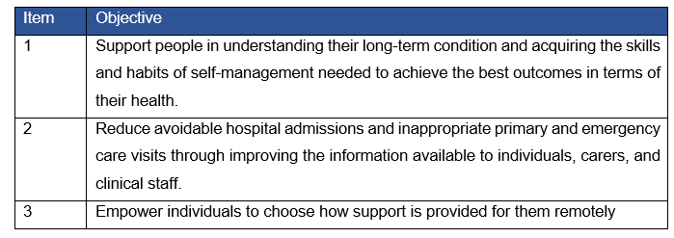
Table 2
Objectives to Support Policy Aim
Forbes (2022) describes a 4-stage process which can be applied at any phase to understand why certain business goals have not been achieved and where organisations want to see an improvement happen, which support the three key objectives detailed above. Stage 3 aligns to the Target Operating Model that is described in Managing Successful Programmes (2021, p.67), which considers the current state, future state and what the gap is, and the technology requirements that are felt a necessity to fulfil the current gap. This paper reviewed the aspects of the policy goal and used feedback from internal discussions with stakeholders, as well as personal experiences, to map out the current gaps and what the requirements are to get to the future state.
Lamb et al. (2020) used a gap analysis tool to involve staff in a quality improvement project that aimed to reduce fall rates. The project resulted in a 60% reduction in falls over a 7-year period, which shows how planning can support digital transformation.
As Lilford et al. (2010) identified, cost driven policies and service intercessions can’t be identified at patient level, therefore Donabedian developed a framework in 1966 to evaluate the quality of health. The model focused on three areas defined as “structure”, “process”, and “outcomes” as shown in Figure 2. The structure explains the environment in which care is delivered, including infrastructure and staff. Process looks at how healthcare is delivered between the patient and provider. Lastly, outcomes describe the effect healthcare has on the patient.
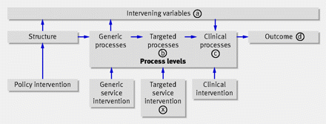

Figure 2
Modified Donabedian Casual Chain, 1966
This model was taken into consideration when looking at the gap analysis and developing the service improvement strategy in the discussion section, focusing on the “current environment” to the future state” and the processes that need to take place to get the required outcome.
2.2 Options Appraisal
Developing a gap analysis meant a specific element from the policy goal could be evaluated into an options appraisal, using elements of the stage 5 appraisal developed by the Department for Digital, Culture, Media, and Sport (2017). The importance of carrying out an appraisal allows for several delivery model options to be explored, allowing for the preferred option to be carefully chosen from a set criterion, which best suits the organisation.
2.3 Sampling & Procedure
To evaluate the effectiveness of the policy, conversations took place with the Living Well Service Team to understand how they support patients with long term conditions using Telehealth. A survey was shared with 33 clinicians from the Living Well Service Team as they had been actively using the system for over 12 months. Microsoft Forms was used to conduct the poll along with a free text box to gain further feedback, with links distributed via Microsoft Teams Chat which was open for a period of four weeks during April 2022. Clinicians were pre-engaged via their Line Manager’s to provide background and to encourage. Results were shared with the author due to working collaboratively within the health board.
Florence is a system that makes use of text messages to encourage patients to manage their own health and wellbeing. It has potential to remind people to keep active, eat healthy, provide diabetes readings and signpost to services which can support them to regain their independence. Florence has been used by Powys Teaching Health Board since 2016, however the uptake has been relatively low, so this provides an optimal time to evaluate the requirements needed by professionals and users before looking at future options.
Digital solutions, such as Florence, has been proven to support the reduction of healthcare interventions. Wolters (2017) conducted a survey in NHS Highland which evidenced that Florence supported self-management by reducing hospital admissions and GP appointments for patients with Asthma, COPD and Heart Failure. NICE Guidance (2012) also published a document that identifies telehealth as being a system to support patients with hypertension using just a home blood pressure monitor and interactive SMS texting between clinician and patient with a mobile telephone. The results published detailed that patient satisfaction with the system was high.
3.0 Results
3.1 Findings
3.1.1 Professional Involvement
A survey was shared with 33 clinicians from the Living Well Service where 11 responded (33%). The survey looked at thirteen statements with an additional box asking for ways it could be improved.
No. | Statement | Positive | Neutral | Negative
1 | It’s easy to sign people up to Florence | 81.8% | 18.2% | 0%
2 | I found it easy to explain how Florence works | 81.8% | 18.2% | 0%
3 | I find Florence easy to use | 90.9% | 9.1% | 0%
4 | People tell me the text messages arrive at helpful times | 36.4% | 45.4% | 18.2%
5 | I find Florence's online administration easy to use | 63.6% | 18.2% | 18.2%
6 | Overall, I'm satisfied with how Florence works | 81.8% | 18.2% | 0%
7 | I've found the training and support really useful | 72.7% | 18.2% | 9.1%
8 | Florence helps people manage their condition more effectively | 81.8% | 18.2% | 0%
9 | Florence provides positive advice & guidance | 100.0% | 0% | 0%
10 | People feel empowered as a result of Florence's messages | 54.5% | 45.5% | 0%
11 | I think Florence has helped people speed up their recovery | 18.2% | 81.8% | 0%
12 | I found it helped engage with people who live in a remote area | 64% | 36% | 0%
13 | Do you recommend Florence to other services/ clinics/ colleagues? | 100% | 0% | 0%
Table 3
Powys Teaching Health Board Living Well Service Clinician feedback

The results in table 3 indicate that 90.9% found Florence easy to use and that it helped provide advice and guidance and supported people manage their condition more effectively. 64% also felt Florence helped engage with people who live in a geographically remote area. This resonates with finding from Wolters (2017) who evidenced that clinicians found communicating via telehealth made it easier to liaise with patients without the need to depend on home visits or trips to GP practices in remote areas, which is prevalent in Powys. Areas where responses were less positive was around patients not feeling more empowered, which is an objective of the policy aim, and only 18.2% noted that Florence helped speed up people’s recovery.
Areas where improvements were suggested in the free text box focused on the ability to send pictures/gifs/ motivational quotes, allowing people to self-refer and better timings of the texts being sent, and having access to educational material. From conversations with the Living Well Service Team, Florence does not link with any existing Application Programme Interface (API) which Forbes (2021) believes strategic business are doing wrong if not looking at APIs. It currently integrates with EMIS and Vision which are systems used by GP practices, but not with any existing Health Board system, i.e., WPAS, and there is currently no audit tracking. Technical requirements that need to be considered as part of the options appraisal.
3.2 GAP Analysis
The GAP analysis initially took into consideration all the themes relating to “information for you” from the policy aim. The results are contained in Table 4 where 1.3 was chosen as the area to focus on due to the lack of engagement and the benefits the system can bring if used to improve independence and promote well-being as evidenced above.

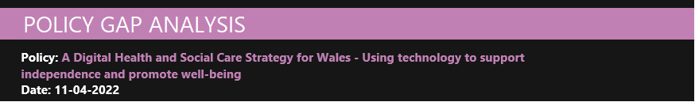

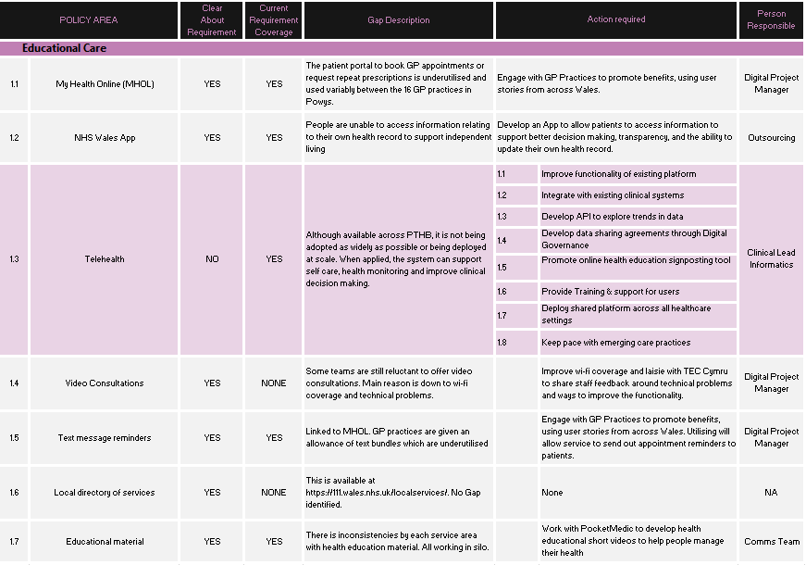

Table 4
Results of Powys Teaching Health Boards Gap analysis
3.3 Options Appraisal
Several options were considered looking at how the service improvement could empower people to look after their own health and well-being and improve communication and health education through Telehealth technology.
Option 1 – Do nothing
Advantages | Disadvantages
No additional Costs | No progress on bridging the policy gap
No disruption

The costs associated with this option are nil.

Option 2 – Build on local knowledge and improve existing telehealth platform
Advantages | Disadvantages
Bridge the policy gap | Business Case required for resource implications, i.e., infrastructure, skills,
Integrate data into existing clinical systems which will improve decision making and patient care | Project team to provide training, support, and stakeholder engagement
Learning from feedback to improve useability and performance | Budget implications
Enhance independence & well-being
Online health educational signposting tool and educational material
System interoperability
Platform familiar with existing users
Improved channels of communication

Continuing to use a system that is familiar to users but requires small enhancements, will promote engagement in attracting more departments to use the telehealth SMS system by developing user stories.
The costs associated with this option are £8,960 for a 12-month Service Level Agreement which includes unlimited remote support and remote advice around creation of protocols. In addition, texts bundles cost £3,200 for 40,000 messages. (£0.08 per message).
Total cost for option 2 = £12,160.
Option 3 – Procure a new system
Advantages | Disadvantages
Bridge the policy gap | Will require Data Protection Impact Assessment completion
Integrate data into existing clinical systems which will improve patient care | Business Case required for funding and resource implications
System interoperability | Costs to maintain system
Enhance independence & well-being | Project team to provide training & support
Online health educational signposting tool and educational material | Stakeholder engagement to co-create new system
Improved channels of communication

Procuring a completely new system will bring about further change and potential resistance when the existing platform was performing adequately.
The costs associated with this option are £20,000 for a 12-month Service Level Agreement. In addition, texts bundles cost £4,000 for 40,000 messages. (£0.10 per message).
Total cost for option 3 = £24,000.
Consideration of Options:
It is proposed that the different options are considered against the following criteria:
- Care closer to home
- Helping older people or those with long-term conditions, mental health, or a disability
- Improve quality of life at home
- Using technology, digital tools, and applications to connect with health & social care
- Empowering people to look after their own health & wellbeing.
All options have advantages and disadvantages. Do nothing option entails no direct costs however means no progress on bridging the identified policy gap. Option 2 is developing an already known system, using feedback from users and patients to improve useability and performance. Option 3 has similar benefits, however introducing a new system can come with resistance to change as identified in the Topol Review (2019). Therefore, option 2 is the recommended way forward where the benefits out way the risks, and costs are lower.
Key Risks
Risks have been identified in table 5, taking into consideration the three available options:
Option appraisal | Risk ID. | Description of risk | Mitigating action
1 | R1 | No progress on bridging the policy gap | Develop a solution
2&3 | R2 | Does not allow interoperability with existing systems | Select product that allows API integration to allow interoperability in healthcare system
2&3 | R3 | Budget constraints to purchase Telehealth license | Develop business case to secure funding
2&3 | R4 | Lack of external resource for system interface development | Application support from Digital Health & Care Wales to support integration.
2&3 | R5 | Lack of internal project resource to implement, promote and support teams adopt telehealth tool | Develop business case to obtain board approval
3 | R6 | Adopting a new Telehealth system | Engage with stakeholders before procurement to co-create system
Table 5
Key Risks with Options
3.4 Causal Chain
When looking at the Donabedian casual chain (1966), the service improvements were focused on the following factors:

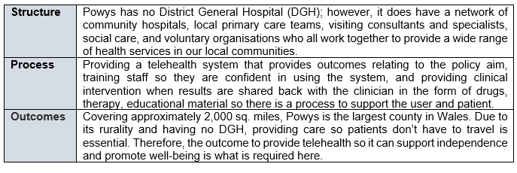

3.5 Technology Requirements
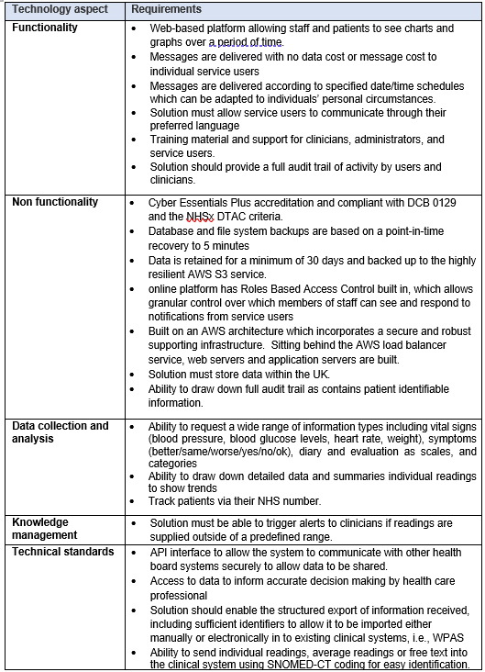
As described by Kupersmith, Mulvey and McGoey (2016), technology requirements specify the design of the specific technical elements needed for a solution to be developed, implemented, and operated. Fellman (2016) found that failure to adequately document technical requirements can cause serious problems for a company. Therefore, to improve the service requirements relating to the specific policy goal, digital technology requirements need to form part of the system upgrade to ensure fit for purpose, as evidenced in Table 6.

Table 6
Technology Requirements for Florence

The above technology requirements were developed from conversations with the Living Well Team and the Informatics and digital transformational department who have implemented many systems and are aware of the future needs of the national health service.
4.0 Discussions
Curtis (2019) believes digital transformation provides great possibility, but only if supported with cultural change, powerful leadership, better information sharing, and cross-organizational collaboration focused on customer need. Based on experience, NHS Providers (2021) have published a guide which they believe are signs of a good digital strategy. These encompass:
Integrated | Needs to form part of a trust-level strategy and plans are incorporated as an enabler for wider improvement
User centred | Addresses the needs of patients, service users and staff through active engagement
Useful to teams | Focuses on providing principles to help people make the right decisions i.e., give people the tools they need to do their job, get better with data, make the infrastructure and systems more modern
Mainstream | Widely understood, adopted, and aligned across many teams
Realistic | What has already been delivered and setting realistic goals
Focused | Clear measurable objectives and outcomes for patients and staff

Not having a digital strategy was a mistake that the National Programme for IT (NPfIT) made when adopting their ambitious programme of works, so having the foundations in place is crucial, as evidenced in the National Audit Report 2020. To ensure the policy gap is implemented, engagement will be required with service leads, collaboration with organisations, and support from senior management via the Digital Transformation Programme Board.
4.1 Service Improvement Strategy
The results from the gap analysis, using feedback from patients, internal discussions and own experiences provided the requirements of moving from current state to future state as evidenced in Diagram 1, using the Target Operating Model to map out the gaps.

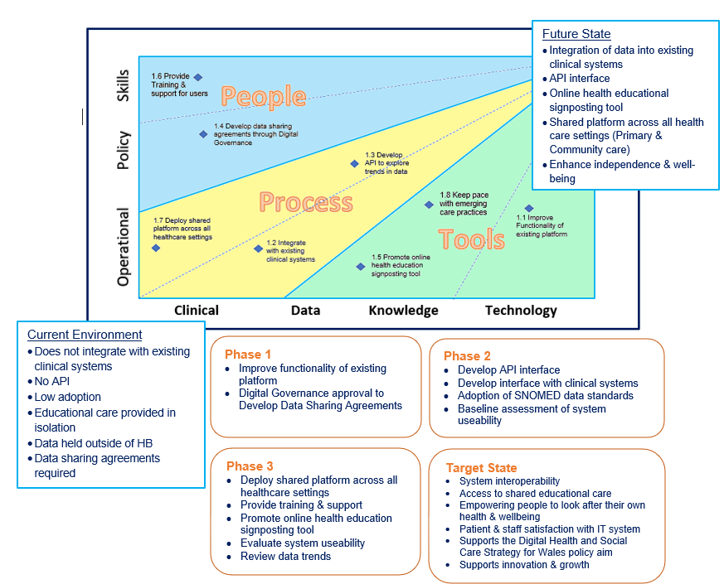

Diagram 1
Service Improvement Strategy for Powys Teaching Health Board
4.2 Engagement
As stated by Curtis (2019) and NHS Providers (2021), service improvements can support a digital strategy as technology alone will not fulfil a gap. Stakeholder engagement is pivotal to facilitate innovation and acceptance criteria, which focuses on empowerment, improvement, and benefits realisation. Identifying key stakeholders will play a vital role when implementing change and can be a reason why a project fails because they were not identified (Shirley, 2020, p.34).
Time needs to be spent engaging with departments to promote the benefits of telehealth; using case studies developed from service users and outcomes evidenced by NHS Highland and NICE guidance. Working collaboratively with third sector organisations and social care to support digital innovation, who have close links with the community, which is aligned to the goal that the Department of Health and Social Care detail in their 2021 report.

4.2 Evaluating the outcome

Design and evaluation are crucial in ensuring informatic interventions work (Coiera, 2019). The recommendation is adopting option 2 from the options appraisal and making service improvements to the existing system “Florence” which will improve the “design”. Working with the provider to incorporate the technology requirements to make the platform more resilient, giving patients access to health education material and working in collaboration with organisations to provide support and information. Enhanced features will also provide health care professionals with a greater level of data which will support timely clinical decision making.

Evaluating the impact will be fundamental. The survey used by professionals will be re-issued 6 months post implementation to evaluate the effectiveness of the change incorporated and to see if the policy gap has reduced. However, there is a need to engage with patients to find out their views of the system as the goal is to empower them to look after their own health and well-being through Telehealth technology and how the service can support them reach that end point.

5.0 Conclusion
Evidence suggests that telehealth works because it builds an active link between patients and clinicians without the need to travel. This provides a platform where patients feel listened too and cared for, and clinicians get real time data and an accurate picture of their patients’ condition and well-being, which enables improved medical decision making.
Working together and Integrating systems so data and outcomes can be shared is what we should be working towards to improve outcomes.

Referencing
- Axelos (2020). Managing Successful Programmes. 5th edition. Cyprus: Stationary Office.
- Coiera E. (2019). ‘Assessing Technology Success and Failure Using Information Value Chain Theory’. Studies in health technology and informatics, 263, pp. 35–48. https://doi.org/10.3233/SHTI190109
- Craig L. (2018). Service improvement in health care: a literature review. British journal of nursing (Mark Allen Publishing), 27(15), 893–896. https://doi.org/10.12968/bjon.2018.27.15.893
- Curtis, S., 2019. Digital transformation—the silver bullet to public service improvement? null, 39(5), pp. 322-324.
- Department for Digital, Culture, Media and Sport (2017) Stage 5: Options Appraisal. Available at: Stage 5: options appraisal - GOV.UK (www.gov.uk). (Accessed: 6 April 2022).
- Department of Health & Social Care (2021). Integration and Innovation: working together to improve health and social care for all. Available at Integration and Innovation: working together to improve health and social care for all (publishing.service.gov.uk). (Accessed: 6 May 2022).
- Fellman, R (2022) Award-Winning Results. Available at: https://reneefellman.com. (Accessed: 6 April 2022).
- Forbes (2022). What Is a Gap Analysis? Available at: https://www.forbes.com/advisor/business/what-is-a-gap-analysis/ (Accessed: 10 April 2022).
- Georgiou, A., & Prgomet, M. (2019). E-health: Developing trust, confidence, quality and sustainability. Health information management: journal of the Health Information Management Association of Australia, 48(2), 59–61. https://doi.org/10.1177/1833358318808064
- Greaves F, Joshi I, Campbell M, et al. (2018) 'What is an appropriate level of evidence for a digital health intervention?' Lancet, 392(10165), pp. 2665–2667. Doi: https://doi.org/10.1016/S0140-6736(18)33129-5 (Accessed: 13 April 2022).
- Kupersmith, K, Mulvey, P, McGoey, K (2013) Business Analysis for Dummies. For Dummies.
- Lamb, K., Ambutas, S., Sermersheim, E. & Ellsworth, M. (2020). Gap analysis. Nursing Management (Springhouse), 51 (10), 16-22. doi: 10.1097/01.NUMA.0000698108.86942.f9. Gap analysis: A tool for staff engagement in fall reduction improvement processes (ovid.com)
- Lilford, R. J. et al. (2010) Evaluating policy and service interventions: framework to guide selection and interpretation of study end points. BMJ (Online). [Online] 341 (7775), 715–720.
- NHS England (2019) The NHS Long Term Plan. Available at: https://www.longtermplan.nhs.uk/wp-content/uploads/2019/08/nhs-long-term-plan-version-1.2.pdf (Accessed: 6 April 2022)
- NHS Providers (2021) What Makes a Successful Digital Strategy. Available at: https://nhsproviders.org/media/691129/building-a-digital-strategy-short-1ca.pdf. (Accessed: 5 April 2022).
- NICE Guidance (2012) Interactive Simple Health Tool for the Management of Blood Pressure. Available at: Interactive simple telehealth for the management of blood pressure | NICE. (Accessed 15 April 2022).
- Shirley, D., (2020). Project Management for Healthcare. 2nd Ed. Boca Raton: CRC Press
- The Medic Portal (2022) Challenges Facing the NHS and Current NHS Issues. Available at: Challenges Facing The NHS - The Medic Portal. Accessed 6 May 2022
- Topol, E., (2019) The Topol Review. Preparing the Healthcare Workforce to Deliver the Digital Future. Available at The Topol Review — NHS Health Education England (hee.nhs.uk). (Accessed: 8 April 2022).
- Tsiknakis, M., & Kouroubali, A. (2009). Organizational factors affecting successful adoption of innovative eHealth services: a case study employing the FITT framework. International journal of medical informatics, 78(1), 39–52. https://doi.org/10.1016/j.ijmedinf.2008.07.001
- Wachter, R. (2016). Making IT work: Harnessing the Power of Health Information Technology to Improve Care in England. London, Department of Health and Social Care. Available at: Making IT work: harnessing the power of health information technology to improve care in England - GOV.UK (www.gov.uk). (Accessed: 18 November 2021).
- Welsh Government (2015) Informed Health and Care - A Digital Health and Social Care Strategy for Wales. Available at: A Digital Health and Social Care Informed Heath and Care; A Digital Health and Social Care Strategy for Wales (gov.wales). (Accessed: 8 April 2022).
- Welsh Government (2018) A Healthier Wales – Our Plan for Health and Social Care. Available at: A Healthier Wales (gov.wales). (Accessed 15 November 2021).
- Wolters, M. (2017) Service Evaluation of Three Telehealth Services for Monitoring Patients with Asthma, COPD and Heart Failure, Delivered to NHS Highland. Available at: Contact name (scot.nhs.uk). (Accessed: 15 April 2022).

