

Postgraduate/Distance Learning
Assignment coversheet & feedback form

THIS SHEET MUST BE THE FIRST PAGE OF THE ASSIGNMENT YOU ARE SUBMITTING (DO NOT SEND AS A SEPARATE FILE)

For completion by the student:
Student Name: Alejo Matías López Silva
Student University Email: 1710936@student.uwtsd.ac.uk
Module code: HPCA7019  Module title: Sacred Skies | Student ID number: 1710936 |  |  | Educational support needs:  Yes/No
Assignment title: Essay
Assignment due date: 14 May 2021
This assignment is for the 6th module of the degree
I confirm that this is my original work and that I have adhered to the University policy on plagiarism.
Signed ……ALEJO MATIAS LOPEZ SILVA…………
Email submission:if you are submitting this form via email, please tick this box x
(as a substitute for your signature) to confirm that you agree to the above declaration.
Assignment Mark
1st Marker’s Provisional mark
2nd Marker’s/Moderator’s provisional mark
External Examiner’s mark (if relevant)
Final Mark

NB. All marks are provisional until confirmed by the Final Examination Board.

ALL COMMENTS ARE ON THE PDF OF YOUR PAPER IN TURNITIN

For completion by Marker 1 :
Comments:

Marker’s signature: |  |  | Date:
For completion by Marker 2/Moderator:

Comments:

Marker’s Signature: |  | Date:
External Examiner’s comments (if relevant)

External Examiner’s Signature: |  | Date:

Cultural representation of the sunset in three movies
Word count: 5242

Introduction
The aim of this essay is to explore the representation of the Sunset, in three films: Lovers of the Arctic Circle, by Julio Medem; Before Sunset, by Richard Linklater and Your Name, by Makoto Shinkai. The first film was released in 1998 under Spanish production. It told the story of Otto and Ana, who fell in love with each other when young. As teenagers, they learned that within the Arctic Circle, the Sun did not set. After a life of coincidental miss-encounters, they both decided to travel to Finland (in Spanish ‘End-land’) to finally be together. But before that could happen, Ana tragically died.

Before Sunset came out in 2004 and was released in the USA, it was a sequel to Before Sunrise (1995). In the first movie, Jesse and Celine had met on a train in Vienna and decided to spend the evening/night together. Before saying goodbye, they had promised each other to meet again in six months at that same spot. Nine years later, in Before Sunset, the viewers learned that this second encounter had not occurred. Jesse was now a published writer who was touring to promote his book, based on that night with Celine. After running into each other again, they decided to spend the evening together, before Jesse flew back to USA at sunset. In the end, he decided to miss the plane and stay.

Finally, Your name, a Japanese production released in 2016, told the story of Taki, a boy in Tokyo, and Mitsuha, a girl in rural Itomori. One morning, they found out that in some random days they would exchange bodies, so that she woke up in his body and he woke up in hers. By living each other’s lives, they fell in love with each other. However they were not just in different towns, but also in different times, as Mitsuha’s reality was three years prior to Taki’s present. In fact, in Taki’s time, Mitsuha’s town had been destroyed by a meteorite three years before. When he discovered this, he travelled to Itomori’s ruins. At Sunset, he was given the chance to physically meet her on her last day of life, just before the catastrophic comet crashed. He then warned her so that she could save herself and the entire town. Figure 1 is a diagram of this plot-line. To sum up, all three narratives were linked to the sunset. Each approach is discussed after the literature review. All Spanish quotes have been translated by myself.

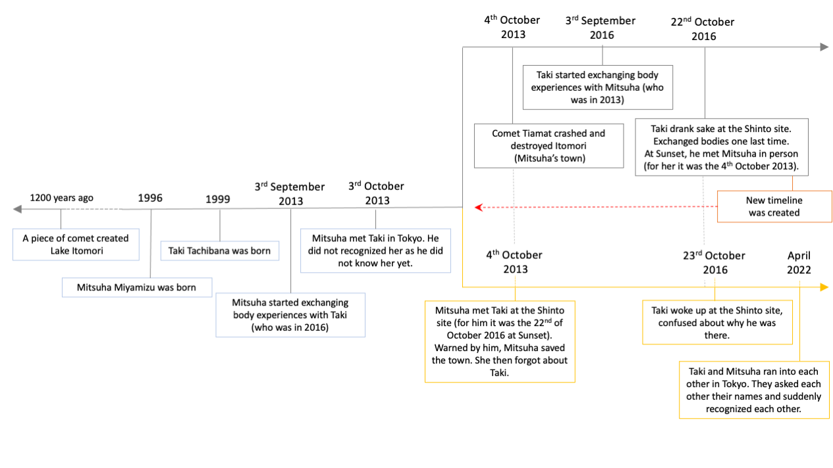
Figure 1. Timeline from Your name. Diagram: Alejo López.

Literature Review
This section creates a framework from previous scholarship. Bill Scalia suggested that ‘film signifies in a way closely related to poetry’. Sunset may thus be studied not only as the astronomical event but as encompassing some other meaning. Analyzing a film, Scalia continued, opened ‘a spring of metaphors of poetic language’. Juan Egea claimed that the viewer should read beyond the narrative. In fact, he concluded that ‘poetry was the stuff cinema was made of’.

Regarding Lovers of the Arctic Circle, Txetu Aguado mentioned that Ana and Otto tried to deny that death was part of life. Thus, their desire to go to a place where the sun did not die. Wolf Martin Hamdorf and Clara López Rubio seemed to agree as they suggested that Ana and Otto were projecting childish fantasies into the Arctic Circle, with its absence of sunset. Instead, Brian Cope worked from a different perspective. He suggested that the movie was based in Taoist philosophy. The tragic finale responded to Otto and Ana unengaging with the natural flow of events and forcing an encounter together.

The Before trilogy (Before Sunrise, Before Sunset and Before Midnight) surveyed the nature of time as expressed through sky phenomena. According to Holly Willis, ‘Linklater has explored the vicissitudes of temporarily’. Erick Neher claimed that indeed the Before films were ‘a living testament to the passage of time’. Aaron Cutler added that time was the greatest threat for Jesse and Celine. Linklater’s film only showed liminal moments between them, when the state of things was at the edge of change. Thus, Peter Lurie concluded that when Celine decided to hug Jesse, she gave their first step in leaving the unstable liminality to a zone of decisive decision. The end of the day marked by the upcoming sunset may have symbolized the end of past illusions. Maria San Filippo added that the image of the sunset ‘evokes a thirty-something symptom of nostalgia’.

In Your name, sunset was also present and allowed change in the course of events. One of the main cultural elements present here was the contrast between modern Tokyo and traditional Itomori. The connection between the two places was possible due to Mitsuha, who was training as a Shinto priestess. James Boyd and Ron Williams explained that in Shinto, ‘nature was understood as the manifestation of creative and life-giving power (musubi)’. Musubi was indeed mentioned by Mitsuha’s grandmother. Edward McDougall described it as a loom of divine forces. Furthermore, Boyd and Williams mentioned that this superior power could manifest in natural elements ‘such as heavenly bodies’. Mircea Eliade believed that irruptions in time and space distinguished the sacred from the profane. Sacred time had characteristics of its own: ‘circular, reversible and recoverable’. Mythical time could be made present, it was indefinitely repeating itself. To sum up, in all three movies sunset had a particular role. In Medem’s film, by trying to escape sunset, Ana and Otto were trying to escape death. In Linklater’s, Celine and Jesse were pressured by the proximity of sunset and the end of their second encounter. Finally, in Your Name, sunset had a life-giving power.

Findings and discussion
The findings and discussion are organized in three themes that emerged from the different expression of the sunset in each film. In Lovers of the Arctic Circle, the Sun ran parallel to the horizon (Figure 2). Thus, Otto and Ana did not experience a proper sunset. On the other hand, Before Sunset’s last scene took place in an apartment from which the viewers could not see the sun setting either. However, the movie poster showed both Celine and Jesse in a boat and the sunset behind them, which was also mentioned in its title (Figure 3). Finally, in Your name, both characters and spectators got to experience the sunset. It was during this moment that the border between Mitsuha and Taki’s worlds dissolved so that they could finally meet. The discussion is organized in three instances: a second chance, a sacred moment and a reminder of mortality.

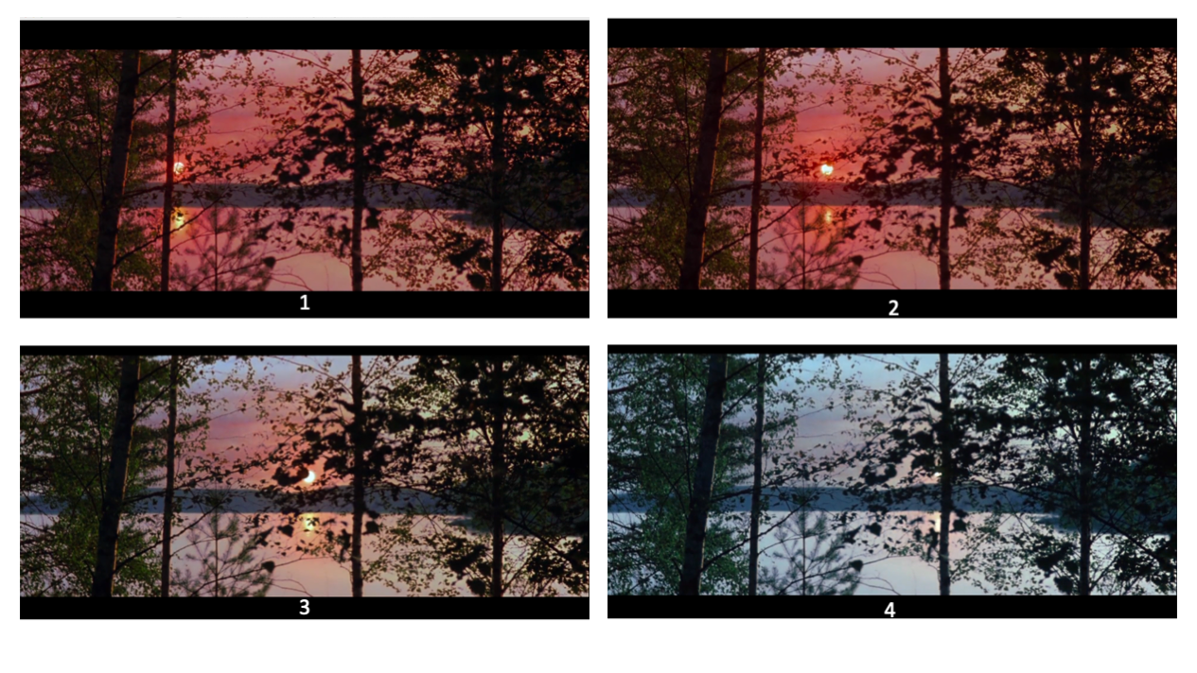
Figure 2. The Midnight Sun. Captions: Julio Medem, Lovers of the Arctic Circle [Film].
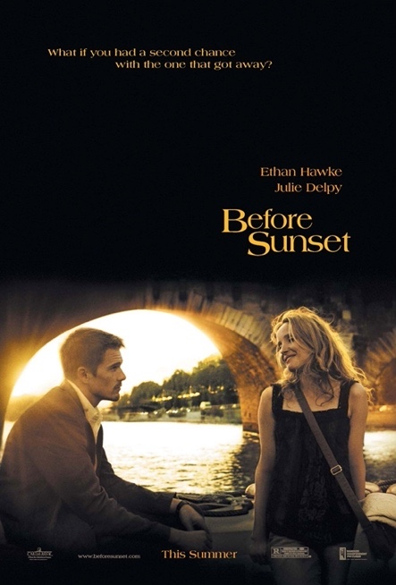
Figure 3. Ethan Hawke and Julie Delpy with the sunset behind them in the film Before Sunset. Poster design: Crew Creative Advertising.

A second chance
The idea that sunset brought a second opportunity is discussed here. Before Sunset’s tagline was: ‘What if you had a second chance with the one that got away?’ (Figure 3). The film started in Paris during the evening. On their first walk, Celine asked Jesse: ‘How long do we have? Twenty minutes and thirty seconds?’, already setting the pressure of time. The movie played for one hour and sixteen minutes and the events were represented in real-time scale, providing an imminent sense of reality to the viewer, therefore, sunset coercing them from the beginning. According to Lurie, Linklater’s Before trilogy most significant element was time. San Filippo added that ‘Linklater discusses time as the building block of cinema’.

At the bookshop, Jesse was answering questions about his book, which narrated his meeting with Celine in Vienna nine years before. As he was being interviewed, the film showed moments of the previous movie, as re-living them by telling them (Figure 4). Jesse mentioned that his next idea was to write about a man who had a kind of epiphany, that allowed him to live simultaneously in his present time and in his teenage years. Thus, from the beginning of the movie, the idea of re-living a past situation was present. Erik Neher mentioned that ‘they each contain within themselves the person that fell in love on a long night wandering through Vienna’. But the sunset was here threating their opportunity to relive their encounter all over again. In an interview, Linklater added that ‘he was not interested in the plot, but in how the characters matured through time’. San Filippo concluded that the sunset represented the melancholic feeling of the past, ‘even as this narrative races against time’.
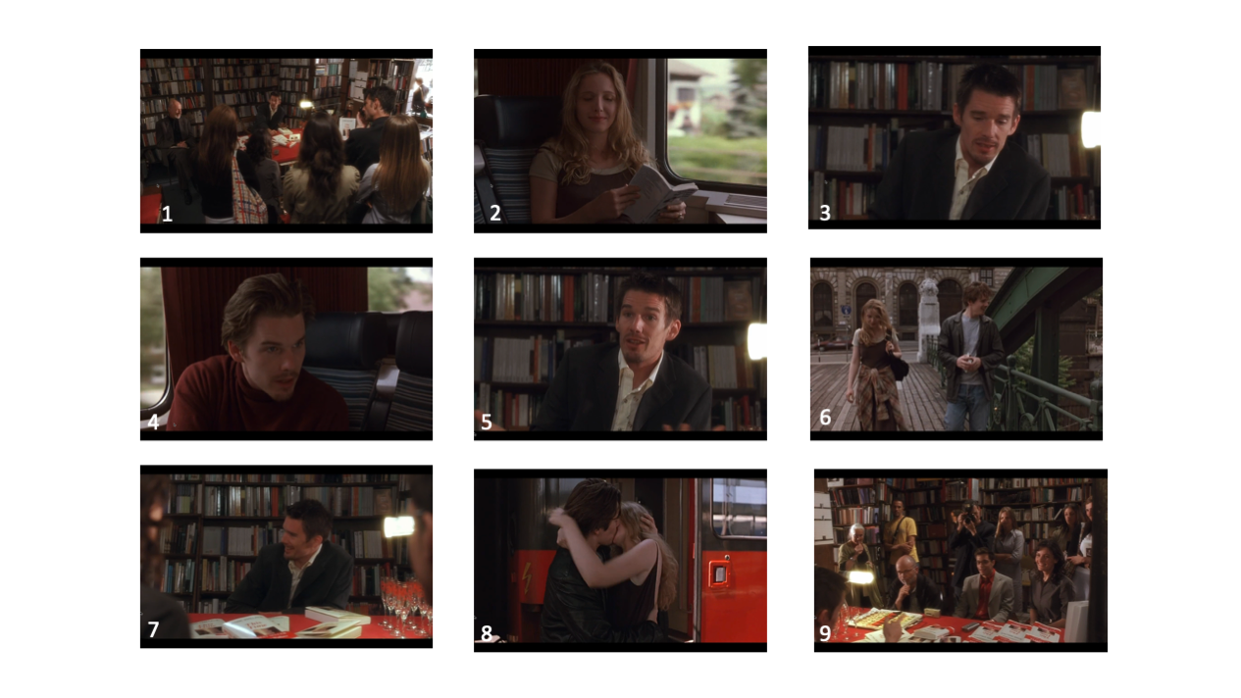
Figure 4. First scenes in Before Sunset. Numbers 2, 4, 6 and 8 were flashbacks from Before Sunrise. Captions: Richard Linklater, Ethan Hawke and Julie Delpy, Before Sunset [Film].

In Lovers of the Arctic Circle, Ana and Otto had also been looking for a second chance. Brian Cope explained that ‘as adults, Otto and Ana never cease to think about each other and wait patiently for their paths to cross’. The movie began with a sequence of scenes that would only make sense at the end of the movie (Figure 5). The midnight sun was shown afterwards while Otto said: ‘It is good for lives to have many circles. But mine, my life has only done one turn, and not completely’ (Figures 2). As Cope suggested, he was expecting to meet Ana in the Arctic Circle. Aguado added that they both travelled to Fin-land (which in Spanish read ‘End-land’) to ‘rebuild once again their love, the most perfect and true’. But here, the sun did not set. Otto added: ‘And here, right now, I can’t close anything’. Without a sunset, there was no end of day. In contrast to Linklater’s film, the absence of sunset might have meant that a second chance was totally missed. As Scalia had proposed, the visual element must be taken into account. Thus the opening image of the Sun, drawing a parallel line to the horizon, may be studied under Aguado’s suggestions that perhaps the circularity of the midnight sun meant that they preferred a life of no uncertainties, which was only possible utopianly. Cope added that acceptance of life was entangled because they had forced their meeting. At the end of the film its beginning was made clear, the woman running on the stairs was Ana’s illusion of meeting Otto. Her eyes and the newspaper flying were Medem’s poetic way of expressing that she had actually been killed by a bus. The man running on the street was Otto going towards her. The Sun did not set in the Arctic Circle, a second chance was not given to them.
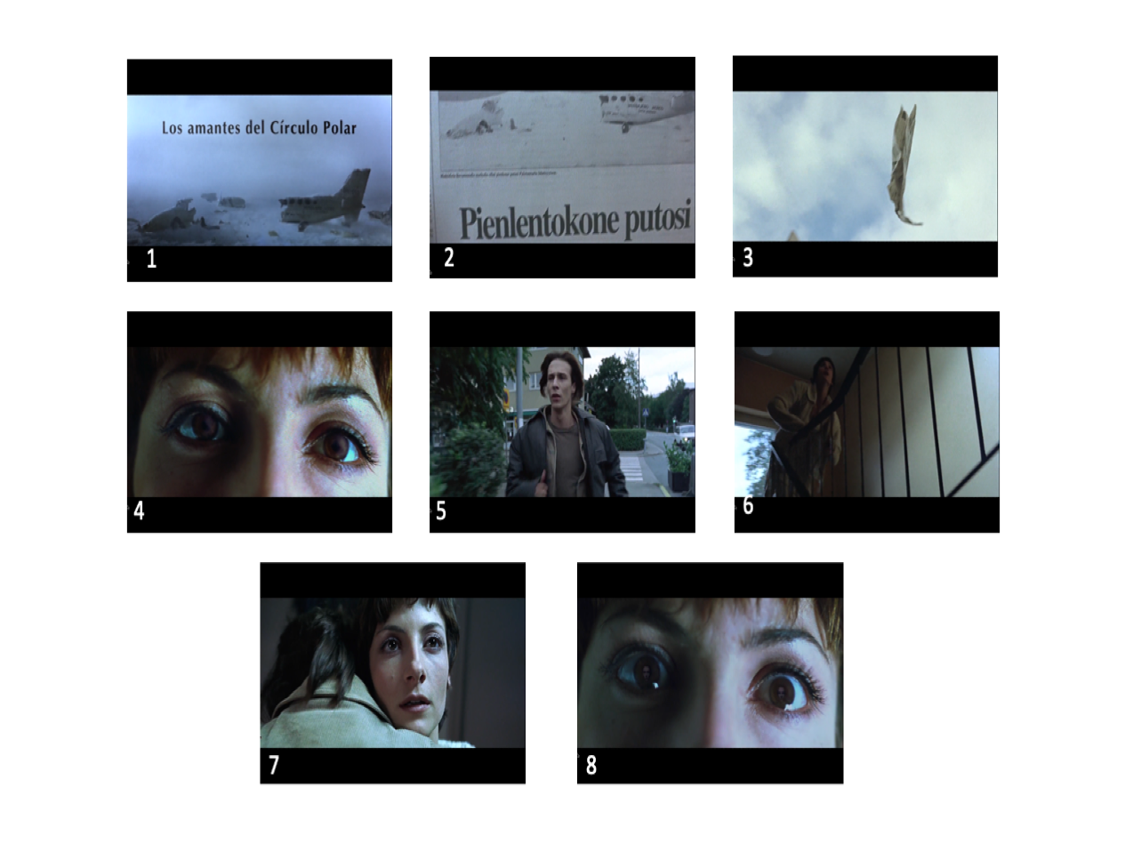
Figure 5. First scenes in Lovers of the Arctic Circle. Captions: Julio Medem, Lovers of the Arctic Circle [Film].
In Your name, both Taki and Mitsuha found themselves at a Shinto sacred site, but each one in their corresponding timeline. During sunset, the borders of time dissolved and they got to see each other for a few minutes (Figure 6). In many ways, this meant a second chance, as well as a second encounter between the two of them. Mitsuha gained the opportunity to live her last day once again in order to save her town. Furthermore, Mitsuha’s timeline was three years back to Taki’s. The day before the comet hit her town, she had gone to Tokyo to meet him. But for him, the body exchanges had not occurred yet, as in his timeline, these would happen three years later, therefore he had not recognized her. Instead, during sunset, as they were meeting again, Taki acknowledged who she was.

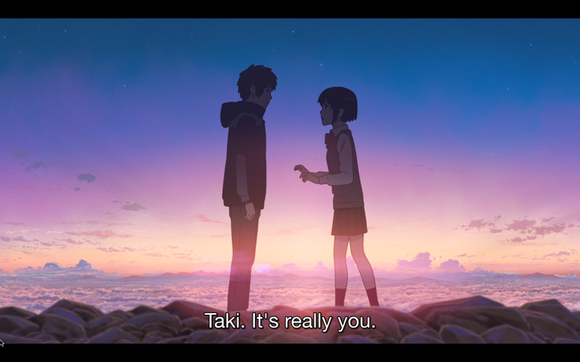
Figure 6. Taki met Mitsuha at Sunset. Caption: Makoto Shinkai, Your name [Film].

To conclude, in Before Sunset, there was both an opportunity and a threat to meet again and make different choices, perhaps representing a melancholic pseudo-neurotic feeling that all past life was better, as implied by San Filippo. In Lovers of the Arctic Pole, this chance got frustrated as the sun did not set. The sky here may be representing the impossibility of escaping from life tribulations, following Cope’s suggestion. Finally, in Your name, the characters got to experience the sunset and gained a second chance.

A sacred moment
This second chance may be echoed in the idea of circular time. According to Mircea Eliade this re-occurrence was in some ways the nature of sacred time and this possibility is discussed here. He believed that sacred time repeated itself constantly. Sacred rites allowed their participants to go back to the beginning of the world in order to create it anew once again.

Circularity was present even in Lovers of the Arctic Circle film’s name. Medem himself mentioned that ‘The movie can be seen as in an instant’. Going back to Egea, Martin Hamdorf and López Rubio’s ideas, the power of the opening image of the Sun running parallel to the horizon may be greatly significant here (Figure 2). A circle was not only drawn by this midnight sun but also by Otto when he said: ‘I’ve written her name inside so many times. And here, right now, I can’t close anything’, while writing the name ‘Ana’ and circling it on a map of the Arctic Circle (Figure 7). To look for circularity in time meant for them to return to the origin of their love. Aguado specified that it was when reading about the Arctic Circle and seeing ‘this luminous magic place that they loved each other for the first time’ (Figure 8). Thus, their need to return there, ‘where all the previous stories match one single narrative’. They wanted to arrive at a mythical time, a sacred time in which to simply be happy together. As Cope would add, ‘their journeys to individuation develop more circuitously than linearly’.

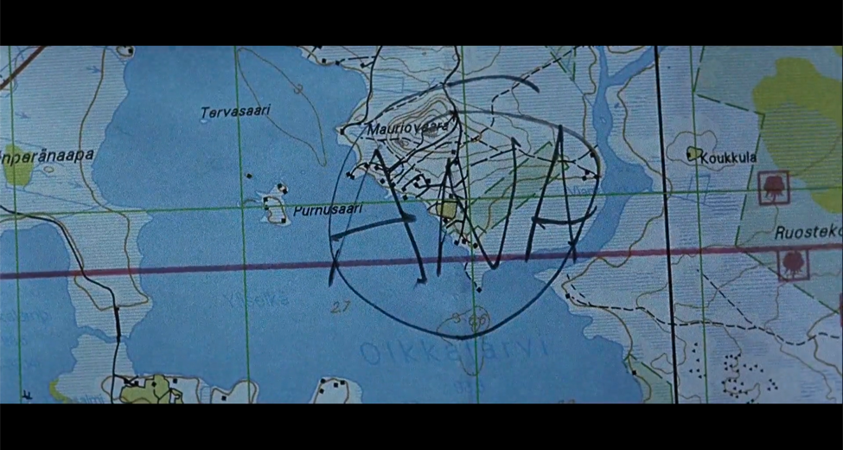
Figure 7. Otto wrote ‘ANA’ in a circle on an Arctic Circle map. Captions: Julio Medem, Lovers of the Arctic Circle [Film].

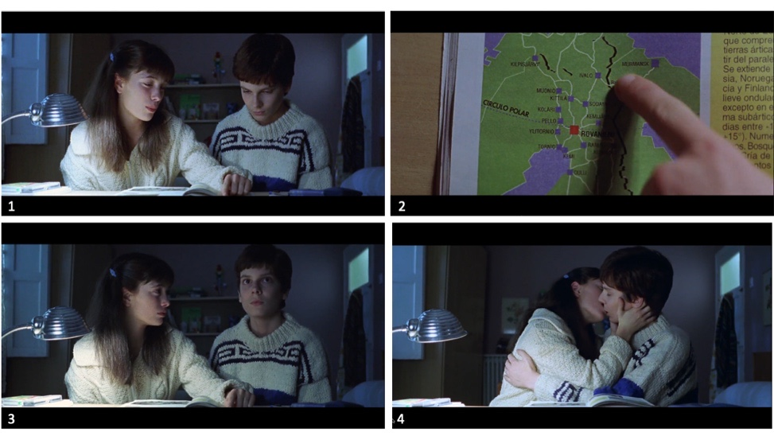
Figure 8. Otto and Ana fell in love as they learned about the midnight sun. Captions: Julio Medem, Lovers of the Arctic Circle [Film].
The sense of a repetitive time, that echoed the circularity of the midnight sun, was made present in the movie in several other different ways. Even their names were palindromes, reuniting in ‘themselves the alfa and omega, the beginning and the end’, as Aguado conveyed. And everything collided in Finland. For instance, Ana met there the man after whom Otto had gotten his name from. Simultaneously, Otto worked as a postman pilot from Finland to Spain and unknowingly took a letter that Ana had written to him on his plane. Medem tried to tie all of events of the movie to the Arctic Circle. Aguado explained ‘all parallel stories converged in the circle’. Eliade claimed that to participate in seasonal rituals was to do the work of the creating gods, which had to be done in a specific way. Somehow, Otto and Ana tried to do this but failed. Otto’s name was given by a German soldier who had been saved from his parachute by a Spanish man. In show of gratitude, they had shared the German’s man last cigarette together. Later, the soldier would marry Cristina, a Spanish woman. When Otto was saved in Finland by a Finnish man from his parachute, he asked him if he had a cigarette, to share it with him and repeat the story. But his saviour did not smoke. Yet Otto forced the encounter with Ana believing that he was repeating a mythical story: that of Cristina and the Geman solider. Ana, when meeting the original Otto, the one saved by the Spanish man, was advised not to constrain transcendental meaning into everything. But she refused to listen, Cope warned. Otto and Ana did not follow the path of the creating gods but pushed their own interpretations into the world. Cope concluded that by forcing sacredness, they got detached from the flow of life. Thus, circularity was not restored, they did not go back to the origin and Ana died.

The idea of a circular sacred time may be discussed in a more secular way when applied to Before Sunset. Jesse and Celine were meeting again in a very special time of the year. ‘Today is sales day in Paris’, she said. This happened every year on the last Wednesday of June, except if the last Wednesday fell on the 28th or afterwards. In 2004, sales day was on the 23rd of June. That year, the Midsummer Solstice occurred on the 22nd. This meant that sunset would occur late in the evening. If Neher was right and Linklater was trying to sculpt his story within real time, the choosing of this day for them to reunite was not mere coincidence. They were meeting at a specific moment in the year in which light was at its greatest and in which the same ritual occurred every year: sales day.

Eliade believed that ‘profane temporal duration can be periodically arrested; for certain rituals have the power to interrupt it by periods of sacred time that is non-historical’. During the whole movie, Jesse and Celine referred back to the night when they met, lost in past mythic time, as they attested during their taxi conversation. When Jesse met Celine outside the bookshop, he told her that he could still not believe that she was real, that she was really there. Later on, he would say that his book responded to the need of making sure that their encounter had happened. In the scene of the taxi drive, Celine also expressed that the night in Vienna had been a mythic and foundational moment: ‘I’ve put my romanticism in that one night’. A few minutes before, on the ferry, she had sighed: ‘It’s about that time, that moment in time that is forever gone’. They both had the feeling that they needed to go back to that origin, the birth of their story together. And, as sunset approached, they were aware that time was cutting short. The last scene seemed to portray a ritual that would take them back to that night, lost in the past. As Jesse walked Celine to her apartment, they stood at the threshold. Eliade believed that thresholds contained the possibility of moving from profane to sacred. A cat had come to greet them, a creature from another world, perhaps a sentinel. According to Eliade, one would expect to find guardians in these liminal zones. They decided to go in and climbed through a passage, up round stairs, widdershins, as going back in time, undoing the path of the Sun. Once in the apartment, Celine, priestess of her temple, performed with her guitar. She sang the waltz of her story with Jesse, as if re-telling a mythical tale, ‘the ritual recitation of cosmological myth’, in Eliade’s words. Circular time was at work, the light of the Sun at its golden hour, pressing them to make a choice. This time, Jesse stayed. San Filippo believed that Before Sunset’s narrative kept going to the past even though there was such a pressing feeling of time running out. She saw this testifying a ‘thirty-something symptom of nostalgia’, as stated above.

If Lovers of the Arctic Circle hypothesized what could happen if the Sun did not die and Before Sunset the pressure that characters might have felt when aware that the end was coming, in Your Name, sunset had a different role. At the beginning of the movie, Mitsuha’s teacher explained:

‘‘Tasokare’ means ‘Who is that?’ and is the origin of the word ‘tasogaredoki’: ‘twilight’, when it’s neither day nor night. When the world blurs and one might encounter something not human’.

Later, in resonance to McDougall’s loom, her grandmother added the concept of ‘Musubi’: ‘Tying thread is Musubi. Connecting people is Musubi. The flow of time is Musubi’ (Figure 9). The Sunset scene occurred at a sacred Shinto round-shaped place. Boyd and Williams claimed that, in Shinto, musubi implied that nature could manifest ‘a creative and life-giving power’. When ‘Tasokare’ occurred, this force might have been at place. When the time boundary got blurry and Taki and Mitsuha met, they were literally allowed to re-create the world. In Eliade’s words, they were ‘created anew; he was reborn, for he began a new life’. Time also gained circularity when Taki returned the red ribbon to Mitsuha, the ribbon that she had given to him the evening before (which for him had been three years before) (Figure 10 and 11). This ribbon connected them with the concept of musubi. Circular shape of time was attested in other ways: Itomori was founded next to a lake in a valley that had formed thousands of years ago when a comet had crashed there (Figure 1). Now, a new comet was approaching to the same spot and Mitsuha was given the chance to re-create the world. In Shinto culture, it was considered that certain conditions generated ‘pollution (tsumi)’, as Boyd and Williams explained. According to their research, it was human action that could re-instate an order of purity so that life-giving forces would reign again. Mitsuha had been trained as Shinto priestess, following her grandmother’s steps. Boyd and Williams implied that Shinto initiates would carry such a task. In this film, the cultural role of the sunset may have been greatly influenced by Shinto culture. Furthermore, sunset may also symbolize the possibility of bringing together modernity and tradition through sacred practices by bonding Taki, a modern Tokyo boy, with Mitsuha, a yet-to-be Shinto priestess from traditional Itomori.

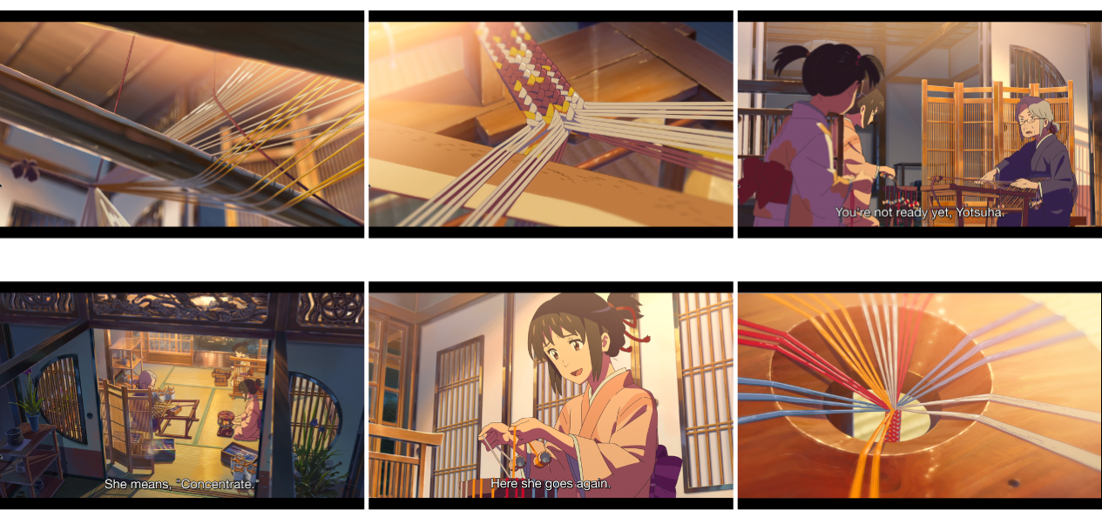
Figure 9. Musubi as threads uniting people together. Captions: Makoto Shinkai, Your name [Film].
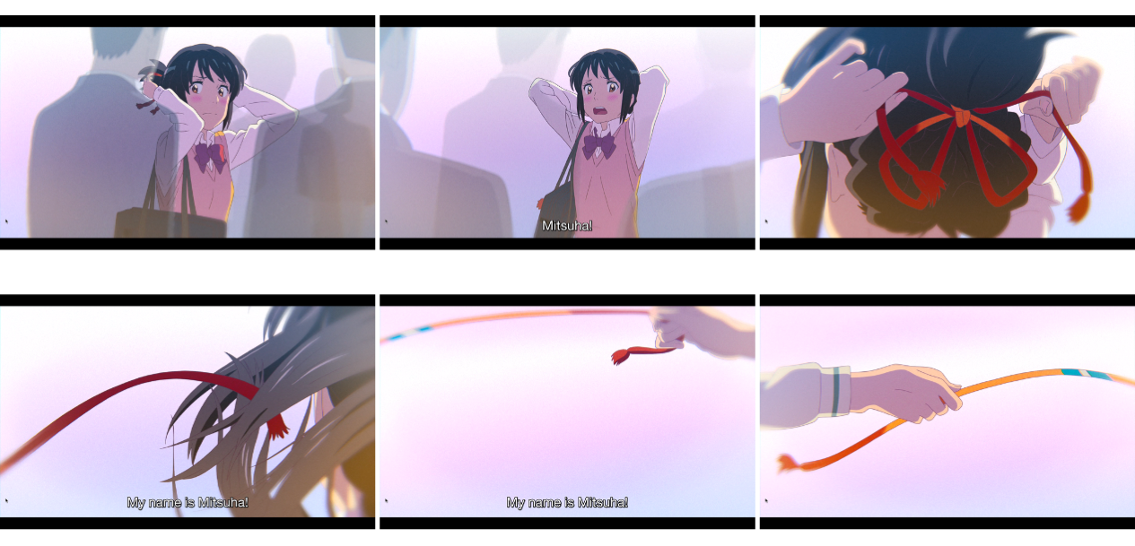
Figure 10. Mitusha gave her red ribbon to Taki in Tokyo even if he did not recognize her. Captions: Makoto Shinkai, Your name [Film].
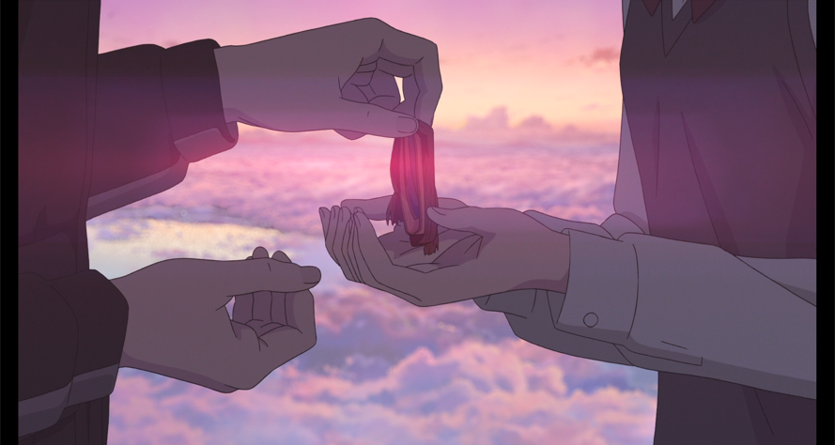
Figure 11. Taki returned the red ribbon when he met Mitsuha at sunset. Caption: Makoto Shinkai, Your name [Film].

To conclude, in all three movies sunset could be linked to a sacred time or the possibility of returning to a lost past and re-creating the world. In Lovers of the Arctic Circle, Ana and Otto’s disconnection from the natural flow of life may probe that fate could not be forced. In Before Sunset, the possibility of making new choices, creating a new destiny for them, was possible by being present and following certain steps (like crossing the threshold or singing a mythic song). In Your name, sacrality of the sunset allowed humanity to work together with the powers of nature and enact life-giving powers.

A reminder of our mortality
The liminal nature of sunset may also represent the final boundary that all humans must eventually face: that of death. It may symbolize that unavoidable limit, not only the end of day, but of life. This possibility is discussed here. In Medem’s film, ‘all characters suffer some kind of loss’, claimed Aguado. In their intention to escape death, Otto and Ana went to ‘another world’, to avoid the distress of this one, the real world. They were desperately seeking to detach from reality. Aguado believed that they were looking for ‘a place where loss stopped ruling’. In one of the conversations with his father, child-Otto refused to accept the idea of death:

‘Otto’s father: Everything is born and dies.
Otto: Not everything.
Otto’s father: Do you know of anything that lives forever?’.

Ana also had a similar struggle as she refused to accept her father’s death. She told to her mother: ‘Dry your tears. Dad is not dead’. Aguado mentioned that Ana ran backwards trying to go back in time. In the skying accident, Otto also looked for a man who could sky upwards (Figure 12). They both wanted to escape the natural flow of time. Paradoxically, in order to do so, they went to ‘END-land’. There, they would not see a sunset, to avoid being reminded that all things come to an end, in Otto’s father’s words. Unaware that even the day (or the summer) would eventually cease, Ana could not believe that the plane crash, reported in the newspaper, could have actually killed Otto, who was its pilot. Completely detached from reality, she crossed the street without paying attention and got hit by a bus while Otto was actually running towards her. Once again, the cultural representation here may be that forcing the encounter may destroy it.

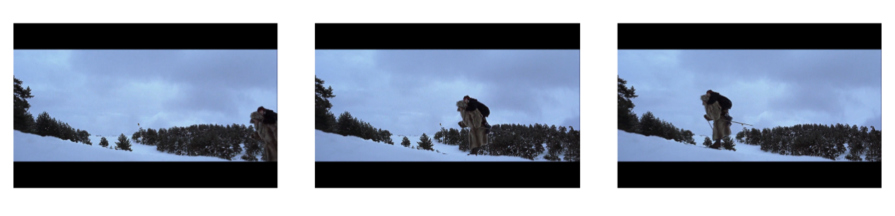
Figure 12. Otto skying upwards. Captions: Julio Medem, Lovers of the Arctic Circle [Film].

In Before Sunset, the awareness that life was limited may have been one of the reasons for Jesse to stay. As stated before, Linklater mixed fiction and reality. Significantly, nine real years had passed between the first movie and its sequel. Fiction time also equated real time as the film was recorded in real time scale. Neher reminded us: ‘The Before films therefore act as a living testament to the passage of time’. This implied that, for the viewers, nine years had also elapsed. Not only Celine and Jesse had matured but also Ethan Hawke, July Delpy and the film spectators. Both Celine and Jesse knew that as the Sun set and the day ended, their encounter would also conclude. This second chance that had been given to them could be lost forever. Celine explained that she had not been able to attend their second encounter in Vienna, nine years ago, because her grandmother had just passed away and she needed to attend the funeral. At the end of the movie, as they were in her apartment, they spoke of the recently deceased Nina Simone and how they missed her. Jesse also found the pictures of Celine’s grandmother. As the day was ending, they both became aware of how short life was, how it would all eventually end. A few minutes before, Celine had hugged Jesse to ensure that he was real, that he would not ‘dissolve into molecules’. Lurie interpreted that this was ‘a decisive step towards realization’, that this was the moment in which their decision about staying together started to take shape. Before that, on the taxi drive, they had argued about how the deception of not meeting in Vienna had ruled their lives. Celine said ‘you can never replace anyone’. At the end of this day, ‘sunset’ could refer not only to the astronomical event, but also to the end of someone’s life. And thus, aware of all of this, as the Sun was setting and the day was dying, conscious of their little time left, Celine sang: ‘You are going to miss that plane’ and Jesse answered: ‘I know’. And stayed.

In Your Name, reality was mixed not only with fiction but also with dream world:

‘Mitsuha: Every now and then, when I wake up, I find myself crying.
Taki: I can never recall the dream I just had, but...
Mitsuha: But... the sensation that I’ve lost something... lingers for a long time.
Taki: I’m always searching for something... for someone’.

Shinkai stated that he was inspired in a poem by Ono No Machi:

‘Did he appear
because I fell asleep
thinking of him?
If only I’d known I was dreaming,
I’d never have wakened.’

The oneiric nature of Taki and Mitsuha’s body exchanges implied that they believed that it was all a dream as they themselves expressed:

‘Mitsuha: In our dreams, that boy and I…
Taki: In our dreams, that girl and I…’ [italics are mine].

But during sunset, they discovered that the exchanges were not a dream. Paradoxically, this happened in the most oneiric of landscapes. Shinkai designed their encounter as if among clouds (Figure 6). Minutes before it, Mitsuha awoke in Taki’s body at the Shinto sacred site and saw that, in his time-line, Itomori had been destroyed and flooded. ‘At that moment... did I...die?’, she asked herself. An instant later, she heard Taki’s voice calling her, in the same place but from a different moment in time. As the sun set, the boundaries between the two realities dissolved and they could meet each other. They were now sure that, though their body-exchanges left a vague uncertain memory, they were real. They were also sure that indeed Itomori would disappear. Thus, it was during sunset that both of them learned that Mitsuha would die that very same evening, unless they did something to prevent it. Sunset here, as one of the powers of nature, may symbolize a life-giving force.

In conclusion, it may be said that in all three movies, sunset was also connected to awareness of death. In Lovers of the Arctic Circle, Otto and Ana travelled to a place where the Sun could not die, but then one of them was killed in an accident. In Before Sunset, as the end of the day brought awareness of the end of life, Jesse decided to stay. In Your name, sunset probed that their exchanges were not a dream so that once that Mitsuha knew that she was about to die, she changed her story.

Conclusion
The aim of this essay was to study the representation of the sky in Lovers of the Arctic Circle, Before Sunset and Your name. Scalia’s advice was followed and the films have been read as poetry, so that sunset was taken metaphorically. In the first movie, the main characters travelled to Finland in a time when the sun would not set. This might have expressed their desire to escape death and the tribulations of life, as stated by Aguado. They were trying to return to the origin of their love, perhaps trying to force Eliade’s sacred time. Tragically, in the land where the sun did not die, Ana was hit by a bus. Culturally, this may express a belief that life could not be pushed to where one wanted it, but that one must respect its cycles instead of trying to overcome them, as Cope had suggested.

In Before Sunset, Celine and Jesse met nine years after a missed rendez-vous in Vienna. As they walked through Paris and discussed their lives, they felt the pressure of the approaching sunset, marking the end of their time together before Jesse returned to USA. By revisiting their first encounter, they felt the opportunity of a second chance. Almost ritualistically, Celine sang a waltz in which she retold their story, creating in some way a sacred moment, as according to Eliade. Aware that life had cycles and that they were not eternal, they chose to stay together this time. It may be speculated that this sunset represented a melancholic feeling that people at around thirty may have, about missed opportunities of the past and how to recover them, as suggested by San Filippo.

Finally, in Your name, the sunset had an even greater role: it allowed Taki and Mitsuha to break the time barrier and meet, so that they became aware of Itomori’s upcoming destruction as to prevent it. Here, sunset gave them a second chance, reminded them of their mortality and generated a sacred reunion that linked Itomori’s valley back to its creation, when another comet had crashed there. The sense of ‘circular, reversible and recoverable’ mythical time may be linked here with Boyd and Williams’ understanding of musubi: a life-giving power in nature. The lives of modern Tokyo and traditional Itomori had also been tied through the mythical red ribbon that Taki and Mitsuha had exchanged. Sunset created a liminal zone in which modern life and tradition could meet as a path to bring balance and life to the world.

Bibliography
Aguado, Txetxu, ‘Amor, utopía y muerte en Los amantes del Círculo Polar, de Julio Medem’, Revista Canadiense de Estudios Hispánicos, 30.2 (Winter 2006), 249-270.

Boyd, James and Ron Williams, ‘Artful means: an aesthetic view of Shinto purification rituals’, Journal of Ritual Studies, 13.1 (Summer 1999), 37-52.

Cope, Brian, ‘Synchronicity in Julio Medem’s “Los amantes del Círculo Polar”: poeticizing coincidence in a Taoist vernacular’, Anales de la literatura española contemporánea, 36.1 (2011), 33-53.

Cutler, Aaron, ‘Love in Time: Julie Delpy, Ethan Hawke, and Richard Linklater’s “Before” films’, Cinéaste, 38.4 (Fall 2013), 24-28.

Egea, Juan F., ‘“El sol del membrillo” and “Los amantes del círculo polar”’, Hispanic Review, 75.2 (Spring, 2007), 159-180.

Eliade, Mircea, The Sacred and the Profane: The Nature of Religion, trans. by Willard R. Trask (New York, NY: Harcourt, Brace & World Inc., 1959).

Hamdorf, Wolf Martin and Clara López Rubio, ‘Julio Medem, la poesía del Norte’, Litoral, 236 (2003), 252-256.

Linklater, Richard and Kim Krizan, Before Sunrise [Film], dir. by Richard Linklater (Castel Rock Entertainment, 1995).

Linklater, Richard, Ethan Hawke and Julie Delpy, Before Midnight [Film], dir. by Richard Linklater (Castel Rock Entertainment, Venture Forth and Detour Filmproduction, 2013).

Linklater, Richard, Ethan Hawke and Julie Delpy, Before Sunset [Film], dir. by Richard Linklater (Castel Rock Entertainment in co-production with Warner Independent Pictures, 2004).

Lurie, Peter, ‘Digital déjà vu: cinephilia, loss, and medial integrity in Linklater’s Before trilogy’, Film Quarterly, 68.3 (Spring 2015), 60-66.

McDougall, Edward, ‘Everydayness, divinity, and the sacred: Shinto and Heidegger’, Philosophy East and West, 66.3 (July 2016), p. 883-902.

Medem, Julio, Lovers of the Arctic Circle [Film], dir. by Julio Medem (Canal +, 1998).

Neher, Erick Neher, ‘Richard Linklater’s Sculpture in Time’, The Hudson Review, 67.3 (Autumn 2014), 470-476.

Quinto, Manuel, ‘Medem & Coixet’, El Ciervo, 573 (December 1998), 11-12.

San Filippo, Maria San Filippo, ‘Growing old together: Linklater’s Before trilogy in the twilight years of art house distribution’, Film Quarterly, 68.3 (Spring 2015), 53-59.

Scalia, Bill R., ‘Toward a Semiotics of Poetry and Film: Meaning-Making and Extra-Linguistic Signification’, Literature/Film Quarterly, 40.1 (2012), 46-53.

Shinkai, Makoto, Your name [Film], dir. by Makoto Shinkai (Comix Wave Films, 2016).

‘Sunset’ in The Oxford Dictionary of Idioms, ed. by John Ayto (Oxford University Press, 2020), https://www.oxfordreference.com/view/10.1093/acref/9780198845621.001.0001/acref-9780198845621-e-2497, accessed 17 April 2021).

Willis, Holy, ‘It’s about time’, Film Comment, 50.4 (July/August 2014), 18-22.
Sinha-Roy, Piya, ‘‘Your Name’ draws modern love film from ancient poem’, Reuters, 5 April 2017, https://www.reuters.com/article/us-film-yourname-idUSKBN1772R0, accessed 17 April 2021).
Machi, Ono No, ‘Did he appear’ in The ink dark Moon, trans. by Jane Hirshfield and Mariko Aratani (New York, NY: Vintage Classics, 1990), p. 26.

Julio Medem, Lovers of the Arctic Circle [Film], dir. by Julio Medem (Canal +, 1998); Richard Linklater, Ethan Hawke and Julie Delpy, Before Sunset [Film], dir. by Richard Linklater (Castel Rock Entertainment in co-production with Warner Independent Pictures, 2004); Makoto Shinkai, Your name [Film], dir. by Makoto Shinkai (Comix Wave Films, 2016).
Richard Linklater, Ethan Hawke and Julie Delpy, Before Sunset [Film]; Richard Linklater and Kim Krizan, Before Sunrise [Film], dir. by Richard Linklater (Castel Rock Entertainment, 1995).
Makoto Shinkai, Your name [Film].
Bill R. Scalia, ‘Toward a Semiotics of Poetry and Film: Meaning-Making and Extra-Linguistic Signification’, Literature/Film Quarterly, 40.1 (2012), p. 49.
Bill R. Scalia, ‘Toward a Semiotics of Poetry and Film: Meaning-Making and Extra-Linguistic Signification’, p. 47.
Juan F. Egea, ‘“El sol del membrillo” and “Los amantes del círculo polar”’, Hispanic Review, 75.2 (Spring, 2007), p. 160.
Juan F. Egea, ‘“El sol del membrillo” and “Los amantes del círculo polar”’, p. 162.
Txetxu Aguado, ‘Amor, utopía y muerte en Los amantes del Círculo Polar, de Julio Medem’, Revista Canadiense de Estudios Hispánicos, 30.2 (Winter 2006), p. 249.
Wolf Martin Hamdorf and Clara López Rubio, ‘Julio Medem, la poesía del Norte’, Litoral, 236 (2003), p. 254.
Brian Cope, ‘Synchronicity in Julio Medem’s “Los amantes del Círculo Polar”: poeticizing coincidence in a Taoist vernacular’, Anales de la literatura española contemporánea, 36.1 (2011), p. 34.
Brian Cope, ‘Synchronicity in Julio Medem’s “Los amantes del Círculo Polar”: poeticizing coincidence in a Taoist vernacular’, p. 47.
Richard Linklater and Kim Krizan, Before Sunrise [Film]; Richard Linklater, Ethan Hawke and Julie Delpy, Before Sunset [Film]; Richard Linklater, Ethan Hawke and Julie Delpy, Before Midnight [Film], dir. by Richard Linklater (Castel Rock Entertainment, Venture Forth and Detour Filmproduction, 2013).
Holy Willis, ‘It’s about time’, Film Comment, 50.4 (July/August 2014), p. 20.
Erick Neher, ‘Richard Linklater’s Sculpture in Time’, The Hudson Review, 67.3 (Autumn 2014), p. 472.
Aaron Cutler, ‘Love in Time: Julie Delpy, Ethan Hawke, and Richard Linklater’s “Before” films’, Cinéaste, 38.4 (Fall 2013), p. 24.
Peter Lurie, ‘Digital déjà vu: cinephilia, loss, and medial integrity in Linklater’s Before trilogy’, Film Quarterly, 68.3 (Spring 2015), p. 60.
Maria San Filippo, ‘Growing old together: Linklater’s Before trilogy in the twilight years of art house distribution’, Film Quarterly, 68.3 (Spring 2015), p. 53.
James Boyd and Ron Williams, ‘Artful means: an aesthetic view of Shinto purification rituals’, Journal of Ritual Studies, 13.1 (Summer 1999), p. 37.
Makoto Shinkai, Your name [Film].
Edward McDougall, ‘Everydayness, divinity, and the sacred: Shinto and Heidegger’, Philosophy East and West, 66.3 (July 2016), p. 889.
James Boyd and Ron Williams, ‘Artful means: an aesthetic view of Shinto purification rituals’, p.38.
Mircea Eliade, The Sacred and the Profane: The Nature of Religion, trans. by Willard R. Trask (New York, NY: Harcourt, Brace & World Inc., 1959), p. 68.
Mircea Eliade, The Sacred and the Profane: The Nature of Religion, p. 70.
Mircea Eliade, The Sacred and the Profane: The Nature of Religion, p. 68 and 69.
Richard Linklater, Ethan Hawke and Julie Delpy, Before Sunset [Film].
Peter Lurie, ‘Digital déjà vu: cinephilia, loss, and medial integrity in Linklater’s Before trilogy’, p. 60.
Maria San Filippo, ‘Growing old together: Linklater’s Before trilogy in the twilight years of art house distribution’, p. 22.
Erick Neher, ‘Richard Linklater’s Sculpture in Time’, p. 474.
Dennis West, Joan M. West and Richard Linklater, ‘Growing up in America: an interview with Richard Linklater’, Cinéaste, 39.4 (Fall 2014), p. 23
Dennis West, Joan M. West and Richard Linklater, ‘Growing up in America: an interview with Richard Linklater’, p. 53
Brian Cope, ‘Synchronicity in Julio Medem’s “Los amantes del Círculo Polar”: poeticizing coincidence in a Taoist vernacular’, p. 37.
‘Es Bueno que las vidas tengan varios círculos. Pero la mia, mi vida, sólo ha dado la vuelta una vez. Y no del todo’. Julio Medem, Lovers of the Arctic Circle [Film].
Brian Cope, ‘Synchronicity in Julio Medem’s “Los amantes del Círculo Polar”: poeticizing coincidence in a Taoist vernacular’, p. 38.
‘Para reconstruir otra vez su amor, el más perfecto y verdadero’. Txetxu Aguado, ‘Amor, utopía y muerte en Los amantes del Círculo Polar, de Julio Medem’, p. 251.
‘Y aquí ahora mismo, no puedo cerrar nada’. Julio Medem, Lovers of the Arctic Circle [Film].
Txetxu Aguado, ‘Amor, utopía y muerte en Los amantes del Círculo Polar, de Julio Medem’, p. 251.
Brian Cope, ‘Synchronicity in Julio Medem’s “Los amantes del Círculo Polar”: poeticizing coincidence in a Taoist vernacular’, p. 47
Maria San Filippo, ‘Growing old together: Linklater’s Before trilogy in the twilight years of art house distribution’, p. 22.
Brian Cope, ‘Synchronicity in Julio Medem’s “Los amantes del Círculo Polar”: poeticizing coincidence in a Taoist vernacular’, p. 47.
Mircea Eliade, The Sacred and the Profane: The Nature of Religion, p. 68.
Mircea Eliade, The Sacred and the Profane: The Nature of Religion, p. 69.
Mircea Eliade, The Sacred and the Profane: The Nature of Religion, p. 75.
‘La película se puede ver como en un instante’. Manuel Quinto, ‘Medem & Coixet’, El Ciervo, 573 (December 1998), p. 12.
Juan F. Egea, ‘“El sol del membrillo” and “Los amantes del círculo polar”’, 162; Wolf Martin Hamdorf and Clara López Rubio, ‘Julio Medem, la poesía del Norte’, p. 152.
‘He escrito tantas veces su nombre dentro. Y aquí, ahora mismo, no puedo cerrar nada’. Julio Medem, Lovers of the Arctic Circle [Film].
‘Este espacio mágico de luminosidad se aman por primera vez’. Txetxu Aguado, ‘Amor, utopía y muerte en Los amantes del Círculo Polar, de Julio Medem’, p. 250
‘Donde todas las historias anteriores confluyen en una única narrativa’ Txetxu Aguado, ‘Amor, utopía y muerte en Los amantes del Círculo Polar, de Julio Medem’, p. 259.
Brian Cope, ‘Synchronicity in Julio Medem’s “Los amantes del Círculo Polar”: poeticizing coincidence in a Taoist vernacular’, p. 45
‘Consigue reunir en sí mismo alfa y omega, el comienzo y el final’ Txetxu Aguado, ‘Amor, utopía y muerte en Los amantes del Círculo Polar, de Julio Medem’, p. 255.
‘Todas las historias paralelas convergen en el círculo’ Txetxu Aguado, ‘Amor, utopía y muerte en Los amantes del Círculo Polar, de Julio Medem’, p. 256
Mircea Eliade, The Sacred and the Profane: The Nature of Religion, p. 81.
Brian Cope, ‘Synchronicity in Julio Medem’s “Los amantes del Círculo Polar”: poeticizing coincidence in a Taoist vernacular’, p. 46.
Brian Cope, ‘Synchronicity in Julio Medem’s “Los amantes del Círculo Polar”: poeticizing coincidence in a Taoist vernacular’, p. 47.
Erick Neher, ‘Richard Linklater’s Sculpture in Time’, p. 472.
Mircea Eliade, The Sacred and the Profane: The Nature of Religion, pp. 71-72.
Mircea Eliade, The Sacred and the Profane: The Nature of Religion, p. 181.
Mircea Eliade, The Sacred and the Profane: The Nature of Religion, p. 24.
Mircea Eliade, The Sacred and the Profane: The Nature of Religion, p. 82.
Maria San Filippo, ‘Growing old together: Linklater’s Before trilogy in the twilight years of art house distribution’, p. 53.
Maria San Filippo, ‘Growing old together: Linklater’s Before trilogy in the twilight years of art house distribution’, p. 53.
Makoto Shinkai, Your name [Film].
Makoto Shinkai, Your name [Film].
James Boyd and Ron Williams, ‘Artful means: an aesthetic view of Shinto purification rituals’, p. 37.
Mircea Eliade, The Sacred and the Profane: The Nature of Religion, p. 79.
James Boyd and Ron Williams, ‘Artful means: an aesthetic view of Shinto purification rituals’, p. 39.
James Boyd and Ron Williams, ‘Artful means: an aesthetic view of Shinto purification rituals’, p. 39.
James Boyd and Ron Williams, ‘Artful means: an aesthetic view of Shinto purification rituals’, p. 39.
‘Todos los personajes sufren algún tipo de pérdida’. Txetxu Aguado, ‘Amor, utopía y muerte en Los amantes del Círculo Polar, de Julio Medem’, p. 249.
‘Otro mundo’ Julio Medem, Lovers of the Arctic Circle [Film].
‘Un lugar donde la pérdida deje de gobernar’ Txetxu Aguado, ‘Amor, utopía y muerte en Los amantes del Círculo Polar, de Julio Medem’, p. 255.
‘Padre de Otto: - Todo nace y muere. Otto: - Todo no. Padre de Otto: - ¿Tú conoces algo que vive siempre?’. Julio Medem, Lovers of the Arctic Circle [Film].
‘Sécate los ojos. Papá no ha muerto’. Julio Medem, Lovers of the Arctic Circle [Film].
Txetxu Aguado, ‘Amor, utopía y muerte en Los amantes del Círculo Polar, de Julio Medem’, p. 249
‘FIN-land’. Julio Medem, Lovers of the Arctic Circle [Film].
Erick Neher, ‘Richard Linklater’s Sculpture in Time’, p. 472.
Peter Lurie, ‘Digital déjà vu: cinephilia, loss, and medial integrity in Linklater’s Before trilogy’, p. 60.
‘Sunset’ in The Oxford Dictionary of Idioms, ed. by John Ayto (Oxford University Press, 2020), https://www.oxfordreference.com/view/10.1093/acref/9780198845621.001.0001/acref-9780198845621-e-2497, accessed 17 April 2021).
Richard Linklater, Ethan Hawke and Julie Delpy, Before Sunset [Film].
Makoto Shinkai, Your name [Film].
Piya Sinha-Roy, ‘‘Your Name’ draws modern love film from ancient poem’, Reuters, 5 April 2017, https://www.reuters.com/article/us-film-yourname-idUSKBN1772R0, accessed 17 April 2021).
Ono No Machi, ‘Did he appear’ in The ink dark Moon, trans. by Jane Hirshfield and Mariko Aratani (New York, NY: Vintage Classics, 1990), p. 26.
Makoto Shinkai, Your name [Film].
Makoto Shinkai, Your name [Film].
Julio Medem, Lovers of the Arctic Circle [Film]; Richard Linklater, Ethan Hawke and Julie Delpy, Before Sunset [Film]; Makoto Shinkai, Your name [Film].
Bill R. Scalia, ‘Toward a Semiotics of Poetry and Film: Meaning-Making and Extra-Linguistic Signification’, p. 47.
Txetxu Aguado, ‘Amor, utopía y muerte en Los amantes del Círculo Polar, de Julio Medem’, p. 249.
Brian Cope, ‘Synchronicity in Julio Medem’s “Los amantes del Círculo Polar”: poeticizing coincidence in a Taoist vernacular’, p. 47.
Maria San Filippo, ‘Growing old together: Linklater’s Before trilogy in the twilight years of art house distribution’, p. 53.
Mircea Eliade, The Sacred and the Profane: The Nature of Religion, p. 70; James Boyd and Ron Williams, ‘Artful means: an aesthetic view of Shinto purification rituals’, p. 37.

