Industrial Research
The Opportunity for Using Voice Services To Deliver Customer Facing Services at The Driver and Vehicle Licensing Agency (DVLA)
Robert James (P144088)
Contents
Figures 2
The Opportunity for Using Voice Services To Deliver Customer Facing Services at The Driver and Vehicle Licensing Agency (DVLA) 3
Project Aim 3
Background Rational 3
Literature Review 4
The Use of Voice skills in Government to Date 6
What Issue Is The Project Addressing? 7
What Is The Wider Opportunity For DVLA? 8
Assumptions 9
Approach and Methods Methodology 10
Philosophy 10
Approach 10
Strategies 10
Development Methodology 11
Testing 12
Plan of Work 12
Tasks For Discovery 13
Conceptual Solution Architecture 13
Costs 14
Success Criteria 14
References 15

Figures
Figure 1 – The VODER………………………………………………………………………………………………………………………3
Figure 2 – Voice Assistants in Use…………………………………………………………………………………………………….3
Figure 3 – Amazon Echo…………………………………………………………………………………………………………………..4
Figure 4 – Google Home…………………………………………………………………………………………………………………..4
Figure 5 – Under The Hood of Ask……………………………………………………………………………………………………5
Figure 6 – Smart Speaker Users in Selected Markets 2019……………………………………………………………….5
Figure 7 – DVLA Alexa Enquiry………………………………………………………………………………………………………….7
Figure 8 – UK Driving Licence……………………………………………………………………………………………………………7
Figure 9 - Tax a Vehicle Online Process Steps…………………………………………………………………………………..8
Figure 10 – Agile Methodology…………………………………………………………………………………………………………11
Figure 11 – Scrum Methodology……………………………………………………………………………………………………….11
Figure 12 – High Level Project Plan…………………………………………………………………………………………………..12
Figure 13 – Tasks for Discovery…………………………………………………………………………………………………………13
Figure 14 – Conceptual Solution Architecture…………………………………………………………………………………..13
Figure 15 – Project Costs………………………………………………………………………………………………………………….14

The Opportunity for Using Voice Services To Deliver Customer Facing Services at The Driver and Vehicle Licensing Agency (DVLA)

Project Aim
The aim of the project is to investigate the viability of using a voice channel, to deliver a transactional service.

Background Rational
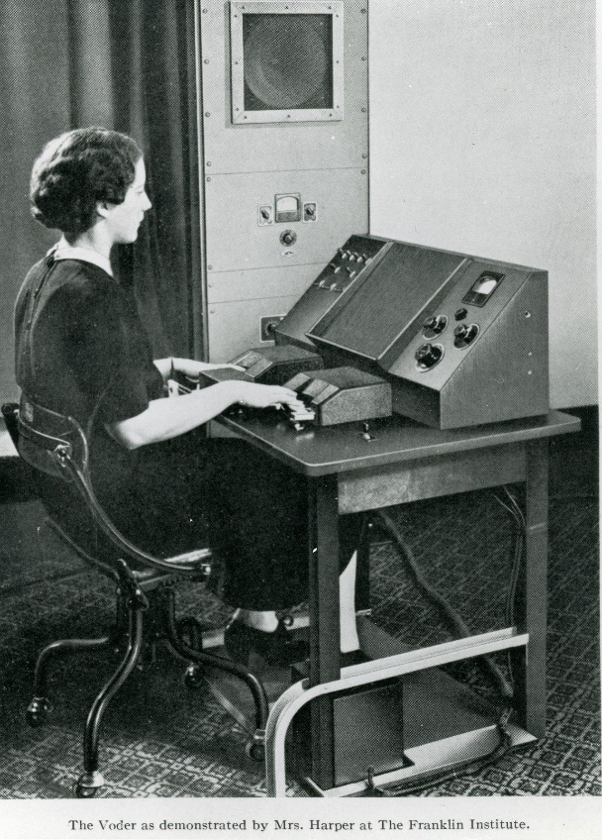
The first machine that could speak to us was Bell Lab’s VODER (figure 1), first shown to the world in 1939 [4]. It was in no way intelligent like todays speaking machines are. The VODER was a machine, operated by a human [5], in much the same way an organ is. The VODER synthesised human voice by creating ‘20 or so different buzzes and chirps,…which the operator could manipulate using 10 keys, a wrist plate and a pedal’ [10] in to sounds that sounded like words.’

Since personal computers became more widespread during the 1990s, and thanks to advances in technology, companies have been developing much better software that allows users to speak to their computer [6], [12].

Figure 1

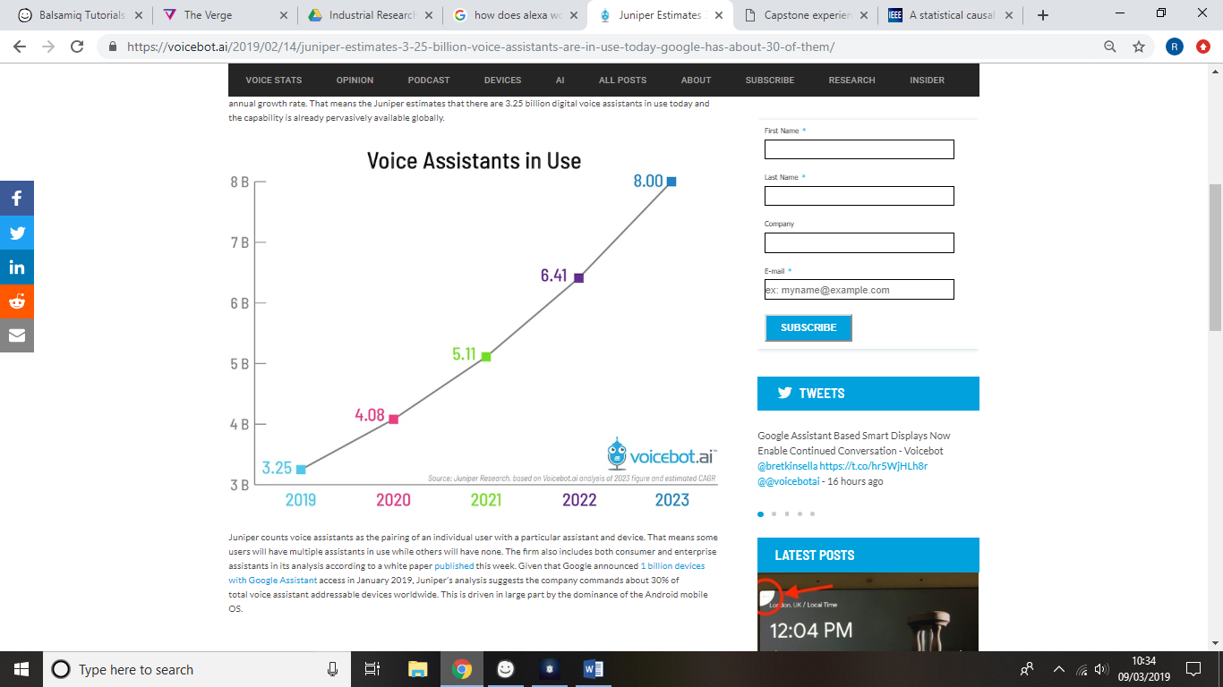
The release of the first smartphone, Apple’s iPhone in 2007 [14] was the first time millions of users had a touch screen interface in their pocket. Touching a screen, became the established way we interacted with modern machines [13]. Although, the release of SIRI, originally as an iOS app back in 2010 [1], then following Apple’s purchase of it for $200million [2], SIRI’s integration with iOS for the release of the iPhone 4s in October 2011 [3], moved human computer interaction a step further by putting devices that could understand human speech in the pockets of millions of users around the world. Then followed the launch of voice searches on Google, Amazon’s Alexa service and Microsoft’s Cortana service in 2014 [7[, [8]. Adding to the growing trend in technology firms releasing voice interfaces for computers.
With over 2.5 billion digital voice assistants in use today globally [31], and the expectation that we’ll see as many as 8 billion in use globally by 2023 [32], voice appears to be an increasingly relevant and in demand channel going forward for organisations. See figure 2.

Figure 2

Literature Review
In the UK, the launch of the Amazon Echo in September 2016 [9] really brought voice user interfaces (VUI) in to the mainstream [15]. Amazon’s Echo (see figure 3) was followed by Google Home [16] (see figure 4), Apple’s Home Pod [17] and a host of other new products that used VUI’s. These products differed from VUI’s on smartphones, because a smartphones primary interaction method is touch [34], [35], voice is secondary.
A smart speaker’s primary interaction method is voice [33]. Supported by smart phone apps for set up and user information [57], [58]. Smart speakers brought with them the added convenience of being able to control other devices by the user speaking to the smart speaker [59], [60], [61]. Users could now control their lights [62], their thermostats [60] and plug sockets by voice [36], in addition to being able to use their voice to interact with a computer that will play music [63], provide information which answers user’s questions, order a takeaway [64] or book a taxi [9].
VUI’s make interaction with computers more accessible for a whole group of users [13], [65], particularly those with physical motor related conditions and visual impairment. VUI’s also make it possible to interact with machines whilst carrying out other tasks. Just as VUI’s made it from our smartphones, into smart speakers and other devices in our homes. They’ve now made their way in to our vehicles as well [66]. Manufacturers have been developing their own VUI’s for interacting with various in car features since the 1990’s [67]. But now the automotive industry is realising that by using voice as an interface for systems within vehicles [44], they can contribute to improvements in road safety as well as usability [38], [68], 69].


Figure 3
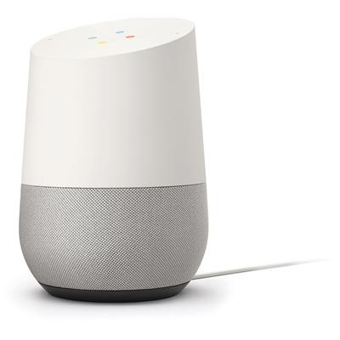

Figure 4

These smart speakers, our smartphones and our vehicles now have virtual assistants [37] that we interact with through voice. ‘Virtual Assistants (VAs) are applications that assist users through the execution of computational tasks’ [37] examples of these are Amazon’s Alexa [41], Google Assistant [42] and Apple’s SIRI [43]. As of early 2019, the manufacturers with VA’s in their vehicles are: BMW, Mini, Ford, Seat, Toyota, Lexus and Volkswagen [18], [19], [20], [21], [22], [23], [24].
VA’s use speech recognition technology to understand what the user is asking, it then performs the action it thinks is correct. Alexa takes an audio recording of what has been said and converts that in to text [70]. The text is then injected in to Amazon’s Alexa application which identifies key words in the text and uses its connection to the internet to find the most appropriate response. Either performing an action or returning some information. When Alexa has found the appropriate response, the text is converted back in to speech and the response is spoken back to the user [25], [26]. See figure 5.
It seems safe to say that the screen ‘is no longer going to be the primary medium’ [40], the voice channel is going to play an increasing role in our day to day lives [32].

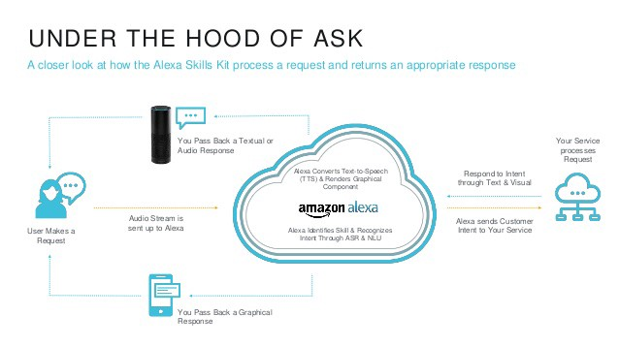
There are over 12 million smart speakers in the UK alone [88]. See figure 6. This doesn’t include the VA’s on smartphones that users interact with using voice. This tells us that VUI’s are increasingly becoming the way humans interact with machines, devices and commonly the internet.
This is driving more and more organisations to create skills [28] through which users can interact with their organisation. Either to request information or complete a transactional service. For example, through Alexa, users can purchase products from Amazon’s online store [29], or order a takeaway from Just Eat [30].
Figure 5
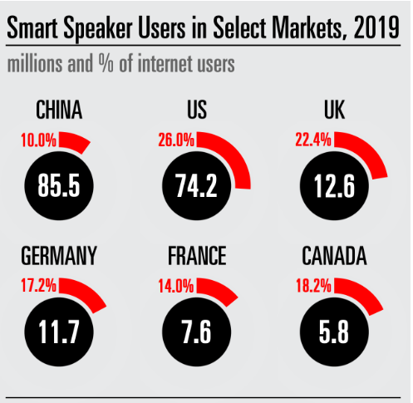

Figure 6

The Use of Voice skills in Government to Date
DVLA was the first body within the UK Government to launch an Alexa skill in July 2017 [47]. DVLA built a skill enabling users to check the tax & MoT status of a vehicle [45]. Users were already able to access this information through a web page [46], but DVLA chose to experiment with a new channel, as the chief executive Oliver Morley [47] said at the time;
“Providing choice in how people use our services is important to DVLA and by trialling this skill we are giving customers another way to get information quickly and easily – helping them to keep on top of their vehicle tax.”
DVLA followed this up with the announcement that it had also created a Google Assistant skill in September 2018 [48]. It stated the reason for launching a skill for Google Assistant was the pressure from users to do so [48]. DVLA spoke at the time of being an early adopter of voice technology [48], and the importance of users being able to access services simply, 24/7.
HMRC followed in July 2018 with a skill that allowed users to ask about the three most common enquiries HMRC received at its call centre [49];
- Reporting a change of circumstance
- Querying payment information
- Renewals.

HMRC state their reason for trialling an Alexa skill is to try and “reduce the need for customers to call our contact centres” [49]. HMRC supports their reasoning for users wanting an Alexa skill by their claims that over 40% of house holds would have a smart speaker by the end of 2018 [49].
The team behind GOV.UK, the UK Government’s one stop website and part of the critical national infrastructure, have also been exploring voice computing [50]. More specifically the need to tailor their website to work with voice searches. They’ve worked to optimise their website to be capable of returning useful information to common questions asked of Government;
- How long does it take to get a new passport?
- How much does a driving test cost?
- When will I get child benefit paid?
All these services are still relatively limited in being simple question and answer enquiry type services [56]. Although the benefit they bring is that users can enquire on them 24 hours a day 7 days a week. The answers to all of these enquiries are available online. Government creating services accessible through a voice channel, using devices such as Alexa and Google Assistant isn’t about allowing users to access new information. It’s about providing users with a new way of accessing this information, in line with how users are increasingly accessing information in 2019. It’s also an improvement in the services provided to users, because they can enquire 24/7/365 and compared to calling a contact centre for the information, their enquiry is answered instantly, instead of them having to navigate a phone menu and wait to speak to an advisor.

What Issue Is The Project Addressing?
Currently DVLA’s Alexa and Google Assistant skills are for enquiries only. If the user enquires on their tax status and learns that they need to tax their vehicle, the user is unable to perform that transact through Alexa or Google in order to purchase vehicle tax.. Instead the user must then choose a different channel to transact with DVLA through, in order to purchase their vehicle tax.
A modern digital channel has been made available to users, marketed by DVLA as an ‘innovative new skill’ [72], as a way of demonstrating DVLA is in touch with how users want to interact with organisations. However, having launched this innovative new channel, it is potentially leading to a disappointing user experience [73] as some users can’t fully complete their journey.
Therefore, the fundamental issue the project is working to resolve is to enable the completion of the user journey, where a user enquires on their vehicle and as a result of that enquiry, they need to purchase vehicle tax.
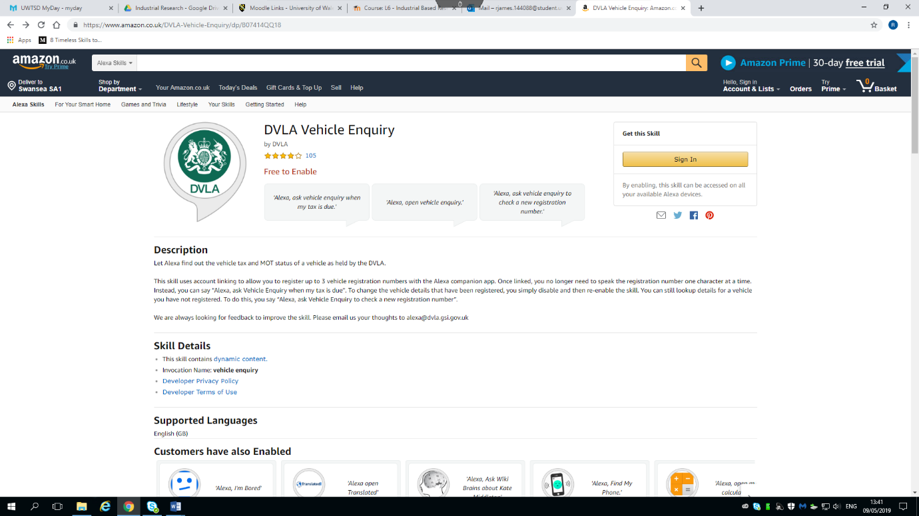

Figure 7

DVLA makes online, paper and telephone channels available to users. Importantly, users can enquire and transact with DVLA through each of these channels to varying degrees. The caveat here is, users can transact through a channel as far as the technology or legislation allows.
In the instance of applying for a first provision driving licence, users are able to enquire about it using the online and phone channels but are unable to actually transact by applying for a driving licence through the phone channel, as they are required to provide a photograph of themselves and their signature. Under driving licence legislation, both of these items are required to be printed on the driving licence. See figure 8. They do however have the choice of transacting using a paper application form or by completing an online application.
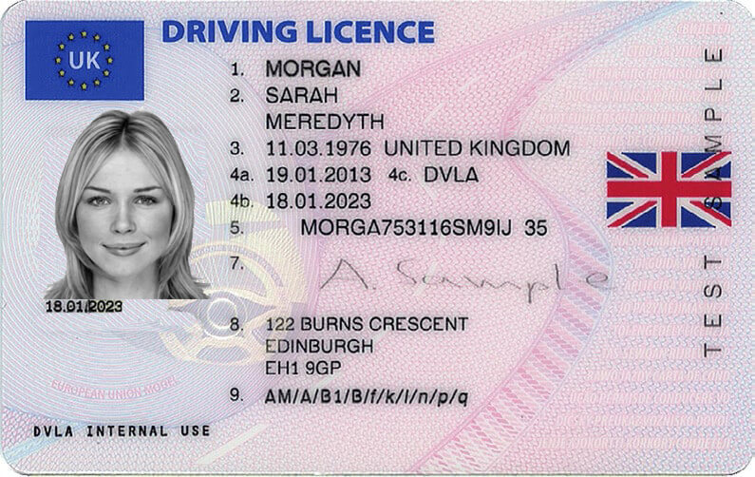

Figure 8

By creating voice skills, DVLA opened up a new channel that is enquiry only. However, this is not stated explicitly anywhere. It is only when interacting with the skills that the user becomes aware they cannot purchase tax using this channel.
In the instance of Alexa, the inability to purchase through this technology is not a limitation of the technology. Nor is it a limitation of legislation. Indeed, Alexa can be used as a voice interface to purchase take away meals [30] and products from Amazon’s online store [74], and vehicle tax can legally be purchased online [75].

What Is The Wider Opportunity For DVLA?
We’ve established that voice is becoming an interface in its own right. The opportunity for users to interact through using the voice channel is at an all time high, through smart phones, smart speakers, in car entertainment systems and other connected devices with voice interfaces. Since it’s launch in July 2017, over 20,000 users have interacted with DVLA’s voice skill. Resulting in over 1000 untaxed vehicles found.
Looking at current DVLA services [51], [52], [53], [54], [55], many are transactional services, enabling users to apply for, renew or update their information on a physical token related to driving or owning a vehicle. The nature of these transactions requires users to provide a relatively large amount of data. Some of which is personal, name, address and date of birth and some is personal sensitive because it’s medical data or data relating to convictions. These transactions do not lend themselves to being made available through the voice channel.
The purchase vehicle tax transaction is ideally suited to the voice channel because of it’s similarity to purchasing goods from Amazon and because of its relative simplicity. Users paying for the tax for a vehicle are not required to authenticate themselves, they enter a reference number relating to the vehicle and their payment details.
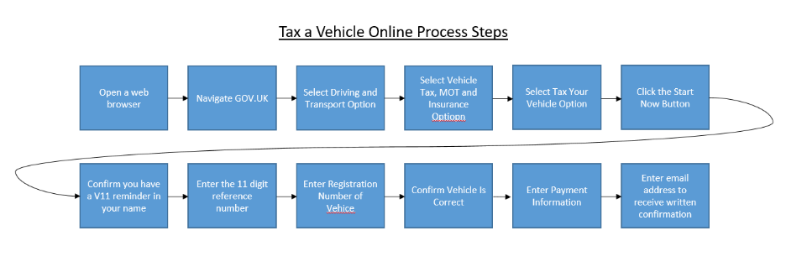
In the case of an Alexa skill, users are required to have an Amazon account to set up Alexa [41]. This means they will have already associated a payment method, credit or debit card, to their account. This is so that this information doesn’t need to be entered each time a purchase is made. Therefore DVLA users could simply quote their vehicle’s reference number and request to purchase tax. Meaning they don’t have to recite their credit or debit card numbers aloud. The overall user journey is much simpler than when compared to the user journey to purchase vehicle tax online. See figure 9 below.

Figure 9

Now consider transacting online using a screen reader or with limited motor control This process would take even longer, with much of the text read out being irrelevant to the users intended outcome. Allowing users to purchase vehicle tax through Alexa would make another channel available for users taxing their vehicle, making it easier for users to comply with vehicle related legislation. It would also provide DVLA with the first transactional voice service in Government.

Assumptions
Prior to commencing work on this project, a number of assumptions have been made. These are:
Overall:
- DVLA will be able to enhance the existing DVLA Alexa enquiry service, by enabling voice purchasing of vehicle tax through the skill.
- DVLA will be the first in government to launch a transactional Alexa skill.
- Accidental evasion of tax payment will be reduced by making a transactional Alexa skill available to users.

Relating to users:
- Users enquiring through Alexa, who discover their vehicle tax has or is due to expire will chose to tax their vehicle using the Alexa skill.
- User experience will be improved as users will be able to fully complete their user journey.
- Users will be able to access Alexa through a range of devices, smart speaker, phone app, watch app and in vehicle app.
- A user will be able to purchase vehicle tax using the payment details stored in their Amazon account.

Relating to the technology:
- Amazon will have clearly defined API’s that enable connection to the users account to take payment information.
- Making an API call to obtain payment information from the users Amazon account, enables DVLA to remain PCI DSS [89] compliant.
- DVLA will be able to develop a serverless transactional service, in keeping with DVLA’s IT strategy.
- DVLA staff have the relevant expertise to develop the transactional service using Alexa.
- DVLA will be able to access the support it may require to deliver the skill in to live, through its enterprise support package with Amazon Web Service (AWS).
- It is possible to update a DVLA vehicle record in real time following the purchase of vehicle tax through Alexa.

Approach and Methods Methodology

Philosophy
For this piece of work, a positivism research philosophy will be used. Positivism ‘is based on the idea that science is the only way to learn about the truth’ [76]. Once an alpha build of the solution has been developed, DVLA will test the solution with users to gain user feedback on the user experience and usability of the new transactional skill. Positivism subscribes to the believe than only knowledge gained through observation is reliable [76]. Therefore the knowledge gained through user testing will be treated as fact, and used in the further development of the solution in to the beta stage. Positivism relies on the collection of quantitative data, so user testers will be asked to complete a small survey, enabling DVLA to capture quantitative data relating to the user experience.
As user experience is not entirely objective, there is an overlap with the phenomenology philosophy, which places significance on what is ‘perceived and felt’ [77] by individuals. User experience is not always about facts, and is sometime affected by the user’s previous experiences or perceptions they bring to the task. Due to phenomenology not being based on scientific data gathering, it subsequently has lower validity than positivism. Therefore it is not being used as the primary philosophy for this piece of work.

Approach
The approach employed for this piece of work is deductive. Deductive approach takes an expected pattern and tests this against observations [78]. This piece of work seeks to test the assumption that DVLA will be able to improve the user satisfaction of its Alexa skill by enabling users to complete their full user journey through the voice channel, as opposed to changing channels between enquiring and transacting. DVLA will be collecting quantitative and qualitative data relating to the user experience, so will therefore be able to come to a conclusion as to whether the behaviour observed supported this or not. Based on the collection of scientific data.

Strategies
There will be three strategies employed during this piece of work. These will be:
- A document review
- Development of new software
- A user survey.

Conducting a document review will enable the project team to have a broader and more detailed understanding of the technologies involved, a better understanding of how other organisations are using similar technology and the voice interface usage more generally. During the development of new software the project will capture user, legislative and organisational requirements, enabling the formation of user stories. The user stories will be prioritised using MoSCoW prioritisation [90]. Once an alpha build has been created this will be tested with users, who will be asked to complete a survey, enabling the collection of quantitative data about their user experience. This will enable statistical analysis data, and the opportunity to identify trends within the data, related to the software solution.

Development Methodology
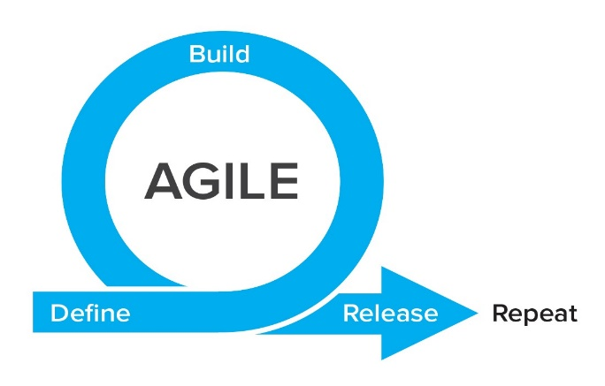
The project will adopt Agile development [79]. Agile is a series of iterative time boxed pieces of work called sprints [81]. Specifically, the project will use Agile Scrum [80], running weekly sprints. The team will hold sprint planning meetings, to plan the next sprint, as well as sprint retrospectives, to evaluate what worked well and what didn’t. Taking these in to account for the next sprint. Stories will be sized before committing them to sprint, only committing to as much as the team expect to be able to deliver within a sprint.

Figure 10

Atlassian’s JIRA cloud based tool will be used to record the project’s backlog of user stories and active sprints. JIRA enables us to capture metrics around the team’s performance and use burndown charts to visualise the progress the team is making. The roles performed within the team will be, a delivery manager, product owner, business analyst, scrum master, solution architect and developer x2. At the testing stage the team will add a user tester and usability professional to the team for the further development of the interface and user experience (UX).
Agile methodology is being used on the project because the requirements are likely to change as the team develops their understanding of user needs and how the solution should work. Scrum specifically is focussed on ‘decision making from real-world results rather than speculation’ [82]. It’s therefore in keeping with the research philosophy and approach.
Agile development is the software development methodology used by DVLA. Employing a waterfall approach would not only not fit with the project but would not align to product development stages and critically financial approval stages within DVLA.
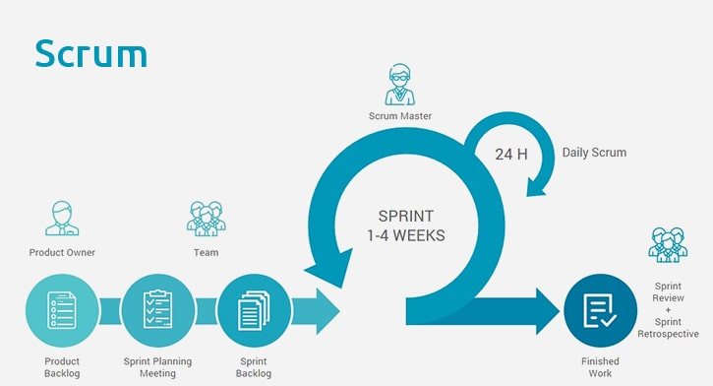

Figure 11

Testing
The individual software components will undergo unit and integration testing. While the alpha and beta solutions will undergo usability and UX testing. UX is about the user experience when using a product or service as a whole [83] as opposed to usability testing which is focused specifically on the degree to which the user interface is successful in enabling the user to achieve their intended outcome [84]. As part of the usability and UX testing, users will be asked to complete questionnaires which quantitatively captures their views on the solution developed. The user testing will be conducted by a user researcher who will capture qualitative feedback from the user during the test.
The solution will additionally undergo a heuristic evaluation by a usability professional here at DVLA, to ensure the solution conforms to industry best practice in terms of usability [85], [86], [87]. As Government we must make services available to all, and not exclude users because of poor usability.

Plan of Work
The completed project proposal will be submitted to the executive team and be presented at an executive board. Allowing the executive team to have any questions they have answered. Once approval is obtained, the project would kick off a discovery phase. During discovery the project will identify and develop user stories as well as identify the technologies and development languages to be used for the build.
During alpha a first iteration based on the prioritised user stories will be created. This will enable the team to quickly deliver a working version of the transactional voice service, which will be tested with users, in order to gain feedback on the service and identify elements for improvement during the beta phase.
During beta, the project will continue to test the service with users, gathering user feedback and iteratively improving the user experience. At the end of beta, the project will be completed. At this point the findings will be delivered to the executive team and shared with colleagues through a show and share session.
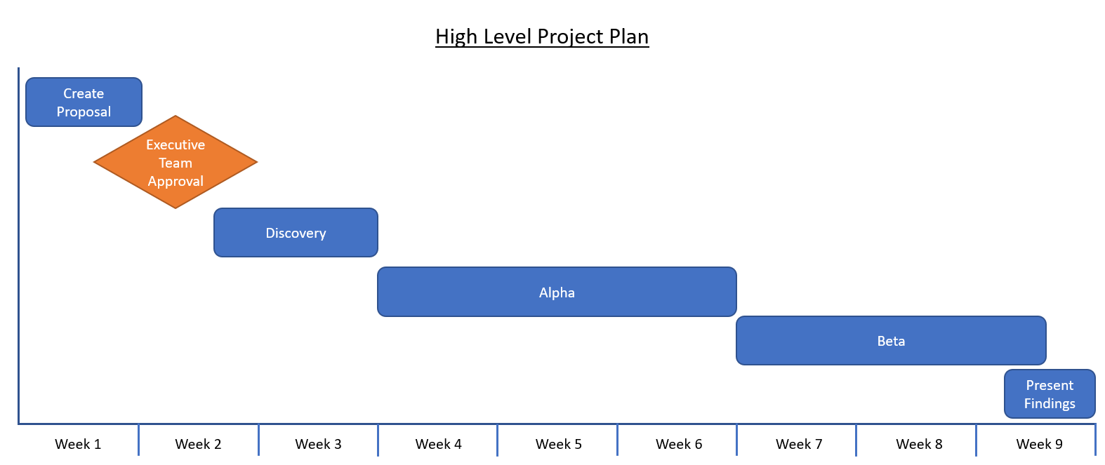

Figure 12

Tasks For Discovery
Figure xx below sets out the high level tasks for the discovery phase of the project. In submitting the proposal to the executive board, being able to show planned tasks for discovery, provides evidence that the project is ready to start work once it’s given executive approval.
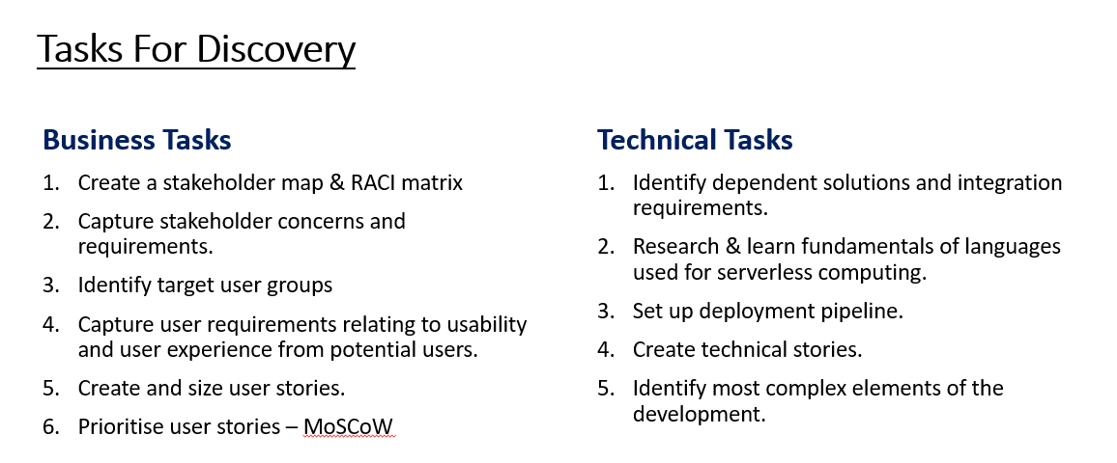

Figure 13

Conceptual Solution Architecture
The diagram below shows the conceptual solution architecture for the DVLA Tax My Vehicle transactional Alexa service.
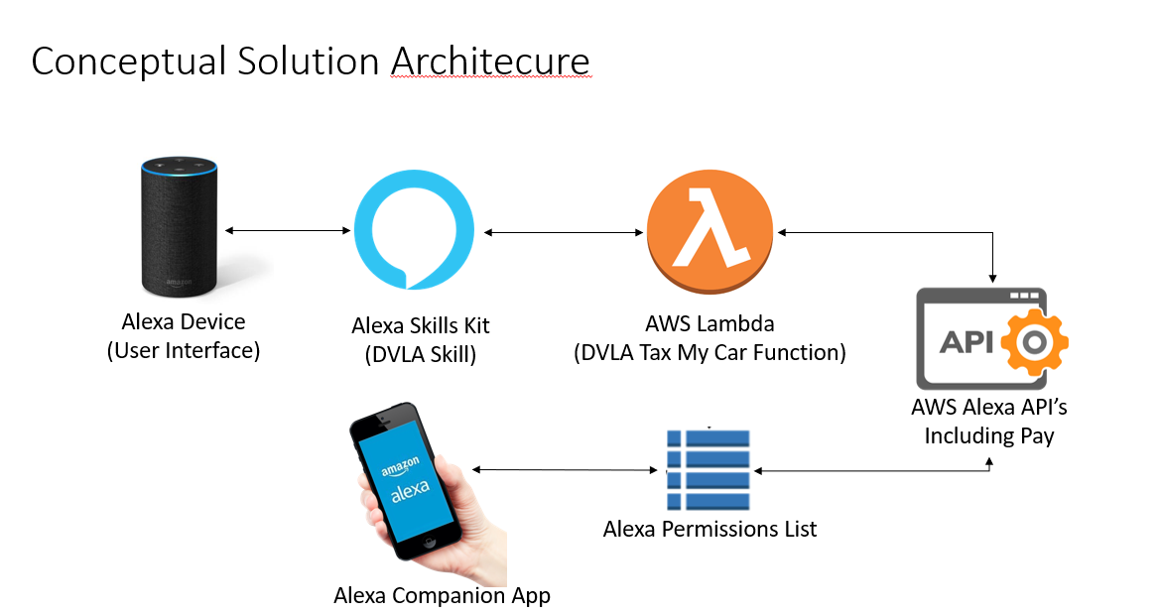

Figure 14

Costs
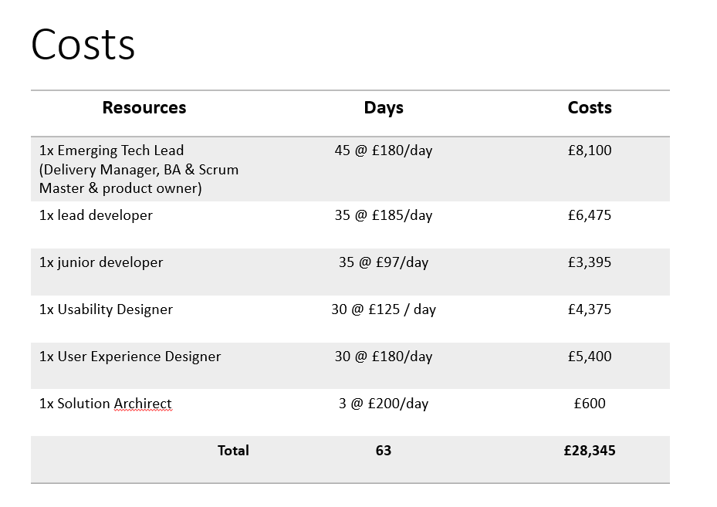
See figure xx below for the staffing costs relating to this piece of work.

Figure 15

There is no cost to the project for accommodation as this is business as usual. Costs related to the IT will be minimal based on the business intelligence forecast for the number of users per annum. This is forecast to be up to 25,000 for the first year. This is based on user numbers of 12,759 per annum for the current Alexa enquiry skill. DVLA expects increased usage of this due to the improvement in user journey, therefore doubling the current user numbers anticipates approximately 25,000 users per annum. £5,000 has been journaled to cover the expected IT costs for development and year 1. A service review will take place during the first year to identify if the service transitions in to year two. At which point appropriate budgeting will be applied.

Success Criteria
The DVLA Tax My Vehicle transactional Alexa skill will be assessed against the following success criteria:
- Users are able to tax a vehicle when necessary, using DVLA’s Alexa skill.
- User satisfaction scores of the DVLA Alexa skill are over 90%.
- The DVLA Alexa skill is built using serverless technology, conforming to the architectural principles set out in DVLA’s IT strategy.

References
[1] Dormehl, L. Today in Apple’s History: SIRI Debuts on iPhone 4S. Available a: https://www.cultofmac.com/447783/today-in-apple-history-siri-makes-its-public-debut-on-iphone-4s/ Accessed 07.03.19
[2] Vincet, J. The last SIRI cofounder has retired from Apple. Available at: https://www.theverge.com/2018/7/19/17589692/apple-siri-cofounder-tom-gruber-leaves-company Accessed 07.03.19
[3] Apple SIRI. Available at: https://www.apple.com/uk/siri/ Accessed 07.03.19
[4] Grundhauser, E. The VODER, The first Machine To Create Human Speech. Available at: https://www.atlasobscura.com/articles/the-voder-the-first-machine-to-create-human-speech Accessed 07.03.19
[5] Available at: https://www.youtube.com/watch?v=TsdOej_nC1M Accessed 07.03.19
[6] Available at: https://www.nuance.com/en-gb/dragon.html Accessed 07.03.19
[7] Nunez, M. Amazon Echo Is the First Artificial Intelligence You’ll Want At Home. Available a: https://www.popsci.com/amazon-echo-first-artificial-intelligence-youll-want-home Accessed 07.03.19
[8] Warren, T. the Story of Cortana. Microsoft’s SIRI Killer. Available at: https://www.theverge.com/2014/4/2/5570866/cortana-windows-phone-8-1-digital-assistant Accessed 07.03.19
[9] Heathman, A. Amazon Echo arrives in the UK: what is it and how does it work? Available at: https://www.wired.co.uk/article/amazon-echo-dot-feature Accessed 07.03.19
[10] Eschner, K. Meet Pedro the “Voder,” the First Electronic Machine to Talk. Available at: https://www.smithsonianmag.com/smart-news/meet-pedro-voder-first-electronic-machine-talk-180963516/ Accessed 09.03.19
[11] Priyadarsini Panda, S. Automated speech recognition system in advancement of human-computer interaction. Published in: 2017 International Conference on Computing Methodologies and Communication (ICCMC). 18-19 July 2017, Erode, India.
[12] Allan, D. Best voice recognition software of 2019. Available at: https://www.techradar.com/uk/news/the-best-voice-recognition-software-of-2017 Accessed 09.03.19
[13] Barbosa da Cunha, E. Dias Cavalcante da Silva, D & Rocha Vasconcelos, D. Enabling Full Interaction
With The Android System and Applications through Speech Recognition and The Web. Proceedings of the
23rd Brazillian Symposium on Multimedia and the Web. October 17 – 20 2017. Gramado, Brazil.

[14] Press Release. Apple reinvents the Phone with the iPhone. Available at: https://www.apple.com/uk/newsroom/2007/01/09Apple-Reinvents-the-Phone-with-iPhone/ Accessed 09.03.16

[15] Rebels, G. How Voice User Interface is taking over the world, and why you should care
Available at: https://medium.com/@goodrebels/how-voice-user-interface-is-taking-over-the-world-and-why-you-should-care-54474bd56f81 Accessed 09.03.19
[16] Burgess, M. Google Home is coming to the UK on April 6 for £129. Available at: https://www.wired.co.uk/article/google-home-uk-okay-launch Accessed 09.03.19
[17] Beavis, G. Apple HomePod Review. Available at: https://www.techradar.com/uk/reviews/apple-homepod-review Accesed 09.03.19
[18] Charlton, A. Which cars have Amazon Alexa integration? Updated for 2019. Available at: https://www.gearbrain.com/which-cars-have-amazon-alexa-2525958778.html Accessed 09.03.19
[19] Ford + Alexa: Frequently Asked Questions. Available at: https://owner.ford.com/support/applink/ford-plus-alexa-faq.html Accessed 09.03.19
[20] Available at: https://www.bmw.co.uk/discover-bmw/technology/alexa Accessed 09.03.19
[21] Available at: https://www.bmwblog.com/2017/09/27/amazon-alexa-coming-bmw-mini-cars-mid-2018/ Accessed 09.03.19
[22] Available at: https://www.volkswagenag.com/en/news/stories/2018/09/alexa-let-s-buy-a-car.html Accessed 09.03.19
[23] Available at: https://www.seat.co.uk/seat-with-amazon-alexa.html Accessed 09.03.19
[24] Available at: http://toyota.custhelp.com/app/answers/detail/a_id/9702/~/how-do-i-set-up-toyota%2Balexa-in-my-vehicle%3F Accessed 09.03.19
[25] Jonas, M. Capstone Experience: Lessons from an undergraduate research group in speech at Unh Manchester. Proceedings of the 2011 Concference on Information Technology Education. October 20 – 22 2011. New York, USA.
[26] Available at: https://developer.amazon.com/alexa-voice-service/learn Accessed 09.03.19
[27] Available at: https://www.emarketer.com/content/global-smart-speaker-users-2019 Accessed 09.03.19
[28] Available at: https://developer.amazon.com/alexa-skills-kit Accessed 09.03.19
[29] Available at: https://www.amazon.co.uk/gp/help/customer/display.html?nodeId=201807210 Accessed 09.03.19
[30] Available at: https://www.just-eat.co.uk/alexa Accessed 09.03.19
[31] Available at: https://techcrunch.com/2019/02/12/report-voice-assistants-in-use-to-triple-to-8-billion-by-2023/?guccounter=1&guce_referrer_us=aHR0cHM6Ly93d3cuZ29vZ2xlLmNvbS8&guce_referrer_cs=q6BurKitEdiOsRDbMsTRNQ Accessed 09.03.19
[32] Available at: https://voicebot.ai/2019/02/14/juniper-estimates-3-25-billion-voice-assistants-are-in-use-today-google-has-about-30-of-them/ Accessed 09.03.19
[33] Available at: https://developer.amazon.com/docs/ask-overviews/understanding-how-users-interact-with-skills.html Accessed 13.03.19
[34] Viet Lee, H. Mayer, S. Bader, P. Bastian, F & Henze, N. Interaction Methods and Use Cases for a Full Touch Sensing Smartphone. Proceedings of the 2017 CHI Conference Extended Abstracts on Human Factors in Computing Systems. May 06 – 11, 2017. Colorado, USA.
[35] Viet Lee, H. Mayer, S. Bader, P & Henze, N. A Smartphone Prototype For Touch Interaction On The Whole Device Surface. Proceedings of the 19th International Conference on Human Computer Interaction with Mobile Devices and Services. September 04 – 07 2017. Vienna, Austria.
[36] Available at https://developer.amazon.com/docs/smarthome/understand-the-smart-home-skill-api.html Accessed 13.03.19
[37] Siebra, C. correia, W. Penha, M. Macedo, J. Quintino, J. Anjos, M. Florentin, Da Silva, F & Santos, A. Virtual Assistants for Mobile Interaction: A Review From The Accessibility Perspective. Proceedings of the 30th Australian Conference on Computer-Human Interaction. December 4 – 7, 2018. Melbourne, Australia.
[38] Ei-Wen lo, V & Green, P. Development and Evaluation of the Automotive Speech Interfaces: Useful Information From The Human Factors and the Related literature. Internaltional Journal of Vehicular Technology. Volume 2013. Article ID 924170.
[39] Huang, Z & Huang, X. A study on the application of voice interaction in automotive human machine interface experience design. AIP Conference Proceedings 1955, 040074 (2018). Available at: https://doi.org/10.1063/1.5033738. Accessed 13.03.19.
[40] Prototypr.io. Voice First, Screen Second: Designing for Voice in Adobe XD. Available at: https://blog.prototypr.io/voice-first-screen-second-designing-for-voice-in-adobe-xd-1a9e5efdca15 Accessed 13.03.19
[41] Available at: https://www.amazon.co.uk/gp/help/customer/display.html?nodeId=201602230 Accessed 13.03.19
[42] Available at: https://assistant.google.co.uk/?hl=gb_en&utm_source=gb_hasem_BKWS&gclid=CjwKCAjw1KLkBRBZEiwARzyE75mTyzISJ0nz-coPLvo_8tSRCAxRFm-W6lqOUr1XZehDAPHHYBy1mxoCdb0QAvD_BwE#?modal_active=none Accessed 13.03.19
[43] Available at: https://www.apple.com/siri/ Accessed 13.03.19
[44] Choi, S. Kim, Y. Han, E. Son, J & Cho, J. Designing Conversational Voice User Interface for Improving intimacy of Share Invehicle. Published in Proceedings of the 2018 ACM International Joint Conference and 2018 International Symposium on Pervasive and Ubiquitous computing and Wearable Computers. 8 – 12 October 2018. Singapore.
[45] DVLA Alexa Skill. Available at: https://www.amazon.co.uk/DVLA-Vehicle-Enquiry/dp/B07414QQ18/ref=sr_1_1?s=digital-skills&ie=UTF8&qid=1501145333&sr=1-1&keywords=DVLA Accessed 16.03.19
[46] DVLA Online Vehicle Checking Service. Available at: https://www.gov.uk/get-vehicle-information-from-dvla Accessed 16.03.19
[47] Available at: https://www.gov.uk/government/news/dvla-gives-a-shout-out-on-alexa Accessed 16.03.19
[48] Available at: https://dvladigital.blog.gov.uk/2018/09/25/hey-google-talk-to-dvla/ Accessed 16.03.19
[49] Kaur, S. Alexa Open HMRC. HMRC Digital Blog. Available at: https://hmrcdigital.blog.gov.uk/2018/07/17/alexa-open-hmrc/ Accessed 16.03.19
[50] Available at: https://gds.blog.gov.uk/2018/08/23/hey-gov-uk-what-are-you-doing-about-voice/ Accessed 16.03.19
[51] Available at: https://www.gov.uk/browse/driving/driving-licences Accessed 18.03.19
[52] Available at: https://www.gov.uk/browse/driving/vehicle-tax-mot-insurance Accessed 18.03.19
[53] Available at: https://www.gov.uk/browse/driving/number-plate Accessed 18.03.19
[54] Available at: https://www.gov.uk/browse/driving/buy-sell-scrap-vehicle Accessed 18.03.19
[55] Available at: https://www.gov.uk/browse/driving/disability-health-condition Accessed 18.03.19
[56] Dubiel, M. towards Human-Like Conversational Search Systems. Published in Proceedings of the 2019 Conference on Human Information Interaction and Retrieval. March 11 – 15 2018. New Jersey, USA.
[57] Alexa App Set up. Available at: https://www.amazon.co.uk/gp/help/customer/display.html?nodeId=201549940 Accessed 08.05.19
[58] Google Home app. Available at: https://play.google.com/store/apps/details?id=com.google.android.apps.chromecast.app Accessed 08.05.19
[59] Alexa Ring App. Available at: https://www.amazon.co.uk/Ring-Video-Doorbell/dp/B01JTL2PYE/ref=lp_10387794031_1_3?s=digital-skills&ie=UTF8&qid=1557303287&sr=1-3 Accessed 08.05.19
[60] Alexa Hive App. Available at: https://www.amazon.co.uk/Hive-Optimised-for-Smart-Home/dp/B01LWK38QD/ref=lp_10387794031_1_6?s=digital-skills&ie=UTF8&qid=1557303287&sr=1-6 Accessed 08.05.19
[61] Alexa Nest Camera App. Available at: https://www.amazon.co.uk/Nest-Labs-Inc-Camera/dp/B075B25HQM/ref=lp_10387794031_1_12?s=digital-skills&ie=UTF8&qid=1557303287&sr=1-12 Accessed 08.05.19
[62] Alexa Phillips Hue App. Available at: https://www.amazon.co.uk/Philips-Hue/dp/B01LYQA2RR/ref=lp_10387794031_1_10?s=digital-skills&ie=UTF8&qid=1557303287&sr=1-10 Accessed 08.05.19
[63] Alexa Sonos App. Available at: https://www.amazon.co.uk/Sonos-Inc/dp/B072ML3N6K/ref=lp_10387794031_1_4?s=digital-skills&ie=UTF8&qid=1557303287&sr=1-4 Accessed 08.05.19
[64] Alexa Just Eat App. Available at: https://www.amazon.co.uk/Just-Eat/dp/B01LXLEL3R/ref=sr_1_fkmr0_1?keywords=just+eatalexa+app+just+eat&qid=1557303949&s=digital-skills&sr=1-1-fkmr0 Accessed 08.05.19
[65] Brewer, R & Findlater, L & Kaye, J & Lasecki, W & Munteanu, C & Weber, A. Accessible Voice Interfaces. Companion of the 2018 ACM Conference on Computer Supported Cooperative Work and Social Computing. Nov 3 – 7 2018. USA.
[66] Etherington, D. Ford’s Going To Put Alexa In Cars Starting Later This Year. Available at: https://techcrunch.com/2017/01/04/fords-going-to-put-alexa-in-cars-starting-later-this-year/?guccounter=1&guce_referrer_us=aHR0cHM6Ly93d3cuZ29vZ2xlLmNvbS8&guce_referrer_cs=7iNZX_tMQ6e1l-Mn8BJlZA Accessed 08.05.19
[67] World-Class In-Car Speech Recognition System for Navigation in 2005 Honda Cars. Available at: https://phys.org/news/2004-09-world-class-in-car-speech-recognition-honda.html Accessed 08.05.19.
[68] Voice controlled radios could improve road safety. Available at: https://www.highwaysindustry.com/voice-controlled-radios-could-improve-road-safety/ Accessed 08.05.19
[69] Automotive Gesture Recognition—The Next Level in Road Safety. Available at: https://www.electronicdesign.com/automotive/automotive-gesture-recognition-next-level-road-safety Accessed 08.05.19
[70] Amazon Transcribe. Available at: https://aws.amazon.com/transcribe/ Accessed 08.05.19.
[71] DVLA business plan 2019 -2020. Available at: https://www.gov.uk/government/publications/dvla-business-plan-2019-to-2020/dvla-business-plan-2019-to-2020 Accessed 08.05.19
[72] Available at: https://www.gov.uk/government/news/dvla-gives-a-shout-out-on-alexa Accessed 09.05.19
[73] Alexa DVLA Skill. Available at: https://www.amazon.co.uk/DVLA-Vehicle-Enquiry/dp/B07414QQ18 Accessed on 09.05.19
[74] Purchase on Amazon with Alexa. Available at: https://www.amazon.co.uk/b?ie=UTF8&node=12469013031. Accessed on 09.05.19
[75] DVLA EVL Service. Available at: https://www.gov.uk/vehicle-tax Accessed 09.05.19
[76] Positivism Research Philosophy. Available at: http://research-methodology.net/research-philosophy/positivism/ Accessed 09.05.19.
[77] Phenomenology Research Philosophy. Available at: http://research-methodology.net/research-philosophy/phenomenology/ Accessed 09.05.19.
[78] Deductive Approach. Available at: https://research-methodology.net/research-methodology/research-approach/deductive-approach-2/ Accessed 09.05.19.
[79] Manifesto For Agile Software Development. Available at: https://agilemanifesto.org/ Accessed 10.05.19.
[80] What is Scrum. Available at: https://www.atlassian.com/agile/scrum Accessed 10.05.18
[81] What Are Sprints. Available at: https://www.atlassian.com/agile/scrum/sprints Accessed 10.05.19
[82] Scrum Methodology. Available ar: http://scrummethodology.com/ Accessed 10.05.19.
[83] Norman, D & Nielsen, J. The Definition of User Experience. Available at: https://www.nngroup.com/articles/definition-user-experience/. Accessed on 29/04/19.
[84] Usability.gov.uk. Improving the User Experience. Available at: https://www.usability.gov/what-and-why/interaction-design.html Accessed on 29/04/19.
[85] Nielsen, J. and Mack, R.L. Usability Inspection Methods. Wiley, New York, 1994.
[86] Nielsen, J. Usability Engineering. Morgan Kaufmann, USA., 1994.
[87] 10 Usability Heuristics for User Interface Design. Available at: https://www.nngroup.com/articles/ten-usability-heuristics/ Accessed 10.05.19.
[88] Smart speaker Users In Select Markets 2019. Available at: https://www.emarketer.com/content/global-smart- Accessed 09.03.19
[89] PCI Security. Available at: https://www.pcisecuritystandards.org/pci_security/ Accessed 15.05.19.
[90] MoSCoW prioritisation. Available at: https://www.agilebusiness.org/content/moscow-prioritisation Accessed 15.05.19

