

Analysing How the Adoption of Business Automation Technologies Alters Traditional Employment Models and Requires New Leadership Competencies: A Case Study of the UK Grocery Retail Industry

BA(Hons) Leadership and Management Skills in the Workplace

Student: Cristina Budureanu
Student Number: 2314760
LCLM6005: Independent Project
Supervisor’s name: MD Kalam

Acknowledgement
I would like to express my sincere gratitude for the valuable guidance, constructive suggestions and continuous encouragement from my dissertation supervisor during this research. I also want to thank my university for providing me with all the academic facilities and the learning atmosphere which enabled me to accomplish this study. Last, but not least, I thank the continuous support, patience, motivation and encouragement my family and friends have provided me throughout this dissertation process.

Declaration
I state that this dissertation is my own original product and has not been previously presented to any academic bodies for any academic award. All sources of information have been properly credited and referenced as per the University's academic integrity policy and plagiarism policy.

Name: Cristina Budureanu

Abstract
Chapter 1 presents the background, research problem, aim, objectives, research question and rationale for the research. It outlines how business automation tools are increasingly being adopted by retailers in the United Kingdom (UK) and their impact on roles and skills. The chapter sets the importance of the research, identifies the gapped knowledge and presents the dissertation's overall structure.
Chapter 2 critically analyses current literature that covers business automation and approaches to employment, through workforce transformation, leadership skills and sustainable practice in organisations in the UK grocery sector. Prior academic research is reviewed, and key debates and areas of research are identified, and the Transformational Leadership Theory is used as the base. It also creates a conceptual bond of business automation, employment transformation and leadership development, which serves as a solid theoretical foundation for the subsequent empirical analysis.
The methodology for this dissertation is presented in Chapter 3. The study is conducted with an ‘interpretive’ research philosophy and ‘inductive’ research approach, and an 'exploratory' research design with secondary qualitative data. Thematic analysis method is used to systematically interpret published literature. This chapter also discusses the search strategy, data collection method, research tools, and the ethical issues that ensure the credibility, transparency, and reliability of research findings.
The secondary qualitative data obtained in the study were presented and discussed in Chapter 4 with the aid of the qualitative thematic analysis technique in relation to the set objectives of the study. The analysis reveals three key themes relating to workforce transformation, leadership skills, and organisational opportunities and challenges that arise with marketing automation in the grocery retail in the UK. Thematic coding, mapping and evidence found in the literature are used to support the findings. The chapter also analyses the findings and discusses their implications by comparing with previous studies and the Transformational Leadership Theory, pointing out the implications in practice for retail organisations that adopt marketing technologies that enable marketing automation.
The dissertation is summarised, and the major findings are tied up to the research objectives in Chapter 5, the conclusion. It offers practical suggestions based on the findings for grocery organisations in the UK, considers the weaknesses of the study and hints at future research studies. The chapter will focus on the need to give equal weight to business automation and human resource development, and good digital management to achieve a sustainable organisation.

Table of Contents
Chapter 1: Introduction 9
1.1 Research Background 9
1.2 Statement of the Research Problem 9
1.3 Research Aim 10
1.5 Research Question 10
1.6 Research Rationale 11
1.7 Structure of the Dissertation 11
Chapter 2: Literature Review 12
2.1 Overview of the chapter 12
2.2 Definition of key business automation concepts 12
2.3 Explore and assess the impact of business automation on the traditional employment models, workforce composition and job profiles 13
2.4 The leadership qualities needed to manage change in an organisation effectively through technology 14
2.5 Guidance to retail organisations who want to pursue technological innovation whilst managing, leading and nurturing their staff sustainably 15
2.6 Theoretical underpinning 16
2.7 Literature gap 18
2.8 Conceptual framework 19
2.9 Chapter summary 19
Chapter 3: Methodology 20
3.1 Overview 20
3.2 Research philosophy 20
3.3 Research Approach 21
3.4 Research Design 21
3.5 Search Strategy 22
3.6 Data Collection Method 23
3.7 Data Analysis Methods 23
3.9 Ethical considerations 24
3.10 Chapter Summary 24
Chapter 4: Results and Discussion 25
4.1 Chapter Overview 25
4.2 Thematic Map 25
4.3 Thematic Coding Table 26
4.4 Thematic code 27
4.4.1 Impact of Business Automation on Traditional Employment Models in the UK grocery Retail 27
4.4.2 Leadership Competencies Required for Business Automation Adoption 30
4.4.3 Organisational Opportunities and Challenges of Business Automation 32
4.5 Findings Analysis 34
4.6 Discussion 35
4.6.1 Overall Interpretation of Findings 35
4.6.2 Comparison with Existing Literature 35
4.6.3 Relationship with Transformational Leadership Theory 36
4.6.4 Practical Implications for UK Retail Organisations 36
4.7 Chapter Summary 37
Chapter 5: Recommendations, Conclusion and Limitations 38
5.1 Conclusion 38
5.2 Linking Findings with Research Objectives 38
5.3 Recommendations 39
5.4 Limitations and Future Research 40
Element 2: Research Process Reflection 41
Element 3: Methodology Poster 44
Reference 45
Appendix A1 – Ethical Approval Form 57

List of Figures
Figure 2.6.1: Transformational leadership Theory 16
Figure 2.8.1: Conceptual Framework 18
Figure 3.2.1: Research Philosophy 19
Figure 3.4.1: Exploratory research for secondary data analysis 21
Figure 3.6.1: Data collection method 22
Figure 4.1: Thematic Map 24
Figure 4.2: Top Skills for the Future Workforce 26
Figure 4.3: Introduction of significant changes in work processes and job reduction 28
Figure 4.4: The way the organisation will best resolve its potential skills gaps related to automation 30

List of Tables
Table 3.1: Tools 25
Table 4.1: Thematic Coding 29
Table 2.0: Action Plan 48

Chapter 1: Introduction

1.1 Research Background
The adoption of artificial intelligence (AI) and business automation technologies has significantly transformed organisational operations, decision-making processes, and workforce structures across industries. Business automation refers to the use of artificial intelligence, robotic process automation, predictive analytics, enterprise resource planning systems, and intelligent digital technologies to automate routine business processes, improve operational efficiency, and support strategic decision-making. To increase operational effectiveness and preserve competitive advantage, the UK grocery retail industry has become one of the top adopters of AI-driven digital transformation. AI is being used by large food stores more and more to automate consumer contact across various digital channels, estimate customer demand, improve pricing strategies, and tailor promotions (Robertson et al., 2025). By redefining work positions and raising the need for digital, analytical, and data-driven capabilities, these technologies have boosted organisational performance while also altering traditional employment structures (Drozd and Tavares, 2024).
The digital transformation has brought about new organisational leadership expectations as well. There is an increasing need for leaders to handle technological change, promote workforce adjustment, promote innovation, and ensure that employees remain engaged in the process of organisational change (Reis and Melão, 2023). The effective adoption of AI technologies does not rely solely on technological skills but on leadership competencies that enable organisational learning and efficient change management (Robertson, Botha, Oosthuizen and Montecchi, 2025). Even though the issue of AI adoption, digital transformation, and business innovation have been discussed in separate studies in the past, there is a scarcity of research that has looked at the combination of the three and how they are integrated to affect the employment models, as well as leadership competencies, in the UK grocery sector. Rita et al. (2025) stress that the existing body of business AI literature seems to focus largely on the aspects of customer-affiliation, operational performance and their business successes, whereas the aspects of workforce modification and leadership skill development in retail organisations have received relatively little focus. The dissertation is thus aimed at examining how automation technologies in business change old employment paradigms and introducing some emergent requirements of leadership competencies in the UK grocery retail industry using secondary qualitative research.

1.2 Statement of the Research Problem
The UK grocery retail sector is experiencing more and more changes in business through artificial intelligence and predictive analytics, as well as automated customer engagement technologies, in organisations with the help of business automation technologies. On the one hand, these technologies enhance efficiency and business performance; on the other, they impact the structure of the workforce, job-related tasks, and leadership in organisations. Conventional employment patterns that were operating on routine operational activities are slowly transforming into digitally empowered jobs with high-order analytical, technological, and collaborative skills (Drozd and Tavares, 2024). The use of artificial intelligence and digital transformation is not a new topic in the literature, and the rate at which business automation affects the employment patterns and leadership skills demands in the UK grocery retail setting is under-researched (Chen, Jiang, Jia and Liu, 2022). The concept of leadership studies has typically been concerned with technology adoption compared to workforce transformation, which has been studied separately, leaving a gap in comprehending the inter- relationship.
Many UK grocery retailers are still struggling to comprehend the role of business automation on planning workforce, job redesign and development of leadership capabilities as organisations undergo digital transformation. Although AI technologies can enhance business performance, lack of evidence with integrated support to employee reskilling, reorganisation of the organisation is common and leaders are problematic, obstructing their ability to upgrade workforce to meet changing requirements. As a result, this study will attempt to fill this knowledge gap by reviewing available scholarly knowledge on how business automation technologies impact the model of employment and emerging leadership skills in the UK grocery retail sector through the secondary qualitative research methodology.

1.3 Research Aim
This research aims to critically analyse how the adoption of business automation technologies transforms traditional employment models and requires new leadership competencies in the UK grocery retail industry through secondary qualitative thematic analysis.
1.4 Research Objectives
● To explore and assess the impact of business automation on the traditional employment models, workforce composition and job profiles.
● To recognise the leadership qualities needed to manage change in an organisation effectively through technology.
● To offer guidance to retail organisations who want to pursue technological innovation whilst managing, leading and nurturing their staff sustainably.

1.5 Research Question
What impact does the adoption of business automation technologies have on traditional employment models and emerging leadership competencies within the UK grocery retail sector?

1.6 Research Rationale
This increase in the use of business automation-based technologies in the UK grocery retail sector has brought about a lot of organisational transformations in the areas of business activities, labour management and leadership functions. The relevance of understanding these developments has been growing since digital transformation remains in the domain of transforming organisational performance and competitive advantage (Reis and Melão, 2023). Evidence-based knowledge is needed by receptive organisations to help them strike a balance between technological innovation and efficient management of their workforce and development of leaders. Past research has mainly focused on the adoption of AI, digital transformation, or organisational performance individually. Very few studies have examined the impact of business automation on concomitant employment patterns, and leadership skills in the UK retail capital at the same time (Robertson, Botha, Oosthuizen and Montecchi, 2025). This results in a lack of insight into the correlation between technological adaptation, transforming workforce demands, and leader skills required in the process of digital transformation. This dissertation is unique in that it synthesises recent scholarly evidence to give an integrated perspective of these organisational changes via a secondary qualitative analysis. The results will enable the retail managers to plan their workforce and develop leaders and organisational change initiatives and help the policymakers and researchers understand the future trends in employment linked with AI-enabled business systems (Wei and Prentice, 2022). Consequently, the research has theoretical as well as practical merits since it discusses a new research field which is gaining more and more credibility in the future of retail management.

1.7 Structure of the Dissertation
There are five chapters in this dissertation. Chapter One presents the background of the research, the research problem, aim, objectives, research question, research reason, and the structure of the dissertation. Chapter Two introduces the literature review of business automation, endorsement of digitalization, the labour models, and the capabilities of leadership. The third chapter describes the research methodology, the secondary qualitative research design, and the thematic analysis methodology. In Chapter Four, the findings and discussion of the thematic analysis of secondary data are presented. Chapter Five is the last part that explores and finally wraps up the dissertation by summarising the findings, then discussing theoretical and practical implications, limitations, and offering future research and practice recommendations.

Chapter 2: Literature Review

2.1 Overview of the chapter
The literature holds information about the leadership practices in the UK grocery sector and the contemporary changes within the organisational practices. Most of the firms are going to include the automation business tools to successfully recruit, retain and involve employees within the organisational activities to fulfil the objectives of the firm.

2.2 Definition of key business automation concepts
Vdovichena et al. (2024) stated that, the concept of business automation technologies is mainly known as the usage of digital platforms that automate tasks and business activities and enhance the efficiency of the business team to fulfil customers’ demands. Technologies that are involved in business activities are analytics, AI, machine learning, and automation that help in delivering personalized content to the chosen audiences at the perfect time. On the other hand, modern business automation technologies are also helping in lead generation and nurturing. In this way, businesses can easily detect potential customers as per the engagement level and score those levels to guide them with appropriate content.
In contrast, Hopkins and Bardoel (2023) argued that the traditional employee model can be known as a conventional form of work arrangement for employees hired by a particular organisation for a long-term period. This model supports a rigid working schedule in which employees typically work fixed hours, perform their tasks, and receive regular wages. One of the most common traditional employment models is full-time employment in which employees are assigned to fulfil tasks within 35 to 40 hours in a week. The traditional employment models are mainly characterised by the clear hierarchical structure, where employees fulfil their duties, including reporting, training, career progression, performance evaluation, and opportunities for promotions.
Bird and Liu (2025) have highlighted another term, such as new leadership competencies, which can be referred to as the skills, knowledge, and abilities to effectively manage an organisation. This new set of leadership is quite different from traditional practices, where leaders are willing to adopt innovation, emotional intelligence, collaboration, and digital competencies. Similarly, the new leadership competency for contemporary business is digital literacy, in which leaders are paying attention to understand the use of AI, cloud computing and data analytics for decision-making. Conversely, adaptability and resilience are also essential for these leaders to face issues such as global disruptions, economic uncertainty and technological changes.

2.3 Explore and assess the impact of business automation on the traditional employment models, workforce composition and job profiles
Business automation has significantly transformed the traditional way of working within the retail firms in the UK. In traditional practices, business depends on labour-intensive activities such as manual customer segmentation, data entry, lead management, and email campaigns. Adepoju et al. (2022) stated that, the issue associated with the traditional business approaches is that it requires more time to do tasks, and the repetitive operations might cause errors in data entry. In that case, the implementation of AI and other automated business tools can positively impact flexibility and conduct knowledge-based employment. Organisations from the retail sector in the UK are repeatedly investing in hiring specialists who can manage AI and automation tools and optimise the digital business campaign (Hunt and Rolf, 2022). The impact of this activity is to enhance productivity through reducing errors and the overall time required to conduct repetitive tasks.
Conversely, Lipton et al. (2022) argued that business automation can impact workforce composition through changing the diversity, skills, and expertise of employees within the retail grocery in the UK. Business automation encourages organisations to practice diversification in workforce construction, such as including software developers, data scientists, and automation specialists. In this way, the multidisciplinary workforce can contribute to promoting creativity in the business strategy. Another benefit is enhancing collaboration within departments through integrating data from sales, customer services, finance, and IT. The impact of this activity is to build a cross-functional team within the organisation who share ideas, thoughts and business objectives to improve decision-making and efficiency. Parker and Grote (2022) pointed out that, in comparison to selecting the job profile for the UK grocery retail sector, the implementation of automation seems to be the unique approach by the industry. Automation can check CVs of candidates, initiate rapid screening from thousands of applicants, and choose the most suitable candidates that completely justify the hiring advertisement. As a result, hiring suitable employees can strengthen the competitive position of the organisations as each employee provides 100% of their efforts to meet the organisational objectives.
Despite these positive aspects, Eshiett and Eshiett (2024) claimed that business automation impacts negatively on the traditional employment model by altering the organisational structure. The traditional employment model supports full-time jobs with a stable working environment. Business automation has already disrupted this process by encouraging leaders of the UK retail sector to prioritise flexible employment arrangements such as contract-based marketers, freelancers, and outsourcing to business agencies. Some small and mid-sized retail organisations are hiring professionals with skills for a short-term period; such practices ultimately affect employee morale, job security, and employees face uncertainties about their career stability.
Tesco is using artificial intelligence in around 250 business apps “to optimise inventory, the supply chain and improving demand forecasting and customer services”. The contribution of operational efficiency and digital innovation through its technology is also evident when looking at the company's sales, which exceeded £66.6 billion of group sales during 2025/26 (Tesco PLC Annual Report 2026). In the same way, Sainsbury's has integrated machine-learning forecasting into stock management, created an AI Centre of Excellence and enhanced the digital capabilities of its colleagues to boost productivity, customer service and the performance of the supply chain (Sainsbury plc Annual Report 2026). These efforts have helped with grocery sales growth but challenged workers to acquire digital skills and leaders to implement organizational change in a clever and competent way. The evidence suggests that business automation is helping to reform the nature of work and driving the need for leadership that adapts in the grocery retail market in the UK.

2.4 The leadership qualities needed to manage change in an organisation effectively through technology
The technological changes have been affecting the UK grocery sector, and leaders are trying to combine technical, strategic, and people-oriented competencies to enhance leadership qualities. The first or foremost leadership strategies for the leaders of the UK grocery sector are digital vision and strategic thinking. As per Ahmad (2022), the digital vision can help in anticipating market trends, aligning digital transformation, and identifying opportunities to meet long-term objectives. Strategic leaders can evaluate the exact market conditions, consumer trends, competitors' strategies, and make decisions for business investment. Cai (2023) stated that, the impact of such leadership is supporting organisational goals through enhancing operational efficiency, customer satisfaction, and profitability. Visionary leadership can develop a clear direction for the organisation and create long-term value creation for employees, stakeholders and customers. One of the excellent examples of excellent visionary leadership is, Stuart Machin as the CEO of Marks & Spencer, as led the organisation through investing in digital transformation for online retailing, inventory management, and supply chain modernisation (Spencer, 2026). Therefore, visionary leadership can help UK retail organisations to manage their operations through employee motivation, engagement and innovation.
In contrast, Ahmadi (2024) claimed that, change management and adaptability can help these leaders to remain competitive in this dynamic business environment. The UK grocery retail is mainly going through technological changes such as self-checkouts, automated warehouses, digital payments, and AI-powered inventory systems. As a result, leaders are carefully planning strategies before applying these technologies within the operation. However, staff are still fearful about job displacement due to automation and struggling to learn new features of this digital system. UK leaders have decided to adopt automation business after noticing the rising demand of online shopping, convenience business, and personalised experiences. The market estimation reviewed that, in 2025, the group sales of Tesco valued at £66.6 million (Tesco 2026). For instance, Tesco has integrated AI into more than 250 business applications, and the group's sales reached £66.6 billion in 2025. In this way, adaptability became one of the major aspects for UK leaders as it encouraged experimentation and paved the path for continuous learning.
Tesco has deployed AI in over 250 business applications to enhance their demand forecasting, inventory management and operational decision-making and among group sales of £66.6bn in 2025/26 (Tesco PLC Annual Report 2026). These were all programs that needed to be led with a focus on continuous learning and undergraduate development of digital capability and engagement of employees to drive organisational change. Sainsbury's has bolstered its digital transformation, with AI-powered forecast, Smartshop technologies and an AI Centre of Excellence, in which business leaders must foster a culture of cooperation and innovation and need to reskill their workforce (Sainsbury plc Annual Report 2026). The cases show that business automation requires more than just technology investments, it requires leaders to adapt and guide organizational change that is still efficient and ensures long-term business success.

2.5 Guidance to retail organisations who want to pursue technological innovation whilst managing, leading and nurturing their staff sustainably
The first guidance for UK retail firms is to develop a human-centred digital transformation strategy to ensure that employees can remain at the centre of the platform. Ledro et al. (2023) claimed that his practical guidance aligns human activities with AI, CRM and other predictive tools to complement human efforts for improving business activities. The combined approach can improve employee acceptance of technologies and enhance employee skills to strengthen organisational commitment for sustainable innovation planning suitable for each employee. The process must involve employees from the initial phases such as consultation, testing, and feedback collection. The impact of this strategy on the UK grocery retail is enhancing the resilience of the workforce through providing resources to employees to fulfil digital skill needs.
In addition to that, the UK grocery retail must invest in continuous learning, reskilling, and sustainable leadership development to develop new competencies. As per Prakash (2024), leaders must arrange new learning opportunities for each employee through a structured programme to cover areas such as digital business, data management, cyber security, automation and data-driven decision making. In contrast, Ahmad et al. (2023) claimed that the traditional supervisory model is not enough for the modern workplace structure, so the digital literacy of leaders needs to be enhanced through coaching, mentoring, and cross-functional collaboration. The impact of continuous learning is to enhance employee confidence and workers' efficiency to deal with organisational challenges and improve operational efficacy.
Tesco has proven that it's absolutely necessary to continuously train employees, provide support and leadership, invest in business systems that will benefit from AI, and maintain employee engagement at the company all of these initiatives are essential for successful digital transformation that can help boost operational efficiency (Tesco PLC Annual Report 2026). In much the same way, Sainsbury’s have improved organisational performance by investing in Smartshop technologies, forecasting using AI, and developing digital skills amongst their employees, signifying the need for reskilling employees during the process of technology change (Sainsbury plc Annual Report 2026). ASDA has implemented digital supply chain and inventory management systems that enhance its operations and promote employee versatility through the adoption of technology. Similarly, by investing in workplace learning and employee engagement, as well as technology, Morrison’s has enhanced its warehouse automation and logistics, underscoring the vital importance of both integration and leadership to gain a sustainable organisational transformation and long-term business competitiveness.

2.6 Theoretical underpinning
The application of transformational leadership theory seems to be appropriate for the modern retail organisation in the UK to justify the appropriateness of implementing an automated business tool within the business operation. The transformational leadership Theory was developed by James MacGregor Burns in 1978, and the theory helps in explaining the efforts of leaders to inspire team members, motivating employees for personal and professional development. Van Dun and Kumar (2023) stated that, the theory aligns with UK retailers as transformational leadership supports innovation rather than a rigid workplace. Transformational leaders guide employees to use AI tools and business software for conducting repetitive tasks errorless.
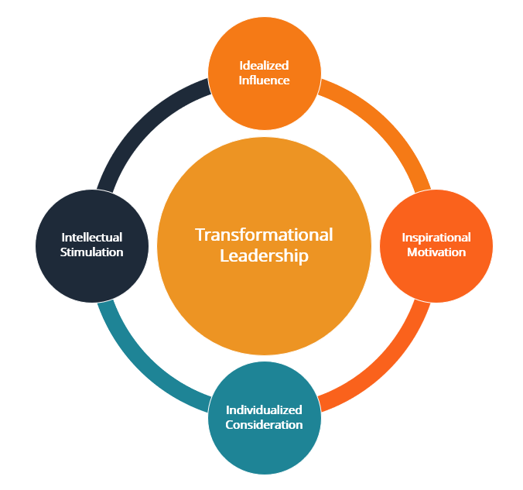

Figure 2.6.1: Transformational leadership Theory
(Source: van Dun and Kumar 2023)
The technological integration enhanced business, advertising, and product showcasing in front of customers and automated the campaign to attract new customers. Farag (2025) claimed that the reason for choosing transformational leadership theory is that it can address the leadership challenges while accepting business automation. Despite traditional work-based models, retail firms from the UK are deliberately trying to upgrade their supply chain, business, customer service, and overall sales to become competitive in this industry. One of the advantages of the transformational leadership theory is its flexibility to adopt new innovative tools and software in the business process. On the other hand, one of the major limitations of the process is providing less attention to the external factors such as government regulations, market competition, infrastructure, and acceptance rate.
One relevant model is the Technology Acceptance Model (TAM) developed by Davis (1989). TAM proposes that users' acceptance of technology is strongly influenced by perceived usefulness and perceived ease of use. Perceived usefulness refers to the extent to which an individual believes that using a particular technology will improve job performance, while perceived ease of use concerns the extent to which the technology is perceived as easy to use. These perceptions influence users' attitudes and behavioural intentions towards technology adoption. In the context of UK grocery retail, TAM is relevant because employees may be more willing to adopt automated systems when they believe that technologies such as AI-powered inventory systems, self-checkout systems, data analytics and automated customer-service tools will improve their productivity and reduce repetitive work. Conversely, technologies perceived as complicated or difficult to operate may create resistance and increase the need for training and managerial support.
Another relevant perspective is the Theory of Planned Behaviour (TPB). TPB extends the relationship between attitudes and behavioural intentions by incorporating subjective norms and perceived behavioural control. Perceived behavioural control reflects the availability of resources, opportunities and skills required to perform a behaviour, while subjective norms represent the influence of other people or groups on an individual's intention to act (Taherdoost, 2018). This is particularly relevant to business automation because employees' willingness to use automated systems may depend not only on whether they consider the technology useful, but also on organisational expectations, support from colleagues and managers, training opportunities and their confidence in using digital tools. Therefore, TPB helps explain why employees with similar access to automation technologies may demonstrate different levels of acceptance.
The Technology–Organisation–Environment (TOE) framework also provides an organisational-level perspective on technology adoption. Unlike TAM, which primarily focuses on individual users, TOE considers the technological, organisational and environmental conditions that influence organisational technology adoption. This is relevant to the UK grocery sector because the implementation of automation depends on factors such as technological compatibility, organisational resources, employee capabilities, competitive pressures and the wider regulatory environment. Consequently, TOE helps extend the analysis beyond individual employee acceptance towards the organisational conditions required for successful automation.

2.7 Literature gap
Business automation has been widely accepted by the retail industry in the UK; however, limited research focused on the region-specific research. Most of the studies involve multinational organisations from all over the globe, while the characteristics of the UK-based retail industry are still unexplored. The current literature focuses on the changing aspect of the traditional employment models through technological acceptance; however, fewer investigations have occurred based on recruitment strategies, pathway involvement and automation composition combined.

2.8 Conceptual framework
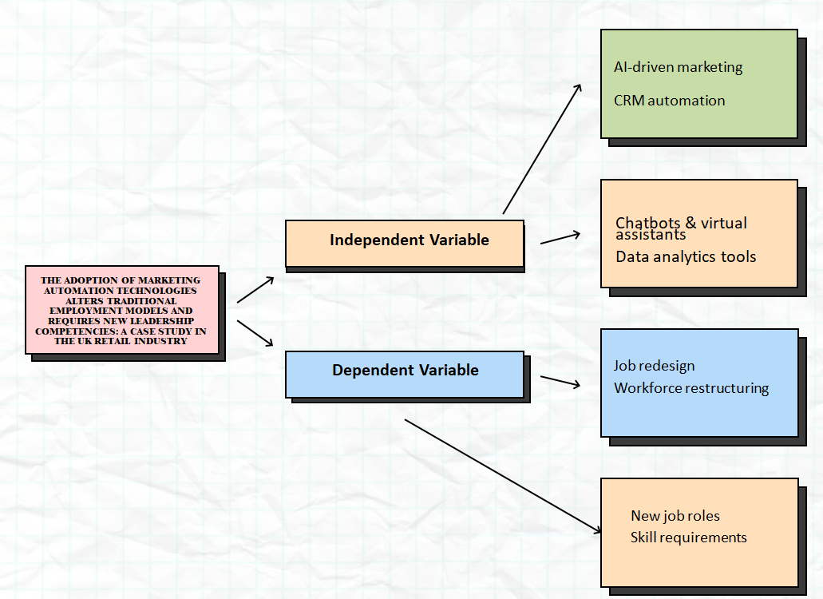

Figure 2.8.1: Conceptual Framework
(Source: self-Developed)

2.9 Chapter summary
The chapter illustrated the differences between traditional recruitment models and their relationship with leadership competitiveness. Different types of leadership approaches have been mentioned throughout the study and their relevance to the acceptance of business automation by the UK grocery retail.

Chapter 3: Methodology

3.1 Overview
Methodology is another essential part of the study; hence, it involves a systematic framework to conduct the research ethically. The methodology section involves a step-by-step process of data collection and analysis. The process ensures that data has been collected lawfully and maintains the overall credibility of the research.

3.2 Research philosophy
The term research philosophy can be explained as a set of beliefs and assumptions taken by the researcher to understand the reality of the research topic. Bergmann, (2023) claimed that research philosophy influences each stage of the study through the approach, design, data collection, analysis, and finally the interpretation of findings. For this research, an interpretivism research philosophy has been chosen to analyse the adoption of business automation technologies for leadership competencies of the UK grocery retail. The reason for choosing interpretivism is to explore the most complicated phenomena of organisations with proper explanation. The research aimed to explore the impact of automation on job roles, workforce compositions, and leadership competencies.
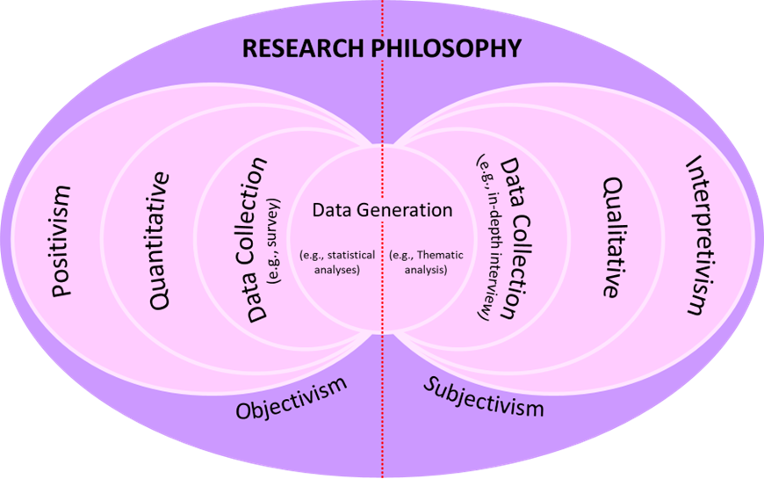

Figure 3.2.1: Research Philosophy
(Source: Bergmann, 2023)
Positivism primarily focuses on objective measurement, numerical data and testing predetermined hypotheses, which would limit the interpretation of complex organisational experiences surrounding automation. Similarly, realism emphasises an objective reality that may not fully capture employees’ differing perceptions of technological change. In contrast, interpretivism enables deeper examination of meanings, experiences and organisational contexts, making it more appropriate for understanding changes in job roles, workforce composition and leadership competencies.

3.3 Research Approach
Hosseini et al. (2024) pointed out that, the research approach can be explained as a strategic framework applied by the researcher to answer each research question effectively. The process involves logical reasoning to ensure that the study is conducted in an appropriate manner. From the perspective of the secondary qualitative data collection process, an inductive research approach has been applied to understand the true meaning of searched information. The justification for selecting an inductive research approach is, its appropriateness to align with research objectives and seek to explore the relationship among the variables such as leadership competencies, business automation, and traditional employment models.
Deductive and abductive approaches were considered but were less appropriate for this study. A deductive approach generally begins with established theories or hypotheses and tests their relationships using predetermined propositions, which may restrict the emergence of new insights from secondary qualitative evidence. An abductive approach focuses on moving between existing theory and empirical observations to develop the most plausible explanation, making it more suitable where unexpected findings require theoretical refinement. In contrast, the inductive approach enables patterns and themes to emerge directly from the literature, aligning with this study’s exploratory objectives and thematic analysis.

3.4 Research Design
The term research design can be explained as an overall framework that guides the researcher on how to conduct the study and analyse the data to provide answers to the research questions. The appropriate research design builds a bridge between objectives and methods through providing proper evidence (Adeoye 2024). For the secondary qualitative data, the choice of an exploratory research design is most suitable as it aims to explore a deeper understanding about the UK-based grocery retail industry, different leadership approaches and the impact of using business automation. The reason for choosing an exploratory research design is to provide evidence of phenomena after a detailed observation rather than measuring it with software.
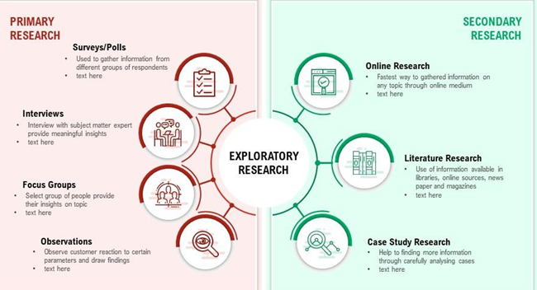

Figure 3.4.1: Exploratory research for secondary data analysis
(Source: Adeoye 2024)
A descriptive design primarily focuses on systematically presenting characteristics of a phenomenon, which would provide limited scope for critically examining the complex relationships between business automation, employment transformation and leadership competencies. In contrast, an explanatory design generally investigates causal relationships between variables and is more appropriate for studies requiring hypothesis testing and measurable evidence. A conclusive design would also be unsuitable because it seeks to provide definitive findings from clearly established research problems. Therefore, an exploratory design is most appropriate because the study investigates an evolving phenomenon and allows patterns, themes and new insights to emerge from secondary qualitative evidence.

3.5 Search Strategy
The search strategy can be known as a systematic approach to identify and extract the most suitable information from the valid academic databases. Ashour and Flouty (2024) stated that, the process ensures that the research is credible, transparent and comprehensive, so that an appropriate search strategy enhances the attractiveness of the study in front of readers. The search strategy began with developing proper keywords after comparing them with the research objectives; then these keywords has implemented on the search bar of the chosen databases. The research has used Boolean operators such (AND, OR, NOT) along with applied filters such as year, language, subject areas, and document type to extract studies relevant to the current research topic.

3.6 Data Collection Method
The secondary qualitative data collection method was chosen to conduct the research. The secondary qualitative method is known as a systematic process to gather reliable evidence from the second-hand data available from the Internet (Cheong et al. 2023). In this process, non-numerical data from published books, articles, journals, industry publications, and government data are mainly collected to justify each objective. The reason for choosing secondary data is, it requires less time to collect credible information without involving any capital investments. The most important source of secondary data is peer-reviewed academic journals. Apart from that, other databases are Google Scholar, Web of Science, Scopus, and Science Direct. Moreover, Government publications, industry reports, Statista, and annual reports provide current trends and statistics of business.
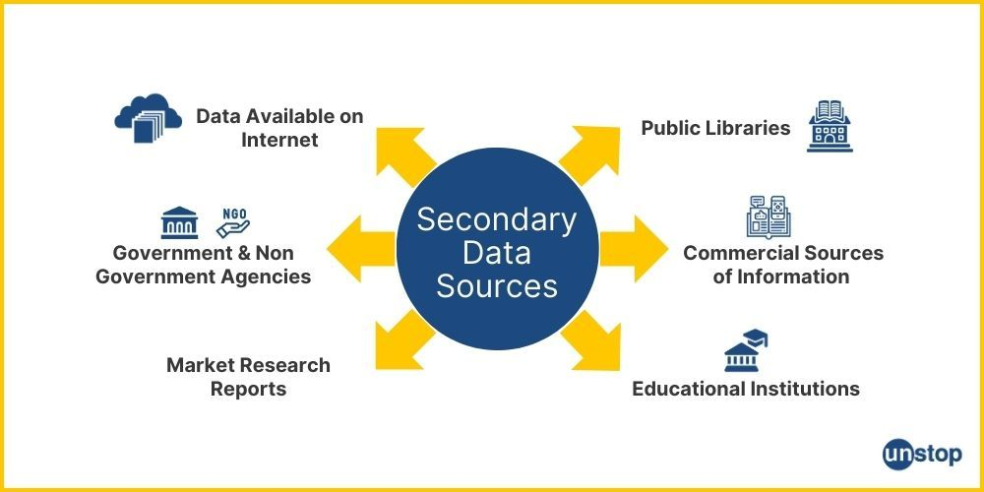

Figure 3.6.1: Data collection method
(Source: Cheong et al. 2023)

3.7 Data Analysis Methods
The data analysis is the systematic process of organising, interpreting and evaluating data to detect patterns and insights to address the contemporary challenges in the mentioned industry. The thematic analysis process has been used to detect the changes within the UK grocery retail. Thematic analysis is a qualitative data analysis process that helps researchers to organize a huge volume of textual information into meaningful categories (Braun and Clarke 2023). The process involves multiple stages, in which the first step is data Familiarisation. The researcher goes through the existing information to identify any perceived gaps to finalise the required datasets for the research. The next step is code formation, so that large datasets are divided into small keywords to match the research objectives. Similar codes are combined to form large themes, and finally those are applied within the analyses section of the study.
3.8 Research Tools

Research tools | Purpose
MS word | To note down all data and shorten information from a bunch of data.
Google scholar | Including high-quality peer reviewed journals, books and articles
Scopus and web of science | To obtain high-quality academic literature
Secured computer system | To search information
Internet | High speed internet required to download articles, books and other resources.

Table 1: Tools used for this research
(Source: Self developed)

3.9 Ethical considerations
Ethical considerations are the moral principles and standards which should be maintained by researchers, so that credibility of the research can be maintained. For secondary qualitative data collection, no direct involvement of human participants is required, however, researchers should ensure that existing data needs to be extracted lawfully. In that case, any hidden information or names should not be mentioned or highlighted at the present research. Another important ethical consideration is data protection and accessibility, which has been conducted after integrating GDPR and UK Data Protection Act 2018. In other words, anonymity and confidentiality needs to be maintained throughout the research and it must be ensured that no one can access those data easily.

3.10 Chapter Summary
The chapter has highlighted the process of data collection and analysis and justified the reason for choosing those processes. The interpretivism philosophy and inductive approach were selected to identify the patterns and trends of the UK grocery sector. Apart from that, the existing data sets were compared and constructed to formulate proper themes for this research.

Chapter 4: Results and Discussion

4.1 Chapter Overview
The results of this study, which employed secondary qualitative thematic analysis of the published literature, are outlined in this chapter. The analysis clusters available evidence in major themes around the research goals and the research question. Research related to the topic is carefully analysed for patterns, similarities, differences and what can be gained from a retail application. The chapter details the impact of business automation on employment models, leadership capabilities and organisational operations using thematic interpretation, which is based on the evidence. As it also designed to include additional supporting characters that will help the reader understand key discovery elements. Lastly, the chapter offers a practical and systematic base for an overall discussion of findings, for meaningful conclusions, and practical suggestions for retail organisations.

4.2 Thematic Map
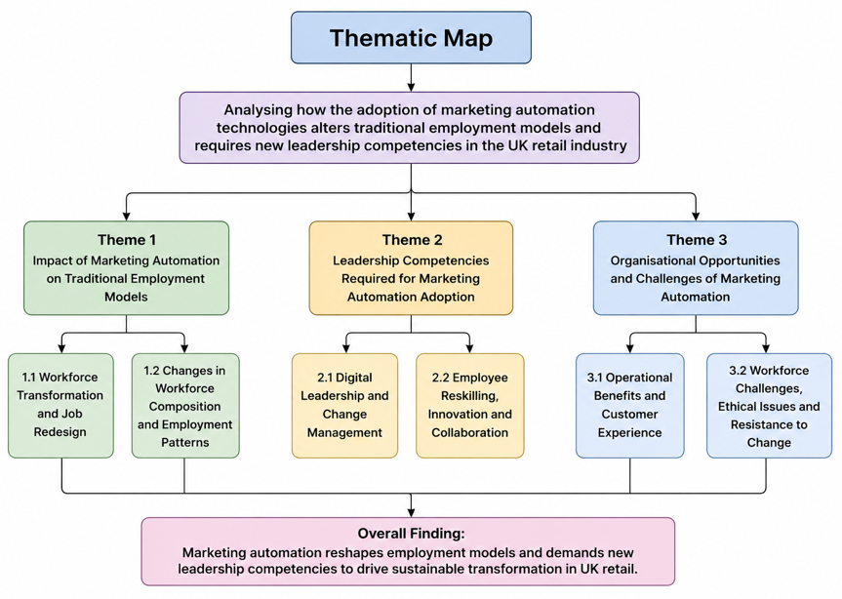

Figure 4.1: Thematic Map
(Source: Self-Developed)
The thematic map is a visualisation of the main themes identified in the secondary qualitative thematic analysis. It shows how the research objectives, thematic (content) categories, and overall findings of the research are logically connected. The selected literature was analysed and distilled into 3 main themes to understand the impact of business automation in the United Kingdom retail sector, as illustrated in Figure 4.1. These themes address both employment change and opportunities and challenges in the workforce, as well as opportunities for leaders. Themes have subthemes, which help to analyse published evidence systematically. The thematic map, however, will enhance the analytical consistency and link each research objective with the thematic results.

4.3 Thematic Coding Table
Research Objective | Initial Codes Identified from Secondary Literature | Category Development | Final Theme
Objective 1: To explore and assess the impact of business automation on the traditional employment models, workforce composition and job profiles. | Job redesign, workforce transformation, digital skills, automation adoption, task automation, employment restructuring, workforce flexibility | Changes in traditional employment models, workforce composition, and evolving job roles within the UK retail industry | Theme 1: Impact of Business Automation on Traditional Employment Models in the UK Grocery Industry
Objective 2: To recognise the leadership qualities needed to manage change in an organisation effectively through technology. | Digital leadership, change management, strategic decision-making, employee engagement, innovation, communication, leadership capability | Leadership competencies supporting successful business automation adoption and organisational transformation | Theme 2: Leadership Competencies Required for Business Automation Adoption
Objective 3: To offer guidance to retail organisations who want to pursue technological innovation whilst managing, leading and nurturing their staff sustainably. | Operational efficiency, customer experience, workforce wellbeing, ethical concerns, employee resistance, organisational sustainability, continuous learning | Organisational opportunities, workforce challenges, and sustainable management practices during business automation implementation | Theme 3: Organisational Opportunities and Challenges of Business Automation

Table 4.1: Thematic Coding
(Source: Self-Developed)

4.4 Thematic code

4.4.1 Impact of Business Automation on Traditional Employment Models in the UK grocery Retail
- 4.4.1.1 Workforce Transformation and Job Redesign
Retailers in the United Kingdom are seeing business automation yield transformation of the workforce and redesign of jobs. According to Hunt and Rolf (2022), AI also helps to get rid of repetitive tasks in retail, freeing up time for employees to focus on tasks that require more human effort, such as customer service, problem solving, and value creation. This transition enables businesses to streamline processes while enabling employees to make the most of opportunities arising in the modern workplace through new work-based training programmes without eliminating all existing jobs. However, Swargiary (2024) thought that the latter may lead to the disappearance of several jobs that are considered routine, along with making adjustments difficult for workers not possessing advanced digital skills. For example, Tesco has realised the ambition of automated stock control and self-service systems and is still rolling out customer advisory services for all frontline staff. Thus, opportunities lie in workforce transformation when organisations need to undertake part of the work and complement skill-up learnings with workforce support.
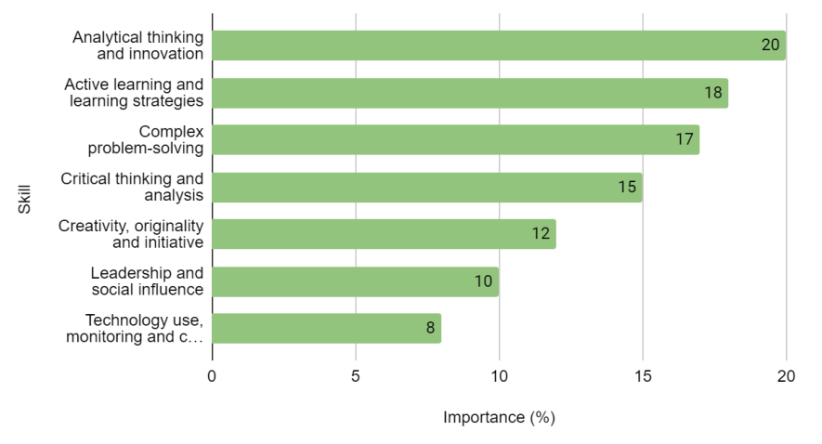

Figure 4.2: Top Skills for the Future Workforce
(Source: Onifade et al. 2022)
Business automation also alters the role of its human resources, mandating them to acquire more versatile technical and analytical skills to be able to operate successfully in the future of retail. Onifade et al. (2022) emphasised the importance of acquiring the following workforce skills for successful adoption of automation - digital literacy, problem solving, creativity, and adaptability, as can be seen in Figure 4.2. These enable employees to be more confident about their task performance and assist organisations to adapt well to the emergence of new technologies in the competitive retail environment. However, Manikandan (2024) proposed that workforce transformation involves a continuous investment within the organisation as the employees might find it difficult to acquire new skills without proper training programmes. For example, Marks and Spencer has been increasing digital sales and providing learning opportunities to motivate staff to develop technology competence. Therefore, ongoing skill development with good organisational commitment is the key to job redesign planning success.
Any workforce transformation efforts must have an even balance of investment in organisational strategy that includes investment in next-generation technology and ongoing employee capability building. According to Naeem et al. (2026), the advent of automation helps employees to be more productive, but only when they have reshaped their roles properly and are ready to implement the changes. The results show that in retail companies, business automation influences or replaces work in some aspects. Effective job redesign enhances organisational performance and also maintains valuable employees' contributions in shifting retailing jobs in the UK.
- 4.4.1.2 Changes in Workforce Composition and Employment Patterns
Business automation keeps reshaping the way things work in the United Kingdom retail industry, with workforce composition and employment patterns changing significantly. Notably, Olaniyi et al. (2024) noted that automation boosts the need for digitally trained workers and reduces reliance on repetitive manual tasks within various business activities. This makes a flexible workforce that can engage with and solve problems in the evolving work environment an attractive option for businesses. Conversely, Tartanoglu-Bennett and Tindal (2022) proposed that employment insecurity can emerge during a workforce transition as many retail workers experience challenges adjusting to revamped roles and responsibilities. Tesco has continued to roll out digital sales and diversified its workforce to promotions that involve more customer service and fulfilment. Thus, the dynamics of employment keep changing over time with the advancement of technology and future planning of the workforce in the organisation.
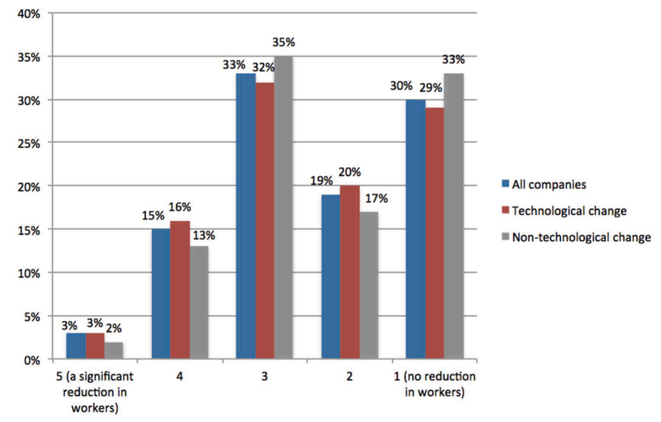

Figure 4.3: Introduction of significant changes in work processes and job reduction
(Source: Souto-Otero et al. 2023)
Business automation is also changing the shape of job functions, including flexible working conditions and ongoing training of staff to ensure their capabilities. The authors highlighted the increasing demand for technologically changed jobs that hire employees with higher levels of digital and analytic skills, as outlined in Figure 4.3 (Souto-Otero et al. 2023). These developments enhance organisational competitiveness, create career opportunities for workers ready to embrace technological innovation, and enhance employee productivity in the workplace. However, Willcocks (2024) had to contend with the possibility that there could be a deepening of inequality within the workforce as those with lower skills might be afforded minimal chances for a digital career upgrade without specific action from the organisation. Sainsbury's has bolstered its e-commerce business and increased the number of roles in the digital fulfilment function which demand greater technological skills. The workforce's composition is increasingly being made up of individuals whose readiness for the modern workplace is directly linked to organisational investment in employee training and technology.
Organisations are continuing to transform jobs, adding a combination of human skills and sophisticated digital technology to the retail mix. According to Wang et al. (2024), the digital transformation journey takes a gradual pathway toward transforming to knowledge-based work, where workers need to be more adept at adapting and possess workforce-specific skills. The results suggest shifts in work and the emergence of new roles for digitally skilled workers. In addition, effective transformations of the workforce rely on two equally important components, including technology and sustainable human capital development wrapped in an orchestrated organisational strategy.

4.4.2 Leadership Competencies Required for Business Automation Adoption
- 4.4.2.1 Digital Leadership and Change Management
In order to effectively drive business automation and organisational transformation in the UK retail sector, digital leadership has become a must. Some advantages of effective leadership in digital learning include employee trust in technology, which is built when an organisation communicates change in technology effectively, and when organisational change leads to an emphasis on innovation and collaboration (Zaghmout et al. 2024). This leadership style contributes to happier staff and ensures seamless business automation integration in-store. However, Ongena et al. (2024) suggested that what frequently and repeatedly frustrates the successful implementation of digital transformation is the absence in the leadership team of the necessary digital competencies and decision-making competence, even after considerable investments in technology. Through leadership commitments for employee engagement and ongoing digital upskilling, Tesco has increased the use of AI in its retail operations. As a result, it is still critical for strong computer leadership to ensure the organisation's successful transition and prolonged adoption of automation.
Educating staff about technological change is also a crucial part of successful change management that must be structured, communicated and supported continually through the organisation. Artificial intelligence implementation is only feasible where organisations are ready for it, with careful planning before implementing artificial intelligence, noting that planning can minimise uncertainty and enhance implementation results (Tursunbayeva and Gal 2024). This enhances the numbers in the workforce and helps those who join the firm to be informed about evolving responsibilities in the automation process. However, Gilli et al (2023) proposed that organisations may lack an awareness of the need for leadership to be able to make the digital transformation, leading them to find gaps in communication and opposition from their employees. Marks and Spencer enhanced the digital retail business through leadership practices that foster collaboration, learning and embrace technology in every business function. This translates to the benefits of employee participation in change as a result of effective change management, and the need for ongoing investments in the organisation.
By fostering long-term goals and employee growth, Digital leadership shapes organisational performance. Hossain et al. (2025) found that with digital transformation, leadership skills that are supported by artificial intelligence help increase organisational adaptability, improve decision-making, innovation and job resilience. The results show that business automation within retail organisations requires talent and investment in technology too. Overall, digital leaders help to lead the organisation to sustainable change while having a certain level of employee engagement during the adoption of digital automation.
- 4.4.2.2 Employee Reskilling, Innovation and Collaboration
Dedicated training of the employee workforce, innovation and collaboration are now key leadership concerns when implementing business automation in the retail sector in the UK. In order to constantly adapt to evolving technological climates, organisations with successful AI adoption invest in workforce upskilling on an ongoing basis (Appiah, 2025). This practice makes employees more confident and enhances the flexibility and competitiveness of the organisation in the long term with continuous capability enhancement. However, when organisations are not capable of creating a supportive learning environment and career progression opportunities, many employees exhibit low motivation for digital training (Śledziewska et al. 2025). Tesco has embraced digital learning strategies designed to help workers cope with the shift to new technology in various retail outlets. Thus, the continuous reskilling of employees is still necessary for maintaining a good going concern and adaptability.
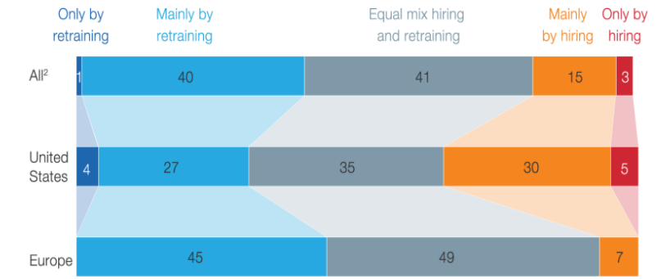

Figure 4.4: The way the organisation will best resolve its potential skills gaps related to automation
(Source: Cvetkovski and Tomanovic, 2024)
Leadership also fosters innovation by facilitating inter-agency co-operation, co-training and inter-regional exchanges among employees and with educational institutions and stakeholders in the context of the transformation of the workforce. Collaborative leadership benefits workforce reskilling by amplifying the bonds between individuals, firms, and even groups, which promotes knowledge sharing, innovation, and in-the-field learning experiences, facilitating organisations' digital transformation (Qiumeng et al. 2025). The findings from the organisations that took part revealed that those with a focus on filling potential skills gaps through structured learning programmes gain from more ready-to-work members of the workforce and stronger results for automating their processes (Figure 4.4). In contrast, Li et al. (2025) maintained that significant investment in a reskilling programme and ongoing managerial involvement are needed before organisations can see measurable organisational improvements. Marks and Spencer's commitment towards digital capability development is manifested through ongoing skills acquisition and joint development in the workplace. Even though there is a high cost and demands to be strongly led to implement collaboration, the development of working together yields long-term value for organisations.
Reskilling employees boosts the innovation of an organisation, as it prepares them with new technological roles in the contemporary retail backdrop. According to Cvetkovski and Tomanovic (2024), companies that provide structured upskilling for their employees to cope with changing task needs end up with more resilient employees and more successful companies. The above results suggest that successful digitalisation is intrinsically linked with continuous employee learning and support by leadership during such a transition. In conclusion, reskilling and cooperation give sustainable competitive advantages and increase the organisation's readiness for technological developments in the future. Tesco has developed its communication among employees and brought digital solutions into play to reduce opposition and make the workforce more accepting. Thus, good organisational support will continue to be a major determinant in minimising resistance and fostering successful implementation of the automation.

4.4.3 Organisational Opportunities and Challenges of Business Automation
- 4.4.3.1 Operational Benefits and Customer Experience
Using business automation tools offers a major operational benefit for the grocery sector throughout the UK and enhances the customer experience. According to Gavrila et al (2023), automation improves customer satisfaction through timely services, personalisation, and seamless customer interactions across various channels. These enhancements enable companies to improve efficiency in their operations and are a response to, and proactive application of, evolving customer expectations in competitive retailing contexts. At the other end of the spectrum, Rolando (2025) suggested that relying too heavily on automated interactions with customers could end up causing less personal and human interaction, in turn impacting long-term customer relationships and loyalty. Tesco leverages personalised digital promotions and automated recommendations to make customers' online shopping experience easier. Thus, balanced automation enhances two vital objectives: one, to promote the satisfaction of customers and two, to keep vital human interaction in retail services.
Business automation also enhances organisations' efficiency by bringing in predictive technologies, customer analytics and streamlined marketing processes that aid business performance. They were quoted in the article as saying that with RPA, the marketing operation of repetitive tasks will be reduced, and employees will be able to concentrate on strategic decision-making and customer relationship management. This helps enhance service delivery and streamline resource utilisation in retail businesses, leading to greater operational efficiency and productivity. However, Anozie et al. (2024) stated that ongoing technological, infrastructure and investment costs are needed, and subject-matter experts are required to implement automation, as system integration problems could limit expected benefits to the organisation. Marks and Spencer have boosted their omnichannel retailing by implementing automated business technologies to assist with better customer engagement and operational efficiency. Accordingly, those organisations that successfully integrate technological innovations and human resources professionals' experience can enjoy more operational benefits.
The integration of automation within a personalised marketing strategy and good customer service can create a better customer experience. Kedi et al. (2024) found that customer engagement rises in retail settings as a result of artificial intelligence-based business automation, which enables them to make personalized recommendations, communicate efficiently, and provide better quality services. The results showed the benefits of automation on organisations' performance and higher customer value due to the ability to make decisions based on data. Operational success is dependent on piecing together technology with people to ensure sustainable customer experiences.
- 4.4.3.2 Workforce Challenges, Ethical Issues and Resistance to Change
Before widespread business automation usage, the UK grocery sector struggled with many workforce challenges that covered suboptimal workplace cultures, poor employee engagement and unwillingness to change. The issues dampened employee confidence, eroded collaboration and slowed organisational performance. Soliz (2025) further notes that when workers do not have confidence in their workplaces or feel supported by the organisation, they are more likely to resist organisational change. This shift to business automation has added challenges to organizations like the uncertainty of employees, reshaping job roles, and increased reluctance to embrace digital transformation. On the other hand, Alabi et al. (2024) noted that with workforce analytics, organisations can be positioned to address uncertainties in the workforce and serve as a mechanism to uncover workforce needs; however, organising/micro-businesses are still grappling with workforce dynamics when employees struggle to adapt to technology.
The ethical implications have also grown as business automation further fuels organisations' decision-making in the grocery segment. Earlier, it was the traditional management strategies that were the main issues for organisations in relation to workforce planning and quality of service. Alabi et al. (2024) state that workforce analytics can be used to support workforce planning and human resources management decision-making. Yet, the present digital transformation has raised new concerns about employee privacy, reliance on technology, algorithms and their decision-making power, and implementation complexity on the governance front of retail organisations (Al-haimi et al. 2025). Hence, businesses have enhanced communication with their staff and encouraged responsible use of digital technologies to help alleviate these concerns, but it creates an ongoing challenge to ensure transparency and trust within their workforce.
AI and business automation are now a part of organisations' workflow, and workforce challenges remain constant. Organisations grapple with ongoing ethical challenges regarding governance, employee adaptation, responsible AI, and employee well-being in these times of technological change (Machucho and Ortiz 2025). These challenges can impact employee engagement, the work culture, and the sustainability of digital transformation efforts. Hence, these challenges must be addressed by effective management through responsible leadership, transparency in governance, ongoing support for employees and successful change management. This can be done to ensure that retailers have a chance of technology transformation that is sustainable and without compromising employee well-being or organisational performance.

4.5 Findings Analysis
The analysis has highlighted that the application of business automation has altered the traditional employment models within the UK grocery industry. Within this, the job design seems to be one of the major outcomes of business automation, because the technology has changed the traditional job roles. The UK grocery sector from the UK has started prioritising employees as an important asset and they might not replace them, rather than allocating each of them to the higher valued activities. Existing markets are supporting a hybrid working environment, so employees and leaders must have technical knowledge along with customer insight. The research support workforce transformation through investing in employee reskilling to enhance the confidence of employees to work under such an advanced environment.
The findings revealed that workforce composition and employment patterns in the UK grocery sector have changed after implementing business automation software such as AI, CRM, chatbots, and others. On the other hand, the traditional marketing departments primarily relied on a large team structure with manual task handling processes. As a result, organisations have been facing repetitive mistakes, delays in project delivery, and ultimately lower productivity across the departments. After the successful adoption of technologies, the employment pattern has changed towards project-based and flexible working environments. Retailers developed small multidisciplinary teams with hybrid working and remote collaboration facilities. It will enable leaders to develop teams across regions and enhance their abilities in this evolving marketplace.
Furthermore, another crucial component of this study is digital leadership and change management. Digital leaders have a strategic vision for technology adoption and align automation with organisational objectives. Before introducing the technology in front of employees, leaders play an important role in taking responsibility for it. Leadership competence such as clear and transparent communication with staff about organisational changes, job requirements, skills and workforce needs, so that employees can get accustomed to the new working environment. For instance, one of the retail giants in the UK is M&S and the CEO Stuart Machin has adopted transformational leadership to focus on employee empowerment through providing training and coaching on automation and CRM systems (Tafuro et al. 2025).
Despite the positive aspect, the sudden implementation of automation in the grocery sector has generated a significant challenge for the workforce. Employees are fearing such changes as automation changes the administrative roles such as scheduling, reporting and email business automatically. This created uncertainty about job roles, employability, and career progress for employees. If leaders are incapable of supporting employees at this phase, employees might think of leaving the organisation, or they search for new jobs. On the other hand, gaps in knowledge among employees create ethical issues and rising concern about data privacy and transparency. Therefore, leaders must develop problem-solving competency to establish an ethical governance framework to conduct a regular audit of AI to ensure the accountability of decision-making.

4.6 Discussion

4.6.1 Overall Interpretation of Findings
The study has highlighted that the grocery sector in the UK has started implementing business automation tools to alter traditional employment. Previously, Pramudito et al. (2023) stated that, candidates were selected manually and after hiring, they accomplished their duties through a manual process. However, the grocery industry has shifted towards technological adaptation, so the organisational culture and structure must be changed simultaneously. The transformational leaders are always wanting to accept new changes and are ready to deal with sudden uncertainties; hence, this leadership approach is suitable for the UK grocery sector.

4.6.2 Comparison with Existing Literature
Pramudito et al. (2023) stated that successful business automation does not depend on technological advancement but also on the leader’s ability to handle sudden organisational changes. In that case, Mwamba (2023) claimed that change management seems to be one of the major competencies that help leaders to guide employees to deal with resistance and ensure that technologies are embedded successfully within the organisational practice. Throughout the operation, leaders need to communicate with the employees transparently to let them be aware of the benefits of business automation along with the challenges faced by these employees after the technology adaptation.
On the other hand, Frazer and Hewitt (2025) claimed that transformational leadership theory is the most suitable approach for the changes in the UK grocery sector. Transformational leaders understand each employee's perspectives towards digital adaptation and ensure that employees feel comfortable within the organisational platform. (Reuters, 2026) pointed out that Tesco is one of the best examples of a grocery organisation which practices personalised business approaches for better customer engagement. In that case, the leaders from Tesco have arranged employee training programs and invested on workplace learning to strengthen the confidence of employees in using the business automation tools.

4.6.3 Relationship with Transformational Leadership Theory
The chosen topic has emphasized the capabilities of modern leaders to guide employees during organisational changes. Rojak et al. (2024) claimed that the usage of transformational leadership theory can inspire leaders to share vision, mission and objectives with employees so that they can rely on the organisational activities. The four dimensions of transformational leadership theory are idealised influence, inspirational motivation, intellectual stimulation and individualised consideration. These stages directly align with the challenges of business automation and value the concerns of employees regarding job displacements. The intellectual stage further encourages leaders to develop creative solutions to the issues by fostering innovation within the industry. Individualised considerations support the culture of training, workshops, and workforce reskilling through recognising each employee's needs and delivering personalised learning solutions to them. Companies such as Sainsbury, Tesco and M&S utilise effective leadership practices for employee wellbeing and organisational sustainability (Sainsbury, 2015). In this way, the transformational leadership theory provides a theoretical foundation for this research as it compares and contrasts the willingness of employees to accept automation for developing new digital competencies.

4.6.4 Practical Implications for UK Retail Organisations
As per Roy (2024), one of the practical examples from the UK grocery sector is Tesco, which has already implemented business automation for maintaining organisational competitiveness. The largest food retailer practice transformational leadership to provide virtual and face-to-face training to employees to improve productivity. In 2025, Tesco generated revenue of approx. £69.2 billion, which holds a 28.5% market share (Tesco, 2025). Tesco has already utilised the Clubcard loyalty programme to promote its products and provide personalised solutions to customers. Leaders of Tesco have already proved that business automation can be taken as an opportunity to redesign jobs rather than reducing headcounts.

4.7 Chapter Summary
The findings have revealed that the sudden changes towards technologies pushed the organisations towards innovation, along with reducing the workers' contributions. Employees are fearful of this sudden change, and they thought their jobs must be replaced soon. Here, leadership competencies play an important role in reskilling and training of employees, so that the confidence of employees can be improved and they can handle these technologies errorless.

Chapter 5: Recommendations, Conclusion and Limitations

5.1 Conclusion
The study has highlighted the business automation technologies that have transformed traditional employment models and leadership practices in the UK grocery sector. The industry has adopted AI, CRM, chatbots, e-commerce, predictive analytics and automated technologies to enhance marketing operations and customer engagement. The implementation of business automation has not completely altered the role of human employees; rather, it has reshaped the nature of work by reducing errors. The study revealed that the automation has contributed to the formation of a cross-functional collaboration team after including IT, customer service and data analytics. On the other hand, technological transformation has impacted negatively and created challenges for the employees, including skill shortage, job displacement, and employees' resistance to change.
The study has mentioned the successful adoption of automation technologies within the UK grocery industry depending on the leadership capabilities. In that case, most of the organisations are using transformational leadership strategies to reshape the abilities of leaders to learn more about digital competencies to run operations, marketing, and manage the workforce. Digital literacy is one of the major competencies for Transformational leaders that must involve a clear understanding of business automation, customer engagement, and analytics for decision-making. Leaders must develop change management abilities to detect the uncertainties within the market. An effective leader provides lifelong learning and knowledge-gaining opportunities for the employees.
The study has involved secondary qualitative data collection to highlight the changes occurs within the UK grocery industry regarding leadership planning, employment structure and productivity. After involving business automation, the industry shifted from task-based roles to technology-oriented positions. The traditional marketing involved manual customer segmentation, data entry, and scheduling tasks, which has cause delays and repetitive errors. On the other hand, after including business automation, leaders need to learn more competencies to alter organisational structure, so that they can support the modern workplace needs.

5.2 Linking Findings with Research Objectives
Objective 1 is about exploring the impact of business automation on traditional employment models, job profile, and workforce composition. Business automation has changed the employment patterns and made the process seamless and faster than before. Schiuma et al. (2024) claimed that it has replaced manual tasks, and the technology enables conducting hiring advertisements online to attract multiple candidates. Moreover, companies like Tesco and M&S prefer to hire employees from all over the globe through digital technologies and intend to involve candidates from different races, religions and cultures.
Objective 2 highlighted the required leadership qualities for managing the changes within the grocery sector in the UK. These findings have evaluated the major leadership competencies required for leaders, including adaptability, strategic vision, digital literacy and emotional intelligence. In that case, Braojos et al. (2024) claimed that leaders who have developed these competencies have already positioned themselves as transparent decision-makers and mentors for the workplace.
Objective 3 stated the technological innovation for leading, nurturing and managing staff for the grocery sector in the UK. The finding introduced comprehensive guidance to the employees for reskilling and up skilling programmes. Valtonen and Holopainen (2025) stated that, the retail organisations are promoting continuous learning and employee participation within the organisation. The benefits of creating a supportive workplace and encouraging employees to participate in organisational activities can enhance job satisfaction, morale, and career development opportunities for them.

5.3 Recommendations
Recommendation 1: Investing in reskilling of workforce through Human AI collaboration
UK retail organisations need to establish opportunities for employees to learn continuously through reskilling programs. Sharma et al. (2022) stated that, continuous investment in digital capabilities can provide lower resistance and stronger employee engagement. The stages of structured implementation should involve a comprehensive digital audit to detect the learning gaps across all departments such as sales, marketing, data analytics and customer service. Then each employee must be given a personalised learning pathway tailored to their digital proficiency. For instance, Tesco has already invested in employee training programs to improve the digital capabilities of employees throughout all departments (Tesco, 2024). The involvement of different learning pathways such as cross-functional projects and mentoring can minimize the rate of job displacements and strengthen employees' confidence in handling technologies like automation.
Recommendation 2: Developing more digital and transformational leadership competencies to support the changes
The UK-based grocery sector must strengthen the digital and transformational leadership competencies to support modern organisational needs. The study has already proved that effective leadership is essential to managing employees' behaviour, attitude, and perception towards newly implemented business automation tools. Phakamach et al. (2023), stated that organisations that have digitally capable leaders are more confident in experiencing employee engagement and greater success after technology implementation. Grocery organisations must establish a new leadership framework that supports practical guidance through workshops, digital coaching, and mentoring about the changes needed for the firm to remain competitive in this market (Sinnaiah et al. 2023). The grocery organisation must design an appropriate leadership development training program to support the existing leaders with digital strategy, automation fundamentals, ethical AI governance, data literacy and employee wellbeing. It will help senior managers, executives, and supervisors to enhance their skills and literacy level to further guide the bottom-level employees.

5.4 Limitations and Future Research
The research solely depends on the secondary data collection from the existing academic journals and industry reports; therefore, this evidence might not be enough to justify the perception of leaders towards the traditional employment system. In that case, Aftab (2025) stated that, the evidence collected from the secondary process does not completely reflect the most recent organisational practices on decision-making for changing the leadership design within the grocery organisation in the UK. On the other hand, another significant gap is that the study only focuses on the UK grocery industry, which limits the Generalisability of the findings to other industries in the same country. The findings from this research only support the UK grocery sector because the leadership competencies for healthcare, hospitality, manufacturing and retail might differ from the chosen sector.
In that case, future research could explain the long-term consequences of using automation for career progress, leadership and employee satisfaction. In the future, more longitudinal studies will be included in the research process to provide valuable insight into the stages of employment structure and the root cause of its changes over time. Future studies will expand beyond the UK or involve different industries such as hospitality, healthcare, and manufacturing to identify the progress of digital transformation at different rates. Moreover, the future scope of the study is to explore some other competencies such as AI governance, cyber resilience and human-centred leadership to support the entire sector with innovation and experience.

Element 2: Research Process Reflection
Gibbs’ Reflective Cycle has helped me approach my own experiences in a more structured and honest way, guiding me to slow down and examine not just what happened but how I felt and why I responded as I did. By moving through its six stages, I’m able to turn everyday moments into meaningful learning, shaping clearer insights and more intentional actions for future practice.
Description
The research has already developed a valuable understanding of the business automation technologies and leadership competences in the UK grocery sector. I have collected secondary data for this research based on Google Scholar, Scopus, ScienceDirect, and other valid databases. This product has developed my research skills, and I understood which articles are suitable for this study, and which are not. Albassam et al. (2023) claimed that research abilities can help in future employment as it guides candidates to make decisions based on the searched evidence. However, I have faced issues while gathering information in the initial phase, which was filtering a large volume of data from secondary sources.
Feelings
Despite the positive aspects, the collection of secondary data logically seems difficult for researchers. Initially, I felt that I spent more time re-reading articles and journals, so that I forgot to note down the facts and trends of the UK grocery sector. It ultimately created time management issues. Fox (2022) stated that time management seems to be crucial for academics, as it help in delivering projects before the deadline and prevents deductions of marks. Initially, I somehow managed to fulfil the first deliverables, and I have experienced stress and anxiety as I failed to complete the first milestones.
Evaluation
I have evaluated that modern organisations are completely relying on proper leadership approaches. Nour and Arbussà (2023) stated that, organisations are reshaping their structure as per modern industry needs, such as implementing technologies to fulfil customer demands. In that case, such transformation requires professional involvement of mentors, leaders, and supervisors who can guide the entire workforce to achieve organisational goals. While collecting leadership-related data, I was confused about which practices I needed to select for the chosen topic. I took assistance from the University instructors and took them as real-life examples of leadership to choose theories wisely.
Analysis
I further analysed that collecting secondary data is not an easy process, and it involves multiple phases. Initially, I did not know how to search articles and journals for the research, so I decided to pay attention to my communication skills to seek help from peers. Biggs et al. (2024) stated that, face-to-face communication can be taken as one of the best leadership competencies, as it helps in reducing confusion and creating new ideas. I have explored that; I need to use short keywords to search articles from academic databases like Google Scholar. Then I have used the AND/NOT/OR process to create short keywords to search articles, journals and books from valid academic databases.
Conclusions
The overall research process has enhanced my digital proficiency at the initial level as I used MS Word, MS Excel, University databases, online databases, and also visited industry publications to gather data from the UK grocery sector. The process has impacted my experiences and provided more knowledge about data analysis. For instance, I did not know how to create themes or analyse that information to formulate a valid conclusion. The overall methodology has given me plenty of new thoughts about data collection and analysis, which will be used in my professional career in the future.
Action Plan
Objectives | Short term plan (0 to 3 weeks) | Medium term plans (3 to 6 weeks) | Long-term plans (6 to 9 weeks)
Time management skills | Creating a daily schedule with priorities with the help of Google Calendar or Microsoft. | Developing time management habits through milestone tracking and rewarding myself after completing each milestone. | Regular productivity checking and adjusting schedules.
Enhancing confidence | Improving confidence through reading more books, journals, and industry publications. Seeking feedback from mentors and leaders. | Strengthening critical thinking and comparing each statement with valid evidence | Doing independent research and investing more in group discussion, public speaking, seminars, and classroom activities.
Improving leadership ability | Setting realistic goals, improving communication, problem-solving, and monitoring process. | Attending more workshops, doing collaboration, academic presentations, and improving futuristic abilities. | Mentoring juniors, promoting collaboration, innovation and continuous learning.

Table 2.0: Action Plan
(Source: Self developed)

Element 3: Methodology Poster
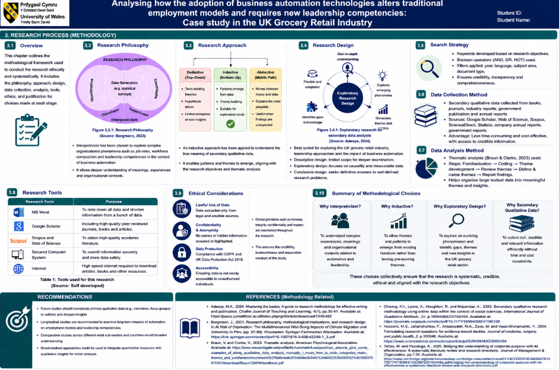

Reference
Adeoye, M.A., 2024. Mastering the basics: A guide to research methodology for effective writing and publication. Chalim Journal of Teaching and Learning, 4(1), pp.30-41. Available at: https://pasca.jurnalikhac.ac.id/index.php/cjotl/article/download/1345/462
Adeoye, M.A., Widiana, I.W., Baharun, H. and Shofwan, I., 2025. Optimising Video Conferencing Tools for Educational Leadership: Enhancing Virtual Collaboration and Leadership Skills Development Theoretically. An-Najmu: Jurnal Manajemen Pendidikan Islam, 2(01), pp.37-52. Available at: https://staisam.ac.id/jurnal/index.php/annajmu/article/download/260/178
Adepoju, A.H., Austin-Gabriel, B.L.E.S.S.I.N.G., Eweje, A.D.E.O.L.U.W.A. and Collins, A.N.U.O.L.U.W.A.P.O., 2022. Framework for automating multi-team workflows to maximize operational efficiency and minimize redundant data handling. IRE Journals, 5(9), pp.663-664. Available at: https://www.researchgate.net/profile/Adebusayo-Adepoju/publication/388734627_Framework_for_Automating_Multi-Team_Workflows_to_Maximize_Operational_Efficiency_and_Minimize_Redundant_Data_Handling/links/67a43ea9645ef274a47139d2/Framework-for-Automating-Multi-Team-Workflows-to-Maximize-Operational-Efficiency-and-Minimize-Redundant-Data-Handling.pdf
Aftab, F., 2025. The Mediating Role of Transactional Leadership Between Last-Mile Delivery Practices and Sustained Change Implementation: A Case Study of the UK Retail Market. https://cmpublisher.com/wp-content/uploads/2025/09/Faisal_Aftab.pdf
Ahmad, T., Aakula, A., Ottori, M. and Saini, V., 2022. Developing a strategic roadmap for digital transformation. Journal of Computational Intelligence and Robotics, 2(2), pp.28-68. Available at: https://www.researchgate.net/profile/Tanzeem-Ahmad-3/publication/389602344_Developing_A_Strategic_Roadmap_For_Digital_Transformation/links/67c98c22bab3d32d843f4218/Developing-A-Strategic-Roadmap-For-Digital-Transformation.pdf
Ahmad, T., Boit, J. and Aakula, A., 2023. The role of cross-functional collaboration in digital transformation. Journal of Computational Intelligence and Robotics, 3(1), pp.205-42. Available at:https://www.researchgate.net/profile/Tanzeem-Ahmad-3/publication/389744145_The_Role_of_Cross-Functional_Collaboration_in_Digital_Transformation/links/67d098b3d7597000650803c2/The-Role-of-Cross-Functional-Collaboration-in-Digital-Transformation.pdf
Ahmadi, H., 2024. Managing organizational change in the digital era: The interplay of technological advancements, leadership, and employee adaptability. Leadership, and Employee Adaptability (August 09, 2024). Available at: https://papers.ssrn.com/sol3/Delivery.cfm?abstractid=4936389
Alabi, O.A., Ajayi, F.A., Udeh, C.A. and Efunniyi, C.P., 2024. The impact of workforce analytics on HR strategies for customer service excellence. World Journal of Advanced Research and Reviews, 23(3), pp.245-263. https://www.researchgate.net/profile/Olufunke-Alabi/publication/383862281_The_impact_of_workforce_analytics_on_HR_strategies_for_customer_service_excellence/links/66ddfadbf84dd1716cddef49/The-impact-of-workforce-analytics-on-HR-strategies-for-customer-service-excellence.pdf
Alabi, O.A., Ajayi, F.A., Udeh, C.A. and Efunniyi, F.P., 2024. Predictive analytics in human resources: Enhancing workforce planning and customer experience. International Journal of Research and Scientific Innovation, 11(9), pp.149-158. https://www.researchgate.net/profile/Olufunke-Alabi/publication/384431752_Predictive_Analytics_in_Human_Resources_Enhancing_Workforce_Planning_and_Customer_Experience/links/67d4cf47e62c604a0dd99006/Predictive-Analytics-in-Human-Resources-Enhancing-Workforce-Planning-and-Customer-Experience.pdf
Albassam, W.A., 2023. The power of artificial intelligence in recruitment: An analytical review of current AI-based recruitment strategies. International Journal of Professional Business Review: Int. J. Prof. Bus. Rev., 8(6), p.4. https://dialnet.unirioja.es/descarga/articulo/8994309.pdf
Al-haimi, B., Khalid, H., Zakaria, N.H. and Jasimin, T.H., 2025. Digital transformation in the real estate industry: A systematic literature review of current technologies, benefits, and challenges. International Journal of Information Management Data Insights, 5(1), p.100340. https://www.sciencedirect.com/science/article/pii/S2667096825000229
Anozie, U.C., Onyenahazi, O.B., Ekeocha, P.C., Adekola, A.D., Ukadike, C.A. and Oloko, O.A., 2024. Advancements in artificial intelligence for omnichannel marketing and customer service: Enhancing predictive analytics, automation, and operational efficiency. International Journal of Science and Research Archive, 12(2), pp.1621-1629. https://www.researchgate.net/profile/Prince-Ekeocha/publication/383265565_Advancements_in_artificial_intelligence_for_omnichannel_marketing_and_customer_service_Enhancing_predictive_analytics_automation_and_operational_efficiency/links/66c54ea9ccd355055fe17325/Advancements-in-artificial-intelligence-for-omnichannel-marketing-and-customer-service-Enhancing-predictive-analytics-automation-and-operational-efficiency.pdf
Appiah, R.I., 2025. Corporate Strategies for Successful Workforce Upskilling and Reskilling in Response to AI Adoption-What Works, What Does not, and Why. International Journal of Emerging Research in Engineering and Technology, 6(1), pp.91-99. https://www.researchgate.net/profile/Robert-Appiah-7/publication/397599468_Corporate_Strategies_for_Successful_Workforce_Upskilling_and_Reskilling_in_Response_to_AI_Adoption_-What_Works_What_Does_not_and_Why/links/6916ce687b9a7247db4cee71/Corporate-Strategies-for-Successful-Workforce-Upskilling-and-Reskilling-in-Response-to-AI-Adoption-What-Works-What-Does-not-and-Why.pdf
Available at: https://www.sciencedirect.com/science/article/pii/S2199853123002536
Bergmann, J., 2023. Research philosophy, methodological implications, and research design. In At Risk of Deprivation: The Multidimensional Well-Being Impacts of Climate Migration and Immobility in Peru (pp. 57-89). Wiesbaden: Springer Fachmedien Wiesbaden. Available at: https://link.springer.com/content/pdf/10.1007/978-3-658-42298-1_3.pdf
Biggs, A., Johnston, S. and Russell, D., 2024. Leadership and communication: how to assess executive skills. Journal of Business Strategy, 45(3), pp.199-205. https://www.researchgate.net/profile/Adam-Biggs/publication/372046745_Leadership_and_communication_how_to_assess_executive_skills/links/64da828278e40b48bd4b03ba/Leadership-and-communication-how-to-assess-executive-skills.pdf
Bird, A. and Liu, L.A., 2025. Mapping the content domain of global leadership competencies. In Global leadership (pp. 125-151). Routledge. Available at: https://nifassilksubcity.com/wp-content/uploads/2024/12/Global-Leadership-Research-Practice-and-Development-etc.-z-lib.org_.pdf#page=129
Braojos, J., Weritz, P. and Matute, J., 2024. Empowering organisational commitment through digital transformation capabilities: The role of digital leadership and a continuous learning environment. Information Systems Journal, 34(5), pp.1466-1492. https://onlinelibrary.wiley.com/doi/pdf/10.1111/isj.12501
Braun, V. and Clarke, V., 2023. Thematic analysis. American Psychological Association. Available at: https://www.researchgate.net/profile/Muhammad-Avais/post/can_anyone_give_some_examples_of_doing_qualitative_data_analysis_manually_I_mean_how_to_code_categorize_make_themes_and_subthemes/attachment/5b379a6e4cde265cb64be3c9/AS%3A643235366060032%401530370670101/download/Braun12APAHandbook.pdf
Cai, J., 2023. Effects of leadership styles and organizational strategy to enhance performance efficiency. Journal of Enterprise and Business Intelligence, 3(1), pp.012-022. Available at: https://pdfs.semanticscholar.org/7fe7/0493998737548a2f08c9f9eb337f9480cde7.pdf
Chen, L., Jiang, M., Jia, F. and Liu, G., 2022. Artificial intelligence adoption in business-to-business marketing: toward a conceptual framework. Journal of Business & Industrial Marketing, 37(5), pp.1025-1044. https://www.emerald.com/jbim/article/37/5/1025/391793
Cheong, H.I., Lyons, A., Houghton, R. and Majumdar, A., 2023. Secondary qualitative research methodology using online data within the context of social sciences. International Journal of Qualitative Methods, 22, p.16094069231180160. Available at: https://journals.sagepub.com/doi/pdf/10.1177/16094069231180160
Cvetkovski, T. and Tomanovic, V.C., 2024. Benefits of upskilling and reskilling. Economic and Social Development in Period of Global Instability (Book of Proceedings), Special Issue, 241. https://www.researchgate.net/profile/Andrey-Zahariev/publication/388674250_Economic_and_Social_Development_in_Period_of_Global_Instability/links/67a1d77652b58d39f26ae82d/Economic-and-Social-Development-in-Period-of-Global-Instability.pdf#page=248
Davis, F.D., 1989. Perceived usefulness, perceived ease of use, and user acceptance of information technology. MIS quarterly, pp.319-340. https://www.academia.edu/download/50364833/Perceived_Usefulness_Perceived_Ease-of-U20161116-16553-lszuux.pdf
Drozd, L.A. and Tavares, M., 2024. Generative AI: A turning point for labor’s share. Economic Insights, 9(1), pp.2-11. http://www.lukasz-drozd.com/uploads/4/3/1/8/43183209/eiq124-generative-ai.pdf
Dwivedi, Y.K., Hughes, L., Baabdullah, A.M., Ribeiro-Navarrete, S., Giannakis, M., Al-Debei, M.M., Dennehy, D., Metri, B., Buhalis, D., Cheung, C.M. and Conboy, K., 2022. Metaverse beyond the hype: Multidisciplinary perspectives on emerging challenges, opportunities, and agenda for research, practice and policy. International journal of information management, 66, p.102542. https://www.sciencedirect.com/science/article/pii/S0268401222000767
Eshiett, I.O. and Eshiett, O.E., 2024. Artificial intelligence marketing and customer satisfaction: An employee job security threat review. World Journal of Advanced Research and Reviews, 21(1), pp.446-456. Available at: https://pdfs.semanticscholar.org/d34a/d0eb927f4e1618b4fd5088a973ddf11bd8a5.pdf
Farag, M.I.H., 2025. Transformational Leadership in the Era of Digital Transformation. Journal of Advanced Research in Leadership, 4(2), pp.55-72. Available at: https://www.diamondopen.com/journals/index.php/jarl/article/download/1269/407
Fox, R.L., 2022. Time management experiences among adult learners in an online undergraduate degree program. https://digitalcommons.liberty.edu/cgi/viewcontent.cgi?article=4971&context=doctoral
Frazer, M. and Hewitt, L.M., 2025. Building transformational leaders: Assessing retail leadership maturity via an HR lens. SA Journal of Human Resource Management, 23, p.2890. https://www.scielo.org.za/pdf/sajhrm/v23/34.pdf
Gavrila, S.G., González-Tejero, C.B., Gandía, J.A.G. and de Lucas Ancillo, A., 2023. The impact of automation and optimization on customer experience: a consumer perspective. Humanities & Social Sciences Communications, 10(1), p.877. https://www.nature.com/articles/s41599-023-02389-0
Gilli, K., Nippa, M. and Knappstein, M., 2023. Leadership competencies for digital transformation: An exploratory content analysis of job advertisements. German Journal of Human Resource Management, 37(1), pp.50-75. https://www.researchgate.net/profile/Katharina-Gilli/publication/360257142_Leadership_competencies_for_digital_transformation_An_exploratory_content_analysis_of_job_advertisements/links/626ba76ebfd24037e9dd1f67/Leadership-competencies-for-digital-transformation-An-exploratory-content-analysis-of-job-advertisements.pdf
Hopkins, J. and Bardoel, A., 2023. The future is hybrid: how organisations are designing and supporting sustainable hybrid work models in post-pandemic Australia. Sustainability, 15(4), p.3086. Available at: https://www.mdpi.com/2071-1050/15/4/3086
Hosseini, M.S., Jahanshahlou, F., Akbarzadeh, M.A., Zarei, M. and Vaez-Gharamaleki, Y., 2024. Formulating research questions for evidence-based studies. Journal of medicine, surgery, and public health, 2, p.100046. Available at: https://www.sciencedirect.com/science/article/pii/S2949916X23000464
Hudgins, A., 2024. The Impact of Technological Transformation on Entry-level Jobs in the Public Sector (Doctoral dissertation, California State University, Northridge). Available at: https://scholarworks.calstate.edu/downloads/5138jn680
Hunt, W. and Rolf, S., 2022. Artificial intelligence and automation in retail. Friedrich Ebert Stiftung. Available at: https://uniglobalunion.org/wp-content/uploads/Artificial-Intelligence-and-Automation-in-Retail_EN.pdf
Hunt, W. and Rolf, S., 2022. Artificial intelligence and automation in retail. Friedrich Ebert Stiftung. https://uniglobalunion.org/wp-content/uploads/Artificial-Intelligence-and-Automation-in-Retail_EN.pdf
Kedi, W.E., Ejimuda, C., Idemudia, C. and Ijomah, T.I., 2024. AI software for personalized marketing automation in SMEs: Enhancing customer experience and sales. World Journal of Advanced Research and Reviews, 23(1), pp.1981-1990. https://www.researchgate.net/profile/Tochukwu-Ijomah-2/publication/383847586_AI_software_for_personalized_marketing_automation_in_SMEs_Enhancing_customer_experience_and_sales/links/66dc409bfa5e11512ca4ecef/AI-software-for-personalized-marketing-automation-in-SMEs-Enhancing-customer-experience-and-sales.pdf
Ledro, C., Nosella, A. and Dalla Pozza, I., 2023. Integration of AI in CRM: Challenges and guidelines. Journal of Open Innovation: Technology, Market, and Complexity, 9(4), p.100151.
Li, K., Griffin, M.A. and Xia, M., 2025. How do workforce adaptability and reskilling initiatives drive innovations: the case of Western Australian construction industry. Construction Management and Economics, 43(9), pp.746-763. https://www.tandfonline.com/doi/pdf/10.1080/01446193.2025.2511831
Lipton, B., Vromen, A., Rutledge-Prior, S., Good, L., Cooper, R. and Foley, M., 2022. Technology and skills in the future of retail work: A summary of findings. Designing Gender Equality into the Future of Work. Available at: https://www.sda.au/wp-content/uploads/2024/07/2022-Research-USyd-ANU-Technology-and-Skills-in-the-Future-of-Retail-Work.pdf
Machucho, R. and Ortiz, D., 2025. The impacts of artificial intelligence on business innovation: A comprehensive review of applications, organizational challenges, and ethical considerations. Systems, 13(4), p.264. https://www.mdpi.com/2079-8954/13/4/264
Manikandan, S.V., 2024. Intelligent automation and workforce transformation: a multidimensional analysis of employment dynamics and skills evolution. International Journal of Innovative Research in Science, Engineering and Technology, 13(8), pp.15261-15272. https://www.researchgate.net/profile/Sijo_Valayakkad_Manikandan/publication/383496357_Intelligent_Automation_and_Workforce_Transformation_A_Multidimensional_Analysis_of_Employment_Dynamics_and_Skills_Evolution/links/66d0010c64f7bf7b1947431e/Intelligent-Automation-and-Workforce-Transformation-A-Multidimensional-Analysis-of-Employment-Dynamics-and-Skills-Evolution.pdf
Moore, J.R. and Hanson, W., 2022. Improving leader effectiveness: impact on employee engagement and retention. Journal of Management Development, 41(7-8), pp.450-468. Available at:https://www.researchgate.net/profile/Jeffrey-Moore-4/publication/363190699_Improving_leader_effectiveness_impact_on_employee_engagement_and_retention/links/6744b6657ca4cb2842ac2f74/Improving-leader-effectiveness-impact-on-employee-engagement-and-retention.pdf
Mwamba, J., 2023. Effective Leadership in Change Management: Ensuring Success in Organizational Transformation. Journal of Policy Options, 6(1), pp.28-38. http://resdojournals.com/index.php/jpo/article/download/280/621
Naeem, W., Butt, M.A. and Javeid, U., 2026. The Influence of Artificial Intelligence Automation on Employee Productivity, Job Redesign, and Organizational Performance in Service Industries. Social Science Review Archives, 4(2), pp.2534-2552. https://doi.org/10.70670/sra.v4i2.2343
Nour, S. and Arbussà, A., 2023. Driving innovation through organizational restructuring and integration of advanced digital technologies: a case study of a world-leading manufacturing company. Available at SSRN 5255476. https://papers.ssrn.com/sol3/Delivery.cfm?abstractid=5255476
Olaniyi, O.O., Ezeugwa, F.A., Okatta, C., Arigbabu, A.S. and Joeaneke, P., 2024. Dynamics of the digital workforce: Assessing the interplay and impact of AI, automation, and employment policies. Automation, and Employment Policies (April 24, 2024). https://www.researchgate.net/profile/Oluwaseun-Olaniyi/publication/380068372_Dynamics_of_the_Digital_Workforce_Assessing_the_Interplay_and_Impact_of_AI_Automation_and_Employment_Policies/links/6629431435243041534098d1/Dynamics-of-the-Digital-Workforce-Assessing-the-Interplay-and-Impact-of-AI-Automation-and-Employment-Policies.pdf
Ongena, G., Morsch, P. and Ravesteijn, P., 2024. Digital leadership competency to enhance digital transformation. International Journal of Innovation and Technology Management, 21(06), p.2450042. https://www.worldscientific.com/doi/pdf/10.1142/S0219877024500421?utm_content=link&utm_source=www.internationalhu.com
Onifade, O., Sharma, A., Adekunle, B.I., Ogeawuchi, J.C. and Abayomi, A.A., 2022. Digital upskilling for the future workforce: Evaluating the impact of AI and automation on employment trends. Int. J. Multidiscip. Res. Growth Eval, 3(3), pp.680-685. https://www.researchgate.net/profile/Bolaji-Adekunle/publication/392348033_Digital_Upskilling_for_the_Future_Workforce_Evaluating_the_Impact_of_AI_and_Automation_on_Employment_Trends/links/68403a1e8a76251f22eb6787/Digital-Upskilling-for-the-Future-Workforce-Evaluating-the-Impact-of-AI-and-Automation-on-Employment-Trends.pdf
Parker, S.K. and Grote, G., 2022. Automation, algorithms, and beyond: Why work design matters more than ever in a digital world. Applied psychology, 71(4), pp.1171-1204. Available at: https://iaap-journals.onlinelibrary.wiley.com/doi/pdfdirect/10.1111/apps.12241
Phakamach, P., Panjarattanakorn, D. and Onsampant, S., 2023. Conceptualization and development of digital leadership to drive corporate digital transformation for sustainable success. International Journal of Educational Communications and Technology, 3(2), pp.30-42. https://ph01.tci-thaijo.org/index.php/IJECT/article/download/252269/170911/939336
Prakash, D., 2024. Data-driven management: The impact of big data analytics on organizational performance. International Journal for Global Academic & Scientific Research, 3(2), pp.12-23. Available at: Available at: https://pdfs.semanticscholar.org/3829/1d56914b5271bb9060032026f3733e0211eb.pdf
Pramudito, D.K., Ahmad, N., Suwanda, R., Zakaria, M. and Judijanto, L., 2023. Designing an E-recruitment information system using simple additive weighting method for employee recruitment in banking industry. Jurnal Informasi Dan Teknologi, 5(4), pp.19-25. https://pdfs.semanticscholar.org/5a0c/2add90f9a8a336cd6f888160d3a058bb50e7.pdf
Qiumeng, W., Liu, Y., Jiang, Z. and Lee, S.Y., 2025. Collaborative leadership in industry–higher education partnerships: A review of theories and practices in workforce reskilling. International Journal of Learning, Teaching and Educational Research, 24(10), pp.869-891. https://www.researchgate.net/profile/Fatima-Belkhir/publication/403842654_Vol_24_No_10_October_2025/links/69dfa0161fbef2350bfd23a3/Vol-24-No-10-October-2025.pdf#page=877
Reis, J. and Melão, N., 2023. Digital transformation: A meta-review and guidelines for future research. Heliyon, 9(1). https://www.cell.com/heliyon/pdf/S2405-8440(23)00041-5.pdf
Reuters (2026). Tesco partners with Adobe to ramp up AI‑driven personalised marketing. [online] Reuters. Available at: https://www.reuters.com/business/media-telecom/tesco-partners-with-adobe-ramp-up-aidriven-personalised-marketing-2026-04-13/ [Accessed 30 July 2026].
Rita, P., Omran, W., Ramos, R.F. and Costa, T., 2025. Exploring the Applications of Artificial Intelligence in Marketing. https://run.unl.pt/bitstreams/92655332-5f9f-4772-b7e1-8894406eea40/download
Robertson, J., Botha, E., Oosthuizen, K. and Montecchi, M., 2025. Managing change when integrating artificial intelligence (AI) into the retail value chain: The AI implementation compass. Journal of Business Research, 189, p.115198. https://www.sciencedirect.com/science/article/pii/S0148296325000219
Rojak, J.A., Sanaji, S., Witjaksono, A.D. and Kistyanto, A., 2024. The influence of transformational leadership and organizational culture on employee performance. EDUKASIA Jurnal Pendidikan dan Pembelajaran, 5(1), pp.977-990. https://www.jurnaledukasia.org/index.php/edukasia/article/download/926/609
Rolando, B., 2025. Marketing automation in e-commerce: Optimizing customer journey, revenue generation, and customer retention through digital innovation. Jurnal Ilmiah Manajemen Dan Kewirausahaan (JUMANAGE), 4(1), pp.566-580. https://ejournal.unama.ac.id/index.php/jumanage/article/download/2039/1504
Roy, B.A.S.I.L., 2024. Digital Transformation Strategies in Traditional Retail Industries: A Case of Tesco PLC. https://www.researchgate.net/profile/Basil-Roy-4/publication/387298621_DIGITAL_TRANSFORMATION_STRATEGIES_IN_TRADITIONAL_RETAIL_INDUSTRIES_A_CASE_OF_TESCO/links/6766dc87c1b0135465ee0e6a/DIGITAL-TRANSFORMATION-STRATEGIES-IN-TRADITIONAL-RETAIL-INDUSTRIES-A-CASE-OF-TESCO.pdf
Sainsbury (2015). working for us. [online] Sainsburys.jobs. Available at: https://sainsburys.jobs/working-for-us [Accessed 30 July 2026].
Schiuma, G., Santarsiero, F., Carlucci, D. and Jarrar, Y., 2024. Transformative leadership competencies for organizational digital transformation. Business Horizons, 67(4), pp.425-437. https://www.sciencedirect.com/science/article/pii/S0007681324000491
Shaheen, N., Shaheen, A., Ramadan, A., Hefnawy, M.T., Ramadan, A., Ibrahim, I.A., Hassanein, M.E., Ashour, M.E. and Flouty, O., 2023. Appraising systematic reviews: a comprehensive guide to ensuring validity and reliability. Frontiers in research metrics and analytics, 8, p.1268045. Available at: https://www.frontiersin.org/journals/research-metrics-and-analytics/articles/10.3389/frma.2023.1268045/pdf
Sharma, A., Jain, R. and Pajni, N.S., 2022. Risk identification techniques in retail industry: A case study of Tesco plc. https://www.um.edu.mt/library/oar/bitstream/123456789/110199/1/JCGIRM9%281%29A13.pdf
Sinnaiah, T., Adam, S. and Mahadi, B., 2023. A strategic management process: the role of decision-making style and organisational performance. Journal of work-applied management, 15(1), pp.37-50. https://www.emerald.com/jwam/article-pdf/15/1/37/1651863/jwam-10-2022-0074.pdf
Śledziewska, K., Włoch, R. and Wilamowski, M., 2025. Adapting to digital transformation: Determinants of training motivation in response to digital automation among workers in six EU countries. Oeconomia Copernicana, 16(2), pp.523-555. https://bibliotekanauki.pl/articles/63520877.pdf
Soliz, C., 2025. The impact of work culture and understanding capabilities on change success. Open Journal of Business and Management, 13(1), pp.628-669. https://www.scirp.net/pdf/ojbm2025131_341534246.pdf
Souto-Otero, M., Brown, P. and Freebody, S., 2023. High skilled workplaces, technological change and employment: Can educational reform do it?. International Journal of Educational Research, 122, p.102265. https://www.sciencedirect.com/science/article/pii/S0883035523001283
Spencer, M. (2026c). 2026 Annual report. [online] Marks & spencer. Available at: https://corporate.marksandspencer.com/investors/our-performance-updates/2026-annual-report? [Accessed 28 July 2026c].
Swargiary, K., 2024. The Rise of Automated Jobs: A Comprehensive Analysis of Industry Trends, Labor Market Impacts, and Strategies for Transition. Labor Market Impacts, and Strategies for Transition (July 01, 2024). https://papers.ssrn.com/sol3/Delivery.cfm?abstractid=4899841
Tafuro, M. and Piccaluga, A., 2025. Bridging the understanding of corporate purpose with its effectiveness: A systematic literature review and research directions. Journal of Management & Organization, pp.1-34. https://www.cambridge.org/core/services/aop-cambridge-core/content/view/CF43CCCBDFBDBA8A57B7475977A71EB9/S1833367225100448a.pdf/bridging-the-understanding-of-corporate-purpose-with-its-effectiveness-a-systematic-literature-review-and-research-directions.pdf
Taherdoost, H., 2018. A review of technology acceptance and adoption models and theories. Procedia manufacturing, 22, pp.960-967. https://www.sciencedirect.com/science/article/pii/S2351978918304335/pdf?md5=c3ad0cf6f20fe31c940c2ad0839dce98&pid=1-s2.0-S2351978918304335-main.pdf
Tartanoglu-Bennett, S. and Tindal, S., 2022. Workforce transitions and worker experiences during the pandemic Dr Minjie Cai Professor Sian Moore Dr Alex Stroleny. https://media.business-humanrights.org/media/documents/TUCRetailReport2023.pdf
Tesco (2024). Jobs and Skills. [online] tescoplc.com. Available at: https://www.tescoplc.com/sustainability/colleagues/jobs-and-skills [Accessed 30 July 2026].
Tesco (2025). Preliminary Results 2025/26. [online] Tescoplc.com. Available at: https://www.tescoplc.com/preliminary-results-202526/ [Accessed 30 July 2026].
Tesco (2026). Investors. [online] Tesco PLC. Available at: https://www.tescoplc.com/investors/ [Accessed 28 July 2026].
Tursunbayeva, A. and Gal, H.C.B., 2024. Adoption of artificial intelligence: A TOP framework-based checklist for digital leaders. Business Horizons, 67(4), pp.357-368. https://www.sciencedirect.com/science/article/pii/S000768132400051X
Valtonen, A. and Holopainen, M., 2025. Mitigating employee resistance and achieving well-being in digital transformation. Information Technology & People, 38(8), pp.42-72. https://www.emerald.com/itp/article-pdf/38/8/42/10071174/itp-05-2024-0701en.pdf
van Dun, D.H. and Kumar, M., 2023. Social enablers of Industry 4.0 technology adoption: transformational leadership and emotional intelligence. International Journal of Operations & Production Management, 43(13), pp.152-182. Available at: https://www.emerald.com/ijopm/article-pdf/43/13/152/993551/ijopm-06-2022-0370.pdf
Vdovichena, O., Potwora, M., Semchuk, D., Lipych, L. and Saienko, V., 2024. The use of artificial intelligence in marketing strategies: Automation, personalization and forecasting. Available at: http://rps.chtei-knteu.cv.ua:8585/jspui/bitstream/123456789/2054/1/The%20Use%20of%20Artificial%20Intelligence%20in%20Marketing%20Strategies%20Automation%2C%20Personalization%20and%20Forecasting.pdf
Wang, J., Tian, Z. and Sun, Y., 2024. Digital economy, employment structure and labor share. Sustainability, 16(21), p.9584. https://www.mdpi.com/2071-1050/16/21/9584
Wei, H. and Prentice, C., 2022. Addressing service profit chain with artificial and emotional intelligence. Journal of Hospitality Marketing & Management, 31(6), pp.730-756. https://www.tandfonline.com/doi/abs/10.1080/19368623.2022.2058671
Willcocks, L.P., 2024. Automation, digitalization and the future of work: A critical review. Journal of Electronic Business & Digital Economics, 3(2), pp.184-199. https://www.emerald.com/jebde/article-pdf/3/2/184/9585703/jebde-09-2023-0018.pdf
Wilson, G., Johnson, O. and Brown, W., 2024. The Adoption of Robotic Process Automation in Marketing Operations. https://www.preprints.org/frontend/manuscript/7b42d0d3fd5d00380cd1f99b50d0054d/download_pub
Zaghmout, B., Achi, F. and Padmini Ema, U., 2024. Navigating digital leadership: How UK-based marketing leaders are redefining brand trust in an AI-driven era. British Journal of Management and Marketing Studies, 7(4), pp.126-142. https://ray.yorksj.ac.uk/id/eprint/11144/1/BJMMS_QYHV6NAU.pdf

Appendix A1 – Ethical Approval Form





