An Evaluation of Hilton Hotels & Resorts: Organizational Structure, Culture, and Strategic Approach

Student ID: 2243719
Programme: BA International Hotel Management
Module: Management & Organisational Behaviour
Module code: BMIH5004

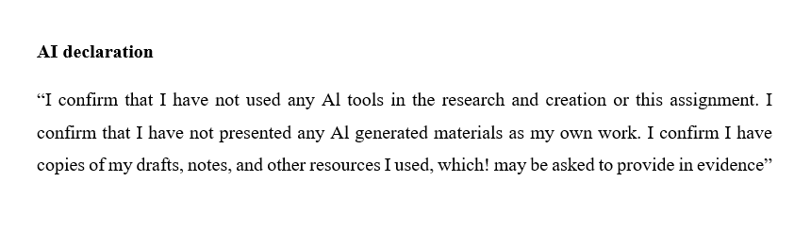

Executive Summary
This report analyses Hilton Hotels and Resorts, with emphasis on its organizational structure, corporate culture, change efforts, and strategic direction. The company follows a hierarchical structure with decentralized management, enabling operational flexibility across various regions. Its service-oriented culture, guided by the HILTON values, which is a key driver of employee motivation and guest satisfaction. In the recent change initiatives which include sustainability efforts, digital transformation, and diversity programs, improving efficiency and brand reputation. Hilton’s strategic goals focus on global expansion, technological advancements, and enhancing guest loyalty or satisfaction. To strengthen its competitive position, the report recommends improving employee retention, expanding sustainability efforts, and enhancing AI-driven guest experiences. A phased implementation plan will ensure smooth execution, consolidating Hilton's position of leadership in the international hospitality sector.

Table of Contents
1 Introduction 4
2 Company Framework, Culture, and Objectives 4
2.1 Corporate Hierarchy and Design 4
2.2 Corporate Culture and Its Influence on Operations 4
2.3 Targets at Corporate and Individual Hotel Levels 5
3 Recent Change Initiatives 6
3.1 Key Change Initiatives at Hilton 6
3.2 Effects of These Measures 6
3.3 Change Management Approach 7
4 Strategic Direction 7
4.1 Hilton’s Long-Term Strategic Goals 7
4.2 Strategies to Achieve These Goals 8
4.3 Theoretical Analysis of Hilton’s Strategy 10
5 Recommendations 10
5.1 Implementation Plan 11
6 Conclusion 12
7 References 13

Introduction
Established in 1919, Hilton Hotels and Resorts is a renowned global hospitality brand with a presence in over 120 countries and more than 7,500 properties. It is known for its strong customer service, luxury experience, and brand loyalty or satisfaction. This report examines Hilton’s organisational structure, corporate culture, and strategic management (Reidhead, 2020). It evaluates by what method these factors influence performance and employee engagement. Additionally, it analyses recent change initiatives and the company’s longstanding strategic direction. The report concludes with recommendations to enhance Hilton’s competitiveness and sustainability. Key topics include organisational structure, culture, change management, and strategic planning to support future growth and innovation.

Company Framework, Culture, and Objectives

Corporate Hierarchy and Design
Hilton Hotels and Resorts follows a hierarchical structure with reorganised management, which allowing flexibility across its global operations management (Reidhead, 2020). The corporate leadership establishes general strategies, policies, and the brand standards, while regional managers and individual hotel leaders make operational decisions tailored to local markets. This approach guarantees consistency which in service quality while allowing hotels to adapt to regional customer needs. With the help of using Mintzberg’s Organisational Structure Model, Hilton aligns with the defictionalized form, where executive is distributed across semi-autonomous divisions (Mendybayev and Perizat, 2022). The corporate headquarters focuses on strategic planning, while regional managers oversee daily operations. This structure enhances efficiency, accountability, and adaptability, enabling Hilton to manage its huge network effectively. With the help of balancing central control with local autonomy, Hilton maintains brand consistency while development innovation and responsiveness in a competitive hospitality industry.

Corporate Culture and Its Influence on Operations
Hilton Hotels and Resorts fosters a strong organizational culture centered on delivering outstanding guest experiences (Lamo, 2019). The company adheres to core values such as hospitality, integrity, leadership, teamwork, ownership, and living in the moment which shape employee behaviour and decision-making. These principles cultivate a positive work environment, encouraging employees to deliver exceptional service, ultimately enhancing customer satisfaction and brand loyalty. Utilizing Schein’s Organizational Culture Model, Hilton’s culture functions across three distinct levels. At the surface level, artifacts include uniforms, service, and brand identity. The adopted values are the essential principles that shape executive and teamwork. At the deepest level, basic assumptions reflect a strong belief in customer satisfaction, teamwork, and continuous improvement. This firm culture raises employee commitment and operational excellence, which guaranteeing Hilton maintains its reputation as a leading global hospitality brand. The strong cultural foundation allows Hilton to consistently deliver quality service across its worldwide operations.

Targets at Corporate and Individual Hotel Levels
Hilton Hotels and Resorts has distinct corporate as well as individual hotel level goals. At the corporate level, Hilton aims to expand its global presence by expanding into new markets and expanding the number of properties worldwide. The company also focuses on the management of sustainability by minimizing its environmental footprint through energy conservation practices and waste reduction. Moreover, Hilton concentrates on digital innovation by refining mobile check-ins, AI-powered customer service, and intelligent room technology to enhance guest experience or satisfaction. At the individual hotel level, goals include enhancing guest satisfaction by providing good services and personalised experiences. Hotels also work to reduce operational costs by improving efficiency and adopting sustainable practices. Another key goal is improving employee retention by offering training, career growth opportunities, and competitive benefits (Lamo, 2019). These goals allow Hilton to maintain its industry leadership, improve operational efficiency, and improve both customer and employee satisfaction across its global operations.

Recent Change Initiatives

Key Change Initiatives at Hilton
Hilton Hotels and Resorts that has introduced various key change initiatives to improve sustainability, technology, and the diversity. Among the key initiatives is the Travel with Purpose program that seeks to cut Hilton's carbon footprint by 50 percent by 2030. This involves the fitting of energy-saving systems, reduction in water use, and reduced waste in all its properties. Upgrades to technology have also been a top focus area for Hilton, looking to improve guests' experiences or satisfaction. Hilton has implemented electronic registrations, AI-based concierge services, and intelligent room technology, which allow guests to tailor their stays. These technologies bring more convenience and efficiency in operation. Hilton actively fosters diversity and inclusion by implementing hiring and leadership programs aimed at underrepresented groups. By cultivating a more inclusive work environment, the company ensures equal opportunities for employees across all levels. These initiatives illustrate Hilton's commitment to innovation, sustainability, and social responsibility, further strengthening its leadership position in the international hospitality sector.

Effects of These Measures
The Hilton's most important change initiatives that have made a strong impact on its operations, staff, and customers. The sustainability initiatives have improved operational efficiency rate by reducing energy consumption and waste, leading to cost savings and a more environmentally responsible business model. Automation through smart systems has further improved efficiency across hotel operations. The diversity and inclusion programs that have positively influenced employee engagement and retention (Ayman Alshaabani et al., 2021). With the help of creating a more inclusive work environment and offering career growth opportunities, Hilton has improved workplace satisfaction, leading to lower staff turnover and higher employee commitment. Technology upgrades such as digital registrations and AI-powered concierge services have enhanced the guest experience or satisfaction, which helps in making stays more convenient and personalised (Talukder, Rahman and Khan, 2024). These innovations that have contributed to higher customer satisfaction ratings, strengthening Hilton’s reputation as a leading global hospitality brand focused on sustainability, efficiency, and exceptional service.

Change Management Approach
Hilton implemented its key change initiatives through careful planning, employee engagement, and strong leadership management (Harrison et al., 2021). The company guaranteed a smooth transition by training staff, investing in new technologies, and promoting a culture of sustainability and inclusivity. To evaluate Hilton’s change management approach, Lewin’s Change Model can be applied. In the Preparation stage, Hilton identified the need for change, such as reducing its carbon footprint and improving digital services quality. The company communicated the benefits of these initiatives to employees and stakeholders, preparing them for the transition. Throughout the Implementation stage, Hilton introduced sustainability programs, digital innovations, and diversity initiatives. Employees received training, and new technologies were integrated into hotel operations. In the Stabilisation stage, Hilton strengthened these changes by embedding them into company policies and culture. Continuous monitoring and feedback guaranteed longstanding success, helping Hilton maintain its competitive advantage in the hospitality industry.

Strategic Direction

Hilton’s Long-Term Strategic Goals
Hilton Hotels and Resorts that has set lasting strategic goals to guarantee sustainable growth and development, digital transformation, and strong customer loyalty. The company aims to expand into new markets while maintaining environmental responsibility by reducing carbon emissions and adopting energy-efficient practices management. This approach helps Hilton grow while supporting global sustainability efforts. Hilton is also focused on digital transformation by implementing AI, data analytics, and mobile-first services (Namita Priya et al., 2024). These technologies which improve guest experiences through personalised services, seamless registrations, and automated customer support. To enhance guest loyalty or satisfaction, Hilton continues to strengthen the Hilton Honors rewards program, offering exclusive benefits and personalised experiences. With the help of focusing on sustainability, technology, and customer engagement, Hilton ensures longstanding success in the competitive hospitality industry.
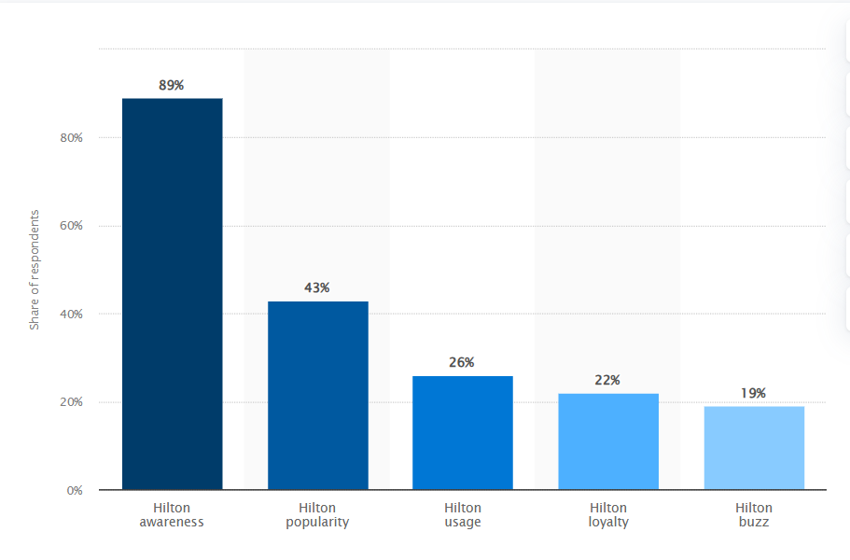
Figure 1: Hilton brand profile in the UK 2023
(Statista, 2023)
(Figure 1) The Hilton Brand Profile in the UK (2023) provides insight into the company’s market presence, performance, and competitive positioning within the UK hospitality industry. Understanding Hilton’s UK operations helps analyse its organisational structure, strategic direction, and future expansion plans, aligning with the report’s focus on growth strategies, change initiatives, and competitive differentiation.

Strategies to Achieve These Goals
Hilton Hotels and Resorts which has developed key strategies to achieve its longstanding goals. The company follows a market expansion strategy by targeting Asia-Pacific, the Internal East, and African markets (Haj Youssef and Teng, 2023). These regions offer high growth potential, that allowing Hilton to increase its global presence while catering to emerging travel demands. To maintain a competitive edge, Hilton uses a differentiation strategy by focusing on luxury brands, sustainability, and digital experiences (Jania Juthi et al., 2025). With the help of integrating ecological practices and advanced technology, Hilton enhances guest satisfaction and brand loyalty. Hilton also arranges employee development by investing in training, leadership programs, and flexible work policies (Enachi et al., 2023). These initiatives improve staff performance, job satisfaction, and retention. Through combining expansion, innovation, and workforce development, Hilton ensures longstanding success in the global hospitality industry.
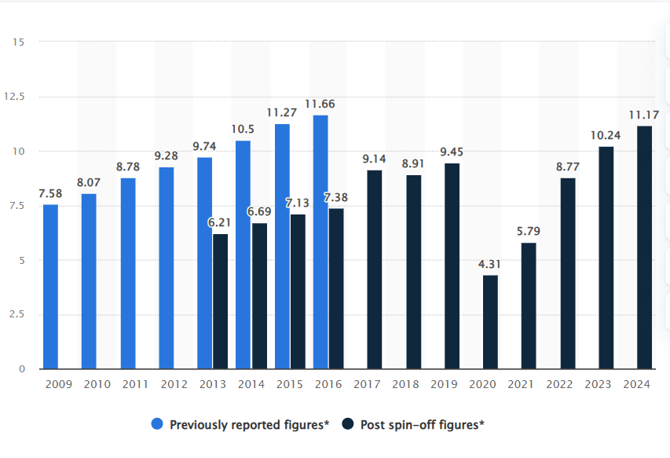
Figure 2: Hilton revenue 2009-2024
(Statista, 2024)
Hilton Revenue 2009-2024 (Figure 2) demonstrates Hilton’s financial growth, highlighting trends in revenue fluctuations due to market expansion, economic conditions, and industry disruptions. This data supports the report by linking Hilton’s strategic direction, change initiatives, and financial sustainability, demonstrating how revenue performance influences long-term growth and operational decisions.

Theoretical Analysis of Hilton’s Strategy
Factor | Description
Strengths | Hilton has a strong global brand, a successful loyalty program, and advanced digital innovations (Bardukova, 2023). Its commitment to sustainability and diverse hotel portfolio enhances its competitive edge.
Weaknesses | High operational costs, reliance on global tourism, and challenges in maintaining service consistency affect performance. Employee turnover remains a concern in some regions.
Opportunities | Expanding into Asia-Pacific, the Middle East, and Africa offers growth potential. Increasing demand for sustainable travel and AI-driven services creates new business opportunities.
Threats | Hilton faces strong competition from Marriott, Hyatt, and Airbnb (Harrison et al., 2021). Economic downturns, rising labor costs, and shifting customer preferences towards home rentals pose challenges.

Recommendations
Hilton has to enhancing their employee retention strategies is essential. Hilton should offer better incentives, career growth opportunities, and flexible work policies to improve job satisfaction and reduce staff turnover. A motivated workforce ensures higher service quality and customer satisfaction (Aburayya et al., 2020).
Hilton’s expanding sustainability efforts will strengthen their environmental commitment. The company should invest in eco-friendly infrastructure, energy-efficient systems, and carbon-neutral properties. These initiatives will reduce operational charges and application to ecologically aware travellers.
The establishment AI and digital innovation can improve guest experiences. Hilton must adopt AI driven chatbots, customized booking suggestions, and intelligent room technology to improve convenience and efficiency.

Implementation Plan
Recommendation | Who | When | Where | Why | How
Enhance Employee Retention Strategies | Corporate leaders develop policies, regional managers oversee execution, and frontline employees receive training (Augusta et al., 2021). | Phased implementation over three to five years, with annual progress reviews. | Across Hilton’s global locations, focusing on regions with high turnover rates. | Improves job satisfaction, reduces turnover, and enhances service quality. | Offer better incentives, career growth programs, and flexible work policies. Benchmark against Marriott’s employee engagement initiatives. Track employee satisfaction KPIs.
Expand Sustainability Efforts | Corporate sustainability teams set goals, hotel managers implement changes, and staff follows new eco-friendly practices. | Gradual rollout over five years, starting with flagship properties. | Hilton’s global properties, prioritising high-energy-consuming locations. | Reduces operational costs, aligns with customer demand for green hotels, and meets global environmental regulations. | Invest in eco-friendly infrastructure, energy-efficient systems, and carbon-neutral properties. Follow Hilton’s "Travel with Purpose" program. Measure success with carbon footprint and energy efficiency KPIs.
Strengthen AI and Digital Innovation | IT and innovation teams develop AI solutions, managers train staff, and employees adopt new technologies (Lee et al., 2019). | Implement AI-driven services within three years, expanding across all Hilton brands. | Initially in luxury and high-tech properties, then expanded globally. | Enhances guest convenience, improves operational efficiency, and maintains competitive advantage (Narendratama and Tuwuh Adhistyo Wijoyo, 2025). | Deploy AI-powered chatbots, personalised booking recommendations, and smart room technology. Monitor guest feedback and digital adoption KPIs.

Conclusion
In summary, the Hilton Hotels and Resorts possess a robust organisational culture and service quality culture that optimises employee performance and guest satisfaction. The recent initiatives towards change in sustainability, technology, and employee engagement have enhanced operational effectiveness and reputation. Hilton's strategy direction is aligned with digitalisation, sustainability, and international market growth to sustain longstanding success. For Hilton to sustain competitiveness, it needs to continue evolving with industry trends and changing customer expectations. Incorporating the recommended suggestions in employee retention, sustainability, and digital innovation will enhance its future growth and strengthen its market position. Through the assistance of adopting innovation and sustainable practices, Hilton can continue to lead the hospitality sector.

References
‌Aburayya, A., Marzouqi, A.A., Alawadhi, D., Abdouli, F. and Taryam, M. (2020). An empirical investigation of the effect of employees’ customer orientation on customer loyalty through the mediating role of customer satisfaction and service quality. Management Science Letters, 10(10), pp.2147–2158. doi:https://doi.org/10.5267/j.msl.2020.3.022.
Augusta, M., Fu, N. and Oliveira, O.J. (2021). Structuring a Training-Oriented High Performance Work System: A Systematic Review on Frontline Employees in the Service Sector. Human Resource Development Review, [online] 20(4), pp.399–435. doi:https://doi.org/10.1177/15344843211024028.
‌Ayman Alshaabani, Hamza, K.A. and Ildikó Rudnák (2021). Impact of Diversity Management on Employees’ Engagement: The Role of Organizational Trust and Job Insecurity. Sustainability, [online] 14(1), pp.420–420. doi:https://doi.org/10.3390/su14010420.
‌Bardukova, L. (2023). Navigating the Hospitality Horizon: Current Trends and Strategies for Customer Attraction and Retention in the Hotel Industry. ELECTRONIC JOURNAL "ECONOMICS AND COMPUTER SCIENCE, (2).
‌Enachi, F., Javed Suleri and Tarus, E. (2023). Retention of graduate trainee programmes: a case study of Hilton’s elevator fast-track to general manager graduate programme. Research in Hospitality Management, [online] 13(3), pp.143–151. Available at: https://www.ajol.info/index.php/rhm/article/view/272611 [Accessed 26 Feb. 2025].
‌Haj Youssef, M. and Teng, D. (2023). Market entry strategies in the Middle East: unveiling the sponsorship strategy. Management in the MENA Region, [online] pp.69–91. doi:https://doi.org/10.4324/9781032637648-5.
Harrison, J.S., Kelso, A., Reilly, P. and Sadler, W. (2021). Hilton Worldwide Holdings Inc. [online] UR Scholarship Repository. Available at: https://scholarship.richmond.edu/robins-case-network/24/ [Accessed 26 Feb. 2025].
‌Harrison, R., Fischer, S., Walpola, R.L., Chauhan, A., Babalola, T., Mears, S. and Le-Dao, H. (2021). Where Do Models for Change management, Improvement and Implementation meet? a Systematic Review of the Applications of Change Management Models in Healthcare. Journal of Healthcare Leadership, [online] 13(2), pp.85–108. Available at: https://pmc.ncbi.nlm.nih.gov/articles/PMC7966357/.
‌Lamo, E.G. (2019). The Center of Success: A Case Study on Hilton’s Company Culture. [online] DigitalCommons@CalPoly. Available at: https://digitalcommons.calpoly.edu/expindsp/4/ [Accessed 26 Feb. 2025].
Lee, J., Suh, T., Roy, D. and Baucus, M. (2019). Emerging Technology and Business Model Innovation: The Case of Artificial Intelligence. Journal of Open Innovation Technology Market and Complexity, [online] 5(3), pp.44–44. doi:https://doi.org/10.3390/joitmc5030044.
‌Mendybayev, B. and Perizat, B. (2022). Application of Social Network Analysis and Mintzberg Classification to Assess the Imbalances in Organizational Structure: Case of Kazakhstan Ministry of Ecology, Geology and Natural Resources. 2022 International Conference on Smart Information Systems and Technologies (SIST), [online] pp.1–6. doi:https://doi.org/10.1109/sist54437.2022.9945721.
‌Namita Priya, Ipseeta Satpathy, Patnaik, B.C.M. and Park Thaichon (2024). Transforming Workplace Wellness in the Next-Generation Hospitality Industry by Leveraging Transformational Digital Technologies and Tools. Routledge eBooks, [online] pp.295–313. doi:https://doi.org/10.4324/9781003488248-20.
‌Narendratama, R.P. and Tuwuh Adhistyo Wijoyo (2025). Enhancing Guest Satisfaction through Human Resource Quality and Hotel Facilities: A Strategic Approach. International Journal of Management and Business Intelligence, [online] 3(1), pp.1–14. doi:https://doi.org/10.59890/ijmbi.v3i1.285.
‌Reidhead, C. (2020). Impact of Organizational Culture on Employee Satisfaction: A Case of Hilton Hotel, United Kingdom. Journal of Economics and Business, [online] 3(1). doi:https://doi.org/10.31014/aior.1992.03.01.209.
‌Shin, H., Perdue, R.R. and Kang, J. (2019). Front desk technology innovation in hotels: A managerial perspective. Tourism Management, [online] 74, pp.310–318. doi:https://doi.org/10.1016/j.tourman.2019.04.004.
Statista. (2023). Hilton brand profile UK 2023 | Statista. [online] Available at: https://www.statista.com/forecasts/1335684/hilton-hotels-brand-profile-in-the-uk [Accessed 26 Feb. 2025].
Statista. (2024). Hilton revenue 2024 | Statista. [online] Available at: https://www.statista.com/statistics/297760/revenue-of-hilton-worldwide-holdings-inc/ [Accessed 26 Feb. 2025].
‌Talukder, M.B., Rahman, M.Z. and Khan, M.R. (2024). Enhancing Guest Experience Through Smart Hotel Technologies. Advances in hospitality, tourism and the services industry (AHTSI) book series, [online] pp.301–324. doi:https://doi.org/10.4018/979-8-3693-7021-6.ch011.

