
Skills for the Workplace
Module Assignment Submission
Student Name: | Karl Roberts
Student Number: | 1917751
Module No: | BMSK4002
Module Title: | Effective Team Working and Communication  Part 2

Statement of Confirmation of Authenticity
By the act of making this submission, the student declares that this is the work of the student named above. The work has not, in whole or in part, been knowingly presented elsewhere for assessment, or where assessment has been built on a previous assessment, this has been identified. Where materials have been used from other sources it has been properly acknowledged. If this statement is untrue, the student acknowledges that an assessment offence has been committed.
Attention is drawn to the plagiarism and unfair practice policies of both the University and of ILM.

Table of Contents
What is communication? 3
1.0 3
Communication Cycle 3
2.0 4
Assessing Own Communication Skills 4
Gap Analysis 5
PDP 5
References 6

What is communication?

Communication is simply transferring information from a person, place or group to another. Communication is used in all aspects of life. To be successful in any task you need to be able to give and receive information in an effective manner. There are four types of communication used, they are verbal, non-verbal, written and visual communication.

The four types of communication are:

Verbal communication – verbal communication is the use of language both spoken and written to pass on Information. Verbal communication requires the person to be fluent in the language that’s spoken. It can be broken up into further four different types depending on who and how many people are receiving the information. These types of verbal communication are Intrapersonal, interpersonal, small group and public communication. Intrapersonal is the form of communication that’s reserved for people of high personal importance such as friends or family. This isn’t a form that’s used often when working in a professional environment other than to build a social rapport with others. Interpersonal communication is the form of verbal communication that’s used when speaking on an individual basis between two people. This requires both individuals take turns swapping between the role of sender and receiver to be able to effectively communicate. This is used often when training or speaking to individuals about their performance or what’s expected of them according to what’s needed. Small group communication is used when having to speak to a group of people on a more interactive basis effectively transferring information and findings back and forth. All managers and leaders need to be able to do this in order to present group meetings properly, to be able to inform them of changes to the plan, what went wrong and what went right. All of which is needed to progress to an effective level. Public communication this is the verbal skill that’s not used often unless your speaking on a broadcasting level or giving a speech at an event or mass gathering. This skill usually requires the individual to be the sender, whilst the audience performs as the receivers in the communication cycle.

Non-Verbal communication – This is the use of gestures, facial expressions and body language to communicate a message. Gestures such as hand signals, waves or nods play a big part in everyday life, especially for some disabled people who use sign language to communicate. Some body language can often happen subliminally without the individual being aware, and can be used to add more emphasis on information if combined with verbal communication.

Written communication – This skill includes use of letters, books, social media and other forms of technology. Thanks to advances in technology over the last 40 years, people even thousands of miles away at any time can communicate and share information worldwide. Many people use this skill in everyday life using apps such as Facebook and other social media. As well as when working to be able type up emails and reports to share with others. Managers use this to give written feedback, as well as when write up reports to be able to track progress and create a plan of action to achieve maximum efficient productivity. Students also use this skill to write up assignments as well as communicating with lecturers and fellow class mates.

Visual Communication – This skill is the use of graphs, charts, maps, etc; to be able to display information visually to the receiver. Often managers will use this to display results and track progress from these. This skill can be very important when presenting something to an audience. Visual aids help visualise information in a more understandable simplistic form as well as the use of bright colours to grab peoples attention and keep them intrigued. Website Skillsyouneed.com was great source of information on this topic.

1.0

Communication Cycle

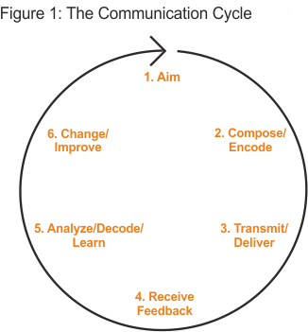

The communication cycle (as shown above in figure 1) demonstrates the six different stages of communication and how it repeats. So what are the roles of the six different stages of effective communication exactly and how do you use them to be an effective team?

- Aim – This is the stage where you think what it is you’re looking to say, achieve or what information it is you’re wanting to transfer to someone else. you should be thinking about who your talking to and how you message will come across.
- Compose/encode – once you’ve worked out what you’re wanting to aim to achieve with your message or information, you can then start to work out how your going to pass on that message or information and how you are going to structure it, either verbally or written. How you write the message or information has an impact on how it is received.
- Transmitter/deliver – this is when the message or information is sent to the recipient
- Receive feedback – listening to others feedback and opinions on what went right or wrong.
- Analyse/decode/learn – this is the stage where you reflect on how well your message or information was received and whether it achieve what you wanted out of it. You take this time to look at the positives and negatives so you can improve in future.
- Change/improve – once you’re able to see where you went wrong and what you did right and you can then implement this knowledge into future actions and tasks which allows you to expand you capabilities.

Popular models of communication:

One of the most popular models on effective communication is the Shannon & weaver Theory which was published by Claude Elwood Shannon, who wrote an article called “a mathematical theory of communication” in the Bell system technical Journal with Warren Weaver. Shannon was a mathematician whereas Weaver was a scientist. The mathematical theory later came to be known as the “Shannon & Weaver” Model of communication or the “mother of all models”. This model is more technological than other linear models. The website www.businesstopia.net was a good source of information on this topic
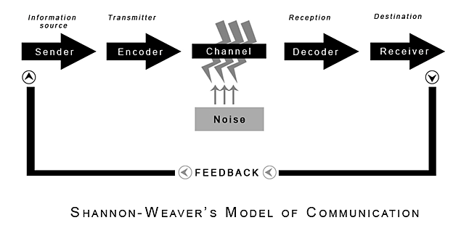
(Shannon and Weaver, 1949)

Sender (information Source) – The sender is the person who decides what information is to be sent and what the message is going to be and what channel is to be used.
Encoder (transmitter) – the encoder is the person who inputs the information into the channel whether it be a text or email. Which then gets turn into signals and codes (binary data). Which is read and sent by the channel.
Channel – this is the medium in which the information is sent such as email sent by computer or a text message sent through social media on a mobile phone or smart device.
Decoder (reception) – this is the person or machine at the other end who receives the message and decodes it so it can be understood. Converts binary data and signals into readable information.
Receiver (destination) – the person the information or message was intended to reach, for the goal to be achieved. The receiver then provides feedback about the message or information accordingly.
Noise – This is physical disturbances such as the environment, people, etc; that get in the way or slow down a message or information from reaching the intended audience.

According to the Shannon & weaver Theory there are three levels to communication problems, these are called:
Technical problems – a problem caused within the channel, such as a bug with the program used to send the message or unable to send due to signal issues.
Semantic – this problem is down to the meaning of the message or information sent been misunderstood by the receiver due to how its worded etc.
Effectiveness – This problem is when the message or information that was sent was clear and full understandable and doesn’t achieve the full intended goal desired.

Another great Model of communication is Schramm’s theory. This theory was proposed by Wilber Schramm in 1954. His theory was that information is of no use unless correctly composed into words and passed on to others. When information is written, it then becomes on the receiver to be able to understand it how it was originally intended to be taken. If the information is perceived in a way that wasn’t intended this can have a negative affect on what is achieved with this information in which case makes the information once again useless. So correct use of communication is vital. Its important the sender encodes the information into the message properly so it can be decoded and understood. Schramm’s theory proposes the two of the most important parts are the encoding and decoding, these are the most vital for information to be passed. His theory emphasises that communication is never complete until feedback or a response is achieve with the information given that way the sender can understand where they went right or what went wrong. Schramm believed that if you passed on information and no response was given or action taken then the communication wasn’t complete as it hadn’t achieved its goal. He also theorised about how your background such as education or social experiences has an effect on how you interpret information from others. The website managementstudyguide.com was a great source of information on this topic.

2.0

Assessing Own Communication Skills

My own Communication skills are in my own opinion very good. I’m good at verbal, non-verbal, written and visual communication. I’m able to look at what it is I’m wanting to tell someone, work out how to compose the information I want to share and then pass it on using various channels to send it on. I’m able to listen to others ideas and feedbacks which I use to better myself in future task. My verbal skills are good, I’m able to comprehend complicated vocabulary and fluent in the given language that information is given to me in.

Gap Analysis

Objective | Current Position | Deficiency | Action
Improve my visual communication skills | I can read and understand charts and maps. I can also create basic charts and graphs. | Ability to create more complex charts or graphs displaying information how I intended for it to be understood. | Use internet and online classes learning how to create charts and graphs using software such as Microsoft excel.
Need to improve my verbal communication skills | I am able to compose a message so it includes the information needed to be sent to recipient | My punctuation and grammar is sometimes poor which could affect how information is composed and received | Pay more time and attention to my grammar and punctuation. Allowing for no mistakes
Improve my public communication skills | I can give presentations and pass on information | I can get nervous when presenting in front of an audience which can have an effect on how clear the information I say is because of speaking to fast or losing my position in the presentation. | Remain calm, make sure I’m fluent and confident in what I’m presenting and practice before hand.

PDP

Objectives | Tasks | Success Criteria | Time Frame | Resources
Be fluent in inputting information into graphs and charts | Learn to confidently use Microsoft excel and other programs similar to be able to display information | Look at others abilities, work out a plan of action and put in the time to learn and improve | As soon as possible so I can use it to aid and support my assignments for university | Youtube tutorials on using Microsoft excel. Online or written guides on using microsoft
Be confident at giving presentations to be audiences | Good knowledge on the task I am presenting and good ICT skills to use the software | Set a target, make a plan of action and follow it, till I am at the level needed to achieve the goal | Before giving a presentation next | Google and books to research information relating to the topic in hand and computers to create the presentation on.

References

Skillsyouneed (2020) What is Communication? [online] available at: https://www.skillsyouneed.com/ips/what-is-communication.html accessed: 21/05/2020

Blenkinsop, P. (2010) The Communication Cycle. [online] Available at: http://manyana-education.blogspot.com/2010/10/communication-cycle.html Accessed: 20/05/2020

Businesstopia (2018) Shannon & weaver theory of communication [online] available at: https://www.businesstopia.net/communication/shannon-and-weaver-model-communication Accessed 21/05/2020
Shannon, C. and Weaver, W. (1949) The Mathematical Theory of Communication. Urbana: University of Illinois Press.

Prachi Juneja (2020) Schramm’s Model of Communication [online] Available at https://www.managementstudyguide.com/schramm-model-of-communication.htm Accessed: 21/05/2020

