Case Study Report
Andrea Jones retail sotre
Mohammed Elnur Abusabah / 2021900
10/12/2021

Executive summary

This report focuses on the development of the Andrea Jones retail store and its problems while growing and becoming an online business. At first, the report discusses the main problems and findings. After that, it discusses how workplace theories can positively impact those in the work environment and help the store.
The report discusses Belbin’s and Tuckman’s theories and how they involve team formation and decrease conflicts. Then it talks about the different types of communication and their effect on the prosperity or breaking organizations.
Finally, it concludes with the given facts and recommendations that might help the store owner ensure her success.

Table of contents

- Executive summary ……………………………………1

- Terms of Reference ……………………………………3

- Procedure………………………………………………4

- Introduction…………………………………………….5

- Findings………………………………………………...7

- Conclusion…………….……………………………...14

- Recommendations……………………………………15

- Bibliography/ References……………...…………….16

- Appendices………………………………………….18

- Acknowledgments ………………………………….20

Terms of Reference

This report is based on the case study of the Andrea Jones retail store and requested by the University of Wales Trinity Saint David as a part of the Effective Team Working and Communication module in term two. It is requested to be delivered on 10th December 2021.
The report discusses this medium-sized retail store’s challenges while expanding and becoming an online store due to the pandemic. It addresses the problems and explains how proper communication and workplace theories can positively impact the future of this store and what recommendations to start.

Procedure

The information on this report was collected from several books and Journals, and related websites.

Introduction

Much pressure will be involved when a retail store expands or changes its approach to selling products to customers. As a result, there should be many changes in managing, hiring new staff, and organizing it. This report discusses the case study of the Andrea Jones retail store and the challenges it encountered while growing in sales and shifting to be an online store due to the pandemic.

Although the owner hired enough employees for a medium-size store yet, there are a noticeable lack of organization and an absence of leadership. For example, there are no teams with clear objectives to execute nor proper communications between staff members, resulting in conflicts. In addition, no one is accountable for the outcomes as there is an absence of delegation to make decisions and organize the work and training process. These problems need to be addressed abruptly to keep the business growing and prevent conflicts from turning into serious hurdles.

The report will try to enlighten how teamwork theories will positively impact improving the situation in this case study. As in teams, the workers will have straightforward tasks to focus on and improve productivity “teams will become the primary unit of performance in high-performance organizations.” (Katzenback and Smith. 1993. Being in a team will create a delegated leadership that decreases and solves conflicts between members.

Furthermore, in the second part of this report, the focus will be on how communication is crucial between the owner, the hired managers, and the employees. As “communications is needed to coordinate activities among individuals and teams, especially as an organization grows in size or complexity or spread across borders.” ( Men, R.L. and Bowen, S.A.2017)
This report will give recommendations regarding the identified challenges as they might affect the business and how to solve them and monitor the team’s performance. Additionally, the report will try to ensure an effective two-way communication channel between Andrea Jones( the owner) and her employees through the managers.

Findings

Teamwork theories and its impact on Andrea Jones retail store

Tuckman’s team development theory role in the case study

The retail store in the case study has expanded from a five staff members small store to a business managed by 27employees in a short period. However, one of the significant issues is that it still keeps the same handling method. There is no pyramidal formation in management, no teams or subteams with precise tasks and responsibilities. The primary formation now is one large team that negatively affects productivity, “Research shows that team members reduce the effort when they feel less responsible for the output. The effect kicks in when teams exceed four or five members”. ( Ferrazzi, K. 2014)

First of all, organizing the work should be started with forming teams. The number of needed teams usually corresponds to the areas needed to cover in the store. The employees worked for a while as colleagues, not a team; thus, it is essential to observe the expected team development as explained by Bruce Tuckman ( Bruce W. Tuckman 1965) in the journey to harvest the best performance from each team. After teams formation, conflicts will present between team members in the storming phase as there is no sense of unity. In this phase, there must be a straightforward approach to solve conflicts and deal with them abruptly so the team can be assertive and collaborate in the tasks (Thomas Kilmann Conflict Model 1974). Avoiding conflicts is one of the most detrimental issues that might affect any organization (Ferrazzi, K. 2012). After going through the storming stages and the team members start to know each other better and their roles and capability, the outcome will be better as they now can perform and be more resilient as a team.

There are a handful of advantages for this online retail store when having well-formed teams and understanding the usual development consequences and expectations during its stages. Overall it enhances performance by giving a sense of belonging, so each team member performs better than being out of a team. (Bowler and Brass 2006)

Belbin’s team roles theory effect in performance

Forming a team is not guaranteed to succeed and reach the performing stage as many teams, due to conflicts, will not survive. Many factors affect teams’ performance, and one of the most important factors is the individuals who formed the team. According to Belbin’s team roles theory, every individual has a different way of participating inside the team “a tendency to behave, contribute and interrelate with others in a particular way.” Belbin team roles theory (1981). Therefore, as the online retail store owner, Andrea Jones must have a good idea of her staff members’ behavior to form effective teams and team leaders. This awareness will allow her to delegate certain employees more responsibilities and choose who acquires the needed character to manage different shifts.

As there is 27 working staff, it is feasible to use Belbin’s questionnaire to know the employees before starting teams formations. “Belbin found successful teams were characterized by the compatibility of the roles that their members played while unsuccessful teams were subject to role conflict.” (Batenburg, van Walbeek and in der Maur, 2013)

Communication

“Communication is the process of transferring information and meaning between senders and receivers, using one or more print, oral, visual, or digital media.” (Bovée and Thill.2016)

“Good employee communication will help people to understand their organization’s purpose and strategy, identify with the organization values, and develop a sense of belongings by understanding how their roles contribute to the wider purpose.”(CIPD.2017)

Without any doubt, communications between the employees themselves and the store owner represent one of the most severe problems. Due to the pandemic, the store became an online store, resulting in a limited number of employees who can have a physical appearance simultaneously while the rest finish their tasks remotely. Additionally, some shifts are covered without a manager to organize the work and solve staff shortages. Although the employees work apart, the online meetings are conducted sporadically, and the personal meetings full of disputes about shifts schedule. Definitely, there is a significant lack of internal communication and leadership.

There is a necessity of establishing an effective communication channel inside this online retail store. It is noticeable that communication is a one-way method inside the retail store, as some employees receive orders and send them to their colleagues who handle the shopping process. It resembles Berlo’s SMCR Model of Communication((Berlo’s SMCR Model of Communication - Businesstopia, 2018). As a linear communication model. Another resemblance is that orders will be sent without feedback to inform the sender about the situation inside the store. Although the sender and the receiver are working in the same store yet, they think individually without considering the work environment, staff shortage, or many orders to handle. Moreover, this type of communication requires the two ends to have the same training in skills to transmit different message codes.

The pyramidal management analogy of this retail store ( sometimes no managers ), so ordering material or buying products or even what time to work might be by a direct order to an employee. Although it seems like a two-way communication method, there will be feedback yet; it is still limited and only remains as a positive notification of receiving the directions. It is similar to the communication model hypothesized by Shannon and Weaver (Shannon and Weaver’s model, 1949). “In Shannon and Weaver’s model, the source is seen as the active decision-maker who determines the meaning of the message; the destination is the passive target.”(Chandler, D. 1994). One more point to consider is that the Shannon and Weaver communication model are only helpful in interpersonal communication, so it can not be used for the staff meeting (“Shannon and Weaver Model Of Communication - Businesstopia, 2018).

Another communication model that might give feedback better than the theories mentioned above is Schramm’s Model of Communication. (Wilber Schramm 1954) . His theory has three essential elements: the source, the message, and the destination. The receiver plays a vital part equal to the sender; the encoding of the message is as crucial as the decoding(Oyero, O.2010). According to Schramm, communication is incomplete until the receiver gives feedback (MSG / Communication- basic and strategies). One of its disadvantages is that it requires a level of overlapping experience to communicate between individuals (Oyero, O.2010).

There are several communication models to choose between, and the most important thing is to know what and when to use each of them. In addition, there must be an open channel for feedback to give a sense of belonging and participation to the employee when it comes to communication. “A lack of communication in the workplace is the single biggest reason why employees want to leave their jobs.”( www.freshbusinessthinking.com. 14/06/2016).

Effective Teamwork

“A highly effective team is one that demonstrates sustained performance, team resilience, and ongoing vitality”(Tannenbaum, S.I. and Salas, E.2021).

Creating teams inside Andrea Jones’s online retail store is not enough to improve the situation as teams may not perform as desired or even fall apart before reaching the performing stage. What is wanted is effective teamwork to produce high-performance teams that ensure success. Effective teamwork starts by choosing the team members to decrease conflicts and have positive communication between them to address work issues. Previously we discussed Belbin’s role theory and how it helps determine each member’s role inside the team. In addition, regular meetings with a presence of a leader who can notice and address conflicts immediately and in a proper way will help.

Conclusion

In conclusion, the Andrea Jones retail store has encountered many challenges while expanding and shifting to an online store. There is an evident absence of organization and leadership and a lack of communication. In addition, the store managing does not correspond to the fast dynamic change in the amount of business they deal with now or the number of new staff working there. These problems accumulate and must be solved by implementing a new management structure with clear responsibilities and more delegations to specific staff members.

The employees need to be allocated into teams based on their work experiences and according to their character. A leader must be nominated inside each team with multiple authorizations to report the team development and address defects.

The communication needs to improve to be two-way communications that allow feedback from the employees and enable them to discuss decisions that might affect their work.

Recommendations

The Andre Jones retail store needs to implement a two-way communication model to facilitate information transformation between employees and to create a more attractive workplace. “Every individual should be on the same platform and the clarity of ideas, messages is mandatory for smooth flow of work.”(MSG. )

“Holding regular, effective meetings was found to have positive effects on the organization’s information and performance evaluation systems.” (Yeatts, D.E and Hyten, C.1998). The meetings must be regular, for example, weekly or twice a month.
The store must invest in communication tools that facilitate meetings online as different teams can use them while working remotely.

The store must hire an experienced executive manager to create teams, organize the work, and establish a clear store structure. In addition, there must be a manager for every shift to observe the work, communicate with the workers and ensure sufficient training for the new employees.

Bibliography/ References

- BATENBURG, R., WOUTER, V.W. and WESLEY IN, D.M., 2013. Belbin role diversity and team performance: is there a relationship? The Journal of Management Development, 32(8), pp. 901-913.

- Belbin team roles theory (1981.
- Bovée, C.L. and Thill, J.V. (2016) Business communication essentials. Seventh, global edition. Boston: Pearson.
- Bowler, W.M. and Brass, D.J. (2006) ‘Relational Correlates of Interpersonal Citizenship Behavior: A Social Network Perspective,’ Journal of applied psychology, 91(1), pp. 70–82.
- Bruce W. Tuckman 1965.
- Businesstopia. 2018. Berlo’s SMCR Model of Communication - Businesstopia. [online] Available at: https://www.businesstopia.net/communication/berlo-model-communication.
- Chandler, D., 1994. The transmission model of communication. URL: http://www. aber. ac. uk/media/Documents/short/trans. html# Top (дата звернення: 24.07. 2013).
- CIPD 14th November 2017.
- Ferrazzi, K. (2012) Candor, criticism, teamwork. Harvard business review. 90 (1-2), 40–40.).
- Ferrazzi, K. (2014) Getting virtual teams right. Harvard business review. 92 (12), 120–..
- Katzenback; K. Smith; J. The discipline of teams .1993.
- Men, R.L. and Bowen, S.A. (2017) Excellence in internal communication management. First edition. New York, New York (222 East 46th Street, New York, NY 10017): Business Expert Press.
- MSG / Communication- basic and strategies.

- Oyero, O., 2010. From one-to-one to many-to-many’: A new model of communication. Mass Communication A Book of Readings.

- Shannon and Weaver’s model, 1949.

- Tannenbaum S.I. and Salas, E. (2021) Teams that work : the seven drivers of team effectiveness. New York, NY: Oxford University Press.

- Thomas Kilmann Conflict Model 1974.

- Wilber Schramm 1954)

- www.freshbusinessthinking.com. 14/06/2016).

- Yeatts, D.E. and Hyten, C. (1998) High-performing self-managed work teams a comparison of theory to practice. Thousand Oaks, Calif: SAGE.

Appendices

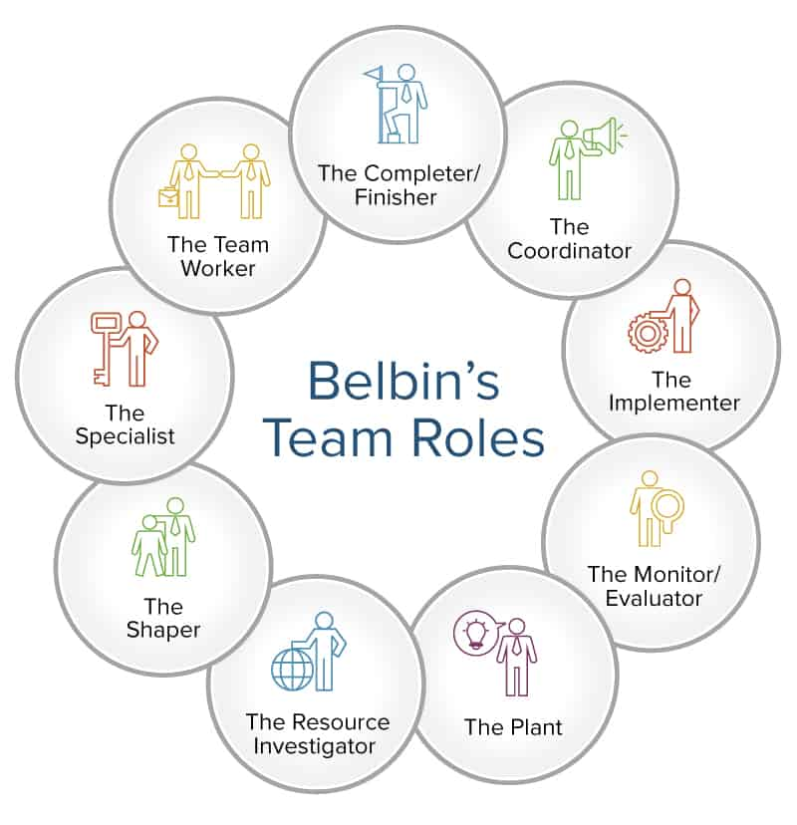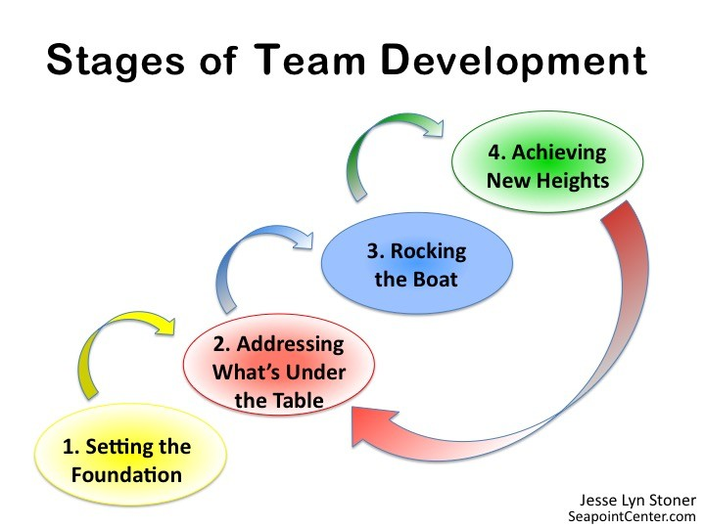

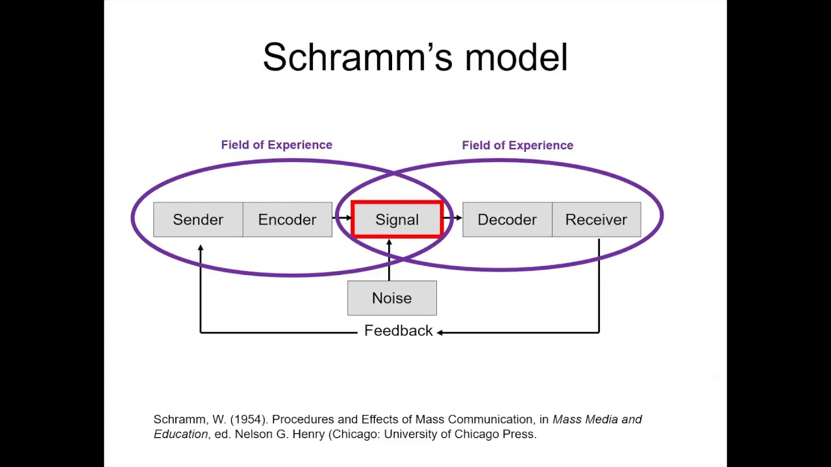

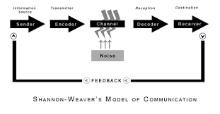

Acknowledgments:

I would like to express my special thanks to my university lecturer Mel Squire for her guidance and support through this module. My sincere gratitude to my wonderful colleagues for their assist and advice.

