


Network Security (NS)

Lab 3

Faculty of Architecture, Computing & Engineering
I.Q. Building room 205
Swansea
SA1 6ED

Introduction

The labs given within this module is geared to assist you in carrying out penetration testing on systems. In a penetration test an Ethical Hacker attempts to break into a company’s network to find vulnerability or the weakest link in the network or the network system. They are also required to analyzes the company security policy and procedures and report any vulnerability to management.

An Ethical Hacker is a person who performs most of the same activities as a hacker but with the owner of the company’s permission. The distinction is important and can mean the difference between being charged with a crime or not being charged. Ethical Hackers are usually contracted to perform penetration tests or security tests. After pre-engagement activities, penetration testers begin gathering information about their targets. Often all the information learned from a client is the list of IP addresses and/or web domains that are in scope. Penetration testers then learn as much about the client and their systems as possible, from searching for employees on social networking sites to scanning die perimeter for live systems and open ports. Taking all the information gathered into account, penetration testers study the systems to find the best routes of attack. Tins is similar to what an attacker would door what an invading army would do when trying to breach the perimeter. Then penetration testers move into vulnerability analysis, the first phase where they are actively engaging the target.

Task 1:

Monitoring TCP/IP Connections Using the CurrPorts Tool

CurrPorts is network monitoring software that displays the list of all currently
opened TCP/ IP and UDP ports on your local computer.

Lab Objectives

The objective of this lab is to help students determine and list all the TCP/IP and UDP ports of a local computer.

In this lab, you need to:
- Scan the system for currently opened TCP/IP and UDP ports
- Gather information 011 die ports and process that are opened
- List all the IP addresses that are currently established connections
- Close unwanted TCP connections and kill the process that opened the ports

Getting started, you need:
- CurrPorts located in the shared one drive
- You can also download the latest version of CurrPorts from the link http://www.nirsoft.net/utils/cports.html
- If you decide to download the latest version, then screenshots shown in the lab might differ
- Follow the Wizard driven installation process
- To run this tool Administrative privileges are required

Monitoring TCP/IP ports checks if there are multiple IP connections established Scanning TCP/IP ports gets information on all die opened TCP and UDP ports and also displays all established IP addresses on die server.

The CurrPorts utility is a standalone executable and doesn’t require any installation process or additional DLLs (Dynamic Link Library). Extract CurrPorts to the desired location and double click cports.exe to launch.

Lab Tasks
- After installation, It automatically displays the process name, ports, IP and remote addresses, and their states.
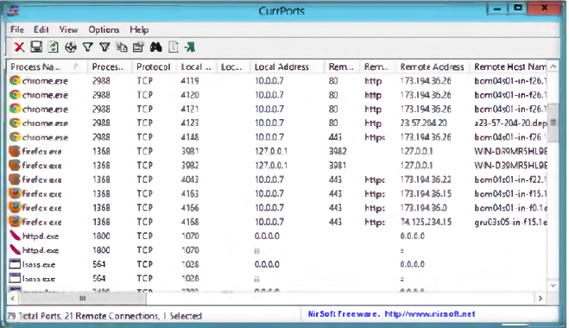

- CurrPorts lists all the processes and their IDs, protocols used, local and remote IP address, local and remote ports, and remote host names.
- To view all the reports as an HTML page, click View HTML Reports ־ All Items.
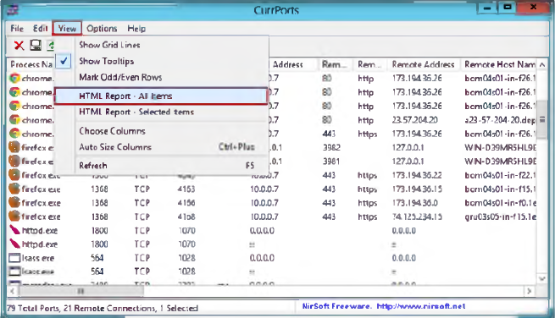

The HTML Report automatically opens using die default browser.
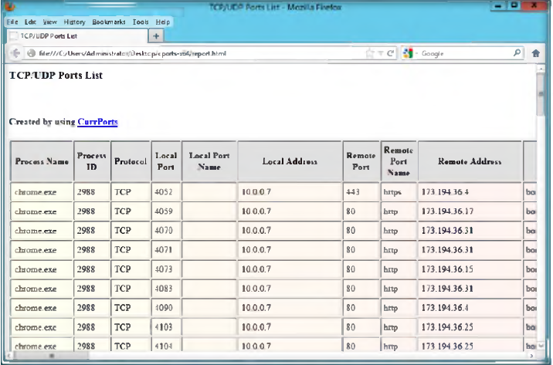

- To save the generated CurrPorts report from the web browser, click File Save Page As...Ctrl+S.
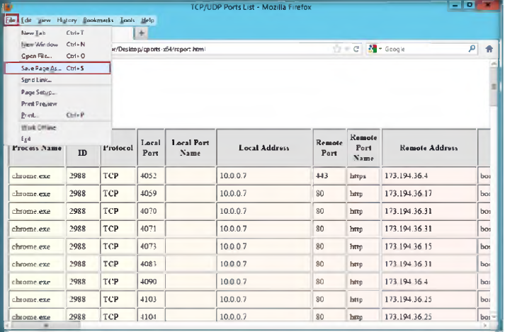

- To view only die selected report as HTML page, select reports and click View HTML Reports ־ Selected Items.
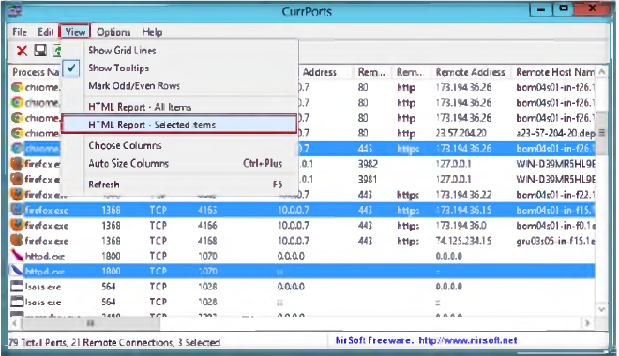

- The selected report automatically opens using the default browser.
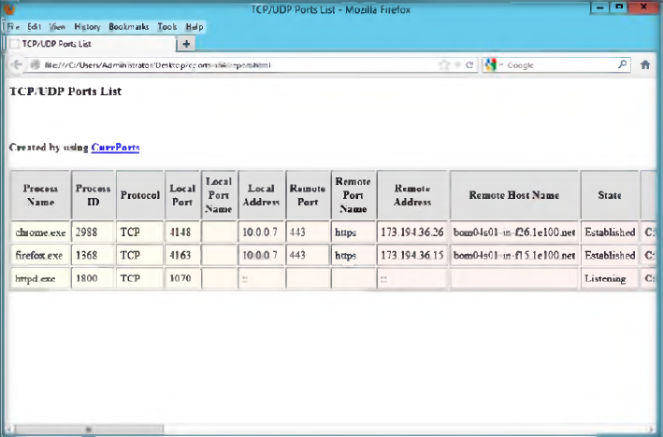

- To save the generated CurrPorts report from the web browser, click File Save Page As...Ctrl+S
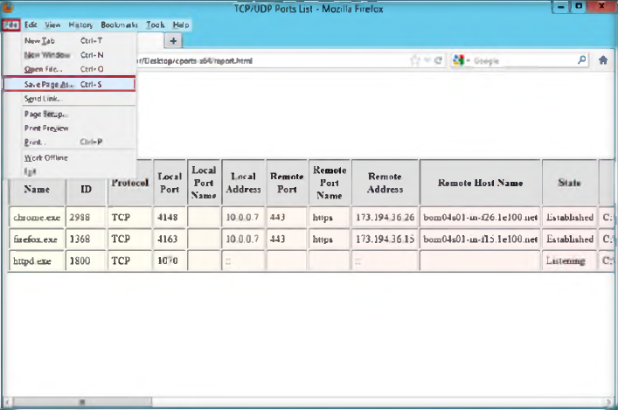

- To view the properties o f a port, select die port and click File Properties.
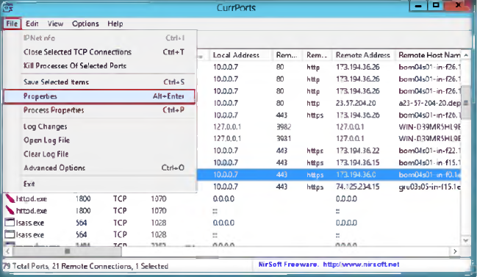

- The Properties window appears and displays all the properties for the selected port.
- Click OK to close the Properties window
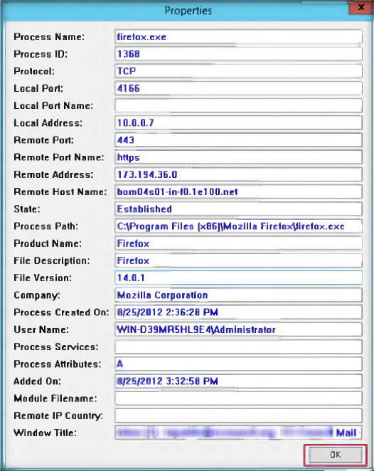

- To close a TCP connection you think is suspicious, select the process and click File Close Selected TCP Connections (or Ctrl+T).
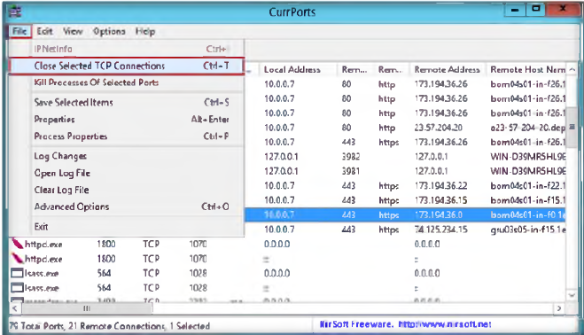

- To kill the processes of a port, select die port and click File Kill Processes of Selected Ports.
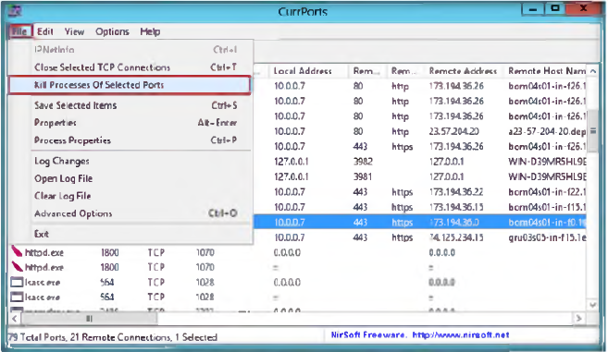

- To exit from the CurrPorts utility, click File Exit. The CurrPorts window closes.
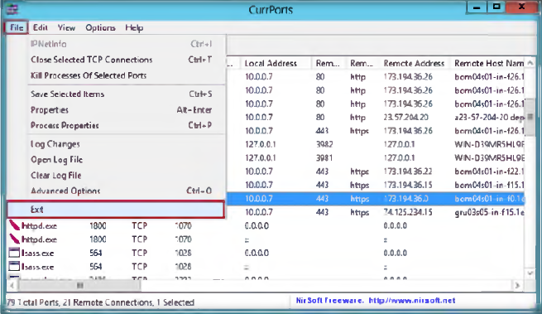

Lab Analysis

Document all die IP addresses, open ports and their running applications, and protocols discovered during the lab.

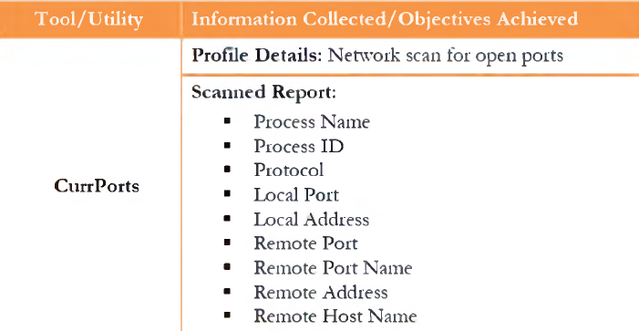

Questions:

- Analyze the results from CurrPorts by creating a filter string that displays only packets with remote TCP port 80 and UDP port 53 and running it.
- Analyze and evaluate die output results by creating a filter that displays only die opened ports in the Firefox browser.
- Determine the use of each of the following options that are available under the options menu of CurrPorts:
  - Display Established
  - Mark Ports Of Unidentified Applications
  - Display Items Without Remote Address
  - Display Items With Unknown State

Task 2
Detect, Delete and Block Google Cookies Using G-Zapper

G-Zapper is a utility to block Google cookies, clean Google cookies, and help yon stay
anonymous while searching online.

Lab Scenario

As an administrator, you can organize safety measures by shutting down unnecessary ports, closing shares, etc. to block attackers from intruding the network. As another aspect of prevention, you can use G-Zapper, which blocks Google cookies, cleans Google cookies, and helps you stay anonymous while searching online. This way you can protect your identity and search history.

Lab Objectives
This lab explains how G-Zapper automatically detects and cleans the Google cookie each time you use your web browser.

Lab Environment

To carry out the lab you need:
- G-Zapper is located on the shared one drive
- You can also download the latest version of G-Zapper from the link http://www.dummysoftware.com/
- If you decide to download the latest version, then screenshots shown in the lab might differ

Lab Tasks

- After installation, launch the G-Zapper tool
- The G-Zapper main window will appear as shown in die following

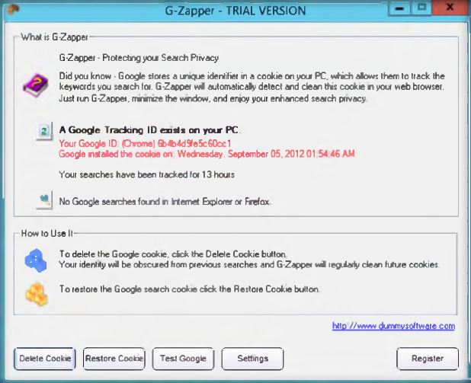

- To delete the Google search cookies, click the Delete Cookie button; a window will appear that gives information about the deleted cookie location. Click OK
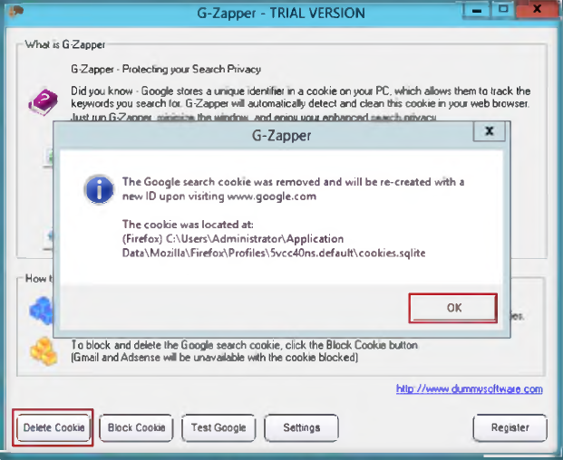

- To block the Google search cookie, click die Block cookie button. A window will appear asking if you want to manually block the Google cookie. Click Yes
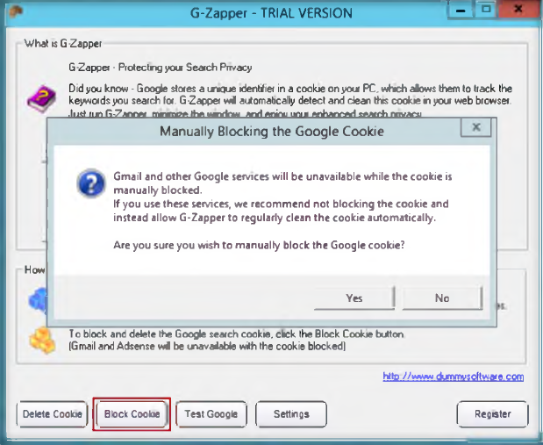

- It will show a message that the Google cookie has been blocked. To verify, click OK
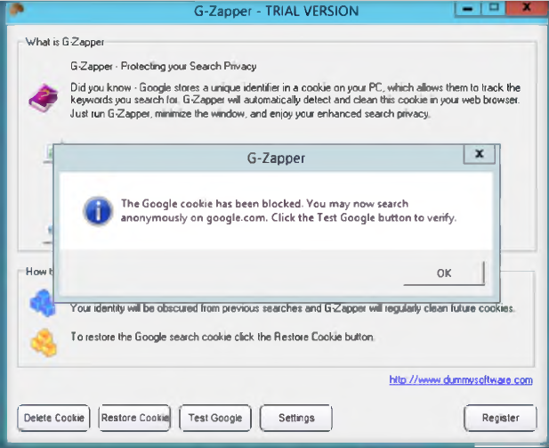

- To test the Google cookie that has been blocked, click the Test Google button.
- Your default web browser will now open to Google’s Preferences page. Click OK.
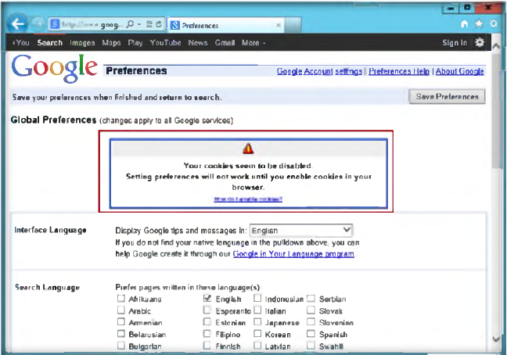

- To view the deleted cookie information, click die Setting button, and click View Log in the cleaned cookies log.
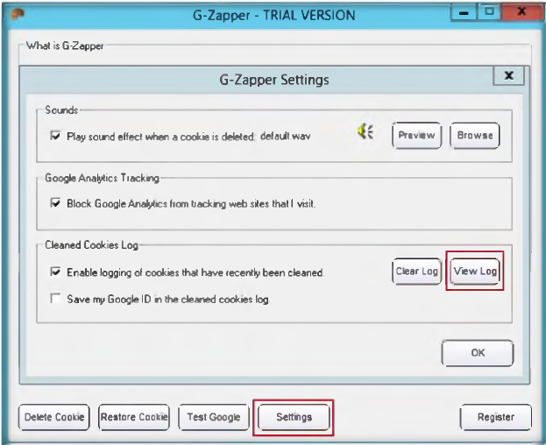

- The deleted cookies information opens in Notepad.
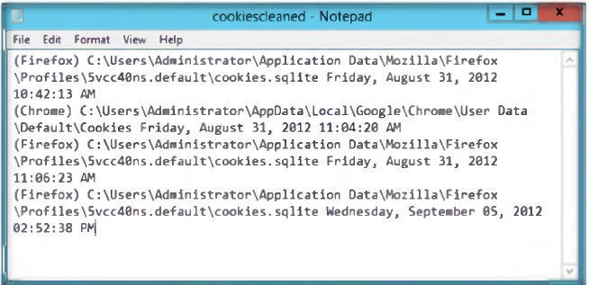

Lab Analysis
Document all the IP addresses, open ports and running applications, and protocols
you discovered during die lab.

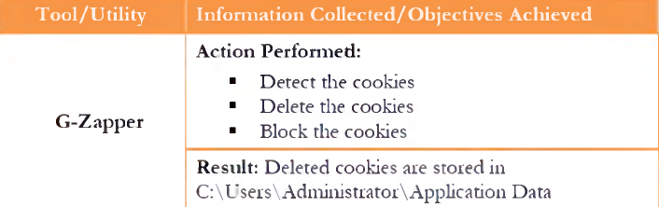

Questions:
- Examine how G-Zapper automatically cleans Google cookies.
- Check to see if G-zapper is blocking cookies on sites other than Google.

Task 3
Anonymous Browsing using Proxy Switcher

Proxy Switcher allowsyou to automatically execute actions; based on the detected
netnork connection.

Lab Scenario

As an expert penetration tester, you should follow typical security practices, to block such Internet-based attacks block the port 137 User Datagram Protocol (UDP) at the firewall. You must also understand how networks are scanned using Proxy Switcher.

Lab Objectives
This lab will show you how networks can be scanned and how to use Proxy Switcher. It will teach you how to:
- Hide your IP address from the websites you visit
- Proxy server switching for improved anonymous surfing

Lab Environment
To carry out the lab, you need:
- Proxy Switcher which is located on the shared one drive
- You can also download die latest version of Proxy Workbench from the link http://www.proxyswitcher.com/
- If you decide to download the latest version, then screenshots shown in the lab might differ

Overview of Proxy Switcher

Proxy Switcher allows you to automatically execute actions, based on the detected network connection. As the name indicates, Proxy Switcher comes with some default actions, for example, setting proxy settings for Internet Explorer, Firefox, and Opera.

Lab Tasks

- After installation, launch Proxy Switcher
- Open the Firefox browser in your Windows Server 2012, go to Tools, and click Options in die menu bar.
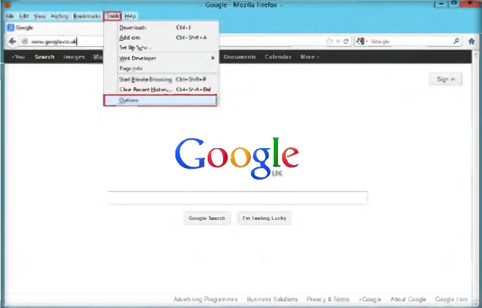

- Go to die Advanced profile in die Options wizard of Firefox, and select Network tab, and then click Settings.
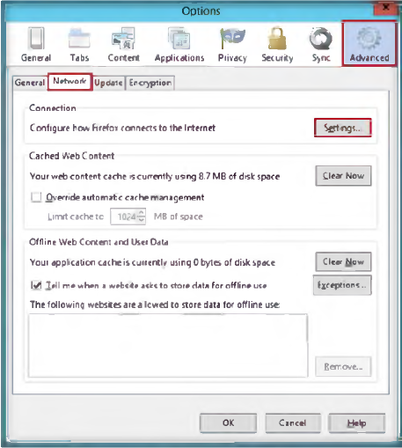

- Select die Use System proxy settings radio button, and click OK
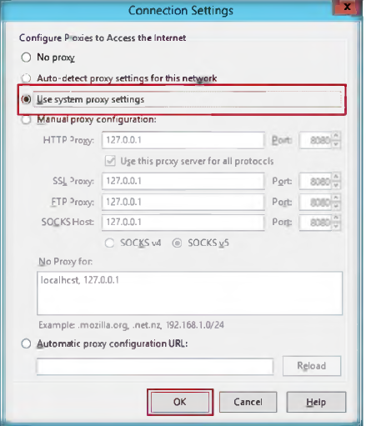

- Now to Install Proxy Switcher Standard, follow the wizard-driven installation steps.
- To launch Proxy Switcher Standard, go to Start menu by hovering the mouse cursor in die lower-left corner of the desktop.
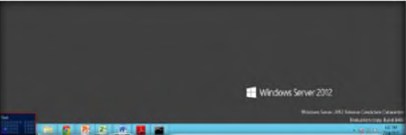

- Click the Proxy Switcher Standard app to open die Proxy Switcher window.
OR

Click Proxy Switcher from die Tray Icon list.
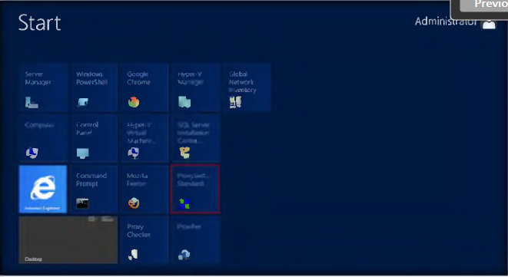

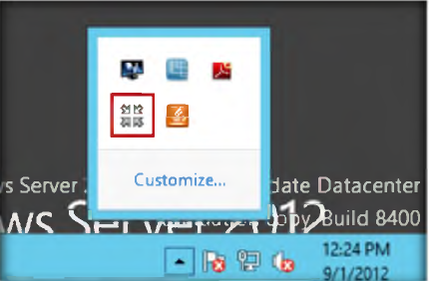

- The Proxy List Wizard will appear as shown in die following figure; click Next
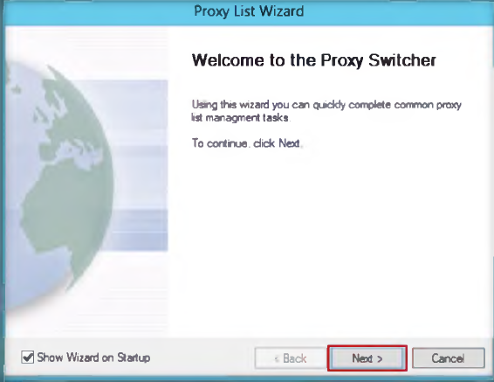

- Select die Find New Server, Rescan Server, Recheck Dead radio button from Common Task, and click Finish.
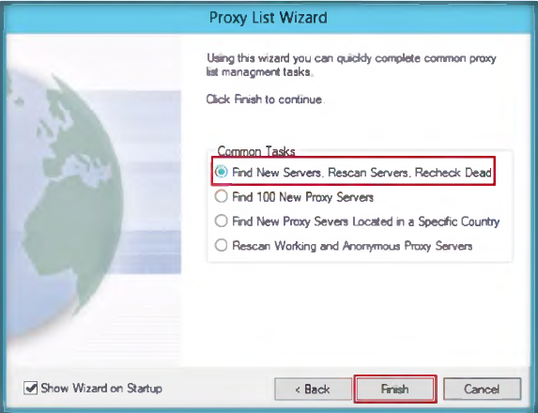

- list of downloaded proxy servers will show in die left panel.
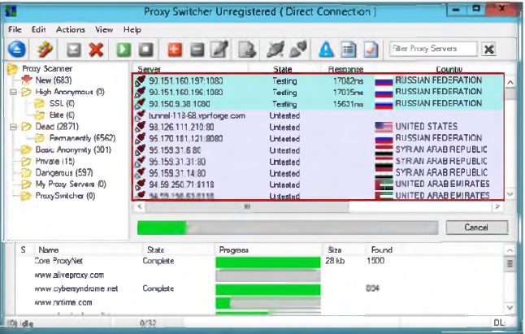

- To stop downloading die proxy server click 
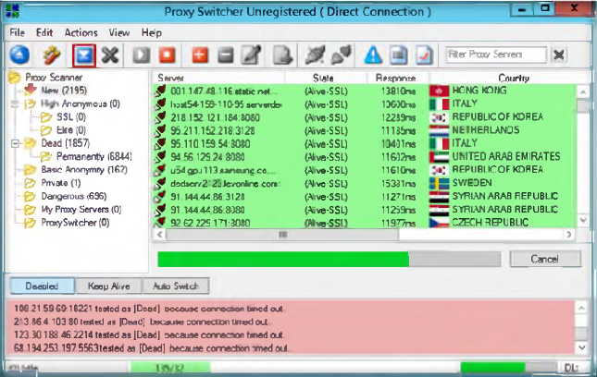
- Click Basic Anonymity in die right panel; it shows a list of downloaded proxy servers.
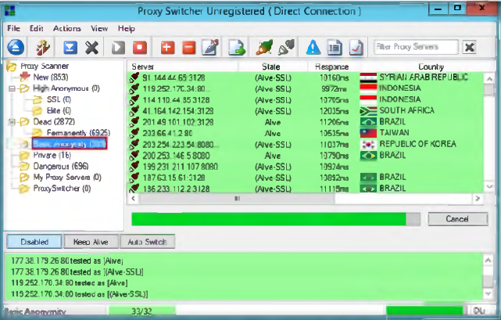

- Select one Proxy server IP address from right panel to switch the selected proxy server and click the  icon.
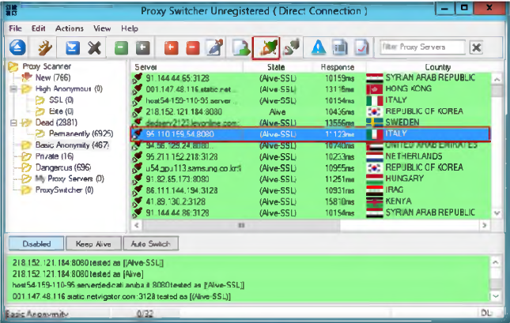

- The selected proxy server will connect, and it will show the following connection icon.
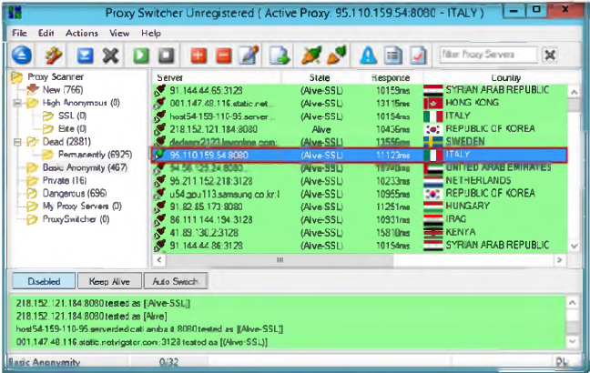

- Go to a web browser (Firefox), and type the following URL http://www.proxyswitcher.com/check.php to check the selected proxy server connectivity; if it is successfully connected, then it show's die following figure.
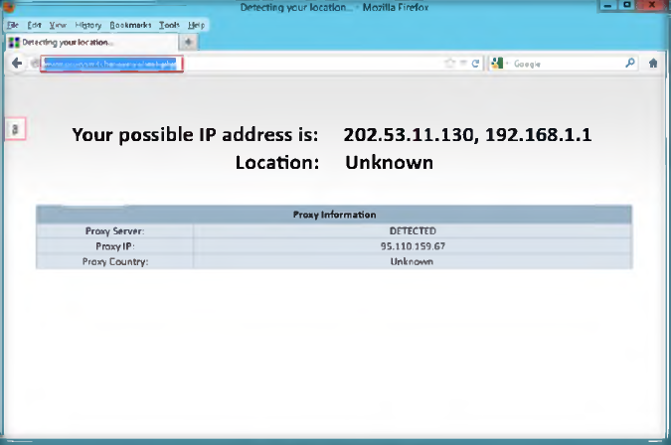

- Open another tab in the web browser, and surf anonymously using this proxy.
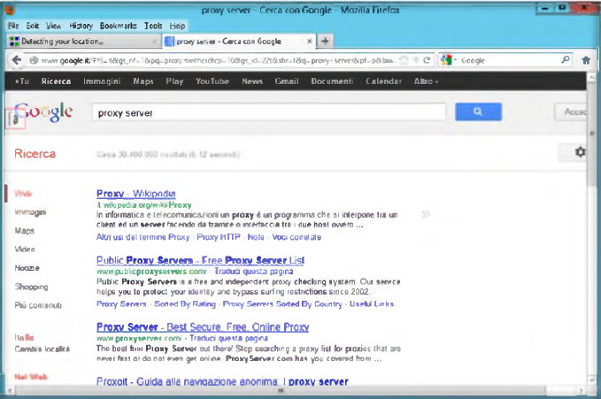

Lab Analysis

Document all die IP addresses of live (SSL) proxy servers and the connectivity you discovered during the lab.

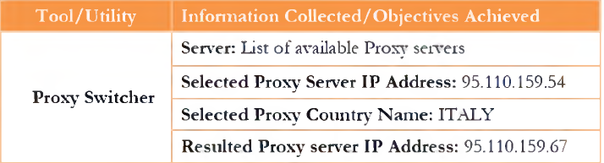

Questions
- Examine which technologies are used for Proxy Switcher.
- Evaluate why Proxy Switcher is not open source.

