Palaeoenvironmental archaeology is multi-disciplinary in nature. Illustrate your answer with reference to two contrasting urban archaeological sites.

Palaeoenvironmental archaeology is multi-disciplinary due to the fact that, according to Headland Archaeology, “Palaeoenvironmental archaeology uses carefully selected recovery techniques to put archaeological sites into their environmental context and provides evidence on such things as diet, economy and living conditions.” (Headland Archaeology, N/D). All of these different types of evidence require their own expert and therefore includes the many disciplines of environmental archaeology in order to be able to succeed at putting the site into its environmental context. This therefore means that these types of sites can be highly useful as there are many different aspects that can be used in order to make as accurate a context as possible. For the purpose of this essay, the two sites that will be used are Calleva Atrebatum (modern day Silchester) excavated by the University of Reading, and Tenochtitlan, the ancient Aztec capital that is buried beneath Mexico City.
Both Silchester and Tenochtitlan are considered urban sites because the oxford archaeology dictionary defines urban archaeology as a “subdiscipline involving the application of archaeological methods to the study of major towns, cities and urban areas, and to the process of urbanization.” (Darvill, 2008). This can be applicable to both of the sites. Silchester was a very important Roman town which was on a roman road that led directly to Winchester (Roman Venta Belgarum). It was the tribal capital of the Atrebates tribe and tiles stamped with the name of the Emperor Nero have also been found there proving that it was a highly important town not just locally but attracted the attention of an emperor. Silchester is located between Basingstoke and Reading in Hampshire, see Figure 1. Also, it can be viewed as part of urban archaeology as it was a major town of its time, and still is an important town in its local area, it spans a large area and has many parts to the city such as temples, housing and a marketplace. It also is an example of some urbanisation in the Roman period as there is evidence of the Iron Age buildings that existed prior to the Roman conquest of Britain and the way in which they were incorporated into the roman town despite iron age buildings being built diagonally and roman buildings being built straight, like the roman roads. Tenochtitlan can also be seen as an example of urban archaeology as it is in an urban area that is directly underneath modern-day Mexico City and when developing the area the archaeology has been revealed. It would have been a major town at the time as it was the Aztec capital, see Figure 2, and also it still is a major town in that the modern-day capital of Mexico is built there too. It also can be seen to show the processes of urbanisation as it developed from a tiny island city to spanning a much larger area. The last record of the city and its size was in 1519 and therefore was urbanised to modern Mexico City much later than Silchester. It was still standing when the Spanish conquered Mexico and therefore shows that it was an urban area and was also urbanised later into the city that you see today meaning that it also fits into the definition of urban archaeology and can be used as a site.

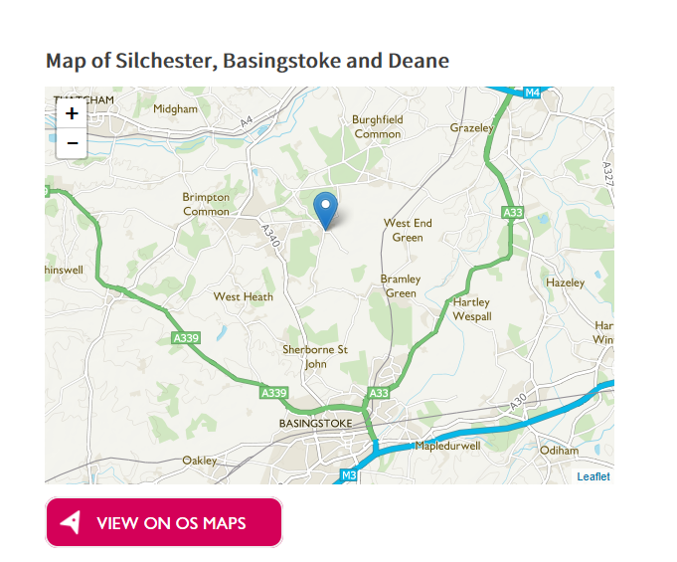

Figure 1 Map of where Silchester is located
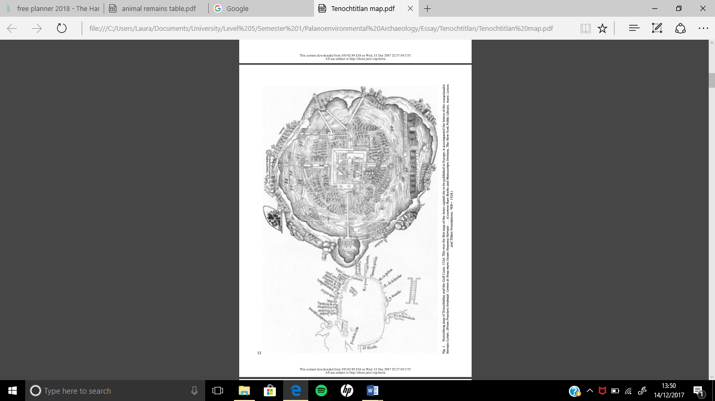
Figure 2 The Nuremburg map of Tenochtitlan and the Gulf Coast

One of the many disciplines that can be included is archaeozoology. Archaeozoology is defined as “the identification and analysis of faunal species from archaeological sites, as an aid to the reconstruction of human diets and to an understanding of the contemporary environment at the time of deposition.” (Renfrew and Bahn, 2015: 576). It is the discipline that specialises in the study of animal remains, typically mammal remains as there are other specialties, within this field, who deal with amphibians and reptiles. Animal remains are found at many sites and may be viewed as the palaeoenvironmental discipline most commonly used when excavating sites as even small pieces of animal bone often survives at a site. This leads to a greater understanding of animals throughout time in the archaeological record. This has been used at Silchester as there are a number of animal bones that had been located. Most recently, during Summer 2017, a horse skeleton. As excavations at Silchester are ongoing the total of animal remains that have been found is uncertain however, Figure 3 shows some of the animal remains collected by hand. When studying animal remains it is important that the archaeologists “decide whether they are present through human agency rather than through natural causes or other predators.” (Renfrew and Bahn, 2015:278). Animal remains have also been found at the Aztec capital of Tenochtitlan as there is an important temple that had many animal remains. “A jaguar was also excavated from beneath the Great Temple at the Aztec capital of Tenochtitlan, a green stone ball having been placed within its mouth.” (Wilkinson and Stevens, 2003:225). This shows that the temple is multidisciplinary as an archaeozoologist would have to be present as there were remains of a number of different animals located and only specialists would be able to identify that the remains were from a jaguar as opposed to any other big cat that may have also been found in Mesoamerica at the time. Many different animal remains were found at the Temple Mayor (the main temple) with National Geographic estimating that “archaeologists have found more than 400 species of animals among offerings found at the site of Tenochtitlan” (Williams, 2013). This emphasises the sheer quantity of animal remains that can be found at urban sites. The fact that over 400 species could be identified is a rare occurrence but the quantity of animal remains is the not same as those that were found at Silchester (Figure 3) as these are two different climates. Therefore, meaning that the preservation conditions may well be different but, regardless a large quantity of animal remains are found. This technique does have some limitations because the long bones do not always survive and that a number of species have a similar skeletal structure and without a full or partial skeleton it is not always possible to identify them. This then, emphasises that there is a need for archaeozoology meaning that palaeoenvironmental archaeology is multi-disciplinary in nature.
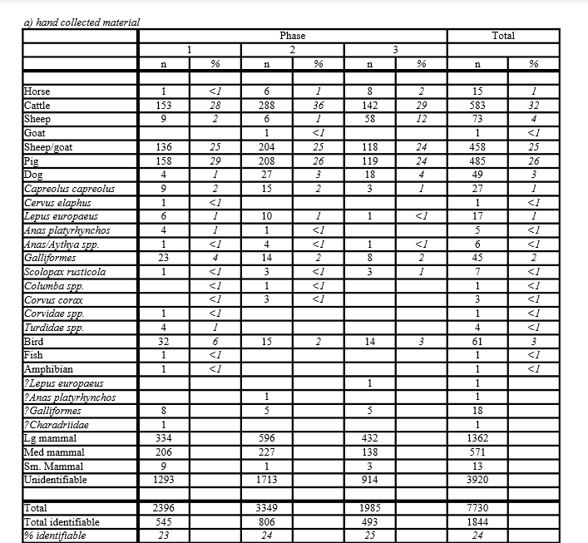
Figure 3 Table of animal remains hand collected at Silchester

Another discipline that is used frequently within palaeoenvironmental archaeology is Radio Carbon Dating. This is defined as “an absolute dating method that measures the decay of the radioactive isotope of carbon (¹⁴C) in organic material.” (Renfrew and Bahn, 2015:582). This is an important discipline due to the fact that it is a method of absolute dating which is “the determination of age with reference to a specific timescale” (Renfrew and Bahn, 2015:576). Archaeologists wish to obtain as accurate a date from a site as possible so that it can be correctly placed within the archaeological record and then inferences can be made about the world at that time. It has some difficulties in that the exact date cannot be pinpointed and that using this technique can be expensive as it has to be in a specialist facility. It also can only reliably date to around 50,000 years ago meaning that it cannot be used for modern history as due to the increased use of coal there is higher levels of carbon in the atmosphere. However, it is highly useful and can be seen to have a lot of benefits as it can provide the dates for organic materials and can be useful when seeing if a site is similar or contradicts other sites from the same period. Radiocarbon dating has been used at both of the aforementioned sites. At Tenochtitlan it has been used to date wood charcoal samples from stratified hearths. These “stratigraphic cuts were also made in the riverbank at Tenochtitlan” (Coe et al., 1967:1399) the results of these can be seen in Figure 4. The results came back as spanning a period before the foundation of the Aztec capital but during the “San Lorenzo phase” (Coe et al., 1967:1400). The samples were analysed at the “Yale Radiocarbon Laboratory” (Coe et al., 1967:1400) and “these dates show a high degree of internal consistency, with the exception of Y- 1799 which may well be contaminated with pieces of asphalt (of which lumps appeared in every one of our excavations) and should thus be disregarded.” (Coe et al., 1967:1400). This therefore shows how the use of radiocarbon dating can be fairly accurate but there are factors that may cause the dates to not be as expected. Radiocarbon dating has also been used at Silchester and has been useful for understanding the nature of some bone fragments found. This is because “excavations at the North Gate, Silchester in 1991 recovered fragments of human bones from five different locations in and around the gate.” (Fulford, 2000:356). Due to these fragments being scattered the ability to determine when they were from and whether or not they were from the same period would be difficult. Radiocarbon analysis of these fragments allowed these questions to be answered. However, due to the cost of radiocarbon dating only two fragments were selected in 1999, “part of the cranium of an adult found in 1991” and “part of a femur with a cut mark sustained in antiquity from the disturbed contexts of excavation trenches of 1890 and 1909” (Fulford, 2000:356). The femur bone “yielded a radiocarbon age of 2320 +/- 40 BP, which calibrates to 550-200 BC” (Fulford, 2000:356). “The cranium was considerably younger at 1600 +/- 40 BP, which calibrates to AD 420-540” (Fulford, 2000:356). Both of these dates were calculated to one standard deviation. This shows how Silchester may have been occupied during the Iron Age and may allow the site to be put into a wider context. This also emphasises how Palaeoenvironmental archaeology is multi-disciplinary in nature as it is not only using radiocarbon dating but also, it can be seen to show how osteoarchaeology and possibly dendrochronology could be incorporated into the discipline.

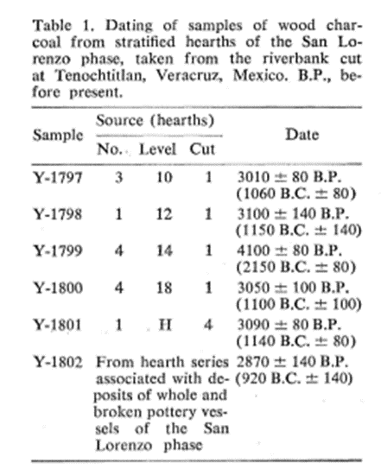
Figure 4 Radiocarbon dates taken from Tenochtitlan

A final discipline that also shows how Palaeoenvironmental archaeology is multi-disciplinary in nature is palaeoethnobotany (archaeobotany) which is defined as “the recovery and identification of plant remains from archaeological contexts, used in reconstructing past environments and economies.” (Renfrew and Bahn, 2015:581). This is a discipline that can be used at a plethora of sites as many sites preserve some plant remains. In Tenochtitlan the plant remains can be seen by the use of chinampas. “Chinampas are narrow, rectangular beds or platforms, which are constructed by alternating layers of lake mud and thick mats of decaying vegetation (cespedes) over shallow lake bottoms, or in marshy zones.” (Calnek, 1972:105). Due to Tenochtitlan being “an island city” (Calnek, 1972:105) this would have been the closest they would have had to agricultural land to grow crops in. See Figure 5 to see the amount of chinampas that were used. “A comment by the Oidor Alonso de Zorita to the effect that the Indians who lived in the city often grew crops “on certain chinampas that they have near their houses, in order to eat [the maize] en elote” (that is while “green”).” (Calnek, 1972:112). This gives an indication as to how the Aztecs of Tenochtitlan were growing the crops and the kind of sites they used would not have been identified if the archaeobotanists had not been able to identify that decaying vegetation had been used. This has also been seen at Silchester in that many plants have been identified and whether this produce came from the local area or had to be imported could be determined. Purely looking at Insula IX of Silchester and in comparison to the plant remains at other Roman towns there is a wide range found at Silchester. Figure 6 shows the amount of imported and local produce. This gives an insight into the diet of the local people which would not have been possible without archaeobotany. Therefore, this also emphasises how palaeoethnobotany or archaeobotany shows how palaeoenvironmental archaeology is multi-disciplinary in nature.

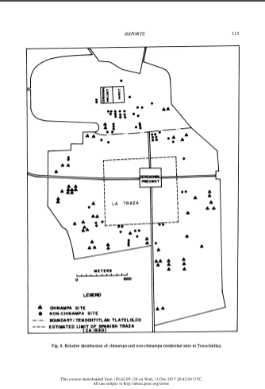
Figure 5 The arrangement of chinampas around Tenochtitlan

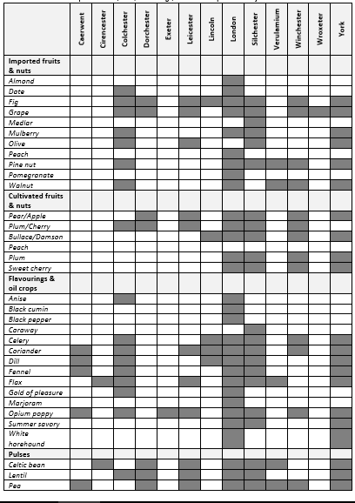

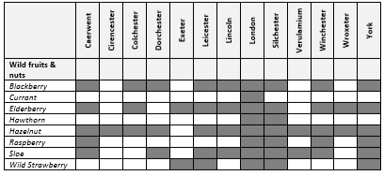
Figure 6 Plant remains at Silchester in contrast to other Roman sites

Overall, Palaeoenvironmental archaeology is multi-disciplinary in nature as the three sub disciplines that have been shown in depth and the couple just touched upon are not the entire range of disciplines that can be used. This is a synopsis of some of the disciplines that may be used and there are plenty more to choose from. The soils and sediments, the insects and pollen are just a few disciplines that were left out. When the subject matter contains so many different sub topics and disciplines how could it not be multi-disciplinary? It needs to be multi-disciplinary though as its purpose is to reconstruct past environments and landscapes and that requires an overall picture from all angles. That could not be achieved without a multi-disciplinary nature.

Bibliography
Archaeology Data Service, 2007. Animal Bone – Data Tables. [PDF] Available at: <http://archaeologydataservice.ac.uk/archives/view/silchester_ahrc_2007/downloadpdf.cfm?CFID=e656c5b8-97f3-4858-bbb5-77eaaa1950d9&CFTOKEN=0> [Accessed 14 December 2017].
Calnek, E.E., 1972. Settlement Pattern and Chinampa Agriculture at Tenochtitlan. American Antiquity, [e-journal] 37(1), 104-115. Available through: JSTOR < http://www.jstor.org.ezproxy.uwtsd.ac.uk/stable/278892?Search=yes&resultItemClick=true&searchText=tenochtitlan&searchText=agriculture&searchUri=%2Faction%2FdoBasicSearch%3FQuery%3Dtenochtitlan%2Bagriculture> [Accessed 14 December 2017].
Coe,M.D., Diehl, R. A. and Stuiver.M, 1967. Olmec Civilization, Veracruz, Mexico: Dating of the San Lorenzo Phase. Science, New Series, [e-journal] 155(3768), 1399-1401. Available through: JSTOR <http://www.jstor.org.ezproxy.uwtsd.ac.uk/stable/1721184?Search=yes&resultItemClick=true&searchText=dating&searchText=san&searchText=lorenzo&searchText=phase&searchUri=%2Faction%2FdoBasicSearch%3Ffilter%3D%26amp%3BQuery%3Ddating%2Bsan%2Blorenzo%2Bphase> [Accessed 14 December 2017].
Darvill, D., 2008. Concise Dictionary of Archaeology. Oxford University Press. Oxford.
Fulford, M., 2000. Human Remains from the North Gate, Silchester: An ‘Early’ and a ‘Late’ Radiocarbon Date from the City. Britannia, [e-journal] 31, 356-358. Available through: JSTOR <http://www.jstor.org.ezproxy.uwtsd.ac.uk/stable/526928?Search=yes&resultItemClick=true&searchText=human&searchText=remains&searchText=at&searchText=silchester&searchUri=%2Faction%2FdoBasicSearch%3FQuery%3Dhuman%2Bremains%2Bat%2Bsilchester%26amp%3Bfilter%3D> [Accessed 14 December 2017].
Headland Archaeology, N/D. Palaeoenvironmental Analysis. [webpage] Available at:
< http://www.headlandarchaeology.com/services/specialist-services/palaeoenvironmental-analysis/> [Accessed 14 December 2017].

Lodwick, L., 2014. An Archaeobotanical Analysis of Silchester and the wider region across the Late Iron-Age-Roman Transition. PhD. University of Oxford. Available at:
< https://ora.ox.ac.uk/objects/uuid%3Afcfc1f93-3f58-405d-a133-4f36fee57627> [Accessed 14 December 2017].

Mundy, B. E., 1998. Mapping the Aztec Capital: The 1524 Nuremburg Map of Tenochtitlan, Its Sources and Meanings. Imago Mundi, [e-journal] 50, 11-33. Available through JSTOR < https://ora.ox.ac.uk/objects/uuid%3Afcfc1f93-3f58-405d-a133-4f36fee57627> [Accessed 14 December 2017].

Renfrew, C., Bahn, P., 2015. Archaeology: Theories, Methods and Practice. Thames and Hudson. London.

University of Reading Archaeology, Geog & Env Sci. 2017. Silchester temple site Horse Skeleton. [3D model] Available at: < https://sketchfab.com/models/a7311f37762e4d41aca688ae616db42d> [Accessed 14 December 2017].

Wilkinson, K., Stevens, C., 2003. Environmental Archaeology: Approaches, Techniques & Applications. Tempus Publishing Ltd. Gloucestershire.

Williams,A.R., 2013. More Than 400 Animals Offered To Aztec Gods. [Article] Available at:
< https://news.nationalgeographic.com/news/2013/06/130617-aztec-offering-animal-tenochtitlan-templo-mayor-mexico-science-archaeology/> [Accessed 14 December 2017].

