Table of Contents – keep adding to this as you go through the assignment.

- Proposed research title ………………………………………………………………………… Page 2
- Abstract ……………………………………………………………………………………………….. Page 2
- Introduction and background ……………………………………………………………….. Page 2
- Aims and Objectives ………………………………………………………………………………Page 3
- Literature Review …………………………………………………………………………………. Page 3
5.1 Construction disasters in the past 10 years (UK based)
5.2 The type of cladding used on the Grenfell towers Project
5.3 Changes made to legislation and risk assessments post Grenfell
5.4 Backlash from Grenfell towers fire on contractors
5.5 Problems currently developing within construction (Concrete Cancer)
6) Methodology ……………………………………………………………………………………….. Page 6
7) Questionnaire ……………………………………………………………………………………….. Page 7
8) Data Analysis ………………………………………………………………………………………… Page 9
9) Reflection ……………………………………………………………………………………………… Page 11
10 ) Bibliography …………………………………………………………………………………………. Page 13

- Proposed Research Question
How has a disaster such as the Grenfell towers effected the way a quantity surveyor will complete their role in the construction process?
- Abstract

This research will aim to seek information on the way disasters within construction effect how a quantity surveyor works within their area. This will mostly focus on how a quantity surveyor prices their work and the care they will take when looking at materials to use.

- Introductions and background

The researcher completing this work has been working and studying within this area of expertise for over a year. And wants to be able to understand the effects a disaster such as Grenfell towers would have on this area of work within the construction industry and process.

The research that I will complete is going to be beneficial for those who are going to be looking at joining this area of work as well as people who are already within the industry and want to be able to understand how these types of disasters can lead to major changes in the way that a quantity surveyor will complete their tasks.
Although there is already a large amount of research into this topic. This research will give a in depth investigate all aspects of disasters as well as comment on the ways in which disasters influence the entire construction process from first designs being created to hand over of the finished property.

Grenfell Tower was a social housing project that was a part of the Lancaster housing estate. Which contained almost 1,000 Homes. The disaster of Grenfell towers took place just before 01:00 on the 14th of June 2017. This devastating fire that started on the fourth floor of the building lead to a total of 72 people losing their lives. Just after the fire started. It then began to spread to each side of the building. Within 2 hours of the fire starting the vast majority of the building was consumed in flames. The fire led to 900 people losing their homes. The fire began within flat 16 on the fourth floor from a Hotpoint fridge freezer. The main reason the fire was able to spread as fast as it did was due to the poor type of cladding that was used on the building. The cladding used was very flammable causing the fire to rapidly spread. (BBC.co.uk, 29th October 2019)

I will look to go into more detail and complete research to find out exactly what caused the fire to cause as much damage as it did and how such a large-scale disaster can influence how a quantity surveyors may work when coming onto a similar contract to Grenfell Towers.

- Aims and objectives

The main objective of this research is to understand the impacts that disasters have on a quantity surveyors work. When looking into depth, my aim will be to focus on the different areas of a quantity surveyors’ job such as writing and producing a tender and how clients will look to see how they can adapt to the changes from the aftermath. I will also look at how the cost of build has increased due to new and more expensive cladding and other materials is required due to it being safer.

I will also investigate a much more recent panic that is occurring right now which involves the concrete used in buildings such as schools, which is now looking very dangerous with a possibility of collapsing. (Concrete Cancer)

To give a summary of what I mean by the term “concrete cancer”. Concrete cancer occurs when a steel frame reinforced with a concrete slab starts to rust. Because of this it then means that the steel expands which then causes the concrete to become brittle and crack which in turn means that the integrity of the structure can become weaker and if this is left unattended it can lead to situations where the buildings are at risk of collapse. This is what is seeming to occur within some schools in England where they are needing to be evacuated due to the possibility of collapse.

- Literature Review

5.1

To best gain an understanding of what causes all kinds of disasters to occur within construction I will begin my literature review by looking at different disasters that have taken place within construction in the UK within the past 10 years. The first place that I will look for these stories is by using the website “Construction management .co.uk”

“Edinburgh schools quality scandal: In 2016, serious structural failings were found at two primary and two secondary schools, among 17 built by Miller Construction under Edinburgh’s £360m “PPP1” deal. The news came to light after a wall at Oxgangs Primary school in the city collapsed. The incident was one of the catalysts for the setting up of the CIOB’s Construction Quality Commission”.

The reason for this disaster occurring mainly comes down to the poor quality of construction. The main aspects of the poor quality can be seen below. This comes from the Construction index.co.uk .
- “The direct laying of the bricks and the positioning of the wall ties;
- the direct supervision of the laying of the bricks and the positioning of the wall ties; and
- the quality assurance processes used by the sub- contractor and main contractor to confirm the quality of the construction of the walls”.
From looking into the reasons for the collapse you can see that this is all down to the contractors in charge of the project. When the quality of the project becomes so poor that it leads to a building collapse. It creates a nightmare for the contractors as when a story like this is released to the public it then means they are going to lose out on possibly millions of pounds worth of business. Not just that but it can lead to large amounts of fines from health and safety issues that could possibly be found within poor quality of construction. (Constructionmanagement.co.uk)
5.2
After finding another type of disaster which has occurred within the UK as well as finding the reasoning as to why the building collapsed. I will now turn my attention back to the largest construction disaster the United Kingdom has seen in decades.
The Grenfell towers fire was a terrible disaster and the main reasons for the fire gaining so much momentum and causing so much damage is because of the cladding that was used on the building. However, what type of cladding was used on the building?
According to (dazeen.com/2022). The type of cladding that was used on Grenfell was Polyethylene – cored aluminium cladding (ACM). The Website also states that:
“The inquiry was informed that the polyethylene-cored aluminium composite material (ACM) cladding that was used on Grenfell Tower's facade was subject to a government-funded safety test in the summer of 2001.
The panels failed dramatically, and the test had to be stopped early as 20-metre-high flames rose from the test rig after just five minutes.
Government officials were made aware of the test in September 2002 – 12 years before ACM was selected for Grenfell Tower and 15 years before the deadly June 2017 fire. However, no warning was passed on to the construction industry”.
This statement suggests how test have previously been completed on the type of cladding as well as showing how the cladding failed the tests very quickly. But the cladding was not banned or taken off the market for being dangerous. If the construction industry was given a warning when the tests were completed it would allow for a order to be put into place for the cladding to be removed. If this was removed the cladding would have not been there and allowed for the fire to spread so quickly leading to a lot more lives saved.
5.3
After the awful disaster of Grenfell towers it became obvious that changes needed to be made to the legislations and laws in place when it comes to new builds, especially for high rise buildings such as Grenfell.
From the quote we can see how these changes have occurred as well as how it will affect the entire the entire construction industry.
“There is also a ban on various types of combustible cladding in relation to buildings more than 18 metres or more in height. This is not retrospective but is under review. The provisions came into force on 28 November 2018 in England and 10 January 2020 in Wales. The provisions apply when the building contains one or more dwellings including student accommodation, care homes, sheltered housing, hospitals and dormitories, but excluding hostels, hotels and boarding houses”. (www.lawsureinsurance.co.uk/ February 2023)
From this quote we can see how combustible cladding such as the type of cladding used on the Grenfell has now been banned from use. This means that it is no longer available for anyone to buy or place onto any sort of building.
From the point of view of a quantity surveyor this can lead to other cladding materials to increase in prices because the cheap dangerous cladding is no longer available which will increase the need for the non-banned styles of cladding.
5.4
As stated above a disaster like this can lead to a huge amount of backlash to a contractor and company that oversaw the construction of the building. The information stated below allows you to see the backlash that comes when a construction project goes wrong.
According to (Constructionnews.co.uk/April 2023) The main contractors that subcontracted work on the construction of Grenfell towers agreed to a settlement of £150 million. From such a large amount of money going towards Grenfell this would have led to a large number of setbacks on the companies from losing out in possible business to having to haul current site as they re fund their projects.
To show how huge of a scale the backlashes became. I look to refer to an article posted by the guardian regarding the possible punishments that were taken into consideration for who was to blame for the many deaths that occurred.
“Police have said they are considering manslaughter charges in relation to the deadly Grenfell Tower blaze as they revealed that the insulation and cladding tiles at the building failed safety tests.
Det Supt Fiona McCormack, who is overseeing the investigation, said on Friday that officers had established the initial cause of the fire was a fridge-freezer and that it was not started deliberately.
She said they were trying to get to the bottom of why the fire grew so quickly and tests had pointed towards the cladding using aluminium composite tiles and the insulation behind it. Investigators will now seek to establish whether the use of these materials was illegal”.

5.5
As my research is focused on the impacts a quantity surveyor has faced due to the Grenfell tower incident. However, The fact that this has happened before means that there is a scenario where problem on such a large scale could happen again. Because of this I believe researching problems that are beginning to occur now and have been laying in dormant In our structures.
One problem that has recently been in the news is surrounded by the term concrete cancer.
“Concrete Cancer”. The easiest way to describe this term is through the rusting of steel columns that are within a concrete slab. (freyssinnit.co.uk)
The steel begins to swell over time, which is due to a chemical reaction between highly alkaline cement paste and the reactive amorphous silica. Because of this reaction it means that the concrete surrounding the steel columns becomes very week and begins to crumble. Over time you can image what crumbling concrete on a structure can do. It can cause structures to collapse. And this is becoming a growing concern throughout the UK. As stories are begging to emerge of schools in England having a severe risk of Collapse.
“More than 100 schools across the United Kingdom have been ordered to close over fears that potentially dangerous concrete used in their construction between the 1950s and the mid-90s could lead to structural collapse” (https://www.aljazeera.com / September 2023)
Looking at this quote alone shows us how serious of a problem this is becoming. The cause of this is because structures like the schools mentioned above were only given a lifespan of 30 year. This is also the same for my secondary school where I was able to see first hand how my school began to lose its structural integrity as when any form of severe weather hit us the roof and buildings collapsed.
6.0 Methodology
The research that I will look to find out the full impact that Grenfell towers had on the job of a quantity surveyor. For this to be reliable and up to date I will look to question people that are within this field. For example, asking how prices changed or what they would need to look out for when completing a site inspection for example. This even relates to how a risk assessment may have changed and is now needed to meet the standards of the new Building regulations act.
For this research to be as effective as possible I will look to complete my research Quantitatively. I will look to use this style of research as it means I am able to gain both numerical and non-numerical answers which will allow me to determine my questions and give me many answers to pull for and take into my consideration when answering my question.
With the research collected, I will be able to create a chart showing my the different styles of answers and what people think of the disaster and how much it impacted them in their own role, the entire organisation as well as the construction industry. The point of gaining research from members of people working in a quantity surveyor role will give me the opportunity to see how different companies from small scale to large scale were affected by this disaster.
To be able to do this the researcher will look to contact quantity surveyors from different companies across the United Kingdom. This will bring a wide range of people from the role.
Some of the questions that I will look for from the researcher will be:
- How long have you been working as a quantity surveyor?
- Have you been in a situation where you have needed to make changes to your original plan of construction?
- Have you noticed a change in prices in cladding since Grenfell Towers?
- How did Grenfell towers force your company to make changes?
I will look to use a quantitative method when it comes to questioning. By using quantitative questions it will allow me to gain the best understanding of the impacts Grenfell towers has had on the construction world. I will look for answers explaining to me the effects it had on the job and what it has changed within the entire industry. I will look to use these answers as quotations showing their exact thoughts on each question.
To make sure my research is reliable I will look to make sure each surveyor is qualified and was working within the field before and after the disaster of Grenfell towers. This will mean that they will have seen the pre and post sides of the disaster and give me the best information possible. They will also be able to show me how the structure of the construction industry was affected.
7.0 Questionnaire
To complete this questionnaire, I have chosen to use the tool of google forms. I have chosen to complete my questionnaire on this website as it allows me to transfer my data easily and efficiently. By doing this it allows me to show my data professionals and correctly. I will be using colleagues from my company. As they each come from different levels of experience and backgrounds within quantity surveying practice. The questionnaire filled with questions I sent out to each of the members are shown below.
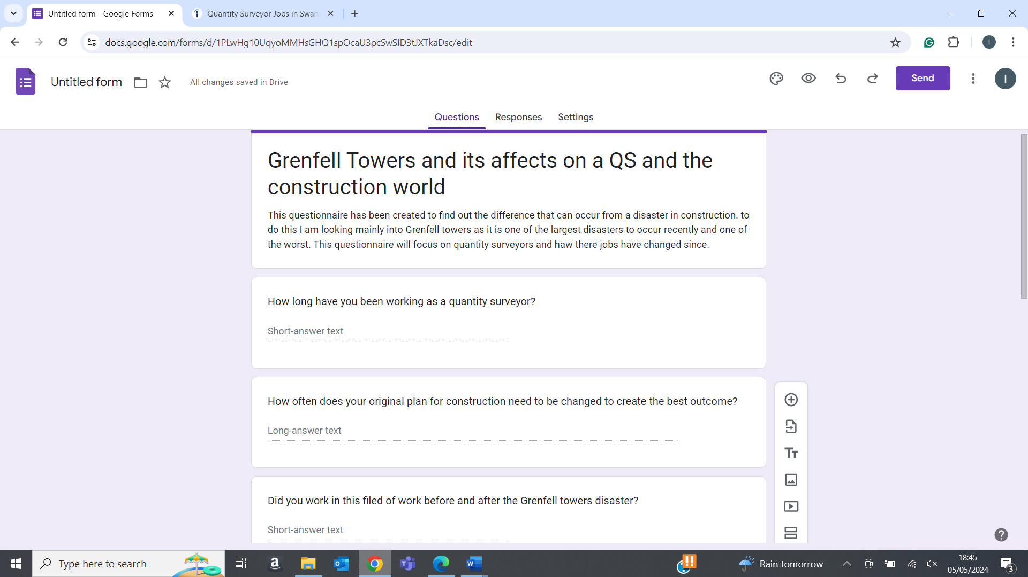
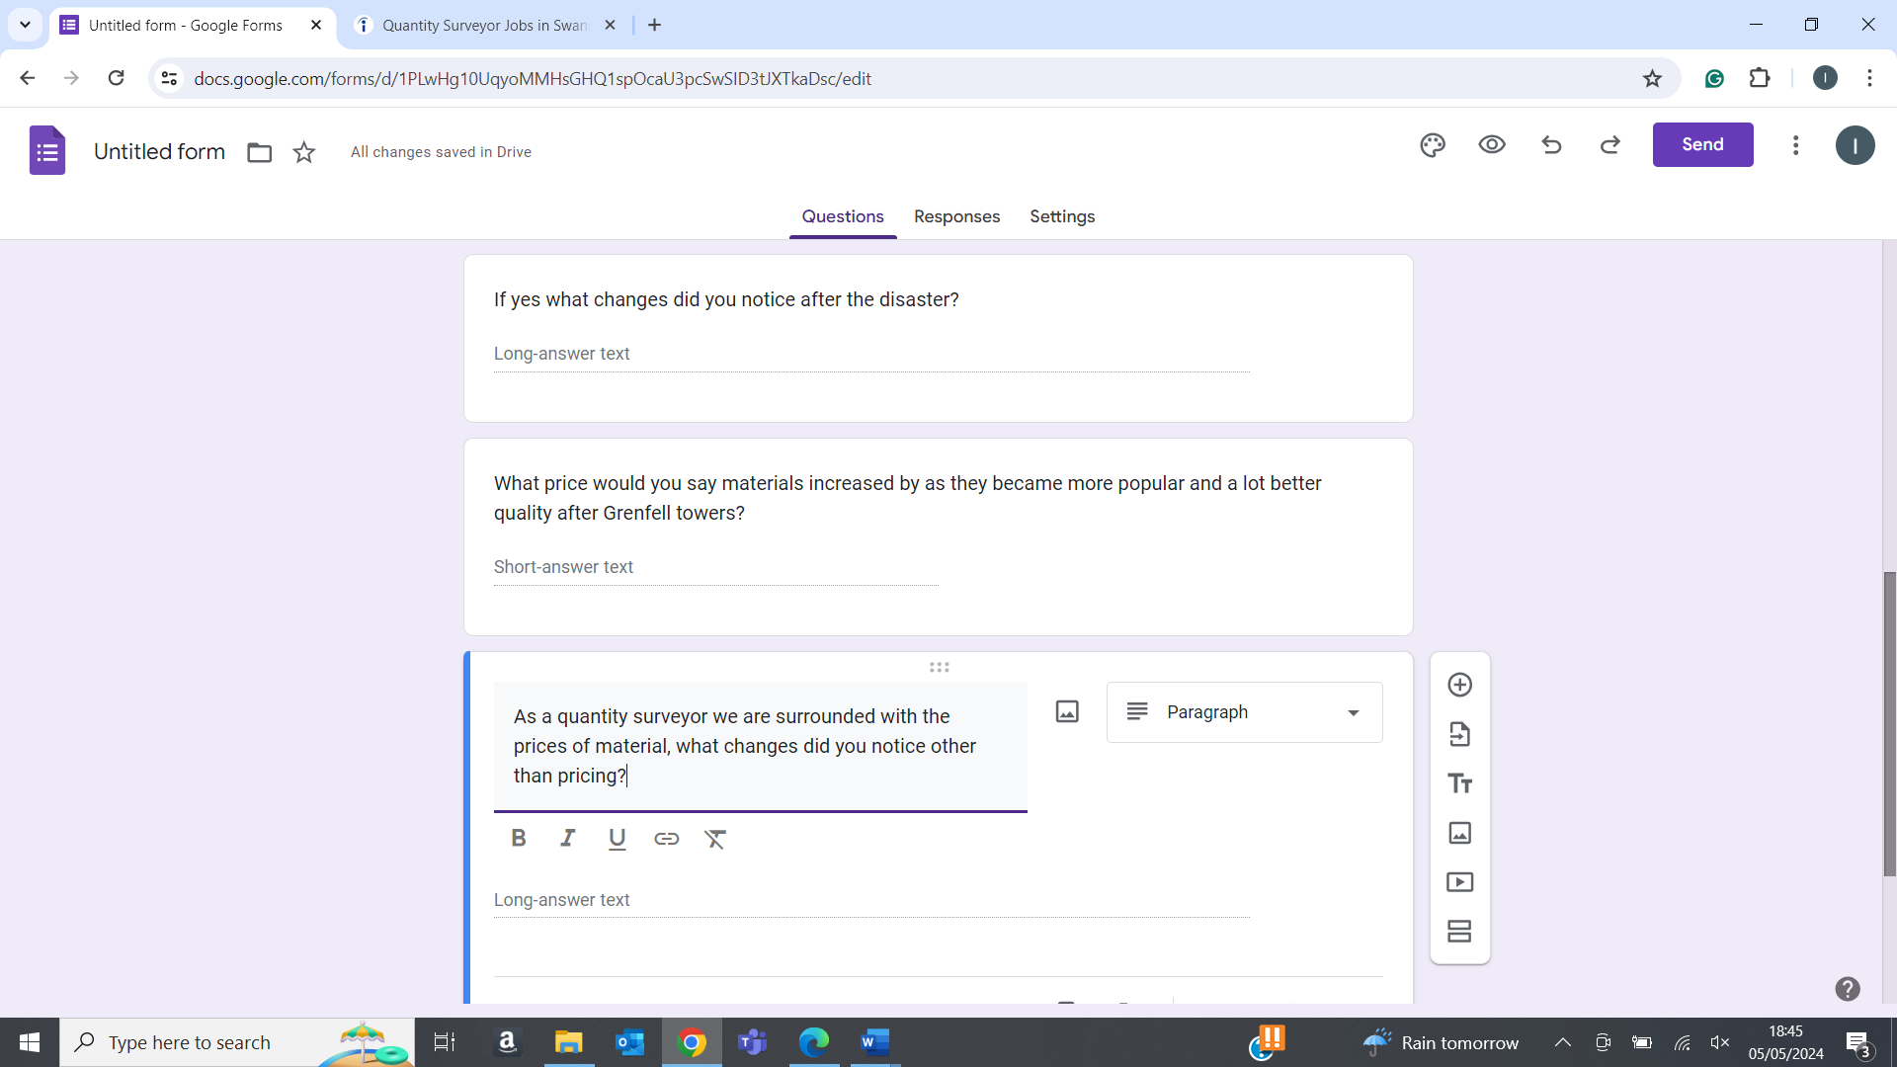
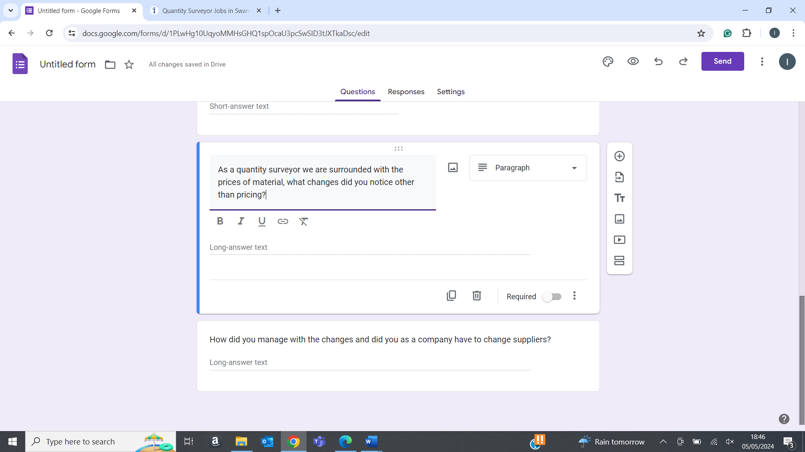

As you can see the questions, I have set out for people to answer will consist of different ways for me to find out what affects were caused from the disaster of Grenfell towers. By doing this I will also be able to hypothesise that the construction world would see similar effects from other such disasters. This is because for a quantity surveyor the main aspect of the job is revolved around the management and pricing of construction jobs and prices can change at many different times.
This questionnaire will allow me to analyse and decide how much of an impact Grenfell had on the job as a quantity surveyor. Which will also allow me to interpret what will happen if another disaster was to take place.
8.0 Data analysis and results
Now that I have received my data from the questionnaire I can now look to analyse and give my conclusion on the proposed question I have set out to find the answers too. I will look to show my results by summarising the information that I have received.
I first looked to ask my colleagues how long they have been working within the industry with a wide range of answers from 30 – 5 years. For the people who have worked in the industry for a lot less time they did not get to witness a large amount of impact. However, they were able to give me an understanding of how a scope of works can change daily. This can be down to a unlimiting number of factors from “rain stopping us from applying render to the exterior of a building” to the “human factor”. Connor Lewis (Joyner Cymru) went onto state “by this I mean that if employees become sick or hurt themselves, they will need to take time away from work and losing people and working with a smaller workforce can lead to work being completed at a slow pace and leading to changes needing to be made to the original plan of construction”. Looking at this I can see how these minor interruptions can lead to many changes being made to a scope of works.
I then continued with my questionnaire by asking if they had been working within the industry whilst the disaster took place. 7 out of 10 people said yes to this leading me with many different opinions for when going onto my next sets of questions. My next question was to see if there were any noticeable changes compared to before and after the disaster. As well as what those changes were. By looking into the answers, I received I was able to notice a similar pattern. 5 out of 7 people to answer this question stated how the first change came with the price changes in cladding as the cladding used on Grenfell became “obsolete overnight” Robert vokes (Joyner Cymru). No company that was looking to use cladding for their renovations or new builds were no longer looking to use the same cladding as Grenfell even though it was seen as the cheap and reliable option. “Because of the Grenfell towers fire the top of the range fireproof cladding was able to increase their prices because the demand for their product.” “For our company personally, Grenfell towers forced us to take on a lot more work. We were able to take on contract for us to take out flammable cladding and replace it”.
By looking at these answers I received It also gave me the impression of how the prices changed when it comes to materials. It looks like the price of cladding mainly increased as they became a higher demand for the product.
Later, down the line the price would look to increase again due to the fact that the cladding used on Grenfell towers would be banned with the new changes made to health and safety legislation as well as the building regulations.
I then also looked to ask a more personal question for the quantity surveyors by asking what impacts the disaster had on their respective companies during that time. I looked to ask this because of the way that this affected the contractors involved with the disaster. As they needed to pay fines adding up to £150million. However, some companies can gain from this disaster such as the suppliers of safe and up to code cladding. Who would receive a high amount of demand when the legislations came into place.
For this question I received a mix of positive and negative reviews. For example, “Because of the new legislation, it worked well into our favour. Because we were able to gain contracts for us to take away the old cladding and replace it. This led to a gain of profits and work for the company”. Whilst another colleague stated that “We had to make amendments to our material list that was approved by the client. As a quantity surveyor especially, it meant changing current projects to suit the new legislation that came in. we needed to make amendments to our take off after the overall price has already been approved”.

9.0 Reflection
In this section I will look to conclude and reflect on the project that I have completed as well as giving my final opinion on what I think about in terms of the disaster of Grenfell towers.
Firstly, I believe that this exercise has been able to fully answer my question by using both literature material that I have found online as well as the primary research I have created myself. Using both resources I have been able to gain a large understanding of how Grenfell towers caused such a large impact on the job of a quantity surveyor. However, it has also led to a large impact throughout the entire construction process. The main factor I gathered from my secondary research was the changes that were made to building legislation in the UK. The legislation that changed the most was surrounding the type of cladding that was used on Grenfell. This is because the cladding was seen to be extremely dangerous and not fit for use according to the new standards. This then also mean that the prices of the safe materials increased heavily as well as the number of buildings that needed to have the illegal cladding removed.
By looking overall at the answers, I received for the questionnaire I sent out I was able to gain a further knowledge from people looking into the field. This allowed me to understand how this disaster made large changes for quantity surveyors when it came to completing their day-to-day task. From the information I gathered I found that the main problem came when the prices of cladding increased. And how even this can make a change to a quantity surveyors pricing sheet. Quantity surveyors needed to change how they would look to use cladding in their builds and how they needed to make sure that they were agreeing to the new legislation set out by the government. Otherwise, it could lead to fine being enforced on the company as a whole and leading to the company losing money of their contracts.
In my opinion. I believe that Grenfell towers was a horrific disaster that led to lives being lost due to the fault of companies looking to use cladding that was not safe or fit for its purpose. All to make the project as cheap as possible. I also believe that companies saw the disaster in different ways for example a company supplying cladding that fit the new legislation would be able to thrive as their demand would skyrocket. However, companies such as contractors and jobs such as a quantity surveyor would need to make some significant changes to make sure that they are use the correct materials so that a disaster like this would not be able to happen again.
When looking back on my report, I believe that I have been able to find the answers that I aimed to find. This became noticeable once I completed my primary research section. Through my primary research I found that the questions I asked gave me the best possible chance to find my aims and objectives for my work. However, If I was given the opportunity to re write my work, I would look to change some questions and use a mixed method approach were I gathered both numerical and literature-based data. This would lead to me having a better overall understanding of how much this affected the job of being a quantity surveyor. Not just that but it would also allow me to show my results more clearly and effectively by using graphs and charts for a question such as “how much did the price of cladding increase by”.
Looking at this topic and my research I can clearly say that it has increased my level of interest in the profession and will hopefully want to look deeper into the topic specifically. This is because I understand how a quantity surveyors’ role can change daily from variations being made to the scope of works to a change in pricing for a contract.

References
Gerrard 17.12.2019, N. and Gerrard, N. (2021) The 10 biggest construction stories of the decade, Construction Management. Available at: https://constructionmanagement.co.uk/10-biggest-construction-stories-decade/ (Accessed: 13 March 2024).
Nat Barker | 24 February 2022 Leave a comment (2022) UK government knew Grenfell cladding was dangerous 15 years before fire, inquiry hears, Dezeen. Available at: https://www.dezeen.com/2022/02/24/government-grenfell-cladding-15-years-inquiry/#:~:text=The%20inquiry%20was%20informed%20that,in%20the%20summer%20of%202001. (Accessed: 13 March 2024).
The-building-safety-act-2022-and-other-post-grenfell- ... (no date) The building safety act 2022 post Grenfell . Available at: https://www.lawsureinsurance.co.uk/wp-content/uploads/2023/02/The-Building-Safety-Act-2022-and-Other-Post-Grenfell-Legislation-200223.pdf (Accessed: 13 March 2024).
Clare (2017) What is concrete cancer & how can it be prevented? - freyssinetuk, FreyssinetUK -. Available at: https://freyssinet.co.uk/concrete-cancer-can-prevented-concrete-repairs/ (Accessed: 13 March 2024).

