Name: Teresa Onyemah
Student Number: 1921783
Module Title: Digital Skills and Research Methods
(BMSW4003)
Assignment Title: The Impact of Virtual Learning Environment
on the Learning Experience of Students at
UWTSD London Campus

Lecturer: Dr. Modak

TABLE OF CONTENTS

Contents………………………………………………………………………. 2

1 Introduction............................................................................................. 3

2 Rationale………...……………………………………..……………… 3

3 Research Objectives…...………………………………………………. 3

4 Literature Review…………..……………………………..……………4

5 Research Methodology……………………………….…………………5

7 Findings, Analysis and Discussion……………………………….……..6

7 Conclusion and Recommendations……………………………….……..17

9 Reference List……………………………………………………….….20

10 Appendices……………………………………………………………..20

- INTRODUCTION
The drive towards e-communication brought proposed modification that will enhance living. VLE emerges with these e-communications. It is said to be the strategic use of internet to aid the delivery of skills and knowledge in an holistic approach without limitations to a definite course, infrastructure or technologies (Henry, 2001). According to Parker (1999), history clearly shows that communication is an essential factor in the learning process. This research work seeks to find out the impact of Virtual Learning Environment on the experiences of students as regards learning at UWTSD London campus. In virtual learning, students and staff are the major source of information. The field of education has been revolutionized by information technology. To the extent that delivery of courses contents becomes easier through the use of the Web and other platforms. This practice is termed virtual learning.

- RATIONALE
The rationale for this study is to ascertain the impact of virtual learning environment on students learning experience using UWTSD London Campus as a case study

- RESEARCH OBJECTIVES
The objectives are:
- To ascertain the impact of virtual learning environment on the learning experience of the students.
- To examine the role of Moodle in virtual learning environment.

- LITERATURE REVIEW
4.1 Virtual Learning Environment
A typical virtual learning environment is seen is a set of learning tools framed to develop students’ learning experiences which includes computers, mobile devices and the internet in the process of learning. A VLE provides components in which learners and tutors take part in virtual interactions (Silva, et al., 2007). The foremost components of a VLE package include curriculum mapping (breaking curriculum into sections that can be assigned and assessed), online support for both teacher and student, student tracking, electronic communication (e-mail, threaded discussions, chat), and links to outside curriculum resources (TechTarget, 2009).

4.2 Moodle As A Virtual Learning Environment
Learning online has become an accepted educational paradigm. ICTs have been adopted into education via virtual learning platforms and are used across the globe to offer complete courses, or even entire programmes in virtual learning methods (Petrova, 2001). Although, some platforms are offered commercially, a noticeable trend in the space of VLEs is the development of Open Source Course Management Systems, an example is Moodle. It aims to provide the educator with tools supporting creative design and to establish and maintain vibrant online learning communities. Moodle offers a platform for social interaction with features like, tools enabling interactive activities such as assessment tasks, chat rooms, journals, discussion forums, quizzes, and glossaries. Moodle is an evolving work-in-progress and was created Dougiamas Martin.

- RESEARCH METHODOLOGY
This research, like other researches in the area of virtual learning used a combination of quantitative and qualitative method. The phenomenon type of survey that mostly relies on the participants’ opinions and experiences was used (Leedy & Ormrod, 2005). The online questionnaire has both closed and open questions with scaling and yes or no answers. The implementation of the survey required approval document which is ethical. Electronic format of questionnaire was emailed to the prospective respondents. This was the most convenient and safe way to distribute the survey considering covid-19. Descriptive statistics are provided to reflect the problem questions while the answers to the open questions are left in their original form for description as there are only a few.

Population, Sample and Sample size
The population of the class is 18 which also covers the sample size as purposive sampling technique was used in consideration that the researcher knows the respondents will be providing valuable information. In addition, the covid-19 surge did not give room for any other technique as the class platform was used to circulate the questionnaire.

Data Collection
In order to evaluate the impact of virtual learning environment (Moodle) on the learning experience of the students at UWTSD London campus, a questionnaire was used. Each of the questions asked about students’ experience on the use of virtual learning. There are no ‘right’ or ‘wrong’ answers; we are interested only in students’ opinion.

Ethics in Data Collection
The research instrument (questionnaire) was subjected to ethical approval following submissions to the course lecturer. Approval was granted for administration and respondents were fully briefed on the purposes of the research.

- FINDINGS, ANALYSIS AND DISCUSSION
The questionnaire was share to all the students in the class and only 12 returned as at when due. the analysis below is for the questions and based on the number of returned questionnaires by respondents. Data generated from the questionnaire were organised and presented in a tabular form and charts to enhance easy comprehension among classes of data using descriptive analysis of data.

Question 1
Are you familiar with Virtual Learning Environment (VLE)?
Table 1
 |  | Frequency | Percent | Valid Percent
Valid | Yes | 8 | 66.7 | 66.7
Valid | No | 4 | 33.3 | 33.3
Valid | Total | 12 | 100 | 100

The table shows that 66.7% are familiar with the virtual learning environment while 33.3% are not familiar with it. This reveals that most of the learners are familiar with VLE platform.

Figure 1: Virtual Learning Environment Familiarity

Question 2
Have you tried to access learning instructions away from home?
Table 2
 |  | Frequency | Percent | Valid Percent
Valid | Yes | 6 | 50.0 | 50.0
Valid | No | 6 | 50.0 | 50.0
Valid | Total | 12 | 100 | 100

The table above shows that 50% have accessed learning instructions away from their homes while the other 50% haven’t.

Figure 2: Accessing Learning Instructions Away from Home
Question 3
What difficulties are you experiencing after been exposed to virtual learning?
Table 3
 |  | Frequency | Percent | Valid Percent
Valid | I didn’t have any difficulty using virtual learning | 2 | 16.7 | 16.7
Valid | I encountered some technical problems | 2 | 16.7 | 16.7
Valid | Nil | 4 | - | -
Valid | Sometimes I cannot log in on the first attempt. | 2 | 16.7 | 16.7
Valid | The environment sometimes is not conducive for me. | 2 | 8.33 | 8.33
Valid | The internet is sometimes slow. |  | 8.33 | 8.33
Valid | Sometimes I have problems with the device am using. |  | 16.7 | 16.7
Valid | Sometimes I have problems logging into the teams till I call IT Unit. |  | 8.33 | 8.33
Valid | Total | 12 | 100 | 100

The table above clearly indicates that students experience difficulties in the usage of Moodle at UWTSD London campus. These problems are diverse depending on the student.

Figure 3: Difficulties experienced after been exposed to Virtual Learning Environment

Question 4
Going by this mode of instructions through virtual learning, in what areas do you think the lecturer needs to improve upon?
Table 4
 |  | Frequency | Percent | Valid Percent
Valid | For me everything is perfect | 2 | 16.7 | 16.7
Valid | I think they should improve on feedback | 2 | 16.7 | 16.7
Valid | Nil | 4 | 33.3 | 33.3
Valid | Participation in class from all he students | 2 | 16.7 | 16.7
Valid | The lecturers need to show more understanding and be supportive especially in class activities; they should give us more time because sometimes the internet is bad or your device may not work properly. | 2 | 16.7 | 16.7
Valid | Total | 12 | 100 | 100

The table above shows that despite the knowledge base of lecturers, there is always room for improvement.

Figure 4: What areas do you think the lecturer needs to improve upon?
Question 5
The opportunity of using visual learning encourages me to learn independently
Table 5
 |  | Frequency | Percent | Valid Percent
Valid | Strongly Disagree | 2 | 16.7 | 16.7
Valid | Undecided | 4 | 33.3 | 33.3
Valid | Agree | 2 | 16.7 | 16.7
Valid | Strongly Agree | 4 | 33.3 | 33.3
Valid | Total | 12 | 100 | 100

The table above shows that learners agree that the use of virtual learning motivates them to learn independently. With the covid19 pandemic, students can now perform better.

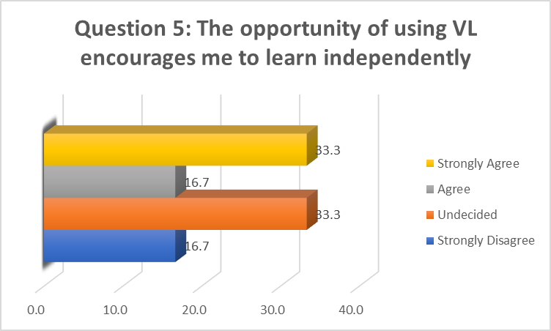
Figure 5: The opportunity of using visual learning encourages me to learn independently

Question 6
The way in which subject/course are set up under virtual learning encourages me to learn independently.
Table 6
 |  | Frequency | Percent | Valid Percent
Valid | Undecided | 6 | 50.0 | 50.0
Valid | Agree | 4 | 33.3 | 33.3
Valid | Strongly Agree | 2 | 16.7 | 16.7
Valid | Total | 12 | 100 | 100

The table above shows that learners agree at 50% that the way in which the courses are setup in the Moodle encourage them to learn independently while 50% could not decide.

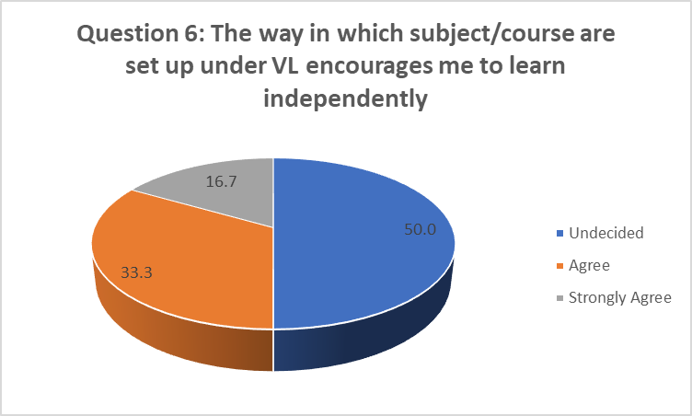
Figure 6: Virtual learning encourages students to learn independently

Question 7
Based on your own judgment, how will you rate virtual learning as a mode of instruction?

Table 7
 |  | Frequency | Percent | Valid Percent
Valid | Fair | 4 | 33.3 | 33.3
Valid | Good | 8 | 66.7 | 66.7
Valid | Total | 12 | 100 | 100

The table clearly indicates that learners’ rate virtual learning as good based on their judgements with 66.7% while 33.3% see it as fair.

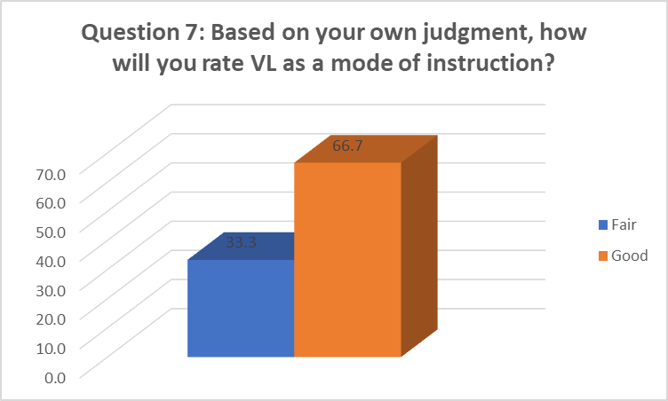
Figure 7: Students judgement rating of virtual learning

Question 8
How has virtual learning through the use of Moodle impact your effectiveness as a student?
Table 8
 |  | Frequency | Percent | Valid Percent
Valid | Undecided | 4 | 33.3 | 33.3
Valid | Positively | 8 | 66.7 | 66.7
Valid | Total | 12 | 100 | 100

The table indicates that 66.7% learners’ see positivity to the effectiveness of Moodle in their studentship. Which further means that Moodle platform is effective for virtual learning at UWTSD London campus.

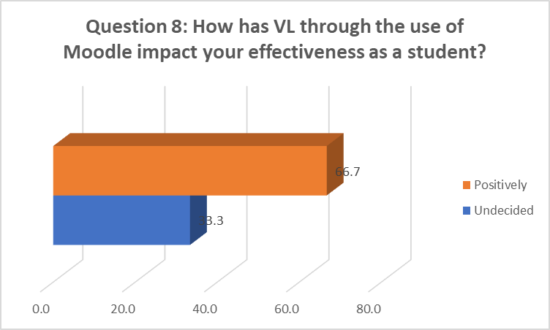
Figure 8: Impact of virtual learning through the use of Moodle on students

Question 9
On average how often are your required by your lecturers to use Moodle outside the classroom?
Table 9
 |  | Frequency | Percent | Valid Percent
Valid | Occasionally | 2 | 16.7 | 16.7
Valid | Frequently | 10 | 83.3 | 83.3
Valid | Total | 12 | 100 | 100

The table clearly proves that recently so many students have been using the Moodle platform frequently with 83.3%. this usage is as a result the recent lockdown. .

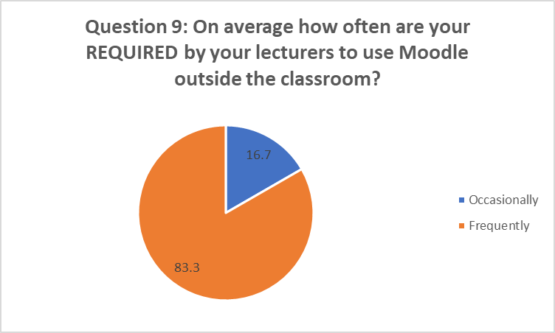
Figure 9: How often are your required by your lecturers to use Moodle outside the classroom?

Question 10
When not required by your lecturers, how often do you access Moodle outside the classroom to support your learning?
Table 10
 |  | Frequency | Percent | Valid Percent
Valid | Occasionally | 4 | 33.3 | 33.3
Valid | Frequently | 8 | 66.7 | 66.7
Valid | Total | 12 | 100 | 100

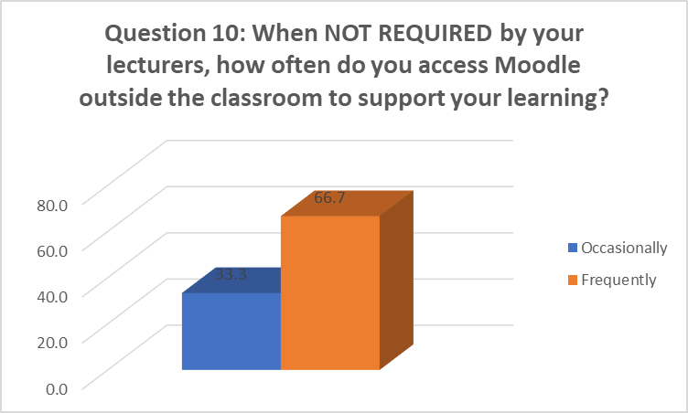
The table shows that when no required by lecturers for any activity, students still use Moodle platform to support their learning.
Figure 10: How often students access Moodle outside the classroom to support your learning without lecturer’s requirement

6.1 DISCUSSION OF THE FINDINGS
In summary, the finding clearly shows the virtual learning environment (Moodle) have impact on learning experiences of students at the University of Wales Trinity Saint David London Campus. The data analysed above from the questionnaires filled by students clearly indicates that students are familiar with virtual learning platforms, reveals that students access platforms away from their homes even when they are not required to by their lecturer. Despite the challenges experienced by students of the London campus, they still feel motivated to learn independently and better. Finally, lecturers also need to continually improve themselves.

- CONCLUSION AND RECOMMENDATION
In conclusion, this work analysed the simple concept of virtual learning environment, the Moodle platform and the tools benefits to students towards independent learning. The analysis of responses to the administered questionnaire revealed that the Moodle virtual learning platform is resourceful and enhances independent learning. It is also a platform that helped in learning during the pandemic. My recommendations are; that the Moodle learning platform be made available at all levels of education in Britain, the interface should be made more user friendly and should be done on the server and as well as to explore on how these tools can help in promoting the successes of the teaching and learning process.

REFERENCES
Fraley, R. C., Waller, N. G. & Grennan, K. A., 2000. An item-response theory analysis of self-report measures of adult attachment. Journal of Personality and Social Psychology, Volume 78, pp. 350 - 365.
Henry, P., 2001. E-learning technology, content and services. Education and Training, Volume 43, pp. 249 - 255.
Hox, J. & Boeije, ., 2005. Data Collection Primary vs Secondary. Encyclopedia of Social Measurement, Volume 1, pp. 593-599.
Leedy, P. D. & Ormrod, J. E., 2005. Practical Research: Planning and Design. 8th ed. New Jersey: Pearson Prentice Hall.
McLeod, S. A., 2019. Likert Scale. Simple Psychology.
Moodle, 2020. Moodle. [Online]
Available at: http://moodle.org/about/
[Accessed 02 January 2021].
Moodle, 2021. Moodle Statistics. [Online]
Available at: https://www.stats.moodle.org/
[Accessed 02 01 2021].
Parker, A., 1999. Interaction in Distance Education: The Critical Conversation. Educational Technology Review.
Petrova, K., 2001. Teaching differently: A hybrid delivery model. Proceedings of the GBATA 2001 International Conference, pp. 117-127.
Silva, N., Costa, G. J. M., Rogerson, S. & Prior, M., 2007. Knowledge or content? The philosophical boundaries in e-learning pedagogical theories: Research, Reflections and Innovations in Integrating ICT in Education. London: Routledge.
TechTarget, 2009. Virtual Learning Spaces. s.l.:s.n.

APPENDICES
Appendix 1 (Questionnaire)
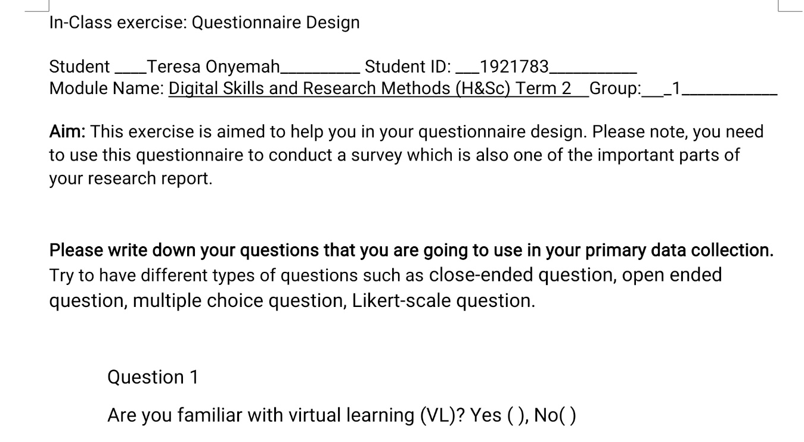

Appendix 2 (Questions Graphical Analysis)


