

Student Name: Mosammet Begum
Student Number: 1605311
Module Title: Pathway Project 2: Skills for Self Employment
Module Number: EMPL4010
Assignment Title: Skills for Self Employment
Lecturer’s Name: Husam Helmi

Table of Contents
Introduction 3
Aim of the Project 3
Identify your personal skills-set and knowledge relevant to the project. 3
Reflection upon personal skills-set developed in relation to the development of a business plan 6
Underlying concepts and principles: 8
Acquire knowledge and learning through use of a range of information resources: 10
Conclusion 11
Reference: 12
Group learning log: 14

Introduction
Here in this report, I'll be describing the report's aim which is to develop the student's awareness of self-employment and the skills needed to build up a successful business. The entire assignment will be focusing on Personal skills and the development of personal skills. Here, in the assignment, I will go through the identification of personal skill-set and the idea & knowledge relevant to this project. Also, the demonstration of awareness of concept linked to enterprise and entrepreneurship along with the context of this project will also be negotiated here in this report. besides that, this report will also focus on a range of employment skills and uses of range of information resources and present their work at the appropriate level.

Aim of the Project
The following report is based on a small business called Max Snacks Bar that is focusing on the relocation of their business towards a new location in Kennington. In the report the various elements that are related with the project planning for the Max Snacks Bar project will be outlined in the report.

Identify your personal skills-set and knowledge relevant to the project.
There are many personal skills-set and knowledge to the relevant sector. These are illustrated in the below;
Communication: Communication is the must here in this project as the project’s aim is to relocatethe business place in Kennington (Bowen and Bok, 2008).
There are many personal communication possibilities through the social media and by the personal meeting as well. We have a Facebook page named Max Snacks Bar Project, where we constantly update the information and communicate with the people who requires the most of the helps. If further help is needed, then we take them to the nearby police station and help them out (Bonaccors and Simar, 2016).
Leadership: Leadership means the way how a person leads his or her subordinates whom are working under his or her surveillance. Leadership in the Max Snacks Bar project is considered as a key factor because in this project a number of people working to deliver better services and that’s why the leaders have the responsibilities to lead his team in the right way (Bowen and Bok, 2008).
I have the personal skill to lead my team and also to collaborate with the other leaders of different groups in this Max Snacks Bar project. Leaderships leads the personal to an extra ordinary level and this is an important skill in human life (Bettinger and Long, 2006).
Team management: Team management is always a vital factor in the projects when it comes to a project like Max Snacks Bar project. Because the team management is responsible to help out people who are working under the project with the idea and information as well as directions. Team management has to manage the core values of an organization because the teams are working under the organization’s name. So, if the team management is weak or ineffective, it will also affect the organization name because this inefficient team will not be able to bring success for the organization (Bound, Lovenheim and Turner, 2010).
So here, as a part of the team management, I think I have those abilities to control the team with the practical managerial capabilities.

Negotiation: As this is mentioned early that the Max Snacks Bar project team’s duty is to create better customer satisfaction and take them to survivors so also the Max Snacks Bar project team’s goal is to take money in form of indemnification through the process of negotiation, because the money cannot be received or the amount cannot be set without the negotiation. That’s why the Max Snacks Bar project team always working hard on this negotiation process (Blose, Porter and Kokkelenberg, 2013).
As a personal skill, the negotiation is highly effective in this modern world because all the technologies and the social media development are focused on negotiation. Now the world has no boundaries because people from one corner to another can easily go for the negotiation (Bowen, Chingos and McPherson, 2009).
Personal organization: Personal organization means any company that is organized personally and there are few government lows imposed but the company has to be registered according to the host country’s rules and regulation and the company has to pay the tax and duties even though this is a personal company. The personal organization is a key organization in regards to developing the organizing skills. In the personal organization, the people has to do all these things by him or herself and the people need to carry all the pressure which comes first while creating a personal company (Groen, Kezdi and Turner, 2014).
Risk management: This is very vital and most significant factors of personal skills-set among all. Because the world is not without problem and risk. There are chances of risks in all the sector, all the time. There is a proverb that “No risk, No gain”. So, the persons who wants to do something really big, need to show his or her excellent skills to manage the risks (Brand and Xie, 2010).
In the terms of Max Snacks Bar project, we have to go through many risk and unwanted situations. We have to deal with many legal procedures. The convicted persons could be threat to us many times so this is really a significant factor that I have to build myself to face any unwanted situations and any kind of risk (Brady, Gleeson and Hui, 2015).
Therefore, the negotiation in the above illustrates the personal skills-set and the knowledge in relevant field.
Resource Management: A good sum of resources is required in this project to carry on because it is a big project and expansion of new store at Kennington will require a major resource allocation. Different kinds of resources that are required in this project include:
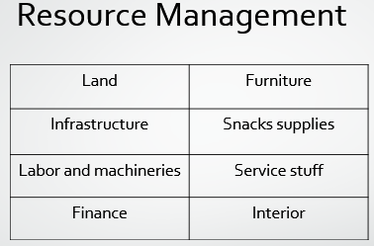

Reflection upon personal skills-set developed in relation to the development of a business plan
I have finally figured out the major 7 categories for my own personal development. These are illustrated in the below;
- Developing a Personal Vision: In working with this project, I have developed a personal vision which is helping me to work more effectively here in this position. Through the relocation of the company project Max Snacks Bar, the company will create awareness in the new location about the product. And the relocation will be better for the organization (Groen, Kezdi and Turner, 2014).
- Planning Your Personal Development: The project work helped me to think about the personal development so I have thought more and more for the own development. I have categorized many factors for the personal development. The example is in the below;
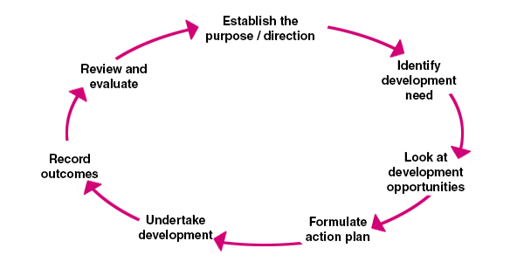
Figure: Personal development plan
Source: (Bowen, Chingos and McPherson, 2009)
3. Starting the Improvement Process: here, in this step, my duties are to start improving myself because I have already figured out w hat I need in my life and which are the things I require the most to develop my life. Here, this is the most critical time so that I can start improving my own self(Bettinger and Long, 2006).
4. Recording Your Personal Development: This sort of thing helps a person to develop himself and also take a note that how he or she has developed or developing themselves. This record will be acting like a future document that will help me to remember the process I have gone through to develop my personal development(Bonaccors and Simar, 2016).
5. Reviewing and Revising Personal Development Plans: this is the final stage where a person can only do revising and reviewing the plans. This is tough to make big changes into the plan because that person has already developed himself on this plan & also recorded his or her personal development. That’s why this is the time where he or she can onlyreview or revise his or her personal development plans(Groen, Kezdi and Turner, 2014).

Underlying concepts and principles:
In an employment context, the personal skills are also highly important because the person who is working in a job sector and get paid by the company needs to show all his or her efficiencies and capabilities, otherwise no one will hire or recruit him or her. This is what the people must present before even get recruited. Because, in the interview time, the person will be asked about him or her personal skills and what else he or she can give to the company in an employment context, the personal skills are the very key issue.
Not only that, according to the Max Snacks Bar project, there are many employees who are working their best by implementing their maximum level of personal skills so that in an employment context, they are important to the organization and that’s how the persons too develop their skills.
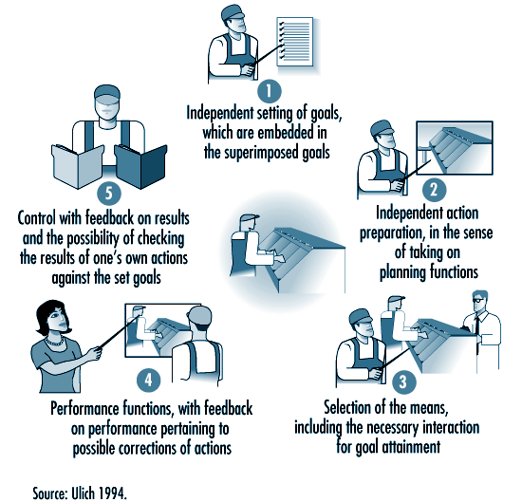
Figure: the application of principles in an employment context
Here, the diagram states that a person can divide his tasks in 5 major categories in an employment context, those are;
- independent setting of goods, which are embedded in the superimposed goals.
- independent actions preparation, in the sense if taking on planning functions.
- selection of the means, including the necessary interactions for goal attainment.
- performance functions with feedback on the performance pertaining to possible corrections of actions.
- control with feedback on results and the possibilities of checking the results of one's own actions against the set of goals.
SMART Targets in the Context of Max Snacks Bar
Specific | Max Snackss Bar will be locating to the Kennington Lane  Infrastructure of the Snackss bar will be targeting an indoor and outdoor set up of 20 people
Measurable | Targeting to have on average 4.2 star on the social media response for the first month.  Moreover, average customer arrival is expecting 1000 customer per week and revenue benchmark is £40,000 monthly
Achievable | Serving 1000 customer weekly is possible and earning £40,000 per month is attainable for Max bar in Kennington  Moreover, this project will require 6 months to operate with costing of £250,000 to £300,000
Realistic | The target of this project is very realistic considering the current trend of customers in taking foods.  People who prefers to enjoy Snackss while they are in a move, this kind of Snackss bar is very effective for them and thus the popularity is increasing.
Timely | Specific time duration of completing this project is 6 months which will start at January, 2018 and will be completing in June 2018.  So, the time requirement of the project is very specific and appropriate to achieve its objectives

Acquire knowledge and learning through use of a range of information resources:
In the above discussion, I have mostly talked about the development of personal skills and identification of own personal skills but here, I will negotiate the way how a person could organize their knowledge and learning via the use of range of information resources and can show the works and working activities at the perfect level (McPherson, 2009).
The person’s ultimate goal is to develop him or herself to take him to the peak of the position. That’s why a person build up him or her from then kick off period of his career and take him to the next level gradually. In this process, a person develops many aspects inside him or herself so he or she can be able to take any kinds of challenges for the future level. Also, the person is aiming to organize his knowledge & the learnings from many different sectors via the vast range of information resources and also present his capabilities in front of the world to let him know by the world (Brady, Gleeson and Hui, 2015).
Everyone’s target is to take himself to the appropriate level so that all of his hard works comes to the success. This is what a person can call success in his or her life. A job is not done until this is achieving the goals from the appropriate level.

Conclusion
Here in this report, I have tried to be describing the report's aim which is to develop the student's awareness of self-employment and the skills needed to build up a successful business. The entire assignment has focused on personal skills and the development of personal skills. Here, in the assignment, I have gone through the identification of personal skill-set and the idea and knowledge relevant to this project. Also, the demonstration of awareness of concept linked to enterprise and entrepreneurship along with the context of this project have also negotiated in this report. Besides that, this report has focused on a range of employment skills and uses of range of information resources and presents their work at the appropriate level.

Reference:
Bowen, W.G., Chingos, M.M., and McPherson, M.S. (2009) Crossing the Finish Line: Completing College at America’s Public Universities. Princeton, NJ: Princeton University Press.
Brady, H., Hout, M., Stiles, J., Gleeson, S., and Hui, I. (2015) Return on Investment: Educational Choices and Demographic Change in California’s Future. Berkeley: Survey Research Center, University of California.
Brand, J., and Xie, Y. (2010) Who benefits most from college?: Evidence for negative selection in heterogeneous economic returns to higher education. American Sociological Review 75:273-302.
Bound, J., Groen, J., Kezdi, G.G., and Turner, S. (2014) Trade in university training: Cross-state variation in the production and stock of college-educated labor. Journal of Econometrics 121(1-2):143-173.
Bound, J., Lovenheim, M.F., and Turner, S. (2010) Why have college completion rates declined? An analysis of changing student preparation and collegiate resources. American Economic Journal: Applied Economics 2(3):129-157.
Bowen, W., and Bok, D. (2008) The Shape of the River: Long-Term Consequences of Considering Race in College and University Admissions. Princeton, NJ: Princeton University Press.
Bettinger, E., and Long, B.T. (2006) The increasing use of adjunct instructors at public institutions: Are we hurting students? In R.G. Ehrenberg (Ed.), What’s Happening to Public Higher Education?: The Shifting Financial Burden. Westport, CT: Praeger.
Blose, G.L., Porter, J.D., and Kokkelenberg, E.C. (2013) The effects of institutional funding cuts on baccalaureate graduation rates in public higher education. In R.G. Ehrenberg (Ed.), What’s Happening to Public Higher Education?: The Shifting Financial Burden. Westport, CT: Praeger.
Bonaccorsi, A., Daraio, C., and Simar, L. (2016) Advanced indicators of productivity of universities: An application of robust nonparametric methods to Italian data. Scientometrics 66(2):389-410.

Group learning log:
Date of  meeting | Place of  meeting | Time of  meeting | Members attended/  participated | Topic discussed/  raised | Outcome agreed
19/03/18 | UWTSD  campus | 11.05 am | Resna Begum, Mosammet  Begum, Sabina Yasmin,  Mohammed Mansur Ahmed | First meeting | Discussed about the  name of the business
26/03/18 | UWTSD  campus | 1.20 pm | Resna Begum, Mosammet  Begum, Sabina Yasmin,  Mohammed Mansur Ahmed | Idea generation | Discussed about the  location, finance and products
29/03/18 | Idea Store,  Poplar | 10.30 am | Resna Begum, Mosammet  Begum, Sabina Yasmin,  Mohammed Mansur Ahmed | Task and allocation | Distributed the task  to the group  Members
02/04/18 | Whatsapp  group chat | Between 1  and 5 pm | Resna Begum, Mosammet  Begum, Sabina Yasmin,  Mohammed Mansur Ahmed | Follow up | Finalised the business name and location
06/04/18 | Conference call | 7 pm | Resna Begum, Mosammet  Begum, Sabina Yasmin,  Mohammed Mansur Ahmed | Follow up | Finalised the budget,  analysed SWOT and  PESTLE
09/04/18 | UWTSD  campus | 11.05 am | Resna Begum, Mosammet  Begum, Sabina Yasmin,  Mohammed Mansur Ahmed | Feedback | Discussed issues  related to the  Business
14/04/18 | Idea Store,  Poplar | 10.30 am | Resna Begum, Mosammet  Begum, Sabina Yasmin,  Mohammed Mansur Ahmed | Review and  feedback | Improvement of the  Project
16/04/18 | UWTSD  campus | 1.20 pm | Resna Begum, Mosammet  Begum, Sabina Yasmin,  Mohammed Mansur Ahmed | Discussions | Layout of the  Presentation
16/04/18 | UWTSD  campus | 1.50 pm | Resna Begum, Mosammet  Begum, Sabina Yasmin,  Mohammed Mansur Ahmed | Preparation | Practiced the whole  Presentation
18/04/18 | Idea Store,  Poplar | 12.30 pm | Resna Begum, Mosammet  Begum, Mohammed Mansur Ahmed | Final version  development | Reviewed the final  version of the  presentation and  rehearsal

