Marketing Essentials
BMIH4005

Marketing Plan for Moxy - Manchester City

Student name: Syeda Begum
Student ID: 2227588
Lecturer: Chris Wilkins
Word count: 1355
A marketing plan is a detailed document that covers an organizations total marketing effort, including objectives, strategies, techniques, and resources necessary to attain marketing objectives (Bowie et al.2017). It acts as a road map for all marketing initiatives and helps integrate marketing efforts with broader corporate goals. Typical elements of a marketing plan include market research, market segmentation, targeting, positioning, product creation, price, distribution, promotion, and budgeting (Housden, 2008). In addition, it measures the performance of marketing initiatives and provides an implementation schedule (Kotler & Kartajaya, 2017). The purpose of my marketing plan is to take a closer look at Moxy in Manchester City, dissecting its marketing strategy, SWOT analysis, PESTLE analysis, and partnerships.
Market segmentation is the process of dividing a large, diverse market into smaller, more similar groups of consumers with similar needs, preferences, and other traits (Kotler et al., 2020). Moxy’s demographic segmentation is aimed at millennials and Gen Z travellers who want to stay in the city centre but do not want to spend a lot of money. In terms of behavioural segmentation, Moxy - Manchester City could divide its market into travellers who want flexible, self-service lodging options and who value ease of use and affordability more than traditional hotel amenities (www.marriott.com, n.d.). See appendix 1. SWOT analysis.
Moxy Hotels is a trendy and modern hotel brand that offers a unique experience to our customers who seek affordable yet stylish accommodation. With its playful design, vibrant atmosphere and innovative technology. Moxy Hotels is a relatively new hotel brand, launched in 2014. The brand was created to appeal to the next generation of travellers who value affordability, style, and technology.
Moxy Hotels has been greatly impacted by the recent pandemic. Government policies and regulations on travel, tourism and quarantines have had a significant effect on hotels. The industry has faced unprecedented challenges. Moxy may be affected by political factors such as new or altered rules, taxes, or regulations enacted by the government. Changes in immigration regulations, for instance, could have an effect on the number of guests staying at the hotel (Okumus, Altinay, and Chathoth, 2010),
The industry is dependent on consumer income, therefore economic factors such as inflation and interest rates has had an impact with travel demand and hotel rates. Inflation, currency exchange rates, and consumer spending are just a few examples of the economic conditions that can have an effect on the hotel business (DeFranco and Bogart, 2017).
Social media and online reviews also have a significant impact on hotel reputation and customer acquisition. Guests are more likely to trust the opinions of other guests and thus the reputation of hotels on social media and review websites can significantly impact their business.
Moxy Hotels has embraced the advancement of technology to enhance the guests experience and increase operational efficiency.
Hotels must comply with various regulations, such as fire safety, health and safety and hygiene standards, which can require significant investment in infrastructure and training. Moxy must be careful to protect all personal information of guests.
Factors on the legal include new or revised laws and regulations that affect things like employee rights and guest safety (Barth, 2020). Moxy may, for instance, be affected by the implementation of new health and safety standards in response to changes in health and safety laws brought on by the COVID-19 pandemic.
Hotels are under pressure to adopt more sustainable practices and reduce their carbon footprint. This can involve investments in energy-efficient technology, waste reduction, and water conservation. Sustainable practices can also be a point of differentiation for guests. The hotel industry has recognized the importance of sustainability and has taken steps to become more environmentally friendly, but there is still much work to be done to reduce the industry's impact on the environment. See appendix 2.
When analysing and assessing competition positioning in terms of price and perceived value, the Bowman's Strategy Clock is a useful strategic tool. For instance, Moxy could implement a hybrid strategy by balancing price and perceived value. This may involve delivering additional services and amenities at somewhat higher prices, such as working with local businesses to provide unique experiences or providing more hotel amenities (Jobber and Ellis-Chadwick, 2020). Moxy can differentiate itself from rivals by providing services and amenities that cannot be found elsewhere in the market.
Moxy, a budget-friendly hotel brand targeted towards the millennial market, relies on a network of B2B relationships, partnerships, and franchises to expand its reach, tap into new markets, and offer unique experiences to guests (Thompson, 2021). Moxy may expand its reach and boost its profile in the online travel sector by forming partnerships with OTAs like Expedia and Booking.com, in addition to working with local companies.
The SMART target for Moxy Manchester City's marketing plan is to increase occupancy rates by at least 10% within the next year by targeting millennial and Gen Z tourists who value unique, local experiences and want to be immersed in the city's culture and nightlife and leveraging digital marketing channels to reach and engage with the target market (Ferrell, Hartline and Hochstein, 2021).
Moxy provides digital concierge services, smartphone check-in and check-out, and high-speed internet access in all guest rooms to improve the overall visitor experience (Tripadvisor, n.d.). The RACE model of marketing communication can be used by Moxy Manchester City to promote the hotel brand and reach the hotel's target market. The RACE model consists of the following four steps: reach, attract, convert, and engage. Moxy can employ digital marketing platforms including social media, email marketing, and online advertising to reach potential customers. The hotel can attract more customers by offering special deals and packages that showcase the hotel's distinct advantages (Chaffey and Elis-Chadwick, 2019). The hotel can employ customer loyalty programmes, social media involvement, and individualised communication to pique the interest of its guests and entice them to return. See appendix 3.
Moxy's marketing strategy is successful if it leads to higher occupancy rates, more new customers, more favourable brand perceptions, and higher profits. The quantity of new clients can be monitored by examining the variety of bookings made by customers. Customer surveys, social media activity, and reviews all provide insight into how the public perceives the company (Baker, 2017). Finally, the profitability of a hotel can be gauged by looking at its financial statistics, such as its revenue growth, ROI, and the efficiency of its marketing campaigns (Ryan, 2012).
Moxy’s selling points is the high quality of its accommodations at a price that young professionals can afford. The hotel chain stands apart from the competition by providing a lively and distinctive ambiance that is especially popular among younger guests. Moxy can reach and interact with its ideal clientele using a wide variety of digital marketing platforms (e.g., social media, email, and online travel agents) that effectively convey the estate value offer. To entice new guests, the hotel chain might also provide special deals that highlight its various services and facilities. Moxy attracts its target demographic by marketing itself as a hip, budget-friendly hotel that specialises in creating one-of-a-kind experiences at an accessible price. A way of marketing using the current trends and ideas is TikTok. Moxy – Manchester, could hold a Nationwide competition for all (UK residents only) to see who can make the best TikTok based in a Moxy Hotel room to win 5 nights free accommodation at Moxy in Manchester City. TikTok’s are the latest trend, free to use and great marketing to really get Moxy Hotels on the map! TikTok’s can be shown on all social media platforms and videos can be shared around the world.
In conclusion, a firm cannot succeed without a well-thought-out marketing plan that serves as a guide for the company's marketing efforts and ensures they contribute to the company's key objectives. Moxy Hotels target a younger demographic of customers who value design, technology, affordability, and experiences. The brand's customer profiles include young professionals, solo travellers, group travellers, and adventurers. As the industry continues to evolve, hotels must be aware of these factors and adapt their strategies to stay competitive and meet the changing needs of their guests. Today is via TikTok, tomorrow – who knows.

References
Baker, M.J. (2017). Marketing Strategy and Management. [online] Google Books. Bloomsbury Publishing. Available at: https://www.google.co.uk/books/edition/Marketing_Strategy_and_Management/DSRIEAAAQBAJ?hl=en&gbpv=1&dq=how+to+measure+the+success+of+a+marketing+strategy&pg=PP1&printsec=frontcover [Accessed 4 Mar. 2023].
Barth, S. (2020). Hospitality Law: Managing Legal Issues in the Hospitality Industry. Wiley
Bowie,D. Buttle,F. Brookes,M & Mariussen,A (2017), Hospitality Marketing. 3rd ed, Routledge, London
Chaffey, D., & Ellis-Chadwick, F. (2019). Digital marketing. Pearson Education Limited.
DeFranco, A., & Bogart, G. (2017). Hotel Asset Management: Principles & Practices. AHLEI.
Ferrell, O.C., Hartline, M. and Hochstein, B.W. (2021). Marketing Strategy. [online] Google Books. Cengage Learning. Available at: https://www.google.co.uk/books/edition/Marketing_Strategy/SewfEAAAQBAJ?hl=en&gbpv=1&dq=marketing+strategy&pg=PP1&printsec=frontcover.
Housden M (2008), Marketing Research & Information, Butterworth Heinemann, Oxford.
Jcobber, D. and Ellis-Chadwick, F (2020), Principles and practice of marketing. 9th ed. London
Kotler, P., Armstrong, G., Harris, L. and He, H., 2020. Principles of marketing. 8th European ed, London: Pearson Education Limited.
Kotler,P and Kartajaya, H. Marketing 4.0 Moving from Traditional to Digital (2017) Wiley. New York.
Okumus, F., Altinay, L., & Chathoth, P. K. (2010). Hospitality and Tourism Management Strategies. CABI.
Ryan, D. (2012) Understanding Digital marketing: Marketing Strategies for Engaging The Digital Generation. Kogan Page, London.
Thompson, R.J., 2021. Seventy-Five Years of Traveler Connectivity: An Evolution Shaping US Hospitality and Beyond. Journal of Hospitality & Tourism Research, 45(5), pp.936-938.
Tripadvisor. (n.d.). MOXY MANCHESTER CITY - Updated 2023 Reviews. [online] Available at: https://www.tripadvisor.co.uk/Hotel_Review-g187069-d23610046-Reviews- Moxy_Manchester_City-Manchester_Greater_Manchester_England.html [Accessed 4 Mar. 2023].
www.marriott.com. (n.d.). Moxy Manchester City | Marriott Bonvoy. [online] Available at: https://www.marriott.com/en-us/hotels/manox-moxy-manchester-city/overview/ [Accessed 3 Mar. 2023].
‌

Appendix
Appendix 1. Swot analysis

Strengths | Weaknesses
- Designed specifically with the millennial demographic in mind, this hotel has a one-of-a-kind idea and identity.  - Superior central Manchester location.  - Exciting, up-to-date decor  - Rooms can be arranged in a variety of ways, and guests can enjoy such conveniences as a self-service bar and a lounge that is open around.  - Joint venture with Marriott International, a prestigious hotel chain with locations across the world. | - Limited services and amenities compared to full-service hotels, such as no room service or spa facilities.  - Small room size and minimal storage space may not appeal to some travellers.  - Compared to well-known hotel brands on the market, the hotel name is not as well-known.  - It also has higher room rates than some of its competitors.
Opportunities | Threats
- More people are looking for cheap places to stay in Manchester.  - There is a chance that the Moxy brand could grow to other cities in the UK and around the world.  - More people will be reached through online travel agencies (OTAs) and mobile booking apps.  - There is a growing trend towards travel with experiences and unique, local things to do, which Moxy Manchester City can take advantage of. | - Strong competition from well-known hotel brands and other lodging options like Airbnb.  - Uncertainty about the economy and how it might affect consumer spending.  - Political instability or changes in immigration policies affecting tourism demand.  - Technological advancements disrupting the traditional hospitality industry model.

Appendix 2. PESTLE Analysis

Political | - The hotel industry may be affected by political factors such as new or altered rules, taxes, or regulations enacted by the government. Changes in immigration regulations, for instance, could have an effect on the number of guests staying at the hotel (Okumus, Altinay, and Chathoth, 2010),
Economic | - Inflation, currency exchange rates, and consumer spending are just a few examples of the economic conditions that can have an effect on the hotel business (DeFranco and Bogart, 2017). For instance, when the economy is bad, fewer people travel for business or pleasure, which means less money for Moxy Manchester City.
Social | - The hospitality sector can be influenced by social and cultural issues such as shifting consumer tastes and habits. Moxy Manchester City, for instance, may set itself apart from rivals by capitalising on the rising demand for "experiential" travel and "unique, local" experiences.  - Alterations in customer tastes and habits, such as the recent upsurge in interest in "experiential travel" and "authentic, local experiences," can have an effect on the hospitality sector. In this respect, Moxy Manchester City has an advantage because to its distinctive branding and collaborations with local businesses.
Technological | - Advances and developments in technology may have an effect on the hospitality sector. Moxy Manchester City, for instance, may capitalise on the increasing prevalence of mobile apps and digital technology in the hospitality sector to better serve its guests and streamline its operations.
Legal | - Factors on the legal include new or revised laws and regulations that affect things like employee rights and guest safety (Barth, 2020). The Moxy Manchester City may, for instance, be affected by the implementation of new health and safety standards in response to changes in health and safety laws brought on by the COVID-19 pandemic.
Environmental | - There are a number of environmental elements that can have an effect on the hotel business. A good example is Moxy Manchester City, which may benefit from the growing demand for eco-friendly hotels by adopting green practises and providing green amenities in response to rising public awareness of environmental issues.

Appendix 3. Communication Plans

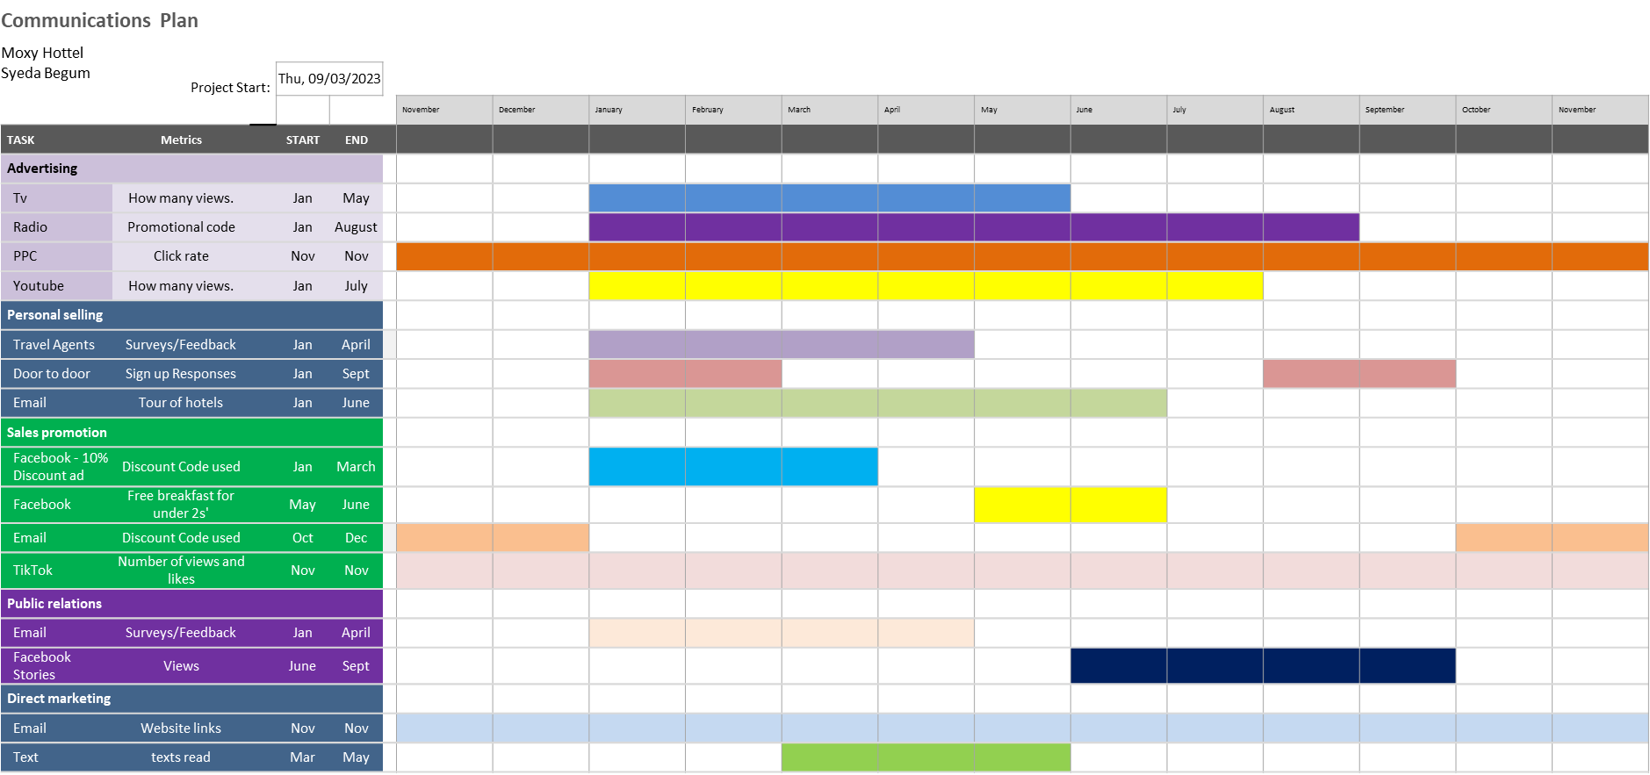

Appendix 4. Presentation slides


