Digital Signal Processing

ACDA5008

Quantifying and Comparing Modulation Methods Through Noise Error Rates.

Contents
Abstract 2
Introduction 2
Simulation Models 2
ASK 2
PSK 3
QPSK 4
QAM 6
Results 6
Discussion 7
Conclusion 8
References 8
Appendix 8

Abstract
This work was undertaken in Simulink, generating perfectly controlled environments with similar levels of noise relative to complexity, this enabled an error rate comparison of this set bit length and the corresponding errors. Allowing the creation of an objective value by which the efficacy of 4 different digital signal processing methods were evaluated against each other, these being Amplitude Shift Keying (ASK) Phase Shift Keying (PSK) otherwise referred to as BPSK (Binary Phase Shift Keying) Quadrature Phase Shift Keying (QPSK) and Quadrature Amplitude Modulation (QAM). These were all tested in a simulated environment in a period of 30 seconds, each at 50 iterations each.

Introduction
This investigation seeks to demonstrate the differences between modulation methods. These are all methods of communicating bit streams with varying levels of redundancy and complexity, each seeking to leverage features to make them suitable for specific applications. All of them are composed of mathematical functions that, among other things; filter, compress, modulate and equalization [1]. This investigation seeks to compare four signal processing methods indirectly and directly: Amplitude Shift Keying (ASK), Phase Shift Keying (PSK), Quadrature Phase Shift Keying (QPSK) and Quadrature Amplitude Modulation (QAM). The applications of each of these individual applications can be varied but still commonly share a similar domain. ASK is frequently used for short range communication and control devices along with low power control devices, and in conjunction with other methods as a validation or error management technique[2]. Whereas PSK is widely employed for Bluetooth [3] and RFID [4] applications, due to the better redundancy against conventional noise. QPSK, while sharing some similar uses with its progenitor, is largely employed for cellular communication and other radio frequency communication [5]. QAM, as a more recent method to enter widespread adoption, sees most of its modern use in Wi-Fi communication as well as digital telecommunication due to its high data throughput compared to the previously mentioned methods [6].
The primary tool with which comparisons will be made is that of the Bit Error Rate (BER), which compares the original signal and the received signal, comparing the two and creating a decimal percentage value [7]. Following this BER metric, along with other observations, this report will seek to demonstrate which of these signals performs with greater efficacy in certain conditions, along with analysing why these differences exist. This will be demonstrated inside simulated environments wherein the processes will be made and applied using an appropriate level of detail as to allow specific readings from points within the design to enable comprehension of the method.

Simulation Models

ASK
Amplitude Shift Keying is a technique that shifts the Amplitude of a transmitted signal by a fixed difference as defined by the carrier frequency against the transmitted signal. This carrier is initially merged with transmitted signal, adjusting the Amplitude such that, for instance; a sine wave would, with a binary signal, adjust at the binary value of 1 by a factor of the transmitted to the carrier, in this case 2. This is then passed along the medium, typically air but in this case, without noise, it would be a perfectly transmissive medium. Following this, the carrier multiplied before filtering, leaving the original transmitted signal when no interference occurs. In order to replicate a controlled level of interference, an Average White Gaussian Noise (AWGN) is added.
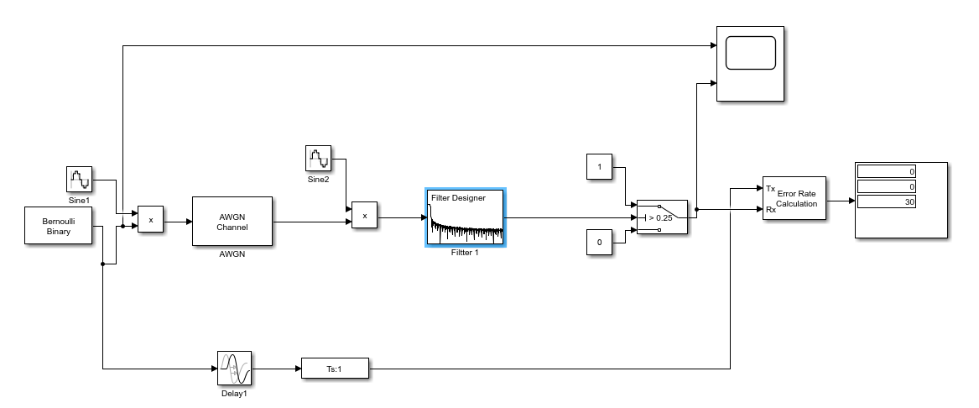
Figure 1, Above - ASK Simulink Block Diagram

The following values are given to the simulation model.

Sine 1 | F = 2*pi*2 Sample time = 0.01 A = 1 | Filter 1 | Fs = 100 Fpass = 1 Fstop = 2 Apass = 1 Astop =40  Density factor = 16
Sine 2 | F = 2*pi*2 Sample time = 0.01 A = 1 | Switch 1 | 0.25
Gen 1 | P₀ = 0.5, Samples/T = 1 SampleFrequency = 1 | AWGN | SNR = Varied

PSK
Phase shift keying utilises a method that, as compared to ASK, shifts the phase of a given signal. This is achieved in a not dissimilar way, with the primary difference being observed in the carrier pair, as one carrier from the pair is shifted by half of a phase, making it perfectly out of phase with the alternative. The results in a shift in the phase of the signal at specific points as opposed to the shift in amplitude observed in ASK. Aside from that the process is identical; Merge the respective signals at their relative points in the wave, feed through the medium, multiply out the carrier and subtract, then filter.
The following values are given to the simulation model.
Sine 1 | F = 2*pi*2 Sample time = 0.01 A = 1  Phase = 0 | Filter 1 | Fs = 100 Fpass = 1 Fstop = 2.5 Apass = 1 Astop =30 Density factor = 16
Sine 2 | F = 2*pi*2 Sample time = 0.01 A = 1  Phase = pi | Switch 1 | 0.5
Sine 3 | F = 2*pi*4 Sample time = 0.01 A = 1  Phase = 0 | Switch 2 | 0.25
Sine 4 | F = 2*pi*2 Sample time = 0.01 A = 1  Phase = pi | AWGN 1 | SNR = Varied
Gen 1 | P₀ = 0.5, Samples/T = 1 SampleFrequency = 1
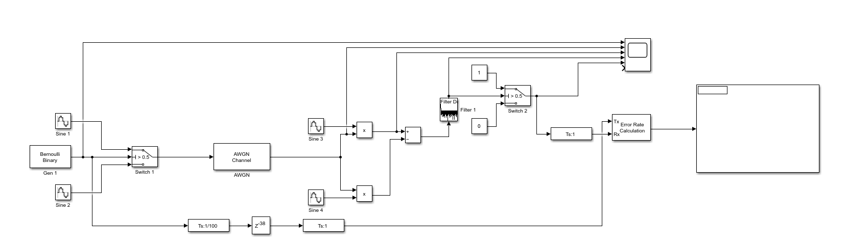
Figure 2, Above - (B)PSK Simulink Block Diagram
In this instance, BPSK was elected for an example due to the ease of demonstration that accompanies a binary method, however, a random integer could be implemented and then a series of switches used for greater binary quantities, or a general gradient shift could be applied to emulate a true PSK.

QPSK
Quadrature Phase Shift Keying is a more complex technique that also uses a phase shift method. Not only does QPSK shift the phase, but partially because of converting the incoming signal to bit vectors, then summing these reserialised transmissions, there are two signals, hence the titular ‘Quadrature’, after the vector is shifted back to a scale of 0 to 1 as opposed to -1 to 1. This is then critically separated and filtered separately, then switched together and serialised, with this serialisation creating a replicated quantity resembling the original transmitted signal.
The following values are given to the simulation model.
Sine 1 | F = 2*pi*2 Sample time = 0.01 A = 1  Phase = 0 | Filter 1 and Filter 2 | Fs = 100 Fpass = 0.75 Fstop = 2.25 Apass = 1 Astop =30  Density factor = 16
Sine 2 | F = 2*pi*2 Sample time = 0.01 A = 1  Phase = pi/2 | DSR 1 | Ratio O/I = 2, Idle Cycle = 0 Init = 0
Sine 3 | F = 2*pi*4 Sample time = 0.01 A = 1  Phase = 0 | SSR 1 | Ratio O/I = 2, Idle Cycle = 0
Sine 4 | F = 2*pi*2 Sample time = 0.01 A = 1  Phase = pi/2 | Switch 2 | 0.5
Gen 1 | P₀ = 0.5, Samples/T = 1 SampleFrequency = 1 | AWGN 1 | SNR = Varied
Switch 1 | 0.5
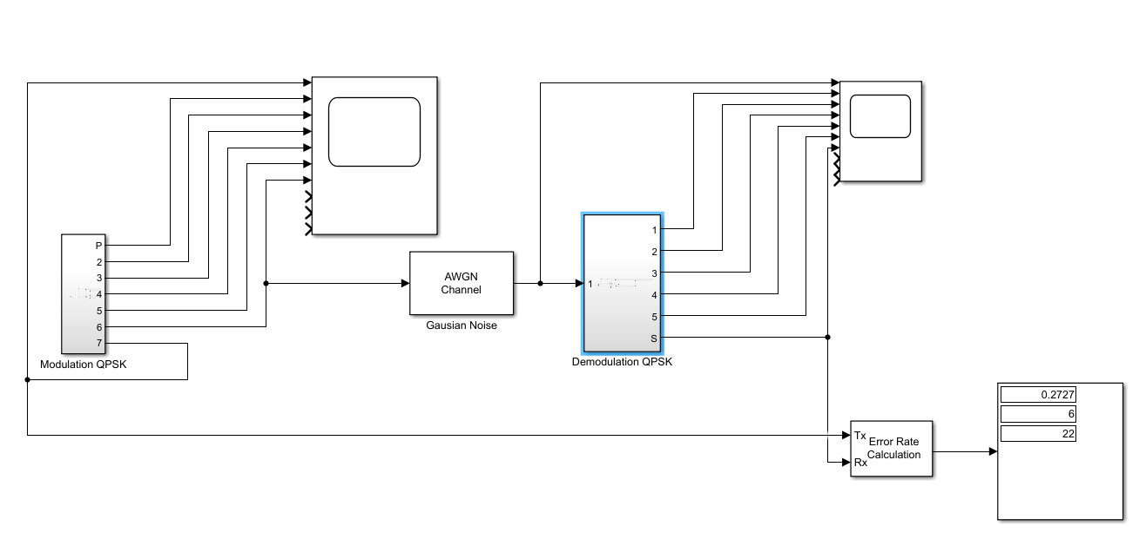
Figure 3, Above - Overview of QPSK Simulink Block Diagram
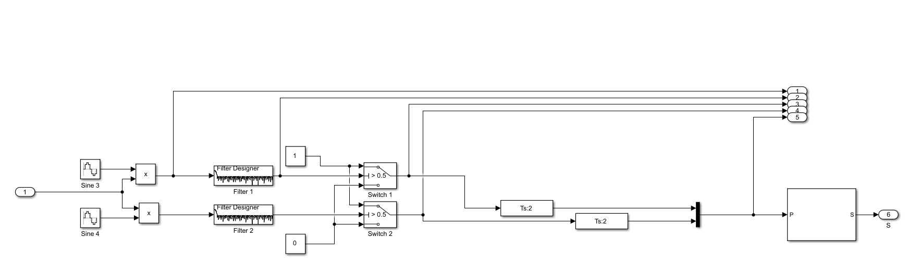
Figure 4, Above - Demodulation layer of QPSK Simulink Block Diagram
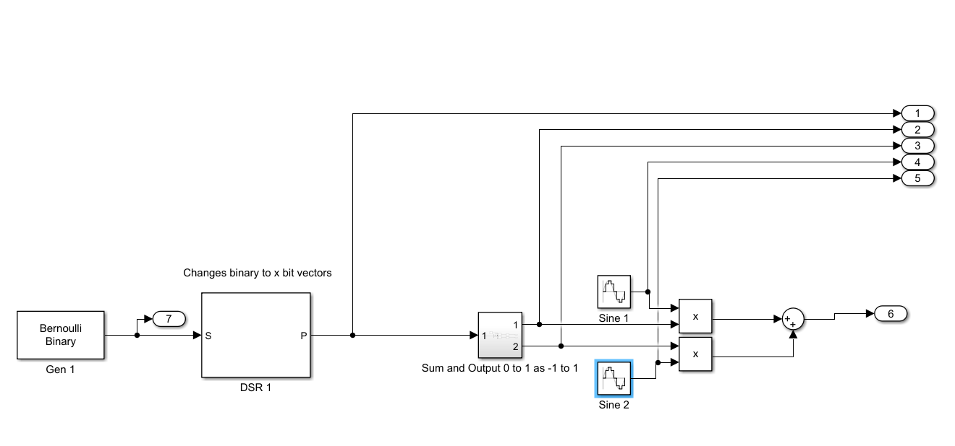
Figure 5, Above - Modulation Layer of QPSK Simulink Block Diagram

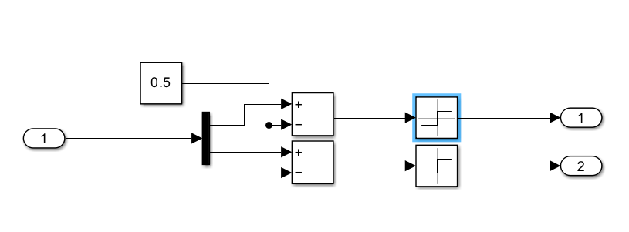
Figure 6, Above - Sum and Output Layer of QPSK Simulink Block Diagram.

QAM
Quadrature Amplitude Modulation is designed to be a highly efficient data modulation method that combines amplitude modulation signal into a single channel, splitting a given signal into two recognisable waveforms. Similar in concept to QPSK but instead allowing a bandwidth that varies by a factor of two from the originator. To demodulate, the signal should be modulated, phase shifted and then passed through a low pass filter. To modulate, the inverse should be true, modulated against the phase shifted signal of 100 Gradians, which in turn is modulated by A*sinωc*t, then the two signals should then be summed to produce the modulated signal in a single channel. 16-QAM uses a 4 bit data set for transmission[8], which is what was tested in the following system.
Due to unforeseen complications with the model initially intended for use, a higher-level Simulink model has been simulated as to provide an evaluation of efficacy, as such, the following values were demonstrated within HDL and applied by Simulink.
Gen 1 | P₀ = 0.5, Samples/T = 4 SampleFrequency = 1
MOD 1 and DEMOD 1 | Binary, average power (watts) = 1, Phase offset = 0.
AWGN | Varried

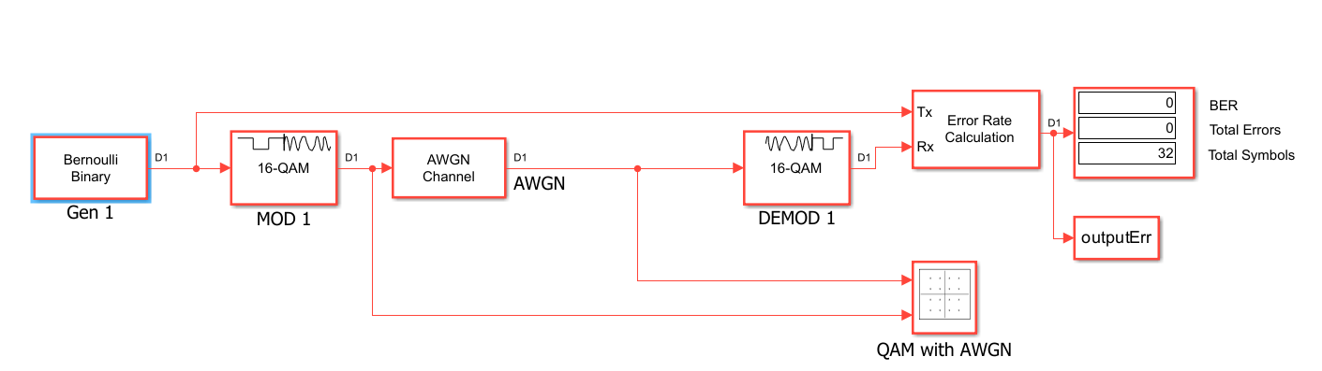
Figure 7, Above - QAM Simulink Block Diagram

Results
The results appeared largely as expected. Theoretically, BPSK should have the lowest error rate with such a simple, low data rate signal. The results were collected into a sheet comprising of 50 runs of each, from 20 to -25 for the Signal to noise ratio (SNR), which is measured along a dB scale. With BPSK and ASK following a more logarithmic curve than the two quadrature methods, while the exact form of the QPSK and QAM lines follow a somewhat peculiar pattern, this may just be attributed to randomness as the general trend is still present. This Trend would likely be remedied by allowing a greater size of dataset, however, due to time and computational limitations, it was deemed that this would yield a significant enough change proportional to the data size already monitored and there being no specifically identified factor invalidating the existing data.
It is also possible to observe the QAM and ASK line exceed 0.5 and approach around 0.6, or a 60% error rate. In this case, it is safe to assume that any points between 0.4 and 0.6 are encroaching upon random chance and, as such, should be discounted for their exact numeric value and instead considered for their proximity to a 0.5 error rate – otherwise known as a perfect error rate.

Figure 8, Above - Bit Error Rate Graph

Discussion
As observed in the results section, there is an undeniable abnormality to the QPSK bit error rate, but aside from that, the results largely look as expected [9]. On such a small scale, it would be difficult to approximate a more exact comparison of figures, and in future investigations, larger bit amounts than 30 to 32 should be considered as to reduce the effect of randomness on the relatively short bitstream.
Due to the nature of ASK and BPSK not incorporating a quadrature component, the complexity of the modulation and demodulation is reduced, this complexity allows for a greater data-throughput but also generating a magnified noise footprint due to its presence in the demodulation. While this is largely factored out through the filtering process, it is still present to a greater degree than in the simpler keying methods. Out of ASK and BPSK, it is possible to observe that they both bear similarities, BPSK seems to surpass ASK, despite their similarity when it comes to sub 0 SNR ratios, a commonality not shared by the Quadrature methods.
In ideal circumstances, an infinite number of tests would be completed, along with several components being more controlled than alternatives. As statistical anomalies skew results more dramatically, a correct comparison dictates identical variables where possible. Due to the difficulty managing randomness in a scientific testing environment, Simulink does incorporate a random method that includes a seeding method. As such, in a retrial, a larger set and identical seeds for the 4 models should be replicated.
Regardless of improvements to the methodology, we do see expected outcomes in terms of the efficacy of the methods sought to test. However, it is worth noting that this is hardly a conclusive test. QPSK and QAM, while designed for the same medium, are designed for distinct applications, in much the same way that a linguistic family would house differences. In these simple cases with a fixed, small, simple transmission with little consideration for actual representation of a real world application, the progenitor of ASK largely maintains a high level of efficacy despite seen a lower usage rate as a large scale data transfer method in comparison to QPSK and QAM, having been conceived as early to assist in transmission of morse code prior to the widespread adoption of radiocommunications in a more consumer based sense, with far smaller data packets being transferred. BPSK is a similar complexity but utilising pulse shifting, which is generally more resistant to gaussian noise, due to gaussian noise producing noise samples units that, on higher frequency models, increasingly distorts the demodulation of an amplitude model, as can be observed by the greater rate of increase in ASK as the noise increases in veracity.

Conclusion
In summary, BPSK performed best in this example, maintaining a lower BER and rate of BER increase when compared to QPSK and QAM, while ASK faired well when lower noise levels were considered. Some errors and problems were identified with the testing method, there was nonetheless a valid conclusion to draw from. Additionally, it is noted that this conclusion is valid for the specific or similar settings. Due to the nature of the more complex quadrature methods, this test is not an accurate representation of the aspects for which they were designed most effectively for. Thusly, any further consideration because of this report should conduct further tests in environments that adequately explore complex, real world environment simulations for any physical application. Also finding that an unknown randomness, such as that used in the Simulink model, can lead to additional unexpected errors if not applied using a consistent uniform randomness, as opposed to non-uniform seeded random, seeming to create a trend, or lack thereof, where not present.
Despite the complexations of realistic simulation environments, the investigation was largely a success in establishing the desired goals and did evaluate the objective effectiveness of the techniques in this with a similar and simple repeatable constant source.

References
[1] L. Tan and J. Jiang, Digital signal processing: Fundamentals and applications. 2018. doi: 10.1016/C2017-0-02319-4.
[2] M. W. Sadiq and M. A. Kabir, ‘Design and implementation of reconfigurable ASK and FSK modulation and demodulation algorithm on FPGA (Field Programmable Gate Array)’, Sensors International, vol. 3, p. 100155, 2022, doi: 10.1016/j.sintl.2021.100155.
[3] M. Steer, ‘2.13: Phase Shift Keying Modulation’, North Carolina State University, LibreTexts.
[4] K. S. Faraj and S. Jabber Fidawi, ‘Phase Shift Keying (PSK)’, Jul. 2020.
[5] G. Charlet and P. Pecci, ‘Ultra-long haul submarine transmission’, in Undersea Fiber Communication Systems, Elsevier, 2016, pp. 165–235. doi: 10.1016/B978-0-12-804269-4.00005-2.
[6] S. Chen and A. M. Wyglinski, ‘Digital communication fundamentals for cognitive radio’, in Cognitive Radio Communications and Networks, Elsevier, 2010, pp. 41–83. doi: 10.1016/B978-0-12-374715-0.00003-4.
[7] A. Xiang et al., ‘Design and Verification of an FPGA-based Bit Error Rate Tester’, Phys Procedia, vol. 37, pp. 1667–1673, 2012, doi: 10.1016/j.phpro.2012.02.492.
[8] M. Matthé and G. Fettweis, ‘Conjugate root offset-QAM for orthogonal multicarrier transmission’, EURASIP J Adv Signal Process, vol. 2016, no. 1, Dec. 2016, doi: 10.1186/s13634-016-0342-2.
[9] M. G. Sadeque, ‘Bit Error Rate (BER) Comparison of AWGN Channels for Different Type’s Digital Modulation Using MATLAB Simulink’, Accessed: Nov. 02, 2023. [Online]. Available: http://asrjetsjournal.org/

Appendix

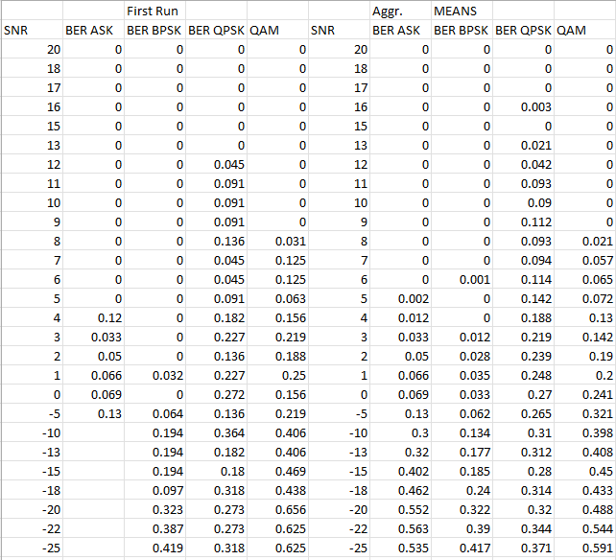
Table of BER first and average aggregate of results.

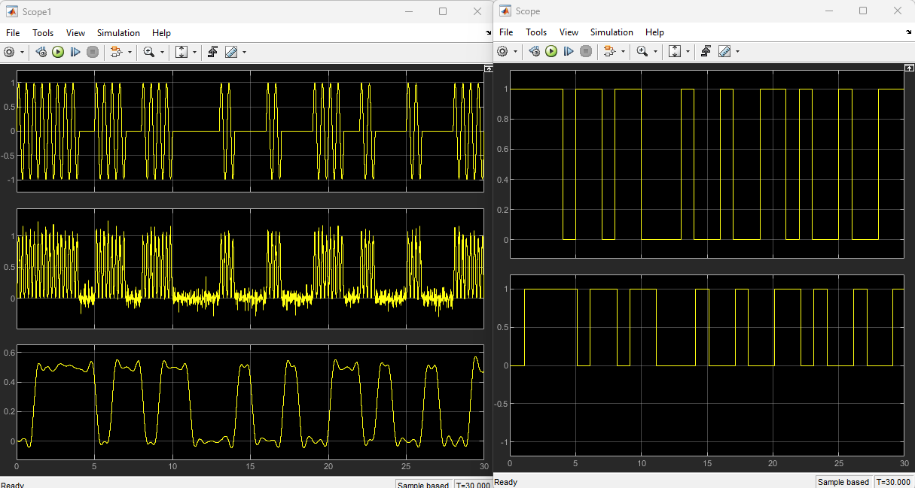
Scopes of ASK, post noise and modulation, with original and received signals.
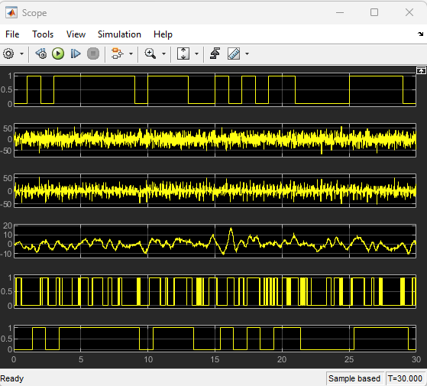
PSK Scope captures of sent and received signals, with the steps in-between with noise and modulation/ Demodulation.
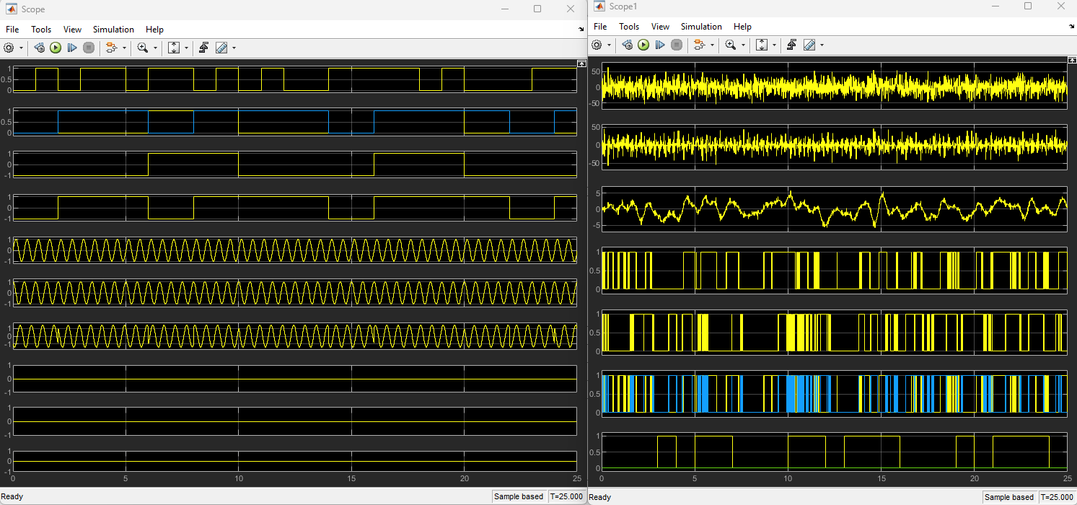
Scope captures of QPSK of all steps of modulation and demodulation.

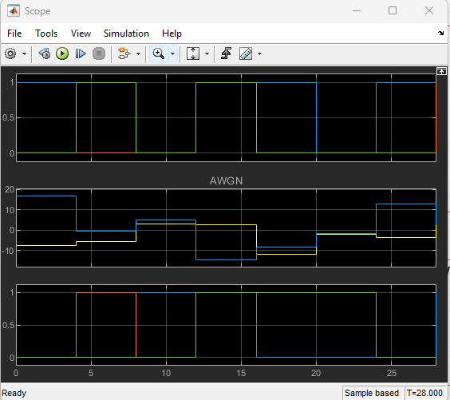
Scope capture of QAM signal modulation with noise
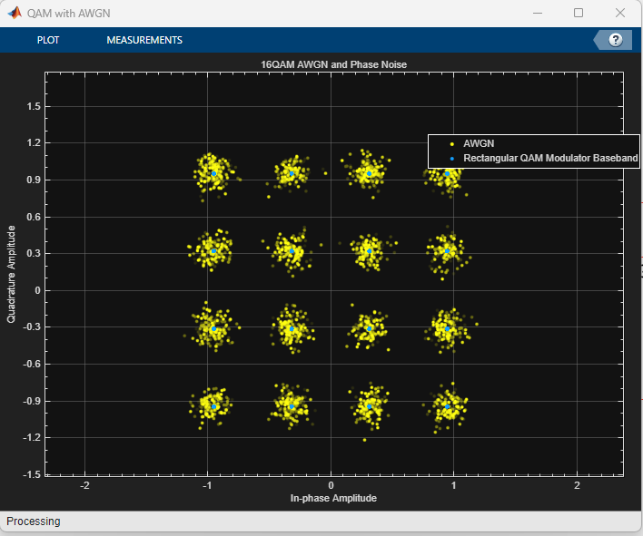
Constellation diagram of QAM with minimal noise.

