Task 1

NBFM modulation and demodulation
The information to support the development of the GNU radio NBFM transmitter and receiver is reference from [1]- GNU radio NBFM transmit which was able to support the understanding of how NBFM transmission and receive works using GNU radio.
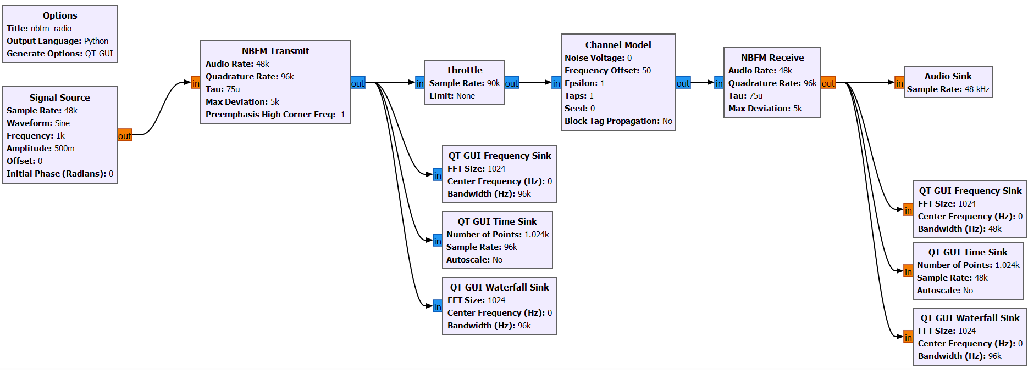
Figure 1 GNU radio flowgraph for NBFM transmitter and receiver with modulation and demodulation
Figure 1 is a flowgraph for an NBFM transmitter and receiver with modulation and demodulation of an audio signal. The top water fall sink is the plot after the NBFM transmitter block and it shows during transmission the central frequency band is between -1.71k – 5.12kHz. The waterfall sink below shows the frequency bands after the NBFM receive block and the signal has been demodulated showing a narrower frequency band between -5.97k – 6.93kHz.
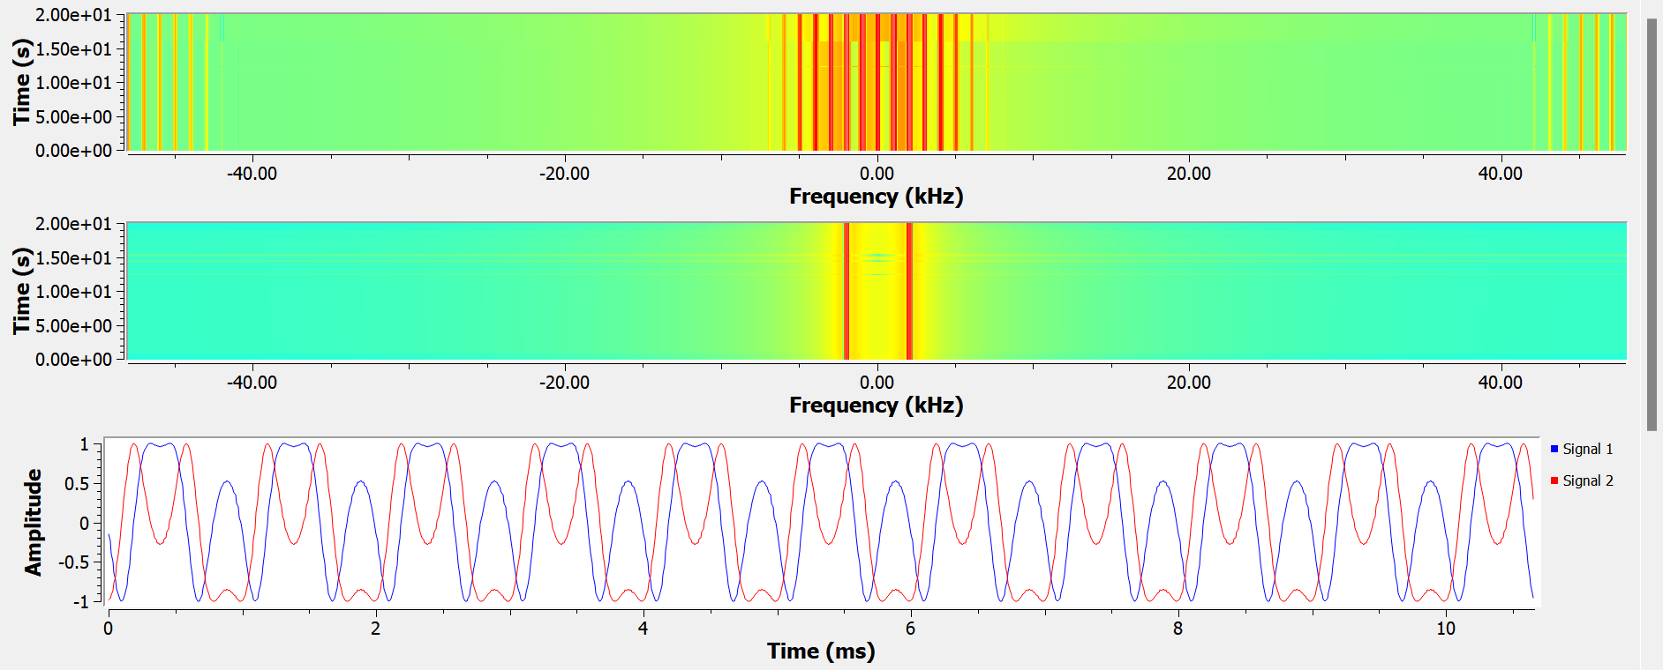
Figure 2 Waterfall sinks for the modulated and demodulated signal
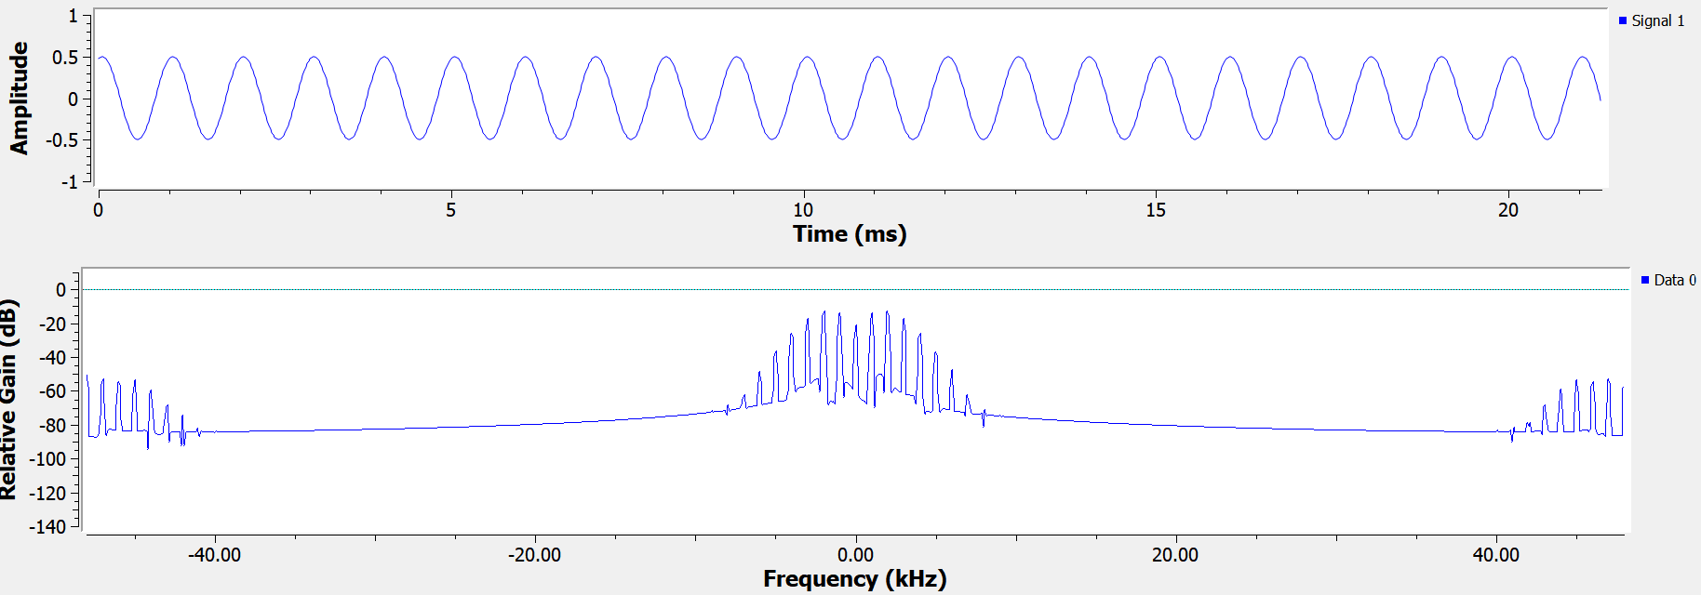
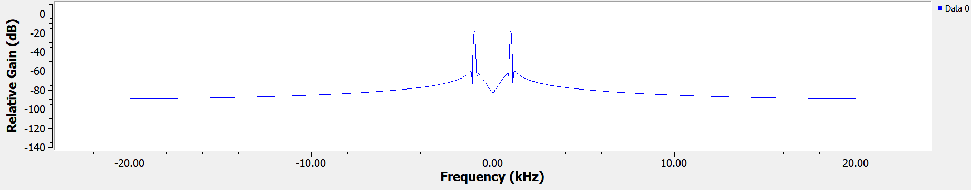
Figure 3 Frequency sinks first for the modulated signal and then the demodulated signal
For the first frequency sink of the modulated signal the highest peak is at 5kHz frequency where the gain is -20db which shows this is where the modulated signal is strongest with the highest frequency. The second frequency sink for the demodulated signal has two equal height highest peaks between -1.07k – 0.97kHz with equivalent elative gain od –22dB and -24Db.
WBFM and NBFM transmitter and receiver design and jamming analysis
An NBFM transmitter modulates a narrow band signal with the input audio signal.
Audio signal $m(t)$ is the input audio signal that needs to be transmitted.
Frequency modulation: The audio signal $m(t)$ modulates the carrier frequency of $f_{c}$ and the modulated signal can be expressed as:
$$s\left(t\right)= A_{C}\cos\left(2πf_{c}t+2πk_{f}\int_{0}^{x}{m(x)}dx\right)$$
$A_{C}$ is the carrier amplitude, $f_{c}$ is the carrier frequency, $k_{f}$ is the frequency deviation constant and $m\left(x\right)$ is the message signal.
The band pass filter is the implemented filter which removes any unwanted frequencies outside of the desired specific bandwidth in the modulated signal and suppresses any unwanted sidebands.
The power amplifier’s purpose is to amplify the filtered signal to the appropriate power for transmission.
$s_{amplfied}\left(t\right)=G . s(t)$ where G is the gain of the amplifier.
The amplified signal is then transmitted through the antenna at the required power level.
On the receiver side, the NBFM receiver demodulates the received narrow band FM signal to recover the original audio signal. The antenna receives the transmitted signal and is amplified to a suitable power.
$$r_{amplified}\left(t\right)=G .r(t)$$
The amplified signal is down converted to an intermediate frequency (IF)
$r_{IF}\left(t\right)= r_{amplified}(t)\cos\left(2πf_{LO}t\right)$ where $f_{LO}$ local oscillator frequency.
The bandpass filter will remove any unwanted frequencies by attenuating them from the IF signal. The IF signal then passes through a frequency discriminator to recover the audio signal $m(t)$
$m_{out}\left(t\right)=\frac{1{dθ}_{(t)}}{k_{f}dt}$ where $θ(t)$ is the phase of the received signal.
The output from the discriminator is filter through a low pass filter, leaving the audio signal which is then amplified to a suitable threshold through an audio amplifier.
NBFM and WBFM differ mathematically in their expressions for the modulated signal and the bandwidth.
NBFM: Modulated signal $s_{NBFM}\left(t\right)=A_{C}\cos\left({2πf}_{c}t+2πk_{f}\int_{0}^{x}{m\left(x\right)dx}\right)$
Bandwidth ${BW}_{NBFM} ≈2\left(∆f+ f_{m}\right)$ where delta f is the frequency deviation and f max is the maximum frequency.
WBFM: Modulated signal $s_{WBFM}\left(t\right)= A_{C}\cos\left({2πf}_{c}t+2πk_{f}\int_{0}^{x}{m\left(x\right)dx}\right)$
Bandwidth ${BW}_{WBFM} ≈2\left(∆f+ f_{m}\right)$
In the case of narrow band FM, the signal to noise ratio is lower due to the narrower bandwidth of transmissible frequency and lower frequency deviation making it more suitable for voice communication. In wide band FM, the bandwidth is higher around 200k – 250kHz compared to 10k – 15kHz for narrow band and so in wide band FM there is a high signal to noise ratio and better noise immunity with less effect from channel interference.

Adding a jamming at the transmitter using a noise source
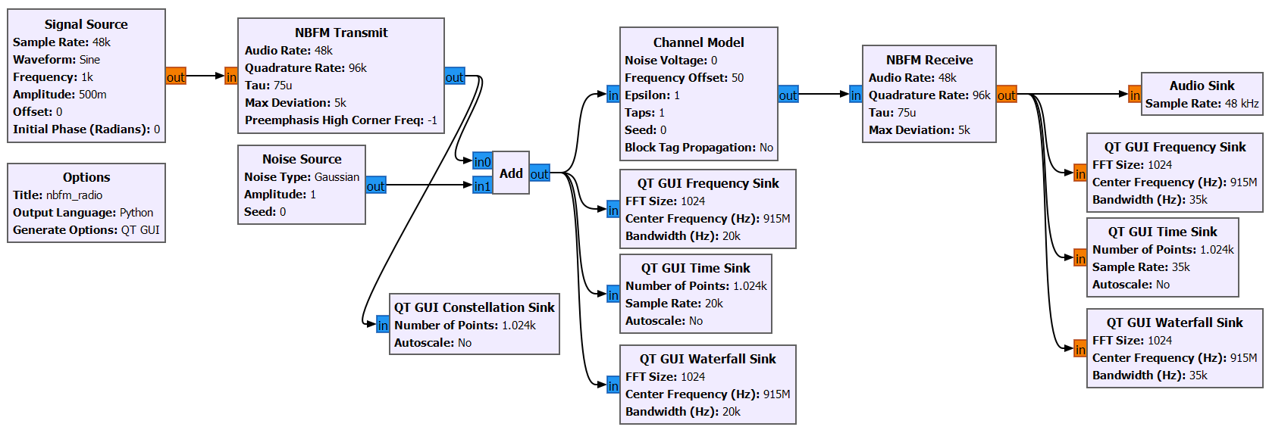
Figure 4 A jammer added to the NBFM transmitter
This is the GNU radio flowgraph of an NBFM transceiver after a jammer has been added in the form of Gaussian noise to disrupt and block the carrier signal being modulated and demodulated and prevent some of the information being transmitted to be correctly received and decoded.
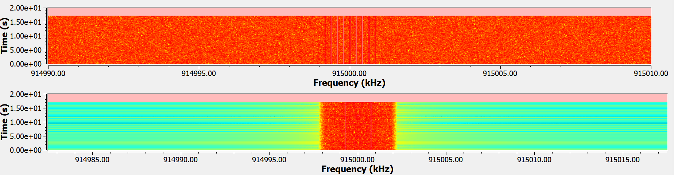
Figure 5 Waterfall sinks for the modulated and demodulated signal after a jammer has been added
The figure above shows the frequency sinks for the modulated and then demodulated signal after a jammer was added to the transmitter which shows the central frequency band is centred around 915MHz.
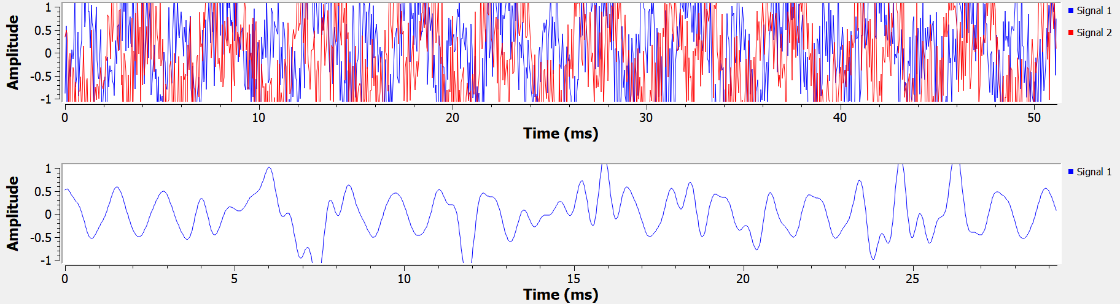
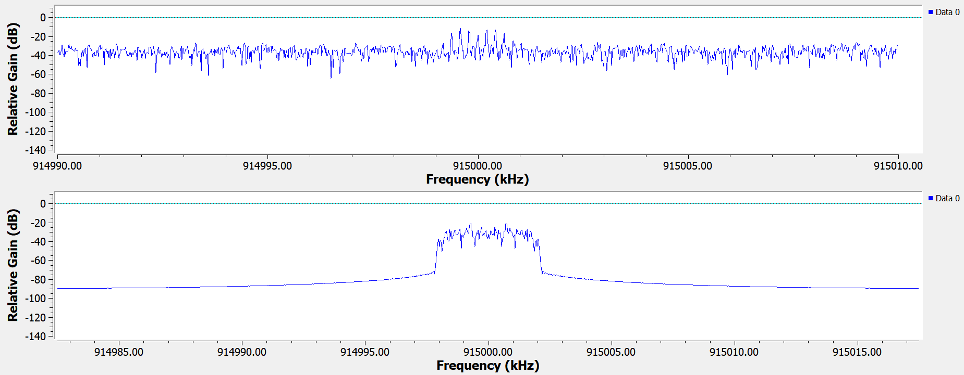
Figure 6 Time and frequency sinks for the modulated and demodulated signals after adding a jammer
The frequency sink for the modulated signal shows the
Top centre frequency 915MHz at relative gain of -18DB bottom centre frequency at relative gain of -22db.

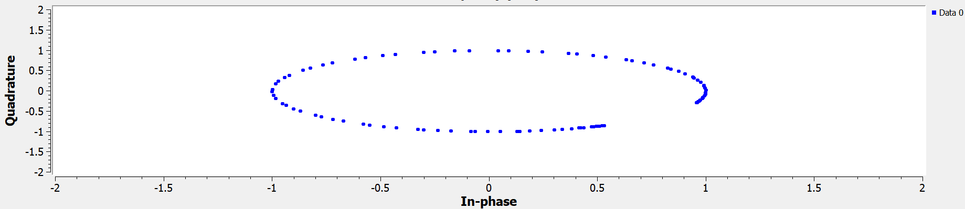
Figure 7 Constellation sink of the demodulated signal after adding a jammer
FM communication
FM (frequency modulation) communication is a method of encoding and decoding information in a carrier wave by changing the frequency in proportion with the amplitude of the signal. In FM, a carrier wave is a high-frequency signal that carries the information (such as sound, data, etc.) and acts as the base for the modulation function. The carrier frequency is typically in the megahertz (MHz) range for radio applications is generally fixed.
To encode the information, the frequency of the carrier wave is varied in proportion to the amplitude of the input signal is the information that’s to be transmitted. This means that when the audio signal increases in amplitude, the frequency of the carrier wave increases, and when the signal decreases, the frequency decreases. The result is a modulated signal with frequency changes that correspond to the original information. At the receiver end, a demodulator (FM radio receiver, for example) detects the variations in the frequency of the received signal and converts them back into the original information. The receiver only needs to track the frequency changes, not the amplitude, to recover the signal.
In FM, the amount of frequency variation (deviation) is directly proportional to the amplitude of the modulating signal. The greater the input signal's amplitude, the more the carrier's frequency is shifted from its central frequency. FM offers higher audio fidelity compared to AM, making it more suitable for music and high-quality audio broadcasts and due to the nature of frequency modulation it is more resistant to static noise and interference making it a suitable modulation type for congested radio frequency environments. FM requires considerably more bandwidth compared to AM, which means fewer stations can fit into the same frequency range and this can lead to congestion in crowded frequency bands.
Anti-jamming techniques
There are several types of spread spectrum technologies which mitigate against the effects of jamming. Frequency Hopping Spread Spectrum (FHSS) is a method of transmitting radio signals by rapidly switching the carrier frequency among multiple frequencies within a specific bandwidth and it is designed to improve security, reduce interference, and reduce the effects of jamming. In FHSS the transmitter and receiver need to have a constant hopping sequence through both the transmitter and receives that dictates which frequencies to use. The transmitter sends small bursts of data on one frequency, then quickly jumps to another frequency according to the predefined hopping pattern. The receiver follows the same hopping sequence to correctly receive and decode the transmitted data. As the signal is spread across multiple frequencies, the receiver reassembles the data correctly and this method ensures that if one frequency is jammed or interfered with, the system can still receive the message on other frequencies. FHSS signals are resistant to narrowband interference because the signal hops to a different frequency band in a short time interval within the predefined hopping pattern. Therefore, signals are difficult to intercept if the frequency-hopping pattern is not known and jamming is difficult because without knowing the hopping pattern the signal can only be jammed for a single hopping period.
FHSS can be categorized into two main types: slow frequency hopping (SFH) and fast frequency hopping (FFH). In SFH the frequency changes at a slower rate compared to the symbol transmission rate and several bits are transmitted before hopping to the next frequency and is often implemented in GSM (Global System for Mobile Communications). In fast frequency hopping (FFH) the frequency changes at a much faster rate, sometimes multiple times per symbol and so forms a higher resistance against jamming and interception and is often found in radar systems.
Time Hopping Spread Spectrum (THSS) is another spread spectrum communication technique that transmits data in short bursts at specific time intervals determined by a random sequence. This method enhances security, reduces interference, and provides resistance to jamming however, unlike frequency hopping spread spectrum (FHSS), which changes carrier frequency, THSS varies the time intervals where data is transmitted. A pseudo-random sequence of hopping determines the exact moments in time when transmission occurs within a defined time frame however, instead of continuous transmission, data is sent in fragments, reducing the likelihood of detection and jamming. The receiver follows the same hopping pattern to correctly decode the message. The data is spread across different time intervals and so the receiver collects the bursts and reconstructs the full message. This method makes it challenging for an interceptor to predict when the transmission will occur, improving security and robustness.

Implementing FHSS for anti-jamming
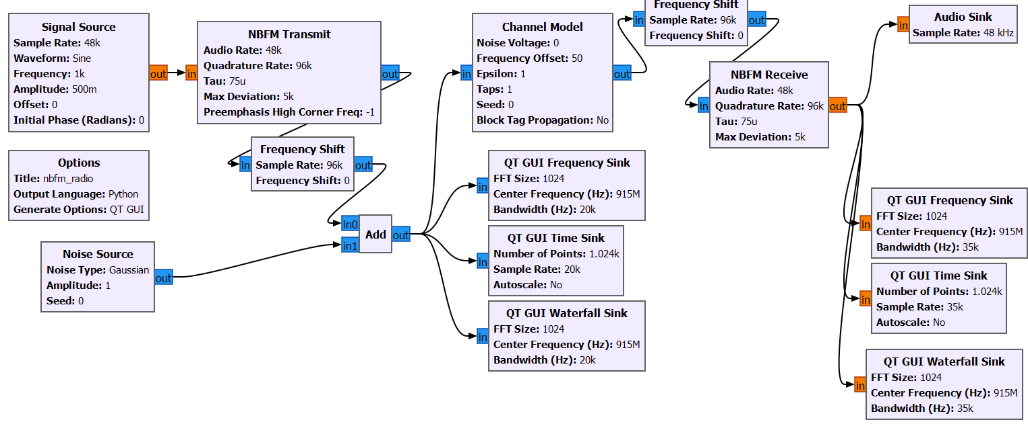
Figure 8 FHSS implemented against a jammer in an NBFM transceiver
This is a GNU radio flowgraph after FHSS has been introduced to limit the effects of the jammer. The FHSS technique mitigates against jammers by rapidly switching the carrier frequency during transmission. This makes it difficult for a jammer to target a specific frequency, as the signal moves across multiple frequencies within a given band. If a jammer manages to interfere with one frequency, the system only encounter s short interruptions, and the data can still be recovered from the unjammed frequencies. This signals are shown in the constellation sink to show the in phase and quadrature pattern of multiple signals. Figure 9 shows that with FHSS introduced against the jammer the noise implemented before transmission is significantly suppressed and the signal is more concentrated and its more likely that more of the information will be able to be received and recovered.

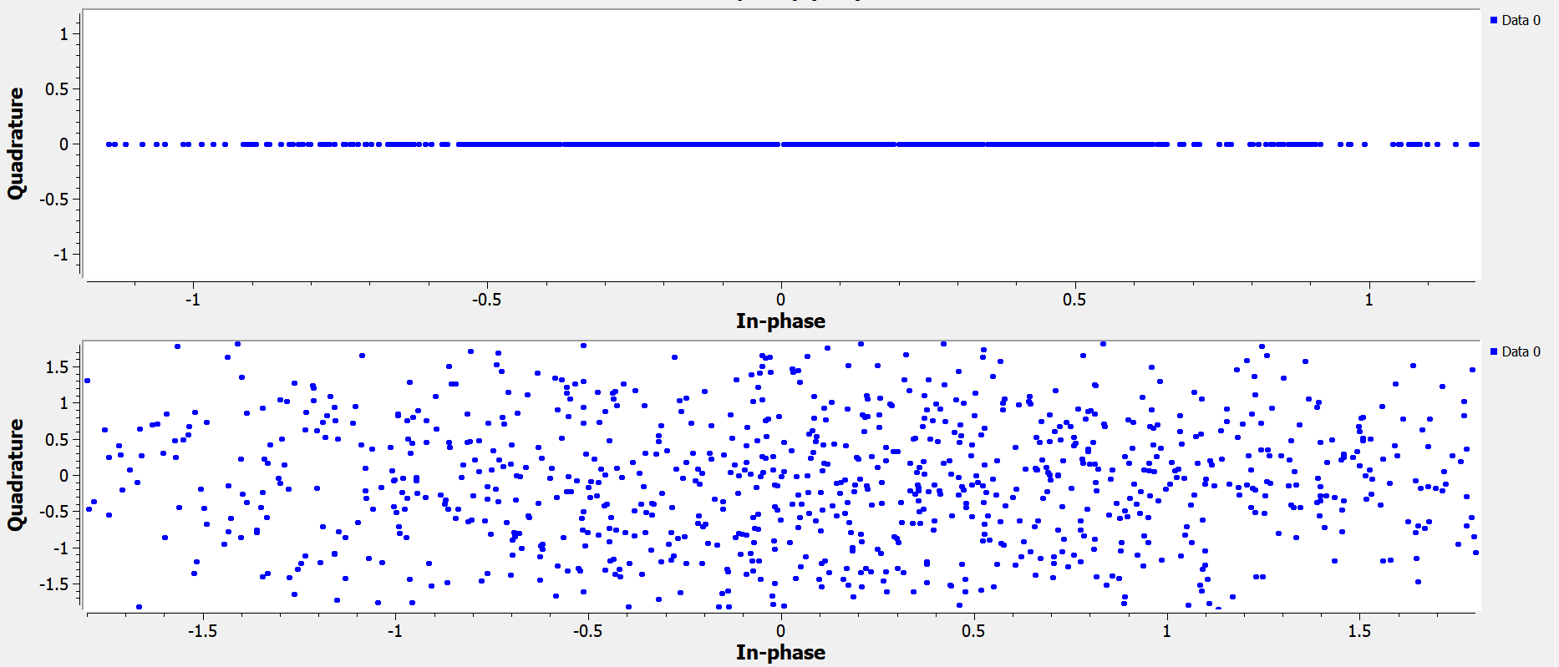
Figure 9 Constellation sink using FHSS against the jammer

Analysis and comparison
Below shows the GNU radio flowgraphs and the associated constellation sinks of the NBFM transmitter and receiver in Figure 11, the NBFM system with a jammer added in Figure 13 and in Figure 15 FHSS has been added to mitigate the effects of the jammer.
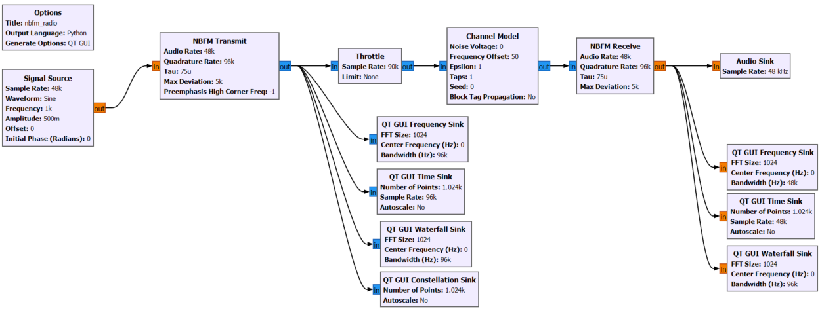
Figure 11 GNU radio graph of the NBFM transmitter and receiver
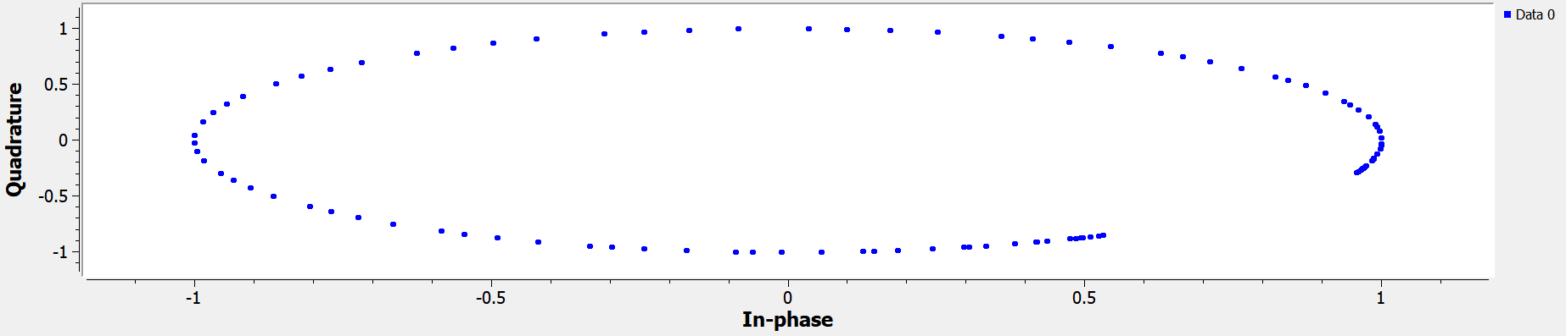
Figure 12 QT constellation sink for the above flowgraph
The QT constellation sink shows that for the original signal after it has been transmitted in NBFM the signal is in an in phase relationship pattern.
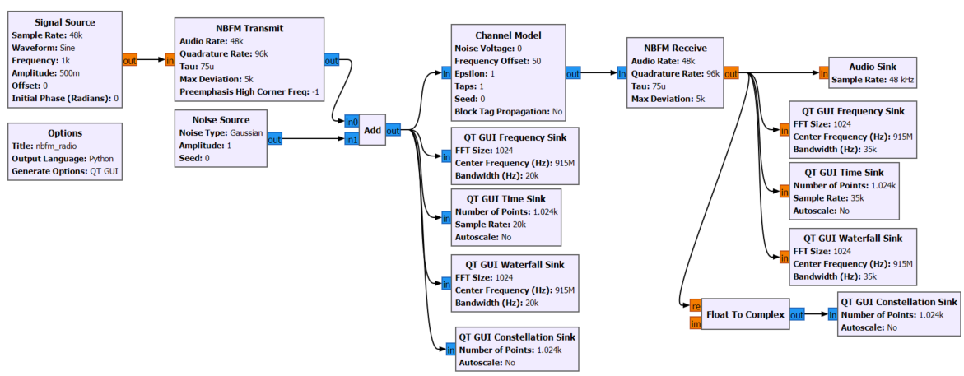
Figure 13 NBFM transmitter and receiver with a jammer added in GNU radio
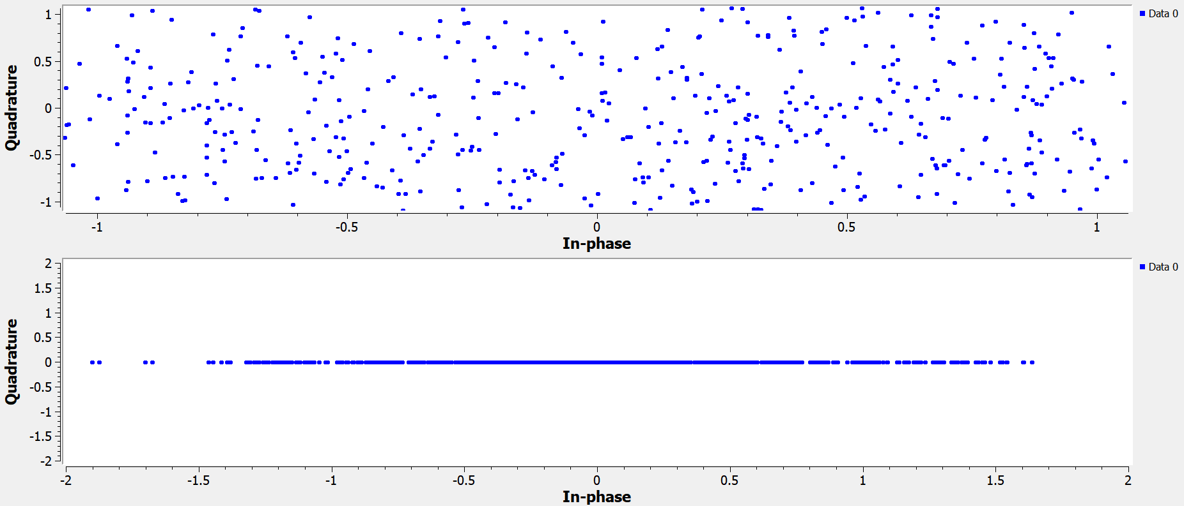
Figure 14 Constellation sink for when a jammer is added
The figure showing the QT constellation sink for the above flowgraph which is NBFM transmit and receive modulation and demodulation with a jammer added shows the jammer has significant effect on the signal distorting it and preventing the original signal being modulated correctly. The constellation sink shows there’s no phase relationship between the original signal and the noise and that there’s significantly more noise than signal in the system. The second constellation sink below shows a straight line with short and long bursts around the quadrature value of 0 on the y axis showing that after the signal has been received and demodulated a large quantity and high quality of the original signal is restored.
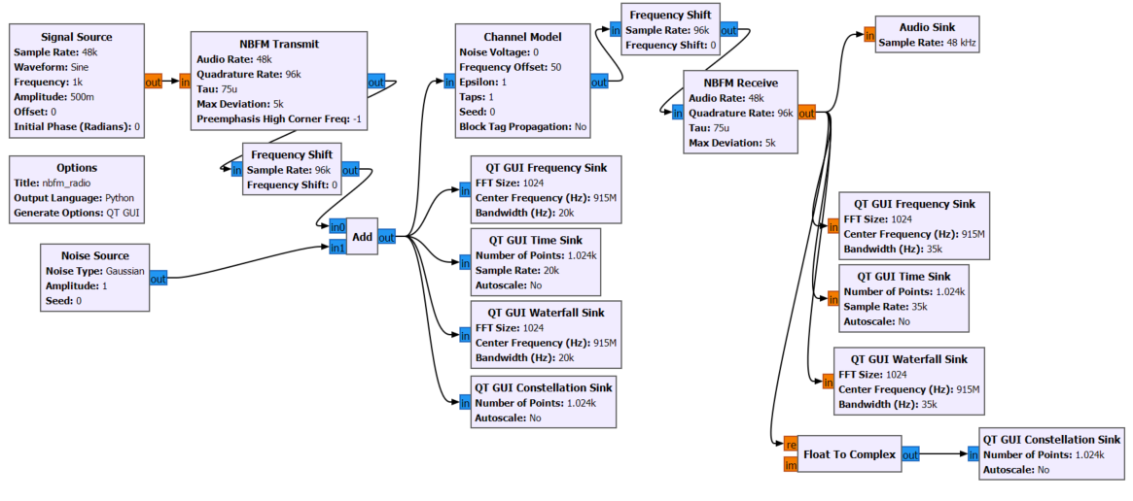
Figure 15 NBFM transmitter and receiver with jammer added and using FHSS to reduce the effects
Figure 16 Constellation sink for fhss to mitigate a jammer
In the figure above the first constellation sink plot shows that after modulation of the carrier signal and the gaussian noise and then FHSS is implemented to reduce the jamming effects from the gaussian noise the amount of interference is reduced. This would therefore increase the signal to noise ratio because a higher signal to noise ratio means that the signal is much stronger and clearer relative to the background noise and affected less by interference. A jammer introduces a high power noise at a specific frequency range into a communication system to disrupt or block a signal. This increases the noise power following the formula for Signal to noise ratio:
$SNR={10log}_{10}\left(\frac{P_{signal}}{P_{noise}}\right)$ where $P_{signal}$ is the signal power, $P_{noise}$ is the noise power.
A jammer increases the noise power and reduces the signal to noise ratio making it harder to receive and decode the original signal. FHSS improves the signal to noise ratio and mitigates the effects of jamming because FHSS continuously changes frequencies and while the signal is being transmitted only transmits over the jammed frequency for a minimal amount of time. If a jammer targets a single frequency and so is a narrowband jammer, FHSS will hop to a different frequency away from the jammed frequency causing interference and disrupting a signal to maintain a higher SNR.

Ethical considerations of jamming and societal benefits of secure communication like FHSS
Illegal jamming without approved permissions and consent is unethical, inappropriate and potentially dangerous for several reasons for example illegal jamming on unauthorised specific frequencies can disrupt and block critical communications infrastructure for the military and emergency services. This could prevent important messages from being sent or received, potentially leading to dangerous situations in areas like search and rescue or law enforcement. Modern wireless network systems like GPS rely on uninterrupted signal reception to provide location information and jamming these signals can cause location and time inaccuracies in navigation which is potentially dangerous in hazardous environments for the military and emergency services like the Coastguard. In some cases, jamming can be used as a tactic in warfare or terrorism, targeting military operations or strategic communication. This can compromise national security and put soldiers and civilians at risk.
Many industries rely on secure communications to transfer information, including banking, transportation, and telecommunications and if these communications are jammed it can cause service outages, delay transactions, and create significant financial losses for businesses and customers.
FHSS is beneficial in several ways because it involves changing the transmission frequency regularly in a randomised pattern and this makes it more difficult to for unauthorised people to intercept or jam the signal because they would need to know the pattern and frequency of the hopping sequence to intercept. FHSS is beneficial because it spreads the signal across several frequencies and this makes it less susceptible to interference if one frequency experiences interference, the signal can hop to another, maintaining communication integrity.

Task 2

RTL SDR receiver flow in GNU radio and mathematical explanations [2- GNU Radio SDR FM receiver]
An FM receiver is a device that receives and modulates radio signals using the frequency modulation technique. The reference from 2- GNU Radio SDR FM receiver helped with understanding how an FM receiver can be built in GNU radio.
Configuration parameters for an RTL SDR receiver flow specifically for FM radio
The signal source block will simulate an FM carrier signal which is the radio signal transmitted by an FM radio station and the block will output a continuous sine wave at a fixed frequency of 100MHz.
- Number of channels – 1
- Sample rate – 1MS/S (adequate for basic FM radio simulation)
- Frequency – 101.1MHz (typical frequency for an FM radio station)
- Waveform – Sine (FM radio signals are sine waves)
- Amplitude – 1 (standard amplitude for the carrier signal)
The audio source block generates an audio signal of sample rate 48kHz that modulates the FM carrier signal being transmitted. Audio sink block outputs the audio signal to the speakers or microphone to hear.
- Sample rates – 48kHz
The FM demodulator block demodulates the audio signal from the carrier.
- Channel rate – 48k
- Audio decimation 10
- Deviation – 75k
The low pass filter block is implemented after FM demodulation to filter the audio signal by removing the high frequency noise above the 15kHz audio range to improve the quality of the demodulated audio.
- Cutoff frequency – 15kHz (typical audio bandwidth FM radio ranges from 0Hz – 15kHz) explain
- Sample rate – 48kHz (standard audio rate)
- Decimation – 21
- Transition width – 2kHz (filter out higher frequencies of noise without distorting the audio) explain
- Sample rate – 1MS/S
The audio sink block will play the demodulated and filtered audio on your computer at a sample rate of 48kHz which is the standard audio playback rate for speakers and headphones.
- Sample rate – 48kHz
The GNU radio flowgraph show below is for an SDR receiver to receive and modulate FM radio signals with no SDR hardware present instead using a signal source block to generate the carrier signal which is a sine wave at 101.1MHz.
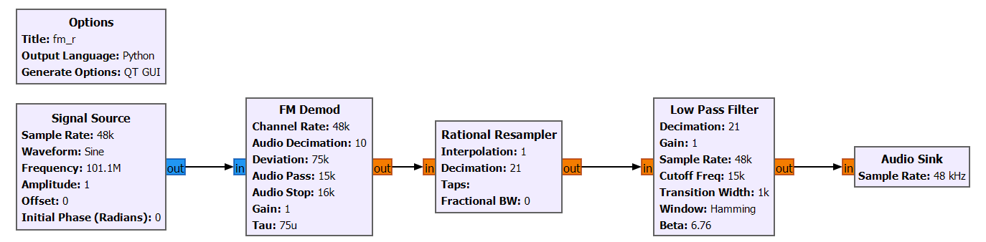
Figure 17 RTL SDR receiver for FM radio with no SDR hardware and using a signal source instead
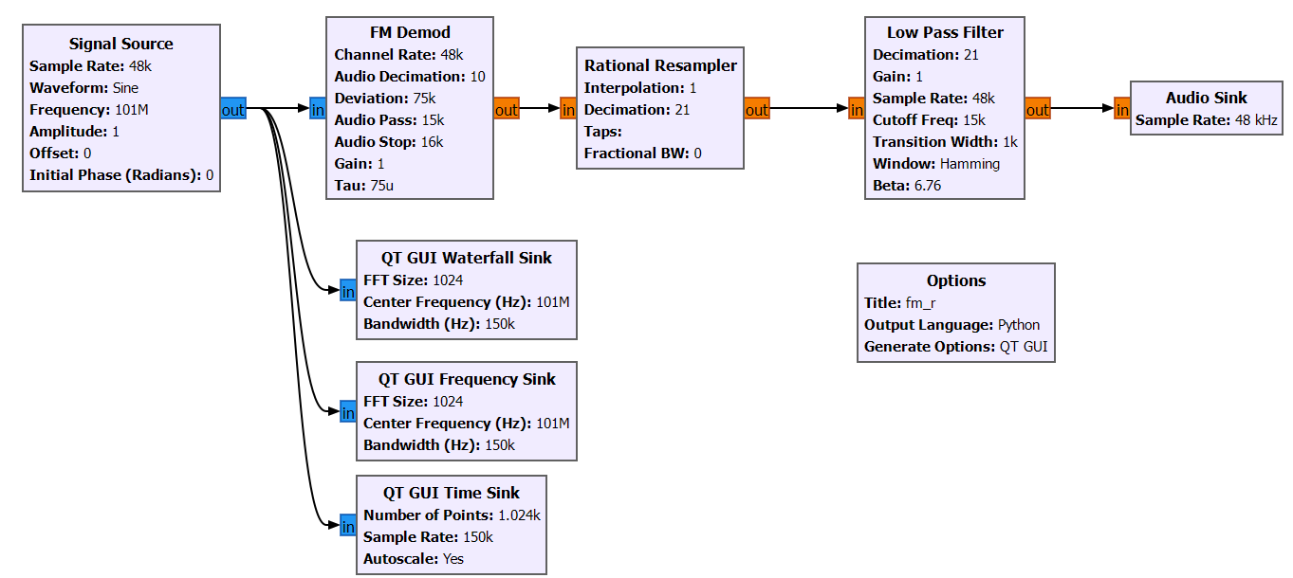
Figure 18 FM receiver with a signal source showing the waterfall, frequency and time sink plots at the signal source
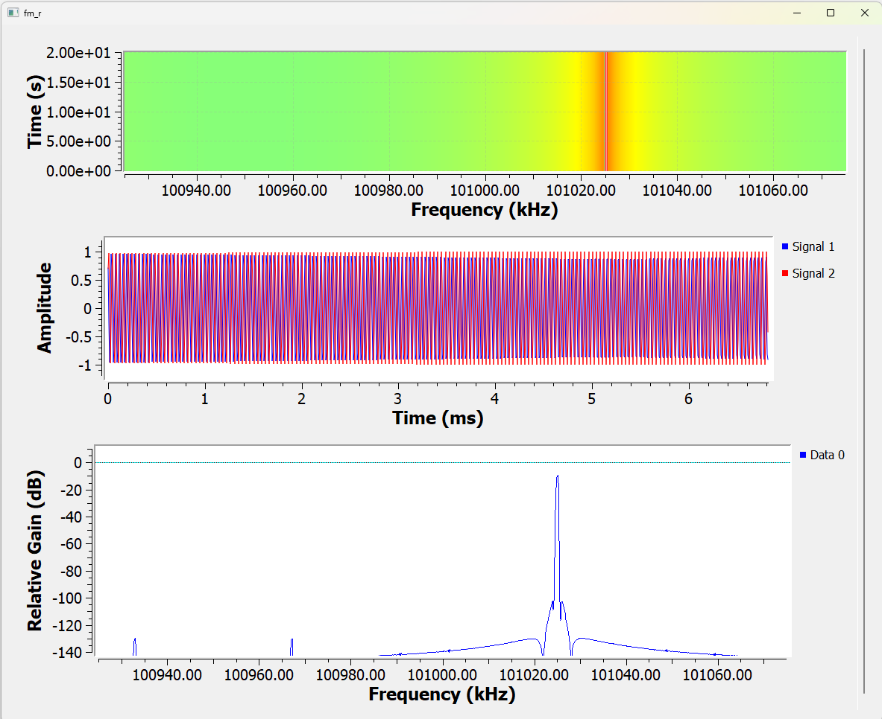
Figure 19 QT waterfall, time and frequency sinks for the FM receiver to show the signal at the signal source
At the signal source the peak frequency is 101.24MHz shifted further to the right with a relative gain of -12dB shown on the frequency sink plot with a hamming window type and this is shown on the QT frequency sink. The QT waterfall sink shows that the central frequency is at 101.24MHz but that the frequency is concentrated mostly in the range 101.2-101.25MHz.
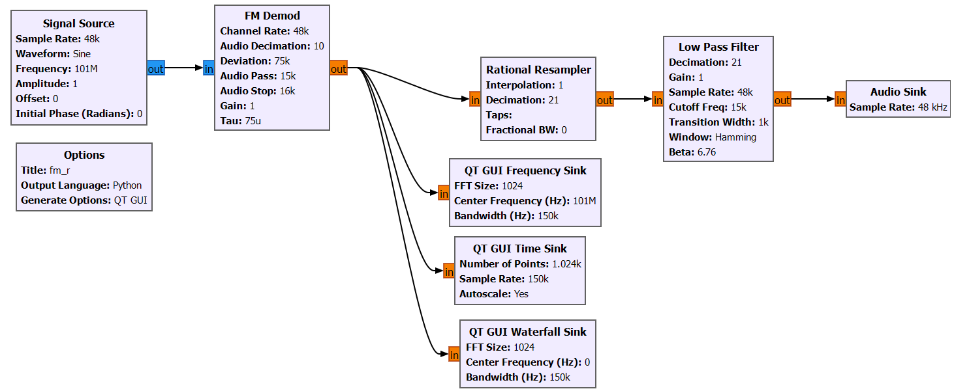
Figure 20 FM receiver with a signal source showing the waterfall, frequency and time sink plots at the signal source
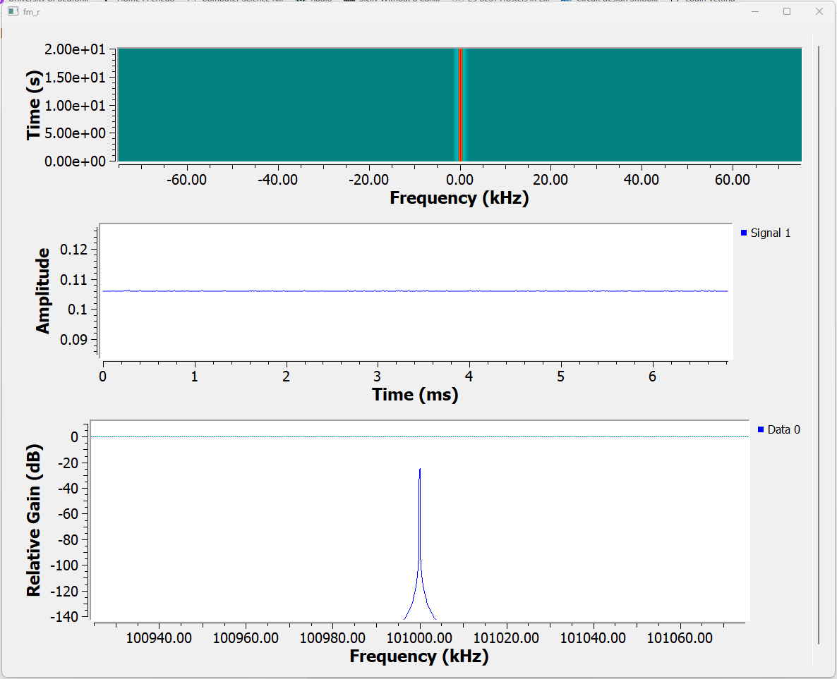
Figure 21 QT waterfall, time and frequency sinks for the FM receiver to show the signal after FM demodulation
After the signal has been demodulated in the frequency domain then the peak frequency is 101.114MHz and with a Hamming window present.
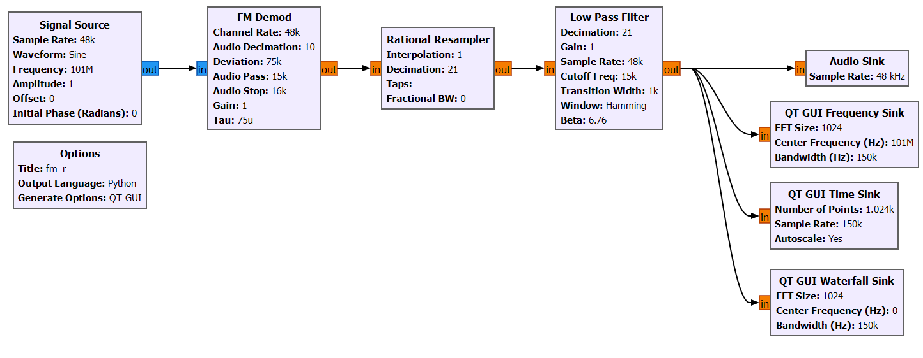
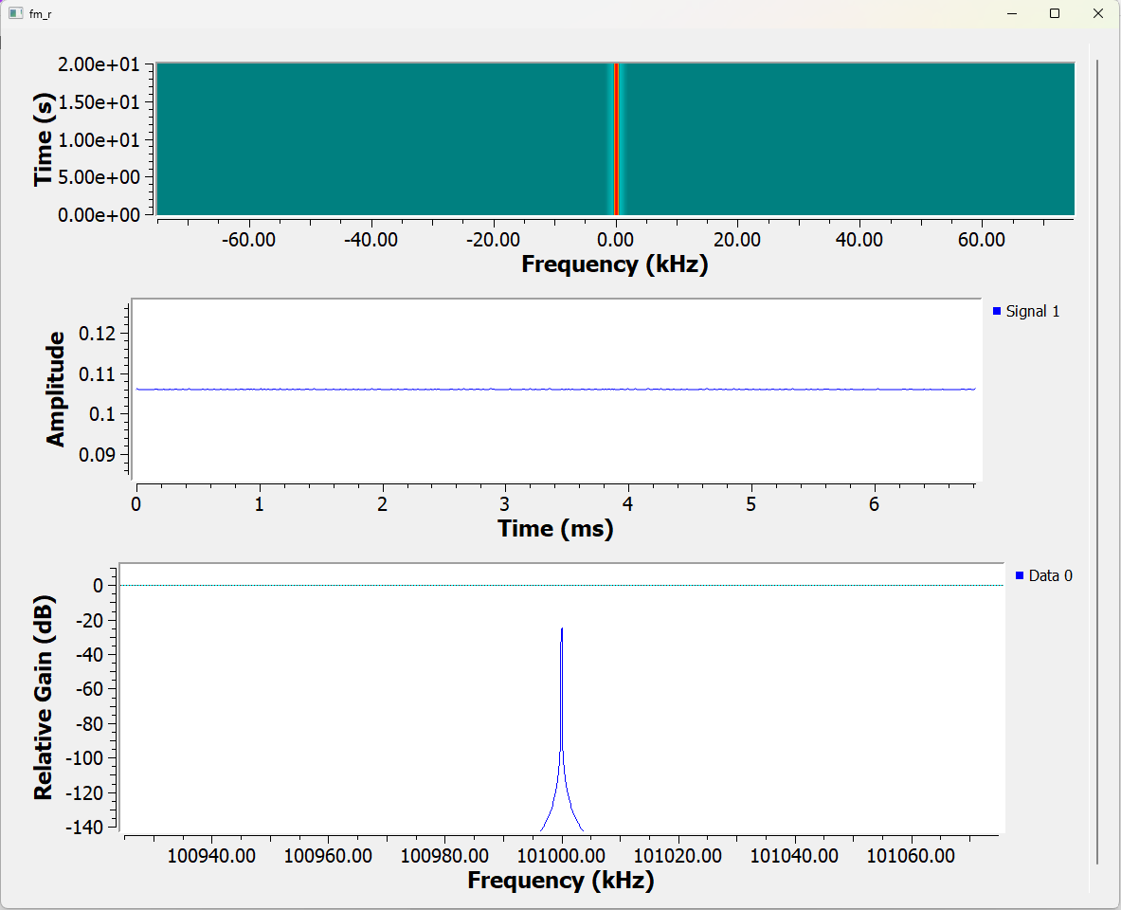
The peak frequency of the signal is 101.08MHz with a hamming window after the signal has been filtered through a low pass filter.
The GNU radio flowgraph below shows the modulation and demodulation through a low pass filter of an audio signal of sample rate 48kHz from a carrier signal of 101.1MHz after additive white Gaussian noise has been added.
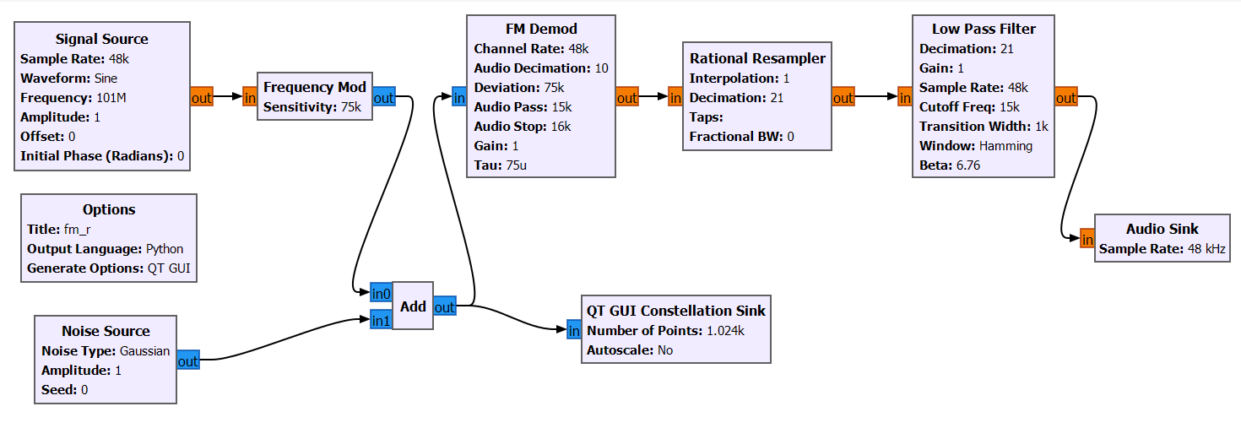
Figure 9
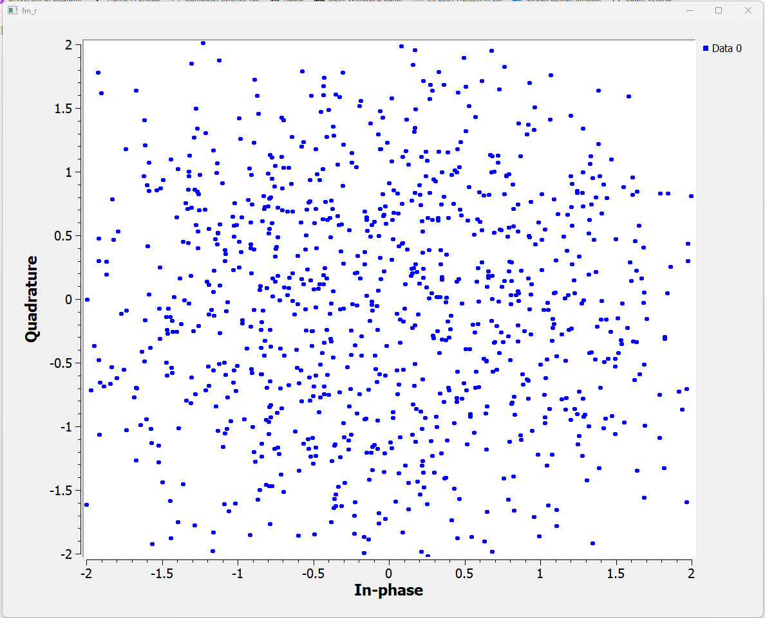
Figure 22 Constellation sink of FM receiver with noise
This plot is the constellation sink after additive white Gaussian noise has been added to the signal and the signal has been modulated in the frequency domain. This shows that there’s significant noise in the system and the signal is very distorted. The constellation sink shows a random display pattern of the signal indicating there’s not a phase relationship present between the signals due to the excessive quantities of Gaussian noise.

Mathematical expressions
General and specific to the signal ( $s\left(t\right)=r\left(t\right)+jq(t)$ ) mathematical expressions for the SDR receiver with FM modulation and demodulation
Signal source (FM carrier) $s_{carrier}\left(t\right)=A×\sin\left(2πf_{carrier}t\right)$ where $A$ is the amplitude, $f_{carrier}$ is the frequency of the carrier signal and $t$ is the time. The signal source represents the FM radio’s carrier signal.
The carrier signal $s_{carrier}\left(t\right)$ (where $s\left(t\right)=r\left(t\right)+jq(t)$) is
$s_{carrier}\left(t\right)= \cos\left(2πf_{carrier}t\right)+j∙\sin\left(2πf_{carrier}t\right)$
Audio source $s_{audio}\left(t\right)= A_{audio} × \sin\left(2πf_{audio}t\right)$ where $A_{audio}$the amplitude of the audio signal is and $f_{audio}$ is the frequency of the audio signal. The audio source is the signal that will be modulated onto the FM carrier wave.
The audio signal $s_{audio}t$is generally a baseband signal, but it is also represented in complex form, where the in-phase (I) and quadrature (Q) components are generated from the audio waveform. If it is assumed that the signal is real valued then
$$s_{audio}\left(t\right)=a\left(t\right)+j∙0$$
FM modulation (modulate audio onto the carrier)
$s_{FM}\left(t\right)=A×\sin\left(2πf_{carrier}t+ ∆f ×\int{s_{audio}\left(t\right) dt}\right)$ where $f_{carrier}$ is the carrier frequency, $∆f$ is the frequency deviation.
In the specific case of FM modulation with complex signals, the modulated signal can be expressed as
$S_{FM}\left(t\right)=\cos\left(2πf_{carrier}t+ ∆f ×\int{s_{audio}\left(t\right) dt}\right)+j∙\sin\left(2πf_{carrier}t+ ∆f × \int{s_{audio}\left(t\right) dt}\right)$
Where $\int{s_{audio}\left(t\right) dt}$ is the integral of the audio signal which generates the phase modulation.
FM demodulation (extract audio from the modulated signal)
The function of the FM demodulation block is to extract the audio signal from the FM-modulated carrier signal. To express the FM demodulation, the instantaneous frequency of the modulated signal needs to be calculated and is a function of the modulating audio signal. The instantaneous frequency is the derivative of the phase and gives the frequency shift caused by the modulation.
Instantaneous frequency is $f_{inst}\left(t\right)=\frac{1}{2π}∙\frac{dθ(t)}{dt}$ where $θ\left(t\right)=2πf_{carrier}t+ ∆f ×\int{s_{audio}\left(t\right) dt}$
$\frac{dθ(t)}{dt}$ is the derivative of the phase with respect to time which gives the frequency.
FM demodulation is typically done by extracting the phase information from the complex signal. To get the instantaneous frequency from the complex signal, we first calculate the phase $θ\left(t\right)$ of the modulated signal. In the case of the complex signal then $θ\left(t\right)=arg⁡(s_{FM}\left(t\right))$
The demodulated signal $s_{audio}(t)$ is found by calculating the frequency deviation and scaling it by the modulation index $∆f.$
$s_{audio}\left(t\right)= \frac{f_{inst}\left(t\right) - f_{carrier}}{∆f}$
Low pass filter
After demodulation, the signal may contain high-frequency noise that needs to be filtered out by removing all above the baseband bandwidth of the signal. The filter passes all signal frequencies below cutoff frequency $f_{c}$ and attenuates all signal frequencies above cut-off frequency.
$$s_{filtered }\left(t\right)=LPF(s_{audio}\left(t\right), f_{c})$$
Where $f_{c}$ is the cutoff frequency of the low pass filter which is the audio bandwidth and in this case id 15kHz for FM radio.
Audio decimation
In the final step, the sample rate of the filtered audio signal needs to be decreased to a suitable audio rate. The decimation factor $D$ is $SR_{output}= \frac{{SR}_{input}}{D}$
${SR}_{output}$is the desired audio sample rate and ${SR}_{input}$ is the sample rate after filtering

Ethical considerations using SDR technology
SDR technology allows easily receive and transmit signals across a wide range of frequencies VHF, UHF and HF bands, which can lead potential violations of privacy. SDR technology can be used to intercept communications such as personal phone calls or encrypted data transmissions through military and civilian networks without the knowledge of the owner. The ability to listen to unencrypted or encrypted signal transmissions which could compromise personal security and privacy, business and commercial confidentially or national security.
SDRs can be utilised to track and position the location of devices or individuals by collecting signals from mobile phones, GPS receivers or wireless networks. This can be illegal because its classed unauthorised surveillance if permission hasn’t been obtained and approved by a relevant authority like the police.
Intentional interference, known as jamming, is when someone using SDR technology to block or disrupt communications on certain specific frequencies. This can be done for several reasons disrupting the communication methods of criminals and illegal organisations like terrorist cells, obstructing the response of emergency responders and disrupting and interfering with systems in a military environment that are considered a threat. Jamming is illegal, harmful and dangerous without the appropriate legal oversight because it can prevent legitimate communication, cause confusion, and obstruct critical services like emergency response and security systems.
Using SDR technology enable the radio frequency bands to be used flexibly and allows users to easily transmit and receive RF signals outside of licenced frequency bands without approval. Spectrum abuse can occur if individuals and organisations transmit on frequencies without appropriate licences and permissions for regulatory organisations like Ofcom. This can lead to interference with licensed services if individuals and organisations transmit on the same frequencies without permissions as the emergency services can lead to interference and prevent transmissions being heard.

References
[1]- GNU radio NBFM transmit “NBFM Transmit - GNU Radio,” Gnuradio.org, 2022. https://wiki.gnuradio.org/index.php?title=NBFM_Transmit (accessed Jan. 29, 2025).
2- GNU Radio SDR FM receiver “RTL-SDR FM Receiver - GNU Radio,” Gnuradio.org, 2022. https://wiki.gnuradio.org/index.php?title=RTL-SDR_FM_Receiver (accessed Jan. 29, 2025).
‌

