Health promotion campaign: Smoking in Wales
Introduction
Cigarette smoking has for a long time been the main cause of preventable deaths in the United Kingdom; it is estimated to be responsible for up to 120 000 deaths per year (DoH, 1999, Twigg et al 2004) and it is estimated that smoking costs the National Health Service (NHS) between at least £1.4 billion pounds annually. It also kills at least 13 people in every hour (Callum, 1995) in the UK overall and also kills over 500 000 a year in the entire European continent annually (Peto et all 2010). NHS Wales (2017) argues that smoking has also remained one of the single main causes of preventable ill-health in Wales. Furthermore, smoking is also a major cause of health inequity in Wales, however, despite some significant progress in reducing the prevalence of smoking, new information from the Welsh Health Survey 2015 demonstrate that there are still about 490,000 adult smokers in Wales (Welsh Health Survey, 2015).
Risks of smoking
In 1999, the UK government launched a White Paper: Smoking Kills which outlined how dangerous smoking is to anyone. The White Paper also noted that when someone who is younger starts smoking, that person is more likely smoke for longer and unfortunately, die early from smoking (Department of Health, 1999). For instance, Department of Health (1999) states that when someone who starts smoking aged 15, they are three times more likely to die of cancer due to smoking than someone who starts in 20s (Office for National Statistics, 2010). Furthermore, Doll and Peto (1981) observe that 84% of deaths from lung cancer involve those who start smoking in their mid-20 while 83% of deaths are a result of chronic obstructive lung disease, which includes bronchitis (Callum, 1998). However, Callum (1998) also found that was responsible for 46,500 deaths annually in the UK. Apart from lung cancer, smoking causes death by larynx, cancer of the mouth, larynx, kidney, bladder, oesophagus, pancreas and stomach (Callum, 1995). Furthermore, about there are about 40,300 deaths annually in the UK from all circulatory diseases (Callum, 1995). Law & Hackshaw (1997) also observes that smoking is associated with several other debilitating conditions such as brittle bone disease and asthma.
The Department of Health (2018) outlines a number of available strategies in the anti-smoking campaign. They include the use of e-cigarettes or nicotine replacement therapies (NRT). The government argues that this approach makes it one and a half times possible for someone to quit smoking (DoH, 2018). The Department of Health also notes that NRT is one of the safest forms of treatment and is licensed for use even during pregnancy and including those with cardiovascular diseases. The danger with nicotine is that it increases the heart rate and blood pressure, and has a range of local irritant effects and carries more than 400 toxins, most of these toxins are harmful to a human health.
The Department of Health (2018) also states that an individual’s chances for quitting is doubled whenever they use a stop smoking medicine that is prescribed by a GP or pharmacist. Furthermore, DoH (2018) states that to combine stop smoking aids with expert support from local stop smoking services also makes someone up to four times as likely to stop smoking successfully.
The Welsh Survey
The Welsh Health Survey also revealed that over two in three smokers would like to stop and about 40 percent of smokers are actively trying to quit smoking every year (NatCen Social Research, 2016). This suggest that some effective anti-smoking strategies could indeed work in Wales
Figure 1: Smoking status: Self-reported in adults
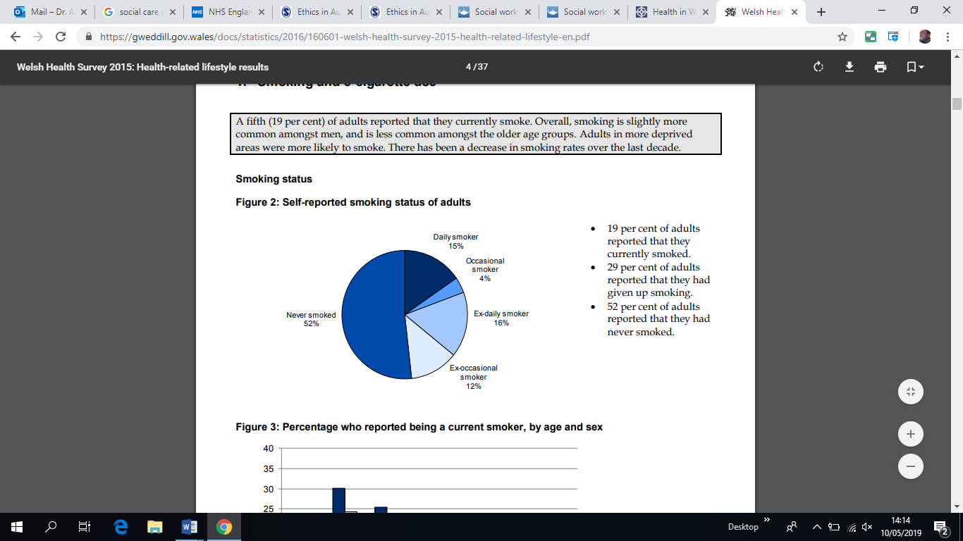
The Welsh Survey (NatCen Social Research, 2016).
The pie chart reveal that 19% reported that they currently smoke, 29% of adults reported that they had given up, while 52% reported that they never smoked (NatCen Social Research, 2016).
NHS Stop Smoking services
Moreover, the Welsh Government has set an ambitious annual target to treat 5 percent of the smoking population through NHS Stop Smoking services and to reduce adult smoking rates to 16% by 2020.
NHS Wales (2018) has launched a significant anti-smoking campaign dubbed “Stop Smoking Wales” and is a programmed sponsored by the Welsh Government. Stop Smoking Wales Stop Smoking Wales (SSW) provides free service in expert support for smokers who want to quit. SSW is found throughout Wales in local communities. It offers some specialist health service sessions to those smokers who genuinely intend to stop smoking. SSW is operated by trained personnel who advise and offer face-to-face support including over the telephone. The project operates in conjunction with various communities across Wales as a means of ensuring that those in need can access SSW services. According to Public Health Wales Annual Equality Report (2016-2017) some of the SSW objectives is to educate young people about the effects of smoking and also the organisation makes weekly stop smoking sessions in various colleges and schools across Wales. Through services provided by SSW, those in need can be assisted to quit smoking in schools and colleges and the supported is also extended to vulnerable groups. People in need of such service can then be afforded a chance to attend a smoke free event at Caswell clinic. This clinic is largely designed for offenders and those with mental health problems. SSW has also become a key part of Public Health Wales and is the central element of the Tobacco Control programme.
This is a vital programme as the services it provides play a key role in reducing the impact of tobacco on the health of people in Wales. The programme also aims at contributing towards reaching the Welsh Government’s target to reduce smoking prevalence in Wales to 16 percent at least by 2020 (NHS Wales, 2018).
NHS Wales (2018) observes that a number of studies on smoking have concluded that smokers are four times more likely to give up with a support programme such as Stop Smoking Wales. For instance, the Stop Smoking Wales provides clients with a 7-week treatment programme that is mainly focused on the withdrawal oriented treatment model. Stop Smoking Wales programme also offers some weekly appointments at the same time and same place each week. There are also available appointments during the day and early evening in local community venues. Among other expert services provided are behavioural support that is provided by a trained Stop Smoking Advisor. There is also an encouragement, support and guidance throughout the quitting processes. Furthermore, there is info on pharmacological aids and some follow-ups at four weeks and 12 months periods.
Department of Health and Social Care (2018), policy document also outlines the UK government’s ambitions to reduce the number of 15 year olds who regularly smoke from 8percent to 3percent or less. It also intends to reduce smoking among adults in England from 15.5% to 12% or less. The policy also seeks to reduce the inequality gap in smoking prevalence, between those in routine and manual occupations and the general population reduce the prevalence of smoking in pregnancy from 10.5% to 6% or less. The aim is to achieve these objectives by the end of 2022.
In 2017, the Welsh Assembly, through the Public Health (Wales) Act 2017, delivered the Tobacco Control Delivery Plan for Wales, 2017-2020 legislation, a strategy that details several measures of further reducing smoking as a means of preventing younger people from smoking and at the same time improve health outcomes for the present and the future (NHS Wales, 2017). The Tobacco Control Delivery Plan for Wales, 2017-2020 plays a critical role in denormalising smoking while also protecting non-smokers from exposure to second-hand smoke (NHS Wales, 2017). It is perceived that the Public Health (Wales) Act 2017 would address several specific public health concerns associated with harms linked to smoking. The intention is to support and ensure the success of the Well-being of Future Generations Act 2015. The Future Generations Act 2015 seeks to define sustainable development across Wales through processes of improving the social, economic, environmental and cultural well-being of Wales. This is hoped to be achieved through some tentative social actions inspired by the sustainable development principle whose principal aim is to realise the well-being goals. To achieve this, it maybe appropriate to ensure that the well-being planning across communities limit the impact of tobacco on the citizens of Wales, thus in the present and the future.
Validity and rational of the initiatives
Hajek et al (2019) concluded that e-cigarettes were an effective method of quitting smoking and was more effective than nicotine-replacement therapy. However, the study found that both approaches needed behavioural support.
The study by Hajek et al (2019) randomly assigned some UK adults enrolled in the NHS stop smoking services to either nicotine-replacement products of their choice, including product combinations, provided for up to three months, or an e-cigarette starter pack. It was a second-generation refillable e-cigarette with one bottle of nicotine e-liquid, 18 mg per millilitre. There was also a recommendation to purchase further e-liquids of the flavour and strength of their choice. Treatment included weekly behavioural support for at least four weeks. The primary outcome was sustained abstinence for one year, which was validated biochemically at the final visit. Participants who were lost to follow-up or did not provide biochemical validation were considered to not be abstinent. Secondary outcomes included participant-reported treatment usage and respiratory symptoms. The main finding was the e-cigarettes were more effective in helping people quit smoking.
Diversity of experiences in contemporary Welsh society
The Welsh Public Health Wales Annual Equality Report (2016-2017) states that to achieve its objectives of a free smoking society, it is vital to work with minority ethnic communities. These should encompass working the Gypsy traveller communities as a means of raising awareness to support means of stop smoking. With this in mind, what is needed is to extend this campaign to workplace stop smoking groups such as the local Polish with fliers designed in their language. This may require hiring an SSW staff member who is Polish, but can also speak good English. Moreover, The Welsh Public Health Wales Annual Equality Report (2016-2017) notes that there have been the promotion of bilingual services as well. There has also been strong religious campaign for instance, The Welsh Public Health Wales Annual Equality Report (2016-2017) also notes that a number of visits and talks have been done in different Mosques to raise awareness of the service around Wales.
After their study, Moore, et al (2015) concluded that more young people who have tried e-cigarettes, this includes non-smokers as well. Moore, et al (2015) observe that regular use of e-cigarettes was uncommon, and this could be linked to tobacco cigarette use. The Welsh government argues that to succeed in the anti-smoking campaign, requires getting equality and diversity right.
This has involved Stop Smoking Wales working hand in hand with the Aneurin Bevan University Health Board. Local Public Health Teams and representatives from black Asian minority-ethnic groups have also been enlisted to identify some exiting barriers. The aim is to improve access to stop-smoking services.
The struggle to address the effects of smoking has also seen Healthy Working Wales working with businesses across Wales on equality and diversity. Furthermore, Cardiff and Vale Public Health Team working with Cardiff and Vale University Health Board (UHB) as a means of developing effective assessment tools which can combine requirements of equality impact assessments with health impact assessments.
The transgender community across Wales has also been working with the Screening Engagement Teams through the provision of training and education to the transgender communities. Also, the Staff Health and Wellbeing steering group’s development of the flexible working toolkit, based on the revised flexible working policy.
Personal Responsibility
The Welsh society also need to take personal responsibility about person health. For instance, the essay has demonstrated some concrete evidence that those who want to give up smoking, e-cigarettes are key and provides an effective treatment than NRT products. With clinical support provided by NHS Wales, the Welsh people can engage in the e-cigarettes and seek more coping help from experts who are provided by the NHS Wales. The smoking services and tobacco control has been forthcoming with information on how to quit smoking through the help of e-cigarettes. The use of e-cigarettes is recommendable as studies have concluded that chemicals in e-cigarettes, particularly the flavourings, are 95% much less harmful than smoking tobacco
Recommendations
The Welsh Public Health Wales Health Intelligence division need to work closely with schools and businesses to prevent children as young as 9, 10, 11 or 12 smoking. This will involve enforcing exiting legislation that prevents selling cigarettes to anyone below the age of 18. By so doing Wales will be able to improve the society’s health and reduce health inequalities.
Some longitudinal research will be needed to understand age-related trajectories of e-cigarette use and to understand the temporal nature of relationships between e-cigarette and tobacco use.
References
Callum C (1995). The UK smoking epidemic: deaths. London: Health Education Authority.
Department of Health (1999), Smoking Kills: A White Paper on Tobacco, London Stationery Office https://assets.publishing.service.gov.uk/government/uploads/system/uploads/attachment_data/file/260754/4177.pdf (accessed on 10/05/2019).
Department of Health and Social Care (2018), Smoke-free generation: tobacco control plan for England, Policy paper.
https://www.gov.uk/government/publications/towards-a-smoke-free-generation-tobacco-control-plan-for-england (accessed on 10/05/2019).
Doll R and Peto R (1981). The causes of cancer: quantitative estimates of avoidable risks of cancer in the United States today. J Natl Cancer Inst 1981; 66: 1191-1308.
Hajek, P (2019), A Randomized Trial of E-Cigarettes versus Nicotine-Replacement Therapy, (Funded by the National Institute for Health Research and Cancer Research UK; Current Controlled Trials number, ISRCTN60477608.)
Law MR & Hackshaw AK (1997). A meta-analysis of cigarette smoking, bone mineral density and risk of hip fracture: recognition of a major effect. BMJ; 315: 841-846.
Moore G, Hewitt G, Evans J, et al (2015), Electronic-cigarette use among young people in Wales: evidence from two cross-sectional surveys BMJ Open,;5:e007072. doi: 10.1136/bmjopen-2014-007072.
NatCen Social Research (2016). Welsh Health Survey, 2015. [data collection]. UK Data Service. SN: 8090, http://doi.org/10.5255/UKDA-SN-8090-1
NHS Wales (2018) Stop Smoking Wales (Last updated April 2018)
https://www.wales.nhs.uk/sitesplus/888/page/43913 (Accessed on 10/05/2019)
NHS Wales (2017)Health in Wales
http://www.wales.nhs.uk/healthtopics/lifestyles/smoking (Accessed on 10/05/2019)
Office for National Statistics (2010). Population Trends Number 93, Autumn 2010. London: The Stationery Office.
Peto R, Lopez AD, Boreham J, Thun M, Heath Jr C (2010). Mortality from tobacco in developed countries: indirect estimation from national vital statistics. Lancet; 339: 1268-78.
Public Health Wales Annual Equality Report (2016-2017) Annual Equality Report, NHS Wales, http://www.wales.nhs.uk/sitesplus/documents/888/PHW%20Annual%20Equality%20Report%202016-17%20E.PDF (Accessed on 10/05/2019)
Twigg L, Moon G, Walker S (2004) , The Smoking Epidemic in England. London Health Development Agency.

