Qualification: CIPD Diploma in Applied Human Resources

Module Name: Understanding Resourcing and Talent Planning

Word Count: 3250

Student Name: Natalie Thomas
Student Number: 1810239
CIPD Membership Number: 53274196

By signing below, I confirm that the work/evidence presented is my own, unaided work. I understand the regulations pertaining to candidate malpractice and the action that may be taken as a result.

Signed: N Thomas
Date: 05/05/2020
Understanding Resourcing and Talent Planning

Taylor and Woodhams (2016) identify that one of the main functions of the HR role is associated with the mobilisation of a workforce. Ensuring that the correct succession planning is implemented and ensuring that the organisation has the correct number of employees who have the desired skills suitable for the organisation can help to achieve successful organisation performance.
1.1
It is important that HR are aware of labour market trends as it is considered a key concept in employee resourcing (Taylor and Woodhams 2016). Ensuring that HR practitioners monitor the status of the labour market is vital as it could help towards predicating likely development in the economy (CIPD 2019).
Economic conditions help to provide information on everyday business of HR and ultimately determines the organisations’ strategy of how many employees need to be recruited, retained and upskilled/developed in order to meet service user demand and allow organisations to tailor their approach for recruitment and selection methods (CIPD 2019).
There are a number of sources of labour including:
- Job seekers in local market – individuals actively looking for work but within close locality to their home address. This can be useful for organisations seeking to fill low skilled roles
- Job seekers in national market – individuals seeking employment anywhere in the country and are usually associated with higher paid, more specialist roles
- Job seekers in the International market – individuals seeking employment anywhere in the world and again tend to be higher skilled specialist or shortage roles
- Those working in other companies – individuals actively seeking employment and may have the appropriate skills and experience that another company is looking for. This group may consider changing companies if the offer is right
- Graduates – individuals who are higher educated looking for a job that entails a structured development plan
- School/college leavers – new to work, actively seeking employment but may require training and development investment from the organisation
- Economically inactive – individuals who usually are not actively seeking employment, are not ready to work but could work such as retired individuals, people with health issues, caring responsibilities etc but with the right incentives and provisions were made, this group of individuals could get back to work

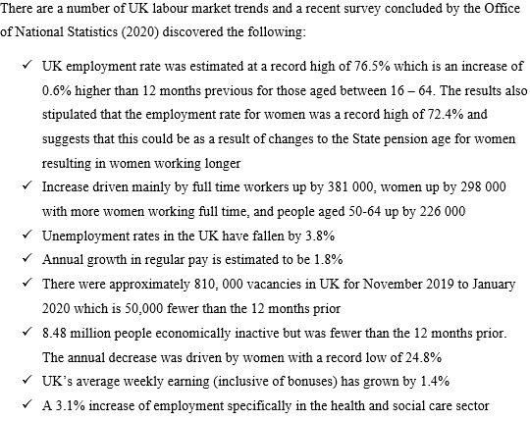

There could be numerous reasons for the above statistics such as employment laws limiting the number of working hours which can increase the demand for number of employees, and discrimination legislation resulting in those who are disabled or past retirement age in gaining jobs (Taylor and Woodhams 2016).
Changes to immigration rules could also affect employment rates only allowing migrants who have specific skills that are in short supply permitted to enter the UK. Flexible working measures could also affect labour market trends and is considered a key emerging issue for organisations. Flexibility strategies aiming to make the organisation more responsive and ‘employee friendly’ could have a positive affect for those with caring responsibilities, particularly women, in returning to the work place (Taylor and Woodhams 2016).
Another factor is considering the type of jobs available within the UK with the mining industry declining, and the requirement for more employees in the Health and Social care sector – perhaps as a direct result of an ageing population.
It is also important to consider the ‘ageing workforce’ with a proportion of over 50’s working longer than ever before but as the ‘baby boomer’ generation heads in to retirement, and with young people spending longer in education and entering the labour market later on in life, it could result in future problems for industries. (CIPD 2019).
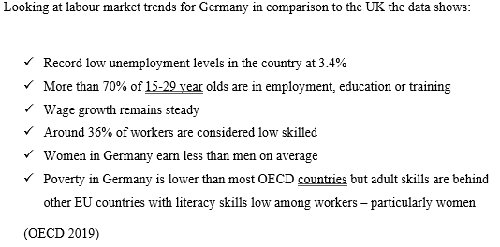

1.2 & 1.3
It is vital that HR practitioners are able to understand workforce planning, including its key principles, the tools required and how to develop succession planning. Workforce planning is conducted by an organisation to understand the specific skills employees will need in the future, and to put in place strategies to achieve this. It is about ensuring the right people with the required skills are in place to achieve the organisations goals (Taylor and Woodhams 2016). Workforce planning can often take place as a result of a PESTLE analysis of the organisation (CIPD 2019). Correct workforce planning can result in:

- Reduction of labour costs
- Identifying and responding to customer needs
- Identify strategies for upskilling workers
- Improve employee retention
- Improve productivity
- Improve employee’s work life balance
(CIPD 2019).
Taylor and Woodhams (2016) identifies that there are 4 main stages to workforce planning:

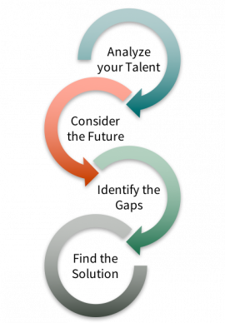

(Cardinal at work 2019)
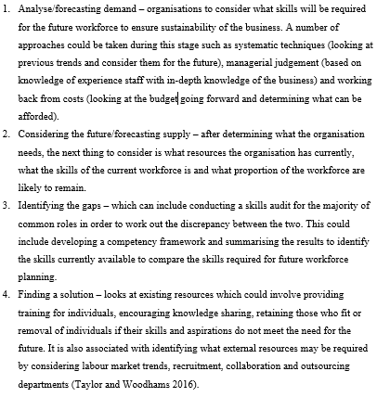

The CIPD (2019) explains that it is important when identifying successors, that all employees are provided fair access to available opportunities and organisations should consider and implement the following:
- Clear and extensive communication to all employees – transparency
- Open competition with formal selection criteria
- Formal appraisals – to identify aspirations of individuals
- Informal conversations where appropriate followed by cleared, structured training/mentoring plans or development plans
- Ensuring development opportunities are available to all
- Auditing of appraisal records
(Taylor and Woodhams 2016)
Upon identification of interested individuals, organisations need to understand the basic principles when creating a ‘people plan’ and succession plans if the business wants to ensure the best performance from its employees. A people strategy isn’t the same as a HR strategy and it is important this is understood from the outset. Following the below steps can assist HR/managers:
- Conduct a PESTLE of the organisation internally and externally
- Understand the business and its employees, stakeholders and customers’ needs
- Establish main priorities of the individual in order to ensure the desired outcome is delivered
- Involve others – using focus groups with a mixture of departments/levels, employee representatives and customers
- Benchmarking – across both industry specific and non-specific companies to understand any success stories and encourage new processes to be developed
- Monitor and measure progress – ensuring they are ‘SMART’ and using an easy to measure system to track progress
- Produce user friendly documents
(CIPD 2020)
Succession planning is also closely related to workforce planning and can be described as the process of identifying and developing possible future managers/leaders to fill future business vacancies, usually at a higher level traditionally (CIPD 2019). It is a group of activities that looks at ensuring an organisation has the correct numbers of people with the required skills, knowledge and ability to take up a position at the next level should their colleague leave/retire. More recently, the process has been extended to consider the whole of the workforce and aims to develop ‘pools of talent’ from which a replacement can be chosen as and when a position becomes available (Taylor and Woodhams 20160).
There are different approaches to succession planning with traditionally, large companies having highly-structured, confidential and top down approach to succession planning by identifying internal employees as successors for key positions and planning their training and exposure around this. More contemporary approaches include a broader vision with less secrecy, open communication and diversity and closely links to talent management practices (CIPD 2019). The CIPD (2019) suggests that organisations who adopt inclusive whole workforce approaches to developing talent will be able to identify business critical roles throughout all levels of the organisation.

2.1 & 2.2
There are various approaches which organisations can take in attracting and retaining talent with a main objective for organisations being able to successfully attract employees in the first place. There are some successful ways to do this, but also some factors which should be avoided where possible:

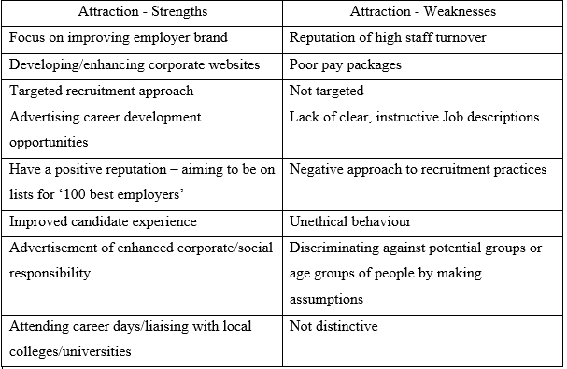(CIPD 2015)

Employee retention is also a critical issue which organisations face and ensuring approaches to retention are correct will allow business to retain talented and motivated employees. There are circumstances which particular approaches can be seen as a strength, and some which are considered a weakness:
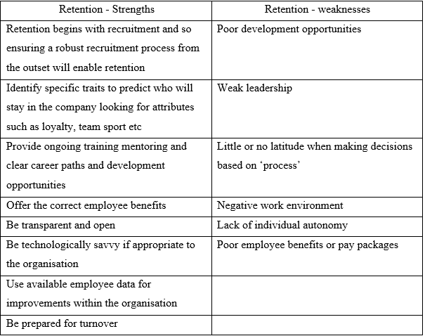(Florentine, S. 2019)
Organisations are often faced with the task of creating a targeted resourcing strategy and in order to be successful, HR practitioners and managers need to attract the right people, and stand out from competitors (Taylor and Woodhams 2016). Firstly, understanding what competitors are offering in terms of salary, job role, working environment and career opportunities can aid in deciding what resource approach/strategy is taken.
Employer branding is one of the main recruitment strategies and is associated with presenting the organisation in the best possible way to the labour market to try and entice employees to work for the company. The CIPD identify employer branding as a set of features and qualities that makes an organisation stand out and appeal to those people in that area of work (Walker 2007). It is vital however, that what the organisation appears to be is actual in reality to avoid disappointment of new recruits and ultimately a negative reputation for the company. In order to ensure that the ‘brand’ reflects the reality, managers need to consider carrying out research on what current employees perceive the brand of the company to be and how the organisation stands out from competitors. Lievens et al (2007) states that there are 5 main factors to consider when deciding how best to present themselves to possible employees:
- Sincerity – branding base don being honest and friendly
- Excitement – branding that focuses on innovation and ‘quirky’ to stand out
- Competence – based on being reliable and successful
- Sophistication – branding based on being sophisticated and respected
- Ruggedness – branding based on being resilient and tough

Once all the above has been considered, the next stage is to develop slogans and key messages to communicate to current and future employees. Eventually, this slogan and statement becomes recognised as the organisations core message and enables it to be differentiated from competitors. Successful employer branding can lead to a positive position in the labour market and eventually, the organisation can be referred to as an ‘employer of choice’ which can result in huge benefits such as reduced staff turnover, highly talented and well-motivated workforce, and improved organisational performance (Taylor and Woodhams 2016). As a result of tighter labour markets in particular areas, it is argued that organisations have been caused to invest heavily in sophisticated employer branding activities to appear irresistible to work for and ensuring the correct person is recruited (Ladjemi 2014).
Strategic reward is another approach which organisations can take when trying to attract talent and can be considered a long-term approach to how an organisation’s reward policies and practices can help to achieve both the organisations objectives, and employee needs. Closely linked with ‘total reward’ which looks at areas which employees value such as individual development opportunities and flexible working alongside good pay and benefits packages (CIPD 2019). Armstrong, M (2007) describes that reward strategies are varied along with the way they are created and implemented by organisations, however there are 4 main elements included in the strategies:
- A statement of proposed reward developments
- A rationale setting out the business case for the reward proposals
- A definition of guiding principles
- An implementation plan

Whilst approaches to strategic rewards differ, the main principles are often included with pay structures and pay progression being designed in a way that ensures the values, performance and behaviours are closely linked together. It is also common to see positioning variable earnings against basic pay to encourage employee performance such as having cash bonuses to drive higher sales or improve individual performance (CIPD 2019).
Approaches to total reward, recognises that pay isn’t the only motivator and looks at various aspects including:
- Performance and recognition
- Work/life balance – flexible working hours, working from home etc
- Organisational culture – involvement in key decision making, freedom and autonomy
- Employee development and career opportunities – access to professional career development, challenging roles, opportunity for personal growth
- Business strategy – flexible benefits
- Human and resource strategy – capacity to raise maters of concern, administrative support
Whilst private companies are considered more at the forefront of total reward policies there is more recently interest in total reward in the public sector (CIPD 2019).
3.1
The recruitment process is a key factor when considering talent and resource planning within the organisation. In order to determine the what skills are needed for a role, it is vital that a job analysis is carried out, ensuring that the job duties, responsibilities, previous education/experience, work environment and performance expectations are considered when creating job descriptions and person specifications (Taylor and Woodhams 2016).
Based on the job analysis carried out previously, the job description is key within the recruitment and selection process. They tend to follow a standard format and key aspects to include should be as follows:
- Job title
- Grade/rate of pay
- Main work base
- Manager’s details
- Summary for the job role
- Listed duties and responsibilities
- Reference to other documents that may clarify or expand on other items
Similarly, when developing a person specification a job analysis is critical and in order to assist with the creation, it would be wise to gain information from current/previous post holders via interviews or information collected form the line manager for the role, appraisal results and training manuals or from external sources with expertise in the area of work. Job specifications summarises tasks of the position and can break these into categories of ‘desirable’ or ‘essential’ such as:
- Skills – including IT competences, experience using software programmes or techniques etc
- Experience – in the same or similar role previously
- Qualifications
- Education – specific qualifications required for the role such as a degree
- Personal attributes
(Taylor and Woodhams 2016).
Another stage of the process is to produce a competency framework which is used to assess each applicant against a list of competencies usually including communication, customer focus, commercial awareness, teamwork, flexibility and team working (Taylor and Woodhams 2016).
3.2
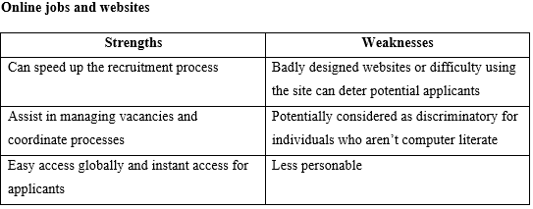
There are also various recruitment methods and it is important that organisations identify the most suitable method to advertise a position and attract applicants. Each method has strengths and weaknesses of use:
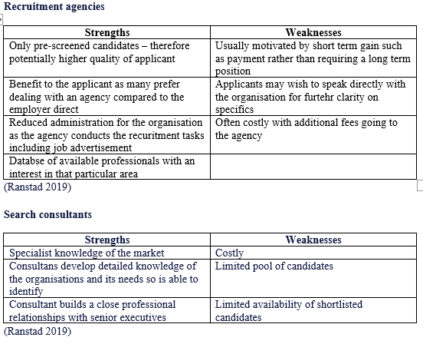

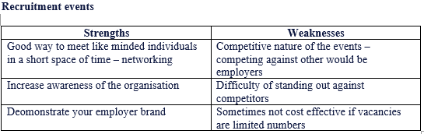
(Ranstad 2019)

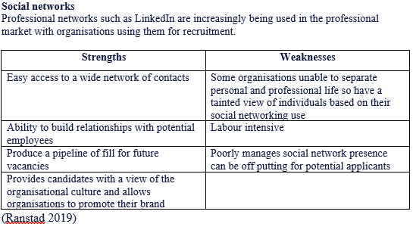
Along with numerous recruitment methods, there are different selection methods that can be used including:
Interviews
- Telephone interviews: usually suitable for candidates being recruited overseas or elsewhere in the country.
- Face to face interviews: often enabling the interview to ‘get a feel’ for the candidates’ personality and abilities
- Panel interviews: more than one organisation representative in attendance which can benefit as each representative will seek out different attributes within the individual but can also be daunting for the candidate
- Group interviews: involves a group of applicants being interviewed

There are concerns over consistency within interviews and so, interview templates are usually followed with specific questions which seek to draw out how the individual would react in a given circumstance (Taylor and Woodhams 2016).

Assessment centres
Designed to bring together a group of candidates and assess each candidate using a range of selection methods such as interviews, candidate presentations, ability/personality tests, group activities and role play. The advantages to this method is it allows more of an insight in to the candidate and a more valid measurement of the individuals suitability to the role. However, it is only viable when there are a high number of candidates and can be costly (Taylor and Woodhams 2016).
3.3
In order to ensure that an organisations’ recruitment and selection process doesn’t discriminate against individuals or groups of people HR need to be aware of what is considered a ‘protected characteristic’ under the Equality Act (2010). These include:
- Age
- Disability
- Race
- Religion or belief
- Sex
- Gender reassignment
- Marriage and civil partnerships
- Pregnancy and maternity
- Sexual Orientation

Organisations must ensure that individuals are short listed in a fair and impartial way with a clear selection criterion to work from, which must be associated with the requirements of the position and free from bias or discrimination. They must also ensure that individuals have an equal opportunity to apply for a position and consider the wording/branding of the recruitment campaign. Auditing the diversity of the current workforce should also be considered along with the use of positive action campaigns of an identified underrepresented group. Organisations should also offer alternative options for applications of a role, such as paper submission options and ensuring that contact details of individuals to further discuss specific circumstances are clear and accessible to applicants (Taylor and Woodhams 2016).

In the case of a dismissal, in which the employment contract is terminated by the employer, usually as a result of the employee failing to meet the requirements of the job role. Employers must be certain that dismissals are handled appropriately and in accordance with the expectations of the law – ensuring there is a valid reason for the dismissal.

To be potentially ‘fair’ a dismissal should be based on one of 5 reasons;
- Capability or qualifications
- Conduct
- Illegality or breaching a statutory duty
- Redundancy
- Some Other Substantial Reason

Organisations must ensure that the correct dismissal procedures are followed, and the ACAS Codes of Practice is adhered to. Dismissing employees should be a last resort and organisations should ensure that a thorough investigation has been carried out without unreasonable delay to establish the facts. Attempting to tackle the issue informally first and providing opportunity to overcome and improve on the issues identified (ACAS).

In relation to retirement, employers must ensure that there is no discriminatory behaviour towards an employee because of their age. They must not prompt a discussion about when an employee might retire including asking the individual outright ‘when are you planning to retire’ or put pressure on them to retire (ACAS). It is good practice to have open communication about the individuals long term plans in order to outline the future of the business and workforce and could help the individual identify their future work preferences. Within a one to one meeting such as an appraisal, when discussing retirement it is vital that the employer informs the individual exactly what is available to them in terms of a flexible or phased retirement such as an initial reduction in hours, less responsible roles etc. it is also important that employees can be sign posted to support available as the individual may have worries about the future impact of retirement financially, emotionally etc (ACAS). Any discussions should be documented and kept on the individuals personal file, and to provide the employee with a copy of the notes.

The key aspects of good practice in relation to redundancy would include searching for alternatives to compulsory redundancy including:
- Looking at flexible working
- Temporarily reducing hours of the workforce
- Request that employees stop working for a short time
- Re-deployment or retraining to another area of the business
- Reduce or stop overtime
- Avoid hiring new staff
(CIPD 2018)
If redundancy is then the only option, the selection for redundancy should be in affair and impartial way such as asking for volunteers, ‘last in first out’ or using staff appraisal marking methods and considering particular skills, or qualifications that need to be retained. A consultation period should also be completed as follows:

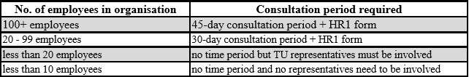

Once completed and a decision made to carry out redundancy, the employer must provide the employee notice in writing outlining the reasons why and the amount of redundancy pay available.
Talent and resourcing remains an ongoing importance in mobilisation of the workforce, workforce planning and selection and retention and it is vital that HR practitioners understand that carrying it out correctly, can ultimately result in great benefits for the employee, the organisation and the economy as whole.

References

ACAS (ND) Help for small firms: Handling pay and wages [online] Available at: http://www.acas.org.uk/index.aspx?articleid=5312 (Accessed on 02/05/2020).

ACAS (ND) Contracts of employment [online] Available at: http://www.acas.org.uk/index.aspx?articleid=1577 (Accessed on 03/05/2020).
Armstrong, M. (2007) Human Resource Management Practice 10th addition London; Kogan Page.

Chartered Institute of Personnel and Development ( 2019) MEGA TRENDS Ageing gracefully: the opportunities of an older workforce [online] Available at: https://moodle.uwtsd.ac.uk/pluginfile.php/351423/mod_resource/content/0/Megatrends-ageing%20gracefully%20the%20opportunities%20of%20an%20older%20workforce%20-%20recommended.pdf (Accessed on 14/04/2020).

Chartered Institute of Personnel and Development (2019) Workforce Planning [online] Available at: https://www.cipd.co.uk/knowledge/strategy/organisational-development/workforce-planning-factsheet (Accessed on 14/04/2020).

Chartered Institute of Personnel and Development (2020) Succession Planning [online] Available at: https://www.cipd.co.uk/knowledge/strategy/resourcing/succession-planning-factsheet (Accessed on 20/04/2020).

Chartered Institute of Personnel and Development (2015) Resourcing and Talent Planning [online] Available at: https://www.cipd.co.uk/Images/resourcing-talent-planning_2015_tcm18-11303.pdf (Accessed on 20/04/2020).

Chartered Institute of Personnel and Development (2019) Understanding the economy and labour market [online] Available at: https://www.cipd.co.uk/knowledge/work/trends/economy-labour-market-factsheet (Accessed on 13/04/2020).

Chartered Institute of Personnel and Development (2019) Strategic reward and total reward [online] Available at: https://www.cipd.co.uk/knowledge/strategy/reward/strategic-total-factsheet (Accessed on 20/04/2020).

Chartered Institute of Personnel and Development (2019) Selection Methods [online] Available at: https://www.cipd.co.uk/knowledge/fundamentals/people/recruitment/selection-factsheet (Accessed on 20/04/2020).

GOV.UK (2014) Redundancy payments: Form HR1 - advance notification of redundancies [online] Available at: https://www.gov.uk/government/publications/redundancy-payments-form-hr1-advance-notification-of-redundancies (Accessed on 3rd March 2020).

Florentine, S. (2019) Employee retention: 8 strategies for retaining talent [online] Available at: https://www.cio.com/article/2868419/how-to-improve-employee-retention.html (Accessed on 20/04/2020).

Lievens, F., Van Hoye, G. and Anseel, F. (2007) Organizational identity and employer image: towards a unifying framework. British Journal of Management Vol 18.

Ladjemi, K. (2014) 5 irresistible employer brand messages for 2014 Recruiter

OECD (2019) Economic Forecast [online] Available at: http://www.oecd.org/economy/germany-economic-snapshot/ (Accessed on 05/05/2020).

Office for National Statistics (2020) Labour Market overview UK: February 2020 [online] Available at: https://www.ons.gov.uk/employmentandlabourmarket/peopleinwork/employmentandemployeetypes/bulletins/uklabourmarket/february2020 (Accessed on 13/04/2020).

Pulakos, E. (ND) Selection Assessment Methods [online] Available at: https://www.shrm.org/hr-today/trends-and-forecasting/special-reports-and-expert-views/Documents/Selection-Assessment-Methods.pdf (Accessed on 22/04/2020).

Ranstad (2019) Different recruitment methods: advantages and disadvantages [online] Available at: https://www.randstad.co.uk/market-insights/attracting-recruiting-talent/different-recruitment-methods-advantages-disadvantages/ (Accessed on 22/04/2020).

Taylor, S., & Woodhams, C. (2016) Human Resource Management. People and Organisations. 2nd edn, London: Chartered Institute of Personnel and Development

Walker, P. (2007) Contemporary issues in HRM. London: Chartered Institute of Personnel and Development

