Information Engineering Test
Information Engineering
Joseph Williams (1902388)
2020
E.R.D:
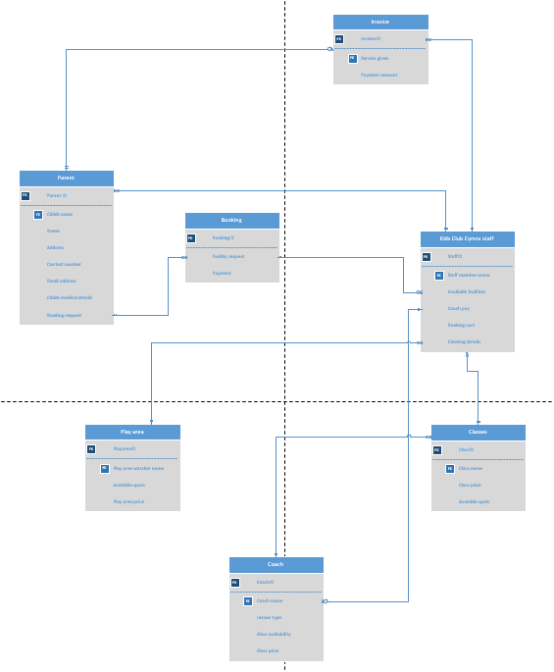
This Entity Relationship Diagram shows the working Kids Club Cymru system in action and how each part communicates with the other.

Context Diagram:
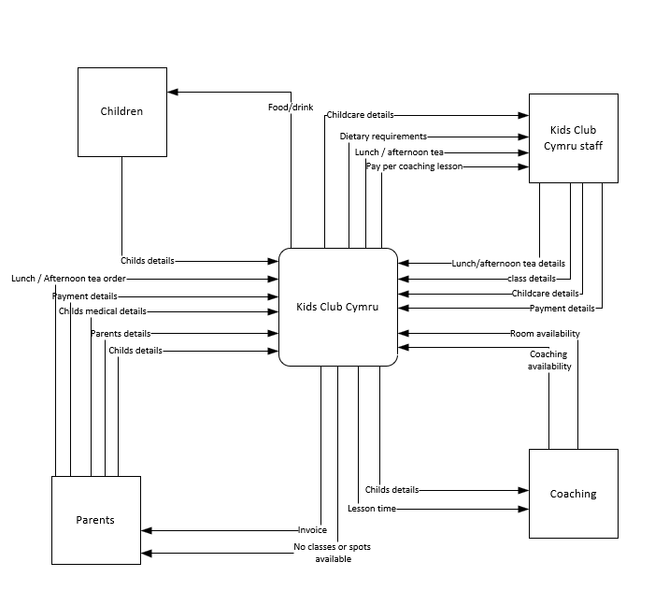
This Context diagram gives a basic understanding of the system in place at the working Kids Club Cymru.

DFD Level 0:
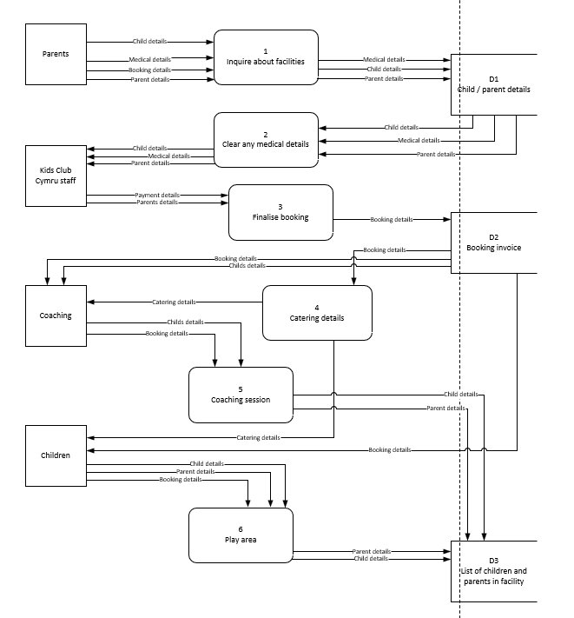
This Data Flow Diagram level 0 gives an advanced understanding of the system in place at the working Kids Club Cymru.

DFD Level 1:
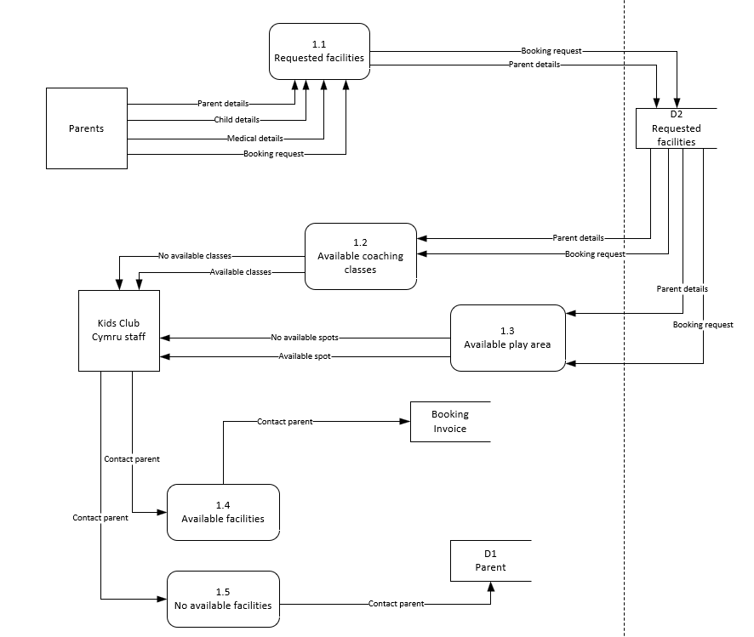
This Data Flow Diagram level 1 goes into more detail on how bookings are completed within Kids Club Cymru.

