Name:__Aled Evans_______________________________

Student Number: _1204278_______________________
__________________________________________________________

WORKSHEET 4 – TESTING

- Original code:
import random
treasures = []
def genList():
treasures.clear()
i = 0
while i < 5:
randomvalue = random.randint(1,50)
if randomvalue not in treasures:
treasures.append(randomvalue)
i += 1
print("Generated numbers: ", treasures)
def intro():
print("Welcome to Treasure Island!")
print("There are 5 treasure chests hidden across the island (locations 1-50)")
def collectGuess():
while True:
try:
guess = int(input("Where would you like to search? "))
if 1 <= guess <= 50:
return guess
else:
print("Please enter a value between 1 and 50")
except ValueError:
print("Please enter a valid number")
def checkNumber(value, list = treasures):
guessdistance = []
if value in list:
print("💰 TREASURE FOUND! You've struck gold! 1000 coins!")
print("Thank you for playing")
return True
else:
maxvalue = 50
for treasures in list:
distance = abs(value - treasures)
if distance < maxvalue:
maxvalue = distance
guessdistance.append(maxvalue)
if min(guessdistance) <= 2:
print("🔥 BURNING HOT! The treasure is practically beneath your feet!")
elif min(guessdistance) <= 4:
print("♨️ Very Hot! Your metal detector is beeping rapidly!")
elif min(guessdistance) <= 7:
print("🌡️ Hot! You can sense something valuable nearby!")
elif min(guessdistance) <= 12:
print("😊 Warm! You're on the right track!")
elif min(guessdistance) <= 18:
print("😐 Cool! You might want to try elsewhere!")
elif min(guessdistance) <= 25:
print("🥶 Cold! You're quite far from any treasure!")
else:
print("🧊 Freezing! You're nowhere near any treasure!")
def mainLoop():
while True:
if checkNumber(collectGuess()) == True:
value = input("Would you like to play again? (yes, no) ")
if value != "yes":
break
else:
genList()
intro()
genList()
mainLoop()

Code Testing

First, create a test rig, so that you can see the generated numbers before testing the programme - so that you can see what you’re doing!

For each test below, run your code and enter the values provided. Provide a screenshot of what happened when the programme ran. Did the programme behave correctly or did it do something unexpected? Fill in a box for each test below. You should present 11 separate boxes, 1 for each test. (Note: the first box is provided as a template)

Test the following:

- Guess is an exact match on the first number in the set
- Guess is an exact match on the last number in the set
- User enters their guess as -4
- User enters their guess as 55
- Within 2 of a number (below)
- Within 2 of a number (above)
- Within 5 of a number (below)
- Within 5 of a number (above)
- Within 2 of two numbers
- Within 2 or 5 of three numbers (you may need to run your program a few times to generate a suitable number set, or you can hard code the values into the test rig)
- What happens if a duplicate number is generated within the random number set?

Test:
- Guess is an exact match on first number in the set

Screenshot(s) of output:
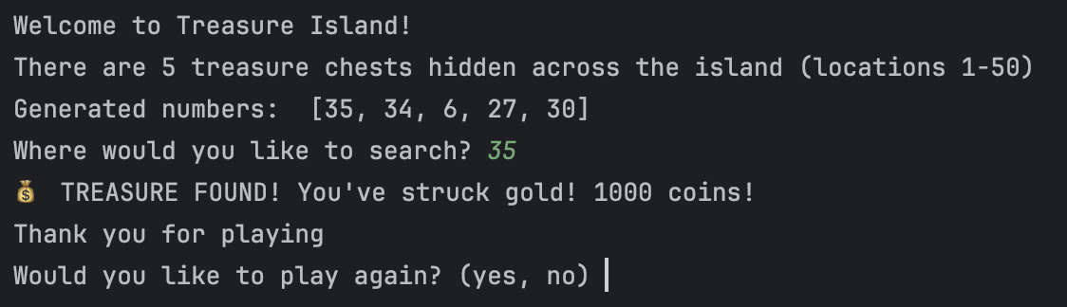
Result: Did the program behave as expected ie syntactically and logically correct?
YES/NO (delete as appropriate)

If NO, what problems were encountered and why? Suggest how things could be improved.

Test:
- Guess is an exact match on the last number in the set

Screenshot(s) of output:
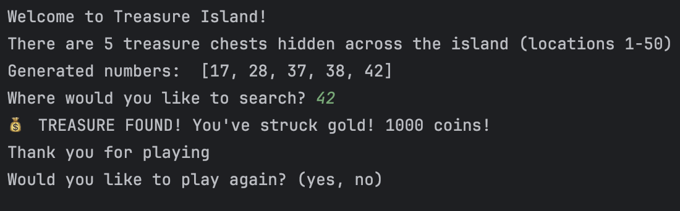
Result: Did the program behave as expected ie syntactically and logically correct?
YES/NO (delete as appropriate)

If NO, what problems were encountered and why? Suggest how things could be improved.

Test:
- User enters their guess as -4

Screenshot(s) of output: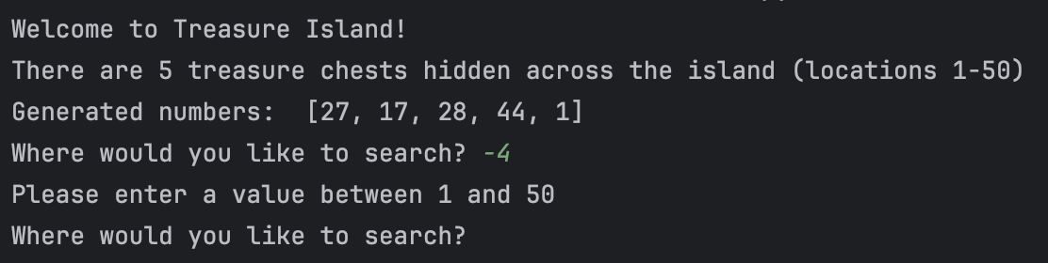

Result: Did the program behave as expected ie syntactically and logically correct?
YES/NO (delete as appropriate)

If NO, what problems were encountered and why? Suggest how things could be improved.

Test:
- User enters their guess as 55

Screenshot(s) of output:
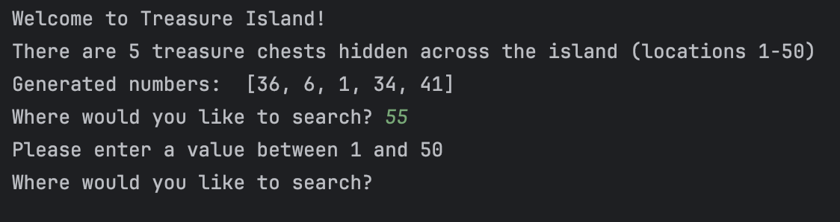
Result: Did the program behave as expected ie syntactically and logically correct?
YES/NO (delete as appropriate)

If NO, what problems were encountered and why? Suggest how things could be improved.

Test:
- Within 2 of a number (below)

Screenshot(s) of output:
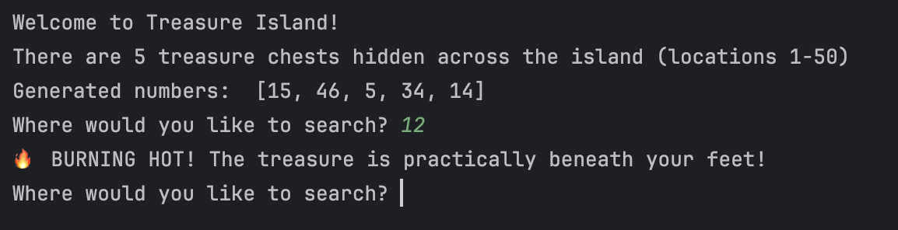
Result: Did the program behave as expected ie syntactically and logically correct?
YES/NO (delete as appropriate)

If NO, what problems were encountered and why? Suggest how things could be improved.

Test:
- Within 2 of a number (above)

Screenshot(s) of output:
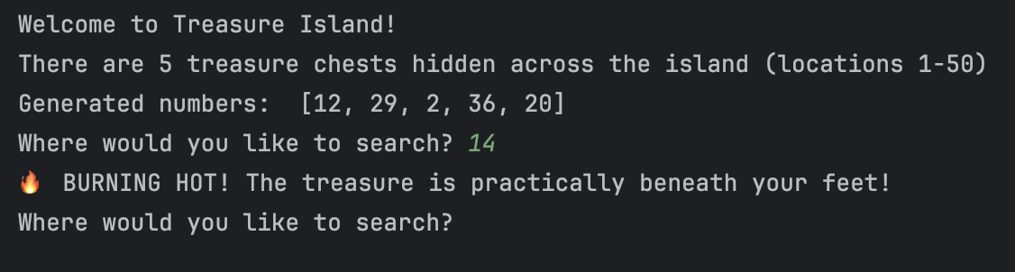
Result: Did the program behave as expected ie syntactically and logically correct?
YES/NO (delete as appropriate)

If NO, what problems were encountered and why? Suggest how things could be improved.

Test:
- Within 5 of a number (below)

Screenshot(s) of output:
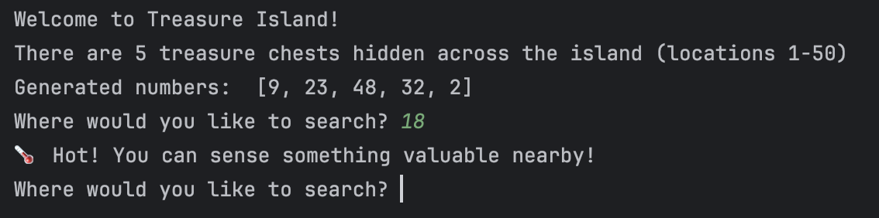
Result: Did the program behave as expected ie syntactically and logically correct?
YES/NO (delete as appropriate)

If NO, what problems were encountered and why? Suggest how things could be improved.

Test:
- Within 5 of a number (above)

Screenshot(s) of output:
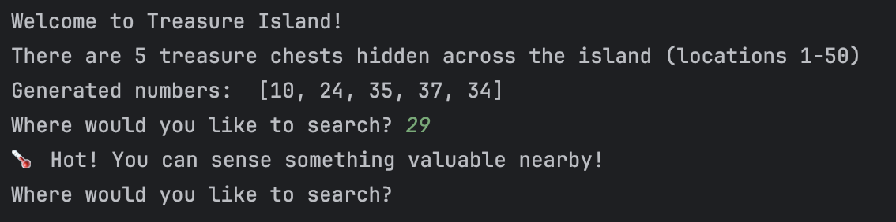
Result: Did the program behave as expected ie syntactically and logically correct?
YES/NO (delete as appropriate)

If NO, what problems were encountered and why? Suggest how things could be improved.

Test:
- Within 2 of 2 numbers

Screenshot(s) of output:
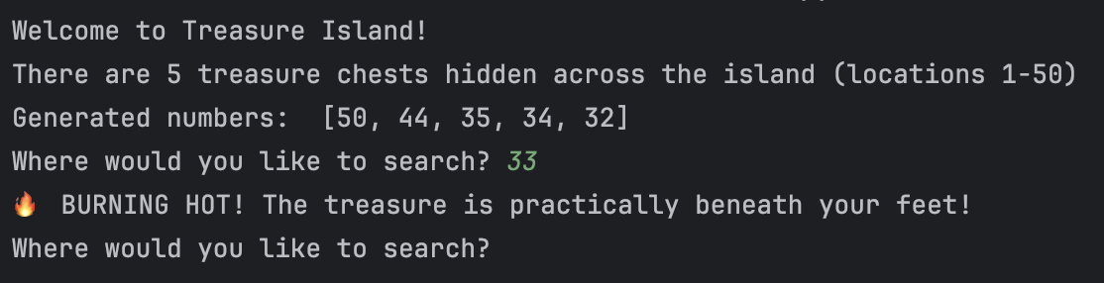
Result: Did the program behave as expected ie syntactically and logically correct?
YES/NO (delete as appropriate)

If NO, what problems were encountered and why? Suggest how things could be improved.

Test:
10. Within 2 or 5 of three numbers

Screenshot(s) of output:
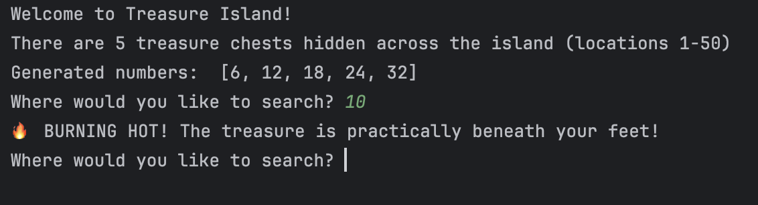
Result: Did the program behave as expected ie syntactically and logically correct?
YES/NO (delete as appropriate)

If NO, what problems were encountered and why? Suggest how things could be improved.

Test:
11. What happens if a duplicate number is generated within the random number set?

Screenshot(s) of output:

This can’t happen as I have provided a check during number generation.

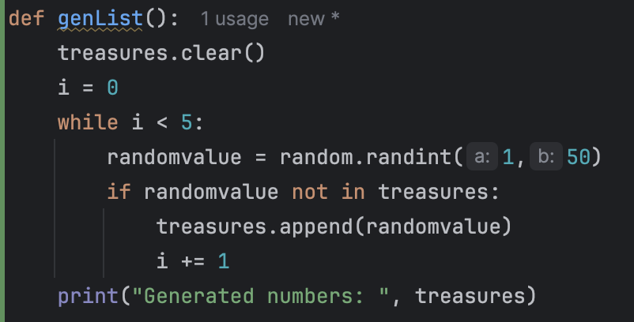
Result: Did the program behave as expected ie syntactically and logically correct?
YES/NO (delete as appropriate)

If NO, what problems were encountered and why? Suggest how things could be improved.

- Consider the results of the above tests and revisit your original code in order to address the tests that failed. (Note: you may not be able to solve all of the problems that were originally encountered, but solve as many as you can.)

Paste your full revised code here :

[Copy and paste your full revised code here – note, do not use a screenshot]

N/A

