

Vehicle Performance Optimisation Using Simulation Software
Temitope Oshodi
2501804
December 2025

Introduction

Optimising how a car performs is one of the main challenges in modern automotive engineering. Modern vehicles must balance performance, safety, efficiency, and regulatory compliance. Engineers cannot just focus on one part of the car; they must look at how all the systems work together. Simulation software is useful here because it allows testing ideas without building a real car, saving both time and money (Milliken and Milliken, 1995 Gillespie 1992). By running models, we can see how changes affect speed, fuel use, and handling.
Vehicle performance depends on several key factors such as aerodynamic drag, rolling resistance, vehicle weight, (Gillespie, 1992) and how the powertrain is set up. Changing these can improve one area but sometimes makes another worse. For example, reducing drag helps at high speeds, while changing gear ratios might improve acceleration but reduce fuel economy. In this study, simulation modelling is used to test changes in aerodynamics, rolling resistance, gearing, and mass reduction. The results are checked using drive cycles, with indicators like energy use, acceleration, and gradeability to see which setups give the best balance.

Method and Simulation setup

For this project I used Optimum software to run the simulations. A simple baseline model of the car was created using values for mass, drag, rolling resistance, and the engine. These are the main factors that affect how a car moves, so they were chosen as the starting point.

The software calculates the forces acting on the car, such as aerodynamic drag, tyre resistance, and the effect of weight. These forces were then applied across standard drive cycles to make the tests realistic. The program produced outputs like speed graphs, gear changes, engine rpm, and cornering forces, which were used to compare different setups.

To keep the process clear, I changed one factor at a time. For example, drag was reduced to see how it helped at higher speeds, mass was lowered to check acceleration, and gear ratios were adjusted to see how shifting affected lap times. Each setup was tested on the same drive cycle so the results could be compared fairly.

Overall, Optimum Lap uses a simplified model that assumes the car and driver are performing at their best, so the lap times it gives are usually quicker than what would happen in real life.

Report

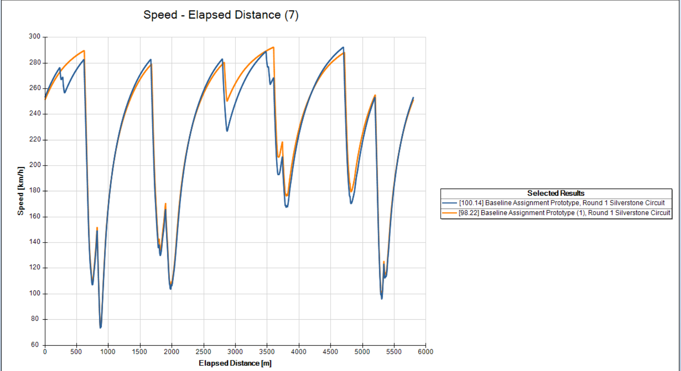

The baseline car completed the Silverstone lap in about 100 seconds. After reducing drag and mass, the lap time improved to 98.22 seconds. This shows that the car was able to accelerate faster and hold its speed more effectively. The speed–distance graph highlights the difference: the baseline car reached slightly higher peak speeds, which suggests lower initial drag, but the modified car-maintained momentum better after the changes. Overall, the results confirm that reducing drag and mass can make a noticeable improvement in lap times and driving behaviour.
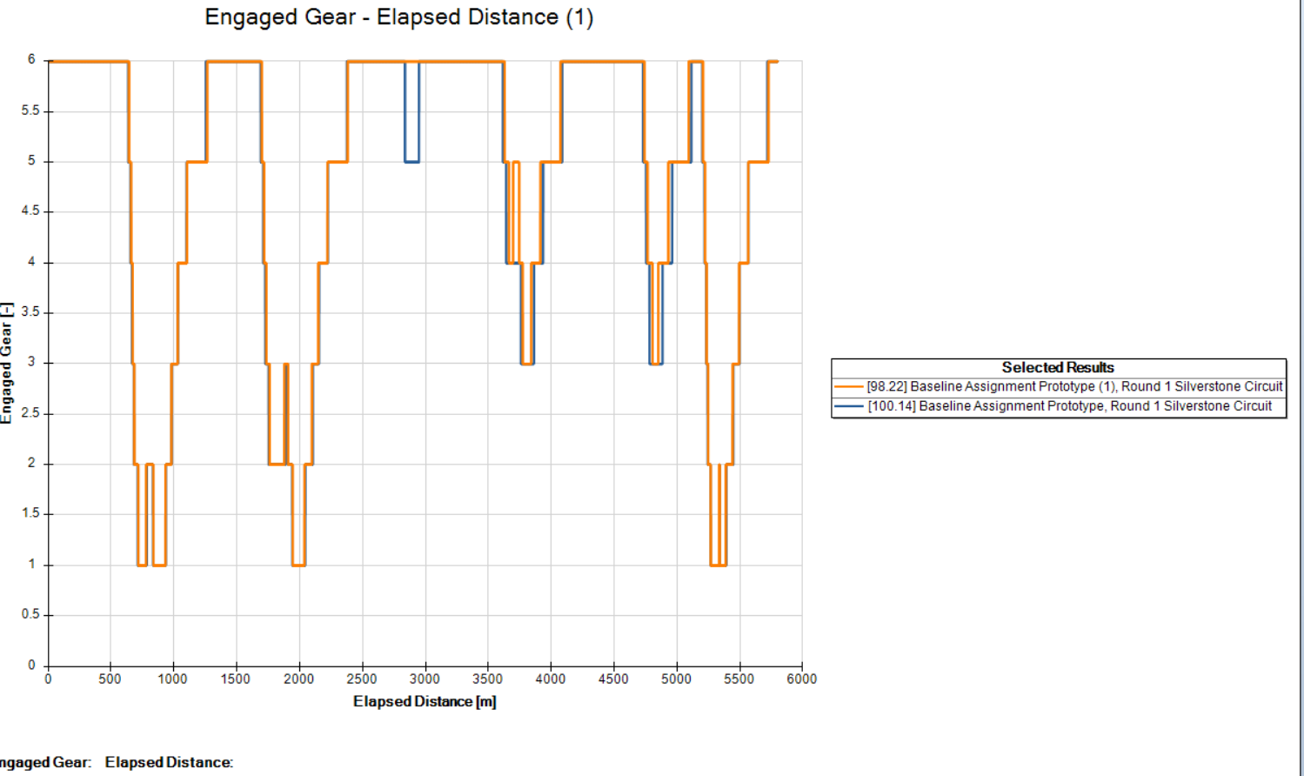

In the first 3000 meters of the lap, both cars shifted quickly through gears 1 to 6. The gear changes were stable across the straights, with downshifts happening when needed. After the drag changes, the modified car (orange line) showed more frequent downshifts and spent longer in lower gears, especially gears 4 and 5. The baseline car (blue line), on the other hand, stayed in higher gears for longer stretches, which suggests it was able to keep momentum more effectively. This difference shows how drag reduction and mass changes can influence gear use and overall driving behaviour.
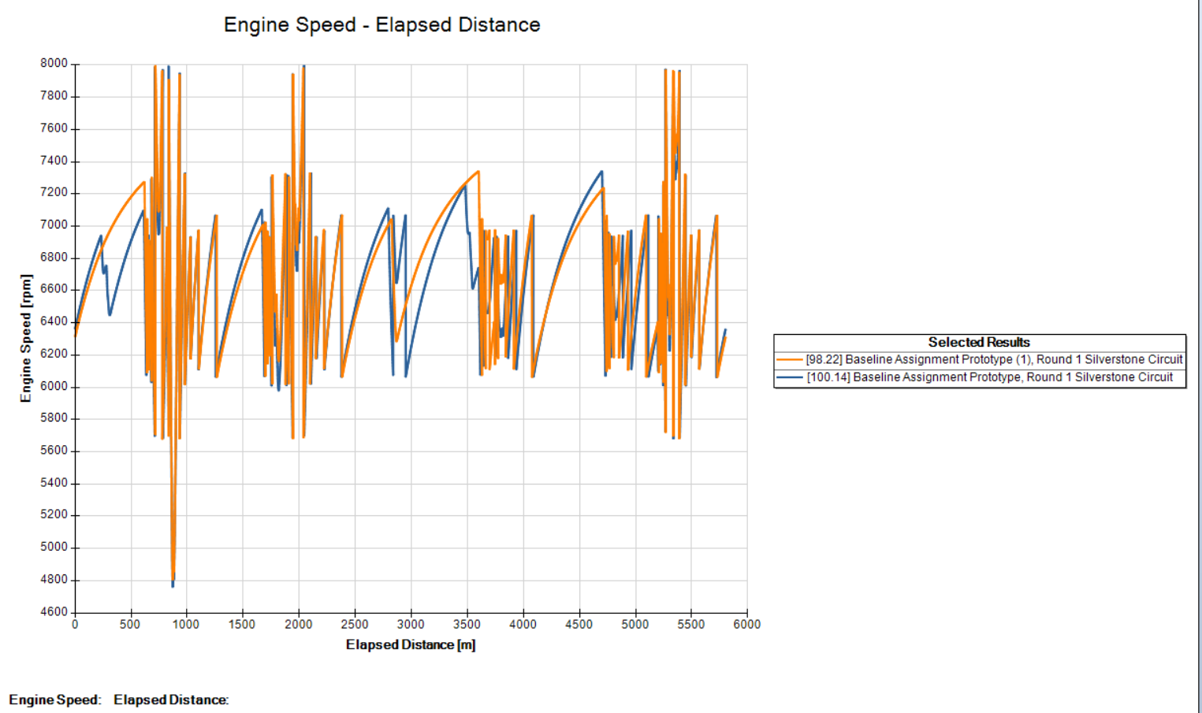

Both cars showed strong acceleration at the start of the lap, with engine rpm rising between 6000 and 8000. This reflects the aggressive gear shifting needed to build speed quickly. After the drag changes, the modified car’s peak rpm dropped below 7000, while the baseline car stayed closer to the higher values. This difference suggests that the baseline setup delivered more consistent power, while the modified setup traded peak rpm for smoother acceleration. Overall, the graphs show how changes in drag and mass can influence the way the engine delivers power across the lap
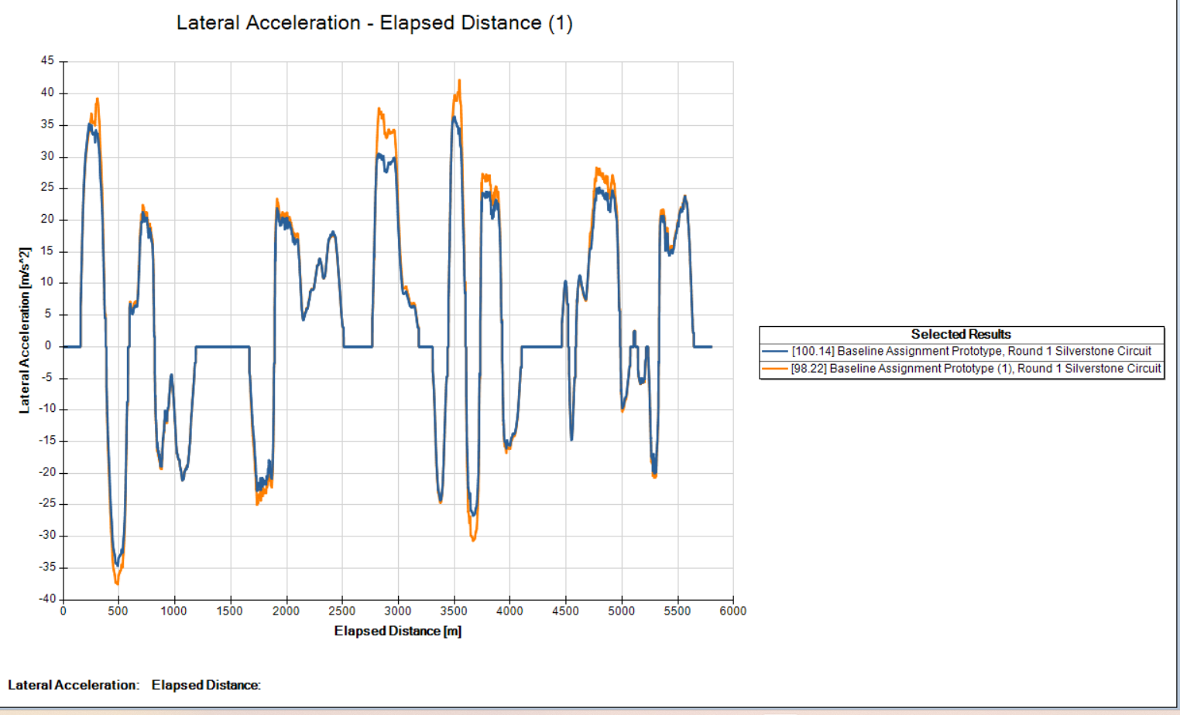

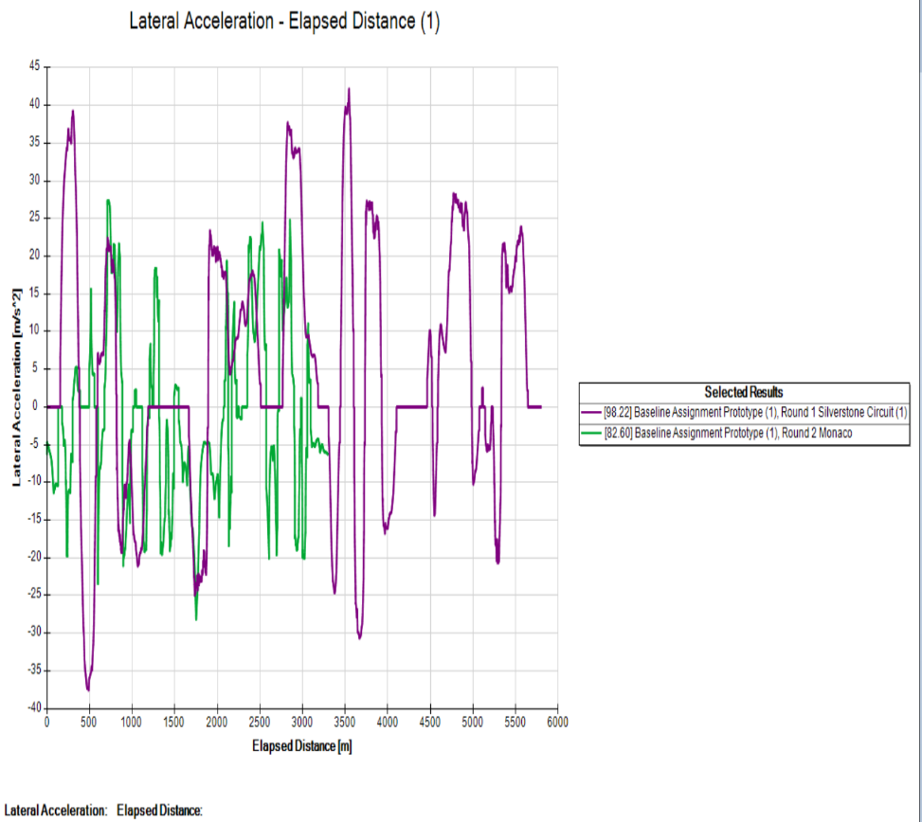
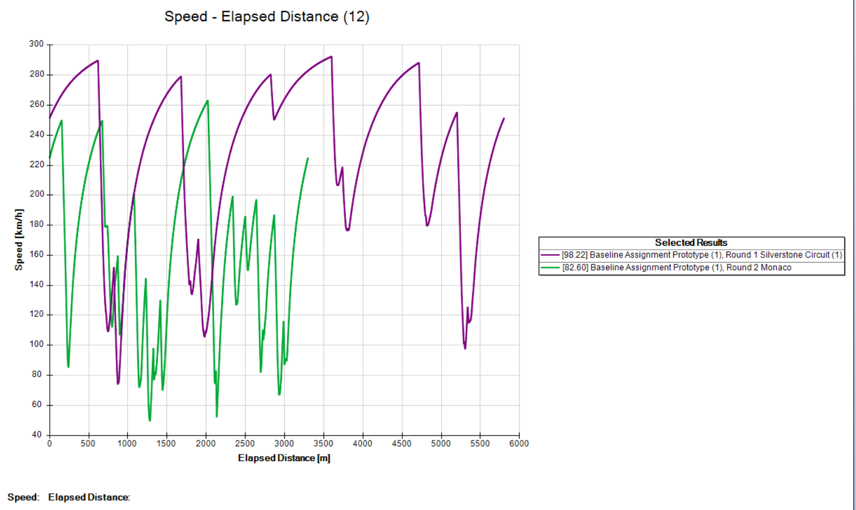
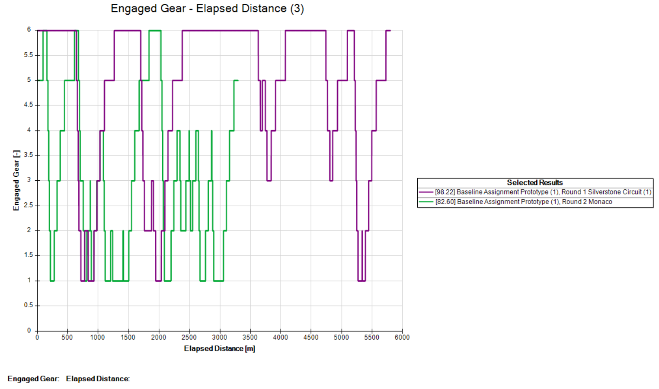
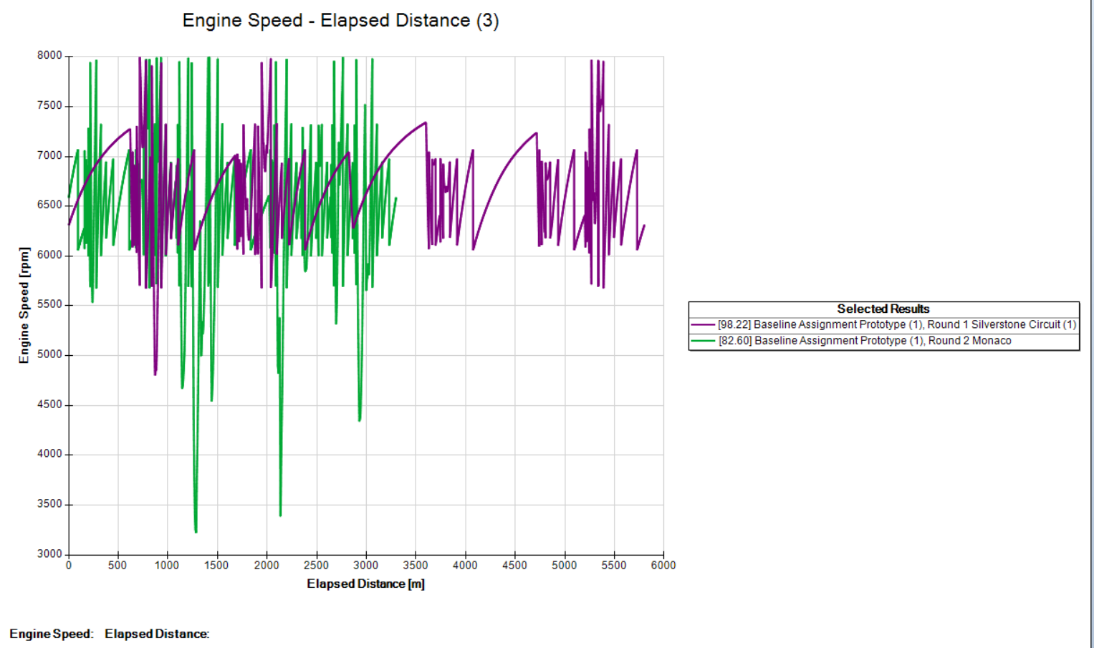
The graphs show how the car performed on two tracks, Silverstone and Monaco. At Silverstone, the car went faster, stayed in higher gears, and kept the engine running at high rpm. Monaco was different because the track is tighter, so the car had to slow down more, change gears often, and the engine speed dropped. The lateral acceleration graph shows sharper turns at Monaco, meaning the car had to focus more on control. Overall, Silverstone is about speed and power, while Monaco is about careful driving and stability. The setup of the car, like drag and gears, made a big difference.

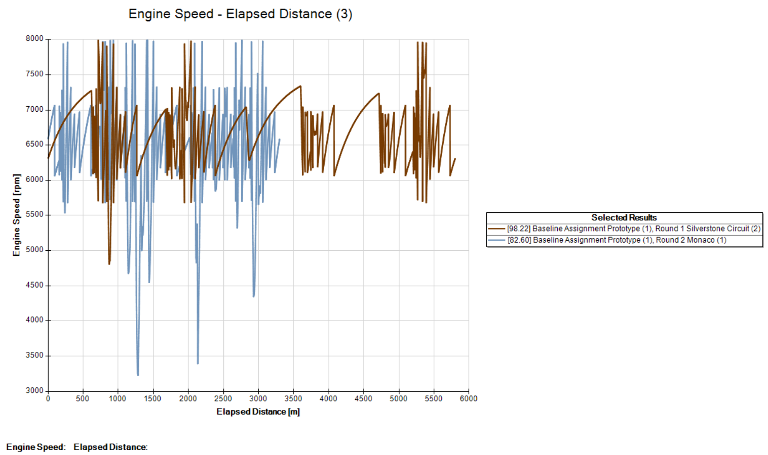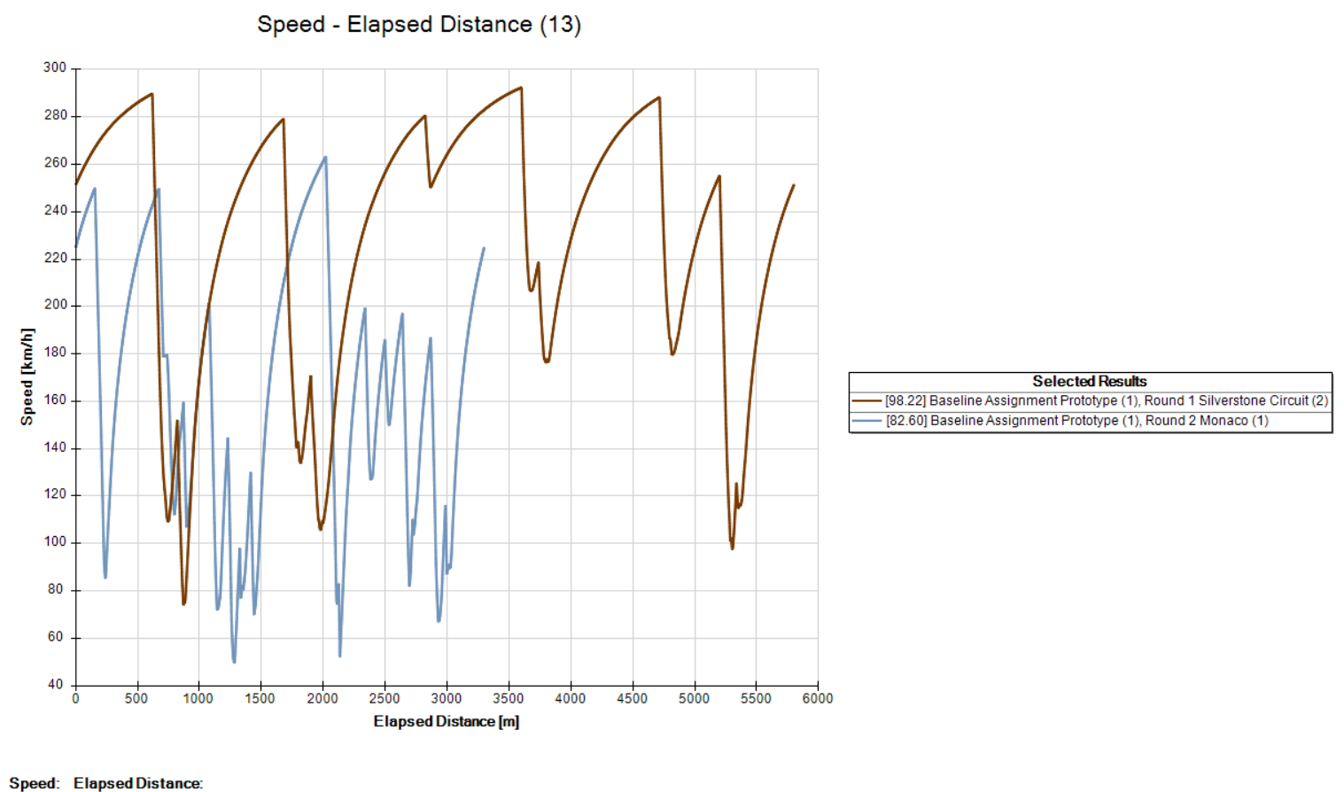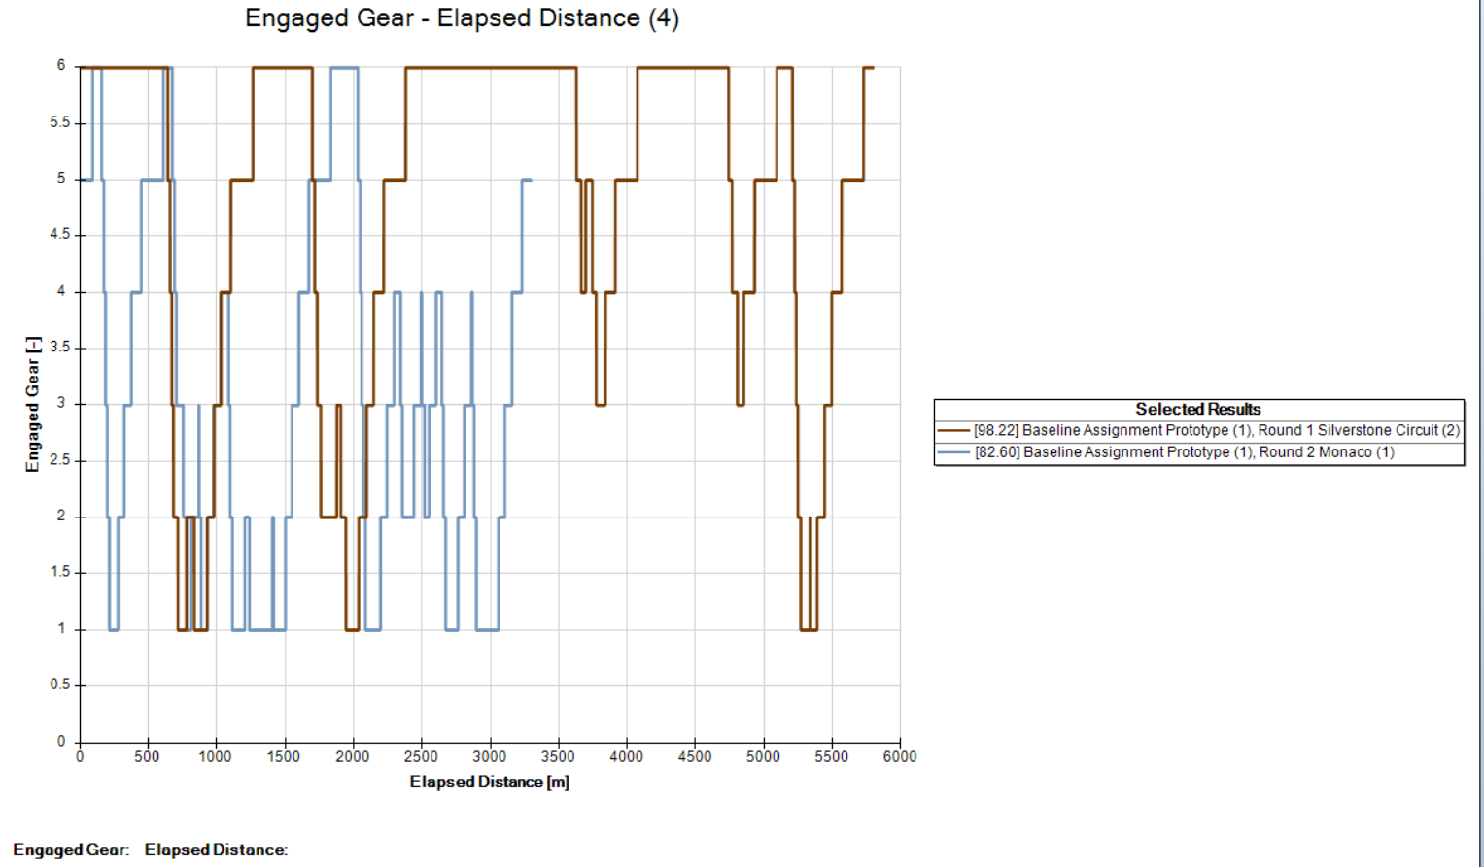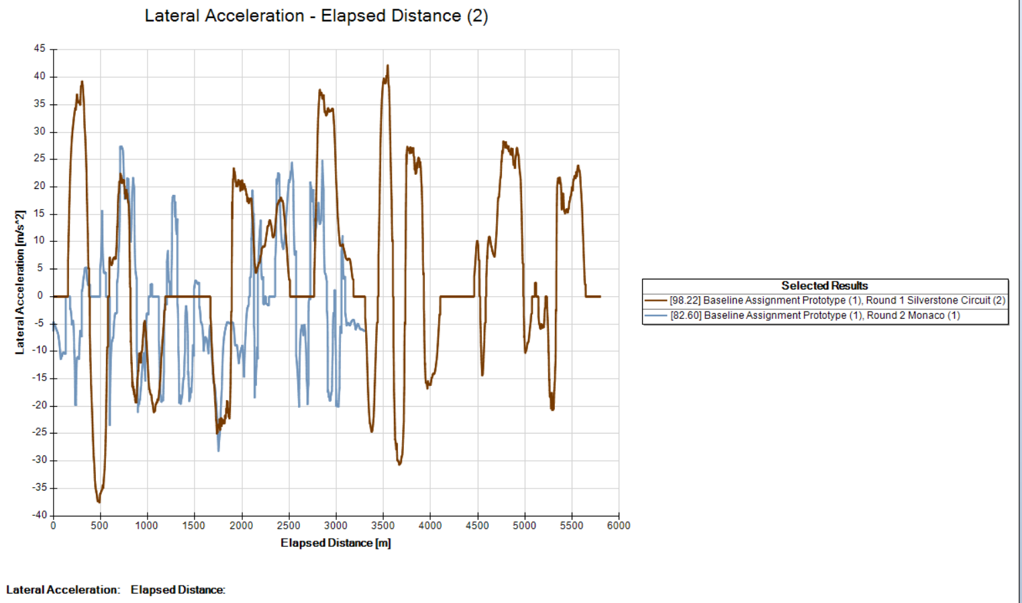

Speed Graph:
At Silverstone, the car reached higher speeds and stayed fast for longer. At Monaco, speeds were lower because the track has more corners and short straights. This shows Silverstone is more about speed, while Monaco slows the car down.
Gear Graph:
Silverstone let the car stay in higher gears, which means smoother driving and faster laps. Monaco needed more gear changes, showing the driver had to keep adjusting for bends and tighter sections.
Engine Speed Graph:
The engine ran at higher rpm on Silverstone, giving stronger acceleration. At Monaco, rpm dropped more often, meaning the car had to slow down and use less power.
Lateral Acceleration Graph:
Monaco had stronger sideways forces, so the car had to turn harder and focus on grip. Silverstone was smoother, with less sideways movement.

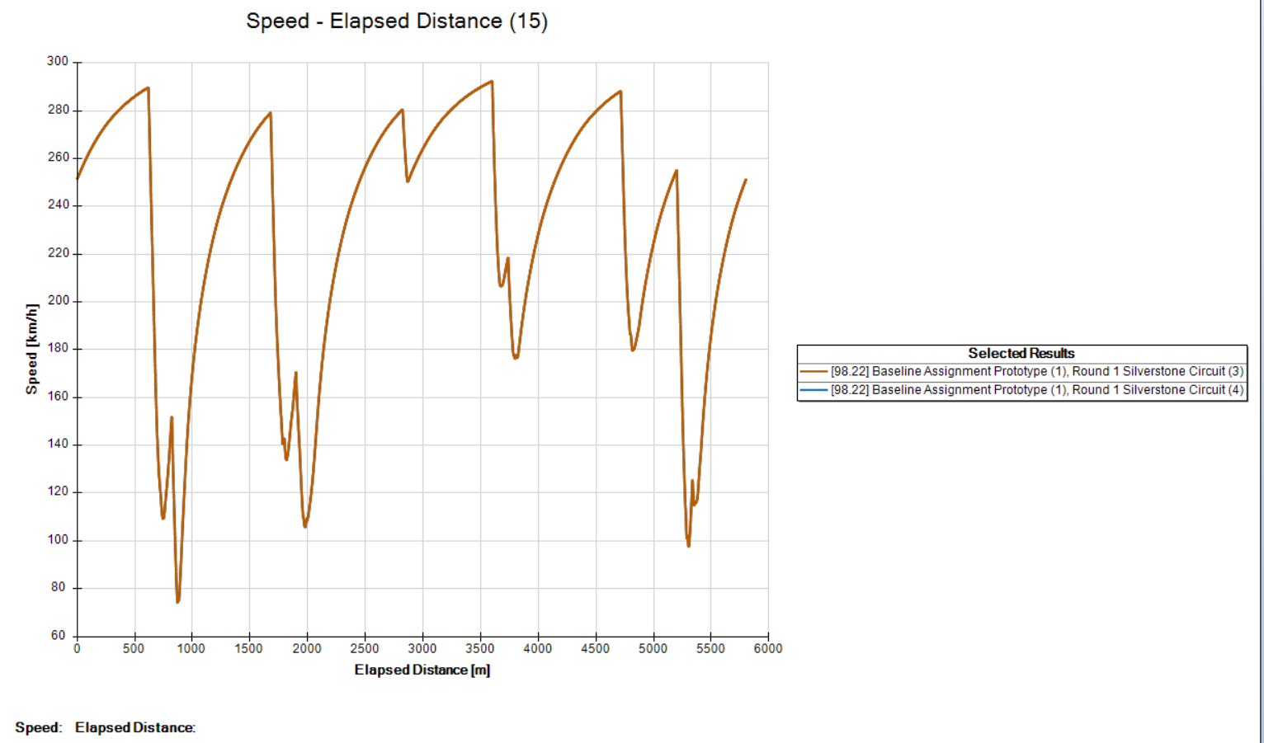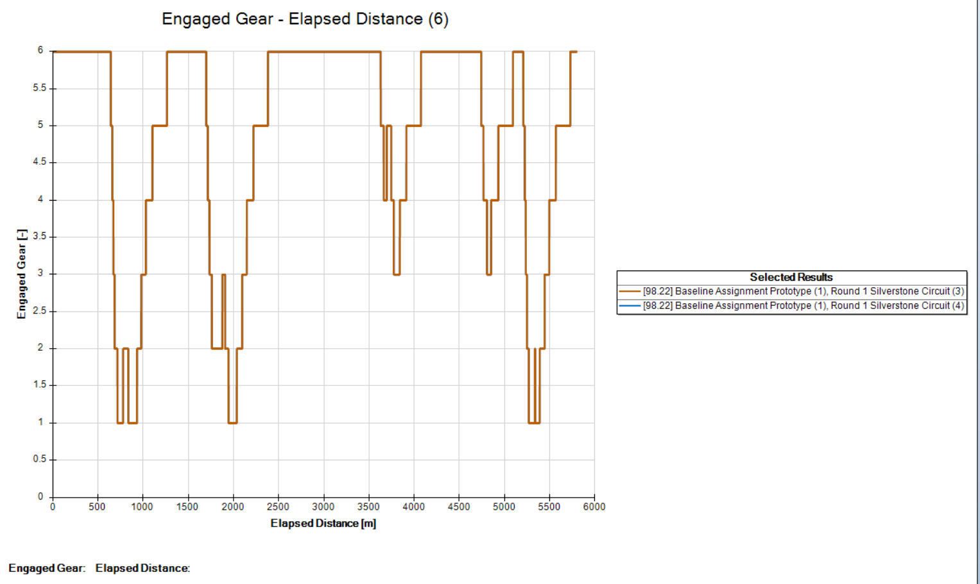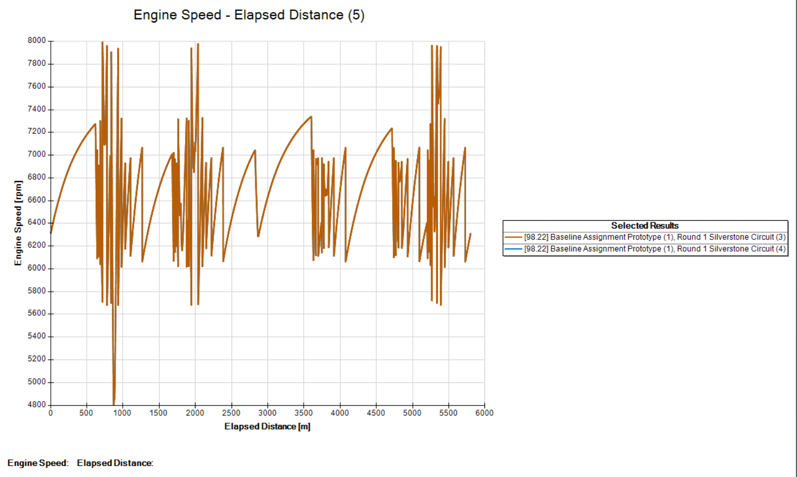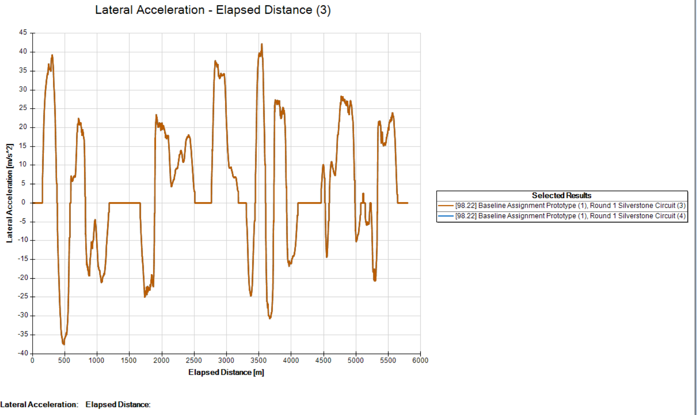
Speed stayed high, gears shifted smoothly, engine rpm was strong, and cornering forces were sharp.

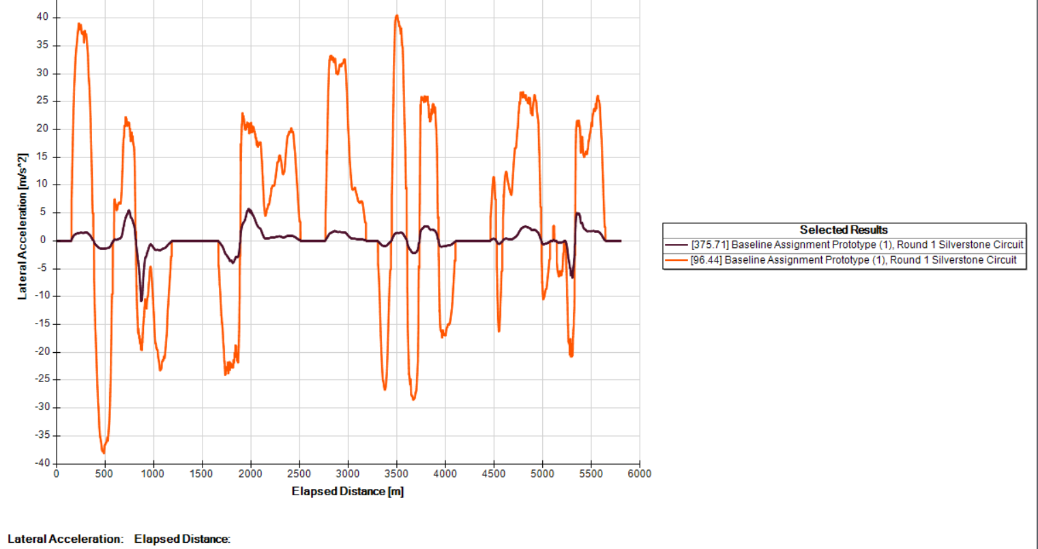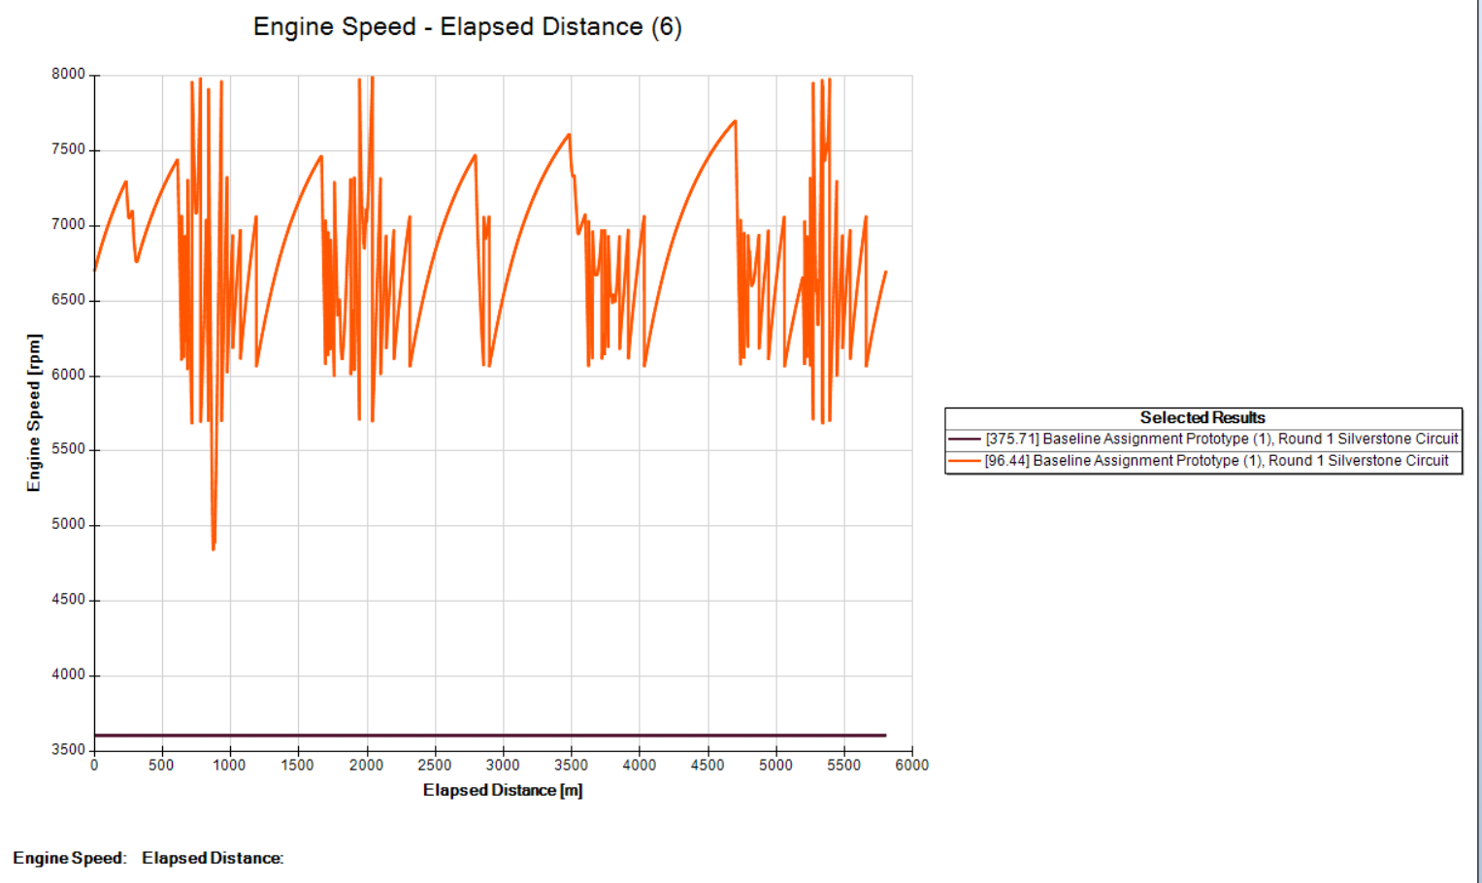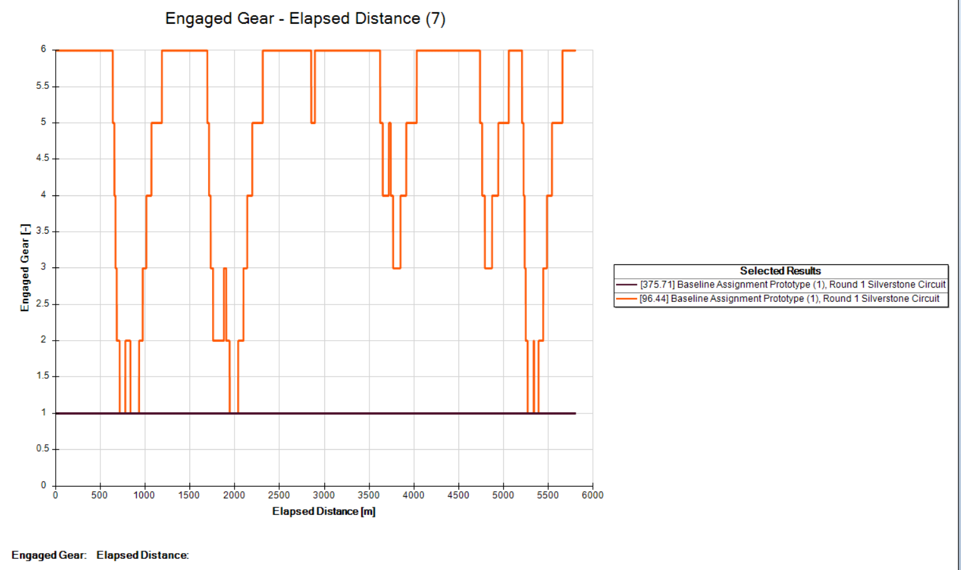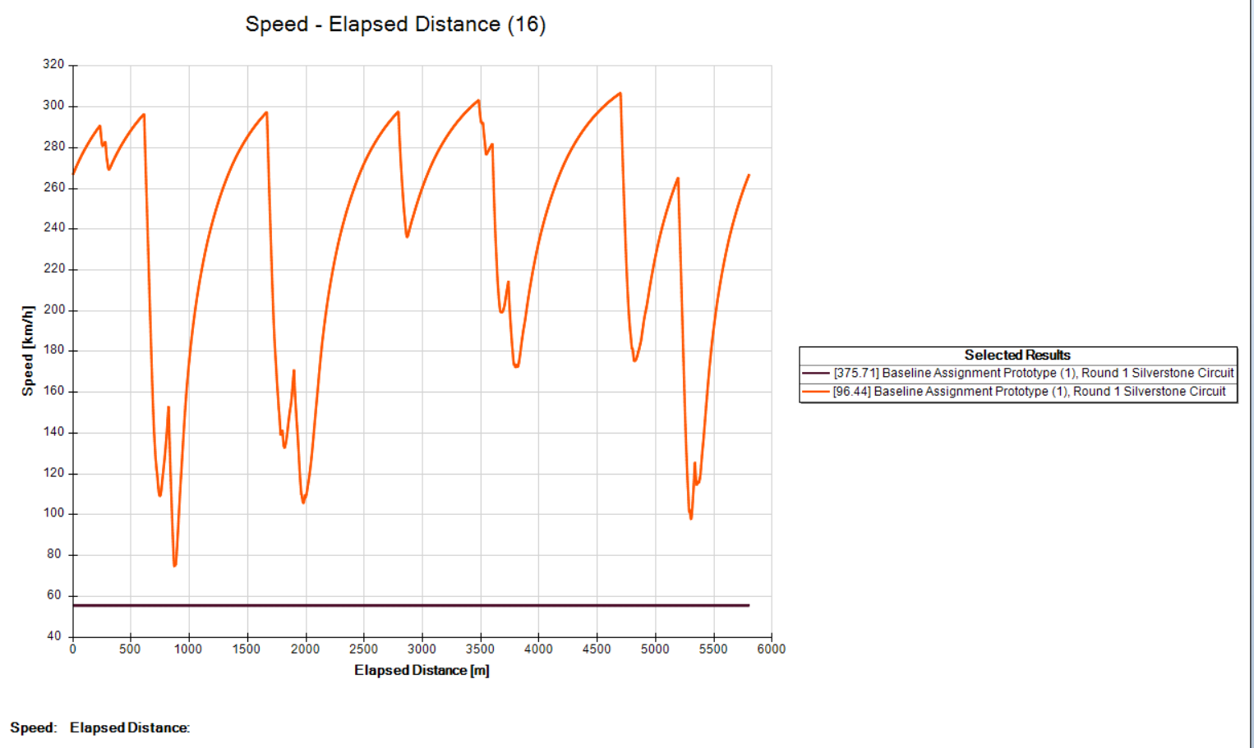
After using Map A (aero/tyres) and Map B (engine), the lap time changed a lot. Before, the car finished in 96.44 seconds, but after the maps it took 359 seconds. The graphs show why: speed stayed low, gears didn’t shift properly, and the engine rpm was almost flat. Lateral acceleration was also small, meaning the car didn’t corner well. Basically, the car was much slower and less active after the changes. This shows that the wrong setup can make a big difference, and matching tyres and engine maps correctly is important for good lap times.

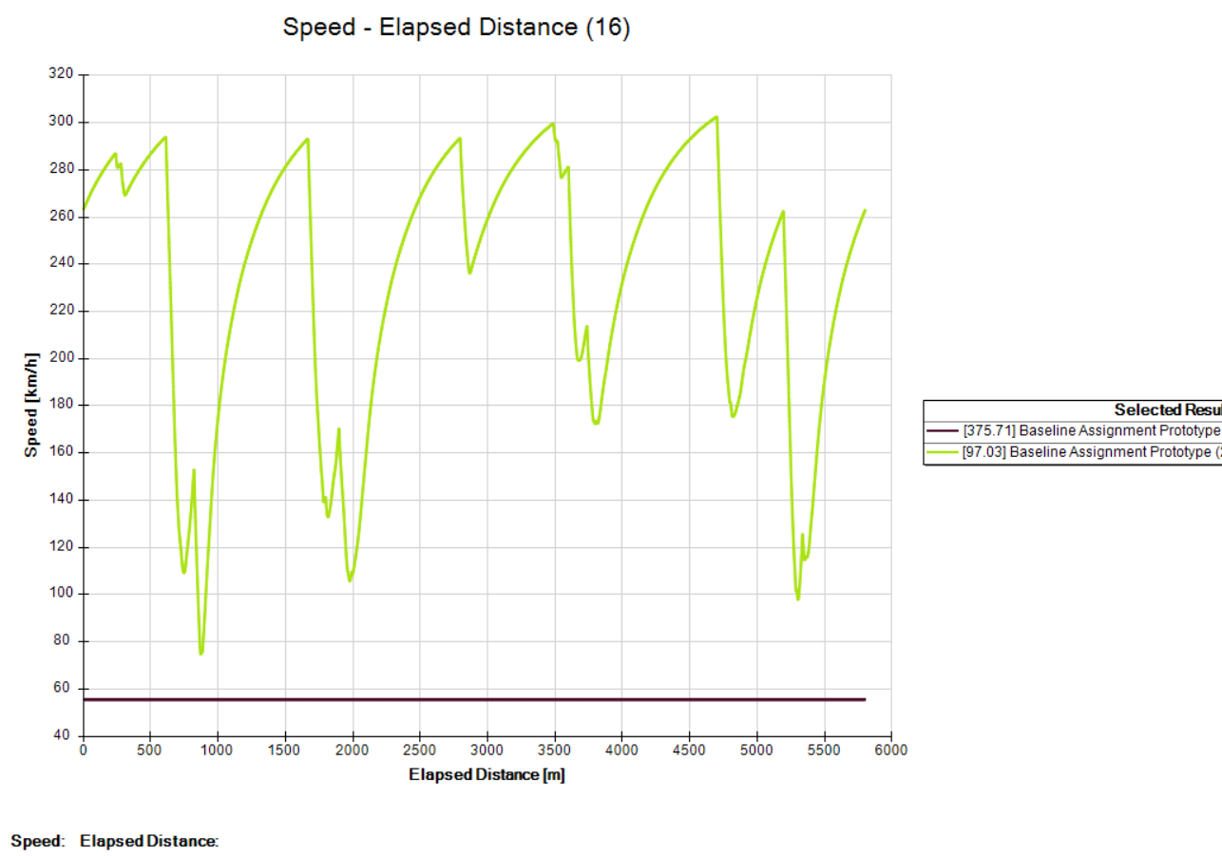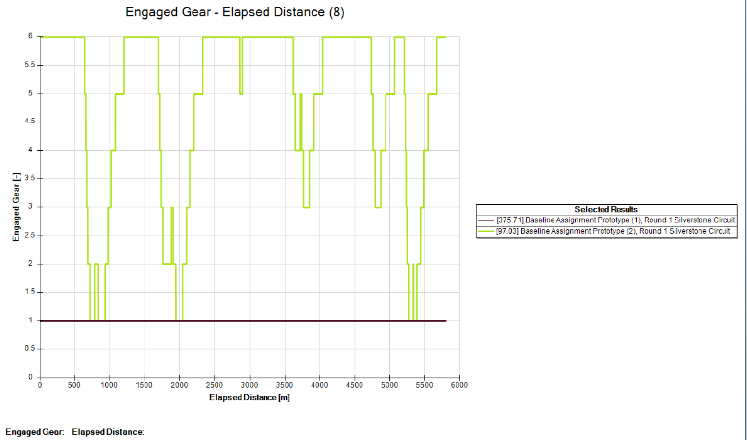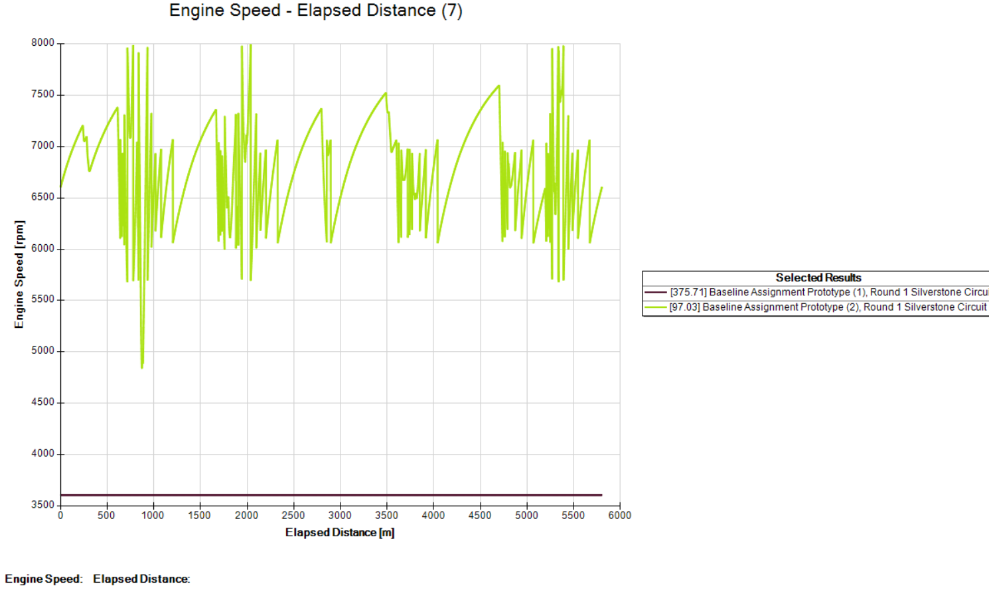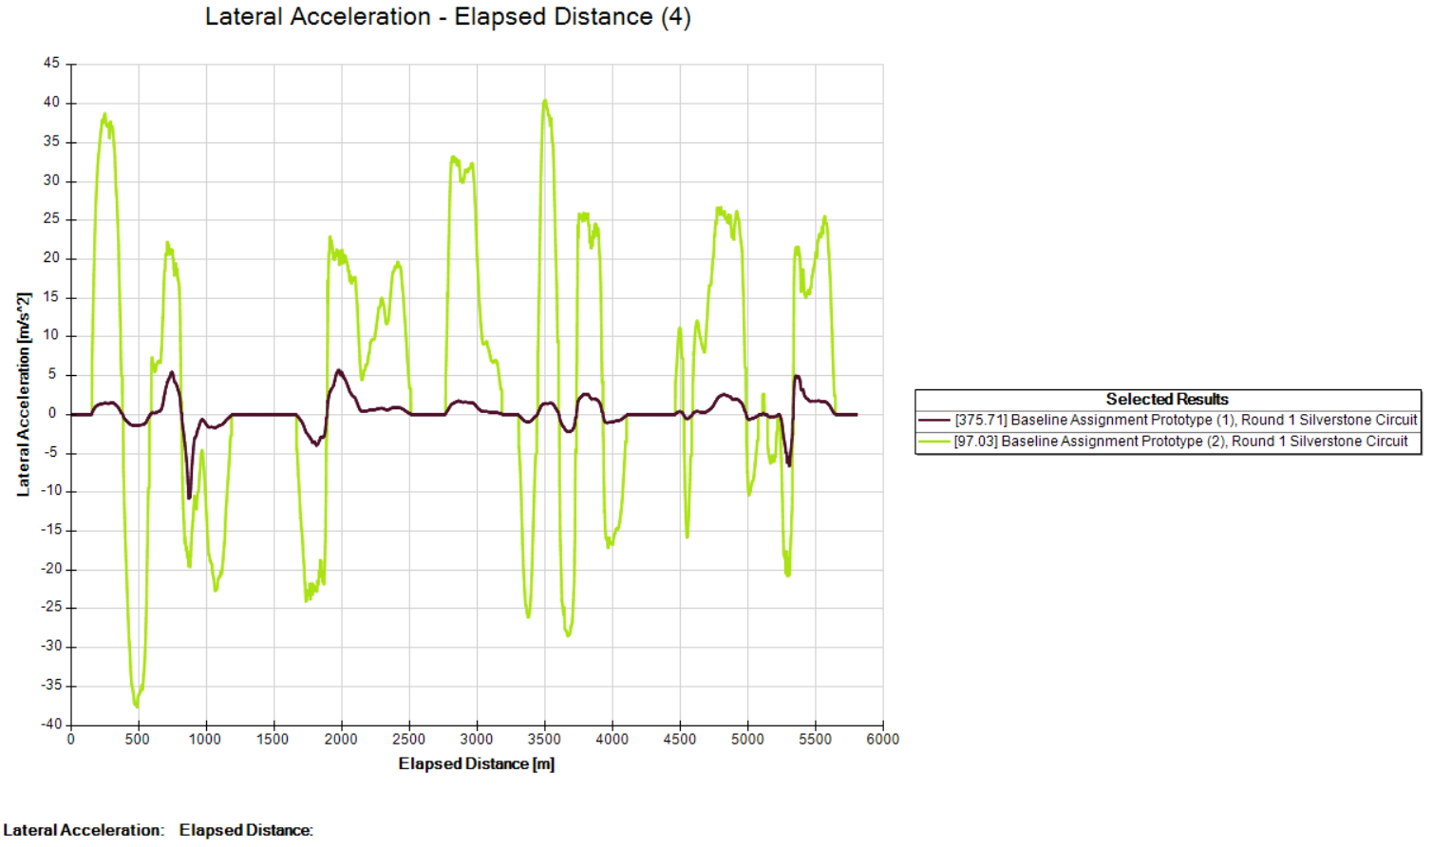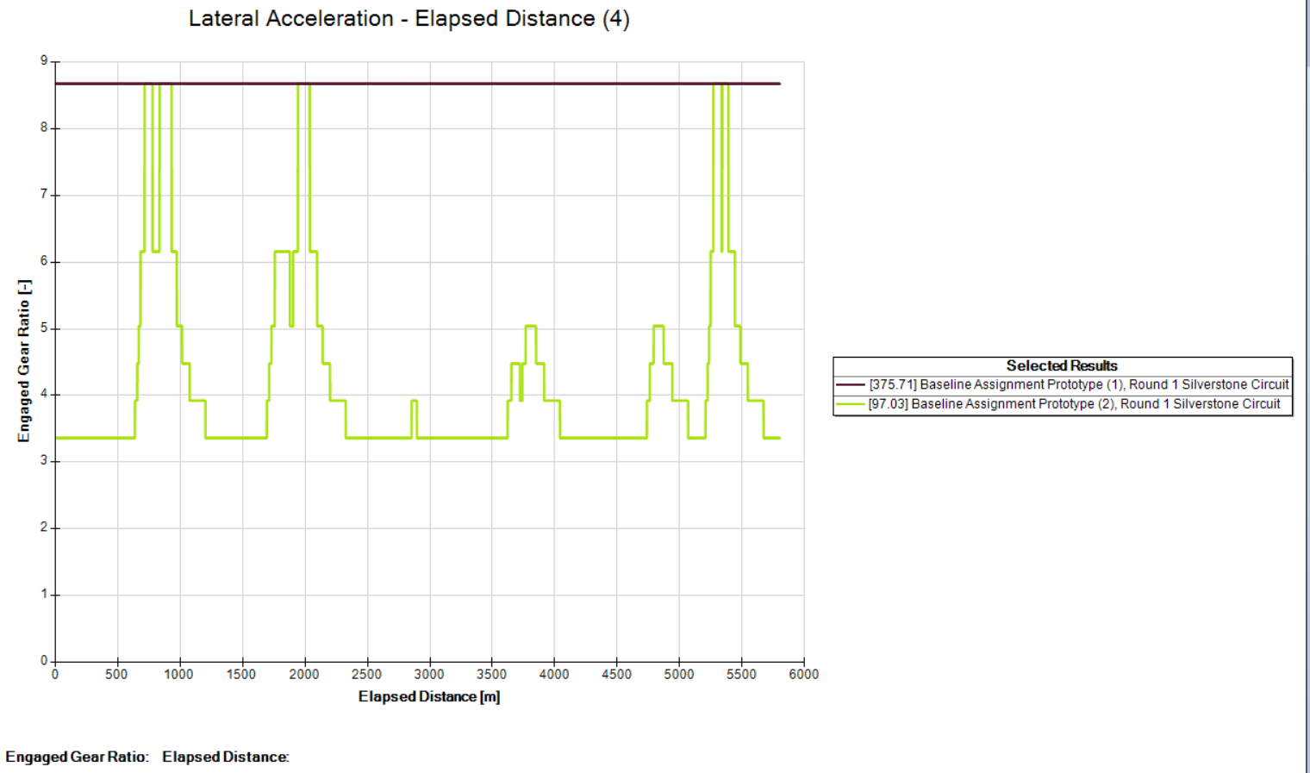

The graphs show two car setups on the Silverstone track. The green car (97.03) behaved normally, with speed going up and down, gears shifting between 2 and 6, and engine rpm rising and falling. It also showed strong side forces in corners, which means it was racing properly.
The purple car (375.71) looks very different. Speed stayed low at about 60 km/h, gears stayed in 1, and engine rpm was flat near 3750. Lateral acceleration was also almost zero. This doesn’t match real racing behaviour. The value 375.71 is most likely a mistake from the software, not the actual gear or lap time. Because of this error, the lap time became much longer, and the car looked unresponsive in the data.
Overall, the green car shows proper racing performance, while the purple one highlights a software error that affected the results.

Discussion
The results show that small changes in setup can have a big impact on performance. Reducing drag and mass gave faster lap times, while gear ratio changes affected how smoothly the car accelerated and shifted. These findings match what we would expect in real driving, lighter cars accelerate better, and lower drag helps at higher speeds (Gillespie, 1992).
Performance is not just about speed. The modified car had lower peak rpm, which might look weaker at first, but it gave smoother acceleration. This shows that optimisation is about balance, not just chasing the highest numbers (Milliken and Milliken, 1995). A car that accelerates smoothly and uses gears efficiently can be more reliable and easier to drive.
Another lesson is the importance of checking data carefully because the software does not include things like suspension effects or weight transfer (Optimum, 2012), the results should be seen more as comparisons between setups rather than exact values. The strange results in run 375.71, where the car stayed in first gear and lap times were unrealistic, show how software errors or wrong maps can give misleading outcomes.

Conclusion
The simulations showed that using the right setup makes a big difference in how the car performs. Runs with good maps, such as 96.44, 97.03, and 98.22 seconds, had smooth gear shifts, strong acceleration, and good cornering forces. Runs with wrong maps, like 375.71, gave unusual results, such as the car staying in first gear and lap times becoming very long. This was most likely a software error, which shows why it is important to check data carefully before trusting it.
Two main points stand out from the study. First, correct setups improve speed, handling, and efficiency. Second, mistakes in maps or software can give results that do not match real driving behaviour. Comparing Silverstone and Monaco also showed how track design matters: Silverstone rewards speed and stability, while Monaco requires more control, frequent gear changes, and stronger grip.
By adjusting drag, mass, and gearing, Optimum helped show how cars can be tuned for both efficiency and drivability. Careful testing and validation make sure the results are reliable, proving that simulation is a useful tool for vehicle performance optimisation.

Reference
OptimumG (2012) *OptimumLap v1.4: Vehicle Dynamics Simulation. Simplified. Help File. Denver, CO OptimumG. Available at: https://students.optimumg.com/product/optimumlap/ (Accessed: 12 December 2025).
(Used in Discussion for software and limitations)
Gillespie, T.D. (1992) Fundamentals of Vehicle Dynamics. Warrendale, PA SAE International.
(Used in Introduction and Discussion for drag/rolling resistance and acceleration theory.)
Milliken, W.F. and Milliken, D.L. (1995) Race Car Vehicle Dynamics. Warrendale, PA SAE International.
(Used in Introduction and Discussion for optimisation balance and race car dynamics.)

