University of Wales Trinity Saint Davids
Wales Institute of Science and art


Analytical Assessment of Engine Internal Components
Contemporary Powertrain ACHA6006

Word Count: 2699

Cody Surridge
2304028
22.03.2026

Table of Contents
1 Introduction 2
2 Component Modelling and Analysis 3
2.1 Midpoint of Connecting Rod 3
2.2 Gudgeon Pin 4
2.3 Connecting Rod Bolt 5
3 Interpolation 6
4 Redesign 7
5 Instantaneous Torque 10
5.1 Engine Torque 12
6 Conclusion 13
7 References 14

Figure 1-Conrod Stress 3
Figure 2-Connecting Rod (Middle) Goodman Diagram 3
Figure 3-Gudgeon Pin Goodman Diagram 4
Figure 4- Connecting Rod Bolting (6000RPM) Goodman Diagram 5
Figure 5- Connecting Rod Bolt (9000RPM) Goodman Diagram 6
Figure 6- Stress Applied to the Conrod Bolt at Both 6000 & 9000RPM 6
Figure 7-Bolt Stiffness Vs Shank CSA & Bolt Extension Vs Shank CSA 7
Figure 8-Young's Modulus Vs Bolt Stiffness 8
Figure 9-Root Radius Vs FSF 9
Figure 10- Redesigned bolt FSF 9
Figure 11-Standard Inertia Torque 10
Figure 12-Cross Plane Inertia Torque 10
Figure 13-Standard and Cross Plane Gas Torque 11
Figure 14- Total Crank Torque for both Standard and Cross Plane Configuration 11
Figure 15-Engine Torque 12

Introduction

In this report, the forces that are acting upon the midpoint of the connecting rod (conrod), gudgeon pin and the conrod bolts will be calculated. This allows for a critical analysis to be conducted regarding the components life expectancy and how they may be over engineered. Next by interpolating the engines RPM to 9000, the conrod bolt will reach the point of failure due to increased stress and therefore the Fatigue Safety Factor (FSF) will be recalculated and reevaluated, because of the change to the bolt’s life expectancy. Based on the results from the extended RPM, the conrod bolts will be redesigned so that the FSF is as close to the original RPM’s FSF as possible. Finally, through realigning the data the instantaneous torque that would be seen from both the standard crankshaft and cross plane configurations will be calculated.

Component Modelling and Analysis

Midpoint of Connecting Rod

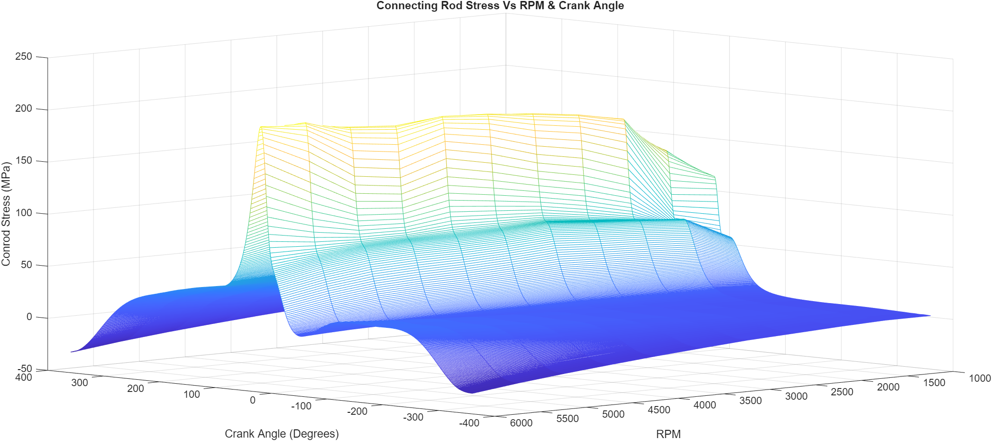
Figure 1-Conrod Stress
The graph above demonstrates the stress that is applied to the conrod throughout the pistons rotary cycle at RPMs varying between 1-6000. The graph shows that the conrod goes through both tensile and compressive forces during the cycle. This is shown by the conrod stress being negative around the first and last 60 degrees of the pistons cycle, demonstrating periods of compressive force.

This is shown in the Conrod goodman diagram which has a minimum lower endurance limit in the negatives at around 450MPa, showing that the midpoint of the conrod experiences a large quantity of compressive forces.
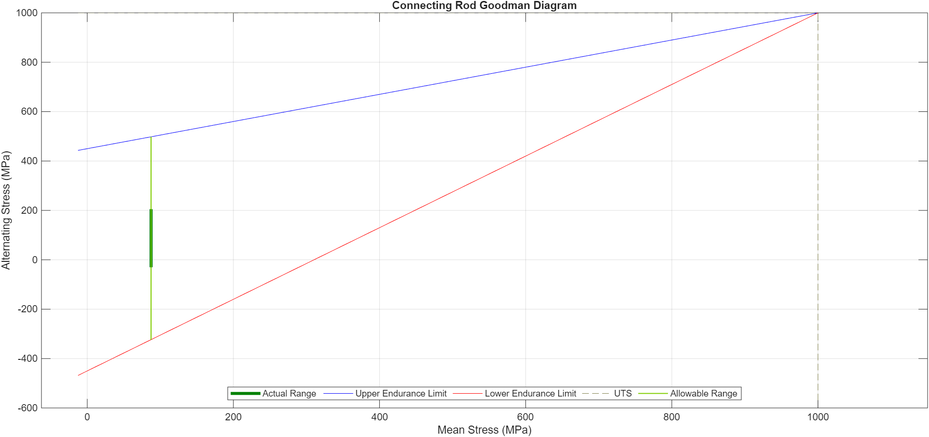
Figure 2-Connecting Rod (Middle) Goodman Diagram

The FSF at the midpoint of the conrod is 3.4915 meaning that the conrod can withstand forces that are around 3.4915 times greater than the actual range. As a result, this means that when the engine may experience abnormal variation of forces when applied at the midpoint of the conrod it will less likely fail. Despite this, having a higher FSF means that the conrod is potentially over engineered. This is a result of the manufacturer’s aim to balance both performance and reliability as the Ford EcoBoost 1.6 GDTi is commonly used in their range of passenger road cars meaning reliability and longevity is idealised over overall performance.
Similarly to Figure 1, Figure 2 is displaying that the conrod experiences both compressive and tensile forces. This is shown by the actual range having values that vary between around 200 to -50MPa. Additionally, figure 2 visualises that during the piston’s cycle the midpoint of the conrod experiences more tensile loads than compressive.

Gudgeon Pin
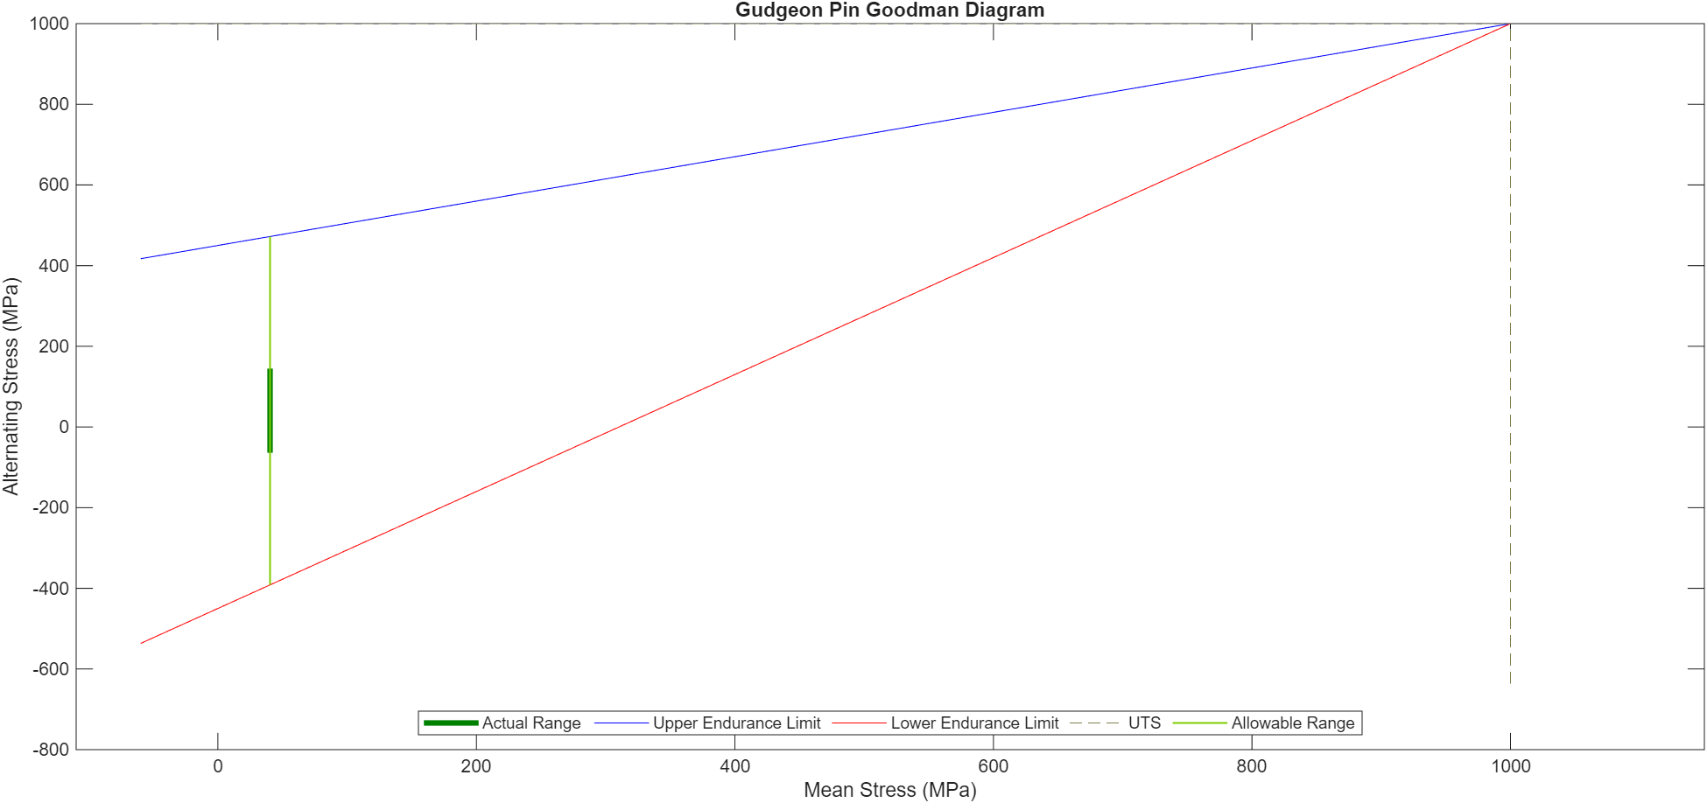
Figure 3-Gudgeon Pin Goodman Diagram
Figure 3 demonstrates the stress applied to the gudgeon pin during the engine’s rotary cycle. Similarly to the midpoint of the conrod the gudgeon pin experiences both compressive and tensile forces, however dissimilarly, the gudgeon pin has a larger balance between the tensile and compressive forces as shown by the actual range having a maximum tensile load of around 144MPa and a maximum compressive load of 63MPa. This stems from the forces acting upon the gudgeon pin being a moment created by the forces acting upon conrod. Furthermore, the gudgeon pin has a FSF 4.127 this means that the gudgeon pin is unlikely to break during the piston engine cycle due to loads applied and can withstand anomalous loads such under bumps. Despite having a high FSF the gudgeon pin is not over engineered due to holding the crucial components in the engine together and therefore preventing additional failure.

Connecting Rod Bolt
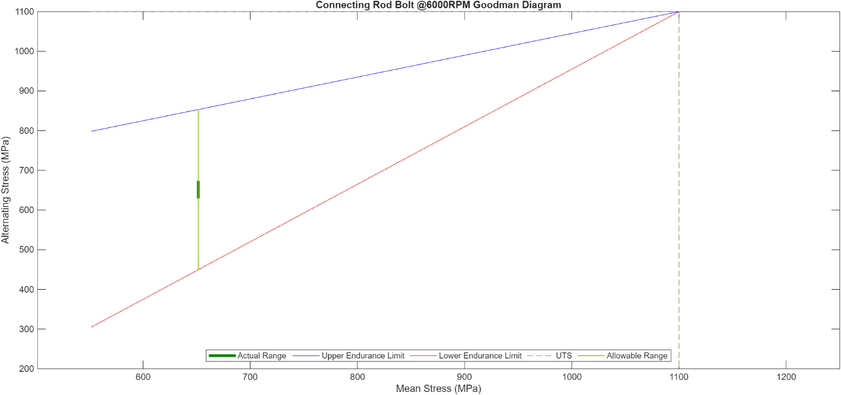
Figure 4- Connecting Rod Bolting (6000RPM) Goodman Diagram
Figure 4 is a goodman diagram representing the loads applied to the conrod bolts through engines cycle at the engine’s original RPM range of 6000RPM. Unlike, the gudgeon pin and conrod the bolt only experiences tensile loads. This means during piston’s cycle the bolts are being always stretched from their original position due to axial force pulling the bolt into the surface of the conrod as well as the thread ends pulling the mating material. This is shown by the actual range having a maximum of 670MPa and a minimum of 630MPa. Furthermore, the FSF for the conrod bolt is 9.187 meaning that there is a potential for the bolt to withstand up to 9 times its maximum stress. However, this value does not include the stress concentration factor which is caused by the shape of the thread which generates small areas of high stress concentration, resulting in those areas of the bolt becoming prone to cracking and therefore failing. Using the stress concentration factor the FSF is reduced from 9.187 to 1.9585, meaning that the bolt can only withstand below 2 times its maximum before failure occurs.

Interpolation
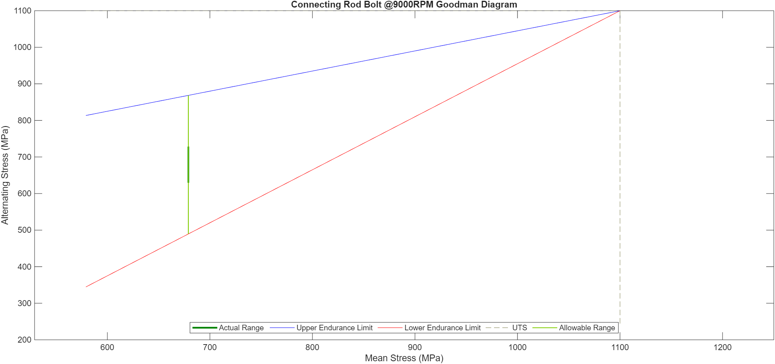
Figure 5- Connecting Rod Bolt (9000RPM) Goodman Diagram
Figure 5 is of a goodman diagram for the loads applied to the conrod bolt (without the stress concentration factor) when the RPM is extended above the normal working range to 9000RPM with the actual range increased to be between 730 and 630MPa.
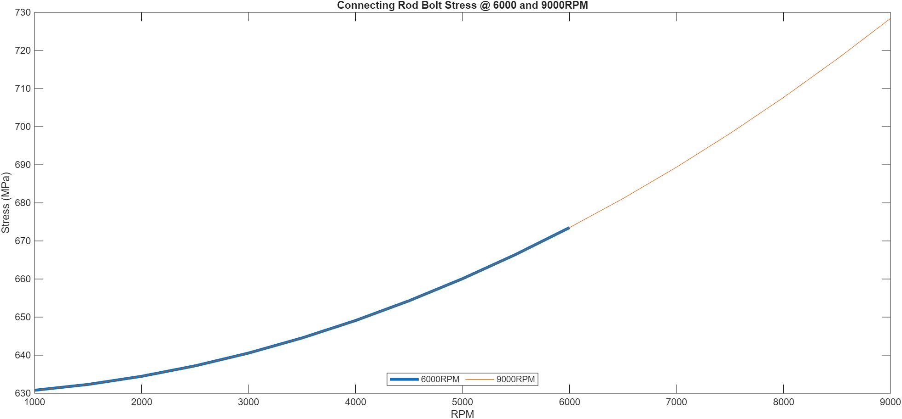
Figure 6- Stress Applied to the Conrod Bolt at Both 6000 & 9000RPM
The effect of increasing the RPM to 9000 is that as the RPM increase the Stress applied to the conrod bolt continues to increase exponentially from a maximum of 670MPa at 6000RPM and 730MPa at 9000RPM. This means that due to the increase in the overall loading on the bolt it is now operating under conditions that the bolt was not originally designed for.
Consequently, the FSF is significantly reduced in comparison to when the bolt is operating with a maximum of 6000RPM. As a result, the FSF without the stress concentration factor is 3.38335 but this is not realistic due to stress caused by the varying geometry in the threads. The result of this is that the FSF is reduced to 0.8171 meaning that at 9000RPM the bolt fails due to the increase in stress applied at 9000RPM.

Redesign
In the previous section, when the RPM range was increased from 6000-9000RPM the FSF of the bolt was reduced from 1.9585 to 0.8171 once the stress concentration factors where applied. This has meant that the bolt will have to be redesigned to withstand forces that are generated as a response of higher RPM which causes the FSF to be lower than 1.
The first area to be redesigned is the Cross-Sectional Area (CSA) of the shank. The reason this was tried is because shrinking the CSA of the shank will make the bolt more compliant to stretching and therefore the stiffness is reduced, increasing FSF.

The specification of the used bolt has an interacting length of 21.26mm but to get scaled proportions for the guard, shank and thread length a scale factor has been applied by using data values for an M8 bolt collected from the ARP catalogue (ARP, 2026).
 | Original Length (mm) | Scaled Length (mm)
Interacting Length | 43.2 | 21.26
Guard Length | 3.2 | 1.574814815
Shank Length | 26 | 12.79537037
Thread Length | 14 | 6.889814815
Table 1-Scaled Interacting Length
These values were then used to calculate individual values of bolt stiffness that directly affects the FSF.

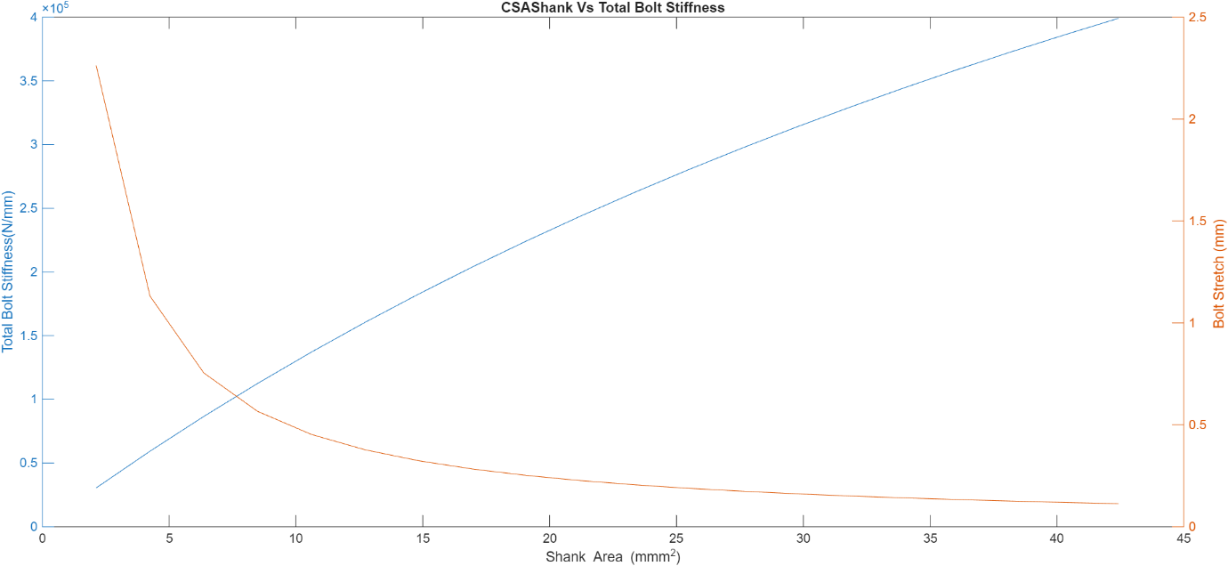
Figure 7-Bolt Stiffness Vs Shank CSA & Bolt Extension Vs Shank CSA
This is then shown in figure 7, which is a plot showing the relation between the total bolt stiffness and shank CSA, whereas the shank area decreases the bolt stiffness reduces at an increasing rate. Figure 7 also shows that there is a reciprocal exponential relation between shank CSA and the bolt extension. The aim should be to Reduce CSA of the shank as much as possible however there reaches a point where it becomes unrealistic at smaller CSAs due the bolt shank being too small. Research has found that “a 20-25% reduction of area following wire drawing was determined to be optimal” (Takashima, et al., 2003). Meaning that for this redesign the shank will have an CSA of 29.701mm^2. As a result, the FSF increases from 0.8171 to 1.0185 meaning that the bolt is no longer failing at 9000 RPM however, further improvements could be made.
The next change that was made was to change the material that the bolt was made from. This results in changes to how the material will deform as well as the modulus of elasticity which directly effects the stress that a material can withstand before failure. The effect of changing the young’s modulus is as the young’s modulus decreases the material compliant due to under the same loading the bolts’ ability to extend will increase. The effect of this can be seen in figure 8 whereas the young’s modulus decreases the bolt stiffness decreases. This is the same as decreasing the shank CSA where the lower bolt stiffness is ideal due to having more compliance to stretch when loaded. Despite this, having an extremely low young’s modulus is a negative due to the bolt being unable to return to its original shape due to going beyond the region. 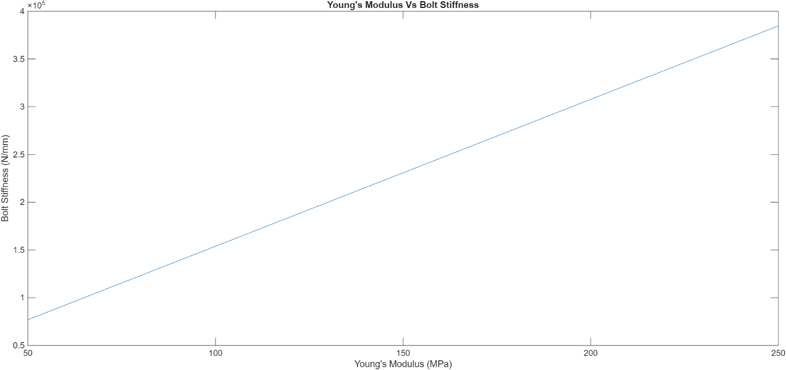
Figure 8-Young's Modulus Vs Bolt Stiffness
As a result, the redesigned bolt will have reduced Yong’s modulus of 150MPa. Assuming, that the UTS of bolt remains the same the FSF increases to from 0.8171 to 1.0712 meaning that the bolt will not fail under the necessary applied load.
To further increase the FSF research has led to the root radius being changed due to “Large radii in the thread roots reduce stress concentration” (Bailey, 1967). The effect of this can be seen in figure 9 whereas the root radius increases the FSF exponentially increases until the root radius reaches a value around 2mm thickness as beyond this point the root radius begins to have a lesser effect on the FSF once the root radius reaches a size closer to the overall thread length. Consequently, there is a point at which the root radius is too large therefore I have decided to use a more realistic value of 0.75. The effect of increasing the root radius is that the FSF increases from 0.8171 to 1.8465 meaning that the bolt will not fail at 9000 RPM.
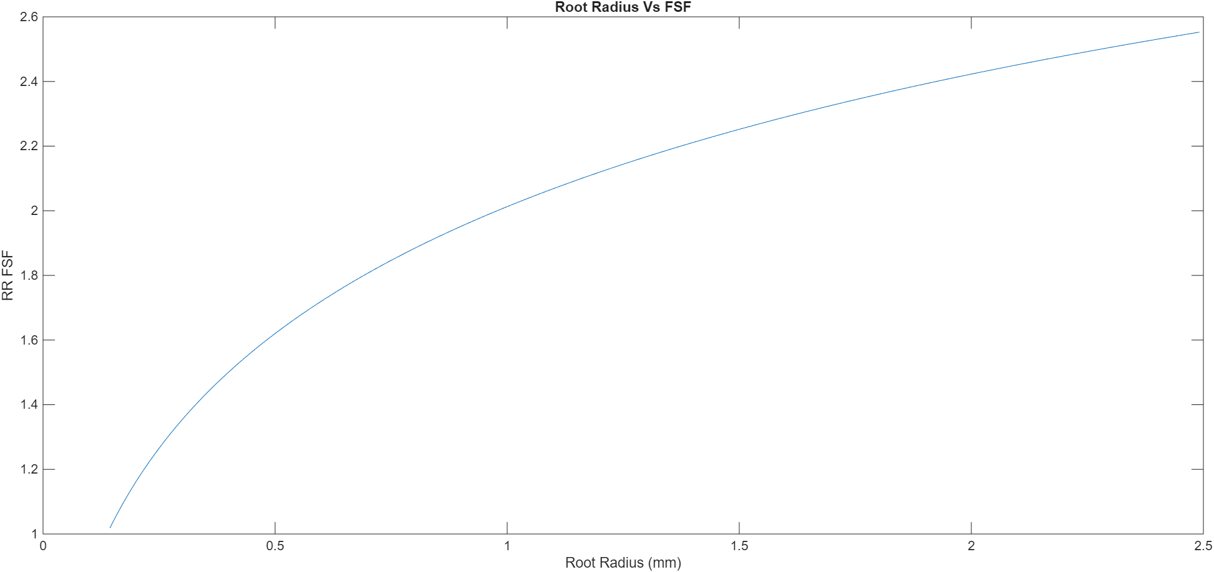
Figure 9-Root Radius Vs FSF

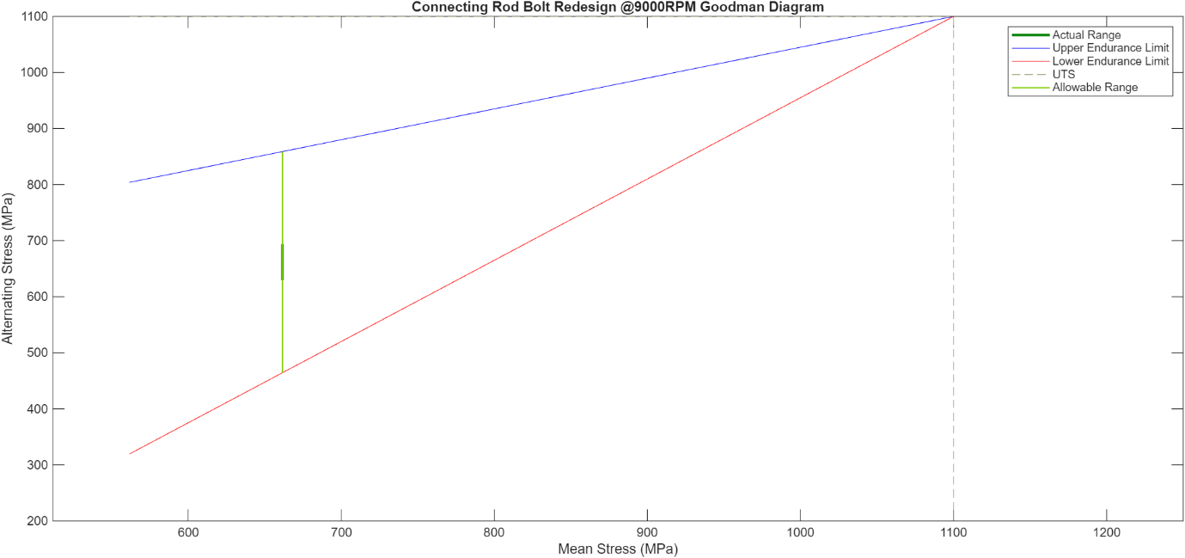
Figure 10- Redesigned bolt FSF
Figure 10 is a goodman diagram depicting the stress applied to the redesigned conrod bolt when the RPM is extended to 9000. The overall changes made were a reduction of 0.7 times the bolt CSA to the shank, a decrease of the young’s modulus to 150MPa (assuming the UTS remains the same) and increasing the root radius to 0.75mm. The effect of the changes made is that the actual range is changed to be between 630 and 690MPa resulting in an actual range like the range at 6000RPM. Furthermore, the FSF changes from 0.8171 to 2.3780 this means that the redesigned bolt will not fail when the RPM is extended to 9000 as well as having an improvement to with stand greater than 2 times the required load resulting in greater resistance to anomalies.

Instantaneous Torque
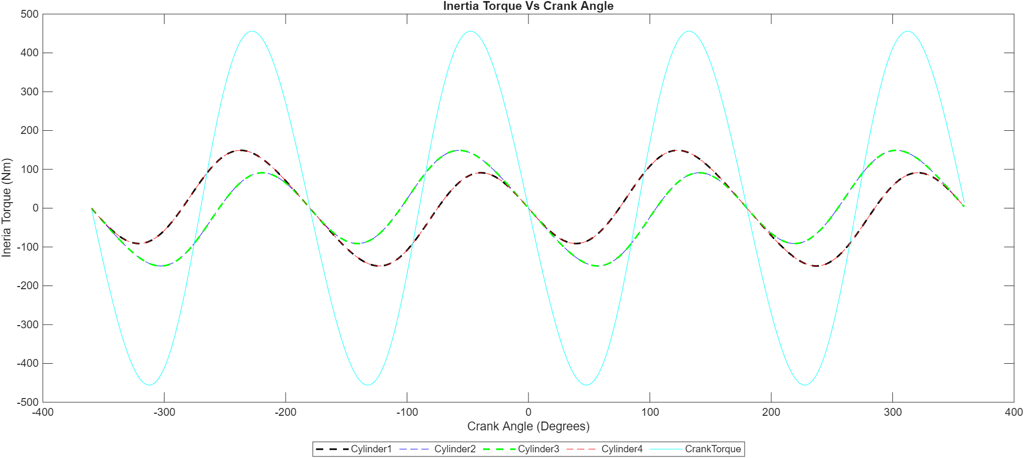
Figure 11-Standard Inertia Torque
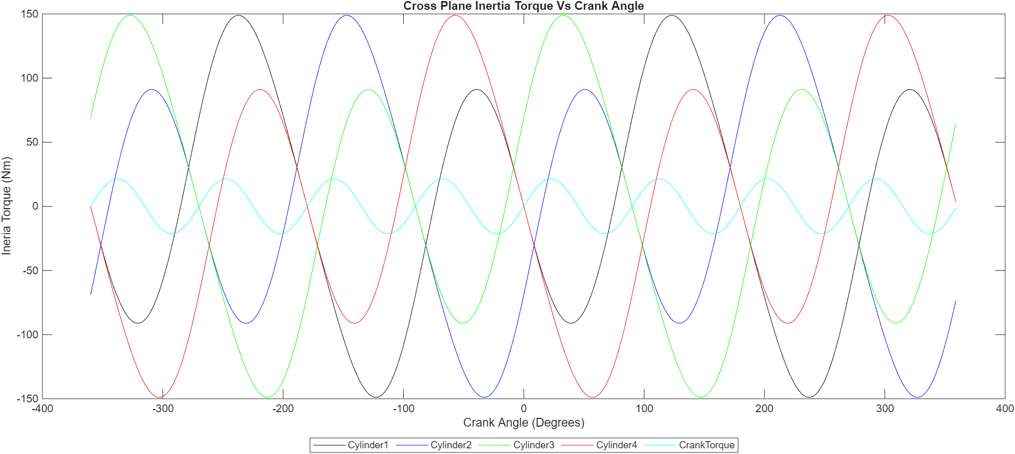
Figure 12-Cross Plane Inertia Torque
Figures 11 and 12 are graphs showing the standard and cross plane inertia torque. In the standard arrangement the pistons are firing 180 degrees apart. This means that the during engines cycle the torque generated at similar points meaning that there is large variation between the total crank torque with the oscillating peaks occurring every 90 degrees and total every 180.
In contrast, the cross plane inertia torque has the pistons offset by 90 degrees meaning “pistons 1 and 4 are a pair that have an upwards force and pistons 2 and 3 have a force directed downwards” (Ooi, 2024). Due to the firing order of the cross plane engine changing from “1-3-4-2” (MotorReviewer, 2026) to “1-3-2-4” (Ooi, 2024) means that the upwards and downwards forces will cancel each other out. This then causes for the overall crank torque to have smaller peaks during the engines cycle as well as the forces oscillating more often compared to the standard arrangement.
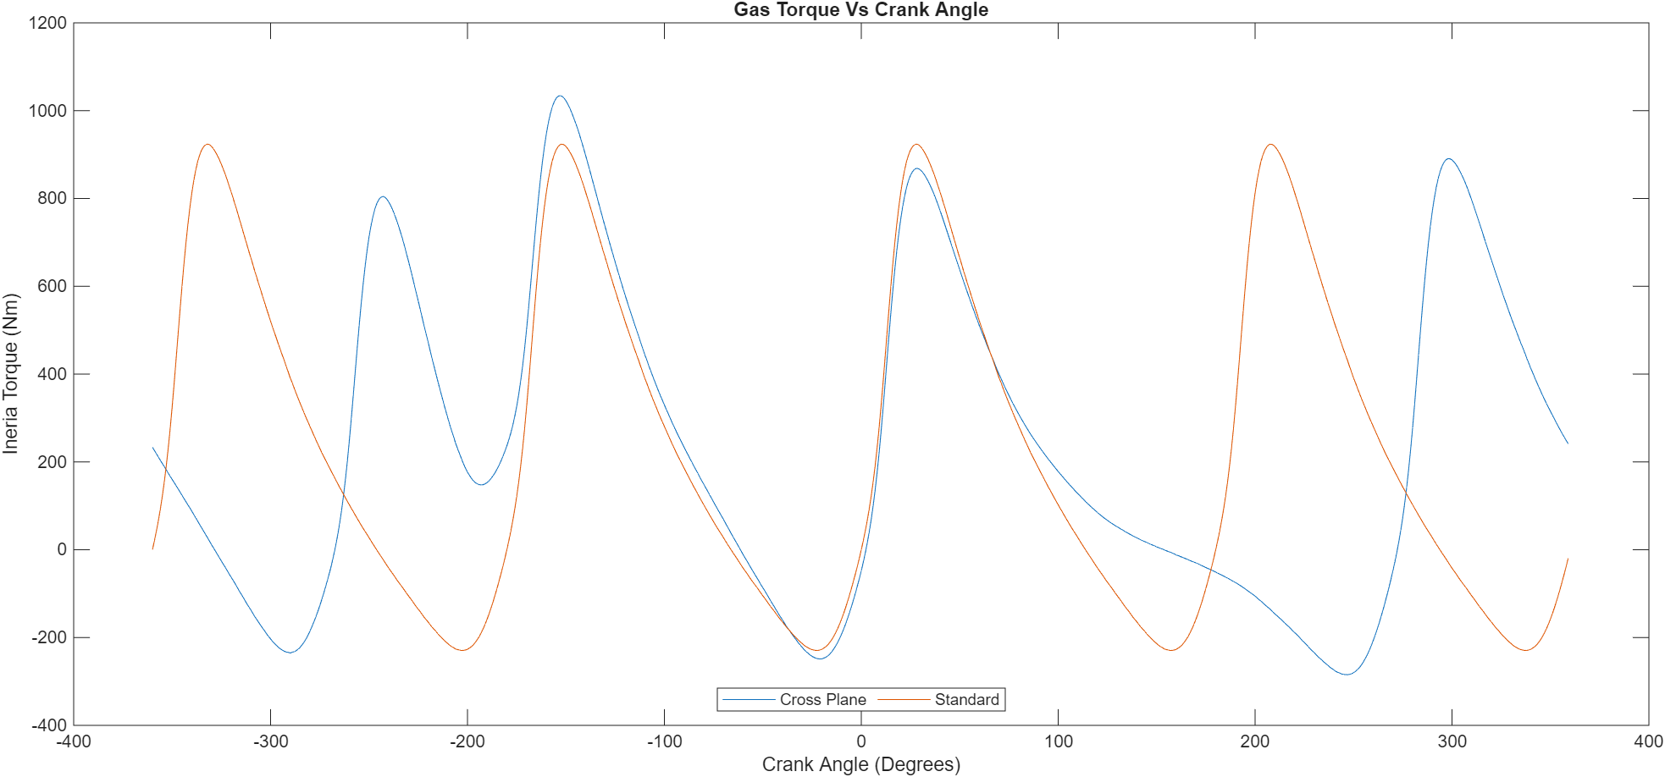
Figure 13-Standard and Cross Plane Gas Torque

Figures 13 is a plot showing the gas torque of both the standard and cross plane arrangement. With the standard arrangement the gas torque peaks in 180-degree intervals whereas for the cross-plane configuration the peak gas torque has some peaks closer together and others further away due to how the cylinders are aligned which the peaks occur in different places. Additionally, the cross plane gas torque has a higher overall peak reaching over 1000 Nm but having a lower average total gas crank torque this is due to the negative peaks being closer together for two of the cylinders and further apart creating a smoother reduction in overall gas torque.
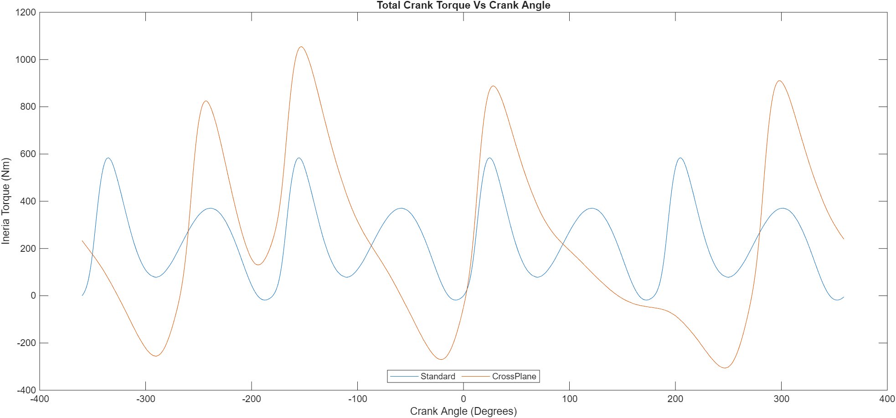
Figure 14- Total Crank Torque for both Standard and Cross Plane Configuration
Figure 14 shows the combined inertia, and gas torques for both the standard and cross plane configuration of the engines cylinder. The plot shows that through the whole cycle the cross plane configuration had larger variation between the maximum and minimum generate by the engine. Despite this, the cross plane configuration has a lower frequency in its change of peaks meaning that the load applied at any point during the engines cycle is easier to predict therefore loads can be managed. This contrasts with the standard configuration which has smaller range between its positive and negative peaks while the peaks occur more often. This is a result of the standard configuration having distinct but separate inertia and gas torque events meaning that the load applied to consistently changing creating the varied peaks. In contrast, the cross plane has a constant changing inertia torque resulting in a smaller force constantly being added and taking away therefore not greatly affecting the torque caused by the gases.

Engine Torque
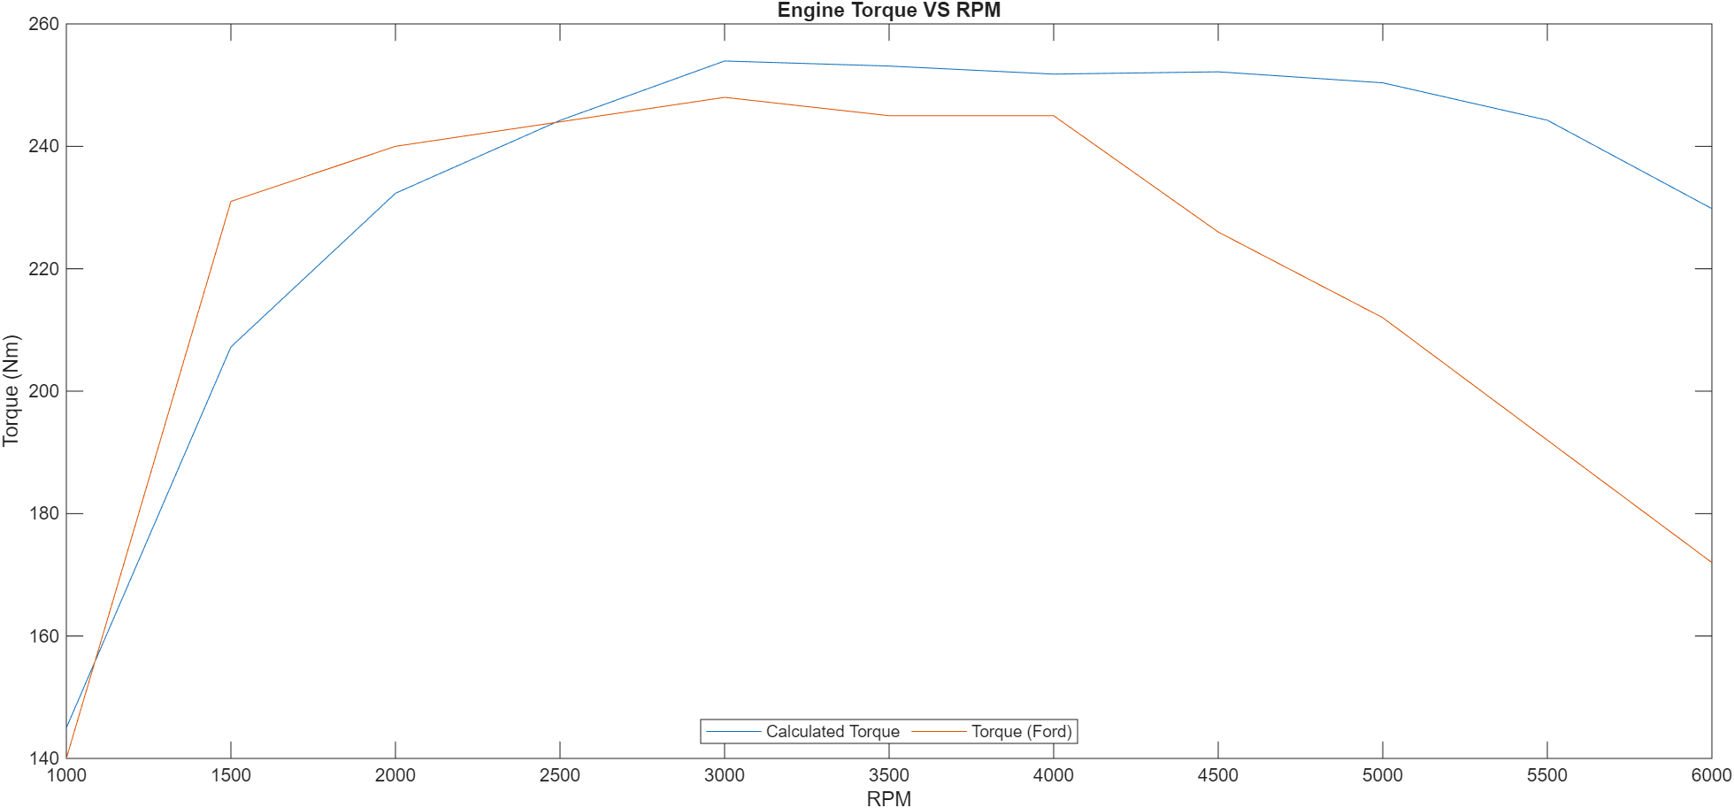
Figure 15-Engine Torque
Figure 15 is showing the calculated engine torque Vs actual engine torque (Ford, 2026). The graph shows that the calculated data is following a similar trend to the actual data as shown by the overlap at 2500RPM, however is under predicting at lower RPMs and over at higher RPMs. At the lower RPMs the engine is underpredicting due to the calculated values not including the turbo which would cause more torque at lower RPMs. Additionally, the engine is tuned to be used for commercial use where vehicles are required to stop/start therefore higher torque is required to repeatedly pull away from rest. However, it is overpredicting at higher RPMs due to the calculations assuming that the engine is 100% efficient therefore losses not included in the calculations. These losses include kinetic, heat and sound, lubrication.

Conclusion
To conclude, during the piston’s cycle components have been made to undergo a variety of forces and therefore must be designed to withstand those stresses. This is then shown through all three components which when operating at 6000RPM will not fail due to having a FSF greater than one. These values of 3.4915 for midpoint of conrod, 4.127 for the gudgeon pin and 1.9585 with stress concentration applied for the conrod bolt. This means that each component has the potential to withstand stresses greater than their actual range but can be limited by the bolt. However, when the RPM is extrapolated to reach 9000 the stress applied to each component increases resulting in the conrod bolt failing. This has resulted in the conrod bolt needing to be redesigned and improve to fail at the increased RPM. A variety of changes could be done including reducing the shank’s CSA, changing the material to find more idealistic properties and finally increasing the root radius to reduce areas of stress concentration. This resulted in a to the bolt having a FSF of 2.378.
Finally, realigning the data has allowed for comparison between standard and cross plane configuration for the engine. The main difference between the two engine types is how the loads is distributed through the cycle with the standard configuration having peak torque occurring every 180 degrees whereas the cross-plane configuration has smaller peak torques but it occurs more often throughout the engine cycle. Furthermore, plotting the overall engine torque compared to Ford’s data has presented limitations in the model including losses through heat, sound and lubrication as well as factors not including such as being unable to model the supercharger.

References
ARP, 2026. ARP Catalog, N/A: ARP.
Bailey, J. R., 1967. Improving the Fatigue Life of Connecting Rods in Chain Saw Engines, s.l.: s.n.
Ford, 2026. 1.6 GTDI EcoBoost. [Online]
Available at: https://www.ford.co.uk/content/dam/guxeu/uk/documents/home/experience-ford/about-ford/ford-component-sales/specification-details-data-sheets/16-ecoboost-np.pdf
[Accessed 22 March 2026].
MotorReviewer, 2026. Ford 1.6L EcoBoost GTDI Engine Specs, Problems & Reliability. [Online]
Available at: https://www.motorreviewer.com/engine.php?engine_id=132
[Accessed 22 March 2026].
Ooi, W., 2024. What Exactly is a Crossplane Engine. [Online]
Available at: https://www.bikesrepublic.com/english/what-exactly-is-a-crossplane-engine/
[Accessed 22 March 2026].
Takashima, M. et al., 2003. Development of 1600 N/mm2 Class Ultra-High Strength Bolts, s.l.: s.n.

