TRDL6017: Study Skills and Research Methods in Bible and Theology
_{Assignment (i)}

biblestudytools.com: A Biblical/ Theological Website Critique (1,000 words)

Imran David Anwar
1102620
A Biblical/ Theological Website Critique

Reinterpreting research from Andrew H. Wakefield’s article, ‘A word about Bible study software’ (2007), as an analysis framework, this piece intends to offer a reasoned critique of the ‘Bible Study Tools’ website.

The Bible Study Tools website is aimed primarily at those adhering to Pentecostal Christian faith, with this proposed demographic comprising citizens of the United States of America. Religiously emotive ‘pop- up’ advertisements which display America-centred patriotism evidence this notion. Other linguistic and stylistic features of United States English are also present throughout the website.
Bible Study Tools aims to “offer the freshest and most compelling Biblically-based content to Christians who take seriously their relationship with Christ.” Here lie the ambiguities; what is the extent of this ‘seriousness’ and what implications does this have? Under whose authority is this and judgement of which is to be made by whom? It is unclear also the extent that Biblically based material will be an aid to the user. The website also lacks a sense of definition to which approach will be taken towards scripture; will there be a more literalist approach to biblical studies? Or a contemporary narrative- literary approach? Or another analytical methodology?
On the ‘homepage’, Bible Study Tools purports to be the, “largest free online Bible website for verse search and in-depth studies”, however, neither evidence nor reinforcement of this claim exists, thus immediately detracting from their credibility. Similarly, when one studies the list of versions available, Bible Study Tools’ posit insinuates the number of different biblical versions available on their website is more significant than it is; this hyperbole misleads users. The intended audience: may not be aware of subsequent editions of the same translation, such as the NKJV being an update of the KJV.

Wakefield offers four fundamental capabilities of Bible software functionality that all similar platforms should provide: Accessibility, Searching, Original Languages and Available Resources. Bible Study Tools facilitates all of these and based upon Wakefield’s model; their website would fall into the category of being a basic level online software.

: Accessibility:
Bible Study Tools offers a restricted, yet easy- use search function. ‘Click and scroll’ functions allow for a line-by- line traverse of the select text itself, or a smooth jump to the next (or previous) book, chapter or verse. Facilitation of other ‘popular’ translations allows for a side- by- side comparison of a given pericope.
Cached pages may be ‘bookmarked’ for points of interest or study; allowing users to return to their search at later convenience.
There is no named originator on the main accessible webpages. Information about the website’s creation and maintenance is only accessible via further links. The webpage footer carries a copyrighted trademark naming ‘Bible Study Tools’ themselves; it is evident that the website is regularly updated as the current year date stamp is included in this Copywrite information. Navigation is required from the ‘About Us’ tab, to access the company’s mission statement, then clicking, ‘More About Us’ and after the subsequent; ‘Vision’, ‘Mission’ and ‘Statement of Faith’ subheadings, there are brief biopic notes for the three members of the website’s editorial team, these including their name, role and their credentials.

Refreshingly, the body text of the website is not overly commercialised, despite being the product of a ‘for-profit’ corporation: Salem Web Network, which owns eleven other feeder brands all with a similar theological disposition and purpose.

The layout and design offer simplicity and are pleasant on the eyes; accessibility could be further improved for a wider audience if for instance there was a more vivid contrast or alternatives such as a schematic inversion or ‘dark mode’ function that many modern websites offer.
A legible sans-serif typeface throughout furthers accessibility. The muted colour scheme is primarily black on white and resonates professionalism, however; this could be said to be cliched, bland and lacking a sense of personality.
Complementary yellow hues break up the monotony and supply a much-needed element of colour. The corporate logo, a simple star graphic, is reminiscent of the archetypal ‘Star of Bethlehem’, found in the Matthean account of Christ’s Birth Narratives (c.f. Matt 2: 1-2).
Social media buttons used, such as those for Facebook and Instagram, provide the only other instances of colour outside the Getty stock photo images attached to popular articles and stories found on the right side-bar of additional webpages
:Searching:
Users can opt for a basic reference entry using the search bar to find a specific passage or theme; resulting in a yield of different Biblical versions containing the specified search term(s) in highlighted text. Search praxis is only available for Latinate alphanumeric characters; there is no availability, for example, for Cyrillic or Oriental graphemes. It is possible to query Greek and Hebrew terms; however, these are actioned by phonetic transliteration. Denoted here is a further exemplification that Bible Study Tools is not for users intending higher academic research in Biblical Studies, but for those with a more profound personal interest.

: Original Languages:
Basal level Bible study software providers are reliant on out-of-Copywrite-dated versions as they do not need a hosting license. Wakefield mentions that the 27th edition of the Novum Testamentum Graece (Nestle- Aland) is a favourite for Koine original language text, and the Biblia Hebraica Stuttgartensia, for the Hebrew Bible counterpart. Such editions do not need the use of specialist software or online resources and are accessible by all in the public domain.
Based on the above, the superlative demonstration of a lack of complexity with Bible Study Tools’ website lies in the limited number of original language Bible versions they have available. Their examples are the versions mentioned above, yet with an older version of the Nestle- Aland Greek New Testament (26th edition) than mentioned by Wakefield.
There are only two available lexicons for users to choose from with the supplementation of Strong’s Concordance; the original and quite literal translation of the King James Version (KJV) or the New American Standard translation (NAS) neither of which are exhaustive in content.

: Available Resources:

“… the more expensive the software […] more likely it is to include more current licenced texts and tools ... Some […] include […] a wide variety of additional texts in other theological disciplines such as church history, theology […]. " - Wakefield (2007).

The above takeaway encapsulates and précises Bible Study Tools, by what is missing from it as a service. De facto by its design, Bible Study Tools is an example of limited online freeware; but, where relying on Wakefield loses utility, is when one appreciates just what is on offer. Being more than just a Biblical study software platform, Bible Study Tools gives a digitised sense of a collective community, of members with their own personal stories, daily trials and tribulations of life in action that can be found in the many articles and advice pages available.
Irrespective of the accuracy and validity of Bible Study Tools as an academic resource, one may posit that it does have something to say about theology, that is, the interaction between God and humankind, particularly in the digital and intangible realms of a post-secular epoch. Individuals identifying with the theistic soubriquet of the website will have more to gain from using it than those favouring it as an academic resource. It enables them a participatory collective within the ‘Word’, within Christ- a gnosis that is experiential and lived.

Imran David Anwar
(1223 Words)

Appendix:

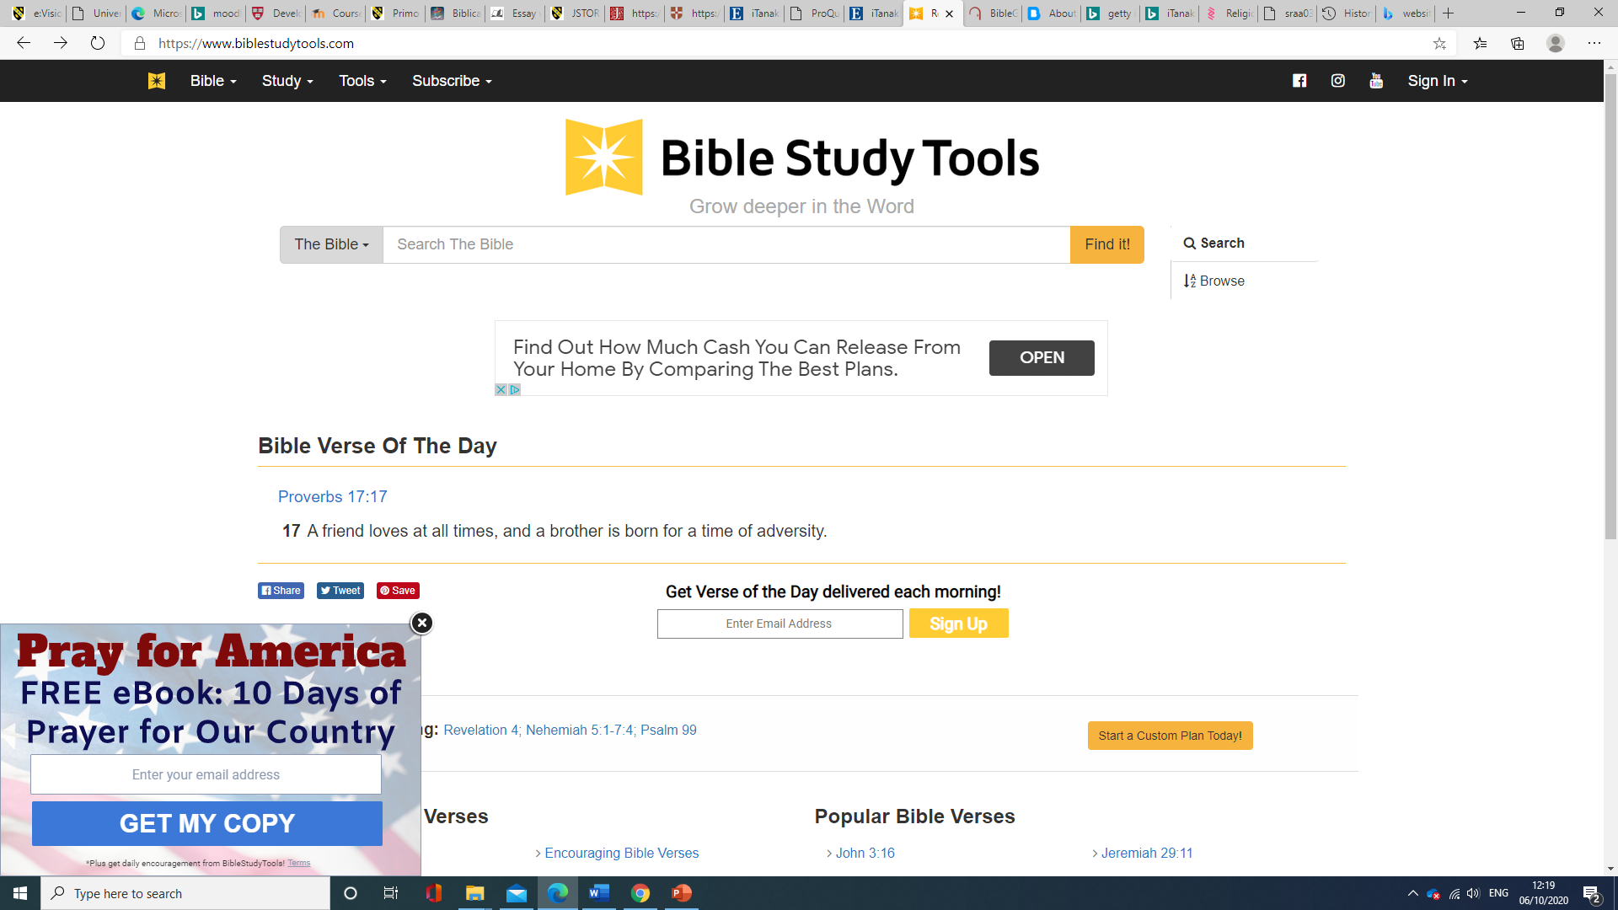
Fig.1 : Bible Study Tools Anwar, I. (2020) ‘Screenshot’ of https://biblestudytools.com homepage. Captured at 12:22 on 06/10/2020.

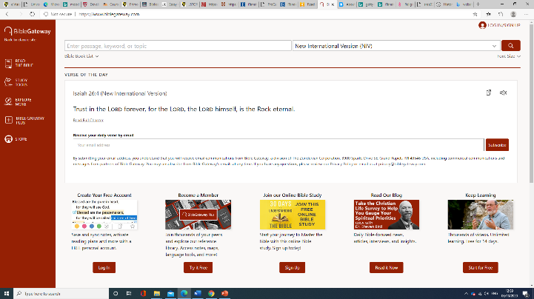
Fig 2a.: Bible Gateway Anwar, I. (2020) ‘Screenshot’ of https://biblegateway.com homepage. Captured at 12:37 on 06/10/2020.

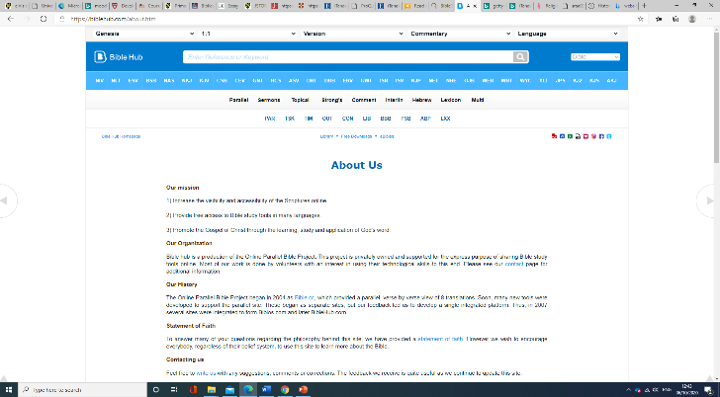
Fig.: 2b Bible Hub Anwar, I. (2020) ‘Screenshot’ of https://biblehub.com homepage. Captured at 12:49 on 06/10/2020.

Bibliography/ References:

Books

- Allison, B. 1996 Research Skills for Students (London: Kogan Page).
- Cottrell, S. 2008 The Study Skills Handbook (3rd Ed.) (Basingstoke: Macmillan).
- Cottrell, S. 2011 Critical Thinking Skills: Developing Effective Analysis and Argument (Basingstoke: Macmillan).
- Rumsey, S. 2008 [EBOOK] How to Find Information: A Guide for Researchers, (Buckingham: McGraw-Hill) Sourced from: ProQuest eBook Central on 02/10/2020 (https://ebookcentral.proquest.com/lib/trinity/detail.action?docID=345140)
Last accessed at 14:46 on 10/10/2020 to verify source.

Bibles

- Biblia Hebraica Stuttgartensia: K. Elliger and W. Rudolph (Eds) 1967 Stuttgart: Deutsche Bibelgesellschaft.

- Novum Testamentum Graece : Aland, B., Nestle, E., (Eds) 1979 Stuttgart: Deutsche Bibelgesellschaft.

General reference/ writing guides

- The University of Oxford, Bodleian Libraries, [2020] ‘English at Oxford: Evaluating Websites’ [Oxford Lib Guides]https://libguides.bodleian.ox.ac.uk/c.php?g=422722&p=4742282
- Westminster Theological Seminary [2014] (Library Website) list of online resources for students https://students.wts.edu/library/freeonline.html
- Harvard University, Harvard College Writing Centre, ‘Developing a Thesis’ [1999] https://writingcenter.fas.harvard.edu/pages/developing-thesis
- The Oxbridge Research Group, Oxbridge Essays, [2020] https://www.oxbridgeessays.com/blog/essay-writing-preparation-website-critique/

Supplementary
- Bible Gateway website https://biblegateway.com
- Bible Hub websitehttps://biblehub.com
- British Dyslexia Association, ‘Advice’, ‘Creating A Dyslexia Friendly Workplace [ii] Dyslexia Friendly Style Guide’ (2018) https://www.bdadyslexia.org.uk/advice/employers/creating-a-dyslexia-friendly-workplace/dyslexia-friendly-style-guide
- Bible Study Tools website https://www.biblestudytools.com
- Christian Radio website https://www.christianradio.com/
- Getty Images website https://www.gettyimagesgallery.com/
- GodTube website https://www.godtube.com/
- iBelieve website https://www.ibelieve.com/
- Salem Web Network website https://www.salemwebnetwork.com/our-brands/
- Salem Web Network website https://www.salemwebnetwork.com/our-story/
- Union Theological College website https://www.union.ac.uk/cmsfiles/Library/GambleGuides/Theology-resources-on-the-web.pdf

Journal Articles

-Baker, J.O. (et al.) [Association for the Sociology of Religion] Sociology of Religion: A Quarterly Review (2020) 81(4) pp. 357-370 (Editor’s Note) ‘Religion in the Age of Social Distancing: How COVID- 19 Presents New Directions for Research’-- retrieved from (https://academic.oup.com/socrel/article/81/4/357/5909375) on 06/10/2020.
Last accessed at 14:34 on 10/10/2020 to verify source.

- Wakefield, A. H. (2007) [Review & Expositor] 104(1), pp. 19–26 ‘A Word About...Bible Study Software’-- retrieved on 10/10/2020 from (https://search.ebscohost.com/login.aspx?direct=true&db=rfh&AN=ATLA0001570606&site=ehost-live)

Last accessed at 15:31 on 10/10/2020 to verify the source.

Biblical References:

- Matt 2:1-2

Wakefield, A. H. (2007) [Review & Expositor] 104(1), pp. 19–26 ‘A Word About...Bible Study Software’.
(www.biblestudytools.com)
See Appendix Fig.1.- “Pray for America: FREE eBook 10 days of Prayer for our Country”
Ibid.
https://www.biblestudytools.com/help/about-us-links/bst-about-us.html
Wakefield, 2007, 19.
Interestingly, of the named editorial staff, only one possesses academic credentials in an associate field of theological or biblical studies, in this instance Religious Studies.
GodTube (a faith-based video sharing platform), iBelieve (a website specifically for women that are looking at how they can fit issues with their faith into broader contexts) and ChristianRadio (on line radio resources to Christian radio talk shows, Christian music artists and other such related audio indicia) are all examples of Salem Web Network’s other companies- See (https://www.salemwebnetwork.com/our-brands/).
There is current evidence to suggest that serif fonts, such as ‘Times New Roman’, can cause complications to those with learning impairments such as dyslexia. See the British Dyslexia Association (2018), (https://www.bdadyslexia.org.uk/advice/employers/creating-a-dyslexia-friendly-workplace/dyslexia-friendly-style-guide).
The images are usually subject-specific with relevance to the articles they stand for. ‘Getty Images’ are freely accessible and useable by anyone within the public domain. Bible Study Tools acknowledges that their images are from Getty (unless otherwise stated) and makes it known that all rights are reserved. See (https://www.gettyimagesgallery.com/)
The articles and stories written by site contributors aim to aid in the spiritual growth and development of the users.
For students or researchers, more sophisticated freeware internet options such as ‘Bible Hub’ exist. With more developed options there can be grammatical or stylistic enquiries such as paralleled textual searches and accurate word- for- word translations that basic packages like Bible Study Tools do not provide. See (https://biblehub.com).
Wakefield, 2007, 20.
Ibid.
From the ‘Interlinear Bible’ tab, under the ‘Bible’ titled drop-down menu, information at the bottom of the pages concerning the sources of the Greek and Hebrew original language texts can be viewed. The Hebrew Bible text is derived from the Biblia Hebraica Stuttgartensia, and the Greek New Testament text is from Novum Testamentum Graece (Nestle- Aland 26th edition). See Biblia Hebraica Stuttgartensia, Elliger, K and Rudolph, W. (eds), 1967, Stuttgart: Deutsche Bibelgesellschaft. And Novum Testamentum Graece (Nestle-Aland ed. 26th), Nestle, E., Aland, B., 1979. Stuttgart: Deutsche Bibelgesellschaft.
Wakefield, 2007, 20.
Again, of import here is that it is explicitly stated beneath the respective lexicon information, that the files are ‘public domain’.
Wakefield, 2007, 21.
Biblical references used herein are to be taken from the New Revised Standard Version (Anglicised), unless stated otherwise.
Despite potential critique at the age of the article and many developments in technology since, there are key hooks and takeaways that are applicable to this piece.

