

MODULE CODE: BMDB7006
TITLE: Resilience, Talent and Technology
Lecturer: Julie Hayward
Internal Verifier: Gareth Hughes
Student Name: Peng Chen

Student ID Number: 1806567

CONTENTS

1. PESTLE Analysis 1
2. Labour Market Trends 6
3. Ted Talk 14
4. Overview 16
5. Presentation 21
6. Analysis 24
7. Model 29

1. PESTLE Analysis
HSBC is a banking and financial services organisation that was founded in Hongkong and Shanghai in 1865, and headquartered in London since 1941(HSBC, 2019). Now HSBC is one of the largest multinational company ranking No. 21 in the latest ‘Forbes World’s Largest Public Companies’(FOBES, 2019), which operates in 65 countries and territories(HSBC, 2019). HSBC Bank (China) Company Limited began operations in 2007 as a locally incorporated foreign bank and has become one of the largest investors among foreign banks in mainland China (CHEN et al., 2018). As the macro environment and external factors have significant impacts on the organizational ability to attract talent (Kew & Stredwick,2016), the following is the PESTLE analysis of HSBC in China’s financial industry.
Political Analysis
Since China joined WTO in 2001, the opening of China's financial industry has made remarkable progress. In recent years, Chinese government has launched a number of policies to lower the threshold for market access and expand the business scope of foreign financial organisations(CHEN et al., 2018). For instance, according to the amendments of regulations on foreign banks and insurers in 2019, Foreign banks are allowed to simultaneously set up branches and wholly foreign-owned bank or joint-venture banks in China; the requirements that companies that apply to establish foreign-invested insurers in China have a track record in the business of over 30 years and have a representative office in the country longer than two years have been removed(Jiang and Zhou, 2019) . The new rules will attract more foreign capitals especially smaller foreign banks and insurers to invest in China.
Economic Analysis
Since the market economy reform in 1978, China has made striking economic development gains and has become the world’s second largest economy(World Bank, 2019). China has been classified as an upper middle-income country by the World Bank. China's economy was ranked the second most attractive to multinational companies for 2017-2019 and world's second largest FDI recipient, only behind the U.S (UNCTAD, 2019). China’s financial market is becoming more open to foreign capitals. From 2003 to 2017, the assets of foreign Banks in China increased from 415.9 billion yuan to 3.24 trillion yuan, with an average annual growth rate of 17%, but foreign banks it is at an obvious disadvantage compared with China's state-owned commercial Banks. (CHEN et al., 2018).
Social Analysis
According to National Bureau of Statistics of China, China has a total population of 1,395,380,000 at the end of 2018(NBS, 2019). Since the government has adopted the universal two-child policy in 2015, China's aging trend has been slowed(Shan, 2016). With a tradition of thrift, Chinese saving rate, at 45.7% of GDP in 2018, is among the world’s highest (IMFBlog, 2018; CEIC Data, 2019), which bring both opportunities and challenges to foreign banks.
Technological Analysis
There are a large number of research and development institutions and universities in China, which indicates that the country attaches importance to investment in science and technology. Oliver Wyman (2017) reported that China's fintech industry has grown spectacularly; from 2013 to 2017, major segments of the fintech market – namely online peer-to-peer lending, online wealth management, digital insurance, and third-party payment – have on average doubled or even tripled every year. China has made obvious achievements in e-commerce, mobile payment and social media platforms, and is making rapid progress in big data analytics，AI, Internet of things and blockchain(Hackett, 2019).
Legal and other Analysis
China is committed to building a country of democracy and rule of law and has built a relatively sound legal system covering laws that fall under seven categories and three different levels (NPC of China, 2014). Compared with the average index of OECD members, i.e. 0.032, China got a much higher financial services FDI restrictiveness Index of 0.268 in 2018, which still represents a decrease of 48.5% from 0.52 in 2015 (OECD, 2019).

References:
Armstrong, M., & Taylor, S. (2017). Armstrong's handbook of human resource management practice. Kogan Page Publishers.
CEIC Data (2019) China Gross Savings Rate [1952 - 2019] [Data & Charts]. Available at: https://www.ceicdata.com/en/indicator/china/gross-savings-rate (Accessed: 25 October 2019).
CHEN, W. et al. (2018) ‘The Opening-up of China’s Banking Sector: Development, Effect and Policy’, Financial Regulation Research, 10.
FOBES (2019) The World’s Largest Public Companies List. Available at: https://www.forbes.com/global2000/list/ (Accessed: 24 October 2019).
Hackett, R. (2019) China’s Fintech Revolution—The Ledger | Fortune. Available at: https://fortune.com/2019/08/12/chinas-fintech-revolution-the-ledger/ (Accessed: 25 October 2019).
HSBC (2019) Who we are | HSBC Holdings plc. Available at: https://www.hsbc.com/who-we-are (Accessed: 24 October 2019).
IMFBlog (2018) Chart of the Week: China’s Thrift, and What to Do About It – IMF Blog. Available at: https://blogs.imf.org/2018/02/26/chart-of-the-week-chinas-thrift-and-what-to-do-about-it/ (Accessed: 25 October 2019).
Jiang，Xueqing and Zhou，Lanxu (2019) Foreign banks, insurers given broader access，China Daily. Available at: https://www.chinadaily.com.cn/a/201910/16/WS5da60bb4a310cf3e35570a66.html (Accessed: 25 October 2019).
Lipman, V. (2014) How Important Is Flexible Work? 43% Choose It Over Pay Raise. Available at: https://www.forbes.com/sites/victorlipman/2014/10/03/how-important-is-flexible-work-43-choose-it-over-pay-raise/#1fe08c6d1bb4 (Accessed: 28 October 2019).
NBS (2019) National Data. Available at: http://data.stats.gov.cn/english/easyquery.htm?cn=C01 (Accessed: 25 October 2019).
NPC of China (2014) China’s Legal System. Available at: http://english.www.gov.cn/archive/china_abc/2014/08/23/content_281474982987244.htm (Accessed: 25 October 2019).
OECD (2019) Foreign direct investment (FDI) - FDI restrictiveness - OECD Data. Available at: https://data.oecd.org/fdi/fdi-restrictiveness.htm (Accessed: 25 October 2019).
Shan, J. (2016) Two-child policy working, birthrate figures show - China - Chinadaily.com.cn. Available at: https://www.chinadaily.com.cn/china/2016-10/31/content_27220568.htm (Accessed: 25 October 2019).
UNCTAD (2019) World Investment Report 2019. New York: United Nations Publications.
World Bank (2019) China Overview. Available at: https://www.worldbank.org/en/country/china/overview (Accessed: 25 October 2019).

2. Labour Market Trends
As a company originated in Hong Kong, HSBC operates in 65 countries and territories including China and UK (HSBC, 2019). The following is a brief summary of the labour market trends in China and UK, since the labour market condition influences significantly the human resource strategy and practice of firms (Edwards & Rees, 2006; Armstrong, 2017; Taylor, 2018).
China Labour Market
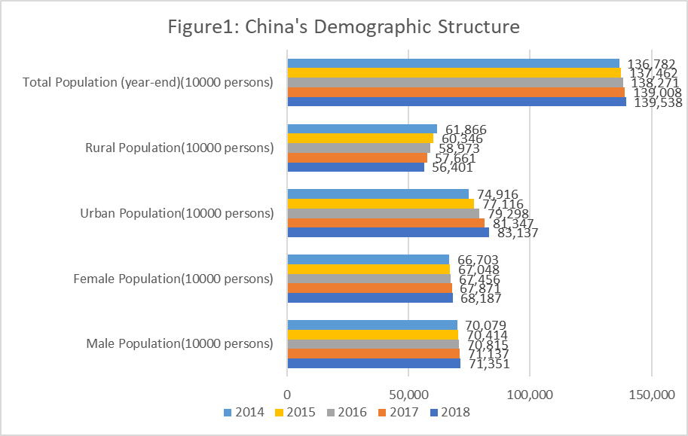
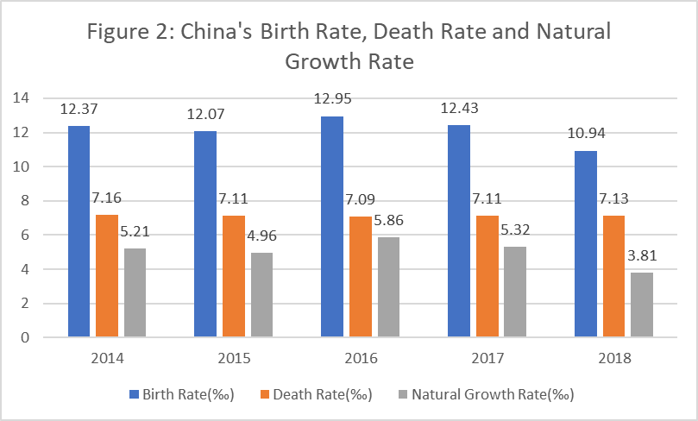
China has the largest population and labour market in the world. Although the total population increased by 530 million to 139,538 million in 2018 (Figure 1), the natural growth rate decreased from 5.32‰ to 3.81‰ (Figure 2) and the economically active population changed little (NBS, 2019). The World Health Organisation (2016) predicted that the proportion of people aged 60 and over in China will rise to 28% in 2040 (Figure 3), i.e. about 402 million, and China’s aging population problem become more serious than many other countries. Because of the processing of urbanization and adjustment of government policies, the Tertiary Industry Employed Persons and Urban Employed Persons have Increased year by year (NBS, 2019).
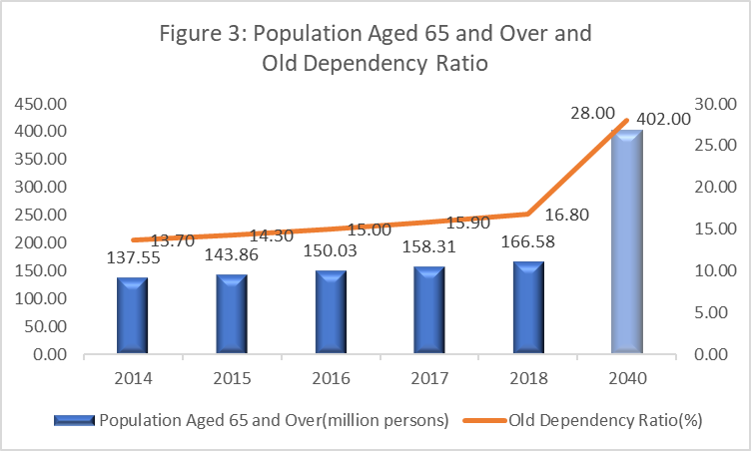
Meanwhile, the Unemployment Rate in Urban Area decreased from 4.1% in 2014 to 3.8% in 2018 (Figure 4), which indicates a tight labour market (NBS, 2019). However, the slowdown of economy and US-China trade war bring more uncertainty to China’s economy (BBC, 2019).

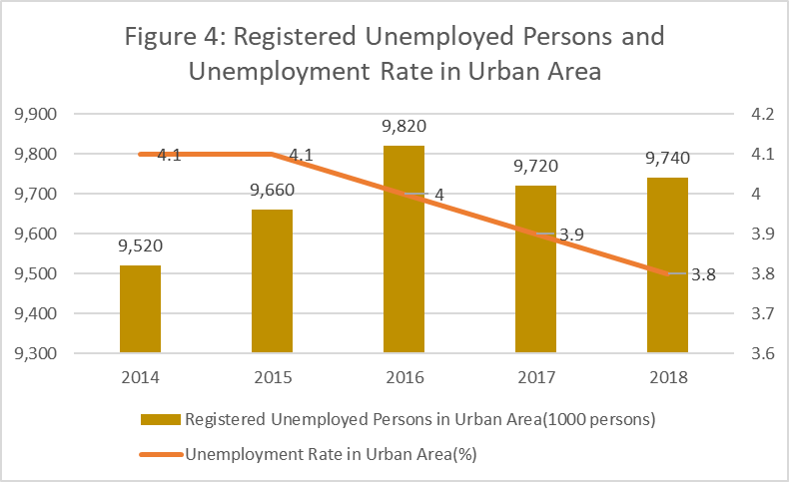

Due to the rapid development of the financial industry and continuous new regulations introduced by the People’s Bank of China, China Banking and Insurance Regulatory Commission and China Securities Regulatory Commission, the financial industry faces a huge talent gap (LinkedIn & Aon, 2019). According to a report of Michael Page China (2018), 92% of fintech employers are concerned about the shortage of fintech talents and 85% of these employers have difficulty in talent recruiting. Moreover, the 7% wage growth rate of foreign financial institutions in 2018 is much lower than Chinese local financial institutions’ 11.8%, which means that foreign financial institutions in China also have to face the challenge of a higher turnover of employees(LinkedIn & Aon, 2019).

UK Labour Market

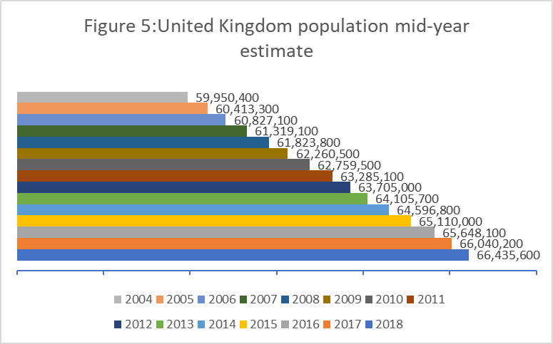

the UK is a multicultural, multi-ethnic country, which has a large white majority and minority communities from all over the world (MarketLine, 2019). The UK’s population was estimated to 66.4 million in 2018 (Figure 5), with a 0.6% increase from 2017, which was the smallest increase since 2004(ONS, 2019). Similar to China, the older population is growing faster than other age groups. Although the total population has a relatively stable growth year-on-year since 1982, migration to the UK has substituted the natural change to be the major driver of the growth (Figure 6) since 1998 (ONS, 2019).
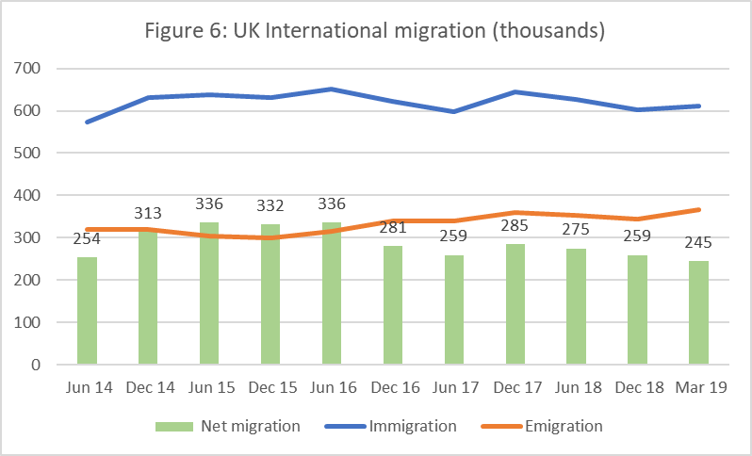
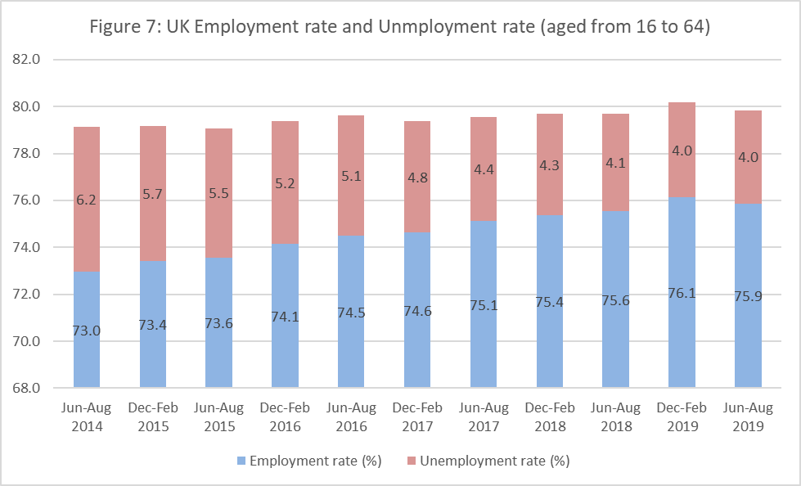
After 5 years recovery from the financial crisis broke in 2008, the UK’s economy has got a slow but stable growth since 2013, with a remarkably high employment and a low unemployment rates (Figure 7) which have been generally falling for the last six years (Conway, 2018; Cribb and Johnson, 2018; ONS, 2018). According to CIPD’s survey, about 41% employers feel more difficult in recruitment over the last year (CIPD & Adecco, 2019), not only because of the tighten labour market, but also due to the uncertainty and concern of Brexit and UK's new immigration system in 2021 (Warrell, 2018; Dmitracova, 2019).
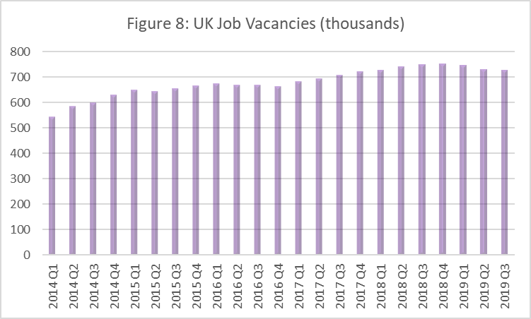
The financial sector is UK’s biggest economic sector, employing only 0.0009% of the entire European Union’s workforce yet producing 16% of all tax receipts (McLeod, 2019), shows huge demand for financial talent. According to a survey conducted by KPMG (2019), about two third of the UK population would not consider taking a job in the financial services sector, which bring more challenge to financial employers when they try to fill the large amount of job vacancies (Figure 8).
Implications for HSBC
Economic and labour market conditions provide the context to daily business of HR (CIPD, 2019). Both China and UK have a tight labour market with high employment and low unemployment rate. HSBC should keep up to date with the labour market trends and global megatrends, so that they can adjust the human resource strategy appropriately.
References:
Armstrong, M. (2017). Armstrong's Handbook of Performance Management: An Evidence-Based Guide to Delivering High Performance. Kogan Page Publishers.
BBC (2019) A quick guide to the US-China trade war - BBC News. Available at: https://www.bbc.co.uk/news/business-45899310 (Accessed: 31 October 2019).
Conway, E. (2018) UK recovery is slower than US after Great Depression | Business News | Sky News. Available at: https://news.sky.com/story/uk-recovery-is-slower-than-us-after-great-depression-11521000 (Accessed: 1 November 2019).
CIPD & Adecco. (2019). Labour Market Outlook, View from Employers. CIPD
Cribb, J. and Johnson, P. (2018) ‘10 years on - have we recovered from the financial crisis?’ The IFS.
Dmitracova, O. (2019) Most UK firms ‘not ready’ for post-Brexit drop in EU workers from 2021 | The Independent. Available at: https://www.independent.co.uk/news/business/news/brexit-eu-workers-immigration-labour-shortages-cipd-bcc-a9113536.html (Accessed: 1 November 2019).
Edwards, T., & Rees, C. (2006). International human resource management: Globalization, national systems and multinational companies. Pearson Education.
HSBC (2019) Who we are | HSBC Holdings plc. Available at: https://www.hsbc.com/who-we-are (Accessed: 24 October 2019).
LinkedIn & Aon (2019) 2019 Talent Flow and Salary Trends Report. Available at: https://business.linkedin.com/zh-cn/talent-solutions/s/sem-report-resources/talent-flow-salary-trend (Accessed: 31 October 2019).
MarketLine. (2019). The United Kingdom In-depth PESTLE insights. MarketLine
McLeod, A. (2019) London calling! KPMG shows huge demand for financial talent - FinanceFeeds. Available at: https://financefeeds.com/london-calling-kpmg-shows-huge-demand-for-financial-talent/ (Accessed: 31 October 2019).
Michael Page China. (2018). Fintech Employment Report. Michael Page China
NBS (2019) National Data. Available at: http://data.stats.gov.cn/english/easyquery.htm?cn=C01 (Accessed: 31 October 2019).
ONS (2018) The 2008 recession 10 years on - Office for National Statistics. Available at: https://www.ons.gov.uk/economy/grossdomesticproductgdp/articles/the2008recession10yearson/2018-04-30 (Accessed: 1 November 2019).
ONS (2019) Overview of the UK population - Office for National Statistics. Available at: https://www.ons.gov.uk/peoplepopulationandcommunity/populationandmigration/populationestimates/articles/overviewoftheukpopulation/august2019 (Accessed: 1 November 2019).
Taylor, S. (2018). Resourcing and talent management. Kogan Page Publishers.
Warrell, H. (2018) How UK’s post-Brexit immigration regime would work | Financial Times. Available at: https://www.ft.com/content/053ebe78-c639-11e8-ba8f-ee390057b8c9 (Accessed: 1 November 2019).
World Health Organization. (2016). China country assessment report on ageing and health. World Health Organization

3. Ted Talk
URL:
References:
Armstrong, M. (2017). Armstrong's Handbook of Performance Management: An Evidence-Based Guide to Delivering High Performance. Kogan Page Publishers.
Christidis, A. et al. (2017) Delivering the Workforce For The Future. Available at: https://www.oliverwyman.com/our-expertise/insights/2017/oct/delivering-the-workforce-for-the-future.html.
CIPD & Adecco. (2019). Labour Market Outlook, View from Employers. CIPD
CIPD (2018) Workforce Planning Practice. London. Available at: https://www.cipd.co.uk/Images/workforce-planning-guide_tcm18-42735.pdf.
Dundon, T., Redman, T., & Wilkinson, A. (2017). Contemporary human resource management: text and cases.
Edwards, T., & Rees, C. (2006). International human resource management: Globalization, national systems and multinational companies. Pearson Education.
Frey, C. B., & Osborne, M. A. (2017). The future of employment: How susceptible are jobs to computerisation?. Technological forecasting and social change, 114, 254-280.
Holbeche, L. (2018). The Agile Organization: How to Build an Engaged, Innovative and Resilient Business. Kogan Page Publishers.
Kalleberg, A. L. (2001). Organizing flexibility: the flexible firm in a new century. British journal of industrial relations, 39(4), 479-504.
Liakopoulos, A., Barry, L., & Schwartz, J. (2013). The open talent economy: People and work in a borderless workplace. Deloitte Development LLC. pp, 1-12.
Morgan, J. (2014). The future of work: Attract new talent, build better leaders, and create a competitive organization. John Wiley & Sons.
Noe, R. A., Hollenbeck, J. R., Gerhart, B., & Wright, P. M. (2017). Human resource management: Gaining a competitive advantage. New York, NY: McGraw-Hill Education.
Pink, D. H. (2011). Drive: The surprising truth about what motivates us. Penguin.
Ramey，Karehka (2012) Use of Technology In Human Resource Management - Use of Technology. Available at: https://www.useoftechnology.com/technology-human-resource-management/ (Accessed: 26 October 2019).
Taylor, S. (2018). Resourcing and talent management. Kogan Page Publishers.

4. Overview
HR policy works as a managemental philosophy and an attitude of employers toward employees that is shown in the way in which HR issues are dealt with (Armstrong, 2017). It can be categorised as overall HR policy and specific HR policies (Armstrong, 2017). To formulate HR policies, organisations need not only to address the internal issues, but also take account of the external factors, e.g. the PESTEL analysis and labour market trends. Multinational corporations should adopt different HR policies in accordance with different economy systems (Farndale, Brewster, & Poutsma, 2014). The following executive summary of HR policies are based on the assumption that HSBC operate in liberal market economy and co-ordinated market economy.
Liberal and co-ordinated economy are two kinds of market economies or business systems which are different in many aspects (Farndale, Brewster, & Poutsma, 2014). Liberal Market Economy primarily organise economic activities through markets, where there are relatively few corporations and associations among firms (Edwards & Rees, 2006). In co-ordinated market economy, there are several forms of non-market co-ordinations, i.e. co-ordinations among firms, co-ordinations between government and society and co-ordinations between government and private economies (Streeck, 1989; Esping-Andersen, 1990).These differences affect many aspects of HR policies such as recruitment and selection, employment relationships, employee welfare, wage determination, training and development, and so on (Griffiths, 2015).
1. Recruitment and Selection Approaches
Compared with co-ordinated market economy, labour markets of liberal market economy are considered to be deregulated and highly mobile (Cooke, 2007). Therefore, HSBC can adopt a more sophisticated recruiting approach in liberal market economy, where a wide range of selection tools can be deployed.
In co-ordinated economy, due to the relatively low mobility and more cultural and institutional barriers, HSBC may focus on local recruitment and less diversity may be expected (Parry, Dickmann, & Morley, 2008).
2. employment relationships
employment relations policies show how the organisation deal with its relationship with employees and their unions, when necessary (Armstrong, 2017). Due to the relatively low-trust relationship between employers and employees in LME, where the contracts are individualised and often last for short period of time after which they can be renewed, HSBC should rely more on numerical flexibility (Hall & Soskice,2001; Taylor, 2018),
While in CME, where there usually exist long-term or unlimited contracts and high-trust relationships, HSBC may rely more on functional flexibility (Taylor, 2018).
3. Employee Welfare and Work-life Balance
Obviously, employee welfare is especially important in tight labour markets, where employees have the rights to choose employers (Henkens, Remery & Schippers,2005). Employers should be conscious of personal boundaries and empower employees to create their own work-life balance (Deery,2008; Morgan, 2014).
As there is more emphasis of flexibility and individualism in LME, HSBC may accordingly adjust the employee welfare policies to provide more flexible work environment to its employees (Morgan, 2014). While more work discipline may be emphasized in CME.
4. Wage Determination
As government, trade unions and associations of companies have more influences in CME than in LME (Thelen, 2001), wage determination is usually centralised and determined by government or negotiations between firms and trade unions in CME. While in CME wage is often determined at workplace or firm level (Griffiths, 2015).
5. Training and Development
Training and development policy could express the organisation’s desire and commitment of employees’ skills so as to develop their potential and ability (Armstrong, 2017). Due to the different contracts and talent mobilities, multinational corporations in LME prefer to develop their own training system rather than comply with sectoral system so that they do not train employees for competitors. In CME, firms may invest more in training and developing because employees do not frequently change their jobs.

References:
Armstrong, M. (2017). Armstrong's Handbook of Performance Management: An Evidence-Based Guide to Delivering High Performance. Kogan Page Publishers.
Bosch, G., & Charest, J. (2008). Vocational training and the labour market in liberal and coordinated economies. Industrial relations journal, 39(5), 428-447.
Cooke, P. (Ed.). (2007). Regional knowledge economies: markets, clusters and innovation. Edward Elgar Publishing.
Deery, M. (2008). Talent management, work-life balance and retention strategies. International journal of contemporary hospitality management, 20(7), 792-806.
Edwards, T., & Rees, C. (2006). International human resource management: Globalization, national systems and multinational companies. Pearson Education.
Esping-Andersen, G. (1990). 4 the three political economies of the welfare state. International journal of sociology, 20(3), 92-123.
Farndale, E., Brewster, C., & Poutsma, E. (2014). Coordinated vs. liberal market HRM: the impact of institutionalization on multinational ﬁrms. In International human resource management (pp. 20-39). Routledge.
Griffiths, D. (2015) Differences between Liberal Versus Coordinated Market Economies. Available at: https://davidg.atavist.com/differences-between-liberal-versus-coordinated-market-economies (Accessed: 2 November 2019).
Hall, P. A., & Soskice, D. (2001) An Introduction to Varieties of Capitalism.
Hall, P. A., & Soskice, D. (2003). Varieties of capitalism and institutional change: A response to three critics. Comparative European Politics, 1(2), 241-250.
Henkens, K., Remery, C., & Schippers, J. (2005). Recruiting personnel in a tight labour market: an analysis of employers' behaviour. International Journal of Manpower, 26(5), 421-433.
Jackson, G., & Kirsch, A. (2014). Employment relations in liberal market economies. In The Oxford Handbook of Employment Relations.
Meunier, S., & McNamara, K. R. (Eds.). (2007). Making history: European integration and institutional change at fifty (Vol. 8). Oxford University Press, USA.
Morgan, J. (2014). The future of work: Attract new talent, build better leaders, and create a competitive organization. John Wiley & Sons.
Parry, E., Dickmann, M., & Morley, M. (2008). North American MNCs and their HR policies in liberal and coordinated market economies. The International Journal of Human Resource Management, 19(11), 2024-2040.
Streeck, W. (1989). Skills and the limits of neo-liberalism: the enterprise of the future as a place of learning. Work, employment and society, 3(1), 89-104.
Taylor, S. (2018). Resourcing and talent management. Kogan Page Publishers.
Thelen, K. (2001). Varieties of labor politics in the developed democracies. Varieties of capitalism: The institutional foundations of comparative advantage, 71, 76-92.

5. Presentation
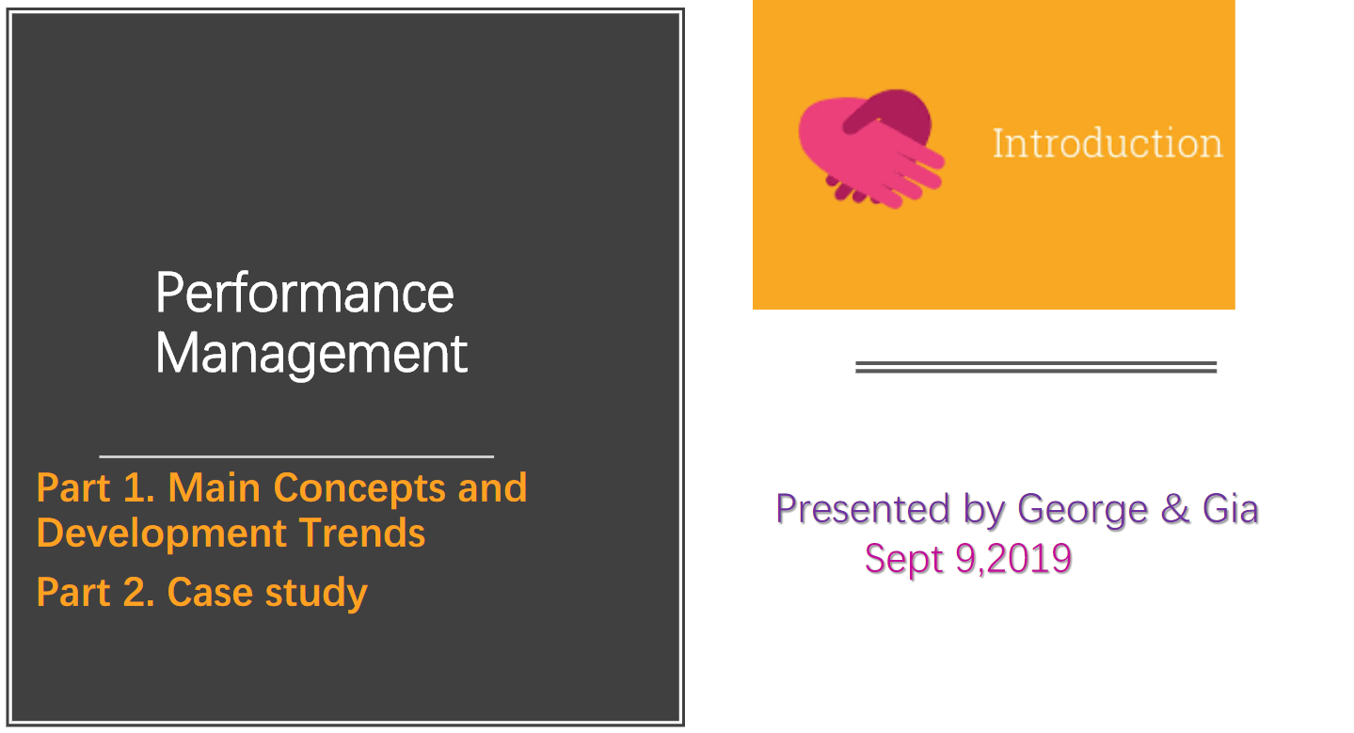

PPT URL：PLEASE CLICK HERE

References:
Aguinis, H. (2009). Performance management. Upper Saddle River, NJ: Pearson Prentice Hall.
Armstrong, M. (2017). Armstrong's Handbook of Performance Management: An Evidence-Based Guide to Delivering High Performance. Kogan Page Publishers.
Bandura, A. (1977). Self-efficacy: toward a unifying theory of behavioral change. Psychological review, 84(2), 191.
Bandura, A. (1989). Human agency in social cognitive theory. American psychologist, 44(9), 1175.
Cappelli, P., & Tavis, A. (2016). The performance management revolution. Harvard Business Review, 94(10), 58-67.
CIPD (2018) Performance Management | Factsheets | CIPD. Available at: https://www.cipd.co.uk/knowledge/fundamentals/people/performance/factsheet (Accessed: 7 September 2019).
Collings, D. G., Wood, G. T., & Szamosi, L. T. (2018). Human resource management: A critical approach. In Human Resource Management (pp. 1-23). Routledge.
Deloitte joins Adobe and Accenture in dumping performance reviews | Impraise (no date). Available at: https://www.impraise.com/blog/deloitte-joins-adobe-and-accenture-in-dumping-performance-reviews (Accessed: 8 September 2019).
DeNisi, A. S., & Murphy, K. R. (2017). Performance appraisal and performance management: 100 years of progress?. Journal of Applied Psychology, 102(3), 421.
Fletcher, C. (2001). Performance appraisal and management: The developing research agenda. Journal of Occupational and organizational Psychology, 74(4), 473-487.
Folan, P., & Browne, J. (2005). A review of performance measurement: Towards performance management. Computers in industry, 56(7), 663-680.
Gruman, J. A., & Saks, A. M. (2011). Performance management and employee engagement. Human resource management review, 21(2), 123-136.
Josh Bersin (no date) The History of Performance Management, from The Josh Bersin Academy - YouTube. Available at: https://www.youtube.com/watch?v=YqdR_ejViMI (Accessed: 8 September 2019).
Lebas, M. J. (1995). Performance measurement and performance management. International journal of production economics, 41(1-3), 23-35.
Locke, E. A., & Latham, G. P. (2006). New directions in goal-setting theory. Current directions in psychological science, 15(5), 265-268.
Louis Efron (2015) Why Millennials Don’t Want To Work For You. Available at: https://www.forbes.com/sites/louisefron/2015/12/13/why-millennials-dont-want-to-work-for-you/#35fab4a51bef (Accessed: 6 September 2019).
Mone, E. M., & London, M. (2018). Employee engagement through effective performance management: A practical guide for managers. Routledge.
Noe, R. A., Hollenbeck, J. R., Gerhart, B., & Wright, P. M. (2017). Human resource management: Gaining a competitive advantage. New York, NY: McGraw-Hill Education.
Redman, T., & Snape, E. (1992). Upward and onward: can staff appraise their managers?. Personnel Review, 21(7), 32-46.
Scriven, Michael (1961). "An overview of stimulus-response reinforcement theory". Psychology. Needham Heights: Allyn & Bacon. pp. 321–329.
Stewart, G. L., & Brown, K. G. (2019). Human resource management. Wiley.
Stuart Hearn (2019) 5 Performance Management Trends of 2019 | Clear Review. Available at: https://www.clearreview.com/performance-management-trends-of-2019/ (Accessed: 8 September 2019).
Vroom, V. H. (1964). Work and motivation (Vol. 54). New York: Wiley.
Warning about Pivot - The FACE of Amazon (no date). Available at: https://sites.google.com/site/thefaceofamazon/home/warning-about-pivot (Accessed: 8 September 2019).
Why Adobe got rid of performance reviews — Impraise Blog - Employee performance management, reviews and 360 feedback (no date). Available at: https://blog.impraise.com/360-feedback/why-adobe-got-rid-of-performance-reviews-360-feedback (Accessed: 8 September 2019).

6. Analysis
Open Talent Economy Changes the World
The megatrends of globalisation, technology, mobility, social business, education and analytics are fundamentally changing our work and lifestyle, which promote the open talent economy in every industry around the world (Liakopoulos, Barry, & Schwartz, 2013). Differentiated from the classical employment model, people work in a much more rapid-cycled, technology-enabled, collaboration-based and transparent way in open talent economy. In this new model, companies whether large or small recruit and manage their employees in a more flexible way. Employers look for expertise and skills for their company in a talent pool of independent professionals with high quality and rich experience. Employees can move from different roles, across companies and geographic boundaries more freely. Equipped with technologies, employers and talent can get in touch with each other from anywhere all over the world.
Today, more and more people prefer to work in a flexible way, i.e. they hope the job can be done anywhere, anytime and focus on output not input (Morgan, 2014). New technologies such as collaborative platform, cloud, Internet of things make people easy to work anywhere, anytime, on any device connected to the Internet. A survey conducted by Unify in 2014 shows that 43% of respondents at all organizational levels would choose flexibility over a pay raise(Lipman, 2014). Therefore, flexibility can be a way to attract and keep employee.
Atkinson’s Flexible Firm Model
in 1984, John Atkinson proposed a ‘flexible firm’ model in his research, which suggested that an effective and competitive organisation in modern business environment should classify employees into three groups, i.e. core workers, peripheral group and a third group on subcontracts and manage them with different policies so as to optimize the use of human resources (Atkinson,1984). The core group consists of employees that are most important to the organisation; they are usually employed on full-time and permanent contracts and functionally flexible, and difficult to replace (Dundon, Redman & Wilkinson, 2017; Taylor, 2018). The peripheral group is divided into primary and secondary categories; the former constitutes the internal labour market of the organisation, who are mainly full-time but have lower level of skills than the core group and less central to the success of organisation; the latter are employed on part-time or temporary basis mainly to cover short time needs(Dundon, Redman & Wilkinson, 2017; Taylor, 2018). The third group, consist of open talent we named today, are not employees of the organisation but can be hired to undertake a specific task or a series of tasks. According to Atkinson (1984), organisation can seek functional, numerical and financial flexibility through his new employment model, which breaks up the hierarchical structure of organisation and divides workers into different groups and pursues them with different policies.
There are many advantages as well as disadvantages associated with ‘flexible firm’ model. First, it may increase employees’ stress and cause a lack of organisational focus or engagement (Golden& Powell, 2000). Second, it increases the difficulties for teamwork and collaboration (Michael, 2019), although social media technology can partly solve this problem. Last but not least, it is not easy for human resource department to divide workers into different groups accurately in VUCA conditions.
Implications for HSBC
Firstly, HSBC can divide its employees into different categories and manage them accordingly so as to improve efficiency and reduce cost.
Secondly, access to talent is more important than ownership of talent. (Liakopoulos, Barry, & Schwartz, 2013). HSBC can make full use of open talent to solve specific tasks rather than sign long-term employment contract with them.
Thirdly, engagement in tasks is more important than engagement in company. As for HSBC, employees can be motivated by autonomy, mastery, and purpose (Pink, 2011). They work as independent agile teams, once the task is finished, the talents move onto something else – with no strings attached (Morgan, 2014).

References:
Armstrong, M. (2017). Armstrong's Handbook of Performance Management: An Evidence-Based Guide to Delivering High Performance. Kogan Page Publishers.
Atkinson, J. (1984). Manpower strategies for flexible organisations. Personnel management, 16(8), 28-31.
Atkinson, J. (1985). Flexibility: planning for an uncertain future. Manpower Policy and Practice, Vol.1, 26-9.
Dundon, T., Redman, T., & Wilkinson, A. (2017). Contemporary human resource management: text and cases.
Golden, W., & Powell, P. (2000). Towards a definition of flexibility: in search of the Holy Grail?. Omega, 28(4), 373-384.
Heery, E., & Noon, M. (2017). A Dictionary of Human Resource Management. Oxford University Press.
Holbeche, L. (2018). The Agile Organization: How to Build an Engaged, Innovative and Resilient Business. Kogan Page Publishers.
Kalleberg, A. L. (2001). Organizing flexibility: the flexible firm in a new century. British journal of industrial relations, 39(4), 479-504.
Liakopoulos, A., Barry, L., & Schwartz, J. (2013). The open talent economy: People and work in a borderless workplace. Deloitte Development LLC. pp, 1-12.
Lipman, V. (2014) How Important Is Flexible Work? 43% Choose It Over Pay Raise. Available at: https://www.forbes.com/sites/victorlipman/2014/10/03/how-important-is-flexible-work-43-choose-it-over-pay-raise/#1fe08c6d1bb4 (Accessed: 28 October 2019).
Michael, J. (2019) What are the Disadvantages of Workplace Flexibility (11 Big Problems if Not Properly Managed) | News | Open Sourced Workplace. Available at: https://www.opensourcedworkplace.com/news/what-are-the-disadvantages-of-workplace-flexibility-11-big-problems-if-not-properly-managed (Accessed: 28 October 2019).
Morgan, J. (2014). The future of work: Attract new talent, build better leaders, and create a competitive organization. John Wiley & Sons.
Noe, R. A., Hollenbeck, J. R., Gerhart, B., & Wright, P. M. (2017). Human resource management: Gaining a competitive advantage. New York, NY: McGraw-Hill Education.
Pink, D. H. (2011). Drive: The surprising truth about what motivates us. Penguin.
Taylor, S. (2018). Resourcing and talent management. Kogan Page Publishers

7. Model

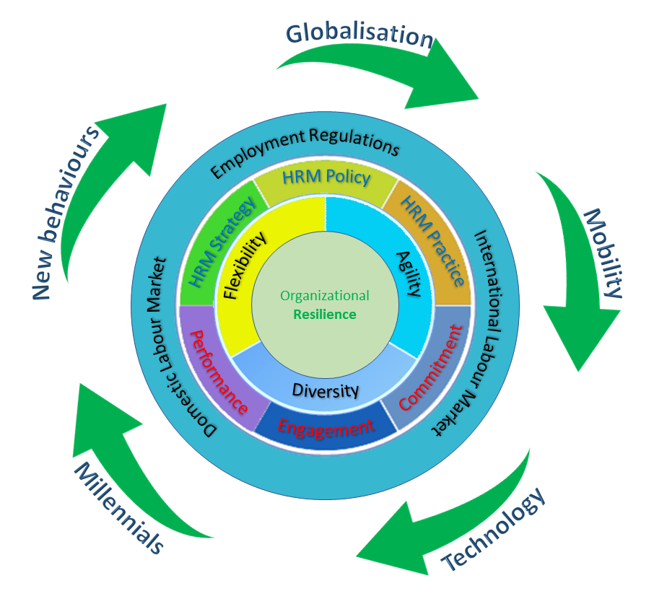

References:
Armstrong, M. (2017). Armstrong's Handbook of Performance Management: An Evidence-Based Guide to Delivering High Performance. Kogan Page Publishers.
Boudreau, J. W., Jesuthasan, R., & Creelman, D. (2015). Lead the work: Navigating a world beyond employment. John Wiley & Sons.
Edwards, T., & Rees, C. (2006). International human resource management: Globalization, national systems and multinational companies. Pearson Education.
Holbeche, L. (2018). The Agile Organization: How to Build an Engaged, Innovative and Resilient Business. Kogan Page Publishers.
Martin, G., & Siebert, S. (2016). Managing people and organizations in changing contexts. Routledge.
Morgan, J. (2014). The future of work: Attract new talent, build better leaders, and create a competitive organization. John Wiley & Sons.
Noe, R. A., Hollenbeck, J. R., Gerhart, B., & Wright, P. M. (2017). Human resource management: Gaining a competitive advantage. New York, NY: McGraw-Hill Education.
Taylor, S. (2018). Resourcing and talent management. Kogan Page Publishers.
Wilkinson, A. (2017). Contemporary human resource management: text and cases. T. Redman, & T. Dundon (Eds.). London: Pearson.

