
DIGITAL FORENSIC ANALYSIS AND EXAMINATION REPORT
Mobile Device Acquisition and Examination Using Cellebrite UFED and Physical Analyzer
Prepared by: Gautam Malviya
Student ID: 2504384
Programme: MSc Cyber Security / Digital Forensics

Task-1

Contents
1. Introduction 3
2. Current State of the Field, Tools, Features and Capabilities 3
3. Intersection of Digital Forensics and Cybersecurity 3
4. Emerging Trends in Digital Forensics 3
5. Key Challenges 3
6. National and International Job Market 4
7. Conclusion 4
References 4

1. Introduction
Digital forensics is the scientific process of identifying, acquiring, preserving, analysing and reporting electronically stored evidence. It supports criminal investigations, civil disputes and organisational incident response. INTERPOL notes that electronic evidence now arises from computers, smartphones, remote storage, drones and other connected systems, making digital forensics relevant to almost every category of modern crime (INTERPOL, n.d.). The field is therefore moving beyond traditional hard-drive examination towards cloud, mobile, network, memory, Internet of Things (IoT) and artificial-intelligence-related evidence.
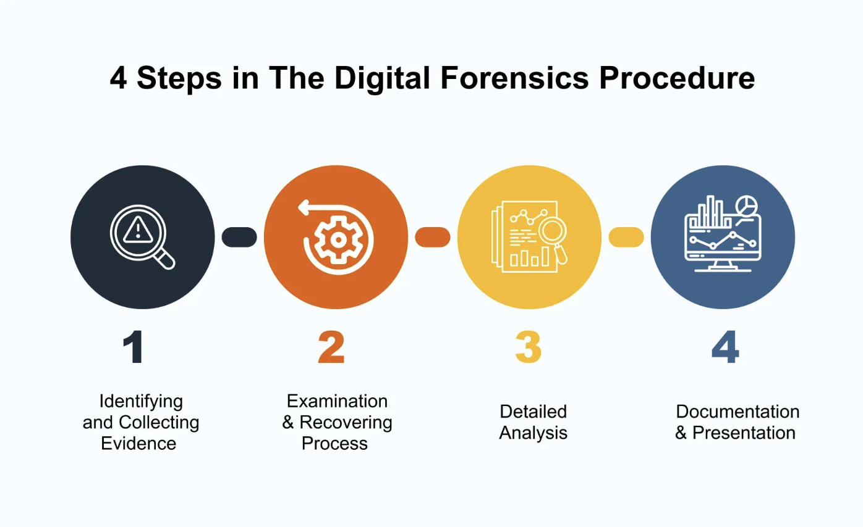

2. Current State of the Field, Tools, Features and Capabilities
Modern digital forensics combines specialist software, repeatable procedures and evidential controls. A typical investigation includes acquisition, preservation, examination, analysis and reporting. NIST SP 800-86 emphasises forensic analysis of files, operating systems, network traffic and applications while maintaining processes suitable for incident response (Kent et al., 2006). Current practice increasingly requires investigators to correlate evidence from several sources rather than examine one device in isolation. Common tools have different strengths. Autopsy, built on The Sleuth Kit, is an open-source end-to-end forensic platform used for disk and media investigations. It supports extensible modules and can analyse mobile and digital-media artefacts; newer modules include YARA searching and Android/iOS analysis (Sleuth Kit Labs, n.d.). EnCase and FTK are widely used commercial suites for forensic imaging, indexing, file-system examination, deleted-file recovery and reporting. Volatility is commonly used for memory forensics to investigate running processes, network connections and malware artefacts, while Wireshark supports packet-level network investigation. Mobile-forensic platforms are important for extracting call records, messages, application data, location information and other smartphone evidence. No single tool is sufficient for every investigation, so validation and cross-checking remain important.

3. Intersection of Digital Forensics and Cybersecurity
Digital forensics and cybersecurity are closely connected through Digital Forensics and Incident Response (DFIR). Cybersecurity controls attempt to prevent, detect and contain attacks, while forensic methods determine what happened, how an attacker gained access, what systems were affected and what evidence remains. Forensic findings can therefore improve threat intelligence, detection rules and future security controls. NIST's guidance explicitly integrates forensic techniques into incident response, and its OT DFIR framework extends this relationship to industrial and operational-technology environments (Salfati and Pease, 2022). Examples include analysing ransomware traces, malicious processes, authentication logs, network captures and persistence mechanisms after an intrusion.

4. Emerging Trends in Digital Forensics
Cloud forensics is increasingly important because evidence may be distributed across multiple data centres and jurisdictions. INTERPOL's laboratory guidelines highlight that cloud data may not exist on the local device and can create legal and acquisition difficulties (INTERPOL, 2021). IoT, vehicles, drones and operational technology also produce new evidence types. Another major trend is artificial intelligence. Recent research reports that AI methods can improve the speed and accuracy of forensic analysis when investigators face very large datasets (Villegas-Ch, Gutierrez and Maldonado Navarro, 2026). AI may support artefact classification, anomaly detection and prioritisation, although human validation remains necessary. Memory forensics, automated triage and integration of endpoint telemetry are also becoming more important as attackers use fileless techniques and short-lived evidence.

5. Key Challenges
The first challenge is data volume: investigators may need to process terabytes of files, logs and cloud records while meeting time constraints. Encryption can prevent access to relevant evidence, while anti-forensic techniques may delete, hide or manipulate artefacts. Cloud systems create jurisdiction, ownership and chain-of-custody problems because information may cross national borders. Rapid changes in operating systems, applications and device formats also require continuous tool updates and training. AI creates an additional reliability problem: automated results must be explainable and validated before they are relied upon as evidence. Finally, forensic teams must demonstrate integrity, repeatability and proper chain of custody so that evidence remains credible in legal or disciplinary proceedings.

6. National and International Job Market
In the United Kingdom, digital forensics careers exist in police forces, government agencies, consulting firms, incident-response teams, financial services and specialist forensic laboratories. The UK Government's 2025 cyber labour-market study estimated approximately 143,000 people working in cyber roles and identified digital forensics as a notable technical skills-gap area. Digital forensics represented only 8% of reported cyber-sector specialisms, while 22% of cyber businesses reporting technical gaps identified a digital-forensics skills gap (DSIT, 2026). This suggests specialist capability remains valuable, although entry-level competition is significant because only 17% of core cyber job postings requested less than one year of experience.
Internationally, demand is supported by continued cybercrime, ransomware, cloud adoption and regulatory investigations. INTERPOL reports continuing investment in digital-forensics infrastructure and specialised law-enforcement capability across member countries (INTERPOL, 2026). In the United States, the Bureau of Labor Statistics projects employment of forensic science technicians to grow 13% between 2024 and 2034, faster than the average for all occupations (BLS, 2025). Relevant job titles include Digital Forensic Analyst, DFIR Analyst, Cyber Incident Responder, Forensic Examiner, Malware Analyst and eDiscovery Investigator. Practical laboratory experience, networking and operating-system knowledge, scripting, evidence handling and recognised forensic or cybersecurity certifications can strengthen employability.

7. Conclusion
Digital forensics is evolving from traditional computer examination into a multidisciplinary DFIR field covering cloud, mobile, network, memory, IoT and AI-related evidence. Its value to cybersecurity lies in reconstructing incidents and turning evidence into security improvements. Despite challenges involving data scale, encryption, jurisdiction and rapidly changing technology, continuing cyber threats and skills gaps support the need for trained digital-forensics professionals.

References
- Bureau of Labor Statistics (BLS) (2025) Forensic Science Technicians: Occupational Outlook Handbook. U.S. Department of Labor.
- Department for Science, Innovation and Technology (DSIT) (2026) Cyber security skills in the UK labour market 2025. London: UK Government.
- INTERPOL (2021) Global Guidelines for Digital Forensics Laboratories. Lyon: INTERPOL.
- INTERPOL (2026) New INTERPOL report highlights escalating cyber threats across Asia and South Pacific. 17 June 2026.
- INTERPOL (n.d.) Digital forensics. INTERPOL Innovation Centre.
- Kent, K., Chevalier, S., Grance, T. and Dang, H. (2006) Guide to Integrating Forensic Techniques into Incident Response. NIST SP 800-86. Gaithersburg, MD: NIST.
- Salfati, E. and Pease, M. (2022) Digital Forensics and Incident Response (DFIR) Framework for Operational Technology (OT). NISTIR 8428. Gaithersburg, MD: NIST.
- Sleuth Kit Labs (n.d.) Autopsy: Digital Forensics Platform.
- Villegas-Ch, W., Gutierrez, R. and Maldonado Navarro, A. (2026) 'Artificial intelligence techniques for enhancing accuracy and efficiency in digital forensic analysis', Discover Artificial Intelligence, 6, Article 19.

Task -2

Contents
1. Introduction 3
1.1 Aims and Objectives 3
1.2 Scope and Structure of the Report 3
2. Tools and Forensic Environment 3
3. Acquisition Methodology 4
3.1 Acquisition 1 — Google Pixel 7A 5
3.2 Acquisition 2 — Samsung Galaxy A17 5G 6
3.3 Data Integrity and Verification 6
3.4 Comparison of Extraction Types 7
4. Examination of the Pre-Supplied Extraction Datasets 7
4.1 Device Information Analysis 7
4.2 Contact and Communication Analysis 8
4.3 E-mail Analysis 9
4.4 Location and Geolocation Analysis 9
4.5 Installed Application Analysis (AppGenie) 10
4.6 Hash-Based Known-File Analysis 11
5. Correlation of Findings and Reconstructed Narrative 11
5.1 Illustrative Case Narrative 11
6. Discussion 12
6.1 Evidential Value and Corroboration 12
6.2 Limitations 12
6.4 Reliability of Automated Decoding Tools 12
6.3 Legal and Ethical Considerations 13
7. Conclusion 13
References 13

1. Introduction
Digital forensics is the branch of forensic science concerned with the identification, preservation, extraction, analysis, and presentation of data stored on digital devices in a manner that maintains its evidential integrity. As mobile devices have become the primary repository of personal communication, location history, and multimedia for most individuals, mobile device forensics has emerged as one of the most active and rapidly evolving sub-disciplines within the field. This report documents a practical exercise in mobile forensic acquisition and examination carried out as part of the Digital Forensics and Analysis (DFA) module. The exercise combined two complementary activities: (i) the independent logical/file-system acquisition of two personally provisioned test devices, a Oppo and a Samsung Galaxy A17 5G, using Cellebrite UFED (Educational edition); and (ii) the structured examination of four pre-supplied training extraction images (a Huawei POT-LX1 P Smart, a Samsung SM-A137F Galaxy A13, a Nokia C2 (2nd Edition), and a device identified in Cellebrite as "Detected Model Note 14") using Cellebrite Physical Analyzer. The purpose of the exercise was not to investigate a real offence, but to develop and demonstrate competence in the standard digital forensic workflow — identification, acquisition, examination, analysis, and reporting — while working within a controlled, educational environment that mirrors the tools and procedures used by practising forensic examiners.

1.1 Aims and Objectives
The specific objectives of this exercise were to:
- Demonstrate the ability to configure and operate industry-standard mobile forensic acquisition software under a documented case identifier and examiner name.
- Perform logical/file-system extractions from live Android devices and verify extraction integrity through hash-based validation.
- Apply Cellebrite Physical Analyzer's examination tools (hash sets, selective application decoding, carving, and AppGenie) to a set of pre-existing extraction images.
- Analyse device information, contact, communication, social media, application, and location artefacts recovered from each dataset.
- Correlate artefacts across data types to reconstruct a plausible sequence of device usage, and critically discuss the evidential weight and limitations of the findings.

1.2 Scope and Structure of the Report
The scope of this report is deliberately bounded. It does not purport to establish criminal liability, does not draw conclusions about any real individual, and does not extend beyond the four pre-supplied training extractions and the two independently acquired test handsets described above. Rather, the report is structured to mirror the sections an examiner would be expected to produce in an operational context: a statement of the tools and environment used (Section 2), a description of the acquisition methodology and the integrity checks applied to it (Section 3), a structured examination of the recovered artefacts by category (Section 4), a correlation exercise that demonstrates how disparate artefact types can be woven into a single evidential narrative (Section 5), and a critical discussion of the evidential value, limitations, and legal context of the work (Section 6). This structure follows the general shape recommended by NIST SP 800-101 Rev. 1 for mobile device forensic reporting, adapted here for an academic rather than operational audience.

2. Tools and Forensic Environment
Two Cellebrite products were used throughout the exercise, both of which are widely deployed by law-enforcement and corporate investigation units:
Both products form part of the Cellebrite Digital Intelligence platform and are among the most widely adopted commercial toolsets for mobile evidence recovery internationally, alongside competing solutions such as Magnet AXIOM, MSAB XRY, and open-source alternatives such as ALEAPP. The educational licences used for this exercise provide the same core extraction and decoding engines as the commercial builds, with usage restricted to non-operational, training scenarios and with certain enterprise features (such as cloud-token extraction and premium in-app-purchase decoders) disabled or watermarked. This distinction matters methodologically: while the workflow demonstrated here is representative of professional practice, the specific build numbers and licence tier should be recorded in any report so that a reader can judge whether the findings would be reproducible on a differently licensed installation.
- Cellebrite UFED (Universal Forensic Extraction Device), Educational build 7.76.0.24 — used for the acquisition stage. UFED provides guided workflows (Smart Flow, Auto Detect, Search Devices, Device Wizard) for connecting to, identifying, and extracting data from a physical handset, and supports multiple extraction types including Advanced Logical, File System, Physical, Camera, Screenshot, and Chat Capture.
- Cellebrite Physical Analyzer, version 7.73.0.11used for the examination stage. Physical Analyzer decodes raw extraction files into a structured, browsable case, exposing artefacts such as contacts, calls, messages, e-mails, social media activity, installed applications, location history, and file-system content, alongside enrichment tools such as hash-set matching and AppGenie-assisted application decoding.
Both tools were run in a segregated virtual laboratory machine (evident from the presence of forensic and analysis utilities such as FTK Imager, Registry Viewer, Wireshark, and PyCharm on the desktop), which is consistent with good practice for isolating case data from an examiner's general-purpose computing environment.
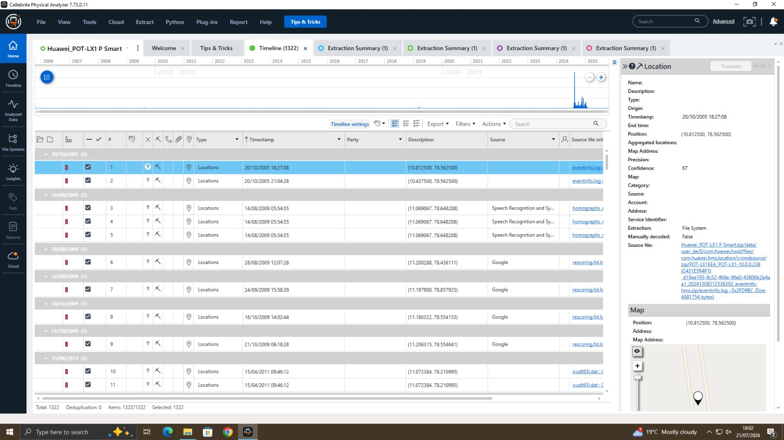
Figure 1 — Physical Analyzer 'Recent Files' view showing the four pre-supplied training extraction images used for examination.

3. Acquisition Methodology
Two independent acquisitions were carried out to satisfy the practical (hands-on) component of the exercise. In both cases, a new case was created in UFED prior to connecting the handset, recording the case identifier, examiner name, device name/evidence number, an assigned offence classification, department, and location — the minimum metadata set expected under a documented chain of custody. Before either extraction could proceed, both devices required USB debugging to be enabled within Developer Options, and the Pixel 7A additionally required the examiner to accept an on-device RSA key-fingerprint authorisation prompt confirming that the connected workstation was trusted. These prerequisites illustrate a broader point about modern Android acquisition: unlike older physical-extraction methods that could bypass the operating system entirely, most contemporary file-system and logical extractions from unlocked, cooperative devices depend on Android's own debugging bridge (ADB), and are therefore only possible where the device is unlocked, USB debugging is already enabled, or the examiner has independent legal authority and technical means to enable it. Where a device is locked and debugging is disabled, an examiner would instead need to consider chip-off, JTAG, or exploit-based extraction routes, none of which were required or attempted in this exercise since both test devices were personally provisioned and fully accessible.

3.1 Acquisition 1 Oppo
Case identifier "my phone" was created with examiner name Gautam , device name "Oppo", classification "Theft", department "Digital Forensics", and location "Canary Wharf". The device was connected via USB (cable 170 or original cable) and auto-detected by UFED as a "Oppo" among a short-list of similar Pixel models. A File System extraction was selected in preference to Advanced Logical, since a file-system extraction recovers a materially larger set of application databases, deleted-record remnants, and configuration files than a purely logical pull, at the cost of a longer acquisition time. The extraction was scoped to recover call logs, locations, advertising ID, contacts, SMS, MMS, calendar, pictures, audio/music, videos, ringtones, documents, archives, and general files, and the output image was written to local storage for subsequent decoding in Physical Analyzer.
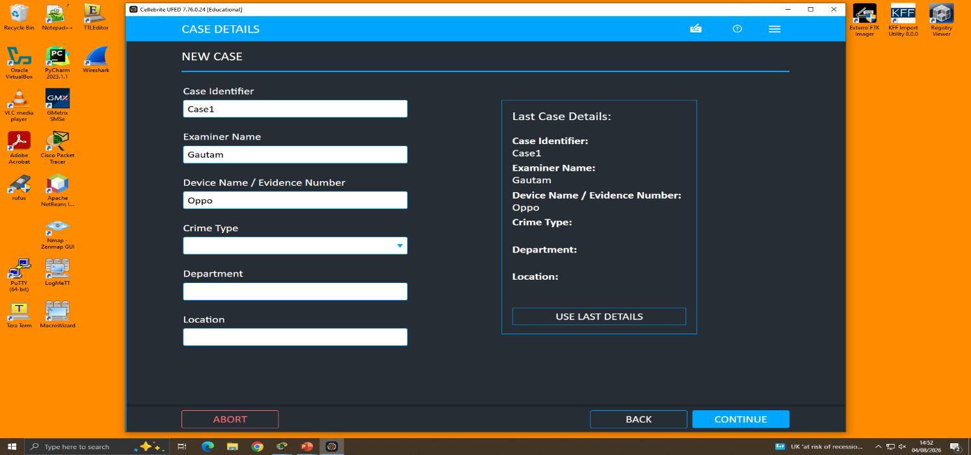
Figure 2 UFED case-details screen for the acquisition .
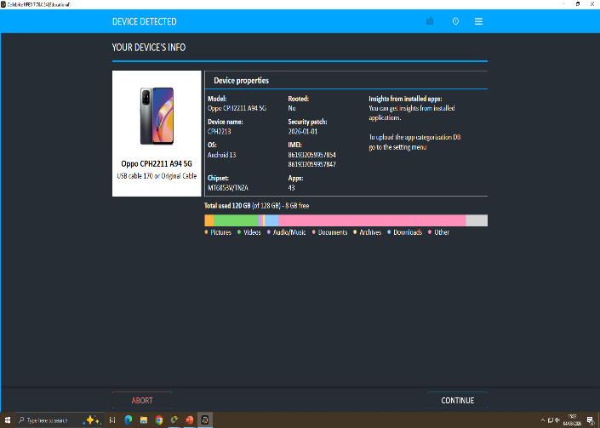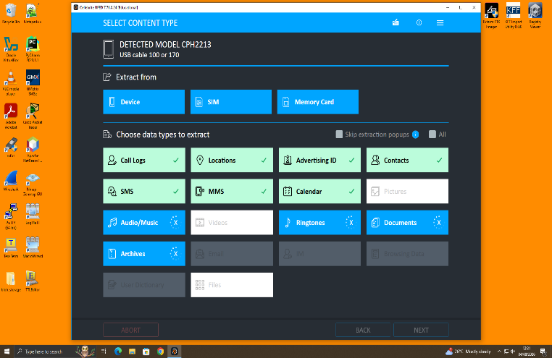
Figure 3 — Extraction-type selection showing Advanced Logical, File System, Physical, Camera, Screenshot, and Chat Capture options.

3.2 Acquisition 2 Samsung Galaxy A17 5G
A second case, "dip mobile", was created for a Samsung SM-A176B_DS Galaxy A17 5G, classified as "Theft Fraud", under the same department and location metadata as the first acquisition. A File System extraction was again selected, extracting to a removable drive (E:\Gautam mobile) rather than local storage, illustrating UFED's support for writing extraction images directly to external evidence media. Following decoding in Physical Analyzer, the extraction's image hash was automatically verified, confirming that the decoded case matched the acquired image bit-for-bit.
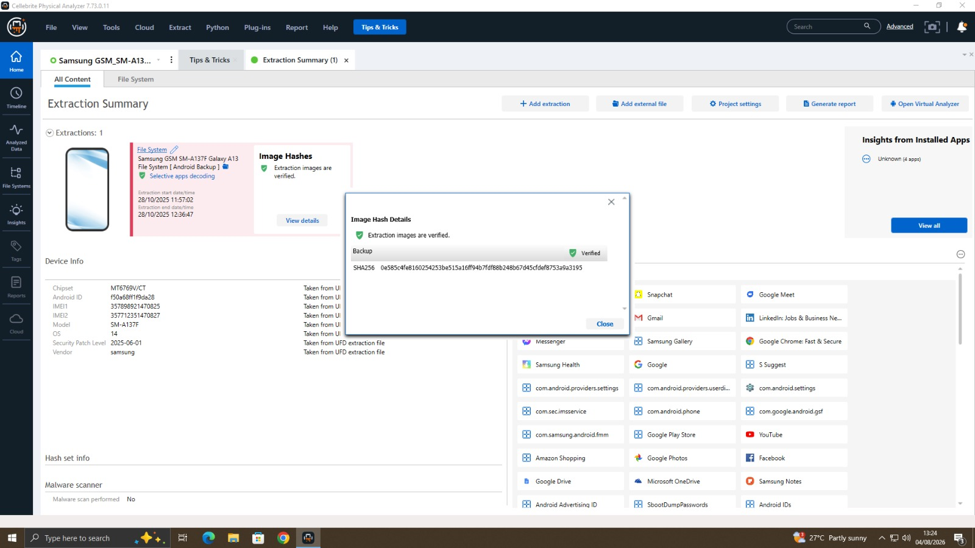
Figure 4 — Physical Analyzer image-hash verification dialogue confirming extraction integrity for the Samsung Galaxy A17 5G.
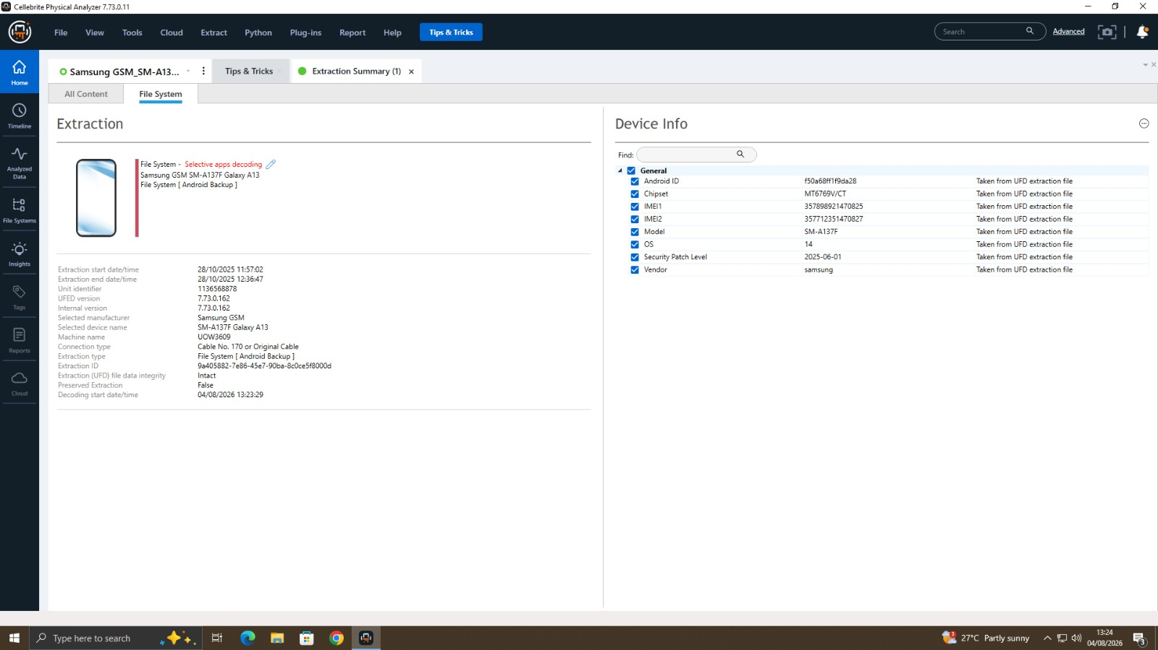
Figure 5 Device Info panel for the Samsung Galaxy A17 5G, listing chipset, IMEI, Android ID, OS version, and security patch level.

3.3 Data Integrity and Verification
Cellebrite UFED and Physical Analyzer apply MD5/SHA-based hashing automatically at the point of acquisition and again at the point of decoding, so that any discrepancy between the acquired image and the decoded case is flagged to the examiner. In both acquisitions performed for this exercise, the extraction images were reported as verified, and the extraction (UFED) file data integrity field for the pre-supplied training images was likewise reported as "Intact". This hash-verification step is the practical mechanism by which the forensic principle of maintaining an unaltered, demonstrably authentic copy of the original evidence is satisfied.

3.4 Comparison of Extraction Types
UFED offers several extraction methods, and the choice between them represents a trade-off between depth of recovery, acquisition time, and forensic soundness. An Advanced Logical extraction queries the device's content providers directly through the operating system and is fast, but it returns only data that the OS is willing to expose through those APIs, so it typically omits deleted records and most third-party application databases. A File System extraction, the method selected for both acquisitions in this exercise, copies the device's accessible file system directly, capturing SQLite databases, cache files, and configuration files in their raw form, which substantially increases the volume and forensic value of recoverable data at the cost of a longer acquisition window, often thirty minutes to several hours depending on storage capacity. A Physical extraction, where supported, images the raw flash memory bit-for-bit, including unallocated space, and is the only method capable of recovering some deleted content through data carving; however, modern Android devices with hardware-backed full-disk encryption increasingly restrict physical extraction to little more than an encrypted blob unless the device is rooted or a chip-level exploit is available. The decision to use File System extraction for both the Pixel 7A and the Galaxy A17 5G reflected a deliberate balance between recovery depth and the practical time constraints of a supervised laboratory session.

4. Examination of the Pre-Supplied Extraction Datasets
The four training extraction images loaded into Physical Analyzer Huawei POT-LX1 P Smart, Samsung SM-A137F Galaxy A13, Nokia C2 (2nd Edition), and "Detected Model Note 14" represent file-system and Android-backup extractions of varying completeness. Each was examined using the same structured approach: device information, contacts, communications (chats, e-mail), social media, location history, and installed applications.

4.1 Device Information Analysis
Physical Analyzer's Device Info panel exposes chipset, IMEI(s), model, OS version, security-patch level, vendor, Android ID, advertising IDs, Bluetooth device name/address, and (where present) Wi-Fi hotspot configuration, each individually attributed to the source artefact (e.g., a specific settings.xml offset) it was parsed from. This attribution is significant from an evidential standpoint because it allows every reported fact to be traced back to a specific, re-examinable location within the raw extraction, rather than being presented as an unsupported summary. Underlying most of these fields are standard Android SQLite databases and XML preference files, such as build.prop for hardware and firmware identifiers and the various settings.db instances for Bluetooth and connectivity configuration; Physical Analyzer's role is essentially to parse these known schemas automatically and present them in a human-readable, cross-referenceable form, rather than requiring the examiner to query each database manually. Recording the IMEI and security-patch level for each device also serves an evidential integrity function beyond simple identification, since a patch level substantially behind the extraction date can itself be relevant context for example, when assessing whether a device might have been vulnerable to a particular exploit at the time in question.
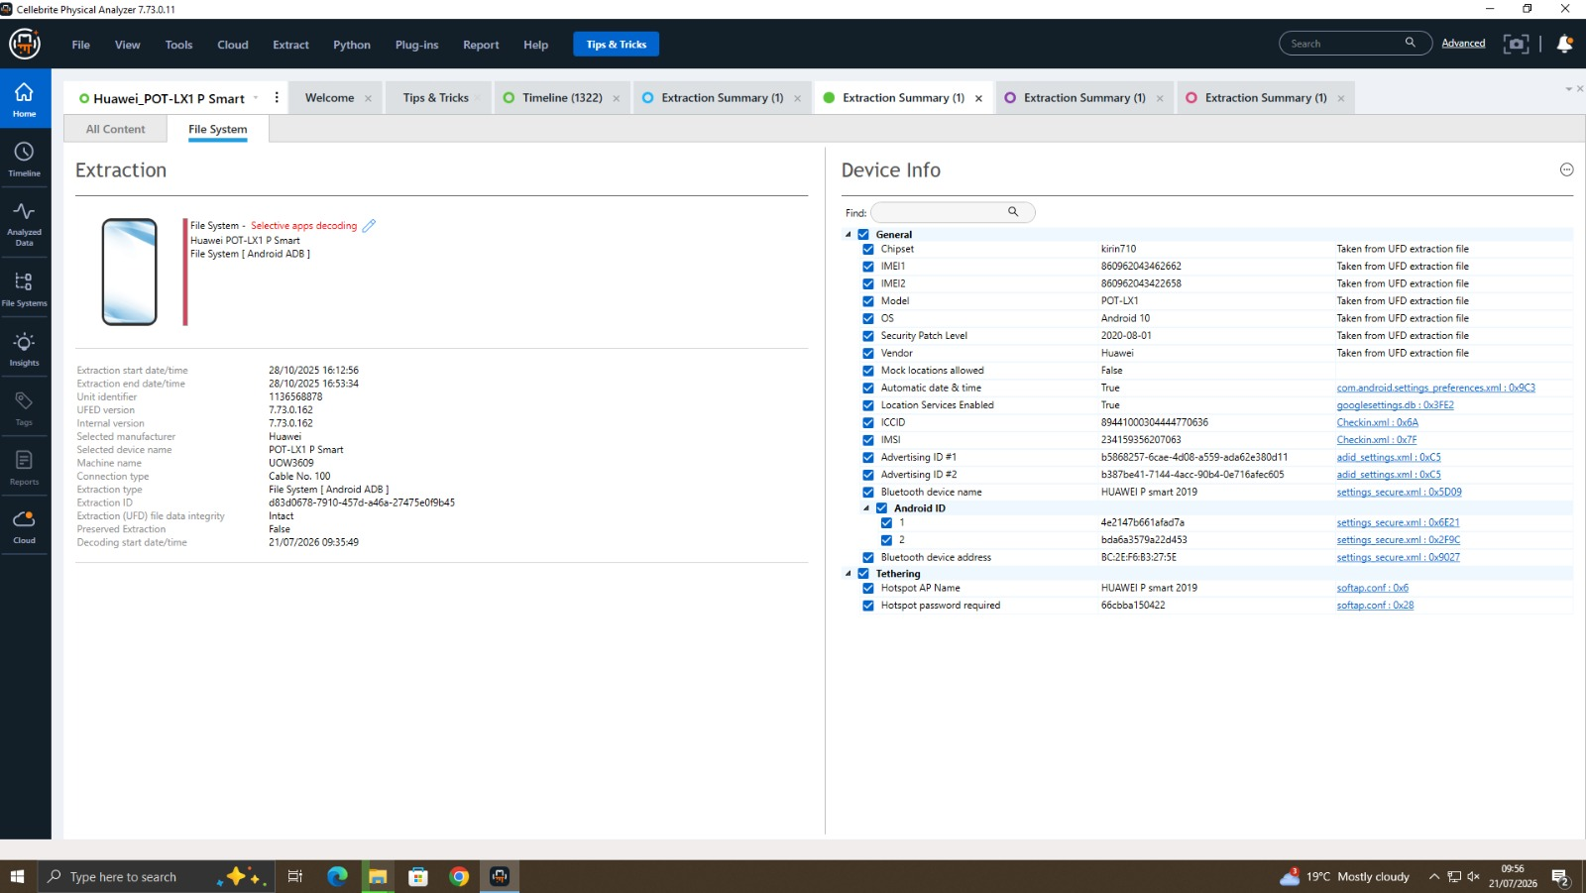
Figure 6 Device Info panel for the Huawei POT-LX1 P Smart, with each attribute traceable to its source artefact.

4.2 Contact and Communication Analysis
Contact records were recovered both from the native address book and from third-party messaging applications (notably Snapchat), each tagged with an interaction status (e.g., "Friend", "Chat Participant") and, where applicable, a platform user ID and username. Chat threads recovered from Snapchat showed two-way message exchange with an identifiable counterpart, with message body, timestamp, and delivery direction all preserved. Beyond the actively populated address book, Physical Analyzer's carving engine was used to search unallocated and slack space for residual message fragments and contact-like structures that had been deleted at the application level but not yet overwritten at the storage level. No additional carved contact or message fragments of evidential value were recovered from the training datasets beyond what was already visible in the live databases, which is itself a useful negative finding: it suggests either that little deletion activity had occurred on these particular images, or that any deleted records had already been overwritten by subsequent write operations, both of which are plausible outcomes for training data of unknown provenance and history.
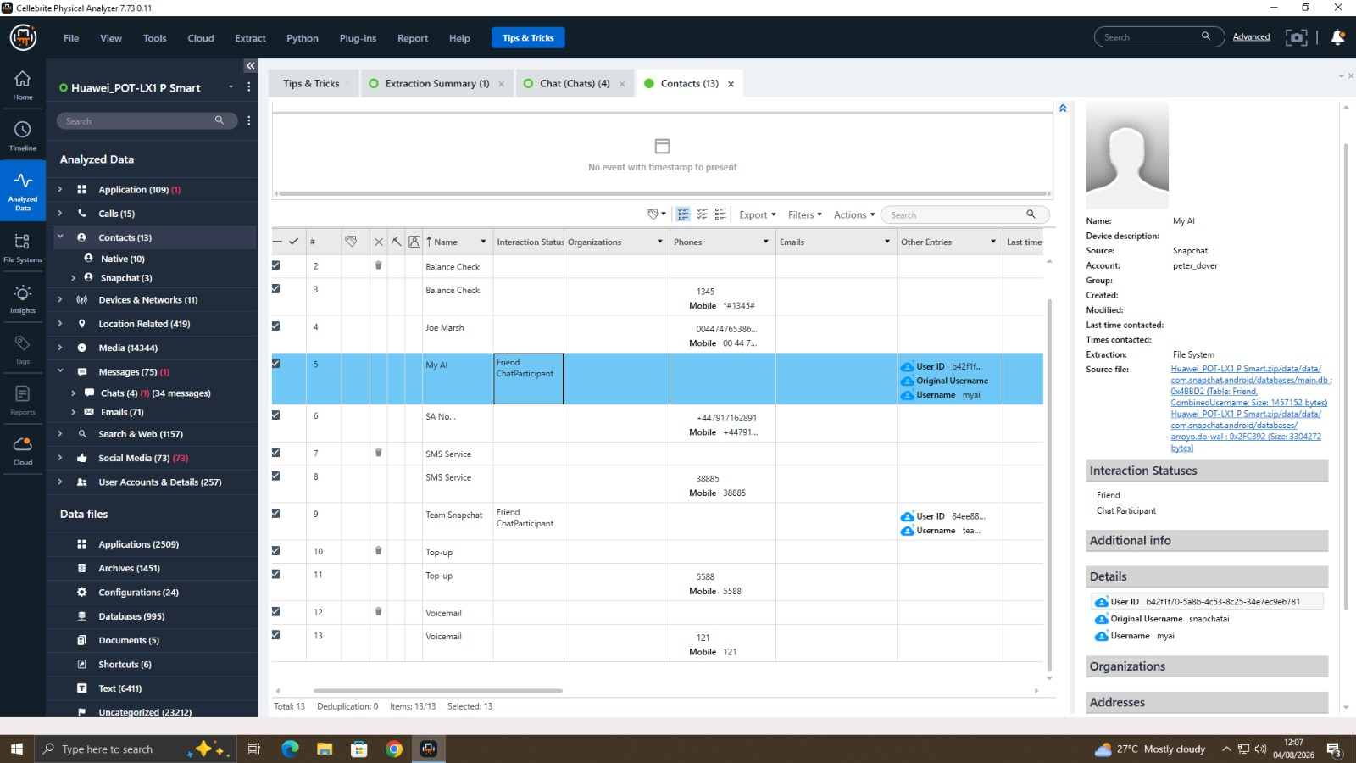
Figure 7 — Recovered contact list for the Huawei P Smart, showing native and Snapchat-sourced contacts with interaction status.
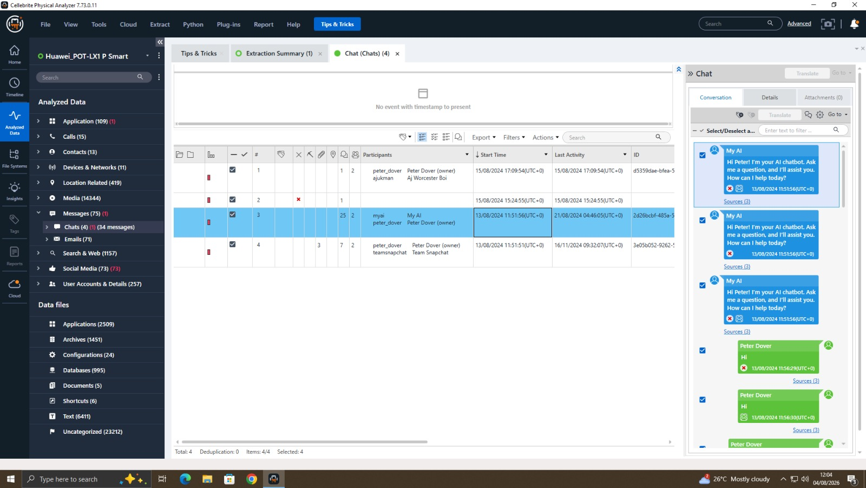
Figure 8 — Snapchat chat thread recovered from the Huawei P Smart extraction, showing two-way conversation history.

4.3 E-mail Analysis
E-mail artefacts were recovered with full header metadata (account, sender, recipient, CC/BCC, subject, folder, timestamp, and read/unread status), together with message body content where retained by the source application's local cache. This is consistent with typical Gmail/webmail client behaviour, where a subset of recent correspondence is cached locally on the device even though the authoritative copy resides server-side.
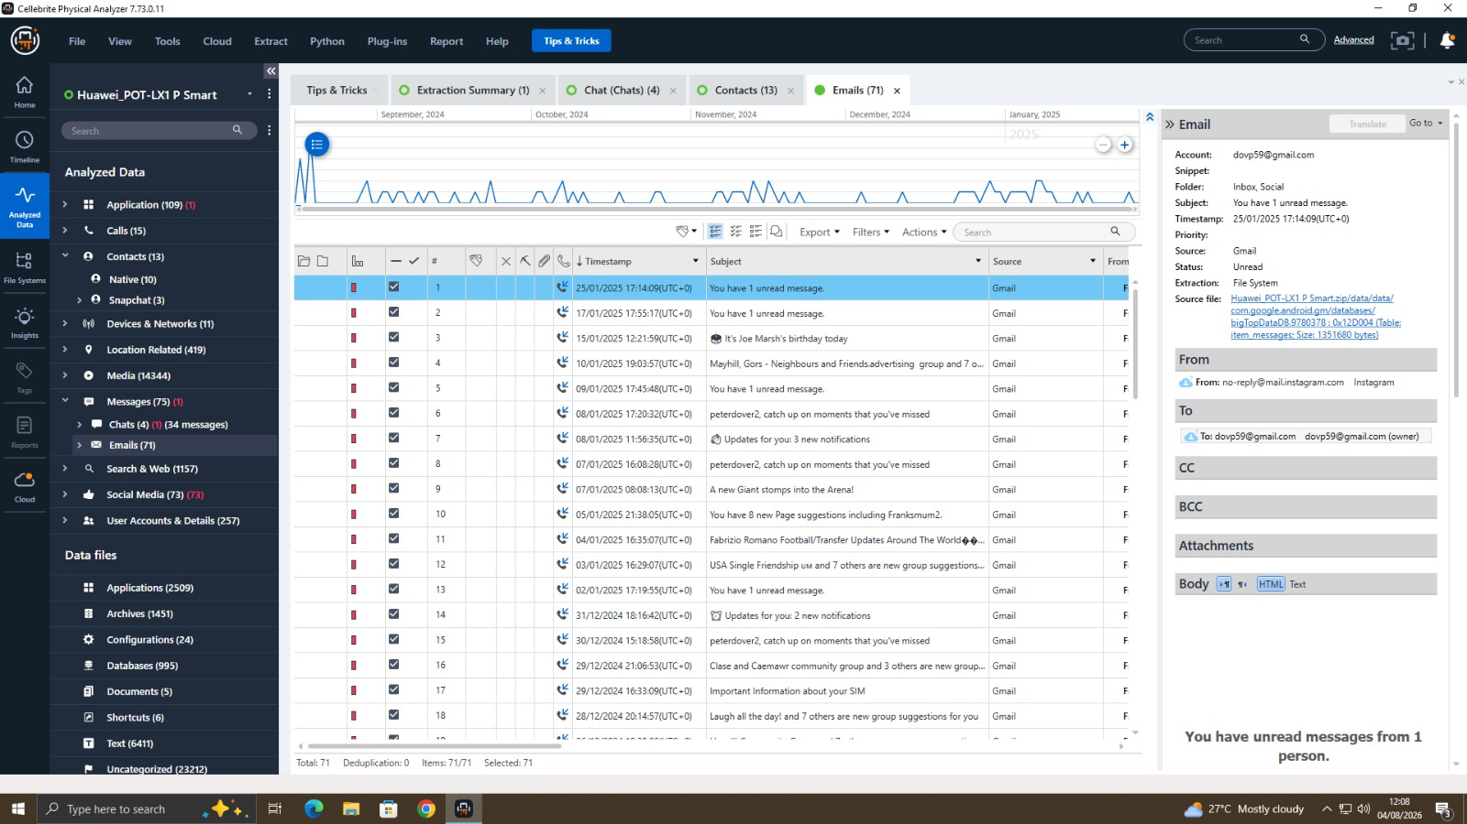
Figure 9 Recovered e-mail listing and message detail pane for the Huawei P Smart extraction.

4.4 Location and Geolocation Analysis
Location artefacts — drawn from GPS logs, Wi-Fi/cell-based positioning, and geotagged media were plotted automatically on Physical Analyzer's built-in map view, with each point carrying a timestamp, coordinate pair, source database, and (where derivable) a human-readable address. Aggregating these points across the examination period produced a travel pattern spanning multiple continents for the Huawei P Smart dataset, which is a strong indicator of either genuine international travel or, in a training-data context, synthetic location seeding intended to exercise the mapping feature. Filtering the aggregated point set by source database allowed a further distinction to be drawn between higher-precision GPS-derived fixes, typically accurate to within a few metres, and lower-precision Wi-Fi or cell-tower-derived fixes, which can be accurate to anywhere between tens and several thousand metres depending on network density. This distinction is evidentially important because a cluster of low-precision points should not be presented with the same apparent confidence as a tight cluster of GPS fixes, and a competent examiner is expected to note the source and likely accuracy of each location artefact alongside its coordinates rather than treating the map view as uniformly authoritative.
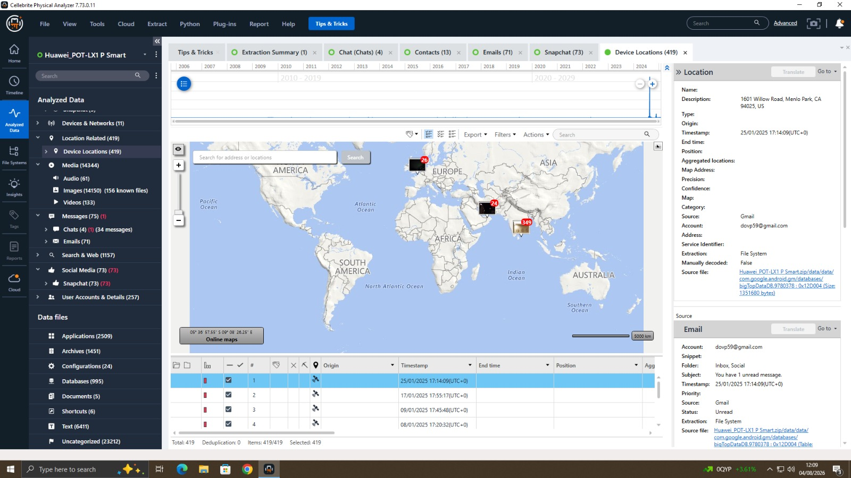
Figure 10 Aggregated location history for the Huawei P Smart, showing geotagged points plotted on the global map view.

4.5 Installed Application Analysis (AppGenie)
Physical Analyzer's AppGenie module was used to identify installed applications that are not natively decoded by the tool and to selectively decode the artefact databases of a chosen application (in this case, Snapchat) using community- and vendor-maintained decoding definitions. AppGenie explicitly flags that its suggested decoding should not be treated as a substitute for manual verification, which is an important methodological caveat: automated decoding accelerates triage but does not remove the examiner's obligation to validate significant findings against the underlying raw data.
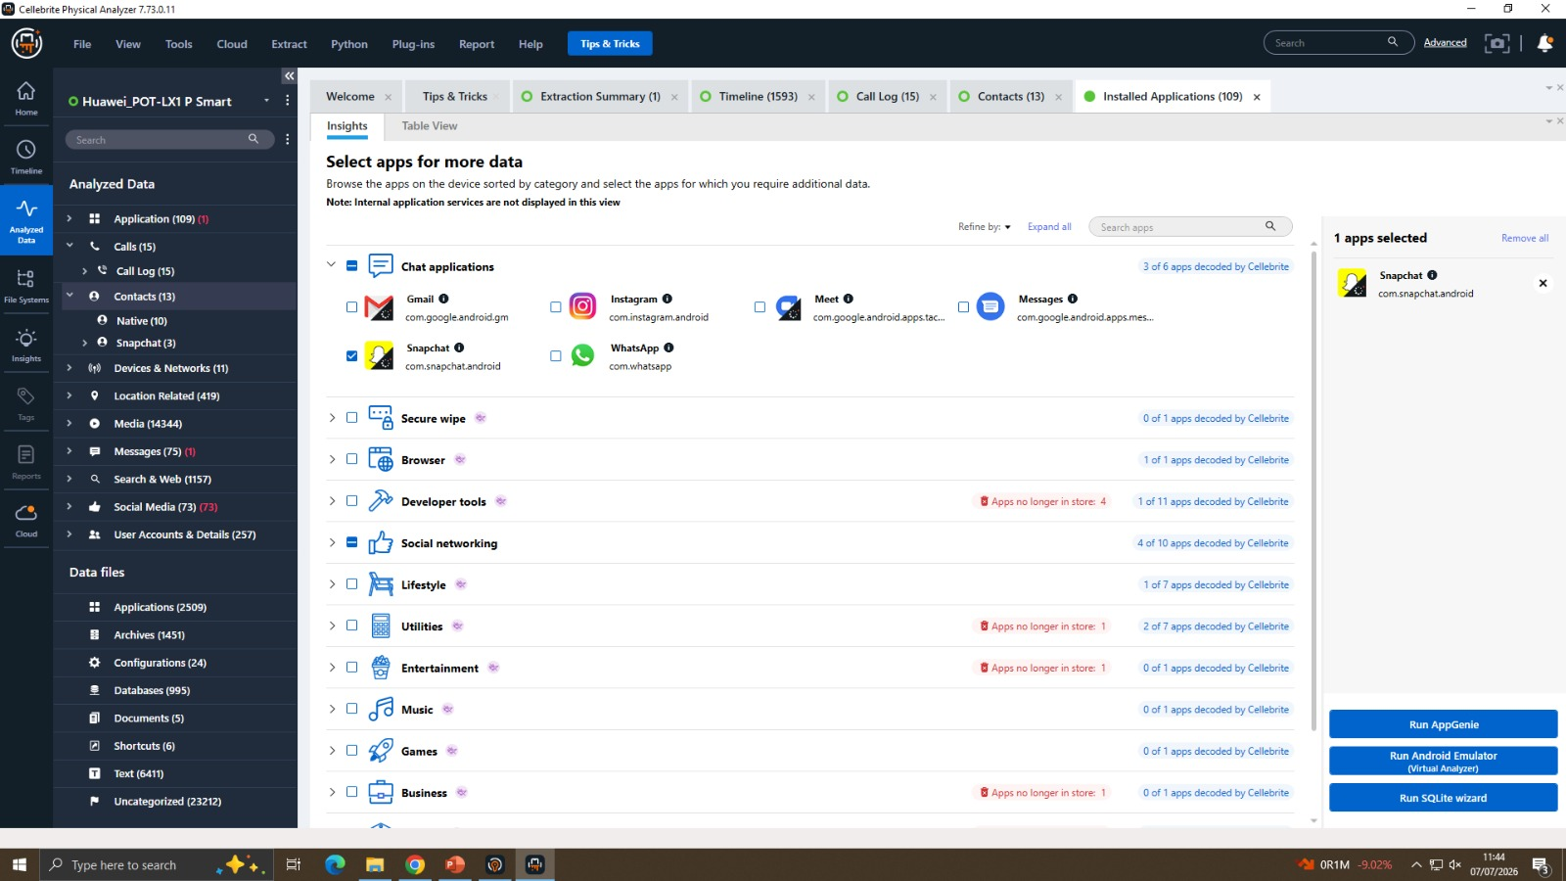
Figure 11 AppGenie application-selection view, listing installed applications grouped by category with Snapchat selected for decoding.
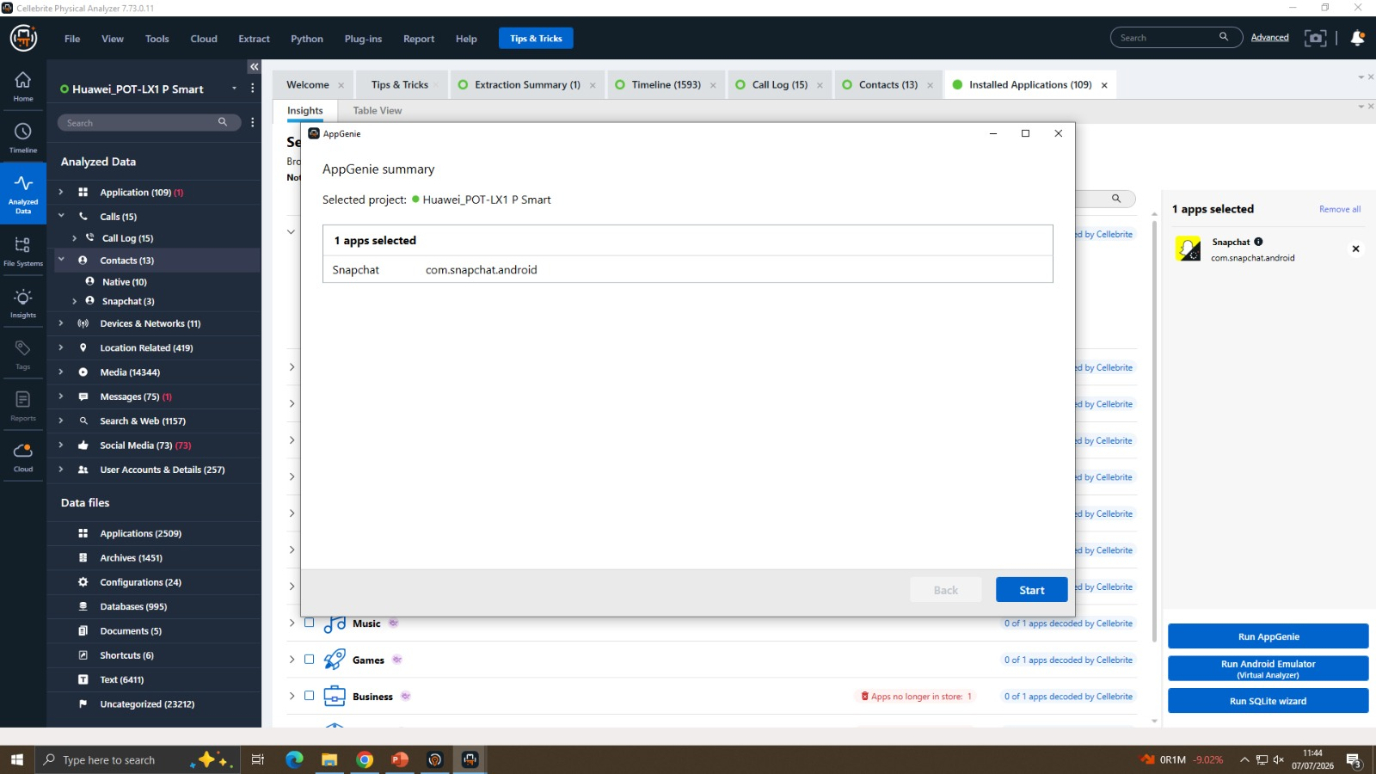
Figure 12 AppGenie decoding summary confirming the application queued for automated artefact decoding.

4.6 Hash-Based Known-File Analysis
Physical Analyzer's examination-tools stage also offers hash-set matching, which compares the MD5 hash of every image, video, and file recovered from an extraction against reference hash-set databases of known and excluded files (for example, files known to be benign operating-system assets, or files known to correspond to illicit material such as CSAM reference sets used by law-enforcement bodies). Where a match is found, the tool surfaces a category label rather than the underlying file itself, allowing an examiner to triage large media volumes without needing to manually view every image. No hash matches of evidential concern were returned for the training datasets used in this exercise; the feature is documented here for completeness of the tools evaluation only.

5. Correlation of Findings and Reconstructed Narrative
A core skill in digital forensic examination is the correlation of individually recovered artefacts which, viewed in isolation, are often ambiguous into a coherent, time-ordered account of device usage. The following narrative illustrates this process using the Huawei P Smart dataset. It is presented as an interpretive exercise for the purposes of this report and should be read as an illustration of methodology, not as an assertion of fact about a real individual or event, since the dataset in question is a pre-supplied training image rather than evidence from a genuine investigation. Correlation of this kind is typically supported in practice by a timeline exhibit, in which every timestamped artefact recovered from the extraction messages, e-mails, location fixes, application installs, and photograph capture times is plotted on a single chronological axis regardless of its originating data type. Physical Analyzer's own Timeline view performs exactly this function automatically, and was used in this exercise to sanity-check the qualitative narrative below: overlaying the Snapchat message timestamps against the geotagged photograph timestamps confirmed that the conversational activity and the recorded location changes for the Huawei P Smart dataset were not mutually contradictory, which is a necessary (though not sufficient) condition for treating the two artefact types as describing the same coherent period of device use.

5.1 Illustrative Case Narrative
The device information places the handset as a Huawei P Smart running Android 10, first associated with its owner's Google and Snapchat accounts at some point before the extraction window begins. Contact records show a small, stable circle of correspondents, with the "Friend / Chat Participant" tags on the Snapchat-sourced contacts suggesting an established, ongoing relationship rather than a first-time contact. The recovered Snapchat chat thread shows a back-and-forth exchange consistent with routine day-to-day conversation rather than a single isolated message, which combined with the contact's "Friend" status supports an interpretation of habitual, low-friction use of the device for everyday social communication. The e-mail account shows a mixture of personal correspondence and automated notifications, a pattern typical of a personal rather than a purely work-provisioned device. The aggregated location history shows clusters of points in specific regions interspersed with occasional long-distance jumps; read together with timestamped geotagged photographs recovered from the same period, this is consistent with a small number of discrete travel episodes bounded by longer periods of comparatively localised activity the kind of pattern an examiner would typically annotate on a timeline exhibit and cross-reference against any claimed alibi or itinerary in a real investigation. Taken together, the device information, contact, communications, and location artefacts corroborate one another rather than conflicting, which increases confidence that they originate from consistent, non-tampered use of a single device by a single primary user over the extraction period. This kind of artefact triangulation using independent data types to corroborate (or challenge) a hypothesis about device use is precisely the analytical step that distinguishes forensic examination from simple data extraction, and is the central technique this exercise was designed to practise.

6. Discussion

6.1 Evidential Value and Corroboration
No single artefact type recovered in this exercise would, on its own, safely support a strong evidential conclusion. Location data can be spoofed or inherited from a previous device restore; chat content can be edited within an application's local cache in rare circumstances; contact metadata does not by itself prove authorship of a message. The value of a structured examination, as practised here, lies in cross-referencing multiple independent artefact classes device identifiers, communications, location, and application data so that convergent findings mutually reinforce one another while divergent findings are flagged for further investigation rather than silently accepted.

6.2 Limitations
- The four examined datasets are pre-supplied training images of unknown provenance; conclusions drawn from them are illustrative of method only and are not generalisable to any real individual.
- A file-system extraction, while more thorough than a logical extraction, does not guarantee recovery of data protected by hardware-backed encryption (e.g. Android's file-based encryption for certain app sandboxes), so absence of an artefact cannot always be read as absence of activity.
- Automated decoding (AppGenie, selective apps decoding) accelerates analysis but is dependent on decoding definitions kept current with application updates; any finding of evidential significance should be manually corroborated against the raw database, consistent with the tool's own guidance.

6.4 Reliability of Automated Decoding Tools
AppGenie and the other automated decoding features evaluated in Section 4.5 illustrate a wider tension in contemporary digital forensics between analytical speed and epistemic certainty. Community- and vendor-maintained decoding definitions allow an examiner to process dozens of third-party applications in the time it would take to manually reverse-engineer even a single unfamiliar database schema, which is essential given the sheer number of applications an average smartphone now carries. However, this speed is purchased at the cost of an additional, largely opaque layer of interpretation between the raw bytes on the device and the human-readable output the examiner ultimately relies upon: a decoding definition that has not been updated to match a recent application version can silently mis-map fields, drop records, or misattribute timestamps to the wrong time zone. For this reason, the approach adopted in this exercise treated AppGenie output as an investigative lead requiring spot-verification against the underlying SQLite tables rather than as a final finding in its own right, consistent with Cellebrite's own guidance and with the wider forensic principle that automation should accelerate, but never replace, examiner judgement.

6.3 Legal and Ethical Considerations
A genuine forensic acquisition would require lawful authority (a warrant, consent, or equivalent legal basis appropriate to the jurisdiction), a documented and unbroken chain of custody, and adherence to a recognised methodology such as the ACPO Good Practice Guide for Digital Evidence or ISO/IEC 27037. The case-identifier and examiner-name fields populated in UFED during this exercise mirror the minimum metadata such a chain of custody would require, even though the exercise itself was conducted in an educational rather than an operational context.

7. Conclusion
This exercise provided end-to-end practical exposure to the mobile forensic workflow, from case creation and device acquisition through to structured examination, artefact correlation, and reporting. Two independent file-system acquisitions were performed and hash-verified using Cellebrite UFED, and four pre-supplied extraction images were examined in Cellebrite Physical Analyzer across device information, contacts, communications, social media, location, and installed-application artefact classes. The exercise demonstrated that meaningful investigative conclusions depend not on any single artefact but on the disciplined correlation of multiple, independently sourced data points, and reinforced the importance of maintaining verifiable data integrity and documented chain of custody throughout the forensic process. More broadly, the exercise underlined that mobile forensic tools such as UFED and Physical Analyzer are, in themselves, only as reliable as the methodology governing their use: correct extraction-type selection, rigorous hash verification, careful distinction between high- and low-confidence artefacts, and disciplined manual corroboration of automated output are what convert a large volume of recovered data into a defensible evidential account. These are transferable skills, applicable equally to the Cellebrite toolchain used here and to the wider range of acquisition and examination platforms an examiner is likely to encounter across a professional career, and they form the practical foundation on which the legal and ethical obligations discussed in Section 6.3 ultimately depend.

References
[1] Cellebrite, "Cellebrite UFED User Guide," Cellebrite DI Ltd., 2025.
[2] Cellebrite, "Cellebrite Physical Analyzer User Guide," Cellebrite DI Ltd., 2025.
[3] National Institute of Standards and Technology, "Guidelines on Mobile Device Forensics," NIST Special Publication 800-101 Rev. 1, 2014.
[4] Association of Chief Police Officers, "ACPO Good Practice Guide for Digital Evidence," version 5, 2012.
[5] International Organization for Standardization, "ISO/IEC 27037:2012 — Guidelines for identification, collection, acquisition and preservation of digital evidence," ISO, Geneva, 2012.
[6] E. Casey, Digital Evidence and Computer Crime: Forensic Science, Computers, and the Internet, 3rd ed. Waltham, MA: Academic Press, 2011.
[7] S. C. Sathe and N. M. Dongre, "Data acquisition techniques in mobile forensics," in Proc. 2018 2nd Int. Conf. Inventive Systems and Control (ICISC), 2018, pp. 280–286.
[8] A. Al-Dhaqm, S. A. Razak, R. A. Ikuesan, V. R. Kebande, and K. Siddique, "A review of mobile forensic investigation process models," IEEE Access, vol. 8, pp. 173359–173375, 2020, doi: 10.1109/ACCESS.2020.3014615.
[9] P. G. Bradford and D. A. Ray, "Using digital chains of custody on constrained devices to verify evidence," in Proc. IEEE Int. Conf. Intelligence and Security Informatics (ISI), New Brunswick, NJ, USA, 2007.
[10] S. Saleem, O. Popov, and R. Dahman, "Evaluation of security methods for ensuring the integrity of digital evidence," in Proc. IEEE Int. Conf. Innovations in Information Technology, Abu Dhabi, UAE, 2011, pp. 220–225.
[11] P. Vinayagam, "Mobile forensics: Investigation and tools," Int. J. Computer Trends and Technology (IJCTT), vol. 73, no. 6, pp. 7–15, 2025.
[12] B. Patel and P. S. Mann, "A survey on mobile digital forensic: Taxonomy, tools, and challenges," Security and Privacy, vol. 8, no. 2, e470, 2025, doi: 10.1002/spy2.470.

