Name – Julian Milligan
Student number – 1904804
Course – Bachelor of Science (Part-time): Computing (Software Engineering)
Module – L6 – Artificial Intelligence and Machine Learning
Module code - ACCA6011
Assignment – Assignment 1

Table of Contents
Abstract 2
Introduction 2
Definition of Artificial Intelligence and Machine Learning 2
Company data 3
AI / ML Tools 4
Power BI 4
Power Automate 6
Power Virtual Agents 6
AI / ML model 7
Conclusion 11
Reference 13

Abstract
The purpose of this report is to show how Artificial Intelligence (AI) or Machine Learning (ML) could be used to help improve future sales and stock levels within the company.

Introduction
The assumption of the dataset provide is that if there is no ‘Customer ID’ then these are sales made with a guest account. The dataset was provided to the company over 12 years ago so several products maybe unavailable at the time of this report. The other limit with the dataset provided is that even though a customer ID has been provided no customer information has been supplied.

Definition of Artificial Intelligence and Machine Learning

Artificial Intelligence was first termed in 1956 by John McCarthy and has stuck ever since. This was also the time the first conference on the subject was held at Dartmouth College [1](page 1), after this conference there was a lot of positive talk about AI but it never started fully and became a false start. There are 3 items that caused this ‘False Start’
- Data
There was not enough data to make it viable for an AI project to work.
- Storage
Around this time there was not enough storage to run Big Data.
- Compute
The computers around this time where not fast enough to process the algorithms needed to run AI projects.

Around the 1970 all this changed , with 3 type of people coming on to the scene Gamers , Hipsters and Angels. Because of the gamers computers got fasters because Video card companies needed to make faster and faster chips to deal with the graphics and gave raise to the Graphic Processing Unit or GPU , Hipsters loved data and collecting it and Angles are the people that took risks and started investing in small starts up. [2]
With these 3 groups people who had only theorised about AI solutions could know put their theories into practice.
As quoted by Choudary [3]
“Artificial intelligence (AI) is the intelligence of computers in a way that simulates human intellect by learning continually as more data is ingested.”
Put simply as the algorithm learns it gets better. An example is a simple program to recognize a cup. The process to know if an object is a cup uses Computer vision.
- An image is captured by the program.
- Using an algorithm, the image is broken down into sections and an outline created.
- The program then looks against a model it has access to see if it matches a cup.
A model is a collection of images that represent a cup , if there is only 10 images in it then the AI does not have must context to match a cup , so models can sometimes contain millions of images , the more advanced the model the higher the accuracy of the result will be. AI is good as long as the data behind is.
Some people believe that AI will the end off a number of jobs around the world however people will still be needed to train , build, and teach AI and the people best suited are the ones already doing those jobs but there are cases where these jobs do not exist or can not be done by human workers.
Machine learning takes this approach one set further. The idea behind ML is that it will perform tasks with out instructions.
If the approach of a driverless car is used , this is in a basic format. The car is asked to drive home from work. A route it has done many times because of this it has remembered the route and calculated routes based on time of day , traffic levels and any works being carried out. All the users needs tell the car is the destination. The AI and ML then calculate the route and using various inputs such time , data collected from on-line sources about traffic / road works it calculates the best / safest route. No need for the user to input anything and the car will remember the route and add it to the model of this route.

Company data

Looking at the data provide by Treonix they provide a wide range of products to a large number of customers via their on-line platform. As the brief does not mention stores this report will assume that they are an on-line company only and the rest of this report will focus on that aspect.
Next the data provided will be broken down and basic ideas on what can be gathered from it will be discussed.
Stock code / Description
Using Stock codes it is easy to see which are the most popular items for sale , however there are a number of stock code with no descriptions such as 10138 or have multiple descriptions such as 16219 on sheet ‘Year 2009 – 2010’ . Accurate data will improve the function of any AI used with the business.
AI could be used with this to control stock. Prediction Algorithms could also be used to look at when a product is popular during a certain time period and order extra stock in , again as the data improves and years are added the accuracy of these predictions will be more accurate.

With the assumption there is another record that holds more information on a product such as
StockCode | Description | Type | StockLevel | SupplierCode
10138 | ASSORTED COLOUR JUMBO PEN | stationary | 1123 | ACD123

Then AI could also be used to look at what type of products are popular around certain times of the year and the data can then be used to build models so other teams can report and increase the range of products types. These two processes can be run manually using database queries but with AI it will learn and in time improve the accuracy of it`s results helping the company improve sales and better use of warehouses by only holding stock it needs to hold.

Using the invoiceDate column AI can be used to look for patterns when people order from their site , this could then be used by the sales team to help them launch new products. As an example if they have a new range of pens and the AI has calculated that most pens are purchased late at evening then launching the new range around the same may increase sales in the new item.

AI / ML Tools

There are a number of software platforms that can be used to allow AI and ML to be used within a business environment. Some of the big companies provide these services such as Microsoft and their Power Platform that includes :-

Power BI
A software package that takes data and provides a visual representation of it , it can be used to produce graphs of data, as part of the visualizations it provides a map showing the location of sales can be viewed , a sales graph which can be drilled down to show ¼ , months and day sales. The software also has a build in AI feature called Q and A , the user can ask a question about the data such as ‘What is the difference between the sales in this year and last ?’ the AI will then look at the data and work out the best solution to show the result of the question.
Just simply adding the combined data of both worksheets into Power BI and dragging the Country column on to the canvas a map is created showing the location of all sales
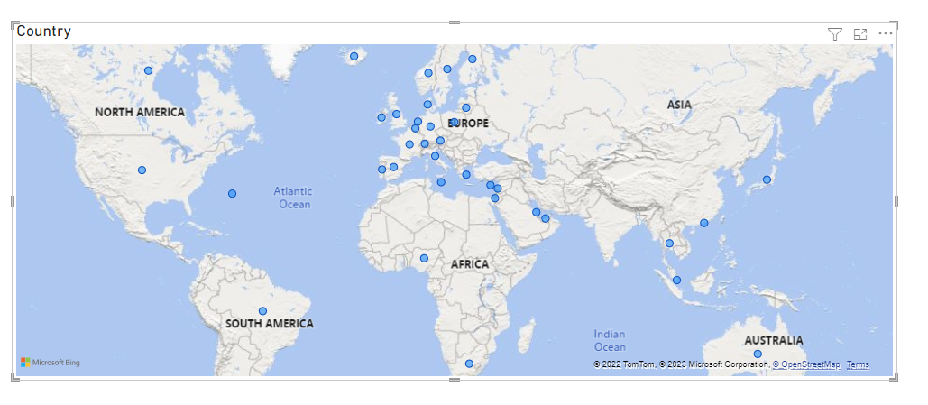
Figure 1 Power BI Sales around the World
Adding two more columns to a table on the canvas Invoice and Description , one can click on the sales in Kanas and the table will change to show just the items purchased there.
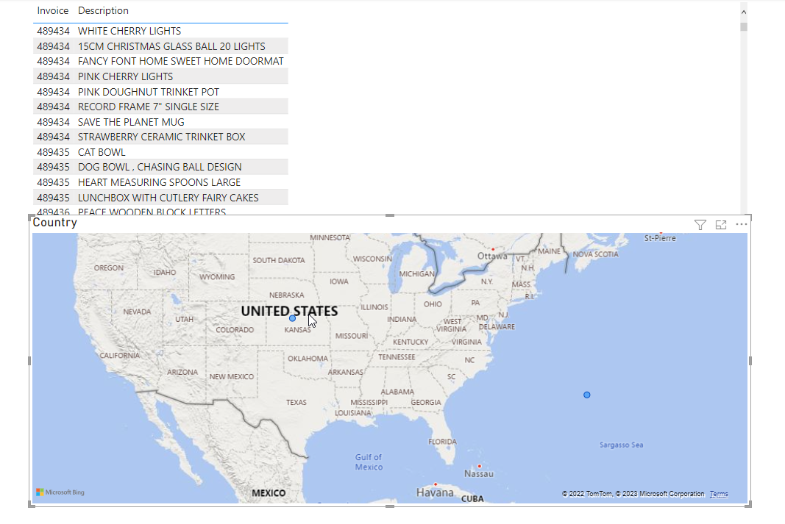
Figure 2 Power Bi Sales in the US
Clicking on Bermuda and the table changes to show the products purchased there.
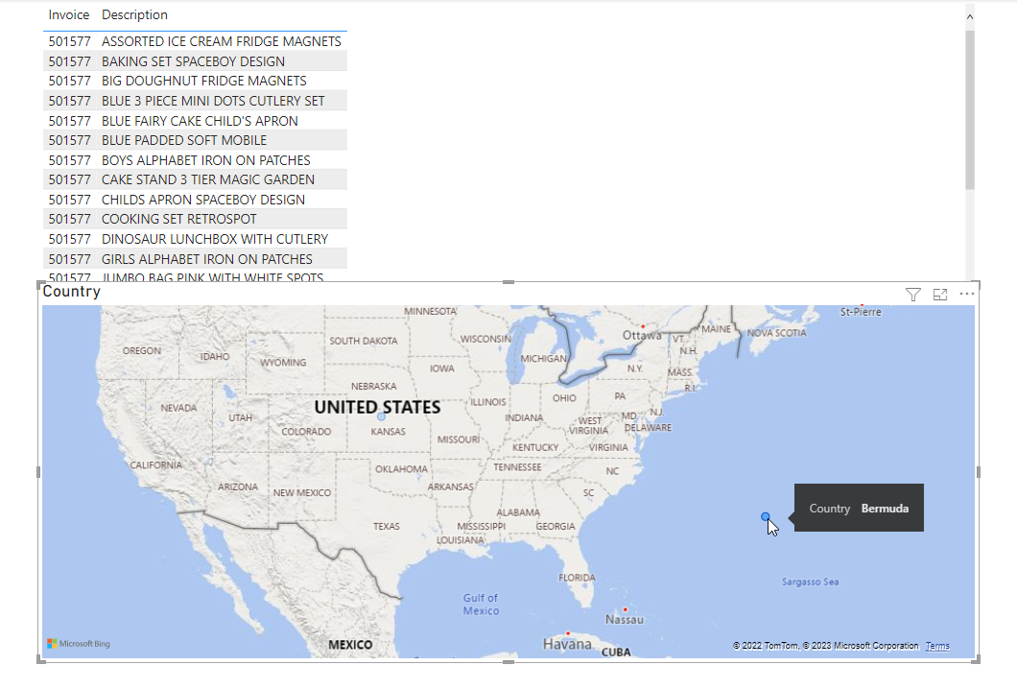
Figure 3 Power BI Sales in Bermuda

Power Automate
This product allows a user to create an automatic flow of processes based on a trigger. If Treonix is taken as example one possible flow could be for stock control.
- Stock level low is trigged on product 4589.
- A team’s requests send to the purchase team for approval.
- An email is sent to the supplier once the request has been approved.
- A calendar entry is entered into the warehouse teams calendar to advice of the delivery.
- An email is sent to the finance teams when it the order is received back from the company.
As you can see the only human interaction is the approval of the request. Various thresholds could be set for each product.

Power Virtual Agents
This part of the suite allows a user to create a virtual worker to complete repetitive tasks such as invoicing or updating the website with new products. This combined with the other parts can create a powerful AI platform for a business . People do argue that AI will cost jobs [4] however the people who`s jobs are replaced by AI will be the best choice to train the new systems and maintain them.

Another company providing a service that uses AI is Google and it is called Google Cloud and one of the AI fields it focuses on is Natural Language which uses Machine Learning to analyses text. Cloud Natural Language | Google Cloud , using the demo provide on the site the text
“Google, headquartered in Mountain View (1600 Amphitheatre Pkwy, Mountain View, CA 940430), unveiled the new Android phone for $799 at the Consumer Electronic Show. Sundar Pichai said in his keynote that users love their new Android phones.”

Is sent to the API and 4 result options are returned Entities , Sentiment , Syntax and Categories. It offers two options to process the data AutoML where you can train your own model to process the data and Natural Language API which uses predefined models.

AI / ML model

For this report a software package called Knime KNIME | Open for Innovation was used. Which is an open source platform however it does offer a paid for version that uses a server version for large enterprise companies.
The first part that was needed was to combine the two worksheets in to one
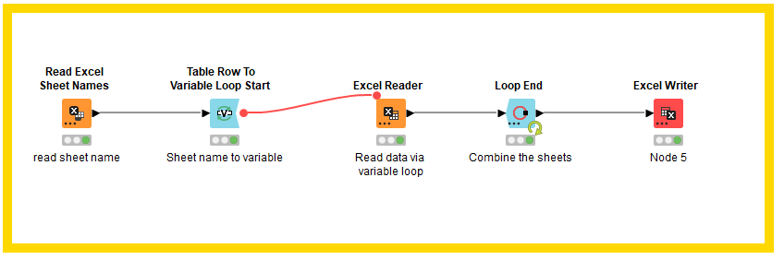
Figure 4 Kmine Loop to combine worksheets
Using Knime , the approach was taken to use a loop , it reads the worksheets and then adds the data to a new sheet and loops through until all the worksheets have been added. At the end a new Spreadsheet is written keeping the originals intact. The new sheet now has 1,048,575 rows in it. Going through all these rows to look for data where fields are missing would take a human a very long time and there would be the chance incorrect rows are updated. Using a Node called ‘Missing Value Column Filter the Algorithm can complete the task in seconds.
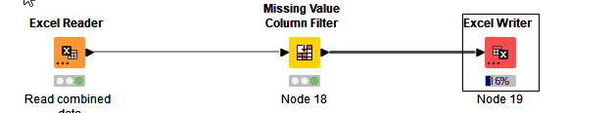
Figure 5 Kmine remove missing data

The new sheet has a number of records removed and is now clean so it can be used in the next stages.
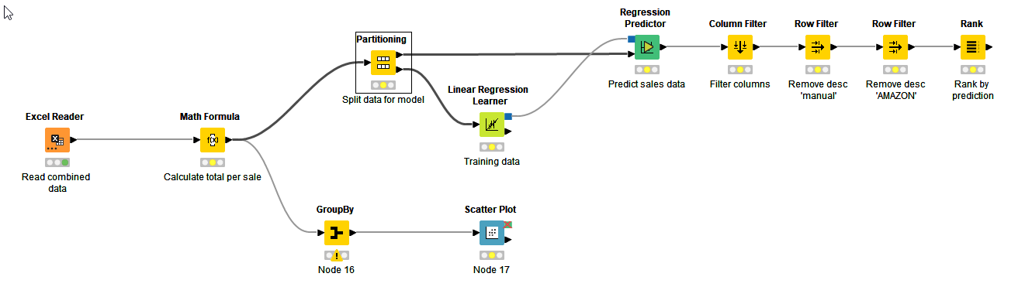
Figure 6 Kmine Main workflow
The next stage is produce some viable data from the newly created spread sheet. First off the total sales by product is run.
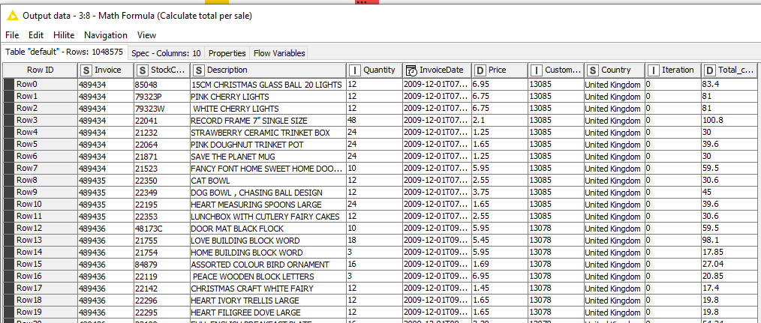
Figure 7 Kmine Showing total sales
The figure above only shows a small selection of the final results however a new column is added to the right hand side that shows the total for each sales.
This data is then used and fed into Prediction Model , as the above image shows the data is split 70% and 30% , the 30% is used for the training model and that is used against the data that remains.
The training model looks at the data and creates a Model that is used to predict an outcome. Some more cleaning is ran to remove certain items that are not needed. The data is then ranked based on price and number of sales , this data can then be used to help with future sales.
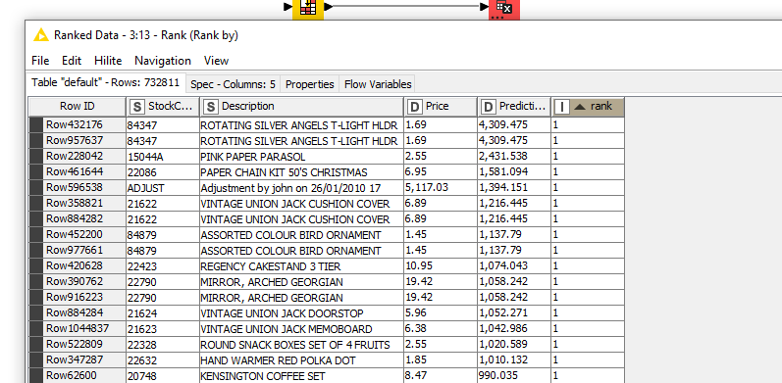
Figure 8 Knime Show prediction number 1

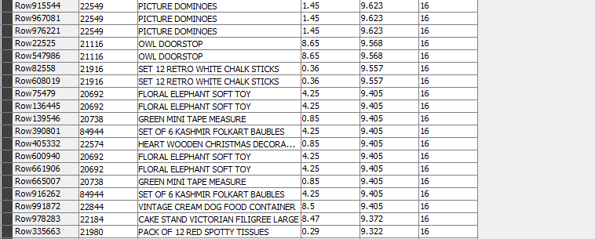
Figure 9 Kmine showing prediction number 16

The final part of the workflow is to run a scatter plot graph to show the stock code per country.
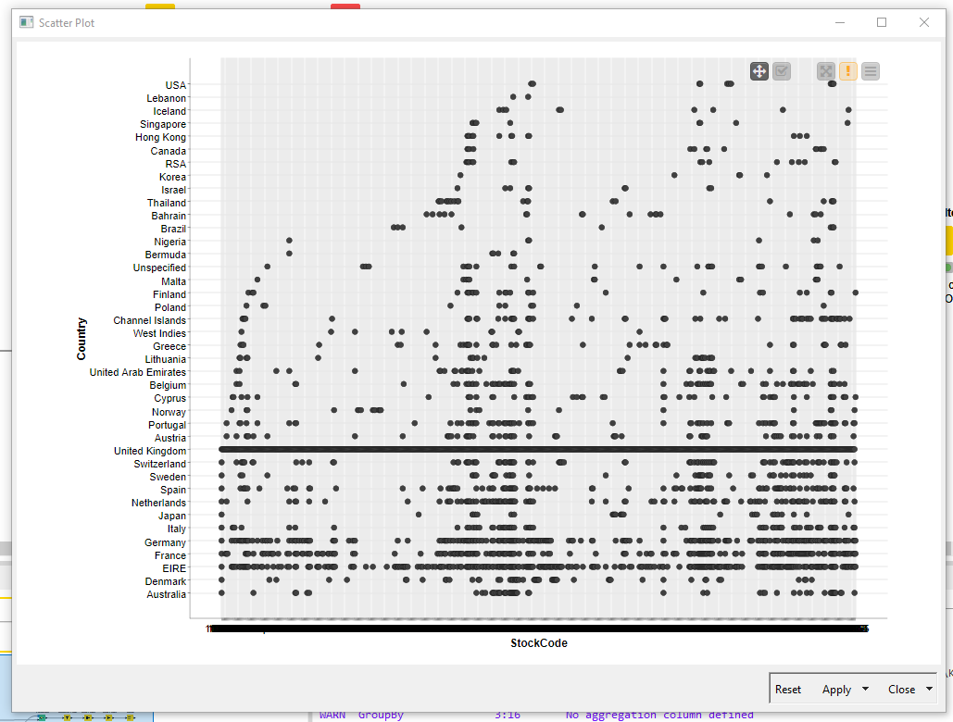
Figure 10 Knime Stock code Scatter Plot

As can be seen at a quick glance the UK has sold at least one of each stock item with Eire following second. At the top of the graph the USA has the least sales.
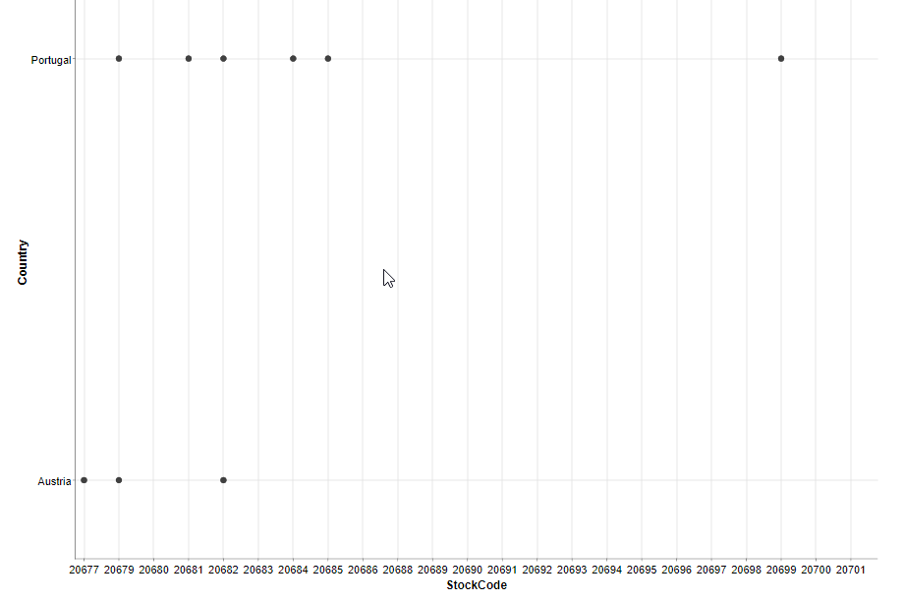
Figure 11 Kmine Zoom of graph

The graph can be zoomed in to show individual show codes so it can be seen how that particular item is doing in various countries.

Conclusion

I believe AI and ML will have more of an active impact in all our lives moving forward. Most people wear a smart watch , which records the number of step a person has taken. The Garmin software knows if you have been sitting for too long and prompts you to move , as someone that suffers from back issues this is a great benefit as it helps keep my back in good condition , More advance options . As quoted in the paper [5]
“AI based sensors can be used to track a patient’s biometric 24/7 even when resting or sleeping” AI can used to help prevent illness and possible a long hospital stay. A persons heartbeat may slow and their body temperature may raise a little , the AI could deduce that an infection maybe brewing in person. Next day a nurse is requested by the AI to visit the person and antibiotics are given after counselling a Dr via a video call. The person is the type not to bother anyone and loves her independence so may have waited too long and may have needed a hospital visit. However because of the sensors and the AI model this was prevented.
Researcher Bart Paulhamus said in a TED talk (Our Future with Intelligent Systems (It’s Better than You Think) that the media paints a very bleak outcome when it comes to AI and ML with ‘Killer Drones’ , ‘Robots could take 38% of USA jobs’ and ‘AI could destroy the world’. Paulhamus shows that AI and ML can be used to benefit humanity and I feel the same. If programmers and developers found a problem that could be used to increase performance or help save lives then they should follow that course.
I for one will and within my role as a Senior Applications Developer within Carmarthenshire County Council we have identified a process where AI and ML can be used , the result will not be in job losses but more time for a team to complete other tasks for councillors , they may also gain new skills in helping build future models for other processes.

Reference
[1] Stuart Russell and Peter Norvig, Artificial Intelligence A Modern Approach , 2nd Edition. 2003.
[2] Andy Chan, “‘Artificial Intelligence and the Future of Work’ | Andy Chan | TEDxStLawrenceU,” 2020. Accessed: Jan. 14, 2023. [Online]. Available: https://www.youtube.com/watch?v=bScAMuegX7Y
[3] R. Choudhary, A. Kaushik, and K. T. Igulu, “Artificial Intelligence in Healthcare,” 2022, pp. 1–20. doi: 10.4018/978-1-6684-4950-9.ch001.
[4] Evan Bourke and Sarah Hedley Hymers, “Will artificial intelligence lead to widespread job losses?” https://www.euronews.com/next/2022/06/15/will-artificial-intelligence-lead-to-widepsread-job-losses (accessed Jan. 23, 2023).
[5] Admin, “Home Healthcare: Bringing AI solutions to home for health care,” 2021. Accessed: Jan. 23, 2023. [Online]. Available: https://www.day1tech.com/bringing-ai-solutions-to-home-for-health-care/

Figure 1 Power BI Sales around the World 5
Figure 2 Power Bi Sales in the US 5
Figure 3 Power BI Sales in Bermuda 6
Figure 4 Kmine Loop to combine worksheets 7
Figure 5 Kmine remove missing data 7
Figure 6 Kmine Main workflow 8
Figure 7 Kmine Showing total sales 8
Figure 8 Knime Show prediction number 1 9
Figure 9 Kmine showing prediction number 16 9
Figure 10 Knime Stock code Scatter Plot 10
Figure 11 Kmine Zoom of graph 11

