Academic and Employability Skills

Contents
1.0. Introduction 3
2.0. Reviews of Online Articles 3
3.0. Auditing of my employability skills 6
3.1. Communication 6
3.2. Leadership 7
3.3. Critical Thinking 8
3.4. Technology 8
4.0. Conclusion 9
Reference 10

1.0. Introduction
A person requires knowledge and skills for getting employed within an organisation. Employability refers having required knowledge and set of skills as well as personal attributes for becoming an appropriate candidate for fulfilling job responsibilities. A person’s acquisitions of such skills, knowledge and understanding are highly required for becoming an employable person. Employability provides a great range of confidence to choose a desired career. The purpose of this report is to review some online literature to evaluate about employability and complete an audit on self-employability. The report will conclude stating a summary of the entire report including some objectives for further development in the career.

2.0. Reviews of Online Articles
Forbes is one of the most prominent business magazines of the world. Bernard Marr, a famous expert in business and employability wrote an article on employability. Globalization has shortened the distance of employment. Throughout his article, he has emphasized mainly technology-related factors as employability skills (Marr, 2019). The first employability he discussed is data literacy. Lead generation is the most important way to make sales for products and services. To generate lead, information about the customer is first requirement. Therefore, Bernard suggested being literate in data management as an employable person. The corporate world is changing and everyday there is something new. Organisations are facing tremendous challenges in coping with such challenges. Adaptation with changes both in the business environment and global arena is necessary. Bernard has sorted out flexibility as a part of the employability scenario. Understanding emotional intelligence is the next recommendation for acquiring employability. People are now more self-centred than before. Having emotional intelligence gives the opportunity to increase demand in the job market. Leadership skill has always been the first choice for being employable in a company or business organisation (Marr, 2019). The candidate for a job must have skill to lead and manage people working under his supervision. The article is good enough to gather knowledge in employability. But, the author has skipped phases and recommendations for acquiring these knowledge. Outlining the process of acquisition could have increased the value of this article. However, it helped in gaining an appropriate knowledge on which employability skills are much needed for career development purpose.
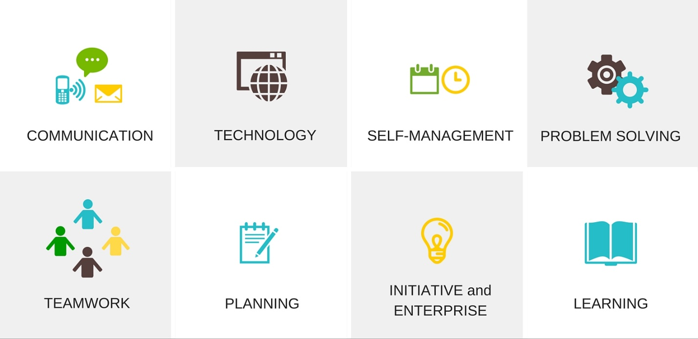
Fig: Employability Skills (Marr, 2019)
Washington Post is another popular newspaper in the USA as well as globally. An article written by Debra Legg specified some trends about employability. Her principal concern is how businesses are looking for employees. She has identified the concern of Gig Economy (Legg, 2019). Employability means being able to work in any condition to a firm. Gig economy is a contract-based way to get involved in the workforce. Thereby, the person must have sufficient knowledge and skill on completing the work according to requirements. Understanding customer requirements is the first employability factor for candidates. Workers are now holding more power in the organization. Therefore, the employee must have management skills to become employable in a firm. Being flexible is another trend in the career segment (Legg, 2019). Thereby, Debra Legg prescribed to become more flexible in workplaces. This will increase outcomes for the person. The positive part regarding the article is contemporary information about trends in employability. There remains some gaps inside this writing though. Authoress could detect specified fields to improve the process. Again, the majority of this discussion is based on USA-oriented job sector. A more global discussion would help in gaining knowledge about the employability issue.
Telegraph is a popular online and offline newspaper that publishes their news in both local and online platforms. The newspaper featured an article by Helena Pozniak. She mainly focused on how a student should begin his journey to gather employability skills from an initial stage. She deemed the importance of networking and communication for this purpose (Pozniak, 2013). A student should gather maximum knowledge on networking for generating a greater understanding in job sector. Job market is competitive. Without having a network and strong connection, it gets difficult to get a proper employment. During the job, a business organization looks for the best result form an employee. The background of establishing best result is to know how to develop the culture of working with the others. Meanwhile, networking is useful not only for generating leads but also to maintain a subtle progression. Helena has focused on communication skill both in active and empathetic listening. In businesses of 21st century, developing listening skill is a prior requirement to become a successful business person. An employee has to collect information from customers. Also, he has to spread the product awareness through speaking to the customers. The whole process is completed using a particular way to develop business outcomes. As the role of employees is to collect information, processing it and providing the final result, both listening and speaking are required in this case (Pozniak, 2013). The article stated only the communication and networking aspects about employability for students. There are scopes to improve in this particular matter. For example, Helena could have mentioned about part-time jobs for students. If a student works part-timely, it will get better with time. He will gain knowledge and skills about this aspect. A future development can be completed through such procedure.
Lucy Jolin is an author of the Guardian newspaper. Her article on employability opened several considerable factor for students. This is a prescribed writing for students enrolled in university. Her writing is mainly concerned with creativity as an employability skill. Rather than acquiring certificates on business or organizational management, she has focused mainly on getting a certificate on creative degree or creative-level certification (Jolin, 2015). Lucy Jolin provided references on how companies are looking for employees having a sustainable way to develop creativity can help to gain a better job. Creativity includes not only creating products or designing services but also innovating the commercial system. Business efficiency is a desired business objective. The more efficient a firm gets, the better profit it earns. Thereby, companies give importance on those candidates having creative ideas and critical thinking skills. Lucy Jolin’s article has both positive and negative sides. Her prescription on creative degree acquisition is good to become an entrepreneur. But, it is time consuming. The person will need to be devoted for acquiring a creative degree rather than spending the time in getting skilled in other aspects too. This is the gap where Lucy could have increased her way to express the matter in a proper way. Employability is a set of skills and knowledge. Creativity is a part of it. The article gives an overview only on this particular topic. The area of this topic could be broadened by the author. She could have included critical thinking as a part of the employability skills to acquire during the student life. Specializing on one aspect has deteriorate the effectiveness in this writing.
This section was a review on employability from different online articles published in reputed sites and magazines. Most of them contain important and vital information regarding employability. In order to access for a better career opportunity, these would be much helpful. However, there are gaps in some of these literatures. Being online articles, their credibility has been enormously useful. Authors have used several ways to determine their opinions on this topic.

3.0. Auditing of my employability skills
Employability skill provides different types of ideas to sustain in the organisational structure. During completing the course, there required completing a variety of tasks. This segment of the report will contain a detailed audit on my own employability skill.

3.1. Communication
The first and most important employability is having an effective communication trait. Communication has mainly four dimensions; reading, writing, speaking and listening. However, there are verbal and non-verbal communication. Verbal communication includes connecting with people through speaking or writing or sign languages (Shannon and Weaver, 2014). Non-verbal communication is the attitude expressed to the person who will receive information regarding the concept.
To audit my communication skill, I have an excellent strong part in speaking. I have the ability to speak both publicly and convincingly. My writing area is weaker than speaking. I face problem in expressing the right emotion or right tone through writing. I did not have any idea regarding the non-verbal communication before undertaking the research on employability. Online articles helped me understanding that non-verbal communication plays immensely important role for establishing a good career. In business organisations, the majority of dealing requires representing the product in front of customers.
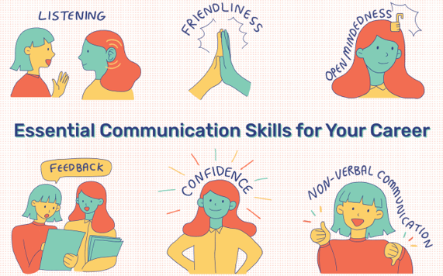
Fig: Effective communication (Shannon and Weaver, 2014)
From this point of view, I will require taking courses and sessions to improve my writing and non-verbal communication process. The more I can devote myself in these two sectors, I can become a strong communicator. The employability skill will help me in getting an effective career.

3.2. Leadership
Leadership skill is another employability. Being a leader is the prerequisite for career development. A leader needs to be specifically confident and visionary. The mission and vision of the leader must focus on developing the team appropriately. Leadership skill development is essential in case of making changes in organisations.
I had to participate in several group works during the course. In most of them, I was the leader. Thereby, I got the opportunity to test my leadership skill. In the beginning, I used transformational leadership approach (Lussier and Achua, 2012). This did not help much as most of the coursework were based on contemporary issues and I had to work with my fellow classmates. Then, I started applying situational leadership model to manage the team and achieve the team objective. Particularly in this field, I gained more success and better way to use the privilege. I noticed both the positive and negative sides regarding my leadership skill. This employability skill is dependable on practice (Lussier and Achua, 2012). The more I can participate in groups, the more I will learn about organisational behaviour and similar factors. Again, there has to be some effective leadership guidance. I will need concentrating more on working with the others to improve this part of my skill to become more employable.

3.3. Critical Thinking
The current report contained the task of reviewing online literatures. The review is an implication of critical thinking. When it is about thinking critically, describing both the positive and negative sides regarding a topic for further decision-making is necessary. My way to develop critical decision-making process contains three stages. The first one is to analyse the issue. The second one is to evaluate the article or literature. The third one is to identify possible scopes for improvements. In this section, my skill is sufficient to be successful in the career. The employability skill is helpful for managing a wide variety of consequences (Moore and Parker, 2017).
I will need to understand the analytical framework more importantly to increase my effectiveness in the critical thinking aspect. Positive and negative analyses would help me in getting a better result as employable.

3.4. Technology
While living in the 21st century, it is an undeniable fact to avoid the importance of technology. My knowledge relating to technology has been sufficient to organise different activities. Technology helps me in making the appropriate outcomes. While writing reports, essays and developing presentations, I have used my knowledge on technology. Though browsing internet was easy for me, I need more knowledge on using data for business purpose. The role of technology and data management in the current corporate sector is highly reputable. My strong side in this employability factor is a chance to learn. I am eager to learn anything new that is helpful for the future. Nevertheless, I will need concentrating more on gaining advanced knowledge.
Thereby, I have to get admitted into courses where advanced knowledge on technology is provided. This will help me in getting a useful outcome in technological sector.

4.0. Conclusion
In concluding the entire discussion, we can state that employability is a mandatory part for a person’s career. Therefore, a person should begin to acquire the knowledge from the very beginning. A successful academic career will help in getting a successful professional career. By following career objectives, it will be possible to determine the success in life.

Reference
Jolin, L. (2015). A creative degree could make you more employable than you think. The Guardian. [online] 3 Mar. Available at: https://www.theguardian.com/education/2015/mar/03/a-creative-degree-could-make-you-more-employable-than-you-think [Accessed 19 Jul. 2020].
Legg, D. (2019). 9 Things We Learned about 2019 Employment Trends. [online] Washington Post Jobs. Available at: https://jobs.washingtonpost.com/article/9-things-we-learned-about-2019-employment-trends/ [Accessed 19 Jul. 2020].
Lussier, R.N. and Achua, C.F. (2012). Leadership : theory, application, skill development. Mason, Ohio: South-Western ; Andover.
Marr, B. (2019). The 10+ Most Important Job Skills Every Company Will Be Looking For In 2020. [online] Forbes. Available at: https://www.forbes.com/sites/bernardmarr/2019/10/28/the-10-most-important-job-skills-every-company-will-be-looking-for-in-2020/#2a90b60a67b6 [Accessed 19 Jul. 2020].
Moore, B.N. and Parker, R. (2017). Critical thinking. New York: Mcgraw-Hill Education.
Pozniak, H. (2013). Graduate jobs: boost your employability while you study. www.telegraph.co.uk. [online] 12 Aug. Available at: https://www.telegraph.co.uk/education/universityeducation/student-life/10225756/Graduate-jobs-boost-your-employability-while-you-study.html [Accessed 19 Jul. 2020].
Shannon, C.E. and Weaver, W. (2014). The mathematical theory of communication. 3rd ed. Urbana: University Of Illinois Press.
‌

