Portfolio of Writing

Name: Moghis Shaikh
Student Number: 2005117
Course: Illustration
Course Number: ADAD4018
Course Tutor: Jonathan Pugh

Task in the order I received them:
Task 1: Observational Writing - 499
Task 2: Manifesto Writing - 495
Task 3: Practise-base writing - 501

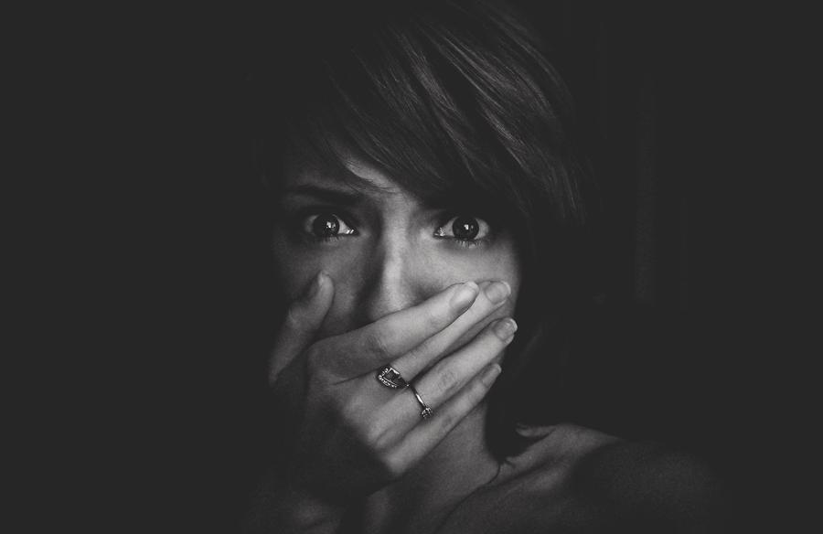
Task 1: Observational Writing

(Fig 1, CoceAddict, Emotions – Fear, 27 January 2014)

Fear is one of the emotion that significantly affects us as an individual, it can undeniably lead to unmeasurable number of struggles such as, health issues, broken trust, trust issues, family trust issues, self-harm, and death,.
There have been many cases where fear prevents certain individuals from preaching. Sometimes it’s abuse, other instances it’s the limited power the victim has, but it also there can be consequences that will occur if the individuals preaches. As Brazier claims, Sometimes, people are afraid to speak up because of the existing balance of power (Brazier, 2018). Unfortunately, the majority of the time, this power prohibits girls and woman from speaking out about the struggles they face. Struggles which be, sexual abuse, sexual harassment, and bullying. I believe majority of the cases where woman and young girls do not preach is because of sexual abuse and it invades their trust as Manlowe claims, Sexual invasion by a trusted relation goes beyond a physical injury (Manlowe, 1995, p. 15). An invasion like that could completely destroy a girls trust and traumatise her for life. If you ask them how they feel, they will say, We are much more than victims. Survivors, yes, but always damaged, always scarred, most often with wounds forever raw (Manlowe, 1995, p. 4). Sadly, sometimes young teen that go through sexual abuse from their own family member don’t live and at some point they die from their own family member.
These girls and woman are howling for support by giving out signs so they can stop this nightmare they are living in. As Phillip claims, Whenever we use a sign to communicate, we are trying to bring something to someone else's mind (Phillip, 2008, p. 6). Now, if we relate what Phillip claims to the image, firstly. you can also see the eyes are wide open which could indicate betrayal of shock and disbelieve. I believe that sometimes a person’s expression can indicate more than what the person is trying to say. It is a way to signal someone for help or to express fear. Next, we can see the hand is covering the woman’s mouth. This could mean that the woman wants to preach out and ask for support, but the hand is protecting her from doing so. Which could also suggest that the woman does not want to get into more danger than she already is.
The image could also represent that she remembered a past memory of child abuse. The hand covering her mouth could also indicate that she doesn’t want to talk about the horror and abuse she went through. The reason why I thought of it in that direction is because the eyes are wide, and the shock expresses that fear and past core memory that traumatised her for a very long time. What I also see is that in the eyes you can see some tears building up, which expresses the level of fear she could have inside of her that is building up.

Bibliography
Manlowe L, J. (1995), Faith Born of Seduction, A Horror beyond Tears: Reflection on a History of Abuse, New York: NYU Press.
Manlowe L, J. (1995), Faith Born of Seduction: Sexual Trauma, Body image, and Religion, Who Are We? York: NYU Press 1995.
Phillip C, (2008), Outward Signs: The Powerlessness of External Things in Augustine’s Thought, Why We Learn Nothing From Words, New York: Oakford University Press.
Brazier Y, (2018), Recognising child abuse, Available at: https://www.medicalnewstoday.com/articles/241532/ (Accessed: 11th November 2020).

List of figures:
CoceAddict, (2014), Emotions – Fear, [Photograph], Available at: https://www.deviantart.com/coceaddict/art/emotions-fear-429898340 (Accessed: 08th December 2020).
My 8 statements
- Art should matter
- Illustration expressed better than words
- Illustration can be more powerful than a speech
- Illustration is a way to express situations and issues
- Emotion should be expressed with art not words
- Colour can make a difference
- if art weren’t a thing, the world would not be what it is now
- Art can be dangerous
3 main statements I want to focus on:
- Art should matter
- Life should be expressed with art, not words.
- Art can be expressed with powerful words

Task 2: Manifesto
Expression can be in many forms, in my view, Art holds a significance importance in not only describing aspects of life powerfully but also benefits us all to understand art in many unique ways, such as, expressing emotions, powerful lessons, stories, political views and power, and it can also express cultures. As Benincasa states, public art is fed by the evolutionary of a multicultural communities (Benincasa et al, 2019, p. 10/11). Which I do approve, in numerous cultures, art evolved us to where we understand life and also it has evolved us to perceiving a variety of ethnicities. It has brought various cultures and societies together to understand each other and it also give us ability to see variety of cultures to present they religions, what it means and what it stands for. For example, In India they celebrate Diwali using a variety of Holi Galal (colourful powders), which shows the culture, the colour, and the beautiful art behind Diwali. Another sample for this is fashion, the bright colourful dresses in china.
In addition, I believe emotions should be expressed through art not words. But that’s not the occasion for everyone. As Matravers claims, Some people are acutely sensitive to the expression of emotion in art and others utterly ‘blind’ to it (Matravers, 2001, p. 5). There are a handful of individuals that see artwork for what they are for and the meaning behind the artwork, the expression, and the message but whereas on the other hand some individuals don’t. It’s how you perceive and understand the artwork. Personally, I consider an artwork that is lacking emotions isn’t an artwork but more of a motionless outcome. What I also believe is that art should attract and affect the target audience with different views, emotions, and outcomes. So, if an artwork were produced with positive engaging colours the target audience would have a variety of emotions. Along with that I believe that an artwork like that would have an impact on the target audience, viewpoints, how they perceive the artwork, and what they see and think about the artwork.
However, art can be dangerous. As Berys says, many artworks have been publicly represented as evil or corrupting (Gaut, 2007, p.1). I believe artwork can be dangerous some artworks presents a positive message but sometimes that message gets misunderstood which then becomes misleading and misused. The army could no more afford to carry cowards than it could traitors, and many of those who did flee faced instant retribution with a court martial and death by firing squad (Peter, 2011). This proves that as Peter Claims, those boys who were recruited into the army and fled from the German guns they were blasted by the British guns. It was ones said a soldier fled the battlefield. When he was caught, he was shot by his own army. These were the traitors and the cowards who fled the time of need and the time where their country needed them.

Bibliography
Benincasa C, Neri G, Trimarchi M, (2019), Art and Economics in the City, Introduction: Urban challenges, Cultural strategies, Germany: Bielefeld.
Matravers D, (2001) Art and Emotions, Belief and Experience, Oxford: Oxford University Press.
Gaut B, (2007), The Long Debate, The Controversies, Oxford: Oxford University Press.
Whiffen T, P. (2001) Shot at Down: Cowards. Traitors, Or Victims? Available at: BBC - History - British History in depth: Shot at Dawn: Cowards, Traitors or Victims? (Accessed: 26th November 2020).

Task 3: Practised based writing
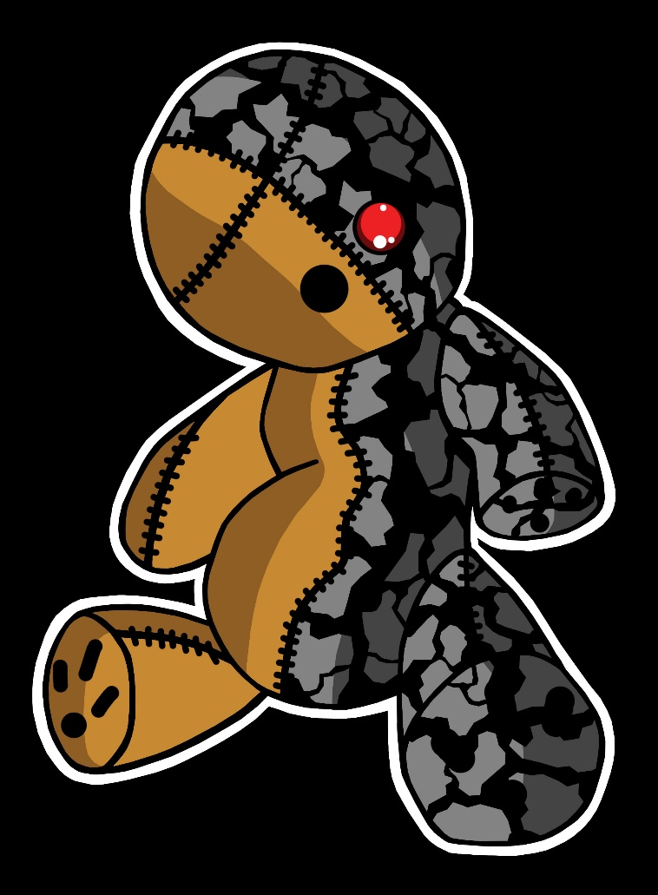

(Fig 2, Mughis, Evil Within The Voodoo Doll, 7th August 2020)

For many years I have been fascinated with the horror genre and over the years, I have studied many new things about horror. Horror is an emotion that makes individuals fear and that is something that makes me excited and makes the whole situation tense. As Clasen claims, ‘it captures and holds our attention by engaging the fear system’ (Clasen, 2017, p. 7) horror is an emotion that overwhelms me with excitement but that is not the case for everyone. I tend to produce artwork in the style of horror.
I wanted to produce an artwork that can show my viewpoint but also show other individuals viewpoint. Horror should be shown in art in a way that make people see fear and also understand the meaning behind the artwork. As Hart claims, ‘horror needs to be understood for the way it directly stimulates viewers’ (Hart, 2020, p. 22). One of my artworks which I called ‘Evil Within The Voodoo Doll’, is based on horror. The purpose why I produced this artwork was because it was a way for me to present my fear and edgy emotions towards dolls and voodoo dolls. Many Individuals will think differently to how I feel towards dolls. As Robinson claims, ‘We ourselves have access to our feelings’ (Robinson, 2005, p.1). Everyone has different viewpoints and emotions towards voodoo dolls. Personally, whenever I produce an artwork based on horror, I think about what message I am trying to convey and why did I produce this artwork.
For me to start the voodoo doll artwork, I first had to look up voodoo dolls in books, films and exhibitions and see how people see them as. Some individals feel very uncomfortable around them where as other individuals find them interesting and paranormal. I then started creating small sketches of my viewpoint on dolls. After finally producing my artwork, I presented two different sides of the doll. I love how the process went and I really love how I presented the different sides of the doll. On one side, I made it where individuals see them as nothing to fear off and I presented that by showing the normal cuddly toy some will see dolls as, and on the other hand I I made it where some individuals will see them as duanting and paranormal. I then showed that as dark, black and grey colours. I also changed the colour of the eyes and the reason behind that was because when I see dolls I sometimes think that there is a demon or some entitiy stuck within the doll.
Personally, I believe that horror is a way to present fear and as an artist I truly love how horror creates fear into some people’s mind and how it connects to people by building up that tension inside them. I think that my art style is something I find a lot of interest in and also think that horror in art is important to present emotion and to present different viewpoint from different individuals.

Bibliography

Clasen M, (2017), Why Horror Seduces, How Horror Works 1, New York: Oakford University Press.
Hart D, C. (2020), Monstrous Forms, Moving Image Horror Across Media, Shocks to the System, New York: Oxford University Press.
Robinson J, (2005) Deeper than Reason: Emotion and its Role in Literature, Music, and Art, Emotions as Judgements, Oxford: Oxford University Press.

List of figures:

Shaikh M, (2020), “Evil Within The Voodoo Dol”, (Digital), (Accessed at: 20th Sunday 2020).

CoceAddict, (2014), Emotions – Fear, [Photograph], Available at: https://www.deviantart.com/coceaddict/art/emotions-fear-429898340 (Accessed: 08th December 2020).
Brazier Y, (2018), Recognising child abuse, Available at: https://www.medicalnewstoday.com/articles/241532/ (Accessed: 11th November 2020).
Manlowe L, J. (1995), Faith Born of Seduction, A Horror beyond Tears: Reflection on a History of Abuse, New York: NYU Press.
Manlowe L, J. (1995), Faith Born of Seduction: Sexual Trauma, Body image, and Religion, Who Are We? York: NYU Press 1995.
Phillip C, (2008), Outward Signs: The Powerlessness of External Things in Augustine’s Thought, Why We Learn Nothing From Words, New York: Oakford University Press.
Benincasa C, Neri G, Trimarchi M, (2019), Art and Economics in the City, Introduction: Urban challenges, Cultural strategies, Germany: Bielefeld.
Matravers D, (2001) Art and Emotions, Belief and Experience, Oxford: Oxford University Press.
Gaut B, (2007), The Long Debate, The Controversies, Oxford: Oxford University Press.
Whiffen T, P. (2001) Shot at Down: Cowards. Traitors, Or Victims? Available at: BBC - History - British History in depth: Shot at Dawn: Cowards, Traitors or Victims? (Accessed: 26th November 2020).
Shaikh M, (2020), “Evil Within The Voodoo Dol”, (Digital), (Accessed at: 20th Sunday 2020).
Clasen M, (2017), Why Horror Seduces, How Horror Works 1, New York: Oakford University Press.
Hart D, C. (2020), Monstrous Forms, Moving Image Horror Across Media, Shocks to the System, New York: Oxford University Press.
See Fig 2.
Robinson J, (2005) Deeper than Reason: Emotion and its Role in Literature, Music, and Art, Emotions as Judgements, Oxford: Oxford University Press.

