Health and Fitness Assessment Report
There are many major benefits to taking part in physical activity, a few being the prevention in relation to cardiovascular disease, stroke, diabetes, and obesity (Bayles and Swank, 2018). Before participating in physical activity, it is vital that Physical Activity Readiness Questionnaires are filled out to determine whether the individual is safe to partake in their desired type of exercise – this including safe pre-exercise screenings. (Humphrey and Lakomy, 2003, p. 187). Pre exercise health screenings are vital before allowing an individual to partake in physical activity, whereby there are three goals when getting an individual to do so – one being to identify who needs medical clearance before partaking in exercise or those who wish to increase the volume, intensity or frequency of their current training programme, two being to recognize those who have clinical diseases and whether participating in an exercise programme would act as a positive to them, and third being to pin point those who should be limited to participating in exercise until their medical conditions improve or are better controlled - from this the exercise professional can then create an exercise programme best suited to the individual (Bayles and Swank, 2018).
Cardiorespiratory Fitness
One of the five health related components of fitness is Cardiorespiratory, this can be defined as the ability for the body to carry out moderate to vigorous intensity exercise while also using larger muscle groups in a repetitive manner for a long duration of time (Bayles and Swank, 2018). Individuals who have poor levels of cardiorespiratory fitness are linked with an increase in all-cause mortality (Bayles and Swank, 2018). When testing an individual’s Cardiorespiratory Fitness, it is vitally important to ensure that you chose a test which best suits them, factors to include being maximal or submaximal, what are the results being used for and healthiness of the individual (Bayles and Swank, 2018). The cardiorespiratory fitness of an individual can be identified by working out their V02 max, of which is the maximum volume of oxygen that can be up taken by the body during an intense aerobic exercise, thus being measured either maximally or sub maximally (Rexhepi and Brestovci, 2011, p. 348). The Astrand Bike test is one of the most popular submaximal tests, this due to it being easy to carry out and minimal equipment is required, the workload/wattage is set during the first minute of the test and it is then continued at that pace throughout the whole test, the aim is to have a steady and consistent heart rate over the duration of the 6-minute test (Rexhepi and Brestovci, 2011, p.348). The average heart rate which was obtained from doing the test is then used alongside the wattage to work out the individuals V02 max by using the Döbeln formula (Rexhepi and Brestovci, 2011, p.249).
Muscular Strength
Muscular strength can be defined as the maximum force that an individual’s muscle or muscle group can produce against an acting resistance, it is vitally important and can be improved on through participating in resistance training and weightlifting exercises (Bayles and Swank, 2018). Muscular strength is important in relation to specific skills within sport and additionally reducing injuries (Suchomel et al, 2018, p. 766). By having a higher level of muscular strength, it is seen to have a positive impact on an individual’s ability to perform (Suchomel, Nimphius and Stone, 2016, p. 1419). During the handgrip dynamometer test, the individual is required to stand upright and looking ahead, the grip will need adjusting to their suitability, from this the individual is required to squeeze the grip as hard as they possibly can, this being repeated three times over on each side, then resulting in an average score (Bayles and Swank, 2018). The hand grip test is seen as very reliable however when standing, it has been proven that the score is higher rather than when sitting – so this is something to be taken into consideration (Bayles and Swank, 2018).
Flexibility and Functional Movement
Assessing an individual’s flexibility and functional movement has been seen as less significant in comparison to other health related components of fitness, this in relation to determining an individual’s fitness level (Bayles and Swank, 2018). J Holt, L Holt and Pelham (1995, p. 170) state:
“Flexibility is the range of motion of a joint or a series of joints that are influenced by muscles, tendons, ligaments, bones and bony structures”.
Flexibility is considered as rather difficult to measure, this being down to the fact that the range of motion is specific to each joint, and the range of motion that’s within the shoulder will not be able to determine the range of movement within the hip joint (Corbin and Noble, 1980, p. 23). Flexibility is vitally important with every individual, and it is seen that issues with bad backs or poor posture, and muscle soreness are often linked with having poor flexibility and therefore is a very important component of health-related fitness (Corbin and Noble, 1980, p.24). The most popular test for measuring an individual’s flexibility is the sit and reach, this being down to how simple it is to carry out and how anyone can take part in it (Bayles and Swank, 2018). This test can be carried out by using a sit and reach box or by a measuring tape being placed out correctly, this determines your hip, hamstring, and lower back flexibility - overall flexibility cannot be determined by carrying out this test, this due to it only measuring limited joints (Bayles and Swank, 2018). During this test, the individual is required to sit with the soles of their feet against the box, the next step is for the individual to reach forward with both of their hands on top of the box – this being as far as they can possibly go without bending their knees, this being done three times which then averages a result to determine the in individuals’ flexibility (Bayles and Swank, 2018).
Muscular Endurance
Under the branch of muscular strength, there is muscular endurance – of which is the group of muscles ability to carry out a muscle contraction continuously over a period, there are many ways to test this component of fitness, a few of which being the 1-minute sit up test or the push up test (Bayles and Swank, 2018). It is proven that by participating in high repetition and low resistance exercises your muscular endurance is able develop and improve (Clarke, 1973, p. 74). Due to many women scoring zero on the normal press up test, the bent knee push up test is a more appropriate alternative whereby their muscular endurance can still be measured (Wood and Baumgerter, 2009, p. 203). The push up test is known for being a very effective and simple way to test the body’s endurance, more specifically – upper body endurance. The traditional way to perform this test is to start in the plank position with your hands shoulder width apart while your feet remaining close to each other, you then lower your body down until your chest touches the ground, following from this you push back up to the starting position – you are required to repeat this action as many times as possible until you can no longer do any more, ensure a second party is there to count how many repetitions you can perform (Bayles and Swank, 2018).

Client Report
Hello,
I hope this message finds you well! I wanted to reach out to you to let you know that I have reviewed the results from the recent health and fitness tests that you participated in.
Firstly, I wanted to let you know that you did a great job in the tests and that I am happy that from the health questionnaire that you are in a fit and healthy state to begin a fitness programme. However, I would just like to go over some areas where some improvements can be made, I’ve identified a few key areas where we can work together to make further progress.
Before beginning a fitness programme, I wanted to test your components of health-related fitness as it helps me to evaluate your overall physical health and identify any areas which require improvement. By doing this I can more accurately track your progress, set goals, and create a more personalised fitness plan for you. By doing so I am now able to pinpoint your current fitness levels and track your progress over the upcoming weeks more accurately.
To test your Muscular Strength, we used the Hand Grip Dynamometer, whereby you scored an average result of 25.2. In comparison to normative data this is considered average (see figure one), which is a great result – however, there is still definitely room for improvement. To improve your muscular strength, we could introduce weightlifting, working with resistance bands, hill walking or cycling. Resistance training is a great way to improve your strength, it is important that this is done two to three times per week to gain the maximum benefit.
To test your muscular endurance, you took part in the push up test – this was performed whereby you complete as many repetitions as you possibly could until failure. You scored a result of 22, in comparison to normative data you scored average (see figure two) meaning there is some room for improvement. To improve your muscular endurance, we could introduce more weight training where the aim would be to complete a movement for around 12 repetitions, it is vital when doing so to perform these slow and controlled to keep the tension on the muscle.
We used the sit and reach test to test your flexibility and functional movement, the average result that you scored was 24 – in comparison to normative data, that is classed as poor (see figure three) – however, this does not mean that we can’t improve this over the course of your training programme. To improve your flexibility, you could start introducing dynamic stretches before your workouts and static stretches post workout, it is also important to target these stretches to the areas that need it the most, in this case it would be your lower back and hamstring flexibility. It is vital that you start stretching frequently and do it in a safe manner.
You participated in the 6-minute Astrand bike test to test your cardiorespiratory fitness, by doing this test we were looking to determine your V02 max in a submaximal way. After calculations, you scored 26.9ml/kg/min which is considered as low – however, there are ways we could improve this and get your cardiovascular fitness levels higher. Ways of which we could improve your cardiovascular fitness would be to introduce walking, jogging, running, cycling, stair climbing or aerobic activities. To see results we would need to make sure that you participate in some of these activities for at least 30-minutes on three days of the week, this could be done over the course of 8 to 12 weeks.
In conclusion, we can see from the results collected that your muscular strength and endurance are average and will need a little bit of work to get the results a little higher. Whereas your cardiovascular fitness and flexibility will need a little more work so that you will overall be healthier and will have strong results within your components of health-related fitness.
Overall, I am confident that we can start this fitness journey and build progress and achieve your health and fitness goals. If you have any concerns or questions, please do not hesitate to reach out to me.
Best Regards,
Courtney Evans.

References
Bayles, M.P. and Swank, A.M. 2018. ACSM's exercise testing and prescription. Philadelphia: Wolters Kluwer.
Clarke, D.H. 1973. Adaptations in strength and muscular endurance resulting from exercise. Exercise and sport sciences reviews, 1, pp. 73-107.
Corbin, C.B. and Noble, L., 1980. Flexibility: A major component of physical fitness. Journal of Physical Education and Recreation, 51, pp. 23-60.
Holt, J. Holt, L.E. and Pelham, T.W. 1995. Flexibility redefined, ISBS-Conference Proceedings Archive 1995.
Humphrey, R.A. and Lakomy, J. 2003. An evaluation of pre-exercise screening questionnaires used within the health and fitness industry in the United Kingdom. Physical Therapy in Sport, 4, pp. 187-191.
Potteiger, J.A. 2018. ACSM's introduction to exercise science. Philadelphia: Wolters Kluwer Health.
Rexhepi, A. and Brestovci, B. 2011a. Comparison of the 3'bike test with the Astrand bike test by VO2max. Hum Mov, 12, pp. 348-352.
Suchomel, T.J. Nimphius, S., Bellon, C.R. and Stone, M.H. 2018. The importance of muscular strength: training considerations. Sports medicine, 48, pp. 765-785.
Suchomel, T.J. Nimphius, S. and Stone, M.H. 2016. The importance of muscular strength in athletic performance. Sports medicine, 46, pp. 1419-1449.
Wood, H.M. and Baumgertner, T.A. 2004. Objectivity, reliability, and validity of the bent-knee push-up for college-age women. Measurement in physical education and exercise science, 8, pp. 203-212.
https://www.brianmac.co.uk/grip.htm 31/03/2023
https://www.brianmac.co.uk/pressuptst.htm 31/03/2023
https://exercisescience-lwwhealthlibrary-com.ezproxy.uwtsd.ac.uk/content.aspx?sectionid=187951081&bookid=2415 31/03/2023
https://www.health-calc.com/fitness-tests/aastrand-test

Appendices

FIGURE ONE
(Davis 2000)
Gender | Excellent | Good | Average | Fair | Poor
Male | >56 | 51-56 | 45-50 | 39-44 | <39
Female | >36 | 31-36 | 25-30 | 19-24 | <19

FIGURE TWO
McArdle et al. (2000)
Age | Excellent | Good | Average | Fair | Poor
20 - 29 | >48 | 34 - 38 | 17 - 33 | 6 - 16 | <6
30 - 39 | >39 | 25 - 39 | 12 - 24 | 4 - 11 | <4
40 -49 | >34 | 20 - 34 | 8 - 19 | 3 - 7 | <3
50 - 59 | >29 | 15 - 29 | 6 - 14 | 2 - 5 | <2
60+ | >19 | 5 - 19 | 3 - 4 | 1- 2 | <1

FIGURE THREE
ACSM (2018)
Category | Age (yr)
Category | 20–29 |  | 30–39 |  | 40–49 |  | 50–59 |  | 60–69
Sex | M | W | M | W | M | W | M | W | M | W
Excellent | ≥40 | ≥41 | ≥38 | ≥41 | ≥35 | ≥38 | ≥35 | ≥39 | ≥33 | ≥35
Very good | 34–39 | 37–40 | 33–37 | 36–40 | 29–34 | 34–37 | 28–34 | 33–38 | 25–32 | 31–34
Good | 30–33 | 33–36 | 28–32 | 32–35 | 24–28 | 30–33 | 24–27 | 30–32 | 20–24 | 27–30
Fair | 25–29 | 28–32 | 23–27 | 27–31 | 18–23 | 25–29 | 16–23 | 25–29 | 15–19 | 23–26
Poor | ≤24 | ≤27 | ≤22 | ≤26 | ≤17 | ≤24 | ≤15 | ≤24 | ≤14 | ≤22

FIGURE FOUR
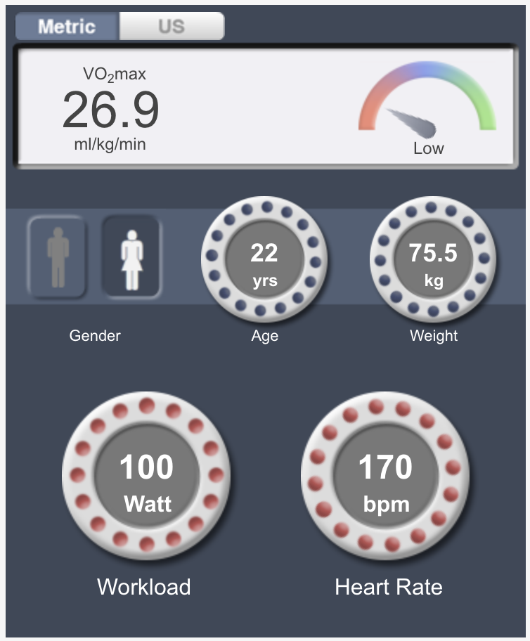

Client Pre-screening Assessment
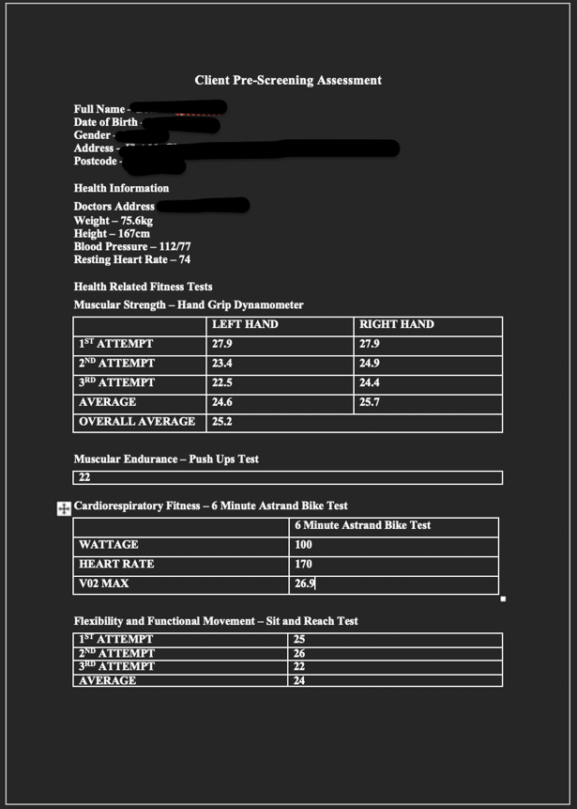

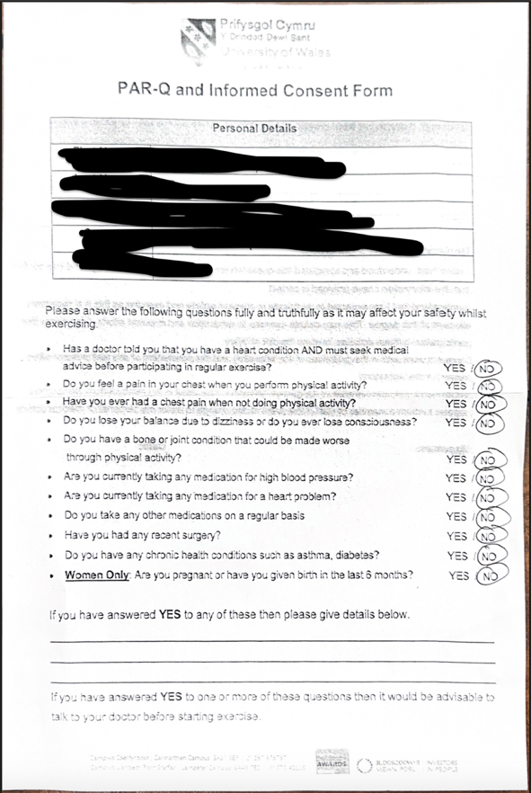
Clint Par-Q Informed Consent Form



