DS 1 Template

My Screenshots/Photos
- Please add 4–6 screenshots or photos of your digital life.
- You can use your phone or laptop.
- For each screenshot, write one or two sentences explaining what it shows.

Screenshot/Photo 1
[Insert Photo/Screenshot below]
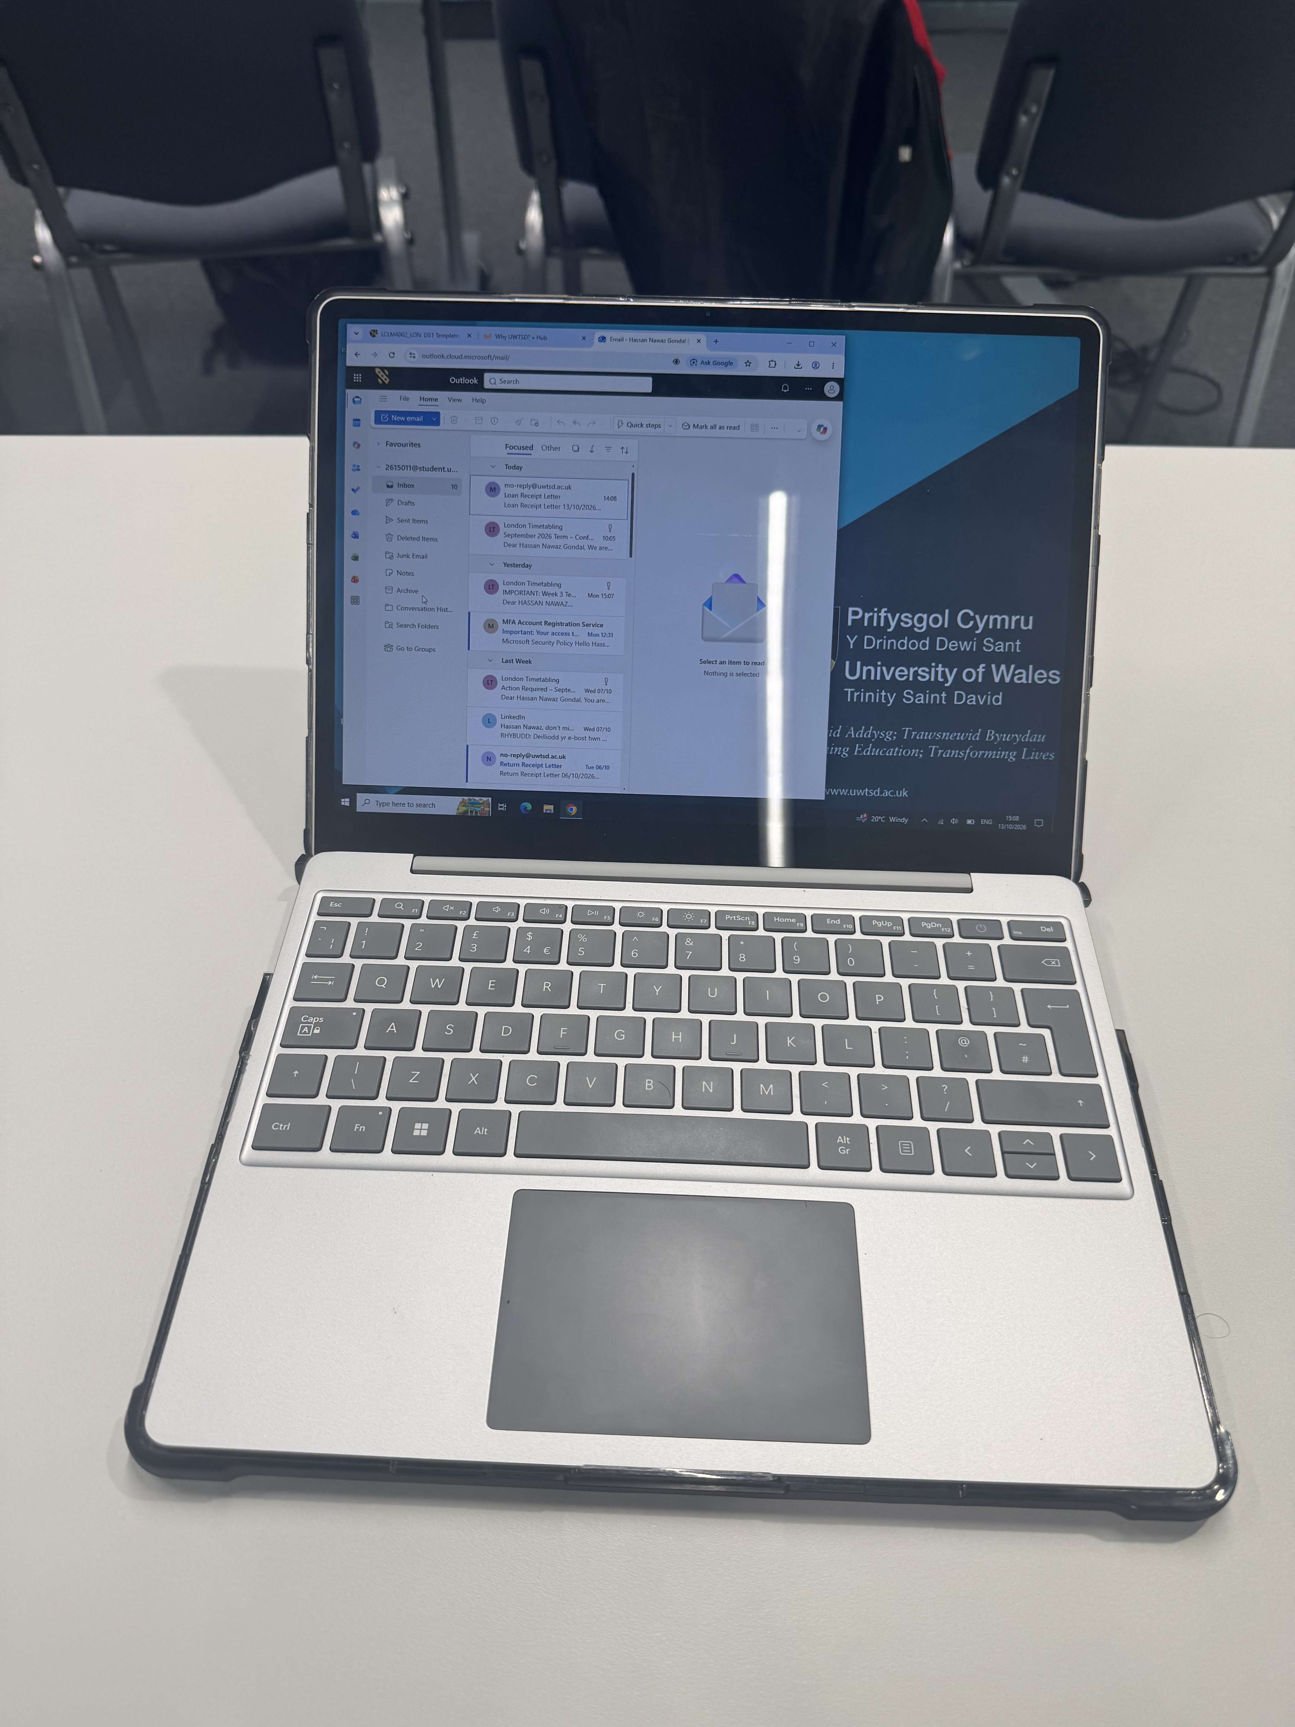
This is my laptop and I use for studies during digital marketing class.i use it for my daily routine life.this is helpful for me in all aspects.i brouse different things.

Screenshot/Photo 2
[Insert Photo/Screenshot below]
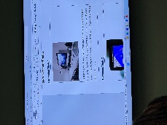
This is picture of the led we use in my classroom.this is actually to instruct us about the course and the information that my teacher teaches.

Screenshot/Photo 3
[Insert Photo/Screenshot below]
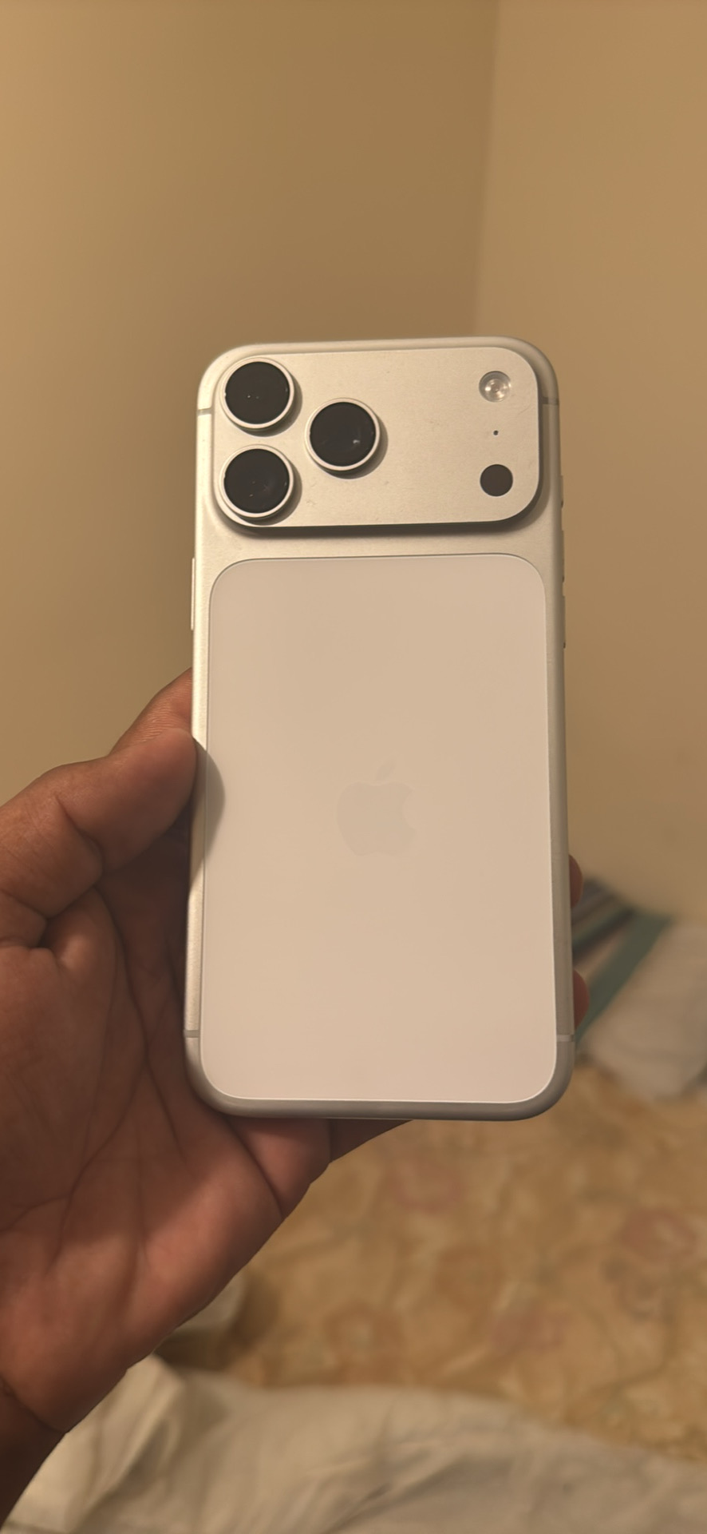
This is my phone and the most important part of digital life.i normally use it for my daily work life.i use it for communication and work.

Screenshot/Photo 4
[Insert Photo/Screenshot below]
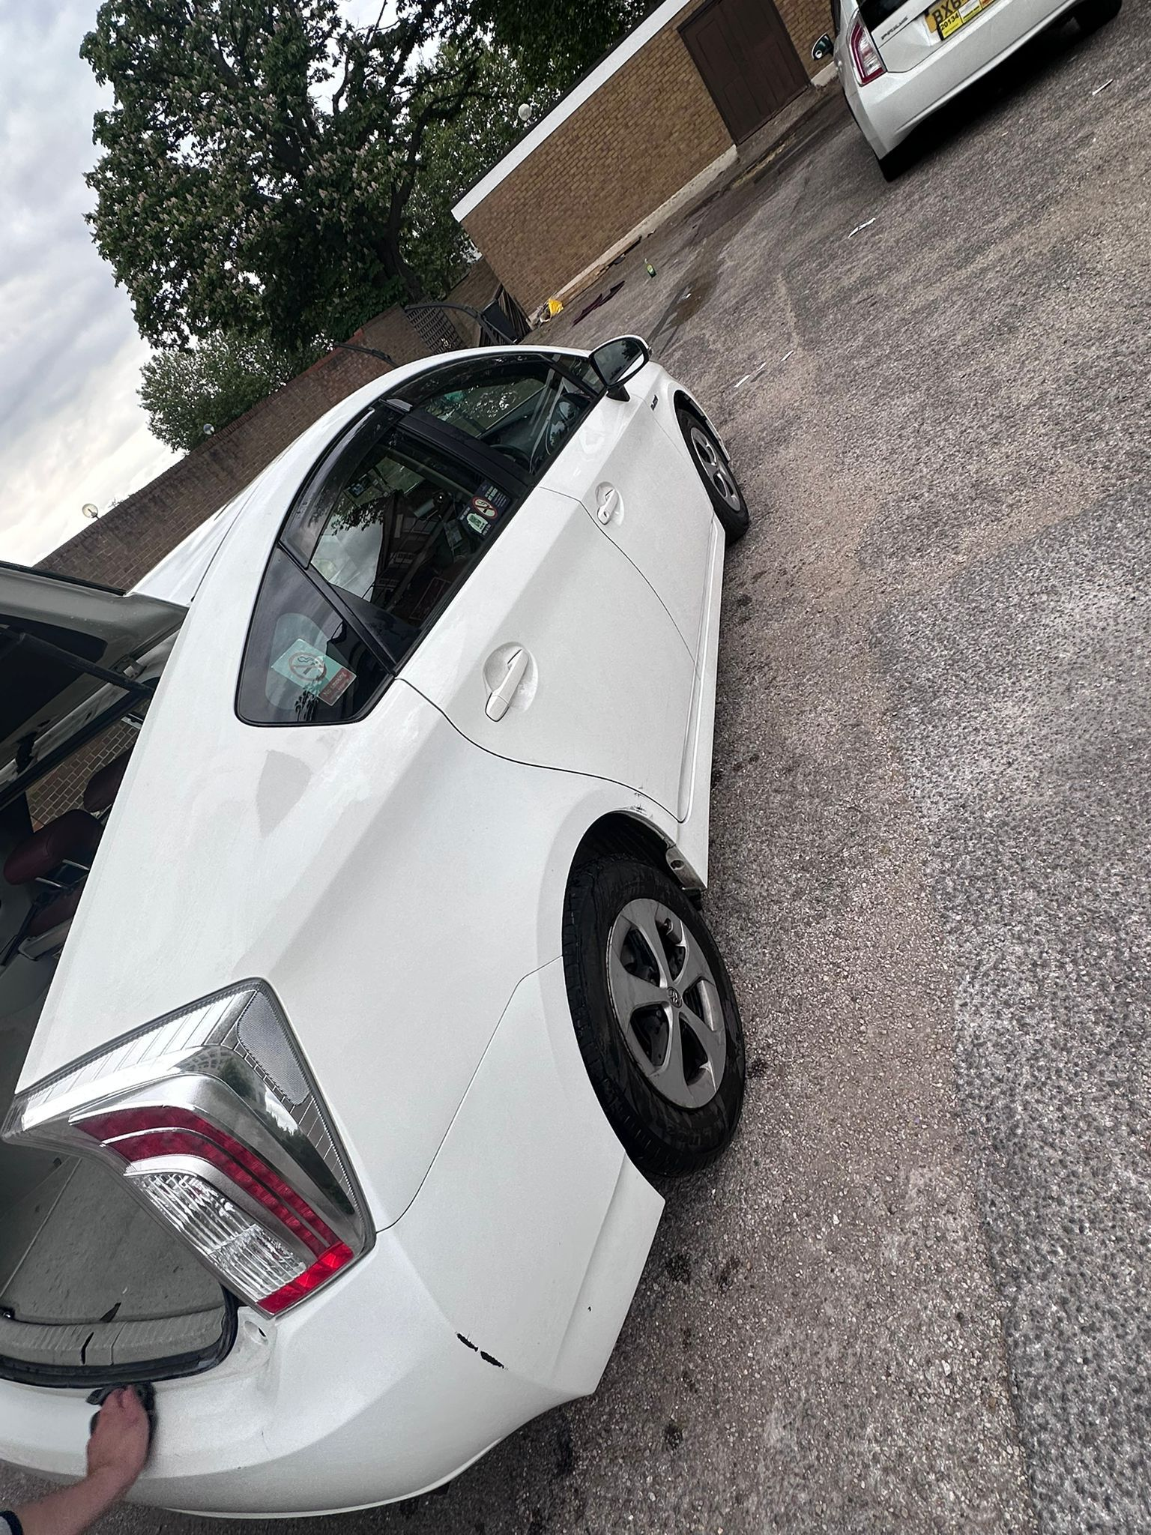
This is my car and I use it for travel and work.i work as a delivery driver so I use it almost everyday.i come to university on my car.

Screenshot/Photo 5
[Insert Photo/Screenshot below]
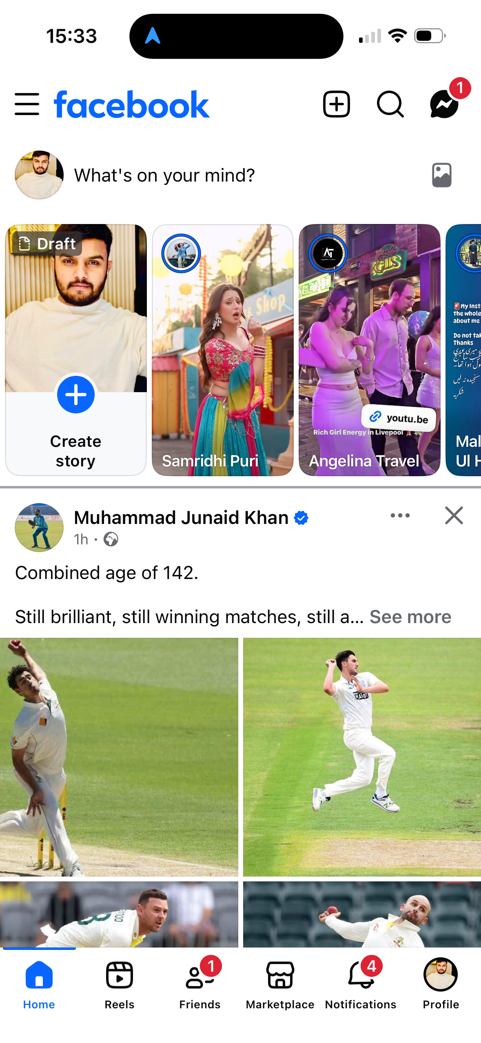
This screenshot is of my facebook feed.this is a source of interaction and entertainment.this is very interesting and help to know the daily routines of peoplr I know closely.

Screenshot/Photo 6
[Insert Photo/Screenshot below]

[Write what this shows of your digital life]

My Short Reflection
- Write 5–8 simple sentences about your digital life.
- You can use the sentence starters below if helpful.
My name is Hassan.i get up early in the morning and sleep early as well. Im hardworking drive a car for hours.i use laptop my phone and social media platforms like facebook,Instagram,tiktok etc everyday.

Sentence starters
- I use digital tools to …
- I feel confident when I …
- I want to improve …
- I often use these tools: …
- I sometimes feel nervous about …
- I hope this module will help me …
- Digital skills are important for me because …
You can write more if you want.

Submission Checklist
Before you submit, please check:
​​​ ☐ I added 4–6 screenshots
☐ I wrote short sentences for each screenshot
☐ I wrote my short reflection
☐ My work is my own
☐ My file opens correctly
​​☐ My file opens correctly

