

Assessment 1 – Reading Task Template
PART 1: Upload your photo of your A3 in-class notes here:
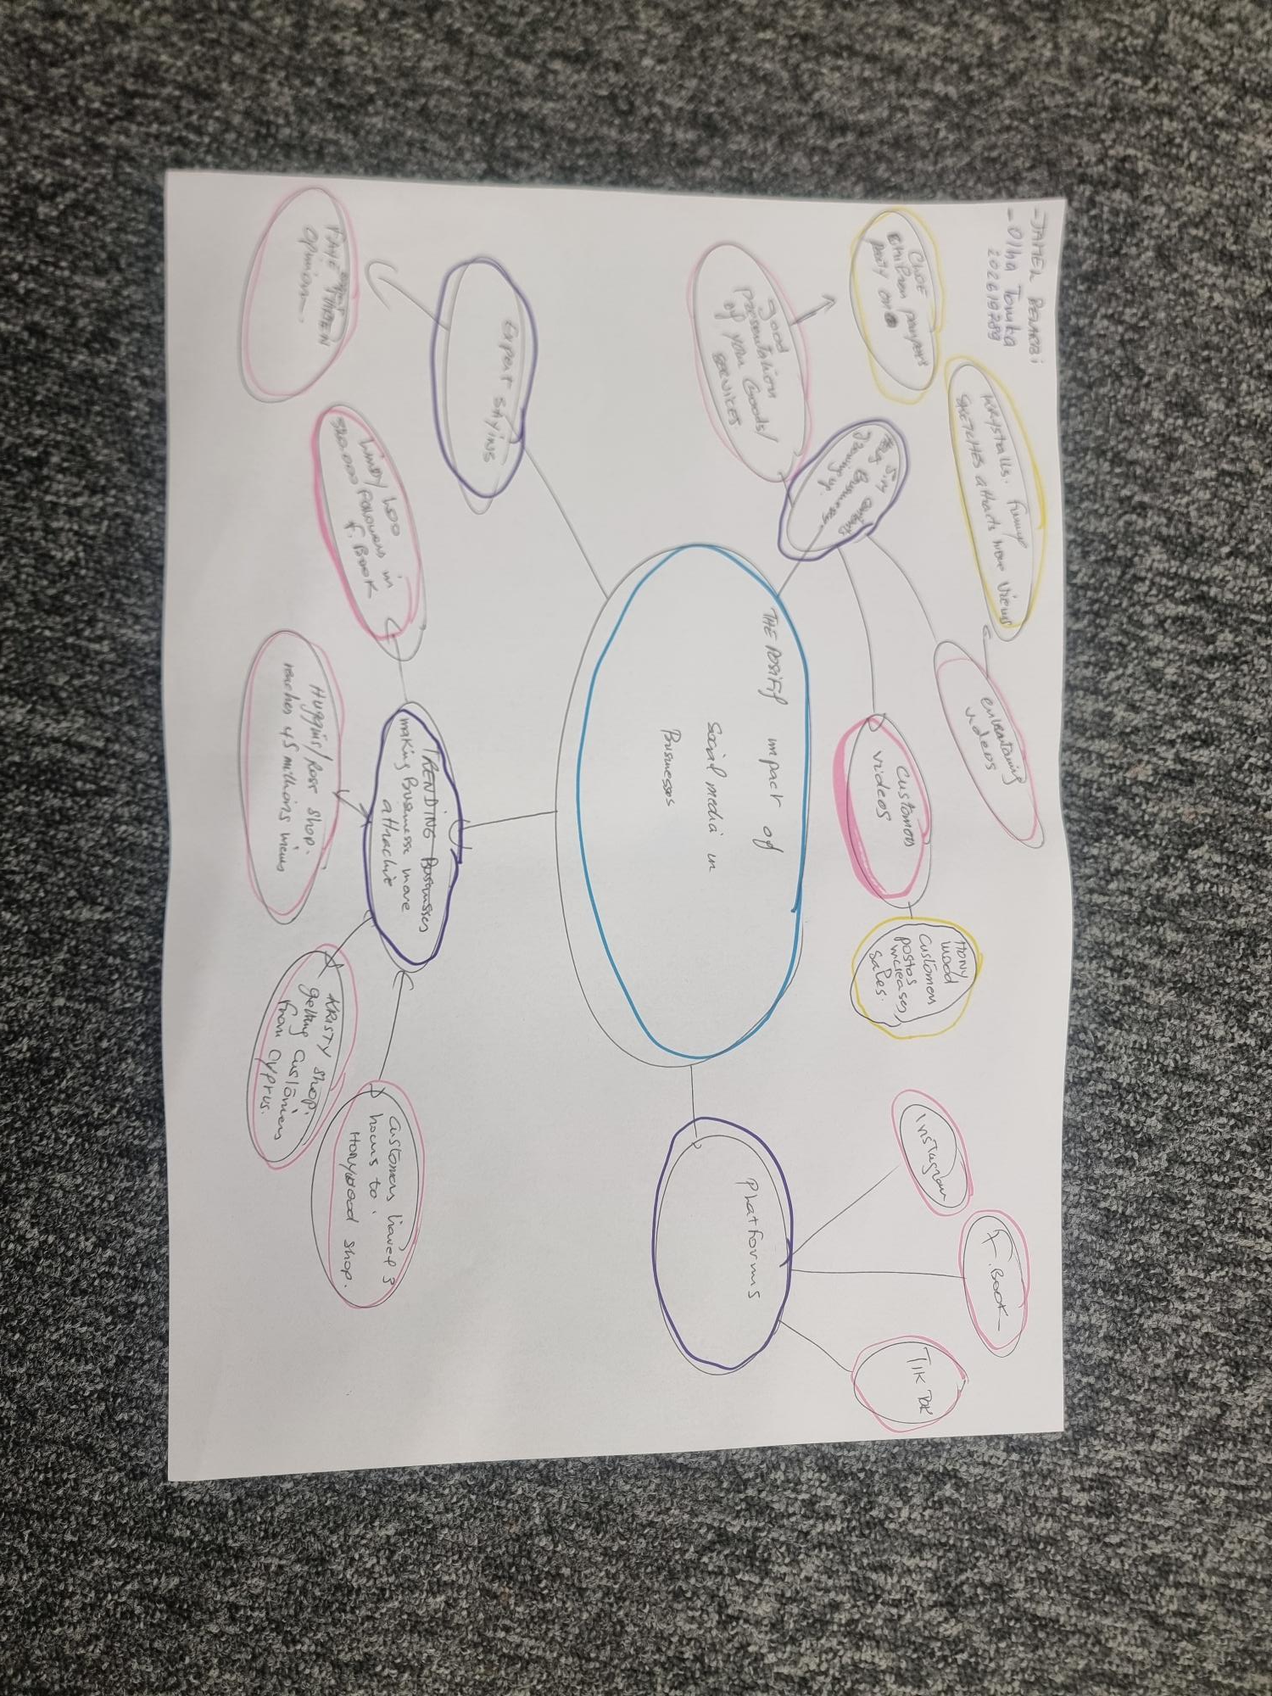

PART 2:
- Answer every question below in 1-3 full sentences.
- Use your own words. Do not use generative AI to answer these questions.
- Include a specific detail from the text when asked.
REMINDER
- The main idea is the overall message of the whole text.
- A key point helps to explain the main idea.
- A specific detail or example from the text shows that the key point is true.

- What is the main idea of the whole text?
- The main idea of the whole text is the impact of the social media on baying and selling and their expansion.

- What is one key point that supports the main idea, and which specific example from the text shows this?
- The key point supporting the main idea is the social media platforms like Facebook and tik Tok, examples of this, such as the Kirsty Chamberlain shop which has gained millions of followers including many from outside UK.

- What is a different key point that supports the main idea, and which specific example from the text shows this?
- The different key points supporting the main idea is the figures for sales achieved by the shops and the growth in their customers base and the experts views on the matter like Linda hunter as example .

- Which part of the text do you think is most important, and why
- The most important part of the text is the figures quoted in the report which prove the extent to which sales risen and the number of customers has increased across all business sectors.

Reflection:
- What did you find difficult in this task (including in-class components), and why was it difficult?
- The only difficulty is distinguishing between the key points and that branch off from them.

- What helped you with this difficulty, and how did it help you?
- All I did is to focus more on the keywords in the text and analysing the text in sections.

