Appendix A – Lifestyle Assessment and Client Profile
Lifestyle assessment and client profile

Page 1 of 6
Learner’s name: Joshua Harvey Date: 31-01-25

Client’s name |  |  |  | Age | Gender
Katie Gardener |  |  |  | 43 | Female
Description of lifestyle, to include: family, occupation, hobbies etc.
- Son 11, just 2 at home
- Lecturer
- Hobbies
- Single parent – time constraint
- Swimming, enjoys
- TV – when tired
- Likes beach, walking climbing and woods
Description of present exercise and physical activity levels (apply FITT where appropriate) |  | Description of past exercise and physical activity levels (apply FITT where appropriate)
F – Not much - F – 2x – 4x a week
I – Beginner - I - moderate – 30 mins cardio 30
Treadmill, machines, StairMaster, incline walks
T – 2x 30 Mins - T – 1 hr
T – Walking w/ Pace > Mainly - T – Weights/ Cardio
Bit of all, gone with a friend

Clients activity likes and dislikes
Likes: |  |  | Dislikes:
Bench Press  Incline walks  Stairmaster  Late Pulls  Leg Press  Yoga > the moves not the holistical element |  |  | Back Squats – hurts neck  Cross trainer  Interval training > likes to vary intensity  Hip thrusts
Client PAR-Q /PAR-Q + completed and informed consent explained: YES/NO |  |  | Did the client answer YES to any PAR-Q/par-q + questions? YES/NO
Analysis of PAR-Q/PAR-Q + response(s) and actions if applicable
Results from tests (physical measurements/assessments (as appropriate to client and goals) –
examples only given – not prescriptive – appropriate to client needs and goals)
Test | Results
Blood pressure | 124/93, 118/96, 122/90
Anthropometrics (tick method): height and weight  BMI  waist circumference waist to hip ratio | 173cm 18.3 stone  38.6 BMI

Body composition (tick method): callipers
bio-electrical impedance
Cardiovascular fitness (tick method):
Astrand bike test Rockport walking test step test
Cooper 12 min walk/run
other machine based time tests (please specify)
Range of movement (tick method): sit and reach test  visual assessment other (please specify) | 14 cm, 15cm, 14 cm
Muscular fitness (tick method): abdominal curl/sit-up test press-up test
estimation of 8-12 rep max other (please specify)
Balance tests:
(specify below)
Results analysis – list any considerations for the programme based on the above
HR monitoring during sessions

Functional ability – list any areas of functional fitness (relevant to client lifestyle and goals) that need applying to the programme
Mobility training and range of motion being of focus
Posture and alignment – list any postural/alignment issues your client might have and how these will be addressed in the programme (refer to postural analysis record)
8+ lordosis in spine
Nothing else to note
Client’s needs
Per week 3 sessions “Up for anything”
Not shouting as a motivational technique

Client’s readiness to participate (list the client’s general feelings towards starting a programme of
exercise and any possible obstacles)
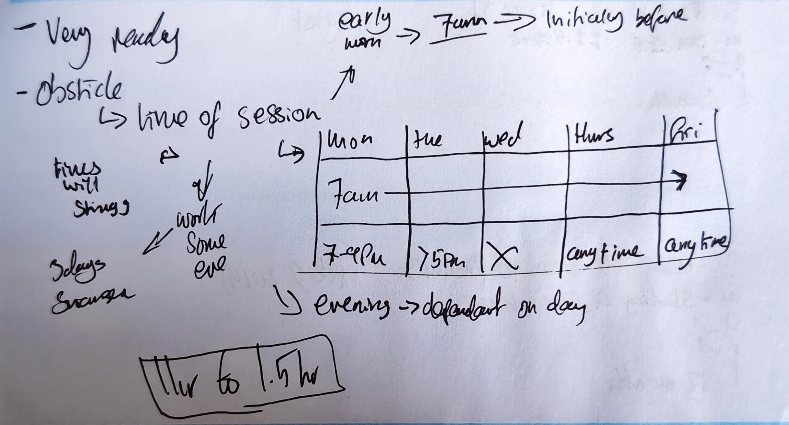
SMART goals: Indicate below if another party other than the personal trainer and client is required for goal setting (please give a reason for their involvement)
Short-term (3 months) | Agreed review dates:
S – Increase general fitness May
M – Increase weights reps and general time on CV
machines
A -
R -
T – 3 months

Medium-term (6 months) | Agreed review dates:
S – Being able to do 1 pushup August
M – stating at 0 on knees
A –
R –
T – 12 months
Long-term (12 months) | Agreed review dates:
S – Weight loss 18.3 Feb 1st 2025
M – down to 11.5
A –
R -
T – 12 months
Barriers to achieving goals
Fitting in the schedule – motivation is high
If not happening quickly can get demotivated
- Little wins are better than big longer achieving wins
Strategies to overcome these barriers
Looking back on the sessions
Showing the mile stones visually
Motivation throughout the sessions and afterwards
Identify any everyday activities the client incorporates into their lifestyle that could compliment a gym programme and assist them in achieving goals
Climbing up the stairs in the office
Walking into town when can
Kneading of bread
Carrying heavy boxes at the moment due to moving house

Postural analysis record

Learner’s name: Joshua Harvey Date: 31/01/25

Client name: Katie Gardener Date 31/01/25

Postural assessment notes and screening (can include a copy of postural assessment records or photographs detailing client’s posture)
Area of the body | Observation (static/dynamic) | Comments/recommendations
Head / neck (cervical spine)
Shoulders, scapulae and thoracic spine

Pelvis and lumbar spine
Knees, feet and ankles

Appendix B – 12 Week Programme Overview

12 week programme overview

Note: learners to identify week numbers eg. Weeks 1-3 etc.
Client’s name: Katie Gardner Learner’s name: Joshua Harvey

 | Weeks 1 – 4  Overview of changes (comment on frequency, intensity, time and type – FITT for each component) | Weeks 5 – 8  Overview of changes (comment on frequency, intensity, time and type – FITT) | Weeks 9 – 12  Overview of changes (comment on frequency, intensity, time and type – FITT)
Warm up | Frequency – 3 times per week  Intensity – Low to Moderate (RPE 3-5)  Time – 15 minuets –  - 10 minuets pulse raiser  - 5 minuets Stretching and Mobilisation  Type – Pulse raise – Treadmill incline walks  - Stretching and mobilisation – Basic stretching movements for beginners, bilateral movements. | Frequency – 3 times per week  Intensity – Low to Moderate (RPE 3-5)  Time – 16 minuets –  - 11 minuets pulse raiser  - 5 minuets Stretching and Mobilisation  Type – Pulse raise – Treadmill incline walks  Stretching and mobilisation – beginner movements with more specific foundation movements added in for progression , bilateral movements. | Frequency – 3 times per week  Intensity – Low to Moderate (RPE 3-5)  Time – 17 minuets –  - 12 minuets pulse raiser  - 5 minuets Stretching and Mobilisation  Type – Pulse raise – Treadmill incline walks  Stretching and mobilisation – all foundation movements are included, bilateral movements with some unilateral movements such as lunges.

Cardiovascular training | Frequency – 3 times per week  Intensity –Moderate (RPE 5)  Time – 10 minuets  Type – continuous incline walks on a treadmill  Incline of 8 speed of 4.3 | Frequency – 3 times per week  Intensity – Moderate (RPE 5-6)  Time – 15 minuets  Type – continuous incline walks on a treadmill  Incline of 8.5 speed of 4.5 | Frequency – 3 times per week  Intensity – Moderate (RPE 5)  Time – 20 minuets  Type – continuous incline walks on a treadmill  Incline of 8.5 speed of 4.8
Resistance Training | Frequency – 3x per week  Intensity – Moderate – 2 x 10 – 12 reps, 5 reps in reserve  Time – 25 minuets  Type – Resistance machines, total body, Body weight  - Upper body – 7 Exercises  - Lower Body – 5 exercises  - Mobility/ Full Body – 7 exercises | Frequency – 3x per week  Intensity – Moderate – 2 x 10 – 12 reps, 3 reps in reserve  Time – 25 minuets  Type – Resistance machines, total body, Body weight  - Upper body – 7 Exercises  - Lower Body – 5 exercises  Mobility/ Full Body – 7 exercise | Frequency – 3x per week  Intensity – Moderate – 3 x 10 – 12 reps, 5 reps in reserve  Time – 30 minuets  Type – Resistance machines, total body, Body weight and a transition into free weights  - Upper body – 7 Exercises  - Lower Body – 5 exercises  Mobility/ Full Body – 7 exercise
Core stability training | Frequency – 1x per week  Intensity – Moderate (RPE 5) – approach:  - Hold for 5 seconds then drop for 5 seconds  - 20 seconds on 5 seconds off  - 20 seconds to 10 seconds each side  - Hold for 5 breaths then swap sides  Time – 10 minuets  Type – Yoga focus moves for core stability training | Frequency – 1x per week  Intensity – Moderate (RPE 5) – approach:  - Hold for 10 seconds then drop for 5 seconds  - 25 seconds on 5 seconds off  - 25 seconds to 10 seconds each side  - Hold for 5 breaths then swap sides  Time – 10 minuets  Type – Yoga focus moves for core stability training | Frequency – 1x per week  Intensity – Moderate (RPE 5-6)– approach:  - Hold for 20 seconds then drop for 5 seconds  - 30 seconds on 5 seconds off  - 30 seconds to 10 seconds each side  - Hold for 5 breaths then swap sides  Time – 10 minuets  Type – Yoga focus moves for core stability training
Other  ’functional’ | Frequency – 1x per week  Intensity – Moderate – (RPE 5)  Time – 8 minuets  Type – Body weight, Kettle bells | Frequency – 1x per week  Intensity – Moderate (RPE 5 – 6)  Time – 9 minuets  Type – Body weight, Kettle bells, Incorporation of smith machine | Frequency – 1x per week  Intensity – Moderate (RPE 5 - 6)  Time – 10 minuets  Type – Kettle bells, free weights
 | These sessions focused on establishing the correct technique, building confidence, and introducing the seven key foundational movements. This is due to the early weeks being prioritised too low to moderate intensity and having high repetitions to accompany it, which is to support neuromuscular adaptation and reduce injury risk, as my client is new to some of the exercises chosen and to the gym environment. | Gradual increase in resistance with a slight reduction in repetitions and an introduction of new exercises to promote adaptation. This was done as the client's confidence and competence improved. In the programme, higher loads and more complex movements which was used to stimulate strength and endurance gains. Cardio sessions became more structured with an increase in duration and intensity, but still a focus on a single variable to avoid confusion and maintain motivation. Adjustments were made based on the feedback received from the client and the overall performance that was observed, such as increasing rest periods when fatigue from the set was high and providing alternatives to exercises when there were equipment availability issues. | The focus of these sessions was maximising performance and trying some testing of a push-up to consolidate gains. The final phases of the plan focused on achieving the client's key goals and preparing for independent exercise post-programme. Sessions included higher intensity efforts and more complex compound movements while ensuring adequate recovery. Based on the client's feedback and progression observed, the programme incorporated exercises that the client enjoyed the most, and gradually introduced more free-weight movements to encourage autonomy and confidence for future training.

Appendix C - Session 3 (Week 1 Legs)

Individual session plans (detailed sessions)

Session plan (x3 detailed sessions)

Client’s name: Katie Gardner Assessor’s name:

Date: 07/02/25 Environment and resources: Gym, Treadmill, free weights, resistance machines

Goal stage this session relates to: Lower body Focus

Warm up

Overview of content (including mobility, pulse raising and pre-stretch – where appropriate) | Equipment and duration | Level/speed | RPE/HR | Adaptation(s) or alternatives
Resistance band walks, BW Lunges, BW squats, side lunges, | Resistance bands  Mat |  | RPE 3 – 5 | Feeding the chickens and opening the gates, resistance band lunges  Supported squats

Cardiovascular training 1

Equipment and approach | Programme timings | Level/speed | RPE/HR | Adaptation(s) or alternatives
Incline walks  Continuous | 10 minuets | 3 / 4 | 5 / 10 | Bike, Stair master  Continuous

Resistance training

Exercise/machine | Resistance (kg/body weight) | Reps | Sets: rest | Training system | Adaptation(s) or alternatives
Romanian Dead Lift | 67% 1RM  5 kg smith | 10 – 12  RIR 2 – 5  RPE 6 – 7 | 2 Sets  45 seconds to 1 minuet rest | Traditional | Good Mornings
Leg Press | 67% 1RM  40 | 10 – 12  RIR 2 – 5  RPE 6 – 7 | 2 Sets  45 seconds to 1 minuet rest | Traditional | BW Squats
Kettlebell Lunges | 67% 1RM  8kg | 10 – 12  RIR 2 – 5  RPE 6 – 7 | 2 Sets  45 seconds to 1 minuet rest | Traditional | Dumbbell lunges
Hamstring Curls  (Machine) | 67% 1RM  15kg 10 reps | 10 – 12  RIR 2 – 5  RPE 6 – 7 | 2 Sets  45 seconds to 1 minuet rest | Traditional | Single Leg Hamstring Curls
Goblet Squats  BW | 67% 1RM | 10 – 12  RIR 2 – 5  RPE 6 – 7 | 2 Sets  45 seconds to 1 minuet rest | Traditional | Goblet Squats  (Dumbbell)

Cardiovascular training 2 - incorporating pulse lowering (if required)

Equipment and approach | Programme timings | Level/speed | RPE/HR | Adaptation(s) or alternatives
Incline Walks  Continuous | 15 minuets | 5 – TBC | 5 – 7 | Rowing, Bike, Stairmaster

Core stability training (as appropriate to client)

Core exercise(s) | Position | Length of hold :rest | Adaptation(s) or alternatives
Ab Machine  Side Crunches |  | 2 sets 10 reps 1 min rest | Crunches  Sit-ups

Other ‘functional’ training (as appropriate to client)

Exercises (can be bodyweight) | Position | Length of hold :rest / Sets: rest | Adaptation(s) or alternatives
Sit ups  Banded Lunges  Pallof press |  | 2 sets EMOM  2 sets 10 – 12  - 1 min rest  3 sets 10 reps  - 1 min rest | Toe touches

Flexibility/mobility (as appropriate to client)

Muscle(s) stretched | Position | Type/ length of hold (static/dynamic/PNF) | Adaptation(s) or alternatives
Neck mobility  Side lunge stretch  Cross body twists  Butterfly Stretching  Seated Hamstring stretch |  | Dynamic Stretching – At the bottom held for 5 seconds  - Bouncing the legs  Static – 20 seconds hold | Raised leg lunge  Kettle bell cross body twists

Appendix C - Session 8 (Week 5 Legs)

Individual session plans (detailed sessions)

Session plan (x3 detailed sessions)

Client’s name: Katie Gardner Assessor’s name:

Date: 07/03/25 Environment and resources: Gym, Treadmill, Freeweights, Resistance machines

Goal stage this session relates to: Lower body Focus Cardio vascular improvement

Warm up

Overview of content (including mobility, pulse raising and pre-stretch – where appropriate) | Equipment and duration | Level/speed | RPE/HR | Adaptation(s) or alternatives
Dynamic Stretching  - Leg swings  - Cross body rotation lunge  - Walk outs to plank  - Side squats  - High knees  Muscle Activation  - Glute bridges  - Resistance band walks  - Bird dog | 3 minuets  2 minuets  Resistance bands |  | RPE 3 – 5 | - Reduce hip highs on swing  - Use equipment for support  - Bend knees  - Hold trx or machine for balance  - Step ups  - Hip thrusts  - Lunges

Cardiovascular training 1

Equipment and approach | Programme timings | Level/speed | RPE/HR | Adaptation(s) or alternatives
Incline walks  Continuous | 10 minuets  Inc 11 mins | 3 / 4 | 5 / 10 | Bike, Stair master  Continuous

Resistance training

Exercise/machine | Resistance (kg/body weight) | Reps | Sets: rest | Training system | Adaptation(s) or alternatives
Romanian Dead Lift | 67% 1RM  7.5 kg smith  24reps  10kg 16 reps | 10 – 12  RIR 2 – 5  RPE 6 – 7 | 2 Sets  45 seconds to 1 minuet rest | Traditional | Good Mornings
Leg Press | 67% 1RM  60 kgs for 20  Inc 24 | 10 – 12  RIR 2 – 5  RPE 6 – 7 | 2 Sets  45 seconds to 1 minuet rest | Traditional | BW Squats
Single leg press | 67% 1RM  10 – 28  20 - 16 | 10 – 12  RIR 2 – 5  RPE 6 – 7 | 2 Sets  45 seconds to 1 minuet rest | Traditional | Dumbbell lunges
Hamstring Curls  (Machine) | 67% 1RM  25kgs – 20  Inc - 24 | 10 – 12  RIR 2 – 5  RPE 6 – 7 | 2 Sets  45 seconds to 1 minuet rest | Traditional | Single Leg Hamstring Curls
Leg extensions | 67% 1RM  10 – 20  12.5 - 16 | 10 – 12  RIR 2 – 5  RPE 6 – 7 | 2 Sets  45 seconds to 1 minuet rest | Traditional | Goblet Squats  (Dumbbell)

Cardiovascular training 2 - incorporating pulse lowering (if required)

Equipment and approach | Programme timings | Level/speed | RPE/HR | Adaptation(s) or alternatives
Rower  Continuous  7.5 minuets 1.2km (rpe8) | 10 ninuets | 9 resistance | 5 – 6 | Rowing, ¼ 4/10  Incline walks 8 4km 6/10  Stairmaster 7 – 5/10 2.5 mins 10/10

Core stability training (as appropriate to client)

Core exercise(s) | Position | Length of hold :rest | Adaptation(s) or alternatives
Ab Machine  Side Crunches | 25  3.75 cable  3second | 2 sets 10 reps 1 min rest  Curls for 8 | Crunches  Sit-ups

Other ‘functional’ training (as appropriate to client)

Exercises (can be bodyweight) | Position | Length of hold :rest / Sets: rest | Adaptation(s) or alternatives
Sit ups  Banded Lunges  Pallof press | Cable 2.5kg | 2 sets EMOM  2 sets 10 – 12  - 1 min rest  3 sets 10 reps  - 1 min rest | Toe touches

Flexibility/mobility (as appropriate to client)

Muscle(s) stretched | Position | Type/ length of hold (static/dynamic/PNF) | Adaptation(s) or alternatives
Neck mobility  Side lunge stretch  Cross body twists  Butterfly Stretching  Seated Hamstring stretch |  | Dynamic Stretching – At the bottom held for 5 seconds  - Bouncing the legs  Static – 20 seconds hold | Raised leg lunge  Kettle bell cross body twists

Appendix C - Session 14 (Week 9 Legs)

Individual session plans (detailed sessions)

Session plan (x3 detailed sessions)

Client’s name: Katie Gardner Assessor’s name:

Date: 24/04/25 Environment and resources: Gym, Treadmill, Freeweights, Resistance machines

Goal stage this session relates to: Lower body Focus Cardio vascular improvement

Warm up

Overview of content (including mobility, pulse raising and pre-stretch – where appropriate) | Equipment and duration | Level/speed | RPE/HR | Adaptation(s) or alternatives
Dynamic Stretching  - Leg swings  - Cross body rotation lunge  - Walk outs to plank  - Side squats  - High knees  Muscle Activation  - Glute bridges  - Resistance band walks  - Bird dog | 3 minuets  2 minuets  Resistance bands |  | RPE 3 – 5 | - Reduce hip highs on swing  - Use equipment for support  - Bend knees  - Hold trx or machine for balance  - Step ups  - Hip thrusts  - Lunges

Cardiovascular training 1

Equipment and approach | Programme timings | Level/speed | RPE/HR | Adaptation(s) or alternatives
Incline walks  Continuous | 11 minuets  Incline 8.5  Speed 4.7  (A little quicker but for not as long) | 3 / 4 | 5 / 10 | Bike, Stair master  Continuous

Resistance training

Exercise/machine | Resistance (kg/body weight) | Reps | Sets: rest | Training system | Adaptation(s) or alternatives
Romanian Dead Lift  dB 10kg 10 | 67% 1RM  10kg 24 reps  Inc 12.5 each side. 16 reps | 10 – 12  RIR 2 – 5  RPE 6 – 7 | 2 Sets  45 seconds to 1 minuet rest | Traditional | Good Mornings
Leg Press | 67% 1RM  70kgs – 18 reps  Increase to 20 reps | 10 – 12  RIR 2 – 5  RPE 6 – 7 | 2 Sets  45 seconds to 1 minuet rest | Traditional | BW Squats
Hamstring Curls  (Machine) | 67% 1RM  25kgs – 26  Inc – 27.5kgs – 16 reps  (Yellow 2.5) | 10 – 12  RIR 2 – 5  RPE 6 – 7 | 2 Sets  45 seconds to 1 minuet rest | Traditional | Single Leg Hamstring Curls
Single leg press | 67% 1RM  20 – 22  Inc 24 reps | 10 – 12  RIR 2 – 5  RPE 6 – 7 | 2 Sets  45 seconds to 1 minuet rest | Traditional | Dumbbell lunges
Leg extensions | 67% 1RM  12.5 – 22  Inc – 24 reps | 10 – 12  RIR 2 – 5  RPE 6 – 7 | 2 Sets  45 seconds to 1 minuet rest | Traditional | Goblet Squats  (Dumbbell)

Cardiovascular training 2 - incorporating pulse lowering (if required)

Equipment and approach | Programme timings | Level/speed | RPE/HR | Adaptation(s) or alternatives
Bike | 15 minutes  Aim for 9 km average watts of 125 same as like the Upper body week and the heart rate to be in the 140s | Resistance 4/5  Magnetic 3  Watts 125 | 5 – 6  Hr zone 140-155 | Rowing, ¼ 4/10  Incline walks 8 4km 6/10  Stairmaster 7 – 5/10 2.5 mins 10/10

Core stability training (as appropriate to client)

Core exercise(s) | Position | Length of hold :rest | Adaptation(s) or alternatives
Ab Machine  Side Crunches | 20 (Slow controlled reps)  3.75 cable  3second | 2 sets 10 reps 1 min rest  Curls for 8  Increase to 3 sets | Crunches  Sit-ups

Other ‘functional’ training (as appropriate to client)

Exercises (can be bodyweight) | Position | Length of hold :rest / Sets: rest | Adaptation(s) or alternatives
Sit ups  Banded Lunges  Pallof press | Cable 2.5kg | 2 sets EMOM  2 sets 10 – 12  - 1 min rest  3 sets 10 reps  - 1 min rest | Toe touches

Flexibility/mobility (as appropriate to client)

Muscle(s) stretched | Position | Type/ length of hold (static/dynamic/PNF) | Adaptation(s) or alternatives
Neck mobility  Side lunge stretch  Cross body twists  Butterfly Stretching  Seated Hamstring stretch |  | Dynamic Stretching – At the bottom held for 5 seconds  - Bouncing the legs  Static – 20 seconds hold | Raised leg lunge  Kettle bell cross body twists

Appendix D - Feedback and Reflection

Session review (3 implemented sessions)

Learner’s name: Joshua Harvey

To be completed after each of the 3 implemented sessions.

Date | Session1: | 07/02/25 | Session 2: | 07/03/25 | Session 3: | 24/04/25
After my sessions, I received the following feedback from the client:
Session 1
The client found the initial upper body session both challenging and somewhat overwhelming, primarily due to the unfamiliar gym environment and the need to adapt to new equipment. Despite these challenges, the client demonstrated measurable progress from the baseline (session 0), with increased weights achieved on both the lat pull-down and chest press machines. Cardio presented a significant challenge, with the client reporting a Rate of Perceived Exertion (RPE) of 7–8, notably higher than the intended target of 4–5. Nevertheless, the client expressed increased enjoyment as they began to acclimatise to the gym setting and the structure of the sessions. Importantly, the client articulated a strong desire to “push themselves each session and make each one count,” indicating high motivation and engagement. The cardio component at the end of the session was reported as particularly demanding, highlighting an area for future adaptation.
Session 2
In the second session, the client continued to find the upper body focus challenging, especially as weights were progressively increased. Notable improvements were observed, including enhanced bench press form and stability, as well as increased weight on bent-over rows. Compared to the first session, the client reported a significant increase in overall enjoyment and a marked improvement in cardio performance, with a lower RPE recorded. The client specifically highlighted the effectiveness of starting the session with incline walks, which helped elevate heart rate and prepare for resistance training, while ending with cardio and stretching helped maintain energy levels for the main lifts.
Session 3
By the third session, the client described the upper body workout as both challenging and highly progressive, citing the achievement of new personal records. There was a clear improvement in exercise stability, and the client found the session “easier” overall, despite increases in both weight and repetitions. Enjoyment levels were reported to be at their highest, with the client even attending additional sessions independently and expressing satisfaction with those experiences. There was a significant reduction in RPE for both resistance and cardiovascular exercises compared to previous sessions, even as the intensity (resistance, incline, or speed) was increased. The client noted that the cardio elements felt easier, reflecting both physiological adaptation and increased confidence.

My sessions met the client’s needs in the following ways:
(comment on the effectiveness of your exercises, relationship with the client, how you communication style motivated the client and how well the programme matched the client’s needs and goals)
Session 1
The exercises selected for the initial session were purposefully chosen to target major muscle groups essential for daily living, directly supporting the client’s functional fitness and long-term health. By incorporating foundational movements such as squats, Romanian deadlifts (RDLs), chest presses, and lat pull-downs, I addressed the client’s goals of reducing body weight, increasing overall enjoyment of gym sessions, and progressing towards achieving a bodyweight push-up.
To foster a strong trainer-client relationship, I maintained consistent communication before and after each session, checking in on the client’s well-being and gathering feedback on their experience. This approach helped build trust and rapport, making the client feel supported and valued. Throughout the session, I used positive reinforcement to keep the client motivated and focused, ensuring they remained engaged and confident in their abilities. Although music could have further enhanced motivation, it was not feasible in the public gym environment. Each session was meticulously planned to align with the client’s long-term objectives, particularly weight loss and improved gym confidence.
Session 2
Progressive overload and exercise variation were key features of the second session, ensuring the client was continually challenged and able to make meaningful adaptations. I maintained a positive and approachable demeanor, which encouraged the client to ask questions and seek clarification whenever needed. By providing clear explanations and demonstrations, I helped the client develop both competence and confidence in performing new exercises.
I remained flexible and responsive to the client’s needs, making real-time adjustments based on their fatigue levels and the availability of equipment in the gym. This adaptability ensured that each session remained effective and enjoyable, while still adhering to the overall programme structure and the client’s goals.
Session 3
The programme’s effectiveness was further demonstrated in the third session, which included a balanced approach of two strength-focused sessions (upper and lower body) and a third session dedicated to full-body mobility and yoga. This structure not only supported the client’s strength and weight loss goals but also enhanced their range of motion and overall well-being.
By actively listening to the client’s preferences and feedback, I was able to tailor each session to their individual needs, resulting in a more personalised and enjoyable experience. The programme consistently addressed all major muscle groups and incorporated the seven foundational movement patterns, ensuring comprehensive physical development. Additionally, I prioritised adequate rest and recovery between sessions, enabling the client to perform at their best and minimise the risk of injury.

With the information gathered from your client and your own evaluation of the sessions within the programme, explain how you will review the Personal Training programme and develop your own skills
Session 1
Drawing on the client’s feedback, I identified that goblet squats on leg-focused days were particularly challenging and did not suit the client’s current ability level. In response, I replaced this exercise with the single-leg leg press, which provided a more accessible yet effective alternative. Additionally, the client found the cardio component overwhelming, as the initial workload was set too high and involved multiple variables. To address this, I will adopt a more gradual approach to cardio progression, focusing on a single variable at a time—such as duration or resistance—before introducing additional challenges. Moving forward, I plan to enhance the programme’s effectiveness by incrementally increasing both the weight and repetitions for each exercise, ensuring progressive overload and continued adaptation.
Session 2
Through my own evaluation, I observed that the client was adapting well to the exercises, finding them easier than in the previous session. This indicated that the programme was effective, but also highlighted the need to further challenge the client. Rather than solely increasing weight, I will also adjust repetitions and reduce rest intervals to promote greater muscular endurance and overall fitness. To ensure the programme remains client-centred and effective, I intend to implement weekly check-ins to gather ongoing feedback and monitor progress. Additionally, I recognise the importance of expanding my knowledge of programme design and delivery; therefore, I will engage in further research and professional development to refine my planning and execution skills. Experimenting with different training styles will also allow me to identify the most effective approaches for my client’s preferences and needs.
Session 3
Reflecting on the outcomes of all sessions, I realised that the client is capable of handling a higher training volume within the allotted hour. By strategically increasing the duration and intensity of cardio segments—through adjustments in tempo, incline, or resistance—I can further enhance the client’s cardiovascular fitness. In response to the client’s preferences, I will continue to prioritise their favourite machines while gradually introducing more free weight exercises to promote functional strength and variety.
I also recognise the need to improve my communication skills, particularly in building rapport through informal conversation during sessions. To address this, I will actively practice small talk and seek feedback from both clients and colleagues, aiming to create a more comfortable and engaging training environment.
I (the client) agree with the above changes to personal training sessions and agree that they are appropriate to my needs.

Client’s signature: Joshua Harvey Date: 24/04/25

Learner’s signature: Katie Gardener Date: 24/04/25

Appendix E – ParQ
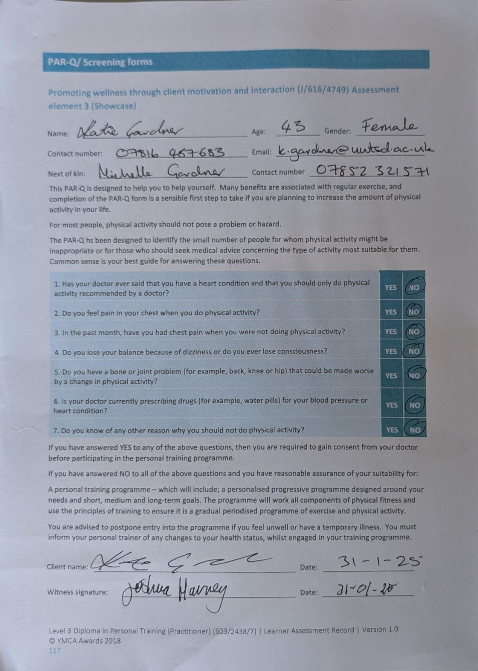
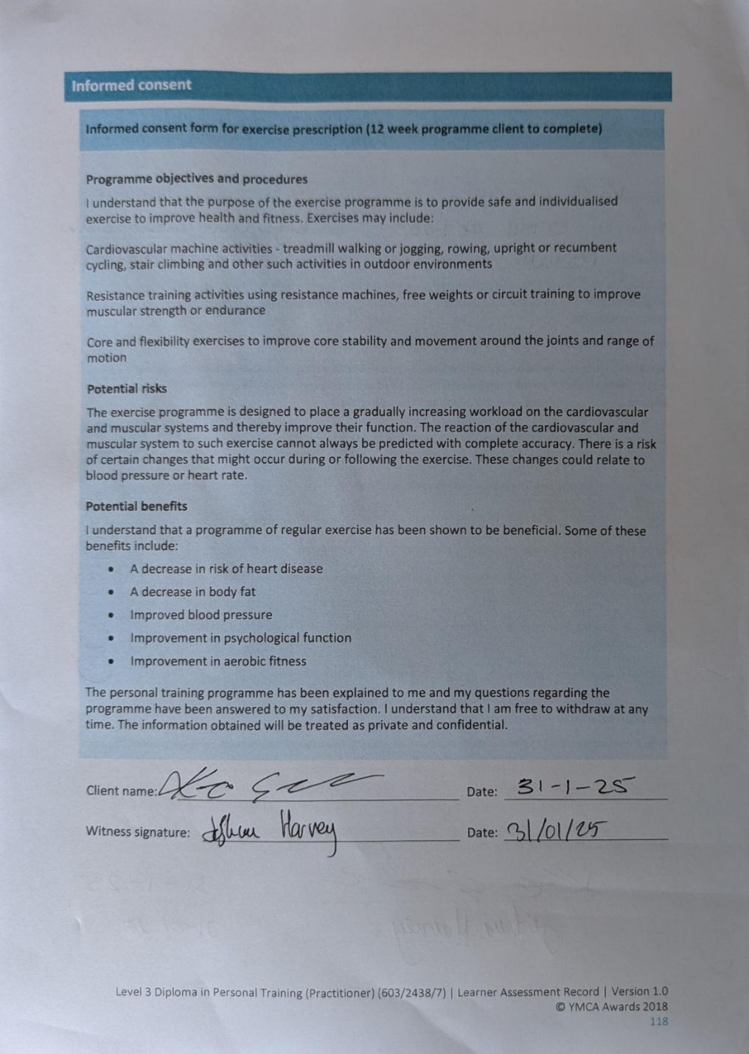

Programme Rationale

Introduction and Client Goals
This 12-week training programme addresses the client's goals of general fitness improvement and weight loss. The WHO recommends "150 - 300 minutes of moderate-intensity" physical exercise or "75 - 150 minutes of vigorous exercise" (WHO, 2020), in the programme, there are 180 minutes total of exercise split into 50 minutes of vigorous effort and 130 minutes moderate with RPE zones of 5 - 7 for the weights training and RPE zones of 6-8 for the cardiovascular sections (Appendix C)

Exercise Selection and Justification

Resistance Training Choices
The inclusion of the bench press was based on research indicating that using both of these forms of horizontal push exercises is useful, as a study by Alizadeh et al. (2020) found that there was significantly less Electromyophraphy activity with the muscles in use in the bench press in comparison to the bench press which made it a better fit for the client as they struggle with pushups and isolating the muscles would be a better fit to build up strength. Compound movements such as horizontal push, horizontal pull, Squats and hinges are used because they focus on the key movements used in daily life. According to Koderi et al. (2020), Romanian deadlifts with the correct stance to increase muscles have been researched to find that strength in the hamstrings from the hinge action performed is beneficial for activities in daily living.

Aerobic Training Choices
The choice of using incline walks at an HR zone of 130 - 145 BPM targets the client's goal of improving overall fitness. It has been discovered to be advantageous for the client's goal as a study conducted by Ehlen et al. (2011) found that obese adults conducting incline walks with lower loading rates benefit weight loss compared to faster tempo walks.
The use of the Bike for the main cardiovascular element of the workout was used as this mode of exercise has been shown to improve aerobic capacity and body composition in a systematic review conducted by Chavarrias et al. (2019), and with a mixture of this and other forms of weight loss such as diet can also aid in the reduction of body fat, this meets the client's goals of weight loss and general fitness increase.

Programme Structure and Split
Included in the workout programme were one upper body day, one lower body day, and one full body day. With this in mind, it is important to accommodate the client's availability and have the opportunity to train all parts of the body with enough stress placed on each part and to give adequate rest to be able to train again. This type of training has been researched by Ravara et al. (2023), that having split days and regularly training each part of the body has been shown to effectively train all major muscle groups of the upper and lower extremities Wochner et al. (2020), while also giving them adequate rest between sessions, this promotes balanced training, and accommodation towards the client's schedule. The strengths of training in traditional set structure were found by Merrigan et al. (2019), to be the most beneficial to elicit a greater amount of gains when tested on male subjects and has been found to elicit similar amounts of muscle gains in female athletes which would help the client for achieving their goals of overall fitness improvement (Appendix A).

Training Variables and Progression
Progressive overload was achieved by planning each session to gradually increase repetitions and the weights to align with progression and achieve the client's weight loss goal. Having more muscular endurance-based sets and having only 30 seconds of rest was found in a study by Yuniana et al. (2023); this was beneficial for achieving the goal of weight, while more rest in the 120 seconds area is found to be a more effective rest length for muscle growth. This training mode was prioritised over hypertrophy and strength training as the client's goals aligned with muscular endurance more than training for strength and hypertrophy.

Variation and Plateau Prevention
Variation was introduced in weeks 6 - 8, to prevent plateau and maintain motivation, as supported by a research study by Gelman et al. (2022), which found that there can be two stages used to be able to add variability to the training, including variability in the muscle stimulation and the second being the pattern in which the individual is training to change the time when this stimulus is being stresses on the muscle.

Individualisation and Adaptation
The programme was tailored to the client in 3 ways to be able to succeed in their needs, stick to their ability and build upon their feedback received with exercise choice; exercises such as goblet squats were swapped to the leg press machine and using light weights at the beginning of the programme to be able to build up from this start point. Adaptations such as teaching styles were changed to accommodate different learning strategies, as in an article by Urick (2016), where this dictates the use of different strategies for learning for different people; this was used to change the teaching supplied to the client.

Summary
In summary, this evidence-based programme has been meticulously designed to support and challenge the client in several ways to aid in achieving their goals of improved general fitness and weight loss in a safe, progressive, and sustainable manner. Using up-to-date research and recognised best practices, the programme first addresses client safety with positive reinforcement, long-term enjoyment and overall satisfaction with the gym environment. Through careful selection of exercises that adhere to the client's goals while also staying in line with the client's preference, progression and ongoing individualisation based upon feedback, this approach ensures that the client is both challenged and supported through their fitness journey.

Reflection

Programme Planning and Delivery
My initial expectation for the programme was that I was going to have to change a lot about it; compared to reality, the programme is a suitable fit for my Client; I had to modify 2 exercises, the goblet squats being changed for leg extensions and also lunges for single leg press, this was promoted by the feedback received from the Client.

Client Engagement and Feedback
The Client responded well to all of the different sessions, with cardio being the main difficulty, and more focus on intensity was needed. There were specific machines that the Client preferred, such as the Smith machine to be used for shoulder press over the machine, and also using the barbell bench press over using the Smith as these both provided challenge while also being supportive and in line with the programme. I built rapport with my Clients by having a communication line, being open and upfront with them about the session, and working with them to aid in motivation. The Client's overall confidence observed in the gym was significantly improved, and independence was increased dramatically to the point where, over Easter, individual sessions were completed with an overview from myself.

Progression and Adaption
I ensured progressive overload throughout the programme by checking in with the Client about every exercise, asking reps in reserve about the rate of perceived exercise, and asking how they felt about it. I monitored and tracked the Client's progression using a book where, session by session, I would write down goals for the session and also write down different personal milestones to aim for for the session, as this was in line with the motivation strategy that the Client raised during the initial consultation.

Unexpected Outcomes and Challenges
The barrier I faced was the early mornings for the Client to accommodate their schedule, and having to be awake and social early in the morning is difficult. I overcame this barrier by completing my personal workout before the session to be more awake and more forthcoming to social interactions.

Personal and Professional Development
I developed my social skills and ability to communicate throughout this experience, my problem-solving skills with the workout, and my ability to think on the spot when different pieces of equipment were being used. I have identified that my communication skills in explaining need improvement and that I should not overwhelm the Client with information. This experience influenced my confidence and competence in being a personal trainer, and how it is all set up, gathering clients and being able to run sessions I have planned.

Impact and Learning
The most rewarding aspect of this experience was receiving feedback that the programme and my plans were working and aiding in achieving goals. The most challenging aspect was the initial sessions with the Client and getting over the hurdle of being a patient. I learned that you must throw yourself out there to learn from mistakes. I will apply what I have learned to future training programmes by approaching each like a blank page and getting their preference for exercises rather than throwing difficult exercises at them to see which they like instead.

References:
Clauss, D., Wochner, R., Nattenmüller, J., Tjaden, C., Bruckner, T., Hackert, T., Wiskemann, J., & Steindorf, K. (2020). Impact of progressive resistance training on CT quantified muscle and adipose tissue compartments in pancreatic cancer patients. PLoS One, 15(11), e0242785.
Graduate Journal of Sports Science, Coaching, Management, & Rehabilitation. (2025). The effects of the conventional deadlift and Romanian deadlift on muscle activation and joint angles at a submaximal intensity. Retrieved from https://www.northumbriajournals.co.uk/index.php/gjsscmr/article/view/1595
Livescience. (2023). Exercise bike benefits: Six reasons to jump in the saddle. Retrieved from https://www.livescience.com/exercise-bike-benefits
Merrigan, J. J., Jones, M. T., & White, J. B. (2019). A comparison of compound set and traditional set resistance training in women: Changes in muscle strength, endurance, quantity, and architecture. Journal of Science in Sport and Exercise, 1(3), 264-272. https://journal.hep.com.cn/josisae/EN/10.1007/s42978-019-00030-8
Northumbria Journals. (2025). The effects of the conventional deadlift and Romanian deadlift on muscle activation and joint angles at a submaximal intensity. Graduate Journal of Sports Science, Coaching, Management, & Rehabilitation. https://www.northumbriajournals.co.uk/index.php/gjsscmr/article/view/1595
ResearchGate. (2020). The effects of stance width on muscle activation and performance during Romanian deadlift exercise. Retrieved from https://www.researchgate.net/publication/342275204_The_effects_of_stance_width_on_muscle_activation_and_performance_during_Romanian_deadlift_exercise
ResearchGate. (2019). A comparison of compound set and traditional set resistance training in women: Changes in muscle strength, endurance, quantity, and architecture. Retrieved from https://www.researchgate.net/publication/334988394_A_Comparison_of_Compound_Set_and_Traditional_Set_Resistance_Training_in_Women_Changes_in_Muscle_Strength_Endurance_Quantity_and_Architecture
ResearchGate. (2023). The effectiveness of the weight training method and rest interval on VO2 max, flexibility, muscle strength, muscular endurance, and fat percentage in students. Retrieved from https://www.researchgate.net/publication/369020886_The_Effectiveness_of_the_Weight_Training_Method_and_Rest_Interval_on_VO_2_max_Flexibility_Muscle_Strength_Muscular_Endurance_and_Fat_Percentage_in_Students
ResearchGate. (2019). Health benefits of indoor cycling: A systematic review. Retrieved from http://researchgate.net/publication/335088317_Health_Benefits_of_Indoor_Cycling_A_Systematic_Review
ResearchGate. (2016). Adapting training to meet the preferred learning styles of different generations. Retrieved from https://www.researchgate.net/publication/311914585_Adapting_training_to_meet_the_preferred_learning_styles_of_different_generations_Adapting_training_to_generations
Sawicki, G. S., & Ferris, D. P. (2011). Energetics and biomechanics of inclined treadmill walking and running. Medicine & Science in Sports & Exercise, 43(7), 1210–1217. https://journals.lww.com/acsm-msse/fulltext/2011/07000/energetics_and_biomechanics_of_inclined_treadmill.16.aspx
World Health Organization. (2024). Physical activity. Retrieved from https://www.who.int/news-room/fact-sheets/detail/physical-activity
Wochner, R., Clauss, D., Nattenmüller, J., Tjaden, C., Bruckner, T., Hackert, T., Wiskemann, J., & Steindorf, K. (2020). Impact of progressive resistance training on CT quantified muscle and adipose tissue compartments in pancreatic cancer patients. PLoS One, 15(11), e0242785.

