Programme: International Hotel Management (BA)
Module: International Meetings Management for the Hotel Industry
Module code: BMIH6007
Assignment 1: Feasibility Plan for an International Meeting.
“Winter Wonderland Charity Gala”
Student name:Andreea Catalina Mecic
Student Number:2215573
Lecturer:Christopher Wilkin

Slide 1: Title

Slide 2: Introduction
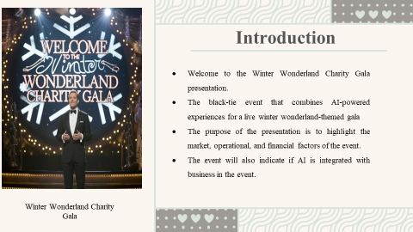
Welcome to the presentation of the Winter Wonderland Charity Gala. In the following lines, this presentation will take you through the market, operational, and financial details of the event. This black-tie gala combines AI experiences and business innovations infused into an interactive winter theme to raise funds for technology education efforts in lesser-privileged populations.
Slide 3: Event Content and Context
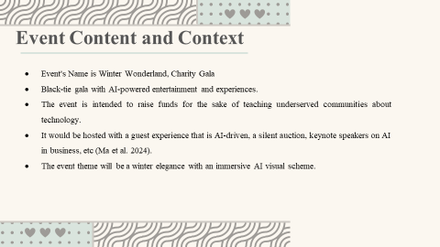
The Winter Wonderland Charity Gala is black-tie-only, concentrating all its energies on raising funds for educational technology in disadvantaged communities. Entertainment will include AI-backed customized guest experiences, AI-based silent auctions, keynote addresses by influential leaders and change agents who will be speaking on the business and philanthropic impacts of AI, among others. Winter wonderland is, after all, quite an enchanting, immersive backdrop.
Slide 4: Event Objectives
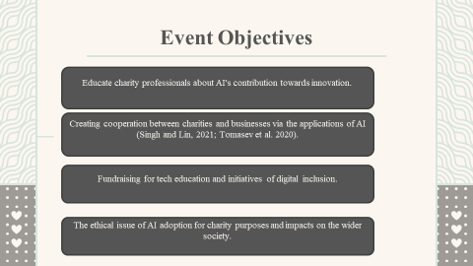
In the production of that event, Winter Wonderland Charity Gala can help create a few important outcomes. It will help charity professionals understand how AI can support them in their daily work, empower business/charity partnerships, raise needed funds for technology education, and answer the question of ethical accountability of AI when applied to philanthropy and social causes.
Slide 5: Market Factor: Target Audience
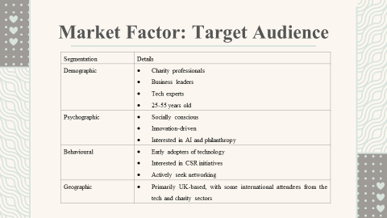
Segmentation | Details
Demographic | - Charity professionals  - Business leaders  - Tech experts  - 25-55 years old
Psychographic | - Socially conscious  - Innovation-driven  - Interested in AI and philanthropy
Behavioral | - Early adopters of technology  - Interested in CSR initiatives  - Actively seek networking
Geographic | - Primarily UK-based, with some international attendees from tech and charity sectors

The target group for the event will comprise charity professionals: managers and digital leads with an interest in making use of AI for good. Specifically, business and tech leaders, especially from CSR departments and innovation teams, and focusing on social causes, will also be prime focuses. The event is UK-based; consequently, participants will be expected to join in from all parts of the UK. Some international interest will also be expected, mainly from interested tech and charity professionals.
Slide 6: Market Factor- Demand and Competition
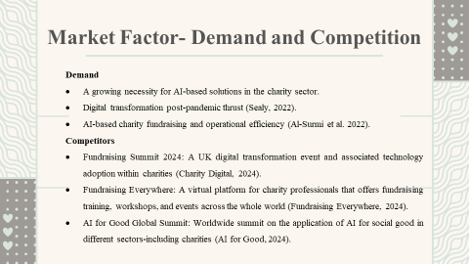
The demand for charity organizations to go digital is increasing with AI. Organizations have to adapt themselves to digital transformation strategies, especially in post-pandemic times. Slightly through competitiveness has been brought in with pure-play competitors who strictly focus on AI; events like the UK Charity Digital Summit and Fundraising Everywhere create this situation. Our AI-driven charity-focused positioning will put us in a unique position.
Slide 7: Market Factor- Marketing Activities
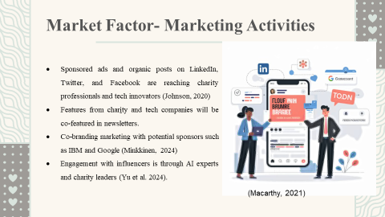
Event will use platforms like LinkedIn and Twitter to reach charity professionals and tech professionals for marketing the event successfully. This event is partnering charity organizations and the tech companies in this event only for the sake of promotions of the newsletter. Also, this event expands our reach and engagement using the promotion from a company like IBM and using the influencers' engagement (Yu et al. 2024).
Slide 8: Event Location and Venue
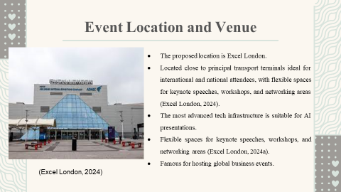
Excel London is very perfect venue for the Winter Wonderland Charity Gala. It is located in a central area of the city, so it will not be a problem to access participants- from local to international participants. The technology-based infrastructure of this venue is highly advanced, suitable for presentations with a focus on AI and very flexible-from large keynote sessions to smaller breakout workshops.
Slide 9: Operational Factor- Staff and Skills Required
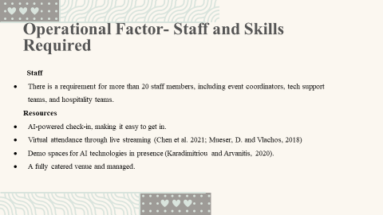
Staff numbers that will be needed to run the program will exceed 20, as it involves all teams of the event coordinators and technical support with hospitality teams. Main resources would involve AI-powered check-in systems that smoothen ease guest management along with an option to present virtual attendance through live streaming. The program also integrates demo sites of AI companies presenting ideas and solutions in their products and, added value to participants and sponsors.
Slide 10: AI and Business Integration
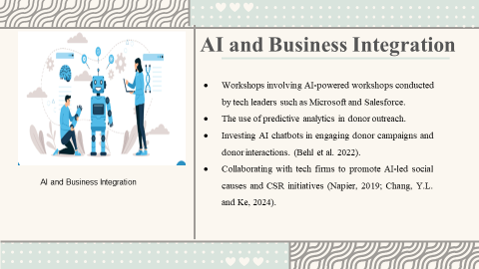
For instance, Microsoft and Salesforce are some of the world's top tech companies, which have structured themselves to come up with AI-driven workshops on the same for these events. The charity work is empowered in fundraising by utilizing AI tools such as predictive analytics to target specific donors, deploying chatbots, among many more. The charity will engage with such prominent tech firms to bring out their charity projects that are AI-driven and the work they are involved with in social responsibility.
Slide 11: Financial Factors
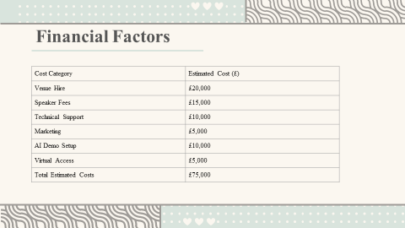
Cost Category | Estimated Cost (£)
Venue Hire | £20,000
Speaker Fees | £15,000
Technical Support | £10,000
Marketing | £5,000
AI Demo Setup | £10,000
Virtual Access | £5,000
Total Estimated Costs | £75,000
This Winter Wonderland Charity Gala is estimated to be around £75,000. Venue hiring is pegged at £20,000, considering that the venue has to be apt and accessible. The payment to the speaker accounts for £15,000 in terms of expert insight. The technical support is estimated at £10,000, considering that there might be need for hitch-free running. Marketing and promotional activities account for £5,000. The cost was split; £10,000 was for setting up the AI demo and £5,000 in virtual access with multiple participation that empowered innovative solutions to be developed to increase engagement and fundraising.
Slide 12: Revenue Streams
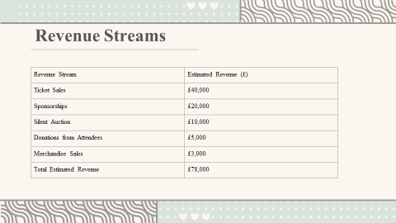
Revenue Stream | Estimated Revenue (£)
Ticket Sales | £40,000
Sponsorships | £20,000
Silent Auction | £10,000
Donations from Attendees | £5,000
Merchandise Sales | £3,000
Total Estimated Revenue | £78,000
The Winter Wonderland Charity Gala has an estimated revenue of £78,000. The key revenues are from gross ticket sales at £40,000 and sponsorship arrangements at £20,000 and £10,000 through a silent auction, adding value to our high-tech-based education initiatives through the £5,000 and £3,000 from guest donations and merchandise sales.
Slide 13: Funding Sources
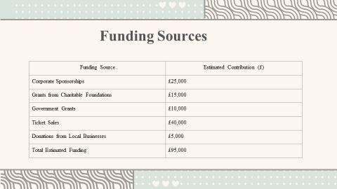
Funding Source | Estimated Contribution (£)
Corporate Sponsorships | £25,000
Grants from Charitable Foundations | £15,000
Government Grants | £10,000
Ticket Sales | £40,000
Donations from Local Businesses | £5,000
Total Estimated Funding | £95,000

Estimated costs for the Winter Wonderland Charity Gala lie around £95,000. Corporate sponsorships will make up most of this: £25,000; grants donated by charitable foundations, £15,000; and we budget further government grants: £10,000. Box office sales will raise £40,000; local business donations £5,000-all for one aim: to raise education through technology and digital inclusion among the underprivileged communities.
Slide 14: Conclusion
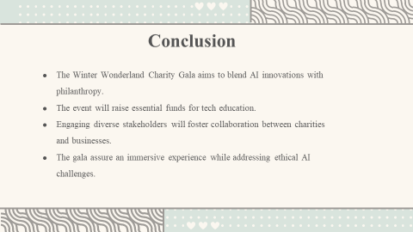
Therefore, the Winter Wonderland Charity Gala is an ideal case for using AI for community benefit as well as for raising funds to support technology education programs. First, attending by a large audience consisting of the representatives of charity organizations, IT companies, and sponsors creates the conditions for cooperation and effective use of innovative practices. In addition to the entertainment, the immersive experience will create further engaging discussions over the ethical issues of AI in charity.
Slide 15: References
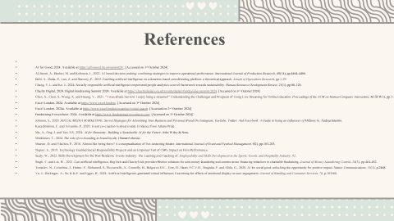

AI for Good, 2024. Available at https://aiforgood.itu.int/summit24/. [Accessed on 3rd October 2024]
Al-Surmi, A., Bashiri, M. and Koliousis, I., 2022. AI based decision making: combining strategies to improve operational performance. International Journal of Production Research, 60(14), pp.4464-4486.
Behl, A., Dutta, P., Luo, Z. and Sheorey, P., 2022. Enabling artificial intelligence on a donation-based crowdfunding platform: a theoretical approach. Annals of Operations Research, pp.1-29.
Chang, Y.L. and Ke, J., 2024. Socially responsible artificial intelligence empowered people analytics: a novel framework towards sustainability. Human Resource Development Review, 23(1), pp.88-120.
Charity Digital, 2024. Digital Fundraising Summit 2024. Available at https://charitydigital.org.uk/events/digital-fundraising-summit-2024. [Accessed on 3rd October 2024]
Chen, X., Chen, S., Wang, X. and Huang, Y., 2021. " I was afraid, but now I enjoy being a streamer!" Understanding the Challenges and Prospects of Using Live Streaming for Online Education. Proceedings of the ACM on Human-Computer Interaction, 4(CSCW3), pp.1-32.
Excel London, 2024. Available at https://www.excel.london/. [Accessed on 3rd October 2024]
Excel London, 2024a. Available at https://www.excel.london/organiser/venue-spaces. [Accessed on 3rd October 2024]
Fundraising Everywhere, 2024. Available at https://www.fundraisingeverywhere.com/. [Accessed on 3rd October 2024]
Johnson, S., 2020. SOCIAL MEDIA MARKETING: Secret Strategies for Advertising Your Business and Personal Brand On Instagram, YouTube, Twitter, And Facebook. A Guide to being an Influencer of Millions In. AndreaAstemio.
Karadimitriou, C. and Arvanitis, P., 2020. Event co-creation in street events: Evidence from Athens Pride.
Ma, A., Ong, J. and Tan, S.S., 2024. AI for Humanity: Building a Sustainable AI for the Future. John Wiley & Sons.
Minkkinen, T., 2024. The role of co-branding in brand loyalty (Master's thesis).
Mueser, D. and Vlachos, P., 2018. Almost like being there? A conceptualisation of live-streaming theatre. International Journal of Event and Festival Management, 9(2), pp.183-203.
Napier, E., 2019. Technology Enabled Social Responsibility Projects and an Empirical Test of CSR's Impact on Firm Performance.
Sealy, W., 2022. Skills Development for the Post-Pandemic Events Industry: The Learning and Teaching of. Employability and Skills Development in the Sports, Events, and Hospitality Industry, 92.
Singh, C. and Lin, W., 2021. Can artificial intelligence, RegTech and CharityTech provide effective solutions for anti-money laundering and counter-terror financing initiatives in charitable fundraising. Journal of Money Laundering Control, 24(3), pp.464-482.
Tomašev, N., Cornebise, J., Hutter, F., Mohamed, S., Picciariello, A., Connelly, B., Belgrave, D.C., Ezer, D., Haert, F.C.V.D., Mugisha, F. and Abila, G., 2020. AI for social good: unlocking the opportunity for positive impact. Nature Communications, 11(1), p.2468.
Yu, J., Dickinger, A., So, K.K.F. and Egger, R., 2024. Artificial intelligence-generated virtual influencer: Examining the effects of emotional display on user engagement. Journal of Retailing and Consumer Services, 76, p.103560.

