E-portfolio report
Learning in the Digital Era – BMPL4007/BMPS4009
Kaiyum Ahmed Khan
2028296
Table of Contents

Task 1 – Written summary 2
Task 2 – Mind map 4
Task 3 – Presentation 5
Task 4 – Reflection 6
Reference list 8

Task 1 – Written summary

Higher Education consists of taking control of your own learning which means that the responsibility of adequate preparation lies within yourself. There are many factors that need to be considered and managed when preparing for higher education.
First and foremost, is preparing a suitable environment of learning in order to ensure that concentration levels are maintained and also to maximise productivity. According to The Study Skills Handbook by Stella Cottrell (2019), some examples of ways in which to ensure this, is to minimise distractions, turning off your phone, choosing a designated area to maintain consistency and deciding on an appropriate layout of the room/area of study. As well as preparing a suitable environment, it is vital to select the best time of day to study which fits in well with your routine. Planning study sessions and establishing a routine will help to optimise your level of learning. It is also very important to ensure that you plan slots to take regular short breaks from study to avoid a decrease in concentration and productivity.
Effective time management is a key factor in ensuring that all aspects of your course are paid attention to and to help maintain a good balance of study life. Keeping track of when and where classes are held, and when assignments are due will enable you to attend classes appropriately and meet deadlines efficiently.
Prioritizing task management is an essential skill to ensure maximum productivity and an important way to do this is by planning ahead. However, failing to plan is ultimately a plan of failure. Following a evidence based principle such as Eisenhower’s Principle will support you to prioritize tasks efficiently.
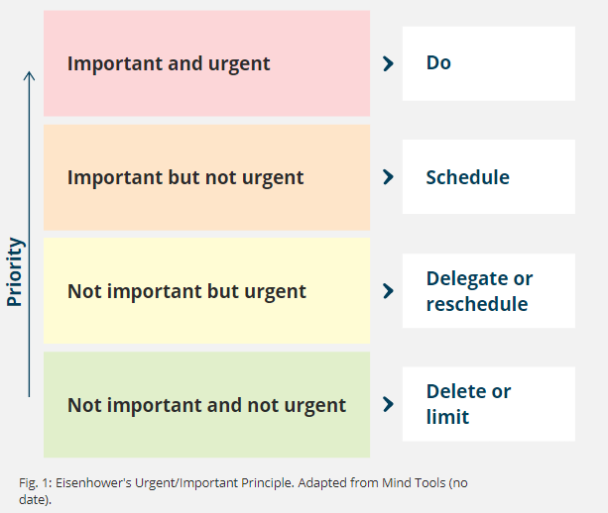

Learning how to correctly use relevant digital mediums to produce information is also a vital skill. Microsoft Word, Microsoft PowerPoint, Microsoft Outlook, and Microsoft Teams are the four core software programmes required to create and share coursework and assignments.
When gathering information for assignments and presentations, it is essential to ensure that all information is evidence based and is obtained from authentic sources. Information should be research based and gathered from reliable credible sources such as journals, articles and books and needs to be referenced appropriately.

Task 2 – Mind map

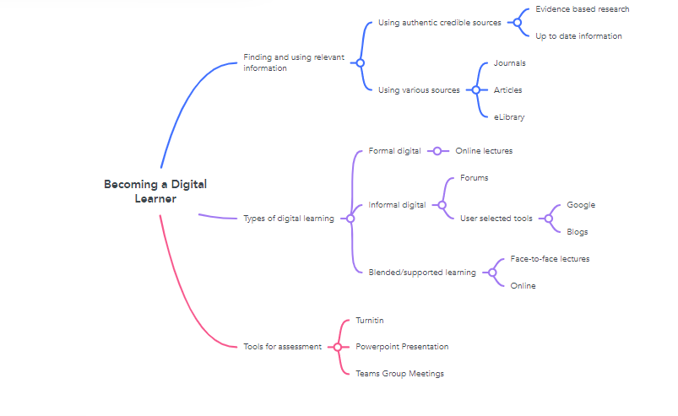

www. Mindmeister.com

Task 3 – Presentation
Please follow this link to view my presentation:
https://youtu.be/M0XGsSP-2bk

- Personal Identity – one of four children, grew up in an extended family which has taught me about sharing a close bond with each other, community spirit
- Grew up in a cultural background, good relationships and society hold a lot of importance in my eyes, I believe in respecting one another and working together
- I understand the meaning of teamwork and being a good team player to meet goals
- Working with dedication and being reliable
- Using effective communication skills and people skills
- Personal interests – cricket, brings me close to like minded people and feel valued as part of a team/group

Task 4 – Reflection
Starting university has been a remarkable journey of both challenges and achievements and has already taught me an incredible amount. It has been a crucial learning process and it is very important to effectively reflect on this journey in order to fully appreciate the whole experience.
When reflecting on any given experience or piece of work, it is vital to use an effective and well produced tool or guide. One such example is Borton’s reflective tool which is a very simple yet extremely beneficial guide that enables the user to easily look back at and evaluate their experience.

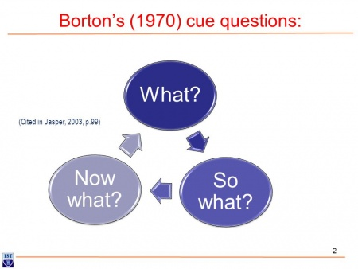

This first question that this tool asks the reflector is ‘What?’ which highlights the description of the nature of the event. Starting university and learning how to navigate through online learning and resources has been somewhat a challenging experience. Learning the basics of accessing the module content has not been much of a struggle. However, learning how to search for relevant information via the university’s online library took some time. Initially I struggled with obtaining high quality and evidence-based information regarding my topic which in turn made it hard for me to write my first assignments.
The next segment of the tool focuses on the question; ‘So What?’. As a result of this difficulty, I had to allow time to familiarise myself with the appropriate search terms and practise how to enter information effectively to obtain the best possible search results. I learnt to use my time management skills to break up the assignment into sections and focus on each section one at a time. It was important to gather my thoughts and write notes along the way to help me to be productive.
The final section of the reflective tool asks the reflector ‘What Now?’. Through this challenging experience, I was able to learn to change my techniques of collating data through effective study sessions with my tutor. I was able to gain knowledge and guidance on how to best access online resources and then write my assignments. Going forward, I will ensure that I seek help from relevant sources and allow myself time to learn new techniques of essay writing.

Reference list
- Business management daily (2021) ‘Try the Eisenhower Matrix for workflow’ vol.47 (10), p.1
- Burns, Tom (2016) The complete guide to success at university. 4th ed. London sage press
- Cottrell, Stella (2019) The study skills handbook. 5th ed. London Red globe press
- Rolfe, Gary (2014) ‘Reach, touch and teach: Terry Burton’ vol.34(4), p.488-489
- www. Mindmeister.com

