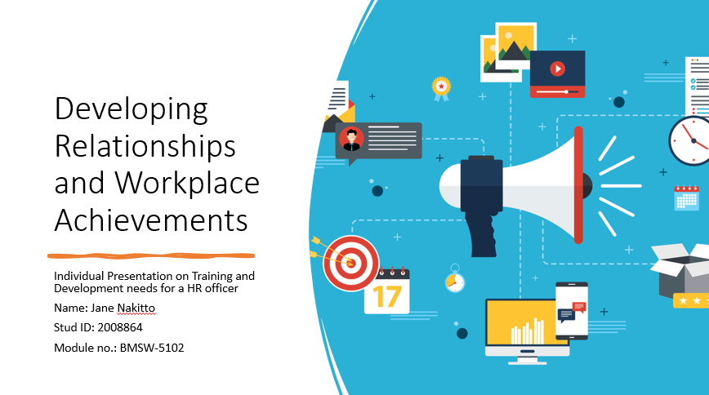

Hi, my name is Jane Nakitto, Today I am going to Do a presentation on developing relationships and workplace achievements.

No let’s have a look on main body. Task 1 is determining KSB that needed by HR professionals across the departments

My personal KSB (knowledge, skills and behaviours) is, I am

let’s move to task 2 which is my personal skills audit. Before I start personal audit, I would like to mention I work as a carer from NHS during the time of Pandemic for short period of time where I lead a small team of 1-5 employee.

As per communication skills

on the other hand, when it comes to problem solving skills,

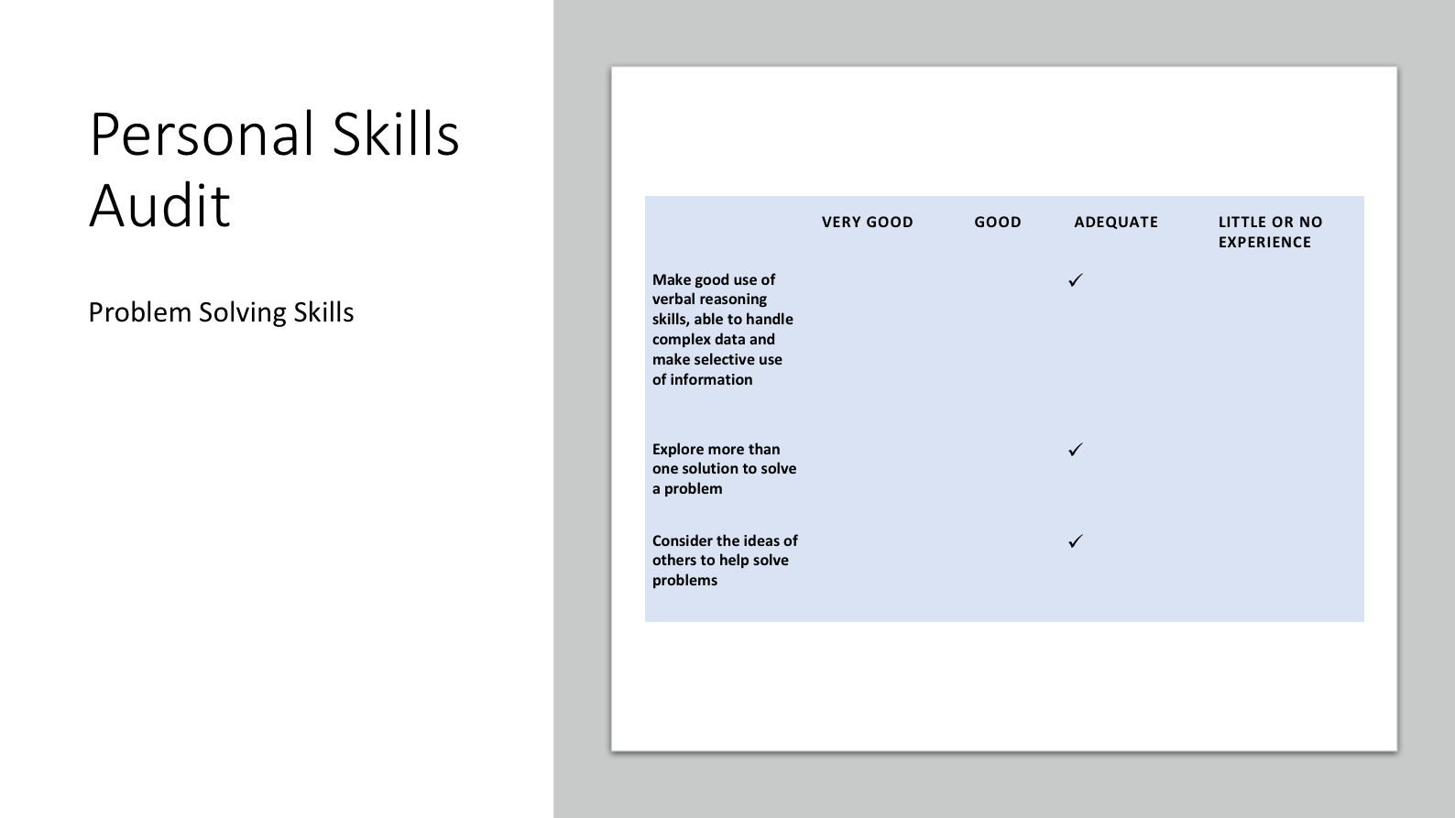

Now, let’s have a look on my supervisory management

the next Task is my individual SWOT analysis as a HR officer where I will demonstrate my Strength. Weakness, Opportunity and Threat

The final question is potential benefits to the organisation of developing me as an HR officer

That’s all for today thank you very much

