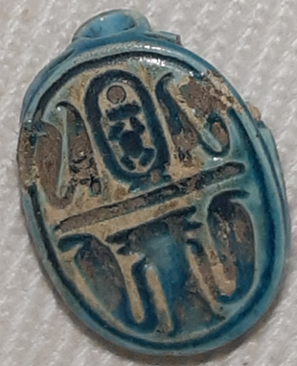
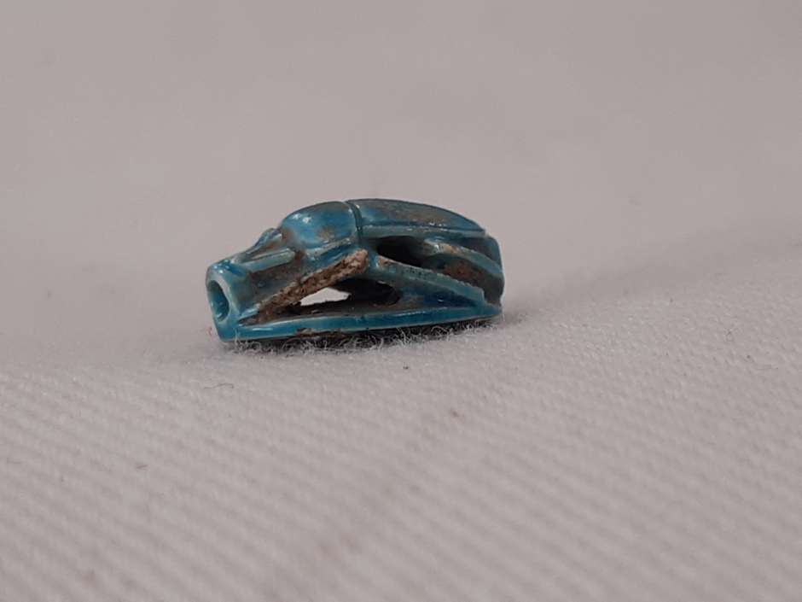
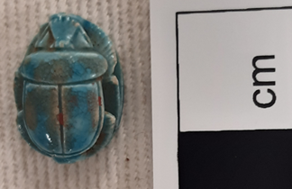
Image 3: Base of scarab with hieroglyph symbols (own Image: 24-01- 2023).
Image 4: Scarab Beetle Left side (own Image: 31-01-2023).

Image 1: Scarab from above (own Image: 31-01-2023).

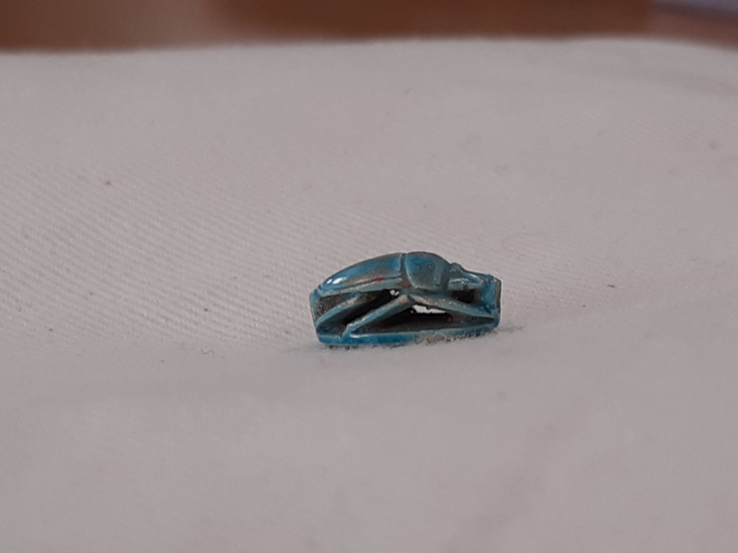
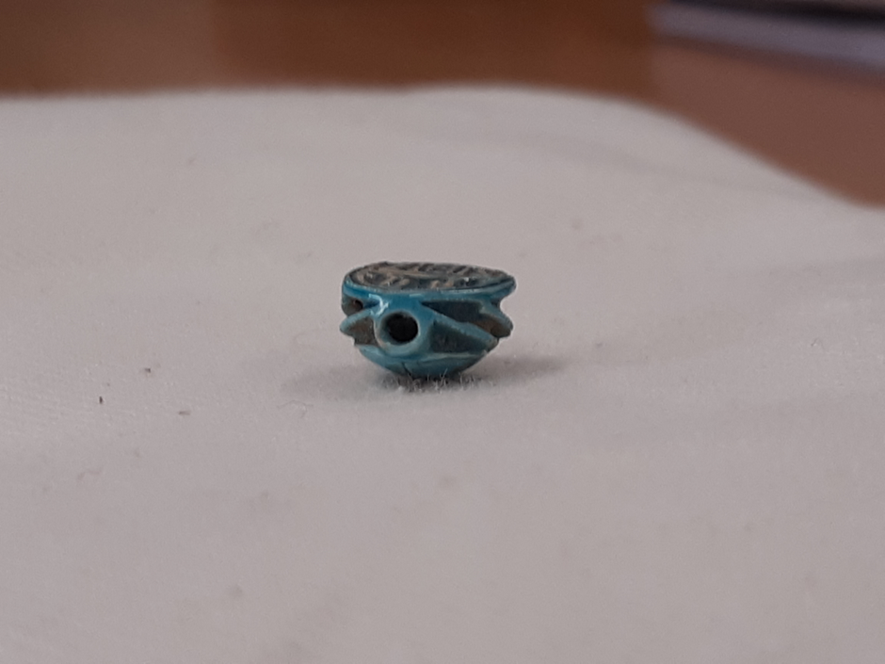
Image 2: Scarab beetle Right side (own Image: 31-01-2023).

Image 5: Rounded ends on either side (own Image: 31-01-2023).

Object name: Scarab
Cyfarthfa Castle Museum Merthyr Tydfil CCM
Number: 1725.004?
Object Type: amulet
Dimensions: height – approximately 0.5cm, width – approx. 0.8cm, length – approx. 1.2cm
Material: Blue/Green Faience (sintered-quartz ceramic?)
Period: Eighteenth Dynasty ca. 1479 B.C.E or later, (End of the Old Kingdom to the Graeco-Roman period (1479BC - 30BCE).
Origin: Egypt - Cairo?
Size – Length - 1.2 cm - height - 0.5 cm - width - 0.8 cm.
Primary/Birth name: Thutmose III
Royal/Throne name: Menkheperra.
Individual; ruler; royal/imperial; Egyptian; Male
Provenance: “Tomb spoils” from Cairo? Egypt. Originally belonging to Major Harry Hartley Southey from Merthyr Tydfil of South Wales. Donated by his family due to his death in 1917 during World War I.
Description: An intricately carved Scarab beetle with a flat plate underneath featuring incised Hieroglyphic symbols.
Object analysis by Julia Jones 2007994.
Colour - greenish blue or turquoise. Displaying surface vitrification, thus creating a bright lustre with various shades including brown and specks of red.
The colour turquoise in ancient Egypt was connected to the ocean and sky representing balance and serenity. A popular colour used in jewellery to protect against unnatural or premature death. Turquoise gemstones were considered sacred by some and believed to bring good luck and fortune.

Faience: A combination of Nile sand, natron, and copper oxide fired to bring the colour out and give it a natural glaze.

Symbols on the head of the scarab:
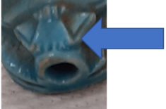
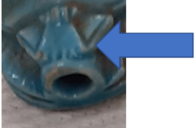
Image 7: Possible flails representing his military achievements or the unity of upper and lower Egypt (own Image: 24-01- 2023).
𓍝
Image 8: Similar layout to the Ma’at Symbol (own Image: 24-01-2023).

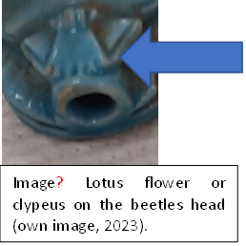
Image 6: Lotus flower or Clypeus of scarab (own Image: 24-01-2023).

(sšn) or blue lily represented death and rebirth in ancient Egypt and was commonly displayed on funerary-related objects.
Image 9: 𓆸 The Lotus flower

Image 10: 𓇮 Thorn (Spd)

Image 11: 𓏙 Cone-shaped bread (di)

The two triangles on either side of the lotus flower could be a reference for "giving."

Image 12: 𓍝 U38 mḫꜣt “Scale”

‘The ‘Ma’at’ symbol also follows a similar design and layout to the triangles and possible flagellums (flails).

Image 13: 𓐒 mat (ṯmꜣ) Total or to assemble, unite lands, bring, or join as one together.

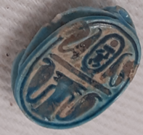
Image 14: Oval Base of scarab (own Image: 24-01-2023).
The top section of the flat oval base design is slightly damaged on either side, more so on the right over the Cobra's head.

Top left: Cobra attached to a flowering reed:
Image 15:
𓇋 i or j
Single flowering reed

The flowering reed leaves could represent the gods Maat, Shu, or Re. The reed and Mn ḫpr Re symbols combined might read (In the name or shape of the God Re). The ‘Plume’ or ‘Ma’at’ feather may also have the same meaning in this setting.

Representing dual expression of good and evil, fertility, rebirth, transformation, immortality, and healing, the “Four Noble Ladies,” are four powerful goddesses or rearing cobras that can be identified as Isis, Nephthys, Selket and Neith, or any other combinations of the many gods and goddesses that took on its form. Two cobras can also be another way to indicate that what is said on the scarab is to be spoken, as knowing, or saying a name activated the magic (Heka) to harness its power to make the offering given to the King. Possibly by a resolute and highly skilled craftsperson to gain favour or acceptance into the afterlife by assisting and nourishing the deceased through ritual and magic.
Image 16: 𓆗 Erect cobra (jꜥrt) Uraeus)

Image 17: 𓍷 V10 (šn or rn) Vertical Cartouche

Top Centre: A Vertical Cartouche meaning “encircle." The inscription is also encircled by a single line” for double the protection. Containing three symbols.

Image 19: 𓏠 Y5 Senet board (mn or men) permanence or endurance and a common Pharaonic epithet (Kings logo).

Image 18: 𓇳 Sun (Ra/Re) (name of the sun god).

Image 20: 𓆣 ḫpr Scarab beetle - form, being, to become or emerge.

Top right: Is a Flowering Reed attached to a Cobra and a mirror image of the other side.
The top and bottom groups of symbols are divided with a flat oval symbol that may represent land or a sandy tract which combined with a cobra may represent eternity.
Image 21
𓈀 sandy tract (horizon).
Image 22: 𓆖 combination of cobra and sandy tract (Eternity).

The lower section: Two Rearing or Erect Cobras known as Uraeus are attached on either side of a central Hes vase, associated with death, rituals, and purification. The vase is similar in appearance to the Djed pillar associated with strength, endurance, the god Osiris, and/or Ptah the god of craftsmen who were often depicted as having blue skin representing the blue lapis lazuli stone that the ancient Egyptians mimicked by making Egyptian blue faience. Thutmosis III was responsible for rebuilding many war-damaged mud brick temples with stone blocks as well as being in charge of building many monumental structures such as obelisks and tombs.
The snakes (Uraeus) on the lower section are so detailed that you can even see the fangs and an opened mouth on the one on the right if you look closely. Their duty was to defend and protect the king and all his sacred areas with their magic glow and belching fire. The goddess Wadjetw was a stylised Egyptian cobra in the form of the uraeus and represented an important deity used as the symbol of sovereignty for the Pharaohs, who incorporated it into their diadem (or crown) which was used up until (30 BC). In ancient Egypt snakes shedding their skins were linked to rebirth and their venomous bites could be deadly. A symbol of protection, with many gods and goddesses taking its form.
The scarab, modelled on the Dung beetle appears both as a hieroglyph and as an amulet and is a combination of art, language, spirituality, magic, ritual, funerary and afterlife beliefs. Ancient Egyptians viewed the rolling ball of dung as a metaphor for the sun moving across the sky. Their burrows resembled the layout of the tomb and the beetle larvae hatching from the dung were seen as a sign of rebirth and regeneration. Many thousands have been found over the centuries even being placed within the wrappings of the deceased’s mummy for protection and good luck. The Scarab is also the symbol for Khepri an Egyptian sun god popular in the Middle Kingdom (2500 BCE).

An amulet could be carried, left in a sacred place, or worn in a ring, charm bracelet, or necklace, they were sometimes placed in tombs with a spell wrapped up in the central void to attain protection, power, or both from the dead ancestral gods. Scarabs from ca. 1479-1425 B.C.E were reportedly amongst the finest ever made and there was a repetition in popularity and belief in the Twentieth to the Twenty-Sixth Dynasty when craftsmen increased the use of a soft, pastel blue pigment that had been created during the reign of Thutmose III.
Thutmosis III reigned for an impressive 54 Years. Trained in the army from a child and was an expert planner, with tactical and strategical skills he never lost a battle. He educated his enemy's children suppressing their mistrust of Egyptian society in return, had several wives and was revered for at least a thousand years after his death. The Cartouche of Thutmosis III contains his Royal name “Menkheperre, which were just two of his five names, others included a Horus name, a Nebty name, and a Golden Horus Name.

Similar objects:

Bibliography
Ancient Resources Auctions, 2016. Lot 38: A lot of 8 Egyptian terracotta amulet moulds [online] Available At: https://www.invaluable.com/auction-lot/a-lot-of-8-egyptian-terracotta-amulet-molds (Accessed 28-01-2023).
Arnold, D., Haeny, G., Bell, L., and Finnestad, R.B., 1997. Temples of ancient Egypt. Cornell University Press.
Baker, A., 2023 image pintrest
Pinterest 2023 Egyptian 18th dynasty scarab
Assmann. 2005. (p.87-112)
.
Assmann, J., 2002. The mind of Egypt: History and meaning in the time of the pharaohs. Harvard University Press (p.9).

Australian Museum, 2018. Tombs in ancient Egypt [online] Available at: https://australian.museum/learn/cultures/international-collection/ancient-egyptian/tombs-in-ancient-egypt/ (Accessed 28-01-2023).
Bard, K.A., 2015. An introduction to the archaeology of ancient Egypt. John Wiley & Sons (p.208; 244-258;259).
Bader, B. and Álvarez, M.S., 2016. Results of five years of pottery analysis in the Temple of Millions of Years of Thutmosis III in Western Thebes (2011–2015). Ägypten und Levante/Egypt and the Levant (p.157-262).
(Baines 1995b: (p. 9-19).

Ben-Arieh, S. and Alon, D., 2004. Bronze and Iron Age Tombs at Tell Beit Mirsim. Jerusalem: Israel Antiquities Authority.
Ben-Tor, D. and Keel, O., 2012. The Beth-Shean level IX group. A local scarab workshop of the Late Bronze Age I. All the Wisdom of the East: Studies in Near Eastern Archaeology and History in Honour of Eliezer D. Oren (p.87-104).

Bentum, 2013. The Sacred Scarab of Ancient Egypt [online] Available At: https://henrivanbentum.blogspot.com/2013/06/the-sacred-scarab-of-ancient-egypt.html (Accessed 28-01-2023.
Brandl, B., 2004. Scarabs, Seals, an Amulet, and a Pendant. Ben-Arieh, S. Bronze and Iron Age Tombs at Tell Beit Mirsim (IAA Reports 23). Jerusalem (p.19-21;117;118;123-188).

British Museum, 2023. Scarab Beetle amulet [online] Available at: https://www.britishmuseum.org/collection/object/Y_EA65413 Accessed 18-01-2023 (Accessed 27-01-2023).
Boonstra, S.L., 2020. Finding Scarab Amulet Workshops in Ancient Egypt and Beyond: Typological vs Material Workshops. Approaches to the Analysis of Production Activity at Archaeological Sites (p.65).

Bowden, D., 2023. Teel vs Turquoise the Key Differences explained [online] Available at: https://www.irreverentgent.com/teal-vs-turquoise (Accessed 02-02-2023).
Borghouts, J.F. ed., 1978. Ancient Egyptian magical texts (Vol. 9). Brill. Page VIII –

Boyce, A., 1989. Notes on the manufacture and use of faience rings at Amarna. Amarna Reports V, pp.160-168.
Brooklyn Museum, 2023. Scarab of Thutmose III Mounted in Ring: Egyptian, Classical, ancient Near Eastern Art [online] Available at: https://www.brooklynmuseum.org/opencollection/objects/4090 (Accessed 27-01-2023).
Çakmak, L.A., 2019. Seals and Sealing. Excavations at Maresha Subterranean Complex 169, Final Report, Seasons 2000–2016 (p.116;126). “Side B features a scarab flanked by ma at feathers and reed leaves p.116 – Thutmose III
Cooney, K.M., 2005. Teeter, E. 2003. Scarabs, scaraboids, seals, and seal impressions from Medinet Habu, with post–Pharaonic seals and seal Impressions by TG Wilfong. –Chicago, University of Chicago Press (Oriental Institute 118). PalArch's Journal of Archaeology of Egypt/Egyptology, 3(1) (p.19;38-45).
The Collector, 2022. Major Harry Hartley Southey (Accessed 03-02-2023).
David, A., Mullins, R.A. and Panitz-Cohen, N., 2016. An Mnḫprrꜥ Scarab from Tel Abel Beth Maacah. Journal of Ancient Egyptian Interconnections, 9, (p.1-13).
Dorman, p, 2006. The early reign of Thutmosis III: an unorthodox mantle of Co-regency. Thutmosis III (p.39-68).
Egypt Museum, [online] Available At: https://egypt-museum.com/alabaster-heb-sed-vase (Accessed 15-02-2023).
(Egypt online). https://www.ancient-egypt-online.com/thutmose-III.html

El Mahdy, C., 1989. Mummies, myth, and magic in ancient Egypt p.13 Manley, B., 2012. Egyptian Hieroglyphs for Complete Beginners: New Step-by-Step Method. National Geographic Books.
Enterprise, 2017. The hypocrisy of antique collection [online] Available At: https://enterprise.press/stories/2017/03/01/the-hypocrisy-of-antique-collection/ Accessed 03-02-2023).
Everipedia, 2022.Thutmose III [online] Available At: https://everipedia.org/Thutmose_III (Accessed 29-01-2023).
Faulkner, R.O., 1964. A concise dictionary of Middle Egyptian.
Gardiner, A.H., 1927. Egyptian Grammar Dictionary (p.32).
Harrington, N., 2012. Living with the dead: ancestor worship and mortuary ritual in ancient Egypt. Living with the Dead, (p.1-208).
?(Harrington, 2013 (p.2)
Hart, G., 2005. The Routledge dictionary of Egyptian gods and goddesses. Routledge.

Hayward, W., 2017. Fascinating Egyptian artefacts collected by a Merthyr explorer a century ago are set to go on display. Wales online [online] Available at: https://www.walesonline.co.uk/news/local-news/fascinating-egyptian-artefacts-collected-merthyr-12630832 (Accessed 03-02-2023).

Ikram, S., 2015. Death and burial in ancient Egypt. American University in Cairo Press (p.47-76).
Food Offerings, Selima Ikram (p.87-92).

Ikram, S., 2011. FOOD AND FUNERALS SUSTAINING THE DEAD FOR ETERNITY. Polish archaeology in the Mediterranean, (XX), pp.361-372.
Iwaszczuk, J., 2015. Rebirth of Temples under the Rule of Hatshepsut and Thutmose III: Vocabulary. Études et Travaux (Institut des Cultures Méditerranéennes et Orientales de l’Académie Polonaise des Sciences), (28) (p.29-30;32-36;161-178).

Josephson, J.A., 1992 A variant type of the Uraeus in the Late period (p.123-130).
El Mahdy, C., 1989. Mummies, myth, and magic in ancient Egypt (p.13;151;154)
Manley, B., 2012. Egyptian Hieroglyphs for Complete Beginners: New Step-by-Step Method. National Geographic Books.
Merthyr Tydfil County Borough Council, 2022. [online] Available at: https://www.visitmerthyr.co.uk/things-to-do/attractions/cyfarthfa-museum-art-gallery (Accessed 01-02-2023).
The Metropolitan Museum of Art History, 2023. Amulets [online] Available at: https://www.metmuseum.org/toah/hd/egam/hd_egam.htm (Accessed 30-01-2023).
The Metropolitan Museum of Art, 2022. Scarab of Thutmose III New Kingdom, ca. 1479–1429 B.C.E. [online] Available at: https://www.metmuseum.org/art/collection/search/557076 (Accessed 28-01-2023). (Hes-vase + snakes-1479) Most important
The Metropolitan Museum of Art, 2022. New Kingdom Scarab, Joint reign of Hatshepsut and Thutmose III [online] Available At: https://www.metmuseum.org/art/collection/search/550524 (Accessed ?-2023).
Nihon, A., 2005. Turquoise Winged Scarab. Late Period, 26th-30th Dynasty, 688-343 B.C.accession no. 72.3024a-c. Fine Arts Museum of San Francisco, 1925.172 and 1925.188. Art Institute of Chicago, 1892.231. Item No. M1090. Meduca ancient Art [online] Available At:
https://medusa-art.com/antiquities-gallery/egyptian/egyptian-turquoise-winged-scarab.html (Accessed ??2023).

Nihon, A., 2005. EGYPTIAN BLUE HEART SCARAB. LATE PERIOD, 26TH-30TH DYNASTY, 688-343 B.C.
A fine ‘Egyptian Blue’ heart scarab, naturalistically detailed with wing case and legs defined, the underside flat, pierced for attachment.https://medusa-art.com/antiquities-gallery/egyptian/egyptian-blue-heart-scarab.html (Accessed ??2023).

Noble, J.V., 1969. The technique of Egyptian faience. American journal of archaeology, 73(4), (p.435-439).

Novus, S., 2014 Egyptian Blue – The Oldest Known Artificial Pigment. Ancient Origins 2013-2022

Pinch, G., 2004. Egyptian mythology: A guide to the gods, goddesses, and traditions of ancient Egypt. Oxford University Press, USA.
Pinch-magic
Why was the Cobra important to the ancient Egyptians? [online] Available At: https://massinitiative.org/what-does-the-cobra-represent-in-ancient-egypt/ (Accessed 25-01-2023).

Petrie, W.M.F., 1914. Amulets: illustrated by the Egyptian collection in University College, London. Constable (p.6;21-22). p.21-22 – preserve name, power over property (p.6)
Sarr, J., 2001. Gayer-Anderson Scarab Collection.
Snape, S., 2011. Ancient Egyptian Tombs: The Culture of Life and Death. John Wiley & Sons p.24-34
Schulz, R., 2020. Seals and scarabs. The Oxford Handbook of Egyptology, p.367.p.359,814

Spieser, C., 2010. Cartouche. UCLA Encyclopaedia of Egyptology, 1(1).
Strouhal, E. and Forman, W., 1992. Life in ancient Egypt (p. 173). Cambridge, UK: Cambridge University Press (p.82;154)
Stupko-Lubczyńska, A., 2014. Inscribed Vessels Represented in the Chapel of Hatshepsut at Deir el-Bahari? Inscribed Vessels Represented in the Chapel of Hatshepsut at Deir el-Bahari? Études et Travaux (Institut des Cultures Méditerranéennes et Orientales de l’Académie Polonaise des Sciences), (27), pp.405-420.

Stupko-Lubczyńska, A., 2015. On the Question of So-called Amun-vases: Observations from the Temple of Hatshepsut at Deir el-Bahari. Études et Travaux (Institut des Cultures Méditerranéennes et Orientales de l’Académie Polonaise des Sciences), (28).

Target Careers, 2023. https://targetcareers.co.uk/university-hubs/university-of-wales-trinity-saint-david for UWTSD logo (Accessed 03-02-2022).
Taylor, J.H., 2001. Death and the afterlife in ancient Egypt. University of Chicago Press.
Taylor, J.H. ed., 2010. Journey through the afterlife: Ancient Egyptian Book of the Dead. Harvard University Press.
Teeter, E., 2003. Scarabs, Scaraboids, Seals, and Seal Impressions from Medinet Habu (p.19;38-45).
Webb, V.E., 2019. The significance of faience in the religious practices at Naukratis and beyond. British Museum Studies in Ancient Egypt and Sudan, 24 (p.312-340).

Wiedemann, A., 1902. The Realms of the Egyptian Dead, according to the Belief of the Ancient Egyptians (No. 1). D. Nutt (p.63).

Wikipedia, 2023.Hieroglyphs [online] Available at: https://en.wikipedia.org/wiki/List_of_Egyptian_hieroglyphs (Accessed 27-01-2023).
Wiki Media, 2023. Cartouches of Thutmosis III [online] Available At: https://commons.wikimedia.org/wiki/Category:Cartouches_of_Thutmosis_III#/media/File:Cartouche_with_scarab.jpg (2006) (Accessed 27-01-2023).
Wilkinson, R.H., 2008. Egyptian scarabs. Shire.
Willockx, S., 2015. The cartouche names of the New Kingdom. S. Willcokx, Ancient Egypt. Disponible en http://www. egyptology. NL/KinglistNK. pdf. Consultado en abril de.
Zinn, K., 2012. Magic, Pharaonic Egypt.

Zinn, K., 24-01-2023) In Person

