Seeing Singing: Developing an AI-Enhanced Visualisation Tool
Informed by Learning Theory and Application Development Best Practices

Wende Ann Donahue
Student ID: 2333885

Module 5, BMPF7074D
Voice Study Centre, University of Wales Trinity Saint David
30 May 2026
Word Count – Component 1: 1631 words
Word Count – Component 2: 6557 words

TABLE OF CONTENTS
COMPONENT 1 4
I. INTRODUCTION 4
II. PLANNED PROGRAMME OF STUDY 5
III. METHODOLOGY 10

REPORT 13
I. INTRODUCTION 13
II. KNOW THAT 14
A. Know That Theme A: Visualisation Tools 14
B. Know That Theme B: Contemporary Learning Theory 16
i. Learning Theory, Theme 1: Multimodal Systemic Teaching 16
ii. Learning Theory, Theme 2: Chunking, Feedback, and Iteration 16
iii. Learning Theory, Theme 3: Reflection and Self-Awareness 17
C. Know That Theme C: Application Development Best Practices 18
III. KNOW HOW 19
A. Theme 1: Visualisation Tools 21
B. Theme 2: Learning Theory 22
i. Learning Theory, Theme 1: Multimodal Systemic Teaching 22
ii. Learning Theory, Theme 2: Chunking, Feedback, and Iteration 23
iii. Learning Theory, Theme 3: Reflection and Self-Awareness 25
C. Theme 3: Application Development Best Practices 25
IV. KNOW WHAT 28
B. Theme 2: Learning Theory 29
C. Theme 3: Application Development Best Practices 30
V. CONCLUSION 32
VI. CRITICAL REFLECTION 33
A. Reflective Model 34
B. Application of the Reflective Model 35
DISCLOSURE OF AI USE 37
VII. REFERENCES 38
APPENDICES
Appendix A: Reflective Model 49
Appendix B: Visualisation Tools 50
Appendix C: Thematic Analysis of Contemporary Learning Theories 51
Appendix C: Thematic Analysis of Contemporary Learning Theories (continued) 52
Appendix D: Iteration Map 53
Appendix E: Technical Specification 54
Appendix F: Vibe Coding Transcript 75
Appendix G: Inclusion/Exclusion Criteria 109
Appendix H: Search Table 110

LIST OF TABLES AND FIGURES
COMPONENT 1
Figure 1: Modes of Knowing 11

COMPONENT 2
Figure 1: Iteration Map 21
Figure 2: Vibrato Visualiser 22
Figure 3: Dropouts 23
Figure 4: Reference Pitch 24
Figure 5: Colour Changes 24
Figure 7: Timer and Pitch Display 25
Figure 8: Text Note 26
Figure 9: Final UI Design 27
Figure 10: Feedback Tools 28
Figure 11: Vibrato Visualiser v001 28
Figure 12: Artefact Video 33

COMPONENT 1

- INTRODUCTION

Artificial intelligence (AI) is positioned within vocal education as a tool for enhancing voice lessons through personalised, real-time feedback (Liu and Guo, 2025; Wang and Zhang, 2025). While interest is growing among educators, research on AI in vocal education remains limited, with studies concentrated in a small number of geographic areas, characterised by minimal long-term tracking, and focusing on technological features rather than pedagogical relevance (Heryanto et al., 2025; Zhang, 2025).

In my previous research, vocal educators expressed interest that AI-enhanced tools could offer visualisation capabilities, including vibrato, pitch matching, and vocal acoustics, provided the tools are pedagogically sound and ethically created (Donahue, 2025; Smailis and Heliadis, 2025). Because the vocal mechanism is hidden from view, real-time visualisation tools can assist singers by making performance observable while supporting more immediate technical adjustment (Li et al., 2025; Wang and Gan, 2025; Santos and Masiero, 2026). Although spectrographic technology has long been used by voice scientists and pedagogues, it has not been widely adopted or readily accessible to most vocal educators (Moss, 2021).

There is a pressing research need to determine how best to create an ethical and credible space for AI in vocal education, as the majority of research to date has been conducted from a computer science perspective with minimal input from vocal educators (Ovcharenko et al., 2020). Given AI’s technical origins, it is unsurprising most research comes from that discipline; yet, AI’s integration into vocal education requires interdisciplinary collaboration among vocal educators, voice scientists, and AI programmers—exploring AI’s potential while ensuring applications are developed to align with user expectations and needs (Bauer, 2023; Huriye, 2023).

With thirty years of experience as a web applications developer and vocal educator, I am positioned to critically evaluate the intersection of technology and vocal pedagogy. For my professional development, this gap presents an opportunity to strengthen my research practice by critically examining how AI-enhanced tools might support vocal pedagogy. My aim is to leverage this duality to identify and develop vocal visualisation tools for use in my practice and with my students, enabling sound to be seen.

This study will examine how insights from previous vocal visualisation tools, contemporary learning theories, and application development best practices can collectively inform the development of an artefact in the form of a technical specification and an AI-enhanced visualisation application.

- PLANNED PROGRAMME OF STUDY

To inform the creation of this artefact, I researched contemporary learning theories and conducted a thematic analysis of key concepts drawn from sources including Metacognition, Cognitive Load Theory, Educational Neuroscience (EdNeuro), and Embodied Cognition (Appendix C: Thematic Analysis of Contemporary Learning Theories). This analysis revealed three themes that will inform the artefact:

- Multimodal Systemic Teaching: the delivery of information using different modes of learning (visual, auditory, reading/writing, and kinesthetic) within a pedagogically sound structure.
- Chunking, Feedback, and Iteration: the intentional scaffolding and segmenting of information to create actionable, specific tasks to be performed, receive feedback, and adjust iteratively.
- Reflection and Self-Awareness: the learner’s current cognitive state awareness and regulation, and independent and educator-guided reflection on their actions.

Although visualisation tools have existed for decades, from spectrographic displays in the 1970s, limited to universities and labs, to more accessible contemporary software and mobile apps, their adoption in vocal education has been slow due to cost, complexity, and misalignment with pedagogical needs (Moss, 2021; Lã and Fiuza, 2022; Caldera, 2024). My previous research found that while AI-enhanced tools offer potential for personalised, real-time feedback, existing systems were largely developed without practitioner co-design, leading to resistance when introduced into established teacher–student practices (Han, 2022; Doğanyiğit and Yiğit, 2023; Moss, 2021; Xie, 2026). Planning and creating an application requires attention to user needs, including user-interface design (UI) and performance optimisation (Shethiya, 2025).
This research project brings these theoretical and practical principles together to inform the creation of an artefact, guided by the research question:

- How can insights from previous visualisation tools, contemporary learning theories, and application development best practices inform the development of an AI-enhanced vibrato visualisation tool for use in vocal education?

- Aim

To explore how insights from previous visualisation tools, contemporary learning theories, and application development best practices can inform development of an AI-enhanced vibrato visualisation artefact for use in vocal education.

- Objectives

- To critically evaluate research on contemporary learning theories as they apply to vocal education through a narrative literature review, completed before designing the artefact.
- To evaluate evidence-based design principles through a narrative literature review to inform the design of an AI-enhanced vocal education tool, completed before designing the artefact.
- To create a technical specification and working artefact prototype to be iteratively developed, with version 1.0 completed by the module’s end.

- Expected Learning Outcomes

- ELO1: Demonstrate the ability to critically synthesise and communicate research across pedagogy, cognitive science, and technology to justify design decisions.
- ELO2: Produce a technical specification as part of a practice-as-research process demonstrating how an AI-enhanced visualisation tool can make the invisible vocal mechanism accessible for educators and students.
- ELO3: Strengthen reflective practice skills through the development and application of a reflective framework and Nelson's practice-as-research modes of knowing.

- Activities and Assessment Criteria

For this study, I will undertake the following activities:

- Conduct a narrative literature review on visualisation tools for vocal education, contemporary learning theories, and application development best practices.
- Complete coursework in applied neuroscience for voice.
- Study vocal acoustics to inform the spectral visualizer of the artefact.
- Learn AI-assisted rapid prototyping (vibe coding).

As part of the assessment criteria, I will evaluate the artefact using Self-Determination Theory (SDT), which reflects three basic psychological needs in learning contexts: autonomy, feeling in control of one's actions; competence, the sense of doing things well; and relatedness, a sense of belonging (Deci and Ryan, 2002). I will also evaluate whether the application meets its aims and objectives by examining how well its design decisions, functional behaviour, and pedagogical logic align with the principles established in the literature review and the technical specification, comparing the artefact against the criteria set out in both documents (Easterday et al., 2014; Li et al., 2025).

- Timescale/Project Plan
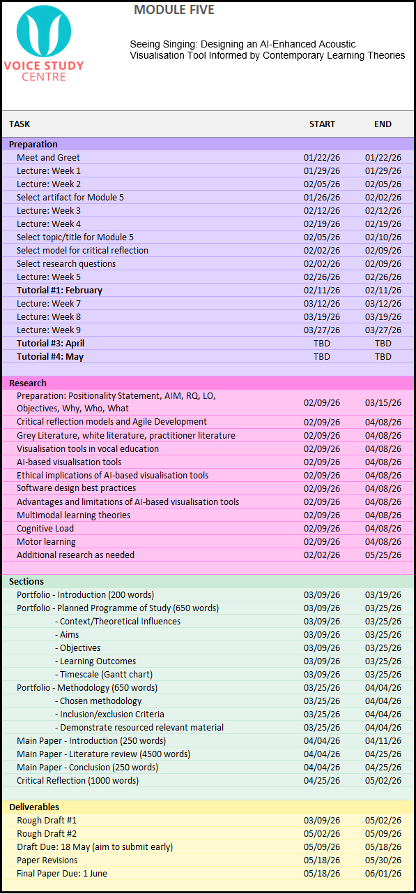

- METHODOLOGY

Several literature review methodologies were considered to leverage the type best suited for this study (Randolph, 2009). A systematic review with its exhaustive search and strict inclusion/exclusion criteria does not lend itself to an interdisciplinary, under-researched topic (Boell and Cecez-Kecmanovic, 2014). Similarly, a scoping review is better suited for examining well-established domains, and a rapid review, while effective for quickly summarising known evidence, is less helpful for an emerging research area (Grant and Booth, 2009). A narrative review was chosen because it can highlight gaps in research, support critical synthesis across adjacent disciplines, and enable the literature to be organised around themes aligned with the research questions, aims, and objectives (Green et al., 2006; Grant and Booth, 2009; Sarkar and Bhatia, 2021; Sukhera, 2022).

This research is being approached from a Critical Realist (CR) paradigm, acknowledging reality as stratified into three layers: the real (underlying mechanisms), the actual (observable events), and the empirical (measurable events) (Shannon-Baker, 2016; Fletcher, 2017; Lawani, 2021). CR is applied by using these three layers to examine AI-enhanced visualisation tools in vocal education by recognising the underlying mechanisms influencing pedagogy and technology (the real), observable practices (the actual), and learner experiences and outcomes reported in the literature (the empirical) (Lawani, 2021). Additionally, Nelson’s practice-as-research modes of knowing were used to organise this paper into three primary sections: Know That (theories informing the artefact), Know How (how the artefact was created), and Know What (artefact impacts and contributions) (Figure 1: Modes of Knowing) (Nelson, 2013, p. 28).

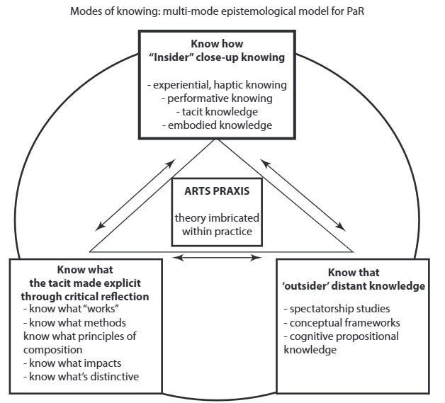
Figure 1: Modes of Knowing (Nelson, 2013, p. 28)

Design-Based Research (DBR) will serve as the methodological structure for this project, as it focuses on designing and developing artefacts to solve context-specific problems in educational settings through integrating research, design, and pedagogical practice to provide deep insight into learning within real-world contexts (Joseph, 2004; Alghamdi and Li, 2013). DBR involves six iterative, but not necessarily linear, phases: focus (identifying an issue), understand (researching the issue to identify the root cause), define (determining goals and assessments), conceive (creating a proposed solution), build (creating an artefact prototype), and test (using an iterative cycle of testing against real-world feedback) (Easterday et al., 2014).

In this study, CR pairs with DBR by using CR’s focus on the mechanisms behind observable events to guide each DBR iteration, helping explain not only why and how the artefact may work, but for whom, under what conditions, and why it may succeed or fail in practice (Mingers, 2004; Shannon-Baker, 2016; Fletcher, 2017; Lawani, 2021).

To facilitate the artefact’s build phase, I will employ AI-assisted rapid prototyping (vibe coding), an emerging software development technique where developers generate code by interacting with large language models (LLMs) through natural language prompts (Fawzy et al. 2025).
Literature was selected prioritising the most recent research, particularly published since January 2025, and using the CRAAP test (Currency, Relevance, Authority, Accuracy, and Purpose) to ensure sources were current, relevant, and credible (Blakeslee, 2004) (Appendix G: Inclusion/Exclusion Criteria). The literature search strategy used keywords such as “learning theory,” “AI in vocal education,” and “UI best practice,” which were entered in Google Scholar, Google, and the University of Wales Trinity Saint David (UWTSD) online library, employing an iterative approach to refine keyword combinations and strengthen results (Appendix H: Search Table) (Aromataris and Riitano, 2014). Google search alerts and ResearchGate filters were set to recommend literature on AI in education.

Given the presence of newer researchers in this field and the use of non-traditional publication outlets conducting internal peer reviews, this study incorporates grey literature, including dissertations, conference proceedings, and websites, together with peer-reviewed sources to capture a broad range of academic perspectives (Adams et al., 2017).

REPORT

Seeing Singing: Developing an AI-Enhanced Visualisation Tool
Informed by Learning Theory and Application Development Best Practices

- INTRODUCTION

Artificial intelligence (AI) is positioned within vocal education as a tool for enhancing voice lessons through personalised, accessible real-time feedback (Han, 2022; Khaydarov, 2024; Hin, 2025). While interest is growing among educators, research on AI in vocal education remains limited, with existing studies focusing on technological features rather than pedagogical relevance and offering limited geographic coverage and minimal long-term tracking (Ovcharenko et al., 2020; Bauer, 2023; Huriye, 2023; Zhang, 2025). AI’s practical integration into vocal education requires interdisciplinary collaboration among vocal educators, voice scientists, and AI programmers—exploring AI’s potential while ensuring applications are developed to align with user expectations (Bauer, 2023; Huriye, 2023).

In my previous research, vocal educators expressed interest that AI-enhanced tools could offer visualisation capabilities, including vibrato, pitch matching, and vocal acoustics, provided the tools are pedagogically sound and ethically created (Donahue, 2025; Smailis and Heliadis, 2025). This study focuses on the design of an AI-enhanced vibrato visualisation tool responding directly to these expressed pedagogical needs. With thirty years of experience as a web applications developer and vocal educator, I am positioned to critically evaluate the intersection of technology and vocal pedagogy.

Because the vocal mechanism consists of internal physiological systems not visible to the naked eye, AI-enhanced visualisation tools may strengthen a vocal learner's experience by supporting immediate technical adjustment, preventing the reinforcement of errors, and managing cognitive load (Han, 2022; Doğanyiğit and Yiğit, 2023; Bin, 2024; Cleveland Clinic, 2025; Wang and Gan, 2025). However, for such tools to be effective and adopted by educators, they must fit within diverse vocal pedagogical frameworks and be supported by intuitive user interfaces (Yu et al., 2023; Donahue, 2025).

Using the three-layered lens of Critical Realism (CR) together with Nelson’s practice-as-research modes of knowing (Know That, Know How, and Know What), this study will culminate in an AI-enhanced vibrato visualisation artefact, delivered as a technical specification and prototype application (Nelson, 2013).

This study is guided by the research question:

- How can insights from previous visualisation tools, contemporary learning theories, and application development best practices inform the development of an AI-enhanced vibrato visualisation tool for use in vocal education?

- KNOW THAT

Three primary themes shaped the creation of this artefact: visualisation tools, contemporary learning theories, and application development best practices.

- Know That Theme A: Visualisation Tools

Unlike instrumentalists who can directly observe their technique, such as a pianist’s fingers on the keys or a violinist’s bow placement, singers work with an entirely internal instrument, requiring learners to rely on proprioception (sensing one’s own position and movements) and aural feedback (Bin, 2024; Li et al., 2025; Wang and Gan, 2025). To compensate for this, voice teachers often use analogies, imagination, and metaphors (AIMs), both verbal and kinesthetic, to convey aspects of vocal technique (Ekholm et al., 1998; Kar, 2021). While experts agree AIMs can improve the voice by affecting involuntary muscles and helping to concretise concepts, AIMs can also confuse students when the educator’s image is not replicated in the student’s mind as intended, highlighting the need for more tangible, visually accessible forms of teaching vocal techniques (Bartlett, 2014; Doğanyiğit and Yiğit, 2023; Bin, 2024; Lim, 2024). Particularly during independent practice and in early learning stages when perceptual skills are still developing, students may struggle to identify and correct errors without timely external feedback, increasing the likelihood of reinforcing inaccuracies (Bin, 2024; Li et al., 2025; Liu and Guo, 2025).

With the technological evolution of computer science and advances in recording technology, visualisation tools in vocal education have progressed from simple feedback systems to AI-powered, real-time diagnostics that make abstract dimensions of vocal instruction more accessible (Elmer, 2000; Bin, 2024) (Appendix B: Visualisation Tools). Spectral waveform analysis transforms a singer’s voice into image-based displays, allowing visual evaluation of timbre, pitch, and intensity (Khan et al., 2020; Bin, 2024). Digital and AI tools can also support multiple modes of learning (visual, auditory, and kinesthetic), but can be difficult for students to interpret without specialised training and are often cost-prohibitive (Han, 2022; Doğanyiğit and Yiğit, 2023; Chen, 2024; Liu et al., 2024).

Current research highlights the development of AI-enhanced visualisation tools that provide analysis of vocal metrics, reflecting a shift from teacher-driven AIMs to student-observed evidence (Caldera, 2024; Liu and Guo, 2025; Rao, 2025; Wang and Gan, 2025). Tools such as the Vocal AI Analyzer and Smart Vocal Coach have demonstrated effectiveness in enhancing vocal skills by identifying microscopic pitch deviations, enabling students to make faster, targeted corrections to vocal technique with or without teacher involvement (Chen, 2022; Wang and Zhang, 2022; Liu and Guo, 2025).

The adoption of real-time visualisation tools in vocal education has been slow since many are misaligned with pedagogical principles, or present monetary or technical barriers, and often encounter resistance when introduced into established teacher–student practices (Erickson, 2021; Xie, 2026). While anecdotally vocal educators are known to use spectrographic software during lessons, there are limited studies available on the overall effectiveness of visualisation tools in vocal education, with most studies involving small samples and short durations (Hoppe et al., 2006; Lã and Fiuza, 2022; Li et al., 2025). Concerns regarding over-reliance on technology suggest it may weaken critical listening skills and cause beginners to lose the ability to critically evaluate the feedback they receive (Odusanya, 2025). To be adopted, vocal visualisation tools must be pedagogically aligned, co-designed with practitioners, and user-friendly, enhancing rather than disrupting established teaching practices (Grassini, 2023; Donahue, 2025).

In summary, while vocal education has a rich tradition, its persistent pedagogical challenges highlight the need for more concrete, multimodal ways to demonstrate technique that support both teacher-led and independent learning (Bartlett, 2014; Ovcharenko et al., 2020; Huang, 2026). With limited evidence on the efficacy, relying solely on AI to provide feedback is insufficient for improving metacognition, highlighting the need for learning theory-informed creation of tools (Wu et al., 2020).

- Know That Theme B: Contemporary Learning Theory

As our understanding of human cognition has grown alongside rapid technological development, contemporary learning theory has shifted with it, treating modern tools as part of an ongoing, lifelong learning process (Ouwehand, 2025). In order to inform the design of this artefact, I researched several contemporary learning theories, including Metacognition, Cognitive Load Theory, Educational Neuroscience (EdNeuro), VARK, TTI, Embodied Cognition, and AI Recursive Theory. While each one has distinctive characteristics, applying thematic analysis revealed 37 key terms, which were grouped into eight categories, then reduced to three primary themes to provide clear criteria from contemporary learning theory to apply to the artefact (Appendix C: Thematic Analysis of Contemporary Learning Theories).

    - Learning Theory, Theme 1: Multimodal Systemic Teaching

The first theme, multimodal systemic teaching, refers to the transfer of knowledge through auditory, visual, reading/writing, and kinesthetic modalities within a pedagogically sound structure, with multisensory integration shown to refine motor responses and strengthen memory (Erickson, 2021; Isma’il and Sodangi, 2025). These multimodal benefits can only be realised when tools are rooted in a structured pedagogical framework informed by student-centred approaches (Wu et al., 2020; Gkintoni et al., 2025; Isma’il and Sodangi, 2025).

    - Learning Theory, Theme 2: Chunking, Feedback, and Iteration

The second theme, chunking, feedback, and iteration, refers to the intentional scaffolding and segmenting of information to gradually introduce new concepts by creating specific, actionable tasks that receive feedback and are adjusted iteratively, allowing learners to integrate new skills and maintain cognitive focus (Gkintoni et al., 2025). Across studies, real-time and iterative feedback has been shown to heighten learners’ awareness of their metacognitive state and deepen cognitive engagement (Molin et al., 2020; Li et al., 2023b; Cosentino et al., 2025; Heryanto et al., 2025). Because feedback requires learners to process verbal, nonverbal, and contextual cues simultaneously, it can elevate cognitive load, making its effectiveness dependent on segmentation, scaffolding, and repetition to manage intrinsic and extraneous demands while supporting efficient skill acquisition (Erickson, 2022; Cosentino et al., 2025; Gkintoni et al., 2025).

    - Learning Theory, Theme 3: Reflection and Self-Awareness

The third theme, reflection and self-awareness, refers to the learner’s understanding of their current cognitive state and their ability to regulate it, along with reflection on their actions, both independently and with guidance from an educator. Reflection and self-awareness shift learning from copying to intentional, self-directed work, allowing learners to identify technical misalignments and incorporate feedback through repeated evaluation cycles (Molin et al., 2020; Li et al., 2023b; Gkintoni, 2025; Heryanto, 2025; Li et al., 2025; Ouwehand, 2025).

Many other learning theory elements fell outside the scope of this thematic analysis since they did not align with the needs of this specific application, including Embodied Cognition’s emphasis on physical engagement with the environment to deepen conceptual understanding, the application of reading/writing from VARK’s theory, and emotion-cognition theory of EdNeuro (Cosentino, 2025; Gkintoni, 2025; Indriyani and Nurmasitah, 2025). Incorporating these elements risked creating a split-attention effect where learners inefficiently divide their focus between different types of content (Xue et al., 2024).

Similarly, some characteristics of learning theory conflict; for example, multimodal approaches encourage rich sensory input, while Cognitive Load Theory cautions against overload, requiring careful synthesis to balance multimodal presentation’s richness with the simplicity needed to optimise working memory (Cosentino, 2025; Gkintoni, 2025). While a single theory offers a streamlined approach, a blended approach is necessary to activate the diverse underlying mechanisms required for deep learning in a multidisciplinary subject like singing (Li et al., 2025).

By integrating these three themes as representative of contemporary learning theory, my aim is to build an artefact that not only functions as a real-time visualisation tool, but also supports the cognitive and reflective processes that underpin effective vocal learning, consistent with a CR approach that considers underlying mechanisms, actual practices, and empirical learner experiences (Bhaskar, 1975; Gkintoni, 2025; Heryanto, 2025; Li et al., 2025; Xie, 2026).
- Know That Theme C: Application Development Best Practices

The effectiveness of digital tools is shaped by their user interface (UI), as poorly designed interfaces can create split-attention effects that increase cognitive overload (Ouwehand, 2025). Effective UI design integrates feedback into the learner’s focus area and aligns cues with attentional patterns, reducing extraneous demands and supporting deeper engagement and self-evaluation to strengthen long-term retention (Cosentino, 2025; Li et al., 2025). Teachers emphasise the need for user-friendly interfaces and seamless lesson-plan integration, underscoring the importance of human-centred design that preserves the teacher’s role (Qian, 2023; Hua and Yi, 2024; Smailis and Heliades, 2025). For vocal training, UI design must translate invisible biological processes into actionable visual cues (Santos and Masiero, 2026). Features such as colour coding can support rapid self-correction, while overly complex feedback systems risk shifting learners toward surface-level verification rather than meaningful exploration (Chen, 2025; Cosentino et al., 2025; Wu, 2026). To be effective, vocal visualisation tools must be co-designed with practitioners to ensure they enhance rather than disrupt established teaching practices (Grassini, 2023; Donahue, 2025).

These objectives are supported through front-end optimisation, efficient backend architecture, and infrastructure choices that enable responsive, accessible delivery (Shethiya, 2025). Developers must prioritise low-latency performance for real-time feedback, ensuring functionality on devices with limited processing power or restricted bandwidth, allowing learners to practice where and when they choose (Li et al., 2025; Gkintoni et al., 2025; Shethiya, 2025; Purba et al., 2025).

The emergence of AI-assisted rapid prototyping, referred to as vibe coding, has introduced a practical way to meet these technical and design requirements quickly, where instead of manually constructing each component, developers use iterative, natural-language prompts to direct an AI model to generate and refine functional code (Sapkota et al., 2025; Sarkar and Drosos, 2025). While this process can significantly accelerate development, vibe coding can also produce code that is overly generalised or structurally fragile, requiring experienced oversight to ensure stability and security (Fawzy et al., 2025; Sapkota et al., 2025). To manage this, developers must perform manual quality checks to ensure the resulting application remains efficient and correctly implemented (Sarkar and Drosos, 2025).

- KNOW HOW

In previous VSC modules, I addressed DBR’s focus, understand, and define phases, justifying the need for visualisation tools in vocal education. Building on this, my initial intention was to develop a vocal acoustics analysis tool, but as I moved through DBR’s define and conceive phases, I discovered producing a well-designed acoustic analysis application would exceed the time constraints of this project. I, therefore, shifted to a more focused tool, a vibrato visualiser, that would still address a pedagogical need expressed by vocal educators. Vibrato is a common area of difficulty for students, with challenges ranging from straight tone to excessively wide vibrato, often requiring teacher guidance to develop control and flexibility between straight tone and vibrancy (Nesterova, 2026). Vibrato was selected because its measurable characteristics, in particular amplitude and periodicity, are directly shaped by vocal training and frequently identified as areas where learners benefit from clear, externalised feedback (Mürbe et al., 2007; Nesterova, 2026).

During DBR’s conceive phase, I created a technical specification and mockups to clearly define the application’s needs as informed by the research (Appendix E: Technical Specification). The remaining phases, build and test, were addressed iteratively to refine and improve the artefact (Easterday et al., 2014) (Figure 1: Iteration Map).

Initially, I attempted to submit a lengthy vibe-coding prompt containing all features and parameters explicitly defined, along with uploading the technical specification into Bolt.ai and Claude.ai simultaneously. While the AI models both implemented all the features requested, the waveform was inaccurately overresponsive to audio input, and iterative prompts to resolve the error compromised other artefact features. I decided to start over using Claude.ai as it had been the more successful AI model during previous attempts, implementing one feature at a time and testing before moving on to the next feature, beginning with the prompt:

I want to create a web-based application to display vocal vibrato as a single waveform. I will add more features as we go along, but I need the proof of concept for the vibrato wave line first...the wave should stay vertically centred regardless of pitch, and only respond to vibrato movements to show the amplitude above and below the centre. (Figure 2: Vibrato Visualiser) (Appendix F: Vibe Coding Transcript).

PROOF OF CONCEPT B
Tools: CoPilot, Claude.AI, Bolt.AI
- Testing different audio extraction tools
- Wave smoothing experiments
- Minimal UI design
PROOF OF CONCEPT A
Tools: Claude.AI, Bolt.AI
- Basic waveform generation
- Basic vibrato visualization
- Pitch detection
- Minimal UI design

12
Retain wave colors after session ends
Iteration 12
2
Waveform stabilisation
Iteration 2
14
Integrate AI for session analysis
Iteration 14
5
Grid opacity, smoothing wave
Iteration 5
4
X & Y axis labels, grid, wave retention
Iteration 4
1
Single waveform, 15s visible, client microphone
Iteration 1
Prototype Build Version 1.0
Tools: Claude.AI
9
Sawtooth wave generator, export PNG, notes, metronome
Iteration 9
8
Reduce display length, WCAG, scroll buffer
Iteration 8
7
Adjust playhead, fix rates
Iteration 7
6
Amplitude & periodicity controls, bumpers, timer
Iteration 6
11
Add colors to wave
Iteration 11
13
Background ‘ghost’ wave sample
Iteration 13
15
UI design and implementation
Iteration 15

10
Spacebar start/stop, save session, mic input level
Iteration 10

Figure 1: Iteration Map
3
Line dropout fixes
Iteration 3
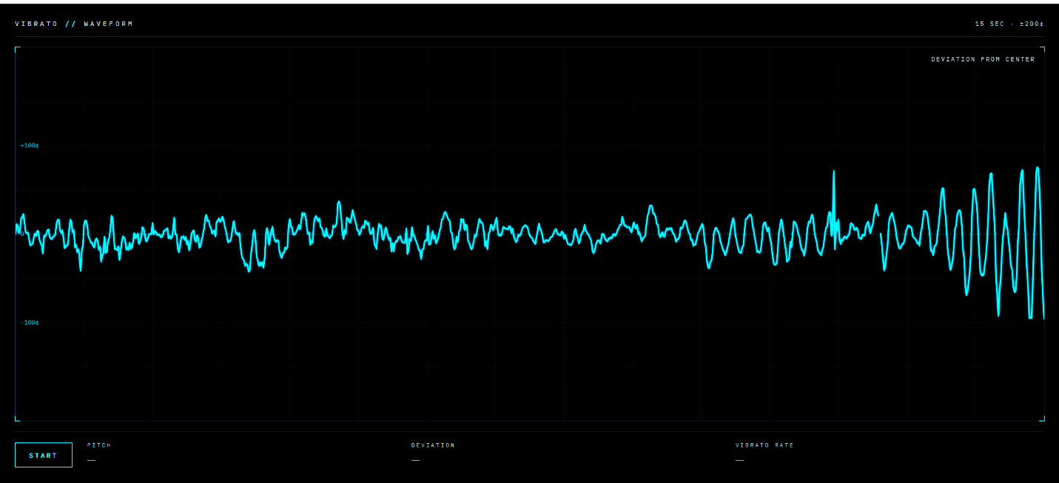
Figure 2: Vibrato Visualiser

- Theme 1: Visualisation Tools

To support clarity and ease of interpretation, I intentionally designed the UI around a single element, the vibrato waveform, which remains fixed in the screen’s centre to maintain the user’s visual stability (Erickson, 2021; Gkintoni et al., 2025) (Figure 2: Vibrato Visualiser). The wave responds in real time to the singer’s audio input, allowing learners to observe how targeted adjustments affect the vibrato pattern, demonstrating the benefit of immediate feedback (Chen, 2022; Wang and Zhang, 2022; Gkintoni et al., 2025).

Due to the difficulty in interpretability of earlier visualisation tools, I chose to prevent the waveform from shifting with pitch, anchoring it in a fixed position to keep the learner’s attention on the oscillatory pattern rather than on distracting pitch fluctuations (Hoppe et al., 2006). Early versions misinterpreted wide vibrato as a pitch change, causing dropouts in waveform generation (Figure 3: Dropouts). This was improved by adding short-window and long-window pitch-comparison averages, multi-stage smoothing, and snap-detection logic to reduce jitter. Additionally, I added dynamic pitch comparison dependent on the user’s periodicity and amplitude settings. Some fluctuation is unavoidable at vocal onset or during pitch changes because the application must interpret rapid pitch movement around the fundamental frequency. This creates a necessary compromise between strict detection for straight-tone singing and greater permissiveness for wide vibrato.
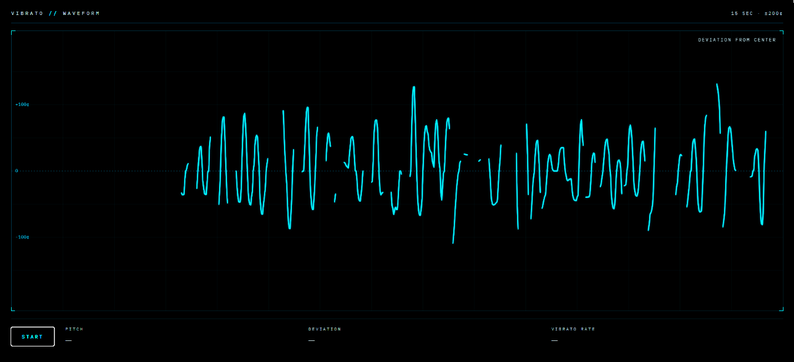
Figure 3: Dropouts

I tested several display waveform orientations, settling on a left-to-right scrolling waveform consistent with established visualisation software conventions such as VoceVista and Audacity, minimising unused space (Erickson, 2021).

Because research shows teachers prefer tools that avoid prescriptive feedback, I kept the artefact pedagogically agnostic, with no evaluative or corrective features, allowing vocal educators to provide their own pedagogical guidance (Erickson, 2021). Within this structure, the artefact acts as a cognitive support tool, providing data-driven feedback rather than replacing teachers’ judgments (Li et al., 2025).

In response to the need for inexpensive, intuitive, and user-centred tools, and because of my extensive experience as a web applications developer, I chose to create this tool as a web-based application supported by AI, able to be used on any desktop or mobile device without extra equipment (Han, 2022; Doğanyiğit and Yiğit, 2023).

- Theme 2: Learning Theory

    - Learning Theory, Theme 1: Multimodal Systemic Teaching

Informed by learning theory theme 1, the artefact pairs auditory and visual input to support more efficient cognitive processing and improved learning outcomes and includes an auditory component in the form of a reference pitch that oscillates at the user-selected periodicity and amplitude, aligning with learning through mimicry (Figure 4: Reference Pitch) (Jarvis, 2019; Erickson, 2021; Gkintoni et al., 2025). At the AI model’s advice, a sawtooth wave with a low-pass filter was used rather than a sine wave to better resemble the timbre of the human voice. Although finger tapping for vibrato has been shown to be effective, the application does not cue any kinesthetic movements currently to avoid cognitive complexity particularly for beginners (Nesterova, 2026).

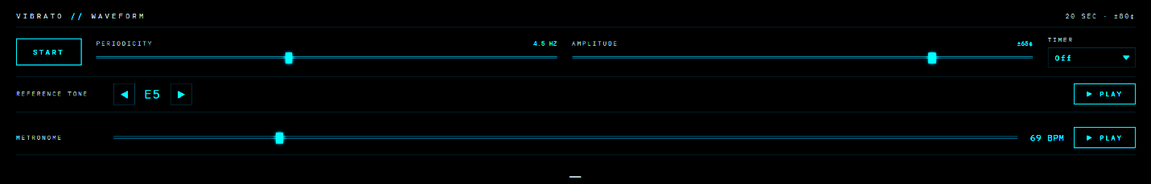
Figure 4: Reference Pitch

To provide an additional visual cue, I introduced colour changes when users maintain consistent amplitude and/or periodicity for a set duration (Figure 5: Colour Changes). This mild gamification supports motivation through reward‑based visual feedback without compromising pedagogical integrity (Gkintoni et al., 2025; Liu and Guo, 2025).

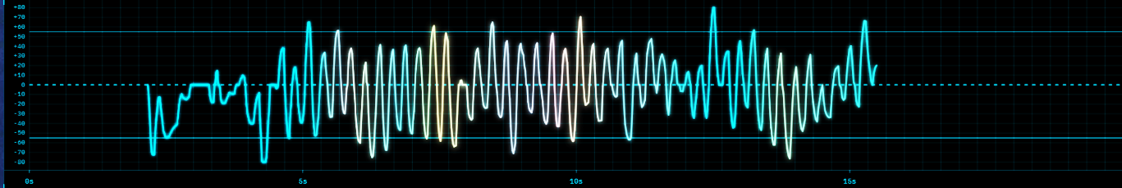
Figure 5: Colour Changes

    - Learning Theory, Theme 2: Chunking, Feedback, and Iteration

To align with learning theory theme 2, the artefact breaks skill development into smaller tasks (chunking) by reducing vibrato to a single, manageable behaviour and providing clear boundaries for practice to prevent overwhelm (Gkintoni et al., 2025). Sliders allow users to select their targeted amplitude and periodicity, generating amplitude guidelines above and below the waveform and vertical lines indicating periodicity (Figure 6: Guidelines and Grid). Adjusting these targets updates the guidelines in real time, and together these markers help learners identify whether the vibrato is too wide, too narrow, too fast, or too slow. A low-opacity sample waveform illustrates the chosen amplitude and periodicity, while the continuously updating trace allows learners to see the effect of each attempt and refine their technique instantly (Liu and Guo, 2025).

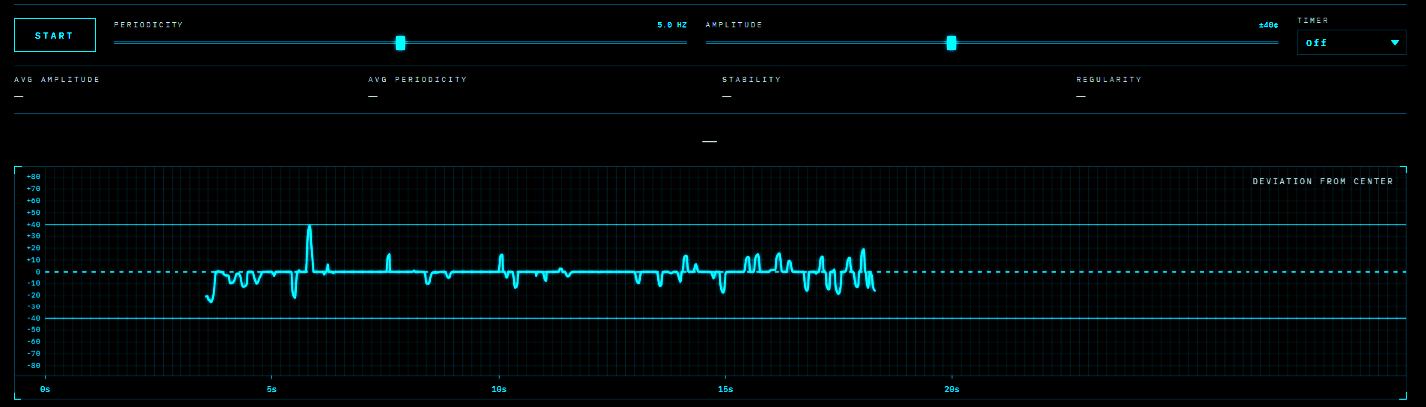Figure 6: Guidelines and Grid

An optional timer (15, 30, 45, or 60 seconds) supports small, repeated units of practice to strengthen skill development and allow complexity to build gradually (Erickson, 2022). Pitch is displayed textually in real time to provide context and uncover vibrato issues across different parts of the vocal range (Figure 7: Timer and Pitch Display).

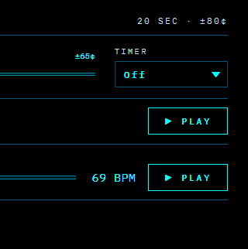
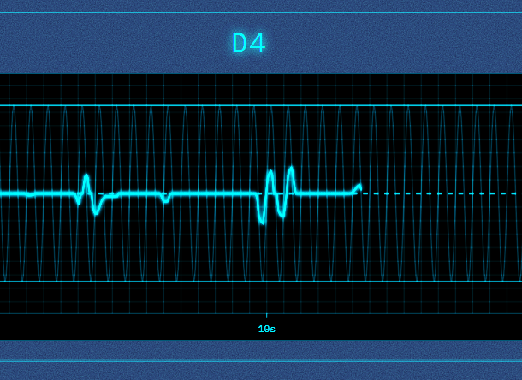
Figure 7: Timer and Pitch Display

To minimise split-attention, a hide/show toggle prioritises essential elements (start/stop control, pitch name, vibrato settings, and the waveform) so the visualisation remains focused and easy to interpret. This minimal design, using a simple waveform and adjustable bumpers rather than complex metrics or spectrogram-style displays, aligns with research showing learners engage more deeply when the task environment is simple, predictable, and free from unnecessary demands, allowing them to clearly see and interpret vibrato stability and irregularity as it occurs (Cosentino et al., 2025).

    - Learning Theory, Theme 3: Reflection and Self-Awareness

To support learning theory theme 3, I added scrollback and waveform retention to facilitate reflection and teacher-led discussion, aligning with research showing that reflection and self-awareness improve learning conditions (Li et al., 2025). The feedback section includes a text field for session notes and waveform metrics stored locally, enabling users to compare their practice over time (Figure 8: Text Note). A history table displays previous averages of amplitude, periodicity, and regularity, and waveforms can be exported as PNGs. Although historical audio data would be useful, I chose to minimally integrate AI by including an API call to Claude.ai that interprets stored session data, allowing experimentation with the technology without compromising privacy or introducing additional ethical concerns, with text notes and waveforms stored locally to support long-term comparison while maintaining a low-risk approach (Rao, 2025).

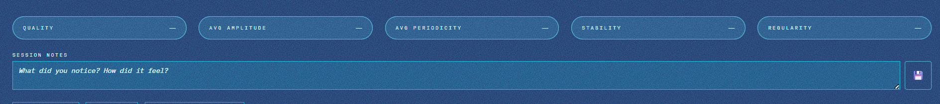
Figure 8: Text Note

- Theme 3: Application Development Best Practices

Given the high demand for applications that run on standard mobile and computer devices that allow learners to practise when and where they choose, I built the artefact as a web-based application with low-latency performance and without the need for high-cost equipment or high processing power (Shethiya, 2025; Purba et al., 2025).

Standard UI elements, including error handling and start/stop buttons, were incorporated. During vibe coding, the AI model recommended the addition of microphone input meter to allow easier troubleshooting if the waveform did not generate.

I attempted to build early prototypes using more robust libraries (Meyda and Pitchy), but they had a difficult time distinguishing between vibrato and pitch change, produced visual artefacts, and introduced latency. I made the decision to use a widely used JavaScript algorithm, YIN, to generate stable, real-time visualisations. Since JavaScript was going to be the most time-consuming part of coding the application, I primarily used vibe coding, knowing I could edit the JavaScript, if needed, and refine the functionality easily.

Although vibe coding with Claude.ai generated a basic UI design, I refined it manually through multiple iterations, adjusting grid opacity levels, fonts, and layouts to maintain visual stability (Li et al., 2025) (Figure 9: Final UI Design; Figure 10: Feedback Tools; Figure 11: Vibrato Visualiser v001; Figure 12: Mobile UI Design). The most significant change was organising the controls by functional need: the periodicity and amplitude sliders are grouped with the timer, as these three controls directly shape the waveform’s interactivity; the tone generator and metronome are grouped together as aural-stimulus tools; and the hide/show toggles for the ghost waveform and feedback section sit alongside one another. All controls are presented on three-dimensional cards and arranged from left to right in order of importance, and colour coding is incorporated across key UI elements to support rapid self-correction (Chen, 2025; Wu, 2026). The completed artefact is available for examination (Appendix I: Artefact Access).

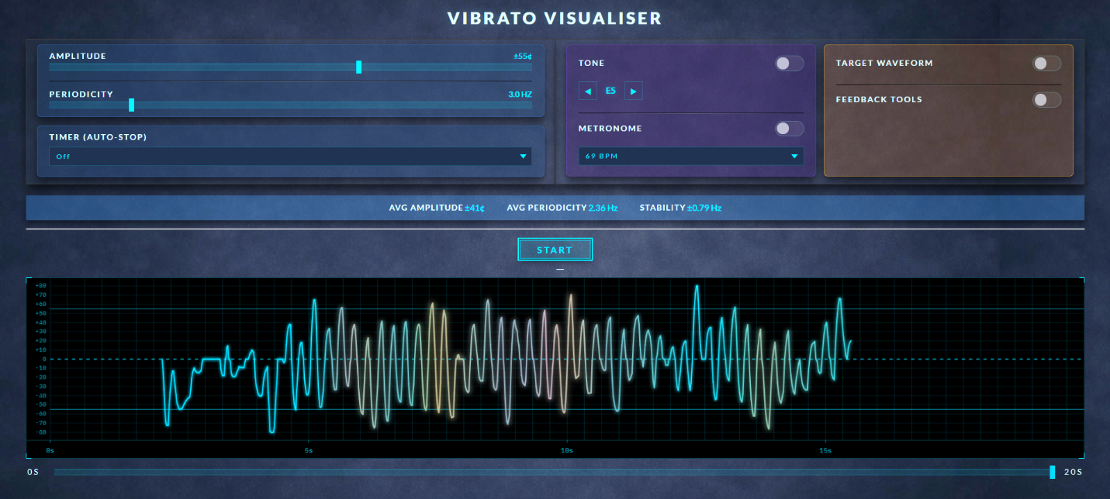
Figure 9: Final UI Design

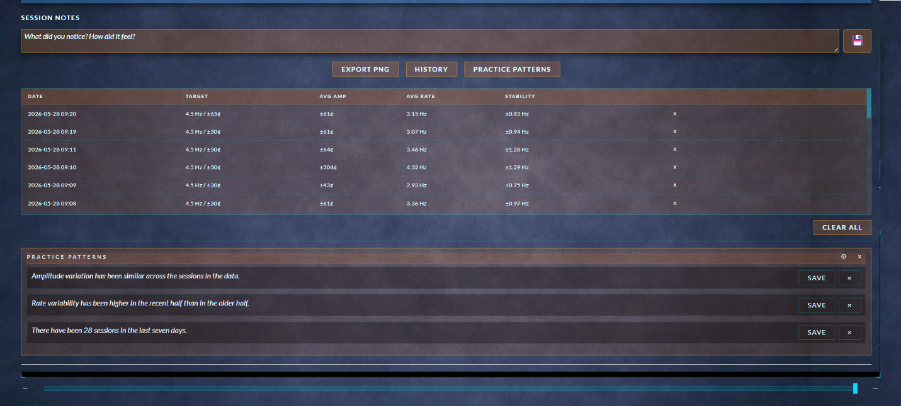
Figure 10: Feedback Tools

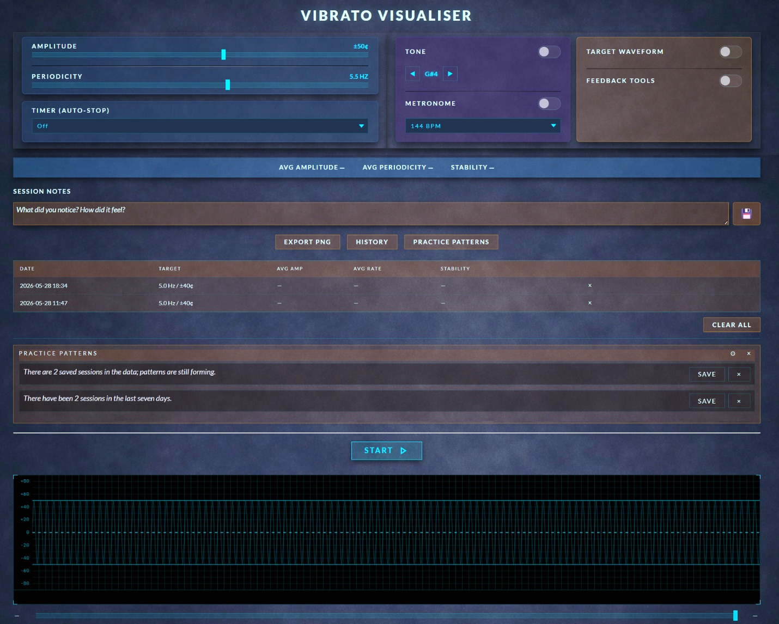
Figure 11: Vibrato Visualiser v001

- KNOW WHAT

This artefact was developed in response to a systemic gap in vocal pedagogy, where accessible, real-time visualisation tools remain limited despite the clear need for precise and immediate feedback in studio and independent practice (Han, 2022; Doğanyiğit and Yiğit, 2023). To address this gap, the artefact was conceptually framed through SDT, DBR, and CR, allowing the design to be examined not only as a technical solution but as a pedagogical one that supports learner autonomy, iterative refinement, and the causal structures that shape metacognitive development (Li et al., 2025). This section explores what the artefact reveals when situated within the wider landscape of visualisation tools, contemporary learning theory, and application development best practices, and considers the implications, tensions, and conceptual contributions that emerged through the design process.

- Theme 1: Visualisation Tools

Previous visualisation tools have paired vibrato with the fundamental pitch and have not offered visual targets, making it difficult for learners to distinguish vibrato from overall pitch movement or to understand the intended amplitude and periodicity of each cycle (Santos and Masiero, 2026). This gap reinforces reliance on teacher interpretation and leaves learners without a concrete reference for deeper concept understanding or independent practice (Li et al., 2025). The real-time waveform addressed this by allowing learners to see the effect of each adjustment as it occurred, echoing findings that immediate feedback strengthens engagement and supports more effective practice (Liu and Guo, 2025). By isolating vibrato from all other pitch information, the tool displays vibrato as a discrete behaviour and offers visual targets in an accessible way that has been needed in vocal education.

From a CR perspective, the study examined not only whether AI-supported feedback was beneficial, but how the tool’s multimodal learning approach functioned as a causal mechanism influencing metacognitive development, suggesting its impact may lie in shaping how learners monitor and evaluate their own practice (Li et al., 2025).

The design process revealed tensions that complicate the creation of visualisation tools in vocal education. Maintaining focus on vibrato alone required resisting the temptation to add additional metrics and features, even though the additions could offer valuable information. This tension between simplicity and feature expansion reflects a broader challenge in educational technology: adding more data does not necessarily support better learning and may instead overwhelm or distract students (Mutlu Bayraktar, 2022; Cosentino et al., 2025). Without real-world testing, it is difficult to predict how educators and learners will interact with the tool in varied studio contexts.

Using SDT as an evaluative lens, the visualisation supports autonomy by allowing learners to explore and adjust without constant teacher prompting, competence by providing an objective yet immediate means of tracking improvement, and relatedness by offering a shared reference point for teacher–student discussion and reflection (Li et al., 2025). However, SDT also highlights the limitation that complete autonomy without guided interpretation and instruction from an educator may lead some learners to misread the visual data or apply incorrect technique to achieve their goals (Li et al., 2025). Learners must therefore understand what periodicity and amplitude represent, what settings are appropriate for their musical style, and how specific technical adjustments affect both.

- Theme 2: Learning Theory

The three learning-theory themes identified through thematic analysis reveal how the artefact functions as part of a broader pedagogical system. The first theme, multimodal systemic learning, emphasises pairing auditory and visual cues within the teacher’s chosen pedagogical framework. This ensured the visualisation functioned as part of a coherent system rather than a standalone stimulus, supporting the teacher’s technical or stylistic focus.
The second theme, chunking, feedback, and iteration, was embedded by creating a single-function interface focused solely on vibrato periodicity and amplitude. This prevented distraction from unnecessary features, reduced cognitive load, and supported a clear, purposeful practice environment (Cosentino et al., 2025). The design aligned with research showing learners benefit from working in small, manageable units and refining them through repeated attempts (Erickson, 2022).
The third theme, reflection and self-awareness, was supported through the persistent waveform trace and session history, which allow learners to compare their performance over time and record notes about their experience. This aligns with evidence that reviewing one’s own performance strengthens metacognitive awareness and supports more intentional adjustment (Li et al., 2025). Although the tool does not include explicit reflective prompts, the visual trace and form field create opportunities for teacher-guided interpretation and learner-led noticing.
Together, these themes show how the artefact translates broad learning principles into a minimal, real-time interface that supports both teacher-led and independent learning. Challenges included maintaining this minimalism without diluting pedagogical value, raising the question of whether selecting a single learning theory might provide a more cohesive foundation for future visualisation-tool design or whether a blended approach remains more appropriate.
Using SDT as an evaluative lens, the learning-theory-informed design supported autonomy by enabling learners to experiment without waiting for external correction, competence by encouraging visible, incremental improvement, and relatedness by preserving the teacher’s role in helping learners interpret what they saw.

- Theme 3: Application Development Best Practices

The application was intentionally designed as a lightweight, browser-based tool requiring no specialised hardware or installation. By storing data locally and avoiding audio storage, the artefact maintained a high level of privacy. Its lightweight build reduced latency, ensuring the visualisation remained stable and responsive, potentially reducing the cognitive and technical friction that can interfere with learning. The technical specification adhered to best-practice strategies for simplicity, accessibility, and cross-browser/cross-platform functionality.

Historically, many applications in vocal education have been created with little practitioner input, resulting in tools that fail to meet pedagogical needs (Barrera Castro et al., 2025). As a dual representative of both the vocal pedagogy and web-development communities, I argue that applications should be grounded in actual pedagogical requirements rather than technological novelty. Leveraging validated research on learning theory increases the likelihood that such tools will be effective, and using thematic analysis to identify commonalities across theories allowed me to balance and maximise relevant research insights. This approach directly addresses the systemic issue of limited, pedagogically aligned visualisation tools by embedding practitioner knowledge and educator perspectives into the artefact.

From a CR perspective, many existing tools remain inaccessible due to cost, limited availability, or misalignment with pedagogical needs, but a deeper underlying mechanism is educators’ fear that technology may devalue their expertise or replace aspects of their role. Tools that provide prescriptive advice can intensify this concern by encroaching on teacher judgement and reducing the educator’s interpretive authority (U.S. Department of Education, 2023). Because these structural and psychological mechanisms shape how technology is adopted in practice, DBR offered a supportive framework for the project’s nonlinear, iterative nature, providing methodological justification for refining the artefact in response to these pedagogical realities and teacher-centred insights rather than prioritising technical novelty (Easterday et al, 2014).

Minimal AI integration allowed for entry-level experimentation without raising privacy concerns or requiring the training of an AI model. The design process revealed many available audio-processing engines are not well developed for specialised pedagogical use and require substantial modification to function beyond basic tuning or pitch-matching tasks. This created tension, as several objectives could not be met using existing libraries without extensive redevelopment.
Using SDT as an evaluative lens and following application-development best practices, the artefact supported autonomy by allowing learners to access the tool independently on standard devices without specialised equipment or teacher supervision. It supported competence by offering a clear, stable interface that reduced technological anxiety and allowed learners to succeed quickly.

Regardless of pedagogical framework, educators can integrate the tool into lessons as a shared reference rather than a replacement for pedagogical interaction, and advanced students can use it to guide self-practice. The visualisation supports this independence by giving learners immediate, interpretable feedback on each attempt, helping them recognise whether their adjustments are moving them closer to their intended periodicity and amplitude and allowing them to refine their technique without waiting for teacher input (Liu and Guo, 2025).

Together, these design choices reveal how ethical, accessible, and minimal development principles can shape the pedagogical function of a visualisation tool. Challenges remain, particularly regarding feature expansion and future data-storage needs, which would require careful and secure handling of sensitive information.

Overall, this project successfully met its aim by creating a vibrato visualisation tool that was designed and developed according to the technical specification, informed by learning theory, and iteratively refined through application-development best practices. The final artefact fulfils the specification’s goals by providing an accessible interface, clear visual feedback, and a user-centred design that can be expanded in future development cycles (Figure 12: Artefact Video).

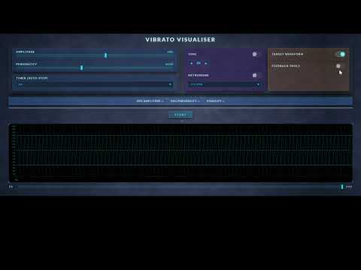
Figure 12: Artefact Video

- CONCLUSION

The aim of this research project was to examine visualisation tools, contemporary learning theory, and application development best practices to inform the creation of an artefact in the form of a technical specification and an AI-enhanced, real-time vibrato visualisation tool. Synthesising the findings across the literature and the development process showed that isolating vibrato as a single, trackable behaviour, presenting it through a stable and minimal interface, and avoiding prescriptive feedback aligned with both pedagogical needs and learning theory principles. Examined using Nelson’s practice-as-research modes of knowing, planned using Design-Based Research, and evaluated using Self-Determination Theory, a working prototype was constructed using vibe coding through iterative natural-language prompts, testing, and refining. Together, these elements show how the research directly informed the tool’s design and shaped the decisions made throughout development.
Through the process of building the artefact, I gained clearer insight into how theoretical principles can inform an artefact’s creation and how design choices shape the learner’s cognitive experience. Without real-world user testing, it is difficult to know whether the implemented features function as intended or if other features should be prioritised. Additional limitations include the constraints of browser-based audio processing, the variability of device microphones, and the risk that learners may misinterpret visual data without teacher guidance. Overall, the project demonstrates how a minimal, ethically-designed visualisation tool can bridge the gap between technical analysis and pedagogical practice in vocal education.

Future revisions could include additional wave-smoothing techniques, optional reflective prompts, and privacy-respecting ways to store audio files, as well as integrations with other visualisation tools. In its current state, the artefact provides a clear visual representation of vibrato that supports, rather than replaces, teacher-led instruction, helping students develop greater awareness and control. It serves as a foundational tool for future research, refinement, and pedagogical implementation of AI-enhanced vocal visualization tools, demonstrating that contemporary learning theory, best-practice application design, and insights from previous tools can meaningfully inform the development of new resources for vocal education. Conceptually, the artefact contributes to the field by showing how a minimal, multimodal, practitioner-informed design can function as a pedagogically aligned alternative to the technologically driven tools that currently dominate vocal education. More broadly, the artefact conceptually fills a gap in cost-effective, user-friendly vocal visualisation tools by offering a user-centred design created collaboratively between voice educators and software developers.

- CRITICAL REFLECTION

In my research, critical reflection, the conscious review and evaluation of past experiences to inform future decisions and actions, has been a personal challenge (Woodruff et al., 2023). Software development students differ from other qualitative researchers since their primary focus is on logical and physical artefacts as opposed to people, and often struggle with critical reflection, making it essential to select a reflective model that provides the structure and guidance needed to support the researcher (Prior et al., 2016).

- Reflective Model

I have found each research project requires a slightly different approach for critical reflection. While there are many established frameworks available, as critical reflection takes different forms across contexts, particularly in interdisciplinary research, generic models may not fully capture the diverse conceptual and methodological needs, and the ongoing debate around these limitations underscores the necessity for frameworks to remain adaptive and continually evolving (Justice et al., 2020). I have experimented with various hybrid models, combining elements from known reflective models with my own added or removed categories. Schön's model of reflection is often used by software engineers due to its simplicity, with focus on reflection in action, encouraging adjustments in real time, and reflection on action, analysing outcomes after project completion (Prior et al., 2016). While Schön’s model presents that doing and thinking are complementary, I prefer to separate these two concepts, believing that to reflect on doing, the thinker must remove themselves from the process to objectively assess their actions and uncover issues (Schön, 1987, p. 280). Gibb’s model offers a rigorous structure through its categories of description, evaluation, analysis, conclusion, and action plan, but it also uses “feelings” and “emotions”, which do not align with my reflective style (Galli and New, 2022).

Driscoll’s cycle of reflection, originally developed for use in healthcare, offers a simple alternative with its three-stage process: “What?” (item description), “So What?” (critical analysis of the item), and “Now What?” (next steps) (Gladd, 2020). Driscoll’s model provided clarity and progression, but I found it limited in capturing the iterative nature needed. In order for Driscoll’s model to meet my needs, I chose to adapt the model by incorporating Agile methods for software development (Agile), which I used previously in web application development as a means to break large projects down into smaller pieces (Hummel, 2014). Agile covers a wide area of beliefs, but its hallmarks are a values-driven framework that emphasises iterative and incremental cycles, flexibility in adapting requirements, and continuous self-assessment to improve practice (Alsaqqa et al., 2020). Agile's iterative process with continuous revisions complements Driscoll’s model by offering additional insight for reflection (Jalali and Wohlin, 2012). Consequently, I developed a hybrid reflective model combining aspects of Driscoll with Agile, utilising Driscoll’s three categories and adding a “Then What?” category to return to the reflection and document whether the issue was resolved or required additional inquiry (Appendix A: Reflective Model). I created a Google form to facilitate tracking and stored the records in a Google sheet, adding keywords to each entry to make sorting and searching data more efficient. These adaptations provided structure and flexibility, allowing me to document challenges, evaluate possible solutions, plan future actions, and revisit past entries in the reflective journal.

- Application of the Reflective Model

Applying this model supported me in addressing several critical decision points. For example, I had intended to create a visualisation tool for vocal acoustic properties (“What?”). Further investigation into the requirement for this tool revealed it may be too complex for my first attempt at creating an AI-enhanced visualisation tool, particularly with the time constraints of this project (“So What?”). This required me to iteratively revisit my options and list potential applications I would like to build (“Now What?”). In my previous research, vocal educators had specifically mentioned the desire for a tool to see vibrato, making it the next logical choice and my final selection, providing a clear trajectory for the study (“Then What?”).

Similar to my experience in Module 4, moments of difficulty, including research fatigue, lack of motivation, and the struggle to maintain a coherent outline, proved pivotal (What?). Rather than viewing these as failures, I reframed them as opportunities for critical learning. Burnout and lack of motivation among newer researchers can result from overcommitment, high workloads, and poor work–life balance, resulting in emotional exhaustion and disengagement from work (Boone et al., 2022). Acknowledging burnout (So What?) led to the development of a detailed revised list of tasks and specific planned times and dates to focus on my research (Now What?). Breaking the project down into small pieces allowed me to focus on one area at a time and avoid feeling overwhelmed. The issue of motivation revealed the emotional dimension of research. Although I tend not to link emotions to technical work, reflection forced me to acknowledge their impact. Recognising fatigue as part of the research process allowed me to plan more realistically, including the possibility of requesting extensions if necessary (Then What?).

Once I began the application-building process, I found while vibe coding hastened development significantly, creating the prompts yielded different results in different AI platforms (Claude.ai, Bolt.ai, and CoPilot.ai). Initially, I attempted to describe the entire application in one prompt and test it on multiple AI platforms and models, which yielded several versions of unusable code which presented display issues, inconsistent audio integration, and significant pitch-shifting issues (“What?”). My next strategy was to separate the functionality from the UI design, knowing it would take significantly longer to handwrite JavaScript to create the functionality than it would manually creating the UI, researching which AI model would likely yield the best results (“So What?”). I selected Claude.ai’s model, Opus, and began with prompting for a simple waveform that used the client’s audio input device along with a start/stop button (“Now What?”). Once this proved successful, I iteratively prompted for each piece of functionality I planned to include in the application, testing the newest version and reviewing the code before moving on to the next iteration (“Then What?”).

Overall, my reflective practice continues to evolve from descriptive journaling to critical evaluation. The hybrid model I developed facilitated documentation and enabled analysis of patterns across my research process. Although this hybrid model was sufficient for this research study, future research would benefit from refining it for greater structural guidance that prompts and sustains my use of the tool and investigating reflective frameworks that have been successfully used in similar cross-disciplinary research, which will guide my next stages of development.

DISCLOSURE OF AI USE

Grammarly AI was used for grammar checking, NotebookLM for organising and searching research notes and papers, and Microsoft CoPilot for organizing structures and checking all citations had corresponding items in the reference list. Claude.AI, CoPilot.AI, and Bolt.AI were used during the initial testing vibe coding of the AI-enhanced, web-based artefact, while Claude.AI was used for the final version to create functionality and a basic UI.

